Dave The Killer™
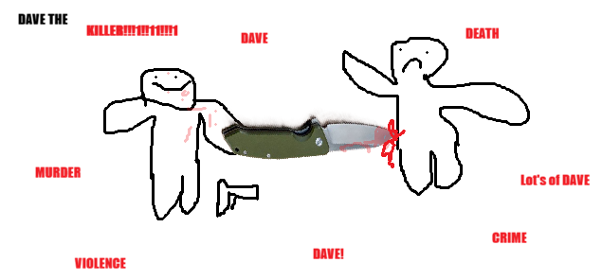

It was a bright and sunny morning. 12 hours later it was cold and raining.
Dave the Killer™ was on the train to the city. A train that wouldn’t be arriving at the city. There was 24,000kg of dynamite on the tracks up ahead. Dave The Killer™ jumped off of the train, as to avoid been turned into 100 little pieces of flesh that resembles chicken nuggets. The other 112 people on the train got exploded by the dynamite.
The explosion threw the people into the air, exploding them to death. Dave The Killer™ chuckled to himself. ‘heheheh’. Dave The Killer™ chuckled. ‘I’m Dave The Killer™’. At that moment the cops turned up. Dave The Killer™ smiled, as Dave The Killer™ never went anywhere without his AK-47 semi-automatic assault rifle.
Dave pulled out his AK-47 semi-automatic assault rifle and loaded some bullets into his AK-47 semi-automatic assault rifle. He then waved it threateningly at the cops. The cops then looked at the gun, meaning they didn’t notice when they stepped on the landmine that killed them with so much force that the surrounding trees were covered in red. It reminded Dave The Killer™ of his childhood Christmases, with the guts looking like tinsel. At least, until you looked closer at Dave The Killer™’s Christmas tree.
‘Dang it’’, Dave The Killer™ thought. ‘I wanted to kill them.’. Dave The Killer™ took it as a lesson to be more careful wuth where he left landmines in the future.
Dave The Killer™’s malevolent car malevolently pulled towards him. The 1966 Ferrari 330 P3 with a custom electric engine and an auto-targeting laser gun silently pulled up besides him. Dave The Killer™’s 1966 Ferrari 330 P3 with a custom electric engine and an auto-targeting laser gun was a very expensive car with a custom electric engine and auto-targeting laser gun. It cost him $,2,150,000,000 to buy it. It cost that much largely because he also had a Mercedes-Benz 300 SLR coupe, with a custom electric engine and a dynamite-catapult. Dave The Killer™ liked the steering wheel on the Mercedes-Benz 300 SLR coupe, so Dave The Killer™ had that steering wheel replace the steering wheel on Dave The Killer™’s 1966 Ferrari 330 P3 with a custom electric engine and an auto-targeting laser gun.
Dave The Killer™’s modifications to the 1966 Ferrari 330 P3 with a custom electric engine and an auto-targeting laser gun and the Mercedes-Benz 300 SLR coupe with a custom electric engine and an dynamite catapult made most of the car community very angry, until Dave The Killer™ tried out Dave The Killer™’s dynamite launcher, killing most of them.

Dave The Killer™ stepped into his car. He realized he was low on eggs. And he felt like an omelet. So he started speeding to the grocery store. Not speeding by a little, speeding by 128 kilometers per hour. He was recklessly driving down the road, passing people left and right, firing his laser gun in random directions, causing people to swerve and crash, one car had a plume of smoke. Dave The Killer™ slowed down. He wanted to see the explosion. The explosion happened. It was big and loud and bright. A charred body landed next to Dave The Killer™. Dave the Killer™ poked at it with his laser gun. It started to disintegrate. No use to him anymore.
Dave The Killer™ sped off to the grocery store. The eggs’ price had increased again. He sighed, grabbing $7.50 from his pocket. Before he gave it to the cashier, he heated it with his blowtorch. He gave it to the cashier.
The cashier screamed, the coin branding the flesh of their palm. Dave The Killer™ pressed more coins into their palm, making up the rest of the $7.50. Eventually Dave The Killer™ got bored of the screaming, and poked the cashier (extremely forcibly) in the head with a crowbar, until their head resembled half-ate pasta bake. Half-Life lied to Dave The Killer™, there was no little flesh nuggets ssflying off of the cashier. Dave The Killer™ made a note in his head to find a torrent for Counter-Strike: Source next time he could, to spite Valve. Dave The Killer™ walked out with his eggs.

Dave The Killer™ went back home and prepared to pirate CS: Source. He made sure to activate the kill switch on his Windscribe Vpn app, to ensure his rea Ip would never be leaked.

