**Game Control Instructions for Test Plan**

**Movement**

**Up**: Press the **W** key to move the player **up** (Northward) in the game

* Expected Output - The player moves up.

**Down**: Press the **S** key to move the player **down** (Southward) in the game

* Expected Output - The player moves down.

**Right**: Press the **D** key to move the player **right** (Eastward) in the game

* Expected Output - The player moves right.

**Left**: Press the **A** key to move the player **left** (Westward) in the game

* Expected Output - The player moves left.

**Combat**

**Attack**: Press the **Left** mouse key to attack.

* Expected Output - The player attacks.

**Block**: Press the **Right** mouse key to block.

* Expected Output - The player blocks.

**Interactions**

**Interaction**: Press the **E** key to **interact** with objects in the environment.

* Expected Output - The object gets added to the inventory.

**Help Screen**: Press the **H** key to **open** or **close** the help screen UI.

* Expected Output - The help screen UI shows up.

**Inventory:** Press the **I** key to **open** or **close** the inventory in the console.

* Expected Output - Pre-obtained and newly acquired items are shown in the Inventory slots on the screen.
  + Press the **1, 2, and 3** keys to select the 1st, 2nd, and 3rd slots on the HUD.
* Expected Output - Pre-obtained and newly acquired items are shown in the Inventory UI.

**Use Item**:Press the **Q** key to use the acquired items.

* Expected Output - The pre-obtained item like health potion will be used - increasing health.

**Debugging**

**Debug mode**: Press the **Tab** key to **show** the debug information (use the same key to stop this mode).

* Expected Output - The red bounding boxes for the player, robots, and the rendered tiles are visualized on the screen.

**FPS Counter**: Press the **F** key to show the FPS counter on the screen (use the same key to remove the counter from the screen).

* Expected Output - The FPS counter shows in the top left in green.

**Restarting and Closing**

**Restart**: Press the **R** key to restart the game.

* Expected Output - The game restarts from the remote location.

**Closing**: Press the **Esc** key to close the game.

* Expected Output - The game closes.

**Boundaries and Obstacles**

**Map Edges**:

The map consists of a remote location where the main walkable region is separated by trees on both sides (top and bottom) and 2 levels which have set walls all around the level.

* Expected Output - When the character reaches the tree or wall, movement in that direction is blocked and collision sound is played.

**Robots:**

Our game should have robot entities spawning at set locations in the first level.

* Expected Output - The robot enemies should follow the player around the camera frame to get within the range to attack. When the robot is within the range to attack, it shoots the projectile. If the player gets too close then the robot stays idle. If the robot damages the player enough, the player should die. If the player attacks the robot enough, the robot should die.

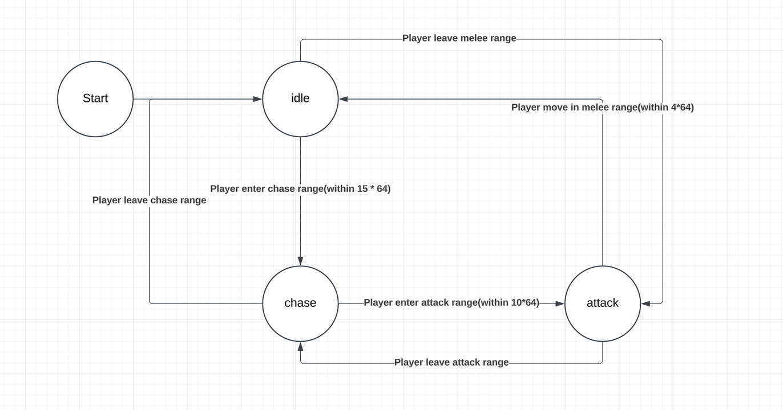

**Obstacles:**

Various in-game objects, such as trees, walls, a spaceship and other environmental elements, can block both the player and robot movement. The player and robots must navigate these obstacles to continue moving through the game world. Additionally, there is a spaceship in the remote location.

* Expected Output - The player and robots’ movement is blocked, colliding with the trees and walls. The robot uses pathfinding to maneuver around.

**Additional Notes**

The map’s boundaries and obstacles are designed to guide the player through specific paths and challenges.