**Assignment 1 – Algorithm**

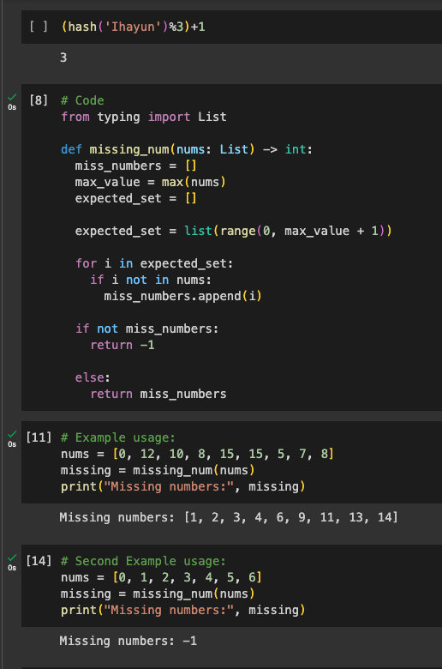

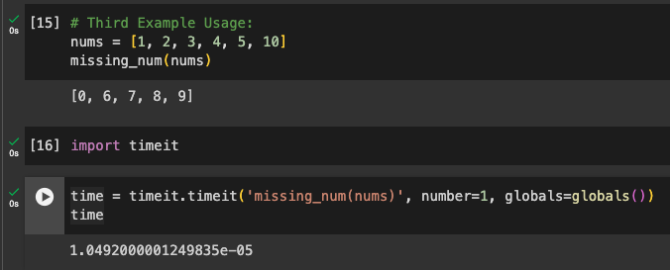

**Defining problem:**

The problem is to find a function in order to find missing number(s) from the list where the elements are in the range of [0, n]. If there is no missing number, then it will return -1.

**Solution Explanation:**

Given a list of numbers, first we try to find expected set. The expected set is a list and it is obtained by having a range of list from 0 to maximum value of the given list + 1 because range does not include the last maximum element.

Then we will try to find the missing numbers from the given list. It is first going through the elements in each expected set, then compare it with the given list. The number(s) that is missing from the expected set is then taken and being shown as the result. If there is no missing number when comparing the expected set and given list, it will give -1 result.

**Complexity:**

The time complexity seems to be O(n) and the space complexity is also O(n).

**Alternative Solution:**

Using sets instead of lists can optimize the time complexity. The alternative solutions would be to change the For loops into difference between the expected set and the given list.