1/creation de folder learn_git



2/change directory

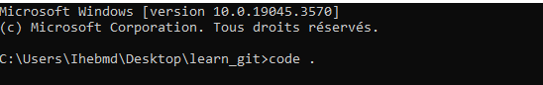

3/creation du file third.txt



4/initialize an empty repository

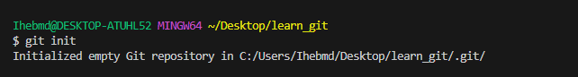

5/add third.txt to the staging area



6/commit with message ‘adding third.txt’

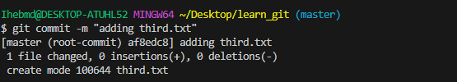

7/check out with git log

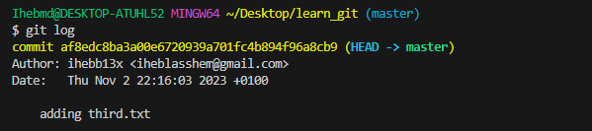

8/create another file fourth.txt



9/adding fouth.txt to the staging area



10/commit with message add fourth.txt

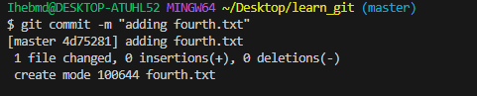

11/ remove third.txt



12/add this change to the staging area



13/commit removing third.txt

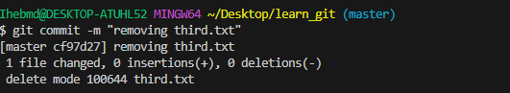

14/check out with git log

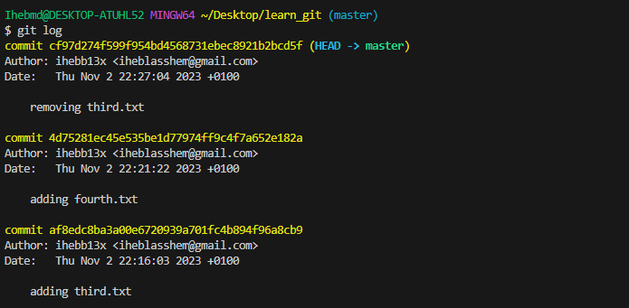

15/Change your global settings to core.pager=cat



16/Write the appropriate command to list all the global configurations for git on your machine.

