RESEARCH MEMORANDUM
  - Is bike rental demand a function of temperature?
Isha Hebbar
2026-09-16
Table of contents

1 Introduction
Researcher: Isha Hebbar
Date: September 16th, 2026
Research Question: Is bike rental demand a function of temperature?
H0: Rented bike count is not related to temperature (slope = 0).
HA: Rented bike count is related to temperature (slope ≠ 0).
This memo tests that relationship with a simple linear regression of hourly rented bike count on temperature, using the Seoul Bike Sharing Demand dataset from the UCI machine learning repository.

2 Key Data & Analysis
Data are from the Seoul Bike Sharing Demand dataset on the UCI Machine Learning Repository.
import pandas as pd
import numpy as np
import seaborn as sns
import matplotlib.pyplot as plt
from IPython.display import display, Markdown
# fetch dataset
df = pd.read_csv("dataset/SeoulBikeData.csv", encoding="cp1252")
# create the scatterplot
fig, ax = plt.subplots(figsize=(7, 3))
sns.scatterplot(data=df, y='Rented Bike Count', x='Temperature(°C)')
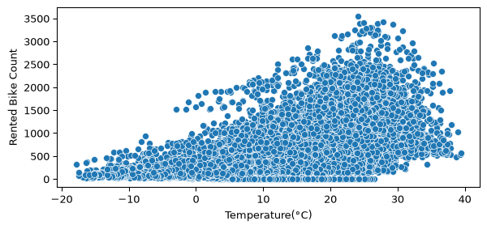
Figure 1: Rented bike count by temperature
import statsmodels.api as sm
# simple ols
X = df['Temperature(°C)']
X = sm.add_constant(X)
y = df['Rented Bike Count']
ols = sm.OLS(y, X)
ols_fit = ols.fit()
print(ols_fit.summary())
OLS Regression Results
==============================================================================
Dep. Variable: Rented Bike Count R-squared: 0.290
Model: OLS Adj. R-squared: 0.290
Method: Least Squares F-statistic: 3578.
Date: Mon, 21 Sep 2026 Prob (F-statistic): 0.00
Time: 11:16:01 Log-Likelihood: -67600.
No. Observations: 8760 AIC: 1.352e+05
Df Residuals: 8758 BIC: 1.352e+05
Df Model: 1
Covariance Type: nonrobust
===================================================================================
coef std err t P>|t| [0.025 0.975]
-----------------------------------------------------------------------------------
const 329.9525 8.541 38.631 0.000 313.210 346.695
Temperature(°C) 29.0811 0.486 59.816 0.000 28.128 30.034
==============================================================================
Omnibus: 954.681 Durbin-Watson: 0.271
Prob(Omnibus): 0.000 Jarque-Bera (JB): 1421.965
Skew: 0.817 Prob(JB): 1.68e-309
Kurtosis: 4.108 Cond. No. 25.9
==============================================================================
Notes:
[1] Standard Errors assume that the covariance matrix of the errors is correctly specified.
The fitted model (Figure 1) is:
$${\text{RentedBikeCount}}_{i}=β_{0}+β_{1}⋅{\text{Temperature}}_{i}+ε_{i}$$
$${\text{RentedBikeCount}}_{i}=330.0+29.1⋅{\text{Temperature}}_{i}$$
For every 1°C increase in temperature, predicted rented bike count increases by about 29.1 bikes, a statistically significant relationship. We therefore reject the null hypothesis that rented bike count is unrelated to temperature.

3 Suggestions for Next Steps
Temperature alone explains only about 29% of the variation in bike demand, so most of it is still unaccounted for. Natural next steps include checking other factors present in this dataset: humidity, wind speed, hour of day, season, and holiday status. Also comparing this relationship against cities with more extreme or less extreme temperature ranges than Seoul to see whether the effect holds.

I was unable to use the ucimlrepo module to import the dataset, so I downloaded it manually. If you want to reproduce this, go to the UCI ML Repository and follow the instructions there for this dataset.

