1.-Create table and name it “dev_CustReportRDPDemoTmp”. To create table right click on Solution explorer tab and over select option and select New item.
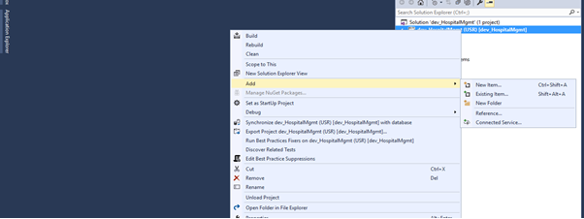
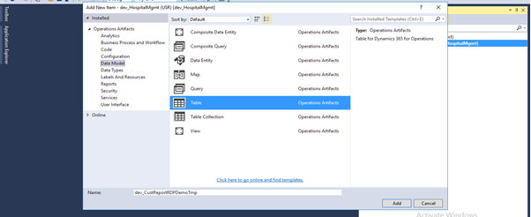

2.-To add Fields in the table right click on the Fields node and select data type which data type fields you want to add in the table.

If you want to add relation with another table, then you have to add that table extension in the current project. If you want to add edit, then select the EDT fields from the selected fields property. It will might take time to add EDT in the selected fields.

Expand the dev_CustReportRDPDemoTmp table node and add the following fields in the table:

No. | Field name | Extended Data Type | Label
1 | CustAccount | CustAccount
2 | Name | Name
3 | SalesOrderInvoiceCount | Integer | Sales order invoiced
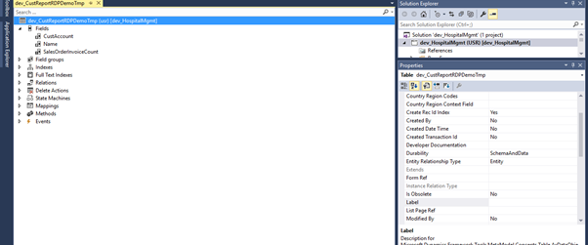

3.-Next step is for report parameters. For this purpose, we use Data contract class. In current report we required parameters base on Extended Data Type CustAccount, FromDate and ToDate. At simplest our data contract class will be look like as follow.
To Add Contract Class in the project right click on Solution explorer tab and over select option and select New item. On the Code table select class and name it “dev_ CustReportRDPDemoContract”.

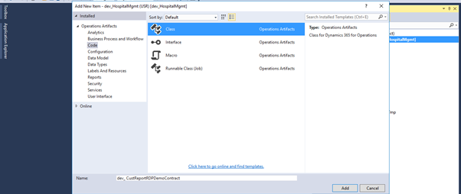
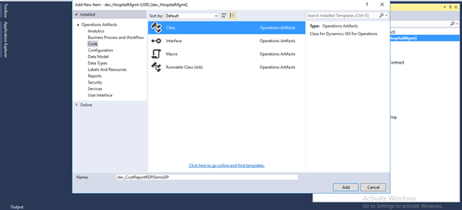

4.-Now create code for parameter like below.Create a Class named dev_CustReportRDPDemoContract and add the code below

[DataMemberAttribute]
class dev_CustReportRDPDemoContract
{
CustAccount objCustAccount;
TransDate FromDate, ToDate;

[DataMemberAttribute('From date')]
public TransDate ParmFromDate(FromDate _FromDate=FromDate)
{
FromDate = _FromDate;
return FromDate;
}

[DataMemberAttribute('To date')]
public TransDate ParmToDate(ToDate _ToDate=ToDate)
{
ToDate = _ToDate;
return ToDate;
}

[DataMemberAttribute('Customer Account No.')]
public CustAccount ParmCustAccount(CustAccount _CustAccount=objCustAccount)
{
objCustAccount = _CustAccount;
return objCustAccount;
}

}

5.- Now we required to write some logic which you above mention class as its data contract and populate the custom temp table we build in pervious step. Now create a RDP class. Go to Classes and create a new class called “dev_CustReportRDPDemoDP" by right click on Solution explorer tab and over select option and select New item and selecting New Class. It is a best practice to suffix the RDP class name with DP.

Create a method and your logic like below.
[SrsReportParameterAttribute(classstr(dev_CustReportRDPDemoContract))]
class dev_CustReportRDPDemoDP extends SRSReportDataProviderBase
{
dev_CustReportRDPDemoTmp objdev_CustReportRDPDemoTmp;
dev_CustReportRDPDemoContract Contract;
TransDate _FromDate,_ToDate;
CustAccount objCustAccount;
CustTable objcustTable;
SalesTable objsalesTable;

[SrsReportDataSetAttribute('dev_CustReportRDPDemoTmp')]
public dev_CustReportRDPDemoTmp GetData()
{
select objdev_CustReportRDPDemoTmp;
return objdev_CustReportRDPDemoTmp;
}

public void processReport()
{
Contract = this.parmDataContract();
_FromDate = Contract.ParmFromDate();
_ToDate = Contract.ParmToDate();
objCustAccount=Contract.ParmCustAccount();
super();
delete_from objdev_CustReportRDPDemoTmp;
objdev_CustReportRDPDemoTmp.clear();
while select * from objsalesTable where objsalesTable.SalesStatus == SalesStatus::Invoiced
&& (!_FromDate || objsalesTable.ShippingDateRequested >= _FromDate)
&& (!_ToDate || objsalesTable.ShippingDateRequested <= _ToDate)
join * from objcustTable where objcustTable.AccountNum==objsalesTable.CustAccount
&& (!objCustAccount || objcustTable.AccountNum==objCustAccount)
{
objdev_CustReportRDPDemoTmp.CustAccount = objcustTable.AccountNum;
objdev_CustReportRDPDemoTmp.Name = objcustTable.name();
objdev_CustReportRDPDemoTmp.SalesOrderInvoiceCount=any2Int(objsalesTable.RecId);
objdev_CustReportRDPDemoTmp.insert();
}
}

}

6.- At this step build the solution, after building Synchronize the database (From the project). Right click Solution explorer and select property.
Now add new report in project. Right click on Solution explorer tab and over select option and select New item. On that select Reports Node and Select report and name it “dev_CustReportRDPDemoReport”.
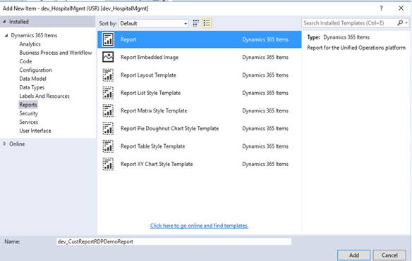

7.- Double click on Report in solution and open in designer screen. And right click on dataset and create new Data Set.
Now double click the report to open it. The description of the individual node is given below:

Datasets: Datasets retrieve data from RDP class. It acts as a bridge between D365 and the SSRS report. Only the fields added in the datasets can be used in a report.

Designs: It defines the layout of the report.

Images: It contains the images that you want to display in the SSRS report.

Data Methods: It contains the business logic which can then be used in the report.

Parameters: It is used to apply filtering to the data in a report. All the parameters defined in the data contract class are automatically added here when the RDP class is defined in the datasets.

- Now you will want to create a new Dataset by right clicking Datasets add dataset. Name it DsMain.

- Now select the DsMain dataset and open the properties window. Set the Data Source Type to Report Data Provider. Then select the Query field. An ellipse button appears. Click it to open a dialog box.

- This dialog box lists all the RDP classes present in the AOT. Select dev_CustReportRDPDemoDPand press Next.

Select the fields to be displayed in the report and press OK. Only the fields selected in this dialog box can be shown in the report.
There are two types of designs that can be created in a SSRS report:
*Auto design
*Precision Design
In this demo we will use Precision Design
Now right click the Designs node Add >> Precision Design. A new design is added. Rename it Design. It is recommended that you set the name of the Design to either ‘Design ‘or ‘Report‘.
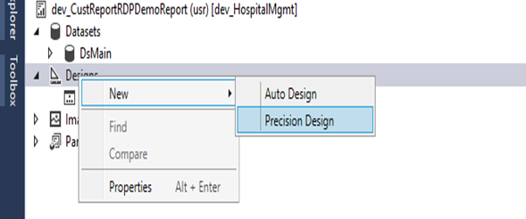

Then select report print layout. Our target is A4 page. so set it from report properties. For that go to Report >> Report Properties.
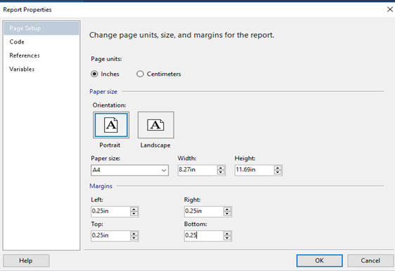
Now design the report design as per your needs.

Add a TextBox from the ToolBox and add the Text “Customer Invoiced Sales Order”

Add a new Table or Matrix Element from the ToolBox

Add 3 new columns with the text:

Bellow these Columns add the field:

[CustAccount]
[Name]
[Count(SalesOrderInvoiceCount)]

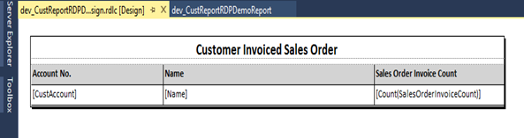

8.-After that right click on report in solution explorer and click on deploy.
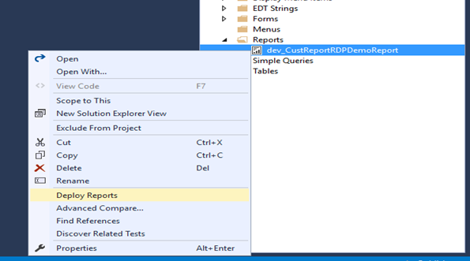

9.- Now add Display menu item like below.
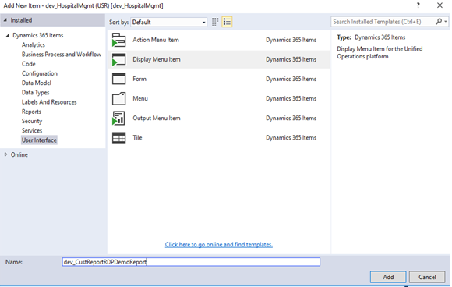
10.- After the add new display menu Item update the its following properties.
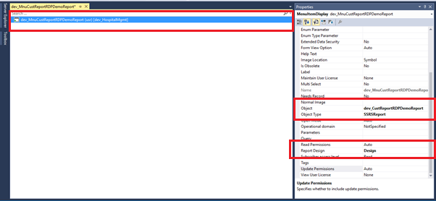

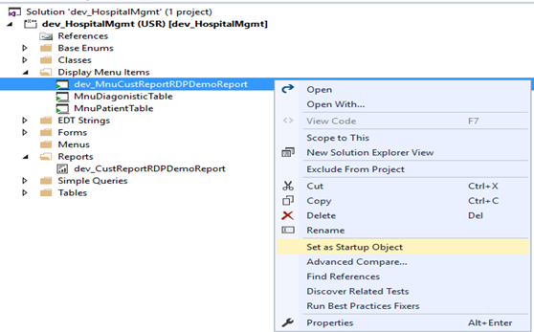

11.- Now new browser window you find similar form.
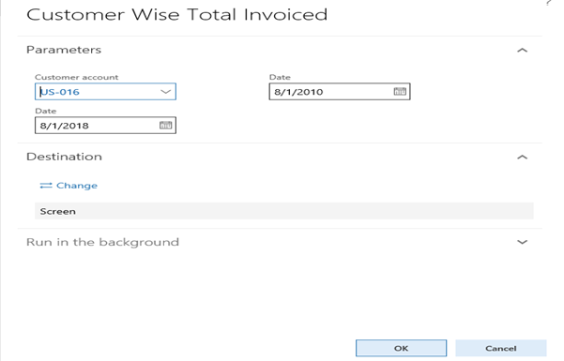
12.- Select parameter. Click on ok.

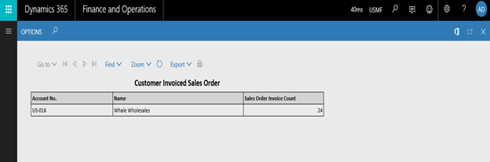
s

