Creating a chronos cartridge
Introduction to MDA

Table of Contents
ABSTRACT 5
Introduction 6
REQUIREMENTS 6
Skills 6
Goal 6
Time 6
(horror) Scenario 6
How-to 6

Document Informations
Author: | Giuseppe Platania
Version: | 0.124
Created: | 11/08/10
Source
The actual version of this document can be found under:
http://olympos.svn.sourceforge.net/viewvc/olympos/trunk/olympos/chronos/docs/HelloWorld_generator.odt

History
date | author | changes
11/08/10 | Giuseppe Platania | Created
01/13/11 | Thomas Schuetz | Review and changes
05/02/11 | Giuseppe Platania | Review
06/16/11 | Giuseppe Platania | Updated for pubblication

ABSTRACT
This document lead to the creation of a simple cartridge for the Chronos generator.

License
This work is licensed under the Creative Commons Attribution-NoDerivs 3.0 Unported License.
Chronos Business Manual by Giuseppe Platania is licensed under a Creative Commons Attribution-NoDerivs 3.0 Unported License.
You are free:
- to Share — to copy, distribute and transmit the work

Under the following conditions:
- Attribution — You must attribute the work in the manner specified by the author or licensor (but not in any way that suggests that they endorse you or your use of the work).
- No Derivative Works — You may not alter, transform, or build upon this work.

To view a copy of this license, visit http://creativecommons.org/licenses/by-nd/3.0/ or send a letter to Creative Commons, 444 Castro Street, Suite 900, Mountain View, California, 94041, USA.

Introduction
Scope of this document is to give a short overview over the possibilities of the Chronos Web Modeler and chiGen.

More information about the chronos and Olympos under: https://sourceforge.net/projects/olympos/

REQUIREMENTS
- Itemis Eclipse distribution with OpenArchitectureware 4.3 from http://oaw.itemis.com/openarchitectureware/language=en/2837/downloads
  - Windows: itemis-oaw-distribution-I20090514-1901-win32-win32-x86.zip
  - Linux: itemis-oaw-distribution-I20090514-1901-linux-gtk-x86.tar.gz
- Working installation of Chronos Web Modeler and the ChiGen from
https://sourceforge.net/projects/olympos/files/

Skills
- good UML knowledge
- Object Oriented programming.

Goal
At the end of this step by step tutorial you will be able to reproduce all steps for creating a simple cartridge that transform a UML model in a FreeMind mind map.

Time
You need about 3 hours to complete this step by step tutorial.

(horror) Scenario
Your boss hates UML diagrams and wants to have a mind map that documents the domain models for easy reference.

How-to

Prerequisites
- read the openArchitectureWare User Guide
- you already know the basic tutorial “hello World CWM”

Installation
- Install freeMind.
- Install Chronos Web Modeler. Follow the instruction provided in the CWM package.
- Unzip the openArchitectureWare eclipse distribution

Modeling
- Start the Chronos Web Modeler by browsing to [YOURURL]/cwm/gui/
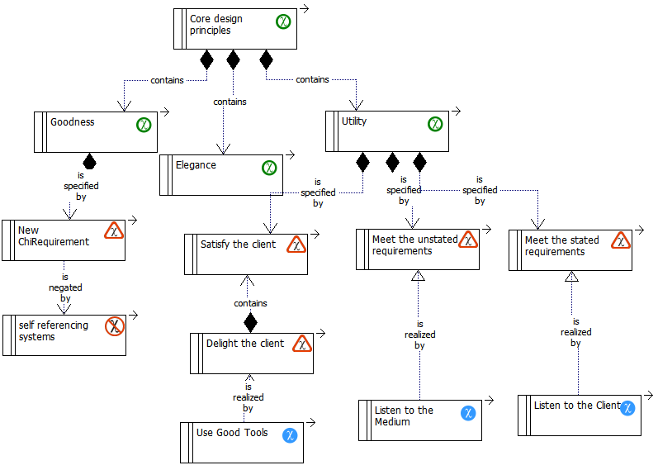
- Model a structure of ChiGoals, ChiRequirements; ChiFeatures and ChiIsssue like the following one:

Configure your Project
- create a new oAW project
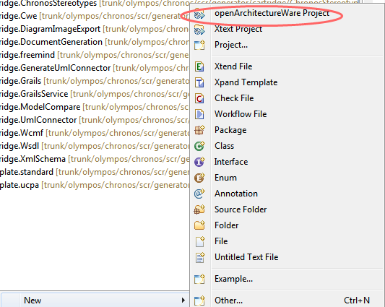
- Call it generator.cartridge.freemind
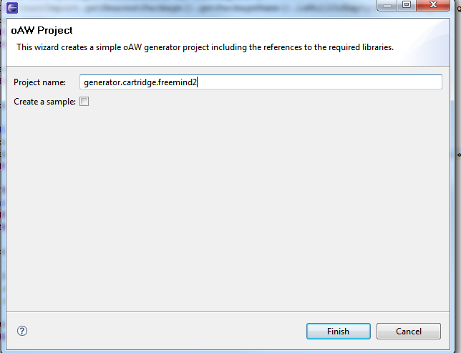
- Enable the UML metamodel in project properties. This tells the oAW Eclipse plugins that this project is a UML2 specific one, you need to specify that in the oAW preferences. In the menu open the project properties, select the openArchitectureWare tab and select the UML2 profiles metamodel.

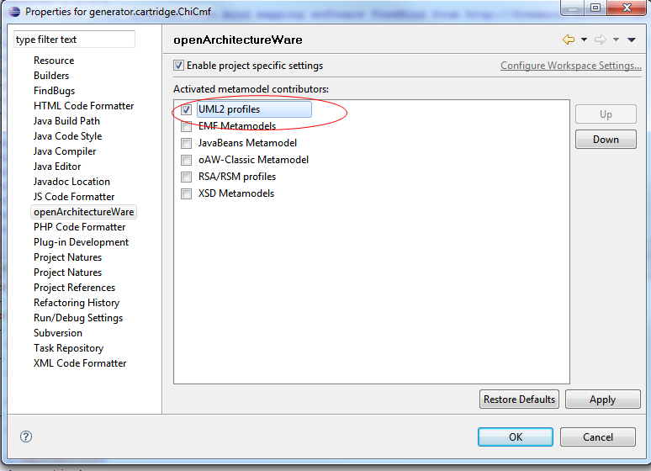
- In the java build path Set the libraries:
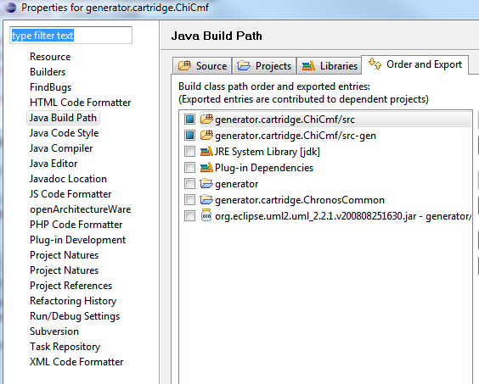
- set the referenced projects: generator and generator.cartridge.ChronosCommon
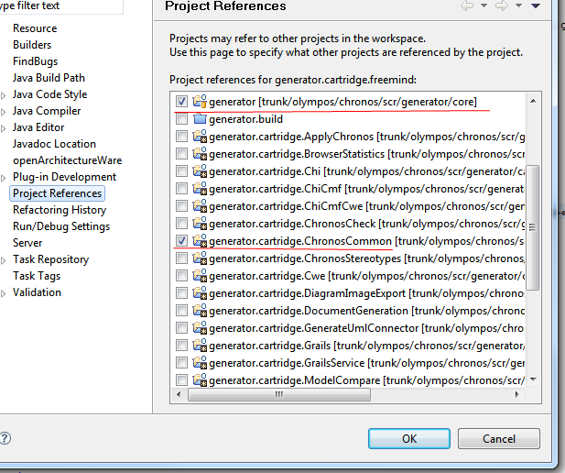

Creating the cartridge structures
each Chronos Cartridge has the following structure:
<project home>/ Home of the eclipse project
src/ Java Classpath root
cartridge/ Package for all cartridges
<CartridgeName>/ Package for this cartridge
cartridgeinfo.xml Information about this cartridge used by the CWM
checks/ contains the code that check constrains for the cartridge itself.
extensions/ contains the M2M transformations and the logical operations.
templates/ contains the M2T transformations.
template/ contains the zip file with a Mind map example, the images and the XSD file
workflow/ contains the execution flow and the property
src-gen/ Generated artifacts
lib/ Additional libraries required by this cartridge (optional)
META-INF/ Information about this bundle (used by Eclipse only)
MANIFEST.MF Information about this bundle (used by Eclipse only)
build.properties Build properties for this cartridge
build.xml Ant build script for this cartridge (optional)
compile-excludes List of files to exclude from Java compilation (must exist, might be empty)
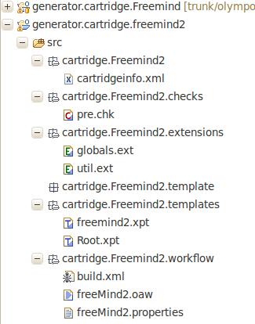
In the end the the structure in the Eclipse Package Explorer should look like the above screenshot. You can also look at the existing project generator.cartridge.Freemind as reference.
Be aware that most names in files and code are case sensitive!

Create the cartridge Information
- in the root of the project create a new file named cartridgeinfo.xml.
- In the new created cartridgeinfo.xml, Copy and paste following code:

<?xml version="1.0" encoding="UTF-8"?>
<!-- Defines if this cartridge is part of the basic ChiGen-->
<cartridgeinfo system="false">
<!-- the name of the cartridge, will appear in the web front end -->
<name>FreeMind2</name>
<!-- a verbose description of the cartridge-->
<description>
this cartridge generates a FreeMind file from the Model.
</description>
<!-- additional cartridges required by this-->
<dependencies>
<dependency>ChronosCommon</dependency>
</dependencies>
<properties>
<!--codeGenerator: true will appear in the list of available generators in the CWM -->
<property name="codeGenerator">true</property>
<!--Name of the file that contains the workflow -->
<property name="workflow">workflow/freeMind2.oaw</property>
<property name="targetPlatform">FreeMind2</property>
</properties>
</cartridgeinfo>

Create the Workflow & property
- under /workflow create a new file freeMind2.properties
- In the new created freeMind2.properties Copy and paste following code:

# freeMind Generator properties

# Profile configuration
# The following property defines the used metamodels.
profilename = Chronos
profileUmlFile = /home/tschuetz/projects/eenergy/export/cwm-export/chronos.profile.uml
#the UMl model used by the transformation
modelUmlFile = /home/tschuetz/projects/eenergy/export/cwm-export/cwm-export.uml
#xx
rootPackage = UNKNOWN

# Check configuration
# The following properties configure the generator checks. preCheckFile is run before model
# to model transformation and postCheckFile is run afterwards
# Should a check be executed?
doCheck = true
#the checks executed before the Model to Text transformation
preCheckFile = cartridge::Freemind2::checks::pre

# Generator configuration
# The following properties configure the code generation from the input model.
#frameworkFile = freemind2ChronosTemplate.zip
#xx
expand = cartridge::Freemind2::templates::Root::root
#this is the name of the file that will be generated
# change if is necessary.
projectname = freemind2Model1
# target dir for the generated code
targetDir = src-gen/freemind2
# tell the generator to backup an existing freemind generated file
doBackup = true
# target dir for the backup
backupDir = src-gen/backup

# This header must be present in each generated file
headerText = <p>generated with the <b>Chronos Generator</b></p> <p>Copyright (c) 2010 The Olympos Development Team.</p> <a scr="http://sourceforge.net/projects/olympos/">http://sourceforge.net/projects/olympos</a><p> All rights reserved. This program and the accompanying materials are made available under the terms of the Eclipse Public License v1.0 which accompanies this distribution, and is available at http://www.eclipse.org/legal/epl-v10.html. If redistributing this code, this entire header must remain intact.</p>

- Notice that the path above reference to a local system. Change the path for the exported uml files in freeMind2.properties → before you generate the code you will have to export the models from CWM to this path in your file system

Windows example:
profileUmlFile = c:/temp/chronos.profile.uml
modelUmlFile = c:/temp/model.uml
Linux example:
profileUmlFile = /home/myuser/projects/olympos/export/cwm-export/chronos.profile.uml
modelUmlFile = /home/myuser/projects/olympos/export/cwm-export/cwm-export.uml

Workflow
the workflow is a XML file that controls the sequence of the action executes by the generator.
- under /workflow create a new file freeMind2.oaw
- In the new created freeMind2.oaw copy and paste following code:

<?xml version="1.0" encoding="UTF-8"?>
<workflow>
<!-- the following properties property maybe overriden from the command line -->
<property name='generatorVersion' value='3'/>
<property name='basePath' value='src'/>
<property name='propertyFile' value='${basePath}/cartridge/Freemind2/workflow/freeMind2.properties'/>
<property file="${propertyFile}"/>

<bean id="UML2Setup" class="oaw.uml2.Setup" standardUML2Setup="true"/>

<!-- Metamodel-Definitions -->
<bean id="EmfMM" class="oaw.type.emf.EmfMetaModel">
<metaModelPackage value="org.eclipse.emf.ecore.EcorePackage"/>
</bean>
<bean id="UmlMM" class="oaw.uml2.UML2MetaModel"/>
<!-- notice of the Metamodel name is stored in the property file -->
<bean id="${profilename}MM" class="oaw.uml2.profile.ProfileMetaModel">
<profile value="${profileUmlFile}"/>
</bean>

<!-- Backup -->
<!-- if the Backup property is true zip an existing freemind file in the dir defined in backupDir -->
<if cond="${doBackup}">
<component class="com.wemove.wcmf.generator.workflow.BackupComponent">
<sourcePath value="${targetDir}/"/>
<targetPath value="${backupDir}"/>
</component>
</if>

<!-- Read the UML model and store it into a slot named 'model' -->
<component class="oaw.emf.XmiReader">
<modelFile value="${modelUmlFile}"/>
<outputSlot value="model"/>
</component>

<!-- read profile as model -->
<component class="oaw.emf.XmiReader">
<modelFile value="${profileUmlFile}" />
<outputSlot value="chronosProfileModel" />
</component>

<!-- Check constraints -->
<if cond="${doCheck}">
<component class="oaw.check.CheckComponent">

<!-- Global variables used by the check -->
<metaModel idRef="EmfMM"/>
<metaModel idRef="UmlMM"/>
<metaModel idRef="${profilename}MM"/>
<checkFile value="${preCheckFile}"/>
<emfAllChildrenSlot value="model"/>
<abortOnError value="true"/>
</component>
</if>

<!-- unzip the images in the target directory-->
<component id="Ant Runner" class="net.sourceforge.olympos.oaw.workflow.AntRunner">
<Param name="zip.template" value="${basePath}/cartridge/Freemind2/template/chronosFreeMind2Template.zip"/>
<Param name="target.dir" value="${targetDir}"/>
<antFile value="${basePath}/cartridge/Freemind2/workflow/build.xml"/>
</component>

<!-- Expand the model into the templates -->
<component id="generator" class="oaw.xpand2.Generator" skipOnErrors="true">
<fileEncoding value="ISO-8859-1"/>

<!-- Global variables used by the generator -->
<globalVarDef name="GeneratorVersion" value="'${generatorVersion}'"/>
<globalVarDef name="ModelFile" value="'${modelUmlFile}'"/>
<globalVarDef name="RootPackage" value="'${rootPackage}'"/>
<globalVarDef name="ProjectName" value="'${projectname}'"/>
<globalVarDef name="TargetDirectory" value="'${targetDir}'"/>
<globalVarDef name="HeaderText" value="'${headerText}'"/>

<metaModel idRef="EmfMM"/>
<metaModel idRef="UmlMM"/>
<metaModel idRef="${profilename}MM"/>

<expand value="${expand} FOR model"/>

<outlet path="${targetDir}">
<postprocessor class="oaw.xpand2.output.JavaBeautifier"/>
<postprocessor class="oaw.xpand2.output.XmlBeautifier"/>
</outlet>

<!-- Protected regions configuration not used -->
<prSrcPaths value="${targetDir}/"/>
<prDefaultExcludes value="false"/>
<prExcludes value="*.svn-base"/>
</component>
</workflow>

- under /workflow create a new file build.xml
- In the new created build.xml copy and paste following code:

<?xml version="1.0" encoding="utf-8"?>
<project name="freemind2" default="packageZip">
<target name="packageZip">
<unzip dest="${target.dir}">
<fileset file="${zip.template}"/>
</unzip>
</target>
</project>

Create the Checks
The checks that control model constraints are written using the declarative language Check.
- under /checks create a new file pre.chk
- In the new created pre.chk copy and paste following code:

import uml;
import Chronos;

extension org::openarchitectureware::uml2::profile::profiling;

extension common::util;
extension common::umlutils;

//check if a Goal name is Null or empty and return an error is true
context Chronos::ChiGoal ERROR
"ChiGoal name may not be NULL or empty: in Package " + ((uml::Package) this.owner).name:
this.name != null && ((String) this.name).length > 0;

//check if a Goal name is very short
context Chronos::ChiGoal ERROR
"Names must be more than one char long" :
this.name.length > 1;

Create the extensions
An extension gives the possibility to define libraries of independent operations and no-invasive metamodel enhancements: for example Model to Model (M2M) transformation or iterations over the model. In this case we will only make some variable available for the XPAND files.

- under /extensions create a new file gobals.ext
- In the new created gobals.ext copy and paste following code:

/**
* this file reads the variable from properties file and made it available trough Extend
*
* metamodel import
*/
import uml;
/**
*extension import
*/
extension common::util;

/**
* Properties from the workflow definition
*/
String GeneratorVersion() : GLOBALVAR GeneratorVersion;
String projectName() : GLOBALVAR ProjectName;
String headerText() : GLOBALVAR HeaderText;

- under /extensions create a new file util.ext
- In the new created util.ext copy and paste following code:

/**
* this file actually don't do nothing useful. But future operations should be placed here.
*
* metamodel import
*/
import uml;
import Chronos;

extension org::openarchitectureware::uml2::profile::profiling;
extension org::openarchitectureware::util::stdlib::io;

extension common::util;
extension common::umlutils;

extension cartridge::Freemind2::extensions::globals;

Create the Templates
Templates files written in XPAND language control the output generation.
A template file consists of any number of IMPORT statements, followed by any number of EXTENSION statements, followed by one or more DEFINE blocks (called definitions).
for our scopes we will create 2 templates:
- under /templates create a new file Root.xpt
- In the new created Root.xpt copy and paste following code:

«IMPORT uml»
«IMPORT Chronos»
«REM»Import the extension used in this xpand file.«ENDREM»
«EXTENSION common::util»

«EXTENSION cartridge::ChronosCommon::requirements::ChiGoal»
«EXTENSION cartridge::Freemind2::extensions::util»
«EXTENSION cartridge::Freemind2::extensions::globals»
«REM»main definition evaluate the model elemen «ENDREM»
«DEFINE root FOR Model»
«info('Expand Model')»
«REM»creates a file with the file name coming from freeMind2.Property«ENDREM»
«FILE projectName()+".mm"-»
«REM»jump to the next XPand«ENDREM-»
«EXPAND cartridge::Freemind2::templates::freemind2::printHeader FOR this»
«EXPAND cartridge::Freemind2::templates::freemind2::Copyright FOR this»
«EXPAND cartridge::Freemind2::templates::freemind2::printChiGoal FOREACH this.allOwnedElements().typeSelect(Chronos::ChiGoal)»
«EXPAND cartridge::Freemind2::templates::freemind2::printFooter FOR this»
«ENDFILE»
«ENDDEFINE»

- under /templates create a new file freemind.xpt
- In the new created freemind.xpt copy and paste following code:

«IMPORT uml»
«IMPORT Chronos»

«EXTENSION common::util»
«EXTENSION common::umlutils»
«EXTENSION cartridge::Freemind2::extensions::globals»
«EXTENSION cartridge::ChronosCommon::requirements::ChiGoal»
«EXTENSION cartridge::ChronosCommon::requirements::ChiRequirement»
«EXTENSION cartridge::ChronosCommon::requirements::ChiFeature»
«EXTENSION cartridge::ChronosCommon::requirements::ChiIssue»
«EXTENSION cartridge::ChronosCommon::usecases::ChiBusinessUseCase»

«DEFINE printHeader FOR Model-»
«info('Expanding header')-»
<map version="0.9.0">
<!-- To view this file, download free mind mapping software FreeMind from http://freemind.sourceforge.net -->
<attribute_registry>
<attribute_name NAME="Fea. Status" RESTRICTED="true">
<attribute_value VALUE=""/>
<attribute_value VALUE="Implemented "/>
<attribute_value VALUE="Proposed "/>
<attribute_value VALUE="Rejected "/>
<attribute_value VALUE="Validated "/>
</attribute_name>
<attribute_name NAME="Req. Status" RESTRICTED="true">
<attribute_value VALUE=""/>
<attribute_value VALUE="Mandatory"/>
<attribute_value VALUE="Proposed"/>
<attribute_value VALUE="Satisfied"/>
<attribute_value VALUE="Validated"/>
</attribute_name>
<attribute_name NAME="Type" RESTRICTED="true">
<attribute_value VALUE=""/>
<attribute_value VALUE="ChiBusinessUseCase"/>
<attribute_value VALUE="ChiFeature"/>
<attribute_value VALUE="ChiGoal"/>
<attribute_value VALUE="ChiIssue"/>
<attribute_value VALUE="ChiRequirement"/>
</attribute_name>
</attribute_registry>
«ENDDEFINE»

«DEFINE printFooter FOR Model-»
</node>
</map>
«ENDDEFINE»

«DEFINE Copyright FOR Model -»
«info('Expanding copyright ...') -»
<node CREATED="1228144317281" ID="ID_1823873164" MODIFIED="1289855583935" TEXT="«projectName()»">
<font NAME="SansSerif" SIZE="12"/>
<hook NAME="accessories/plugins/HierarchicalIcons.properties"/>
<attribute_layout NAME_WIDTH="132" VALUE_WIDTH="141"/>
<node CREATED="1289855562192" HGAP="16" ID="Chi287Req" LINK="http://garr.dl.sourceforge.net/sourceforge/olympos/Chronos_Profile_Documentation.pdf" MODIFIED="1290093666784" POSITION="left" VSHIFT="-18">
<icon BUILTIN="help"/>
<richcontent TYPE="NOTE"><html>
<head>
<style type="text/css">
<!--
p { margin-top: 0 }
-->
</style>

</head>
<body>
<p> «headerText()»</p>
</body>
</html></richcontent>
<attribute_layout NAME_WIDTH="132" VALUE_WIDTH="141"/>
</node>
«ENDDEFINE»
«REM»this definition print the code for the goals«ENDREM»
«DEFINE printChiGoal FOR ChiGoal»
«info('Expanding goal ' + this.name + " alias:" + this.Alias) -»
<node CREATED="1228144960531" HGAP="97" ID="«this.Alias»" MODIFIED="1228149662000" POSITION="right" VSHIFT="-4">
<richcontent TYPE="NODE"><html>
<head>
<style type="text/css">
<!--
p { margin-top: 0 }
-->
</style>

</head>
<body>
<p>
<img src="ChiGoal.png"/>
«this.name»
</p>
</body>
</html></richcontent>
<richcontent TYPE="NOTE"><html>
<head></head>
<body>
<p>
«this.getComment()»
</p>
</body>
</html>
</richcontent>
<font NAME="SansSerif" SIZE="12"/>
<attribute_layout NAME_WIDTH="109"/>
<attribute NAME="Type" VALUE="ChiGoal"/>
<attribute NAME="Priority" VALUE="«this.Priority»"/>
<attribute NAME="Value Name" VALUE="«this.Value_Name»"/>
<attribute NAME="Value ammount" VALUE="«this.Value_ammount»"/>
<attribute NAME="Value Goal" VALUE="«this.Value_Goal»"/>
«EXPAND printChiGoal FOREACH this.getChildGoals()-»
«EXPAND printChiRequirement(this.Alias) FOREACH this.getRequirements() -»
</node>
«ENDDEFINE»
«REM»this definition print the code for the requirement«ENDREM»
«DEFINE printChiRequirement(string parentID) FOR Chronos::ChiRequirement -»
«info('Expanding requirement ' + this.name + " alias:" + this.Alias + ' attached to ' + parentID)»
<node CREATED="1228144432312" HGAP="56" ID="«this.Alias»" MODIFIED="1228148095734" VSHIFT="3">
<richcontent TYPE="NODE"><html>
<head>

</head>
<body>
<p>
<img src="ChiRequirement.png"/>
«this.name»
</p>
</body>
</html></richcontent>
<richcontent TYPE="NOTE"><html>
<head></head>
<body>
<p>
«this.getComment()»
</p>
</body>
</html>
</richcontent>
«REM»
<arrowlink DESTINATION="«parentID»" ENDARROW="Default" ENDINCLINATION="0;0;" ID="Arrow_ID_512851619" STARTARROW="None" STARTINCLINATION="0;0;"/>
«ENDREM»
<font NAME="SansSerif" SIZE="12"/>
<attribute NAME="Type" VALUE="ChiRequirement"/>
<attribute NAME="Priority" VALUE="«this.Priority»"/>
<attribute NAME="Author" VALUE="«this.Author»"/>
<attribute NAME="Proofreader" VALUE="«this.Proofreader»"/>
<attribute NAME="Req. Status" VALUE="«this.Status»"/>
<attribute NAME="Req. Type" VALUE="«this.Type»"/>
«REM»look for children requirement or features or issue«ENDREM»
«IF this.getChildRequirementsRecursive().size != 0 -»
«info('**** Expanding children of '+this.name+' that is requirement ' + this.getChildRequirementsRecursive().first().Alias) -»
«EXPAND printChiRequirement(this.Alias) FOREACH this.getChildRequirementsRecursive()-»
«ENDIF»
«IF this.getFeatures().size != 0 -»
«EXPAND printChiFeature(this.Alias) FOREACH this.getFeatures()-»
«ENDIF»
«IF this.getIssues().size != 0 -»
«EXPAND printChiIssue(this.Alias) FOREACH this.getIssues()-»
«info('completed Expanding ' + this.name) -»
«ENDIF»

</node>

«ENDDEFINE»

«DEFINE printChiFeature(string parentID) FOR ChiFeature-»
«info('Expanding ChiFeature ' + this.name + " alias:" + this.Alias + " parent is" + parentID)»
<node CREATED="1228144657578" HGAP="65" ID="«this.Alias»" MODIFIED="1228149635234" VSHIFT="-4">
<richcontent TYPE="NODE"><html>
<head>
<style type="text/css">
<!--
p { margin-top: 0 }
-->
</style>
</head>
<body>
<p>
<img src="ChiFeature.png"/>
«this.name» attached to «this.parents()»
</p>
</body>
</html></richcontent>
<attribute NAME="Type" VALUE="ChiFeature"/>
<attribute NAME="Author" VALUE="«this.Author»"/>
<attribute NAME="Proofreader" VALUE="«this.Proofreader»"/>
<attribute NAME="Fea. Status" VALUE="«this.Status»"/>
«REM»call ChiUCs«ENDREM»
«EXPAND printChiBusinessUseCases(this.Alias) FOREACH this.getBusinessUseCases()-»
</node>
«ENDDEFINE»
«REM»this definition print the code for the Issues«ENDREM»
«DEFINE printChiIssue(string parentID) FOR ChiIssue -»
«info('Expanding issue ' + this.name + " alias:" + this.Alias + "parent is" + parentID)»
<node CREATED="1228144362937" HGAP="83" ID="«this.Alias»" MODIFIED="1228149645562" VSHIFT="-34">
<richcontent TYPE="NODE"><html>
<head>
<style type="text/css">
<!--
p { margin-top: 0 }
-->
</style>

</head>
<body>
<p>
<img src="ChiIssue.png"/>
«this.name»
</p>
</body>
</html></richcontent>
<attribute NAME="Type" VALUE="ChiIssue"/>
<attribute NAME="Author" VALUE="«this.Author»"/>
<attribute NAME="Responsible" VALUE="«this.Responsible»"/>
</node>
«ENDDEFINE»
«REM»this definition print the code for the Use case«ENDREM»
«DEFINE printChiBusinessUseCases(string parentID) FOR ChiBusinessUseCase -»
«info('Expanding UC ' + this.name + " alias:" + this.Alias + " parent is" + parentID )»
<node CREATED="1228148660484" HGAP="172" ID="«this.Alias»" MODIFIED="1290093675817" VSHIFT="7">
<richcontent TYPE="NODE"><html>
<head>
<style type="text/css">
<!--
p { margin-top: 0 }
-->
</style>

</head>
<body>
<p>
<img src="ChiBusinessUseCase.png"/>
«this.name»
</p>
</body>
</html></richcontent>
<attribute_layout NAME_WIDTH="95" VALUE_WIDTH="145"/>
<attribute NAME="Type" VALUE="ChiBusinessUseCase"/>
<attribute NAME="Author" VALUE="«this.Author»"/>
<attribute NAME="Primary Actor" VALUE="«this.PrimaryActor»"/>
<attribute NAME="Goal in Context" VALUE="«this.GoalInContext»"/>
<attribute NAME="Scope" VALUE="«this.Scope»"/>
<attribute NAME="Level" VALUE="«this.Level»"/>
<attribute NAME="Stakeholders" VALUE="«this.Stakeholders»"/>
<attribute NAME="Precondition" VALUE="«this.Precondition»"/>
<attribute NAME="Main Success Scenario" VALUE="«this.MainSuccessScenario»"/>
<attribute NAME="Extensions" VALUE="«this.Extensions»"/>
</node>
«ENDDEFINE»

export your model from Chronos Web Modeler
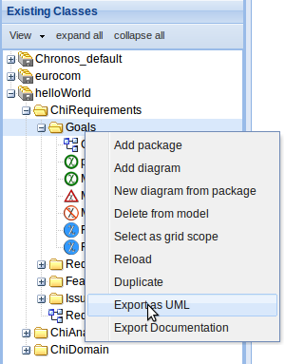

- Save and extract the file to the path according to freeMind2.properties (profileUmlFile and modelUmlFile)

test your cartridge
- right click on freeMind2.oaw and select “run As” /oAW Workflow”
- the console produces the following output (the part in bold is to help you follow the output:

0 INFO WorkflowRunner - --------------------------------------------------------------------------------------
3 INFO WorkflowRunner - openArchitectureWare 4.3.1, Build 20090107-2000PRD
3 INFO WorkflowRunner - (c) 2005-2008 openarchitectureware.org and contributors
3 INFO WorkflowRunner - --------------------------------------------------------------------------------------

start of the Workflow
3 INFO WorkflowRunner - running workflow: cartridge/Freemind/workflow/freeMind.oaw

Run the beautifier
3 INFO WorkflowRunner -
1169 WARN XmlBeautifier - This beautifier has been deprecated. Use org.openarchitectureware.xsd.XMLBeautifier or the Fornax XML formatter (http://www.fornax-platform.org/cp/display/fornax/XML) instead.

Execute the Backup
1229 INFO CompositeComponent - IfComponent: executing if cartridge/Freemind/workflow/freeMind.oaw in cartridge/Freemind/workflow/freeMind.oaw:23
1230 INFO ConditionalComponent - BackupComponent
1236 INFO Logger - BackupComponent: Backing up source files to C:\Users\pgiuseppe\My Projects\olympos\scr\workspace\generator\cartridge\Freemind\src-gen\backup\backup_20101122_152840_842.zip …

Reads the UML file in a XMI format
1259 INFO CompositeComponent - XmiReader: file 'c:/temp/model.uml' => slot 'model'
1336 INFO CompositeComponent - XmiReader: file 'c:/temp/chronos.profile.uml' => slot 'chronosProfileModel'
1370 INFO CompositeComponent - IfComponent: executing if cartridge/Freemind/workflow/freeMind.oaw in cartridge/Freemind/workflow/freeMind.oaw:43

the constrains are checked
1370 INFO ConditionalComponent - CheckComponent: slot model check file(s): cartridge::Freemind::checks::pre

The images are unzipped in the target directory
1870 INFO CompositeComponent - AntRunner(Ant Runner)
1888 INFO Log4jListener - Build started.
1914 INFO Log4jListener - Target "packageZip" started.
1914 INFO Log4jListener - Task "unzip" started.
1981 INFO Log4jListener - Expanding: C:\Users\pgiuseppe\My Projects\olympos\scr\workspace\generator\cartridge\Freemind\src\cartridge\Freemind\template\chronosFreeMindTemplate.zip into C:\Users\pgiuseppe\My Projects\olympos\scr\workspace\generator\cartridge\Freemind\src-gen\freemind
2009 INFO Log4jListener - Task "unzip" finished.
2009 INFO Log4jListener - Target "packageZip" finished.
2009 INFO Log4jListener - Build finished.

The generator iterates now trough the model.
2010 INFO CompositeComponent - Generator(generator): generating 'cartridge::Freemind::templates::Root::root FOR model' => src-gen/freemind(overwrite=true,append=false,fileEncoding=ISO-8859-1)
2053 INFO Logger - Expand Model
2078 INFO Logger - Expanding header
2078 INFO Logger - Expanding copyright ...
2089 INFO Logger - Expanding goal a alias:Chi124Goa
2127 INFO Logger - Expanding requirement c alias:Chi778Req attached to Chi124Goa
2131 INFO Logger - Expanding issue f alias:Chi079Issparent isChi778Req
2132 INFO Logger - completed Expanding c
2132 INFO Logger - Expanding requirement d alias:Chi779Req attached to Chi124Goa
2135 INFO Logger - Expanding ChiFeature g alias:Chi383Fea parent isChi779Req
2138 INFO Logger - Expanding UC h alias:Chi493BUC parent isChi383Fea
2140 INFO Logger - Expanding requirement b alias:Chi780Req attached to Chi124Goa
2144 INFO Logger - **** Expanding children of b that is requirement Chi777Req
2147 INFO Logger - Expanding requirement e alias:Chi777Req attached to Chi780Req
2149 INFO Logger - Expanding ChiFeature i alias:Chi382Fea parent isChi777Req

everything worked: a file is created
2153 INFO Generator - Written 1 files to outlet [default](src-gen/freemind)
2153 INFO WorkflowRunner - workflow completed in 924ms!

A warn is produced because the check discovers that the rule is not respected.
2154 WARN WorkflowRunner - Names must be more than one char long [org.eclipse.uml2.uml.internal.impl.ClassImpl@ab835a (name: a, visibility: <unset>) (isLeaf: false, isAbstract: false) (isActive: false)]
- refresh the scr-gen by pressing f5
- under Backup you will have a zipfile with the last generated code.
- Under freemind you will find your fresh generated mind map
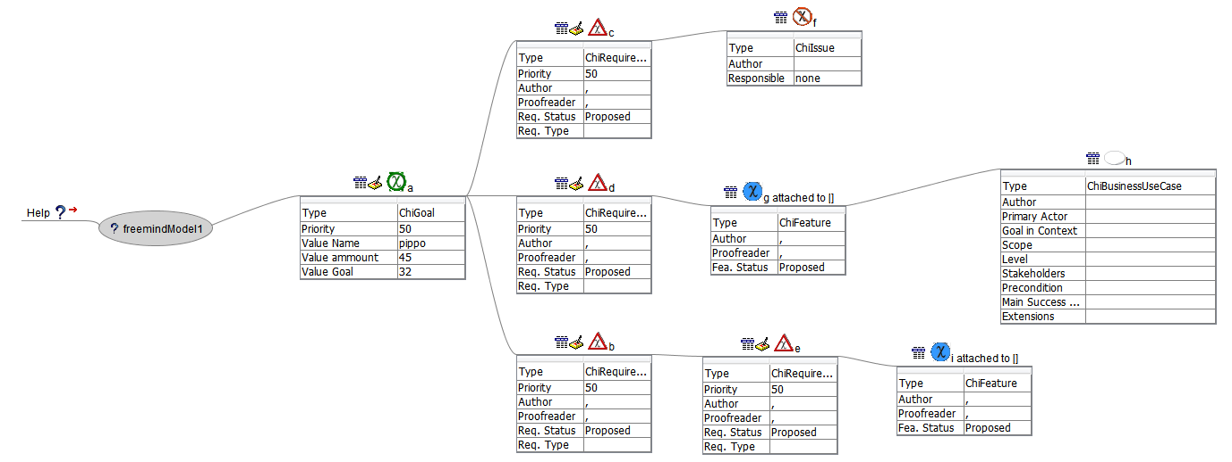

you have finished your first generator tutorial!!

