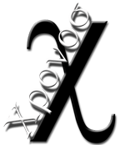

version 2.0

Author: Giuseppe Platania

Customer: IBM

Document History
Document Location
This is a snapshot of an on-line document. Paper copies are valid only on the day they are printed. Refer to the author if you are in any doubt about the currency of this document.
The source of the document will be found in wcmf.sourceforge.net
Revision History
Date of this revision: | Date of next revision (date)

Revision Number | Revision Date | Summary of Changes | Changes marked
(#) | (-) | (Describe change) | (N)
1.4 | 19/04/2007 | Requirement tagged values version 1.4
1.5 | 26/04/07 | Minor changes in description and documentation
1.6 | 14/08/07 | New tagged value inserted for UseCases
1.7 | 30/08/07 | inserted new stereotypes for modelling activities
1.9.1 | 06/11/07 | Stakeholder analysis
1.9.2 | 06/12/07 | Stakeholder analysis review
1.9.3 | 01/02/08 | Stakeholder analysis review
2.0 | 28/02/2008 | relations
Approvals
This document requires following approvals. Signed approval forms are filed in the Quality section of the PCB.
Name | Title
Ingo Herwig | (title)
Distribution
This document has been distributed to
Name | Title
Ingo Herwig
Fred Meyer
Fabian Czicholl
Enzo Failla
Contents

Document History 3
Document Location 3
Revision History 3
Approvals 3
Distribution 3
Contents 4
1. Copyright 8
2. ChiMetamodel 9
2.1 About the ChiMetamodel 9
2.1.1 Project roles 11
2.1.2 Types of Relationships used in Chronos 12
2.1.2.1 Aggregation 12
2.1.2.2 Realization 12
2.1.3 Outputs 13
2.1.3.1 Requirement 13
2.1.3.2 Analysis 13
2.1.3.3 Implementation 13
2.2 ChiRequirements 14
2.2.1 ChiGoal 14
2.2.2 ChiRequirement 15
ChiReq001 Provide Field Worker with additional information 15
2.2.3 ChiFeature 16
ChiFeat001 SVNCRM will be implemented 17
2.2.4 ChiIssue 17
2.3 ChiInterestAnalysis 19
2.3.1 ChiStakeHolder 19
2.3.2 ChiOpinion 20
2.3.3 ChiOpinionInner 20
2.4 ChiAnalysis 21
2.4.1 ChiBusinessProcess 21
2.4.2 ChiBusinessUseCase 21
2.4.3 ChiUseCaseCore 23
2.4.4 Chi Business Partner 24
2.4.5 Chi Business partner Active 24
2.4.6 Chi Passive Business Partner 25
2.4.7 ChiWorker 25
2.4.8 ChiWorkerExternal 26
2.4.9 ChiWorkerInternal 26
2.4.10 ChiActivity 27
2.4.11 ChiDecision 27
2.5 ChiImplementation 28
2.5.1 ChiNode 28
2.5.2 ChiController 29
2.5.3 ChiView 29
2.5.4 ChiRule 29
2.5.5 ChiSystem 30

Copyright
This document is released under the Creative Common Licence.
You are free to make use of this document but you must give the original authors credits.

ChiMetamodel

About the ChiMetamodel
-Original Creator:
Ingo Herwig.

Extensions:
-Giuseppe Platania
Contributors:
-Fabian Czicholl.

The Chronos (Chi) Metamodel is a UML profile which defines the notation for all elements used in the different stages of the project life cycle from the requirement to the application.
It is created to use a Model Driven Architecture approach.
It is divided in 3 parts:
- Requirements
- Analysis
- Implementation

Typically those are used in sequence as following:

Implementation
Find use cases
Find actors
Group the use cases in processes
Describe each Use case
Model the enterprise structure
Define goals
Define requirements
Find features
Model classes
Write custom MCV
Generate the application
List issues
Analysys
Requirement
Image 1 Project parts

Using the following stereotypes and relations
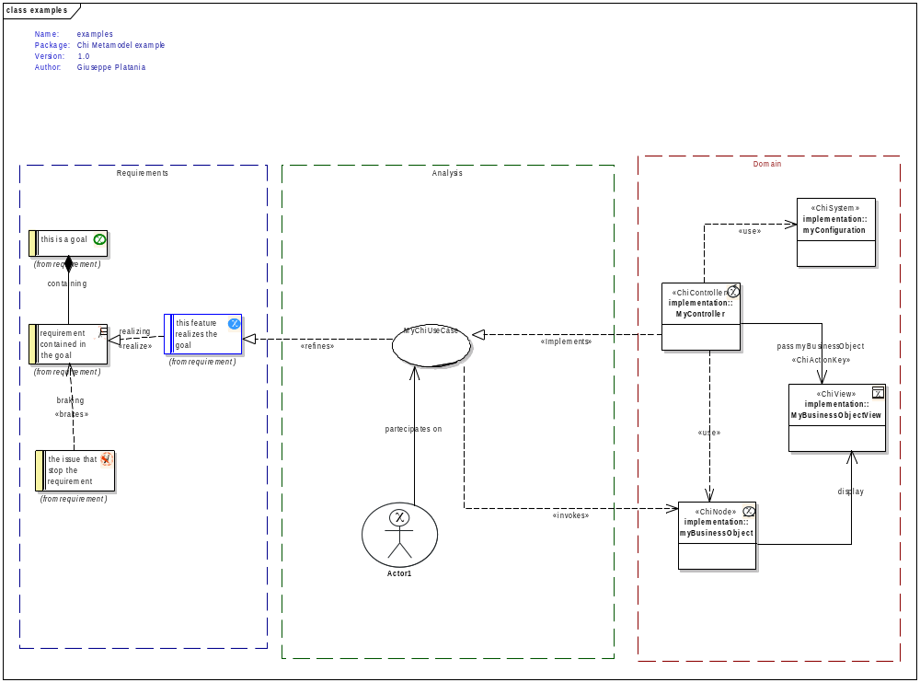
Image 2: Chi stereotypes and relationships

Project roles
Below the project roles against the stereotypes:
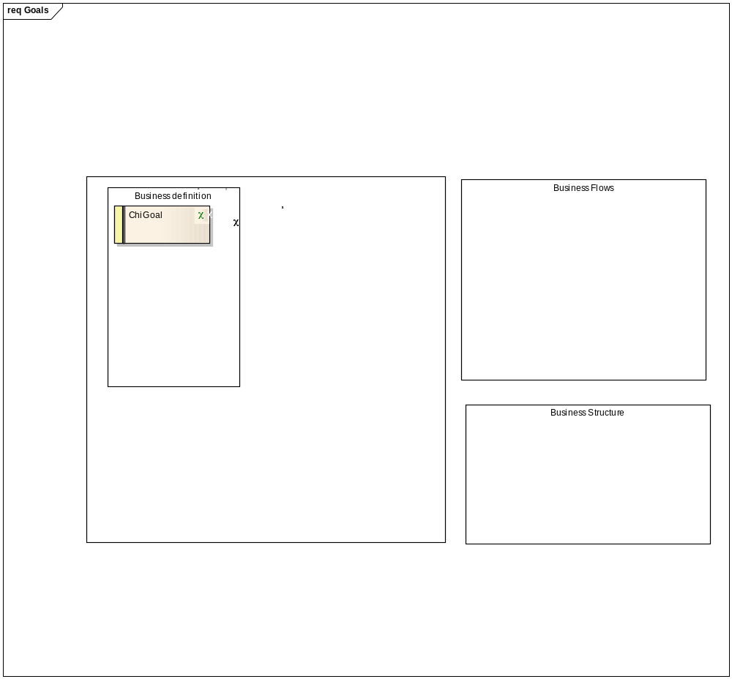
Image 3: stereotypes and roles

Types of Relationships used in Chronos

Aggregation
Chi Objects linked by aggregation relationships form a composition hierarchy. High level
Objects may be composed of lower level Objects, which in turn are made up of finer and
more specialized Objects. This hierarchical structure helps manage the complexity of large systems
with thousands of Objects and many elements being employed to implement the requirements.

Realization
ChiRequirements are implemented by ChiFeatures. You must specify this relationship in using the realization link. A ChiFeature element is marked as 'Realizing' a ChiRequirement.

A ChiFeature is further specialized by a ChiUsecases,. You must specify this relationship in using the realization link. It is possible to use the stereotype “Refines”.
A ChiUseCase is implemented by a ChiController,
use the realization link with the stereotype 'Implements.'

Outputs
A Chronos Project produces following outputs:

Requirement
- High level Proposal Request document (includes Goals and Requirements)
- High level Proposal Response document (includes Features and Issues)

Analysis
- Process Documentation (includes Processes, Use cases, Actors, Activities)
- Use Case Point calculation

Implementation
- Class model
- Complete Code

ChiRequirements
The ChiRequirements model is a structured catalogue of end-user requirements. These are represented as either Requirement or Feature elements.

The model is divided into 4 sub-catalogues:
- Goals
- Requirements
- Features
- Issues
Below the stereotypes used by the requirements analysis.

ChiGoal

Definition: a Measurable scope that the enterprise wants to achieve.
A ChiGoal contains one or more ChiRequirements.
Condition:
A goal must be measurable the Value_Goal SHOULD be an integer. If this is “0” (default) the goal is not valid and the generator produces a warning.
- All the ChiGoals MUST be linked with one or more ChiRequirements with a shared or composition link .

Tagged Values:
Key | Notice | Value
Type | Type of goal | Strategic|Operational
Priority | A priority in % | 1-100
Value_Name | The name of the value this goal intends to alter
Value_Name | The actual amount of the value this goal intends to alter | 0
Value_ammount
Value_Goal | The amount by which the value is to be altered | 0

Example:
ID | ChiGoal01
Type | Strategic
Description | Improve percentage of “satisfied” or “very satisfied” customers by 10%
Priority | 80
Value_Name | Customer Satisfaction
Value_ammount | 50
Value_Goal | 60
Linked Requirements ID | ChiReq001  ChiReq002

MDA Realization:
HTML documentation is generated. Model is validated against above rules.

ChiRequirement


Definition: A Business guide line about the Enterprise or the project.
Condition:
All the ChiRequirement MUST be linked with a ChiGoal. CAN be linke with a ChiFeature or an ChiIssue.
Each requirement needs to be confirmed by a proofreader. If proofreader is “none” (default) the requirement is not valid and the generator produces a warning.
Until the requirement has not the status “Validated” the generator produces a warning.
Tagged Values:
Key | Notice | Value
Type | Type of requirement | Business Rule| Security |Performance |Persistence |Scalability |Transport
Priority | A priority in %. Requirements are ordered by priority. | 1-100
Author | This requirement’s author’s name and role in the project | Name, Role
Proofreader | Each requirement needs to be confirmed by a proofreader. This requirement’s proofreader’s name and role in the project | Name, Role
Status | This requirement’s status | Proposed|Mandatory|Validated

Example:
ChiReq001 Provide Field Worker with additional information
ID | ChiReq001
Description | MUST provide Field Worker with additional information
Type | Functional
Priority | 90
Details | Unnecessary travel and inappropriate worker assignments due to missing task skills should be eliminated. Increase effectiveness on the job by providing additional information about known issues or best practices. Eliminate the need to call for specialists as a result of a field worker not being able to successfully finish a task.
Author | T. Hoffmann
Proofreader | F. Czicholl
Status | Validated
Linked Feature ID | ChiFeat001  ChiFeat002

MDA Realization:
HTML documentation is generated. Model is validated against above rule.

ChiFeature


Definition: A characteristic of a system that realizes a ChiRequirement.
A ChiFeature is a small, granular function or characteristic expressed in client-valued terms as a satisfaction of a requirement;
A ChiFeature CANNOT exist without a requirement for it. One Feature might realize one or more Requirements, and one Requirement might be realized by more than one Feature.
Features have a relationships (of type Implementation) with Requirements.
One Feature might realize one or more Requirements, and one Requirement might be realized by more than one Feature.
Features also have relationships (of type Realization, stereotype <<Refines>>) with Use Cases. A Use Case defines the interaction a user has with the system in order to satisfy one or more Requirements. The Feature identifies the facility that provides the means for that interaction.
Condition:
To each feature are attached one or more elements like:
- ChiProcess
- ChiUseCases
- ChiRule
..etc

If the Model is in the realization phase, each feature that has the Status “Implemented” MUST specified by a further element. In other case the generator produces a warning.
Tagged Values:
Key | Notice | Value
Author | This feature's author's name and role in the project | Name, Role
Proofreader | This feature's revisor's name and role in the project | Name, Role
Status | This feature's status | Proposed | Validated | Rejected | Implemented

Example:
ChiFeat001 SVNCRM will be implemented
ID | ChiFeat001
Description | SVNCRM will be implemented and customized to fit EUROCOM’s needs and work according to their business processes. SVNCRM will consist of the Chronos business model, an Aphrodite server and Dionysos clients.  SVNCRM is an open source CRM system similar to SugarCRM that is based on an MDA-approach. Based on a UML business process model the application is generated and therefore flexible to changes within the model and the business operation structure.  SVNCRM will implement a dashboard as a “homepage” in SVNCRM that lists the most frequent actions and objects accessed by a worker. Dashboards vary according to roles of workers who access SVNCRM. Different dashboards will be implemented for the roles Field Worker, Call Center Agent and System Administrator.
Realizing requirements: | ChiReq001
Author | F. Czicholl
Revisor | none
Status | Implementing

MDA Realization:
HTML documentation is generated. Model is validated against above rule.
The model generates an ERROR if an actual ChiFeature is not implementing a ChiRequirement.

ChiIssue

Definition: A characteristic of a system that could slow down or even completely stop the realization of a ChiRequirement.
Condition:
An Issue MUST be linked to a ChiRequirement element. The Model generates an ERROR if the above condition is not true.
The

Tagged Values:
Key | Notice | Value
Author | This issue’s author’s name and role in the project | Name, Role
Responsible | The responsible to close the present issue | Name, Role

Example:
ID | ChiIss001
Description | UMTS coverage not at 100%. In case of missing UMTS coverage, connection to the internet and intranet is lost. Access to SVNCRM no longer possible.
Author | F. Czicholl
Responsible | G. Platania, Chef Analist
Affecting requirements: | ChiReq001

MDA Realization:
HTML documentation is generated.
Model is validated against above rule.

ChiInterestAnalysis
Goal of the interest Analysis is to list the stakeholder and understand the relative positions and their conflicts.

ChiStakeHolder

Definition: Any person or force that have an interest in the considered domain.
Stakeholders in a process are actors (typically persons or but can be also organizations) with a vested interest in the policy being promoted.

Condition:
Each ChiStakeholder MUST have at least one ChiOpinion. CAN have a ChiOpinionInner.
If is necessary to give a stakeholder more that one Opinion, make sense to display them in different diagrams, organized by argument (packages).
Tagged Values:
Key | Notice | Value
Role | The official role that this stakeholder play in context.
Power | the measure of the real possibilities in context that this stakeholder has to realize his objectives. | Low|Medium|High  Default: Medium
Legittimacy | The ammount of official possibilities in context this stakeholder has to realize his objectives. | Low|Medium|High  Default: Medium
Urgency | How pressing are the objectives related to the inner consideration of the Stakeholder. | Low|Medium|High  Default: Medium

Example:
ID | ChiSta001
Role | Project manager
Power | High
Legittimacy | Medium
Urgency | Medium
Notes

MDA Realization:
HTML documentation is generated.

ChiOpinion
Definition: The explicit opinion of a stakeholder.

Condition:
Each ChiStakeholder MUST have a ChiOpinion. CAN have a ChiOpinionInner.
Every ChiOpinion can be linked with another Opinion with the stereotypes ChiAccord OR ChiDiscord.
Tagged Values:
Key | Notice | Value
Notes

Example:
ID | ChiIss001
Notes | the project must be ready in Time

MDA Realization:
HTML documentation is generated.
Model is validated against above rule.

ChiOpinionInner
Definition: The not declared opinion of a stakeholder.
Not declared opinion should be PER DEFINITION always present and have the scope to avoid open conflicts, gain a better position, hiding information, etc.

Condition:
Each ChiStakeholder CAN have a ChiOpinionInner
Tagged Values:
Key | Notice | Value
Notes

Example:
ID | ChiIss001
Notes | the project must be ready in Budget.

MDA Realization:
HTML documentation is generated.
Model is validated against above rule.

ChiAnalysis
Goal of the ChiAnalysis is the description of the system.
Output of the ChiAnalysis is a document that contains this description.

ChiBusinessProcess
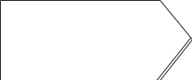
Definition: A Business Process is a sum of actions that produces a business advantage to the enterprise. It is composed by one or many ChiBusinessUseCases
Condition:
At lease one ChiBusinessUseCases or ChiBusinessUseCasesCore must linked.
Tagged Values:
Key | Notice | Value

Example:

MDA Realization:
Business Processes COULD be transformed in packages.

ChiBusinessUseCase

Definition: A Business Use Case is part of a business process that produces an advantage to the enterprise.

Condition:
It SHOULD have a name composed a Verb and an Object ().
It MAY have one or more ChiIssues attached.

Tagged Values:

Key | Notice | Value
Primary Actor | The list of actors associated with the use case. Although this information is contained in the use case itself, it helps to increase the understandability of the use case when the diagram is unavailable.
Other Actors
Goal in Context | The goal should implicitly express the actor's intent or purpose of the use case, such as "Enrol Student in Seminar."
Scope | Boundaries in which the use case is operated when invoked (E.g. CMS) | systemA
Level | Authorizations for operations/actions to be performed against the Chi business objects in scope. Against every object/process 4 CRUD basic operations are possible:  Create (Write)  Read (Open)  Update (Change)  Delete (Destroy) | ObjectNameA(CRUD)| ObjectNameB(CRUD);
Stakeholders and Interests | List of actors that have a special interest (i.e. to be informed every time) in completion of the use case | ActorA|ActorB
Precondition | A list of the conditions, if any, that must be met before a use case may be invoked. Can be a previous Use case or self the presence of the system in Scope. | (ConditionA|ConditionB)
Trigger | Event that is responsible for invocation of the use case
Main Success Scenario | The main path of logic an actor follows through a use case. Often referred to as the “happy path” or the “main path” because it describes how the use case works when everything works as it normally should.
Extensions | The use case that this use case extends (if any). An extend association is a generalization relationship where an extending use case continues the behaviour of a base use case. The extending use case accomplishes this by inserting additional action sequences into the base use-case sequence. | ID

Example:
Use Case | Technician repairs Module
Primary Actor | Technician
Other Actors | SVNCRM, Specialist
Goal in Context | Repair faulty Module
Scope | SVNCRM
Level | RWU (Trouble Call, Schedule, Knowledge Base);  W (Visit Report);  R (Transmitter, Module, Manual, Visit Report, Trouble Call, )
Stakeholders and Interests | Customer, Technician
Precondition | SVNCRM is available
Trigger | Module is not working properly
Main Success Scenario | Module is successfully repaired
Extensions | - Technician requests Specialist  - Technician orders Repair parts (urgent)  - Technician adds an item to the Knowledge Base

MDA Realization:
- The implied actors (=>Groups) get the appropriate CRUD access Level to the ChiNode.
- Stakeholder are informed (E.g. email) about the change of object
- Precondition COULD BE checked as ChiRule .

ChiUseCaseCore

Definition: A Core Use Case generates a value for an active business partner and is directly connected to the objectives (ChiGoals) of a company or the process of his existence (typically making money).
Condition:
It MUST be connected to a ChiGoal.
Tagged Values:
See above

Example:
Core Use Case | Field Worker performs Maintenance Call
Primary Actor | Field Worker
Other Actors | SVNCRM, Facility Manager
Goal in Context | Perform regular Transmitter Call
Scope | SVNcrm Dionysos
Level | RWU (Schedule);  W (Visit Report, Opportunity);  R (Transmitter, Module, Transmitter Module, Transmitter Module Manual)
Stakeholders and Interests | Customer, RM
Precondition | Field worker available
Trigger | Field Worker checks schedule
Main Success Scenario | Transmitter has been successfully checked, no problems have been found
Extensions | - Field Worker repairs transmitter  - Field Worker creates opportunity

MDA Realization:
Model is validated against above rules.

Chi Business Partner

Definition:
A ChiBusinesPartner is an external person that has a Business relation with the enterprise.
Condition:
A business partner must be linked to or more business cases.

Tagged Values:
Key | Notice | Value

Example:

MDA Realization:
HTML documentation is generated. Model is validated against above rule.

Chi Business partner Active

Definition:
A ChiBusinesPartnerActive is a direct customer of the enterprise.
Condition:
- Can initiate a Use case
- Can have direct access to the system.

Tagged Values:
Key | Notice | Value

Example:

MDA Realization:

Chi Passive Business Partner

Definition:
A ChiBusinesPartnerPassive is an indirect customer (typically a supplier) of the enterprise.

Condition:
- Cannot initiate a Use case.
- Has never direct access to the system.

Tagged Values:
Key | Notice | Value

Example:

MDA Realization:

ChiWorker
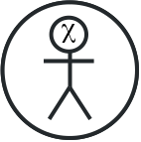
Definition: A ChiWorker is a special actor that works within the enterprise.
Condition:

Tagged Values:
Key | Notice | Value

Example:
MDA Realization:

ChiWorkerExternal
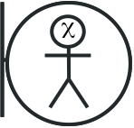
Definition: A Chi External Worker is an employee that interacts directly with ChiBusinesPartner outside the enterprise.
Condition:
Tagged Values:
Key | Notice | Value
OfflineUser | Define if the user require to have a offline access to the system. | True|false

Example:
MDA Realization: every ExternalWorker become a Group that has a CRUD access to the type (ChiNode) listed in the Use case in which the ChiExternalWorker take part.
NICETOHAVE

ChiWorkerInternal
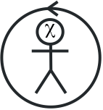
Definition:
A Chi Worker Internal is an employee of the enterprise that has no contact with Business partners.
Condition:
Tagged Values:
Key | Notice | Value

Example:
MDA Realization: see above ChiExternalWorker.

ChiActivity
χ

Definition:

Condition:

Tagged Values:
Key | Notice | Value

Example:
MDA Realization: see above

ChiDecision
χ

Definition:

Condition:

Tagged Values:
Key | Notice | Value

Example:
MDA Realization: see above

ChiImplementation

ChiNode

Definition: A Business Object type used in Chi. Nodes and Values define the application data model.
Condition:
Tagged Values:
Key | Notice | Value
table_name | The name of the database table. If not given the name will be taken.
pk_name | The name of the primary key column. The Chronos generator will add this. | id
is_ordered | Is this type to be ordered in a list? Chi generates a sort key ChiValue for this type if it is ordered. | true|false
initparams | The configuration section that is used on initialization of the corresponding mapper. | database
child_order | The order of the associated children e.g. for Enterprise: Worker,Customer,Location
display_value | The display value of a node e.g. for Enterprise: name|AdminInfo/status|Info/status
is_soap | Indicates weather or not a SOAP interface should be generated for this type. | true|false

Example:
MDA Realization:

ChiController

Definition: A View used in Chi. Controller, Views and Associations define the application flow. See tagged values for further information.
Condition:
Tagged Values:
Key | Notice | Value

Example:
MDA Realization:

ChiView
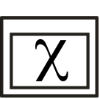
Definition: A View used in Chi. Controller, Views and Associations define the application flow. See tagged values for further information.
Condition:
Tagged Values:
Key | Notice | Value

Example:
MDA Realization:

ChiRule

Definition:
A ChiRule is related to one or more specific ChiNode (Business Object). Its specialize a ChiFeature and is implemented by ChiMethod.

A rule is atomic. Can have boolean and +, -, /, * operators.

A rule Know automatically the parent Object in which exist. Other objects must be pass as (IN)Params.
A rule modify ONLY the state or the characteristics of his object.
Condition:
Tagged Values:
Key | Notice | Value

Example:

MDA Realization:
For every ChiRule a Method in the ChiController is created. The Method has the same Name as the Rule. The Note of the ChiRule is taken as comment of the Method.

In the ExecuteKernel method a If-Then structure is generated with all the methods.

In the application flow the actions are modelled.

ChiSystem

Definition:
A class used for configuration purposes.
Each property of the class is used for define a configuration key.
The Initial value is used for the actual value of the key.
Condition:

Tagged Values:
Key | Notice | Value
Config | The name of the configuration file you want generate
Platform | The name of the specific platform

Example:
Key | Notice | Value
Config |  | Config.ini
Platform |  | php

MDA Realization: see above

