Model Driven Enterprise

Chronos Business Manual

How to model a Business using UML

Author: Giuseppe Platania
Owner: Giuseppe Platania

License
This work is licensed under the Creative Commons Attribution-NoDerivs 3.0 Unported License.
Chronos Business Manual by Giuseppe Platania is licensed under a Creative Commons Attribution-NoDerivs 3.0 Unported License.
You are free:
- to Share — to copy, distribute and transmit the work

Under the following conditions:
- Attribution — You must attribute the work in the manner specified by the author or licensor (but not in any way that suggests that they endorse you or your use of the work).
- No Derivative Works — You may not alter, transform, or build upon this work.

To view a copy of this license, visit http://creativecommons.org/licenses/by-nd/3.0/ or send a letter to Creative Commons, 444 Castro Street, Suite 900, Mountain View, California, 94041, USA.
Acknowledgements
The text that you are reading is the result of years of work and exchanges with exceptional colleagues. Without their help Chronos would still be a vague vision.
I have learnt a great deal from those who have worked with me over the years.
Let's begin thanking Ingo Herwig, original author of the “Domain” part of Chronos and best Open Source committer. He developed for it his PHP framework wCMF. That is one of the most powerful frameworks around and maybe the most powerful written by one man only. Ingo was the ideal partner for conversations that clarified my thinking on Chronos and other matters.
Niko Stotz was the developer of most part of the generator code. He is a sharp mind in pointing out the problem and finding the solutions and an ironic voice when the solution is still to be found . Niko was very good at implementing ideas I expressed verbally.
The venture of applying Model Driven Enterprise concepts in a project began with Fred Meyer, for many years my “twin consultant”. I am particularly grateful to Fred for his thoughtful and creative comments on the business side of Chronos. I'm indebted with Christian Schiller and Andreas Herdt for modelling “Moma” and “E-Energy”: the most complicated Chronos model ever, discovering “on the job” new requirements and pointing out bugs.
My manager Jürgen Schweickhard has backed the idea behind Chronos for many year, without him would be not possible for me to keep working on it.
Most thanks should go, however, to Pierre Joeris and Detlef Schumann for defending the introduction of Chronos in an Energy & Utility context in difficult meetings.
Thanks to Marco Eilers that wrote the original version of the Chronos Web Browser.

Thanks also to in not special order:
Enzo Failla, Stephan Heller, Christoph Weiss, Jan Laczay, August Ziesemer, Thomas Schuetz, Johannes Hintsch, Gustav Tschirschnitz, Christian Panzer, Paul Robinson, Sai K. Ari, Raul Duczek, Sabine Shentzel.
To all the above colleagues, and to several others whose names I cannot continue listing and who have assisted me one way or another I feel very much indebted.

Last but not least, I am deeply indebted to my family for the all patience and the love.

Document History
Document Location
This is a snapshot of an on-line document. Paper copies are valid only on the day they are printed. Refer to the author if you are in any doubt about the currency of this document.
The source of the document will be found in C:\Users\giuseppe.platania\Documents\svn\olympos\chronos\docs\chronosBusinessManual.odt
Revision History
Date of this revision: April 13 2016 | Date of next revision Dec 21 2016

Index of Tables
Table 1: Stati in the workflow 26
Table 2: Chronos stereotype names 28
Table 3: fields of a chiValue 70
Table 4: fields of ChiNode 72
Table 5: definition of logic in different stages 77
Table 6: Glossary 101

Introduction
This manual lead to in the step by step creation of a Business Oriented model that can be used in the context of a Model Driven Enterprise (MDE) project.

Some suppositions about the reader
If you’re reading this, we can safely suppose that not only have you already opened this file, you’re probably also a Business Analysts, Architects and Developers that intend to use the Chronos methodology for capturing requirements, describe the business processes, model the domain and generate code and documentation.
For the most part, we assume that you fall into one of two major categories: Either you’re a modeler (with a yen to communicate requirements or how you think the world works), or you’re an Architect (looking to designs software in so plain way that can be executed by a -stupid- machine). Either way, this manual is for you.
We won’t assume that you know any particular computer language, although knowing some could certainly help. A basic knowledge of Unified Markup Language (UML) and processes modeling is suggested.

How this book is organized
After this Introduction the book contains following sections:

- Concepts: introduce the foundation of the Chronos methodology and his tool.

- Handling Projects easily with the Chronos Methodology: Introduce the Methodology work flow.

- Requirement, Analysis and Model sub Models: describe step by step ho to full fill those sub models.

- Additional Tools: describe the use of the Model browser, the Document and code generators

How to read it
This manual is written with a pragmatical approach. While you can read it from the start until the end is very probable that you will jump to the part that you think is more interesting in this moment. Feel free to do in this way, this text is structured to consent you to jump in and out from any point. For this reason some concepts are repeated in different sections. An understanding of the Chronos structure can help you a lot, so maybe you can invest some time in this part. So let's begin.

About MDE
Today most of the enterprise's information is prisoner within special systems and or files. Knowledge related to a certain process is split in Documents, Spreadsheets, Project plans, Presentations, Mind Maps and so on. The subject matter is unique, it is only expressed in different ways.

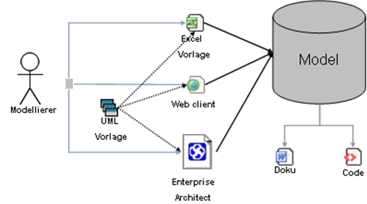Illustration 1: in a MDE system all the knowledge in his complexity is stored in a special kind of ontology in form of a UML model. The artifacts, including code and documents, are generated from a model. Different tools can contribute to the manipulation of it.

The aim of the MDE is to hold the business knowledge of the enterprise in a single place: the model. A model is an abstraction of concepts that describe a certain domain.
All the products of this knowledge (documents or code) are generated from this rather that produced, managed and stored separately.

MDE is a shift of paradigm in the IT projects similar of the invention of production lines in the production of cars. Using a “knowledge production line” the time decreases while the quality increases. In fact an IT project build on this methodology can spare 25% until 63% compared to a Business as Usual one.

the Chronos methodology

The daily life of an IT consultant in the western hemisphere is full of challenges. From one side the continuously shift of knowledge requires a continuously learning, on the other the strong pressure from the customer side to remain in time and budget... still delivering excellence.
So far the theory.
But, following the The Standish Group Chaos Report, in 2009 an astonishing 31.1% of projects were canceled before they ever get completed. Further results indicate that 52.7% of projects' cost 189% of their´original estimates. The research shows that 68% of all the considered IT projects go over time and budget. In the experience of the author one major reason for those failure is miss managing of business requirements.
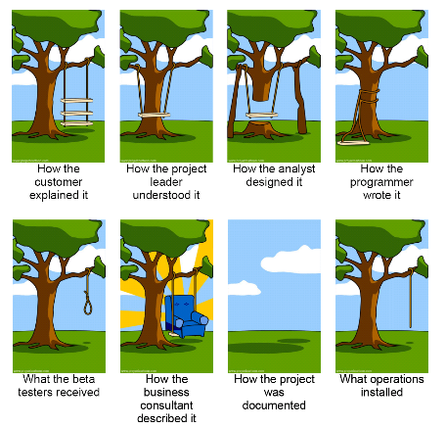
Illustration 2: Today most IT projects suffers of poor understanding between different roles

The business and the technical language don't fits. Managers, Business consultants, Solution architects and Developers speaks all different languages that needs to be translated again and again. Parts of the original meaning are lost in translation.
The Chronos methodology was created as an answer to this situation. Describing a how to use the Model Driven Enterprise approach and supporting it with tooling. The basis or the methodology is a certain structure called ChiMetamodel.

About the Chi Metamodel
Chronos was created as pragmatic way to realize the vision of a MDE approach define above.
The Chi Metamodel is a language with a precise syntax and grammar. This rules allows to creates so precise models that can be also understood from a machine (the generator).
From a formal point of view it is an UML profile which defines the notation for all elements used in the different stages of the project life cycle from the requirement to the application. For details about Chronos consult the documentation.

About the name “Chronos”
In Greek mythology Chronos was the father of Zeus. The prefix of all the Chronos objects is the Greek letter χ (see http://en.wikipedia.org/wiki/Chi_(letter) initial of the name Chronos (Χρόνος). The Chronos Metamodel is part of the Olympos family that include Aphrodite (an abstract specification for a server), Dionysos (an abstract specification for a client and the communication with the Aphrodite server) and Ouranos (a metamodel that addresses how to extract models from legacy code).

Introducing the Chronos Web Modeler
In this text the Chronos Web Modeler (CWM) is used for create a valid Chronos UML Model. CWM aims to provide a collaborative environment to create and manage Chronos models. The result can be exported to be used in other UML editors or directly transformed in code and/or a documentation. While CWM is optimized for this purpose, any UML tools that support profiling can be used. Chronos models where created successfully by using tools like IBM Rational Software Architect, Eclipse Modeling Framework or Sparx EnterpriseArchitect.
CWM is freely available under the Eclipse Public Licence.
You can download the most recent CWM version from: http://sourceforge.net/projects/olympos/ .

Concepts
In this chapter we introduce some basic concepts used in a Chronos project that uses CWM as a modeling tool. The aim of the project is to create a Valid Model described by a certain metamodel that where the origin and history of the information can be traced. This information need to be properly displayed as abstract information.

Models and Meta-models
A Model (m1) is an abstracted representation of the Reality (m0). To describe it the model adds Meta data that describes the concept. Let's explain this.
In the following example “Name” is a certain concept coming from the reality.
M0 = “Name”
By enclosing “name” within the tag “Property” we define the type of concept
M1 = “<Property>Name</Property>”
Now that we have defined the type of concept “<Property>” we could use it in any situation. e.g.
M1 = “<Property>Color</Property>”
In a similar way a metamodel (m2) is an abstract representation of a Model (m1). This is created by adding a definition to “Property”, in our case “ChiValue”
M2 = <ChiValue>Property</ChiValue>
Chronos is a Metamodel, expressed as UML profile. An UML Profile describes Stereotypes that are applied to existing concept of the UML metamodel to extend them.

About diagrams
A lose collection of elements is in an entropic status. To order them it is necessary to establish a structure trough relationships. They are the added value that transforms data in knowledge. This, when considered it as whole, can be very complex. For this reason models are visualized in diagrams. Diagrams becomes a form of knowledge representation that helps the understanding. Diagrams are NOT the knowledge model itself. Each of them is a View, that help the understanding from a certain view point, used by a certain actor.
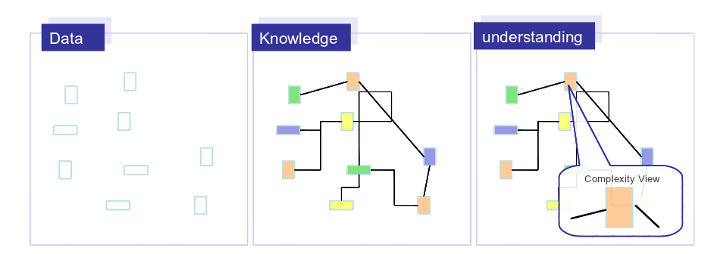Illustration 3: Diagrams are views to facilitate understanding of complexity
Bottom line: a model can be very complex and that to display this complexity it is required to have multiple point of views (diagrams). The modeler can creates so many diagrams as he retains necessary to visualize the considered point of view.

Diagrams types in a Chronos Model
In a Chronos Model, typically, we can find following types of diagrams:
- Work diagram
- Package Overview
- Chain Inheritance
- Deep View
- Mapping

Work diagram
A work diagram is anything that you create by simply drag, drop and connect objects in your workspace. Works diagrams are typically created while you add objects to the model and establish relationships.
They become easily huge and very hard to understand for an external reader. Conventionally they have the name prefix “<<Name>> Work diagram”.
Work diagrams don’t suit for concepts presentation (see 2.2.2 The seven rule below).

Relevant nodes
The relevant nodes diagram (see also 5.2 Create the domain model) contains all the ChiNodes that are involved in a Use Case (see #2.1.Modelling Use cases).

Package Overview
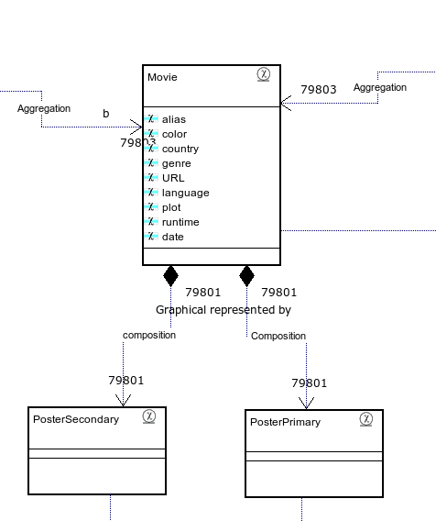Illustration 4: Example of relevant nodes diagram

The Package Overview Diagram contains all direct children elements of a Package.
As default name you SHOULD use “<<PackageName>> Overview”
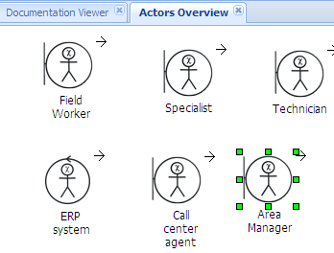
Illustration 5: Package overview example

The CWM offers an automatic method to create a package overview diagram.
Click on a package and select “New Diagram form package”
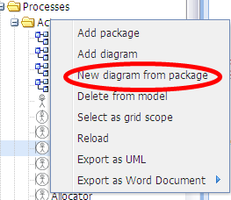Illustration 6: CWM menu for creating a Package overview

Chain Inheritance
The Chain Inheritance diagram contains the elements related to a single chain of parent- children.
As default the name you SHOULD use “<<ObjectName>> Inheritance”

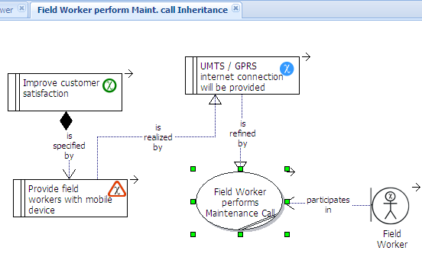Illustration 7: Chain Inheritance diagram example

The CWM offers a function to follow the Inheritance chain.
Right Click on an object and select “Show in Hierarchy”

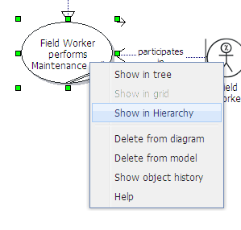Illustration 8: Show in Hierarchy menu
You can direct drag objects from the Hierarchy and drop them in the Inheritance chain diagram.
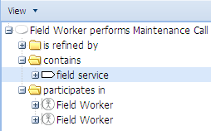Illustration 9: Show in Hierarchy example

Deep View
A deep view diagram shows a special aspect of the knowledge model.
You can use any combination of objects here and you are limited from the readability (see seven rule below) only.
Use many deep views diagrams to present complex aspect of the knowledge model.
As default the name you SHOULD use “<<ObjectName>> relevant”
Example of Deep View are relevant objects diagrams (see #2.2.1.2.Relevant nodes).

Mapping
Mapping diagrams show how a certain type of object is linked to another one.
Example of mapping are ChiObject to ChiNode or Container to ChiNode Mapping (see below).

The “seven” rule
A diagram SHOULD NOT display more that SEVEN elements. A good diagram has five.
See the Inheritance diagram below:
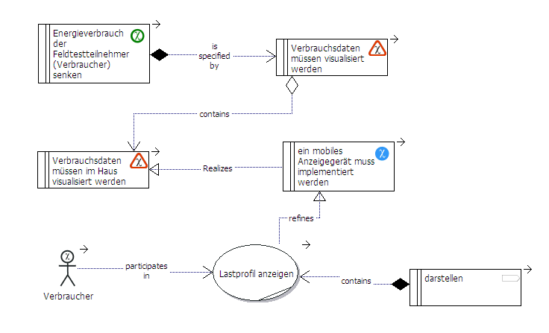Illustration 10: example of the seven rule
Such a representation is already complex to understand.
Studies have shown that most people have a hard time visually comprehending more than seven elements at a time.
A diagram with more that seven element is a good method to build the knowledge model (see diagrams types above) but not to display it.

Traceability
An important feature of the Metamodel structure described above is to support traceability. Following Wikipedia, requirements traceability is defined as:
... the ability to describe and follow the life of a requirement, in both forwards and backwards direction (i.e. from its origins, through its development and specification, to its subsequent deployment and use, and through all periods of on-going refinement and iteration in any of these phases.
CWM supports this by building chains of model elements and by taking notice of the complete history of each of them.
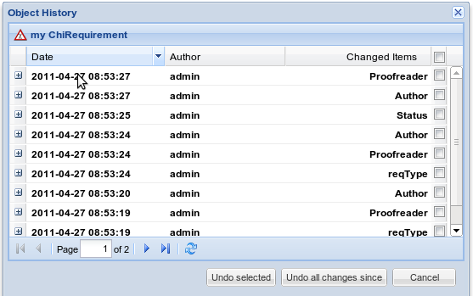Illustration 11: the object history allow to trace every single change that was performed on a model element.

CWM Special Fields and Features
While CWM works pretty intuitively, in some case it is necessary to be aware of the functioning of certain characteristics.

difference between "Author" and “Creator”.
The “Author” field and “Creator” field help also to keep trace of the object history.
The “Author” field in CWM is regarding the original business maker of the object itself. this can be selected from a list of project members (see #3.2.3.Configuring the model).
The author is NOT necessary the technical author means the CWM user that physically inserted the information. This is the "creator" while the "last_editor", as the name suggests, is the last that modified the object. Is a good practice to create technical users with the convention “firstname.lastname” and authors with “FirstName Lastname- Role”

In some cases the 2 are identical, see screen shot:
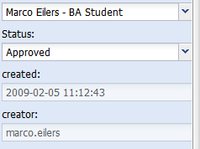
Illustration 12: author and creator fields compared

Rich text area
CWM offer some facilities to write texts. All the Chronos objects have a property “notes” with a rich text area.

- in the text editing interface CWM supports bold (ctrl + B), underline (ctrl + U)and italic (ctrl + I). Bullet Lists and numbering.
With very long documents can be more comfortable to use a full features word processor. On the other side you should be aware that some formatting will be removed on the server side. By pasting any text in the text area it will be appear exactly as-is in the word processor but by reloading the object you can have some surprises:
- Some special characters like “©¥®Ω√” are supported. By writing “∑ a + b + c If b ≈ 5” and reloading you will get “? a + b + c If b ? 5”
- Images are not supported.
- Formulas created with a formula editor like will not works because they are embedded OLE objects.
- Tables are not supported: text in table will be transformed in a list.
- Standard fonts are not supported. This is because they could be not installed on the server.
e.g. “times new roman 13” , “Arial 8” or “courier new 10” will be reset to the default font.
- Those limitation are required to generate documents. You can control the output of your documents by using the document templates of the generator (see #8.The document generator ).

Status types and management
Chronos objects have a “Status” field that can be configured in the CWM administration User interface in the ChiBaseStatus Tab. Following statuses are delivered with the standard model.
Notice that Requirements and Features have special Statuses that can be configured separately.
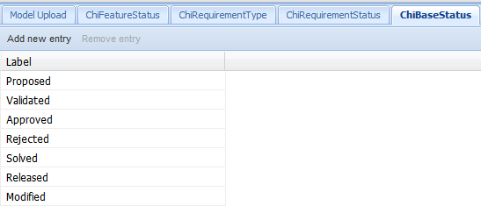
Illustration 13: a list of stati provided in the Chronos Default Model

Status | Notes | Key Color (RGB)
Proposed | the object has been created and is waiting for review | 0,0,255
Validated | The object has been validated in his quality from a technical/model point of view | 51,153,52
Approved | The object has been validated from a Business point of view | 0,255,0
Rejected | The object has been rejected from a technical or Business point of view | 255,0,0
Solved | The reason for the rejection has been eliminated and the object is awaiting for a further review | 255,128,0
Released | The object has been released and cannot be further be modified in this version of the model | 128,128,128
Modified | The object has been modified from his original status Proposed or released. | 255,255,0
Table 1: Statuses in the workflow
The suggested workflow is illustrated below as map of transitions between those:

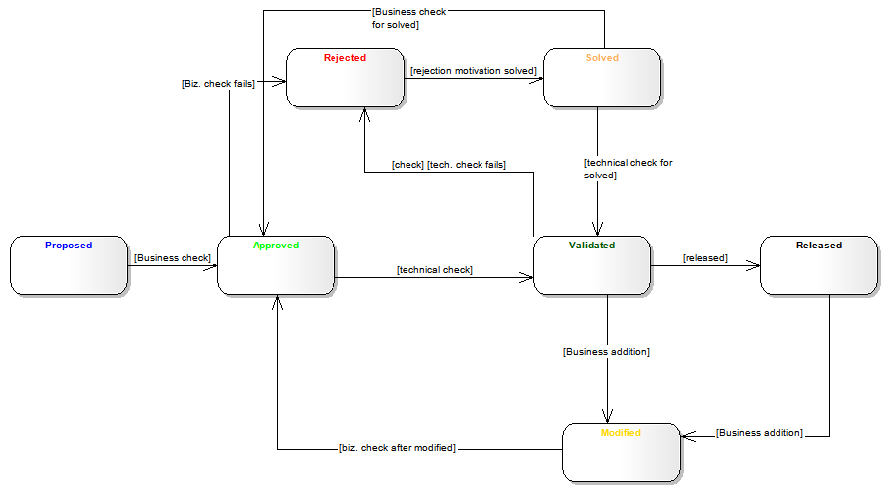Illustration 14: transition workflow between stati

Each object is created in a “Proposed” status.
The object is checked from the business point of view. If it is agreed that it make sense his status is set to Approved. In the next step the object is evaluated from the technical point of view. If it pass the check is set to Validated. In both cases the object that don't pass the check can be set with a status of Rejected. The proofreader MUST explain the reason for the rejection. If an element is rejected the original Author if responsible to evaluate the motivation and propose a solution. In this case the object is set to Solved and send back for Business and Technical approval. A validated object can be transformed in any artifact (e.g. a deliverable document or a piece of code), in this case is Released. A release mean that a physical, non model representation of those object has been created.
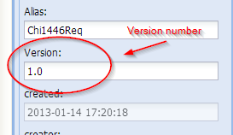Illustration 15: a version number is added when a released object is changed.

If a released object is changed his status is set to Modified and the version number is changed to reflect this.

e.g. as an idea about a requirement is proposed by a Business Analyst. This idea need to be confirmed by a Subject Matter Expert (SME). The SME thinks that the Requirement is fine. The status is set to “Approved”. Now the object is checked vs. his “model technical aspect“ by an Architect. Constrains and relationships must be fulfilled, like the Requirement must have a Parent attached. Because this is the case, the status is set to “Validated”. In both the cases of the SME and the technical proofreader, an object that is non valid can be “Rejected”. When the reason for the rejection has been addressed the status is set to “Solved” and wait again to be approved or validated.
When necessity exists to change it after validation this is set to “Modified” and need to be Approved and Validated again. When a collection of objects (e.g a package) achieve a Validated status they can be “Released”.

Handling projects easily with the Chronos methodology

Chronos Stereotypes and relationships overview
To begin we need to give a deeper look to Chronos.
The Chi Metamodel contains the following stereotypes and relations:

Requirement | Analysis | Domain
- ChiGoal  - ChiRequirement  - ChiFeature  - ChiIssue | - ChiBusinessProcess  - ChiBusinessUseCase  - ChiWorker (3 types)  - ChiBusinesPartner (3 types) | - ChiNode  - ChiController  - ChiView  - ChiConfiguration
Table 2: Chronos stereotype names
In the next chapters we will discuss in detail the sub models, their sequence and use.
Workflow of the 3 sub models
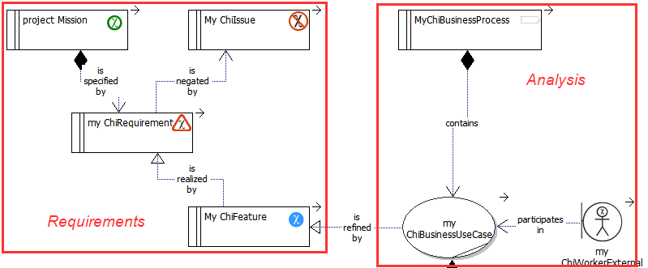Illustration 16: Stereotypes and relationships for the Requirement and Analysis model

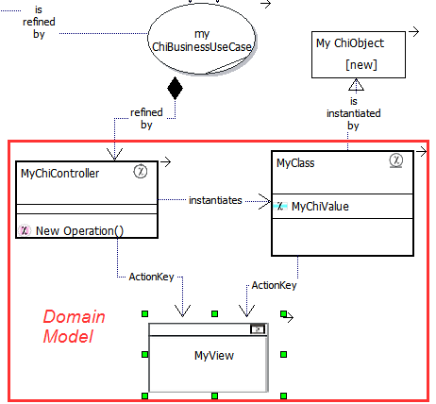
Illustration 17: Stereotypes and relationships Domain Model

Sequence of use
A project based on this methodology uses the stereotypes described before following the structure of the Chronos Model (see #3.2.1.The Chronos Default model) that is divided in 3 parts:
- Requirements sub model
- Analysis sub model
- Domain sub model

logically they are used in sequence as described in the diagram below.
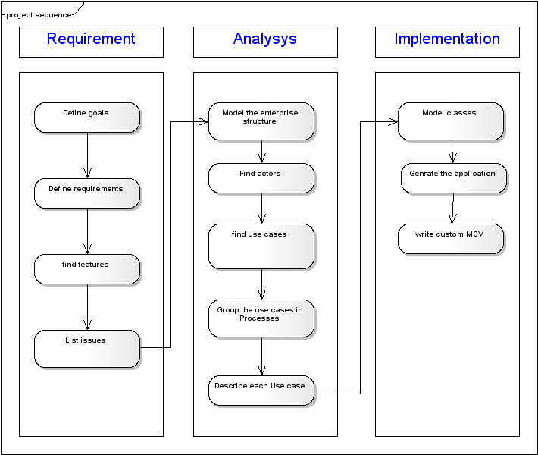Image 1: the waterfall Project sequence, starting with the Goals and finishing with the Domain objects, is the exception rather that the rule.
This work flow is constructed like a waterfall project. That is for representation only, rather that a methodology feature. In real life this sequence seldom materialize.
Rather several people will works on the same time on all the part of the sub models. This could appear very chaotic at the beginning. But thanks to the Chronos Web browser (CWB) it is possible to connect the different pieces. The CWB (see #7.The Model Browser) will help you to go toward an increasing finishing of the model.
Expect to have multiple iterations with different grades of completion.

walk-trough the Chronos stereotypes
In this chapter we will present the Chronos elements. Depending from your role you can use all or only a part of them. The objects in the hierarchy's bottom are more defined that the one in the “top”.
For a complete reference of them consult the “Chronos Profile Documentation”.

Begin defining Goals. A goal is a desirable (and measurable!) status.
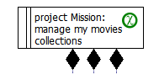
The next steps is to define Requirements specifying the Goal. A ChiRequirement
is a condition that can be true or false.
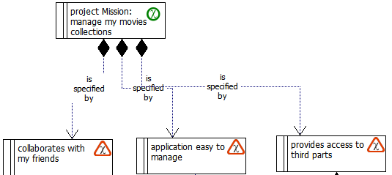
Illustration 18: this goal is specified by 3 different ChiRequirements
Requirements are realized by Features. A Feature is a fact that set his requirement to true.
In an opposite way the Issues are facts that set the requirement to false.
A Feature is realized by one or more Use cases. ChiBusinessUseCases are short stories, step by step descriptions how a feature works.
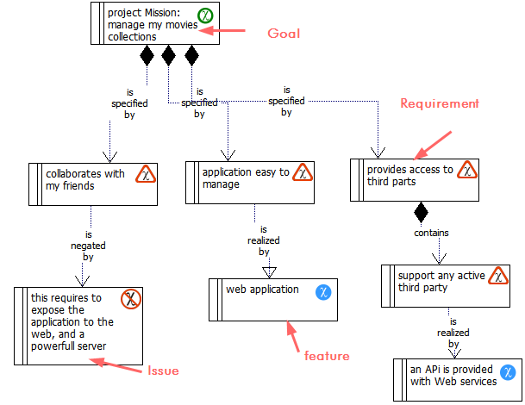
Illustration 19: elements of the Requirement sub model
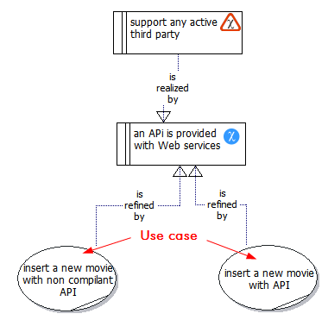Illustration 20: two use cases refining the same Feature
Use Cases are contained in Processes. You can imagine a process as telling the complete story where a Use Case is a chapter. Actors like Workers and Partners are the protagonists of the story that participate in Use Cases.
The “story” of a Use Case is told in his “note” field; additionally the use case include an activity, that visually describe the story, for facilitating the reading and generating documentation.
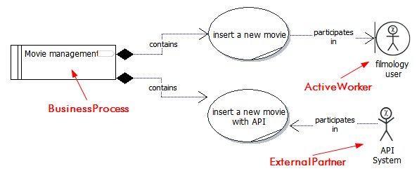
Illustration 21: Example of a Process for movie management containing two Use cases
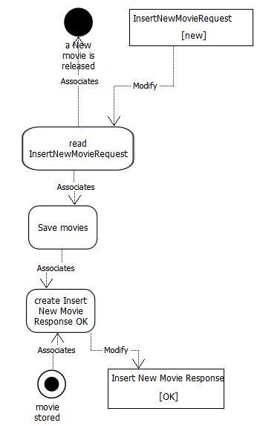

Illustration 22: Activity of the "insert new movie" Use case

A use case is implemented by a ChiController, that is the domain element that host the flow of the story depicted in his Use case, each uml::Activity element becomes an operation of the controller.
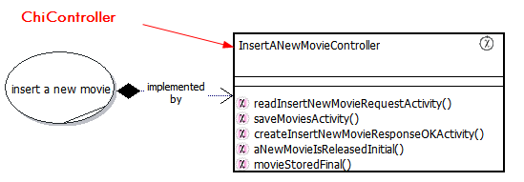
Illustration 23: the ChiController that implement the Use case has operations that correspond to the UC's the activity elements.
ChiObjects within the activity are instantiated by ChiNodes
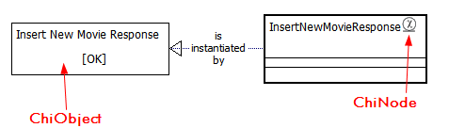
Illustration 24: a ChiObject instantiated by a ChiNode

Before the project start
The Chronos methodology is designed to lead you trough a typical IT project. Before the delivery part starts, other activities like providing a quote need to be performed, typically as “bid budget”. Chronos helps you to minimize this effort. To complete the estimation two experienced consultant needs 1-2 days for a middle project with 10-20 Use cases. Additionally the created model can be reused during the project's execution.

Creating a Request for Proposal

Introduction
A Request for Proposal (RfP) is a collection of functional, non-functional and environmental requirements. Those are expected to be fulfilled by Features contained in the Response. The Chronos Web Modeler (CWM) supports collaboration and management of RfPs.

RfP: walk-trough
To prepare the RfP using CWM:
- Begin modeling with the inner goal (Vision) of the project (optional)
- Describe the which kind of image (Mission) that you want to communicate to candidate contractors
- Describe up to 7 most important goals of the considered project
  - Assign priorities
  - Let validate goals by stakeholders
- Illustrate for each of the above goals 1 or more requirement. Requirements can be functional, non functional and environmental
  - assign priorities to Requirements
  - Let validate goals by a proofreader Subject Matter Expert (SME)
- Generate the RfP Document using the document generator
- Ask the contractors company to describe a Feature for each of the considered Requirements and an Issue for each of them that cannot be realized..

working with the Response to Proposal
- Let a SME proofreader validate each Feature: each of them must be response to a certain requirement fulfilling it. In case a feature a no requirement you can consider to add one or to simply ignore it as non relevant for you.
- Compare the different features in a matrix.

Introduction to estimation
Typically, before a project starts you are requested to give a quote to the client. The proposal team gets a so called Request for Proposal (RfP) documentation from the client. The quality of this can be very variable: from a simple list of requirement to more gigabytes of documents. The task that the team must perform is to read (and understand!) the RfP documents providing a technical and legal response. But the most important part is to produce a forecast of the effort involved in the realization of the client wishes.
In this chapter we describe an approach that uses the Chronos Methodology to categorize client requirements and produce a quality estimation using Use Case Point Analysis (UCPA). This is a method for project sizing and measurement based on Use Cases created by Gustav Karner.

How Use Case estimation works
Project's complexity is a function of the different factors.
- Use Cases: The number and complexity of the use cases in the system
- Actors: The number and complexity of the actors on the system
- Technical complexity: Various non-functional requirements (such as portability, performance, maintainability) that are not realized as use cases.
- Environmental Factor: Various non-functional requirements regarding the environment in which the project will be developed (such as the language, the team’s motivation, and qualification).

Use Cases Complexity Definition
As we build a project using UML, use cases to describe the proposed functionality. We assign a rating to each use case following those guide lines:
- Easy (5 points): fewer than 4 main success scenarios or execution paths in the UC. The use case is considered a simple piece of work, uses a simple user interface and touches only a single storage entity; its success scenario has less than 3 steps; its implementation involves less than 5 classes
- Medium (10 points): 4 or more key scenarios, but fewer than 8. The use case is more difficult, involves more interface design and touches 2 or more storage entities; its main success success scenario has between 4 to 7 steps; its implementation involves between 5 to 10 ChiNodes.
- Complex (15 points): The use case is very complex, involves a composite user interface or processing and touches 3 or more storage entities; its success scenario has over seven steps; its implementation involves more than 10 ChiNodes.
Those values are given for orientation only. Every Use Case could have a rating between 2 and 30 points. The amount of points can be calculated also for every package or set of functionalities (ChiBusinessProcesses)

Actors complexity definition
Karner's UCP method also calculates project effort by considering project actors, and their contributing complexity. An actor can be an human or a technical system.
As guidelines to this assignment we use the information supplied below:

- Easy(1-5 points): The actor represents another system with a defined API
- Medium (2 points): The actor represents another system interacting through a protocol or a human with a command line interface
- Complex (3 points): The actor is a person interacting via User interface.

Technical factor complexity definition
The technical complexity measures which non functional requirements are relevant for you project. The Chronos default model provides a set of Requirements and Features couples that you can customize. The weight factor is described in the Requirement that poses a question the is answered in the Feature Title and with a Value. Value and weight are multiplied and the result the summed as technical factor “Tfactor”. Tfactor is normalized as 0,6+(0,01*Tfactor)
- Requirement Weight (2 points): this factor weights a strong negative impact on your project more that others. For example the definition of “secure” in a bank system very significant and costs effort.
- Requirement Weight (1 point): this factor weights a negative impact on your project .
- Requirement Weight (-1 point): this factor weights a positive impact on your project .
- Requirement Weight (-2 point): this factor weights a strong positive impact on your project more that others. For example in a bank system is not so important that the system is “easy to install“
Depending from the positive or negative Weight, the Feature's value can impact on the context. Generally speaking :
- Feature Value (5 point): implementing this requirement represent a complex task
- Feature Value (3 point): implementing this requirement represent a medium task
- Feature Value (1 point): implementing this requirement represent a Easy task

Environmental Factor complexity definition
This is one of the most under estimated (if not ignored) factors in project estimations. Its describe how qualified your team is, how committed to the project and . Notice that the provided set of Requirements and Feature are set to be used with MDE. So they are more optimistic that in a traditional project. The weight factor is described in the Requirement that poses a question the is answered in the Feature Title and with a Value. Value and weight are multiplied and the result the summed as technical factor “Efactor”. Efactor is normalized as 1,4+(0,03*Efactor)
see above for definition of value and Weight.

Use Case point Analysis Walk trough
Start by right clicking on a template and duplicating the provided default model (see #3.2.Starting a project for details).
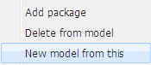

Estimating the Functional requirements
Find the Goals of your potential client: what is he intending to do? How will he measure your common success?
Now identify the Requirements that specify the Goals. After this, describe for each of them at least a realizing Feature. Features realizing functional requirements, needs to be further refined by Use Cases. If you have luck the client has already defined his use cases in the RfP document, if not you need to find them. The difference between a Requirement and a Feature sometime is very subtle. As general Rule a requirement leave always space for interpretation and realization while a feature describes it specifically.
For example saying “the system must have an acceptable performance” is a requirement while “each business functionality will run in less that 1 second” is his feature. Typically requirements are very high level and undefined, especially at the beginning of a project. Sentences like “The client don't know what he need” describes this situation. So in the client documentation you can expect to find more requirements for features that features self. It is the job of an IT architect to find the right solution.
For each functional Feature create at least an Use case (see also Finding candidates for Use Cases) and link them.
In the image below, an estimation model realized using the Chronos Web Modeler.
Illustration 25: Example of requirement model
Now for each use case estimate the complexity factor (see #3.1.2.1.Use Cases). The sum of the complexity factors is normalized against environmental factor and technical complexity.

Estimating the Non-functional and environmental requirements
The technical complexity is the estimated impact of Non Functional Requirements (NfR) over the project.
A standard list of NfR is provided in the Chronos Default model:
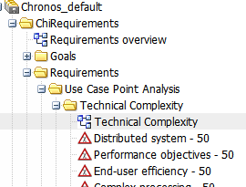
Illustration 26: a standard list of Non functional requirements and their weight is available in the default model.
​the “Use Case Point” Analysis package contains a set of standard requirements for the Use Case point analysis.
Modify them as needed for your project.
Every requirement that should be included in the Use case point analysis must be of type Technical or Environmental.
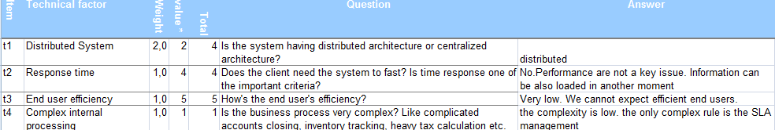
Illustration 27: Standard technical factors are included in the default Model
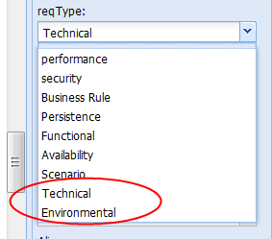
Illustration 28: requirements for the UCPA must be of type "Technical" or "Environmental"
Technical requirements and their features are all them that are not related to business functionalities (Non functional requirements). The weight of the requirement is expressed as integer by using the requirements field “priority”. Typically you don't need to modify the given default weight. Every feature that is not directly described by a use case must be attached to such a type of requirement. In the feature's note field write the actual Value of the feature expressed as floating number (“1,4” or “-2” are valid examples).
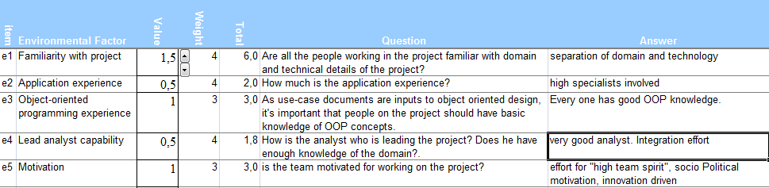
Illustration 29: environmental factor tab of the Use case point generated documentation
The environmental factor is often underestimated in project calculation. It includes concepts like the motivation of the team, the stability of requirements or the methodology used for the project. The default weight and values are estimate optimistic considering the use of Chronos as MDE methodology.

Generating a UCPA spread sheet
Now you are ready to generate the forecast.
The standard Chronos installation includes a document templates for UCPA. It generates a spreadsheet containing all use cases, actors, and ChiRequirements with type == "Technical" or "Environmental". Additionally, all formulas for calculating Use Case Point Analysis are included.
To generate a UCPA right click on the your model element and pick “export documentation”.
Then select the Use case Point analysis Document template.
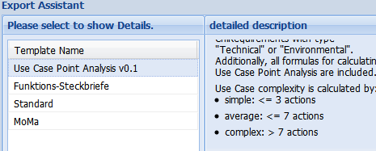Illustration 30: the Use Case Point Analysis document template
The model is exported to XML then transformed to UML. The generator distributes Use cases, Features and requirements in the appropriate fields. An OpenOffice spreadsheet call “cwm-documentation-xport.ods” is returned.
The result look similar to this:
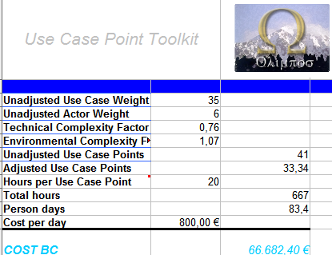Illustration 31: sum up tab of the Use case point generated documentation
The generated document contains information regarding prices, total hour, person day and so on. Those are average data for the consideration of the user only. This must be considered a template that still need the attention of one or more subject-matter experts.

UCPA estimated tasks
After a Use Case Point analysis you get a first concrete estimation of the hours necessary to realize a certain set of functionalities.
A frequent asked question related to this time is what activities are inside that calculation. It includes the time requires for project management, design, development, testing and deployment. All the “standard” phases that are required to complete a project are included. Never the less you can decide to add times for special activity if is required by the special situation.

UCPA Conclusion
The use case point analysis methodology is not the silver bullet that “automagically” solves the challenge of estimating the unknown. As always the experience of the estimator is the decisive factor for the final quality. At least as “second opinion” cannot be wrong to apply it. Nevertheless the normalization parameters and the precise approach offer a defined path for project estimation.
Within the Chronos project's strategy the Use Case Point Analysis offers an additional advantage: being the project itself based on MDE (Model Driven Enterprise), the same model created during the proposal phase can be reused.

Starting a project by selecting a model
Depending from your settings, when you start a project, you may have different models to start with:
- Chronos Default Model that is freely available
- other default model that maybe available on request
It is strongly suggested to start by duplicating one of them. While it is possible to create a model from the scratch, certain structures are necessaries to the generator.

Structure
- (if not already done) Start the project by duplicating the provided Chronos_default model.
- Optional: Import the provided Chronos UML default model.

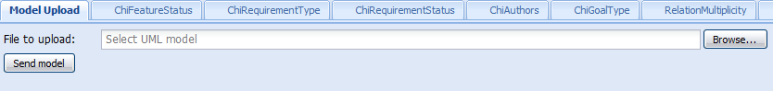
Illustration 32: the "model upload tab" in the "admin" perspective allows to import a valid Chronos model

- Works in the given package structure.
  - Put every object in a package with the object name (e.g. all the goals under the package goals)
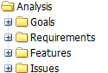

The Chronos Default model
The Chronos default model, is a template that permits to rapid start any Chronos project. It offers a precise structure of packages where place Requirements, Use cases and Domain objects. A single object of each type is available for customizing. It is provided in UML format.
See below for details about its structure.
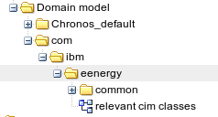Illustration 39: location of the e-energy domain objects

Configuring the model

To configure your CWM installation for the project some steps are required. Some of them are:
- create users and groups in CWM
- Assign rights to the groups
- (Optional) import an existing model
- Customize object statuses for project purpose
- Create a list of model Authors

for more information how to administrate the Business Object Repository (BOR) see his Manual referenced in appendix #2.Additional reading|outline.

The Requirements sub model
In this section we will cover in details the creation of the requirement sub model. This contains:
- Goals
- Requirements
- Features
- Issues

creating ChiGoals
- Define goals for your project.

- Define goal of type “vision”. This is what you intend to achieve in you project at a very high level.
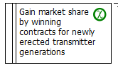
Illustration 40: A goal of type vision is an abstract inner representational of the project scopes.
- Define one goal of type “mission”. Those aims to “political” communication or “external marketing”. For this reason don't need to be specific a special value.
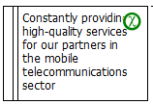
Illustration 41: a Goal of type Mission is the project slogan, how the Vision is communicated to the outside
- Create a number of specific goals that specifies your Vision. For each of them specify a value that you can measure. Specify in Value_name the name and the type. Add in value amount the actual level and in Value_Goal what you intend to achieve with this project. Don't exceed with the goals amount.
- Remember that all the goals must be achieved at the project end. 7 is a good number of project goals.
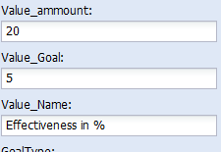

Illustration 42: in this example of goal value the actual effectiveness in % the actual level of 20 should be increased by 5 %
- Link all the goals in a Hierarchy.
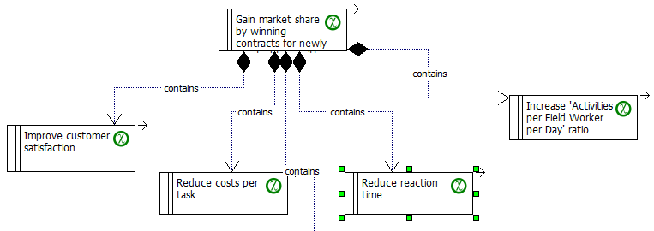Illustration 43: a Hierarchy of goals. the top element of it must be the Vision
- each goal MUST have as a child one or more goals OR Requirements.
- A goal CANNOT contains both types.

Creating ChiRequirements
- create ChiRequirements supporting the goals:

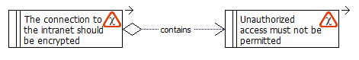
    - add a new requirement
    - Link the requirement with a parent Goal or Requirement .

- each requirement MUST have as a child one or more requirements OR Features.
- A requirement CANNOT have both children types.
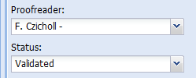
- Review requirement: Each requirement need to be validated by a proofreader
- a proof reader need set the status of each requirement to “Validated”, stating that indeed this is in scope and well understood

Creating ChiFeatures
- manage Features
- A Feature is a characteristic that set the condition posed by the requirement to be true.
- Propose features satisfying requirements. For each requirement describe a feature and link them.
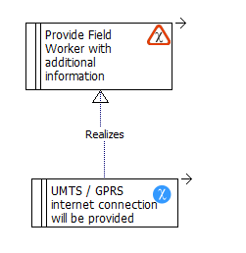Illustration 44: a UMTS connection is a valid feature that cover the requirement of connecting mobile workers
- Review features: each Feature need to be validated by proofreader
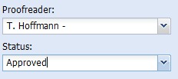
- Confirm feature

Modeling the Requirements and Feature in the correct way
If you want that a Feature is realized in 2 different cases it is necessary to describes 2 different requirements. This is especially true in the case of a Scenario situation where not all requirements are intended to be realized.
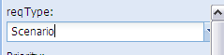
Illustration 45: to create scenarios use the requirements type field
In this example we have two Features: BB and AA
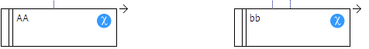
we see that both of them are realized, also if one of the 2 requirements A or B, representing 2 scenarios is no more present in the model. Check the image below out.
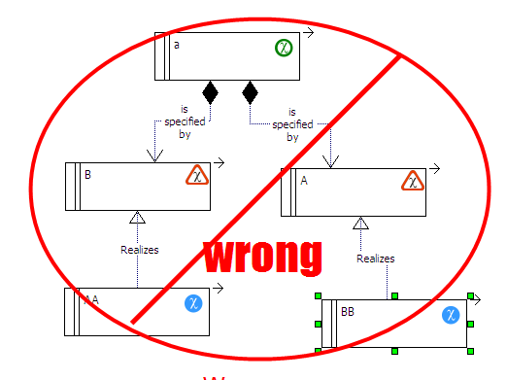Illustration 46: In this example A and B are alternative scenarios. But we seek a way to realize booth feature in any case.
The above modeling would be wrong, because Feature BB is only realized as if the Requirement A is present in the model.
An alternative solution would be to attach the feature BB also to the requirement B. See below
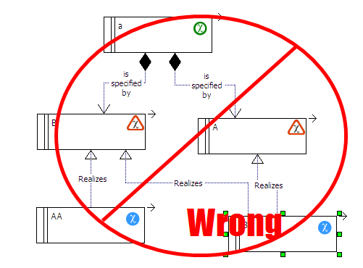Illustration 47: In this diagram a Requirement is realized by two different features. This is not allowed by the Metamodel.
This is OK from the point of view of the feature, but not from the point of view of the requirement. In the Chronos Metamodel a Requirement can have only a realizing feature.
If you have the impression that a requirement requires TWO features means, that it contains 2 children requirements.
Illustration 48: A ChiRequirement has a ChiFeature only. A ChiFeature can satisfy multiple requirements
Imagine a requirement like a hole of a certain dimension and a feature like a screw. You cannot put more that 1 screw in the same hole also if you could use 2 different ones.
We take this as an indication for introducing a new level in our left scenario.
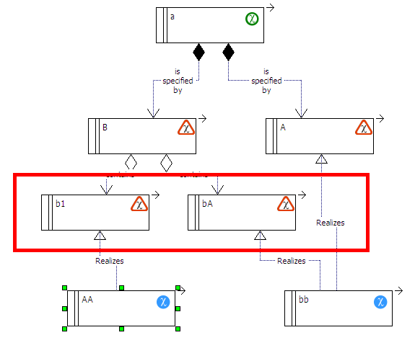

Illustration 49: In this diagram the feature BB is realized in both scenarios A and B
Now also in the case where the “A” scenario is not implemented, the features AA and BB are realized.

Manage Issues
Issues are facts that stop a requirement to become true. This means that a “Problem” cannot exist if you don't have a requirement behind it. The easiest way to solve issues is to decide the parent requirement is not mandatory.

- Discover issues provoked by requirements
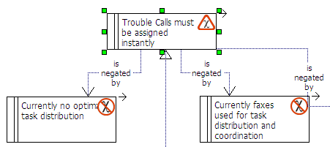
Illustration 50: a requirement with two feature attached cannot become true
- Assign responsible to this Issue
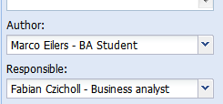
Illustration 51: each Issue must have an author and a responsible

  - Responsible possible evaluation:
    - Delete the requirement from model. It is suggested to don’t keep in the model elements that describes past situations.
    - Change the requirement causing the issue.
    - change the status of the Issue (e.g. to rejected).
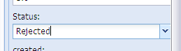

Modeling Features and Use Case in the correct way
In a Chronos Model each ChiFeature that describes a functional requirement must be refined by a Use Case. A feature can realize a non functional requirement like
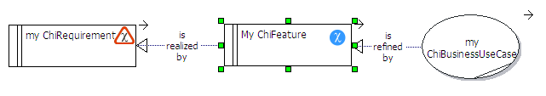Illustration 52: Chronos prescribes that each feature must be realized by an use case apart the non functional ones
A feature that realize a non functional Requirement (types “technical” or “environmental)” can remain without any Use case refinement. This is because a Business use case describes a functional sequence of events Only. A Feature can be refined by more Use Cases on the same time.
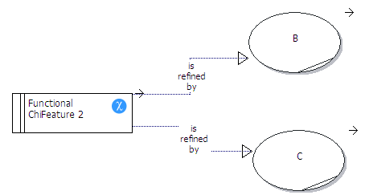Illustration 53: A feature can have multiple realizing use cases
In some cases you can have the impression that a Use Case realizes more that a feature. This is not supported by Chronos Models. Keep in mind that the relationship between a feature and the use case is similar to the one between the overview of a story and the flow of the story itself.
By having 2 different overview you implicitly affirm that two stories exist, not one.
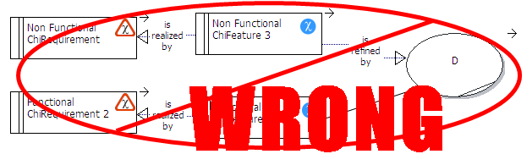Illustration 54: a Use case cannot realize two different features
The diagram below is a possible work around but is NOT suggested.
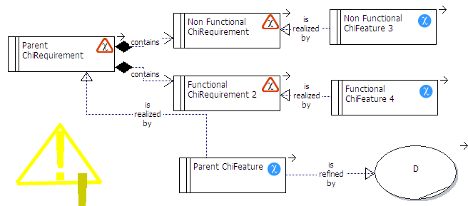Illustration 55: while a requirement can have both a requirement and a feature as children this is not suggested.

The functional and non functional requirements are both parent of a ChiRequirement that has a feature that is directly linked. The refining Use Case in this case is covering all 3 ChiFeatures.
This is possible but is not suggested.
The parent ChiFeature realize as abstract requirement, meaning that also the use case risks to be not concrete enough.

Typically the cause of the situation explained above is that you have too many Features and to few Use Cases. In a good model the level of abstraction should be higher in the top model types.
If the analysis shows that a use case covers 2 features means that it describes two different portion of business. In this case would be better to split the Use Case in two.
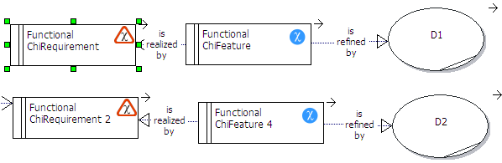Illustration 56: two use cases are created that belong to the same process

the Analysis sub model
In this section you will learn how to create the Analysis sub model.

Use cases
A Functional feature describes which reaction the business has to a requirement. A use case specified HOW this is working.

Modeling the actors
The scope of this section is to develop an Actor model using Chi Actors
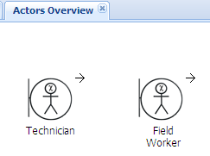Illustration 57: ChiExternalWorkers are one of six different types of Chronos actors
- Model the system's actors using the provided actor package:
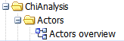
- The Chronos Meta-model defines special type of actors. Answer the following questions to help you find them:
    - which external systems or persons will interact with the considered system? “External” means They are ChiBusiness Partners. A business partner can be further specified defining his active or passive role (see below).
e.g. a generic Business Partner is a client of the enterprise.
    - Of those systems or category of person who will take the initiative to contact the considered system? They are ChiBusinessPartnersActive.
e.g. an Active Business partner is the client that place an order in an online system.
    - Of those systems or category of person who wait for communication from the considered system? They are ChiBusinessPartnersPassive.
e.g. a Passive Business Partner is a weather forecast System that offer a public API
    - In a similar way list of the internal users and systems that will interact with the considered one. They are ChiWorkers.
e.g. a generic Worker is an employee of the enterprise that will use the considered system.
    - Between the Workers find out who has access from or to the outside. Model those as ChiWorkersExternals.
E.g. a field sale worker that need mobile access to the enterprise.
    - Finally model workers that have no direct connection with the outside as ChiWorkerInternal.
E.g. a SAP System from which the considered system get master Data.

Finding candidates for Use Cases
Story-telling is an important activity tat we all learned as children. ask the subject matter expert to tell the “story”. Now divide the story in the his sub parts. Write a list of them: they are the candidates for the use cases.
Another way to find use cases is to consider what each actor requires from the system in scope. Answer the following questions to help you find use cases candidates:
  - For each actor you have identified, what are the tasks in which the system would be involved?
  - Does the actor need to be informed about certain occurrences in the system?
  - Will the actor need to inform the system about sudden external changes?
  - What information must be modified or created in the system?
Independently how you decide to find the candidates follow those rules.
The Use case SHOULD have a name composed a Verb and an Object.
The Use case name CAN contains also the name of the primary actor (see below) but this is not suggested.
- Gather candidates for ChiBusinessUseCases (name only) in a Use case diagram.
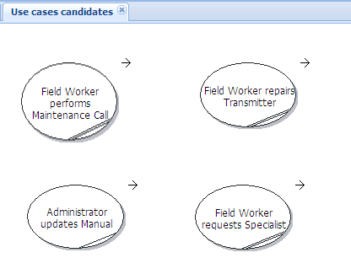Illustration 58: Use case diagram with candidates. The use case name contains the primary actor.

From candidates to final Use cases
- In the previous step you define a list of use cases candidates. This can be very long. This is a good moment to perform a new Use case point analysis (see #3.2.Estimating Projects efforts with Chronos and Use Cases point analysis) to calculate the actual cost. With this information you can decide which ones will be really implemented.
- Share the list and the estimation with business and decision makers.
- They should change the status of the UC to be implemented from “proposed” to “approved“. You can move the rest to another package.
- Transform a “Use cases candidate” in a final ChiBusinessUseCase by linking actors and describing relationships (e.g. with ChiFeatures). See also the paragraph “Modeling Features and Use Case in the correct way” above
See example diagram below:
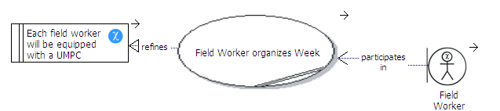Illustration 59: Chain of Feature and Use Case with a linked external worker
See hierarchy:
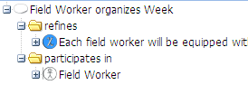Illustration 60: Hierarchy of Use Case, Feature and Actor
- Polish the ChiBusinessUseCase adding a description in “Notes”. This is done by writing in a pointed list of the required steps to achieve the “main success scenario”. Detail the flow of events. All "whats" should be answered. Remember that test designers will use this text to identify test cases.

Scenarios
- In a very complex Use case note think about writing a paragraph call “INTRODUCTION”. (notice the subtitle special formatting capital bold and underline).
- In very complex use cases you can decides to add scenarios in form of alternative logical ends or set of data. A scenario captures one specific path through his use case. Each complex use case typically could have from a few to several dozen scenarios of interest. This is also important for creating the test cases.
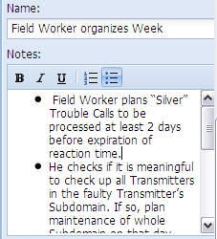Illustration 61: a scenario describing a field sale business process
- Refine the actors’ model adding a description to their identity (the name). You can achieve it by filling the Notes field with a detailed description text.
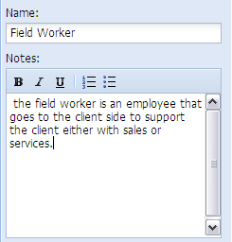
Illustration 62: an actor description is necessary to understand how implement this role
- Create a new Use case diagram for each use case named “<<Use Case name>> Use case Diagram”
- Place the Primary actor to the left and the other actors to the right of the Use case.
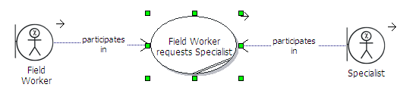Illustration 63: as a graphic convention the primary actor is placed to the left

Completing the Use case
Finish the ChiBusinessUseCase by filling all the remaining properties:
- Use the “Scope” field to describe the business system where this use case is executed. Examples of business systems are “ERP” or “CRM” or subsystems like “Billing”. Basically each use case should be executed in one system only. In case of multiple systems divide them with a comma: the use case will require having multiple implementing ChiControllers (see below).
- The “GoalInContext” field should implicitly express the actor's intent or purpose of the use case.
- Fill the “MainSuccessScenario” field with the Status that your Use case intent to achieve. this is the normal, error-free scenarios in which the system functions as expected.

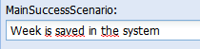
- Fill now the “Extensions” field. Extensions are additional statuses that the the system would achieve. This include any Business exception. Separate multiple Extensions with a semicolon “;”
- the “trigger” field in the use case is the actual action that starts the sequence.
- The “Level” field is a comma separated list of involved Business Object and their CRUD access.
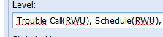

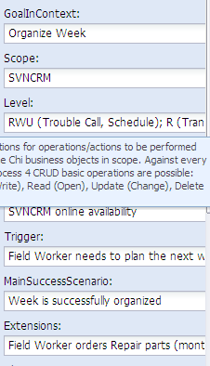
Illustration 64: fields of the use case
- Now organize the ChiBusinessUseCases under ChiBusinessProcesses
  - Drag the Use case and Drop it in the corresponding Process.
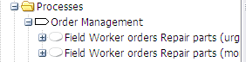
Illustration 65: Use cases can be organized in ChiBusinessProcesses, that are special kind of packages.
- Review the ChiBusinessUseCase in the business processes: decides which one are eventually ChiBusinessUseCaseCore. Within a ChiBusinessProcess you SHOULD define the “most important” Use case as ChiUseCaseCore.
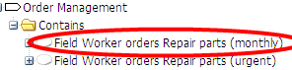
- Refine the actors model specifying the interaction between the consider system and the externals one as base for required interfaces.
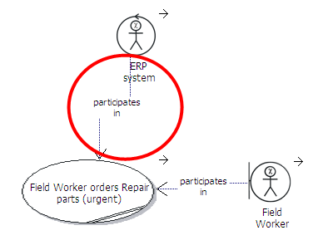Illustration 66: 2 actors participating in an UC
- Refine the Actors model specifying the interaction between human user and the considered system as base for the authorization and right system.

The Use Case's activity
An activity diagram is a visual illustration of the flow of events. It describes graphically each step that is required after the trigger until the achievement of the main success scenario or the alternatives end of the Use case. In the activity you manage instances (ChiObject) of Classes (ChiNodes). E.g.”Car” is a ChiNode while “my Ferrari Testarossa” is a ChiObject.
In each step you can:
- Create, Read, Update Destroy a ChiObject
- get or set attributes of ChiObject
- get or set the parents or the children of the actual ChiObject.

- Create Activity Diagrams for each use Case.
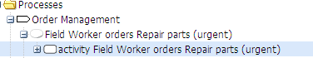
Illustration 67: Activity diagrams are visualized with a special symbol and stored within the Use Case
- Create a diagram with an activity step for each point in the Use cases description pointed list.
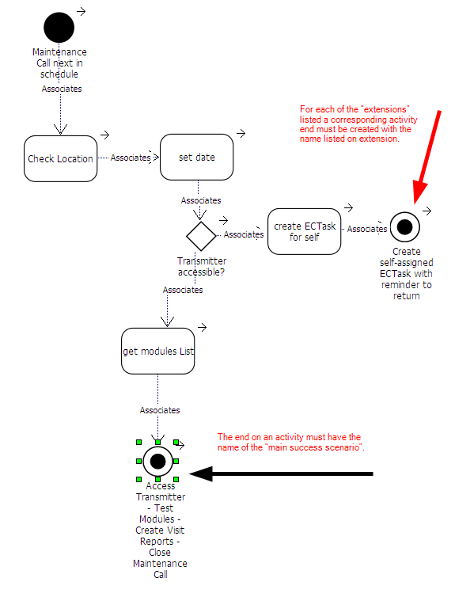Illustration 68: Example of Use case activity
- The name of the “activity Initial” object must be equal to the “trigger” field in the use case.
- The name of the activity end on an activity must have the name of the “main success scenario”. For each of the “extensions” listed a corresponding activity end must be created with the name listed on extension.
- Consider which Concepts are needed in an activity. Describes them as ChiObjects candidates (identity only).
- Add statuses to Objects.
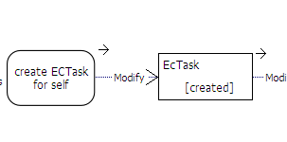Illustration 69: a ChiObject with a "created" status
- (optional) gather all the object candidates in a single Object Catalog package
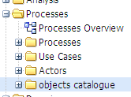
- (if required) Consolidate the Objects by deleting the non necessary ones.

Modeling loops
While modeling activities is very probable that you will face the necessity to iterate an action over a list. This is expressed as loop.

- A loop is modeled by evaluating within a uml::Condition the remaining elements in a list.
- First you need an activity that feed the list
- To this activity a ChiObject is attached with the status “List”
- An activity follows that evaluate the list itself
- A condition with 2 exist Yes No is attached
- The 2 association that comes from the uml:condition element MUST have the names: “LoopStart” and “LoopContinue” .
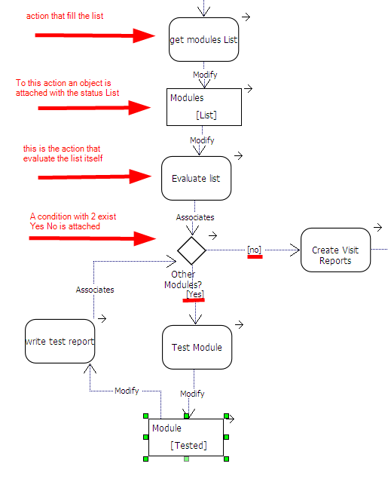Illustration 70: Example of a loop

Use case Check List
Use the following list of questions to help you complete the job of modeling system behavior.
- Have you found all of the use cases? Those you have found must be able to perform all system behaviors. If they don't, some use cases are missing.
- Do the use cases meet all of the functional ChiRequirements? If you have intentionally left any requirements to be dealt with in the object models, such as non-functional requirements, you must mention this somewhere.
- Does the use-case model contain any superfluous behavior? Does it present more functions than were called for in the requirements? Each use case must be attached to a feature that is connected to a requirement.
- Have you found all of the actors? Have you accounted for and modeled all of the roles in the system's environment? You can't be sure until you have found and described all of the use cases.
- Is each actor involved with at least one use case? Remove any actors not mentioned in the use-case descriptions, or any actors without communicates associations with a use case. Note that an actor mentioned in a use-case description is likely to have a communicates association with that particular use case.
- Can you name at least two concrete people or systems who would be able to perform as a particular actor? If not, check the role the actor models. If it's part of another role, merge the actor with another actor.
- Are there actors playing similar roles in relation to the system? If so, merge them into a single actor. Or create a hierarchy of them.
- Will a particular actor use the system in several different ways or does the actor have several different purposes for using the use case? If so, you should probably have more than one actor.

Modeling services
- In a Chronos Model it is possible to model an activity that automatically generate a service (for example a WSDL or a XSD definition).
- the Import and export parameters MUST be modeled as ChiObjects, instances of ChiNode that inherits from type Container.
- The request is linked to the first activity in the ActivitySet. The convention is: <USECASENAME>Request
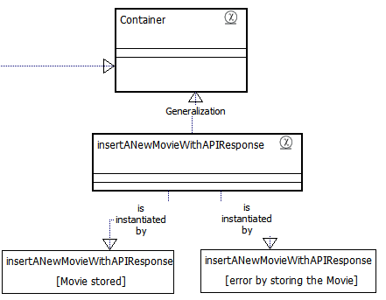
Illustration 71: each Request or Response ChiObject must be an instance of a ChiNode that inherits from the class Container.
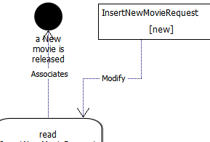
Illustration 72: A Request ChiObject transports the import parameters for the service
- Export Params MUST be modeled as ChiObjects linked to the last activity in the ActivitySet. The convention is: <USECASENAME>Response
- The final ActivitySet should looks like the diagram below
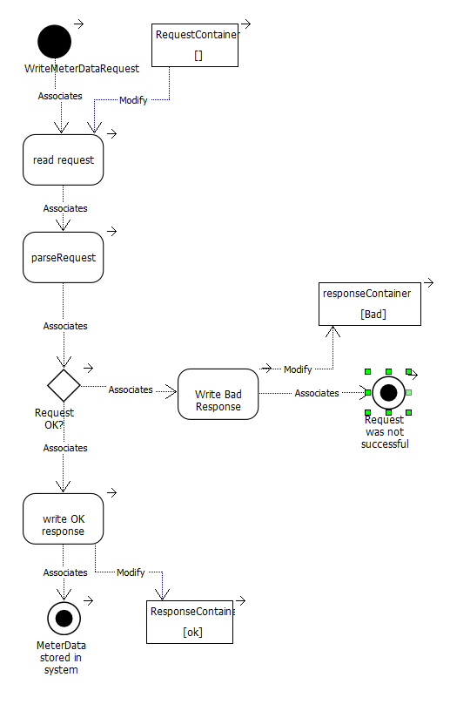Illustration 73: a finished activity diagram. It includes a start, Request and response containers, a decision main success scenario and an extension.

The Domain sub model
The scope of this sub model is to host the identified business domains that is required to instantiate the analysis model.

Introduction: Model View Controller
The Chronos Meta model uses a p[articular interpretation of the Model View Controller (MVC) as an approach to conceptual model domain knowledge. The MVC pattern is a widely used approach for describe concepts separating functionality among objects as to minimize the degree of coupling between them. To achieve this, the pattern divides the domain into three layers: Model, View, and Controller.

Chronos expand this pattern to use it outside from a technological environment so that an abstract domain can describe from a business point of view.
Each layer handles specific tasks and has responsibilities to the other layers:
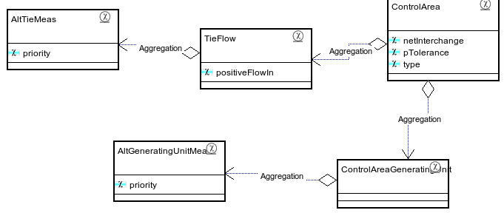
Illustration 74: CIM domain objects as ChiNodes

- The ChiNode (Model) represents domain objects, the “nouns”. In the SID standard model, classes like ControlArea or TieFlow are ChiNodes. It describes the identity, property of the BO. Operations, apart common object manipulation (CRUD), are included only if they govern exclusively the access and modification of the considered ChiNode .
- The ChiController (controller) represent the action of your domain, the verb.
It defines application behavior and the Business Logic that involve more that one ChiNode. It dispatches requests and selects views for presentation. It interprets user inputs and maps them into actions. A ChiController that is has the visibility set as “public” exposes a service to external system (for a detailed specification check out the Chronos documentation http://olympos.svn.sourceforge.net/viewvc/olympos/trunk/olympos/Chronos/Metamodel/chiProfileDoc.doc)
- The ChiView (view) represent the visible context, the page where the “sentences” are displayed. It displays the contents of a Model and the results of Controllers operations. Any kind of visualization can be modeled as a view.
It gets data from the model and specifies how that data should be presented. It updates data presentation when the model changes. A view also forwards user input to a controller. A view cannot execute business logic apart syntactical validation.

Create the domain model
- This section describes how to create the Domain Sub model
- Browse to the Domain Model package
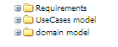
- Create a package structure composed by
Universal company URI, project specific definition , Business Process, use case Name
for example:
org.olympos.filmology
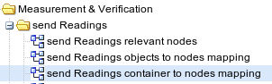
Illustration 75: required Diagrams in the Use case package.
- For each use case package you should create 3 diagrams:
  - Relevant Nodes to display the relevant ChiNodes (see #2.2.1.2.Relevant nodes)
  - Object to Node: to map the ChiObject to the ChiNode (see #2.2.1.6.Mapping)
  - Container to Node: to link relevant ChiNodes with the Request and Response Containers.

Mapping ChiObjects to ChiNodes
In a previous section you created Activities containing ChiObjects. Scope of this section is to link each of them with a ChiNode.
- Create a new diagram call “Mapping object to node ” (see also 2.2.1.6 Mapping)

Using the default model
- Browse the industry model Library
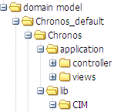Illustration 76: the CIM lib in the default model
- Consult the list of existing CIM classes.
- Link a ChiNode from CIM library with every ChiObject in the Use Cases ActivitySet diagram.
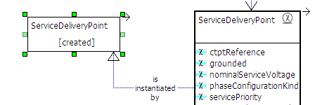
Illustration 77: example of instantiating a ChiNode from CIM library with a ChiObject
- In alternative you could create a new specific ChiNode for every UML::ChiObject that you have identified in activities. This should be done in conjunction with an architect.
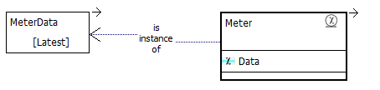
Illustration 78: a new meter ChiNode is created to support the instance of the ChiObject
- See below an example of class inheritance hierarchy
- (if a new ChiNode was required) check if is possible to add library inheritance. In case the new object is a logical extension of the library. Most CIM objects inherits from IdentifiedObject that is already connected to Node in the standard model
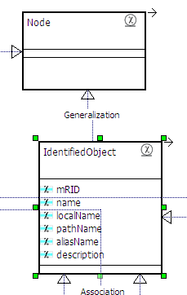Illustration 79: IdentifiedObject Inheritance from Node

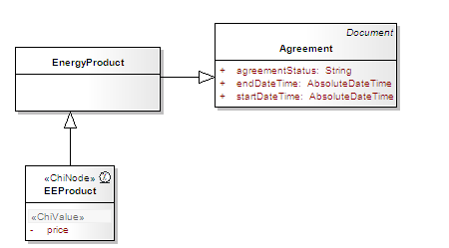
Illustration 80: In this example EEproducts extend the CIM class EnergyProduct to add the property "price"
- (if a new ChiNode was required,) that is unrelated to CIM it SHOULD inherits from org.olympos.energy.common.core.EntityBase
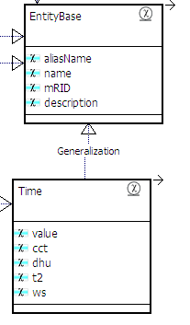
Illustration 81: EntityBase contains the same properties as the CIM class IdentifiedObject. Must be the super Class of all the new created ChioNode within a Energy & Utility project.
- (if a new ChiNode was required, see above) Consult the list of existing chiNode to establish relationships.
- (if a new ChiNode was required, see above) Model ChiNodes class's properties as ChiValues
- set the fields of the chiValue. See table below:

Tagged value | Meaning | Values | Default value
app_data_type | The attribute's application datatype. This can be used in the application to group attributes and execute special logic on them. | 0 | DATATYPE_ATTRIBUTE
db_data_type | The atribute's database type. This will be used in the table definition. | according to the database  e.g. INT, VARCHAR, TEXT, ... | VARCHAR(255)
is_editable | Declares, if the attribute is editable. | false | true
input_type | Definition of the attribute's input control in the HTML form. | text, password, textarea, select, radio, checkbox, file, fileex, fckeditor, filebrowser, linkbrowser, date  + additional definitions | text
display_type | The HTML display type for the attribute e.g. image. | 0 | text
restrictions_match | Regular expression, which must be matched by the attribute value. | e.g. [1-2][0-9][0-9][0-9] for years
restrictions_not_match | Regular expression, which must not be matched by the attribute value. | e.g. [a-z] for years
restrictions_description | A text describing the restrictions, which will be shown in case of an error. | e.g. “please insert a year in YYYY format”
column_name | The name of the database column. If not given the attribute name will be used. |  | attribute name
Table 3: fields of a chiValue

- Most Chronos generator cartridges support a “convention instead of configuration” pattern. This means that also if you let all those properties to the default a running application will be generated from the model. On the other side, for fine tuning will be necessary to edit most of them.
- (optional) Model ChiNode statuses as UML Enumerations (not supported by CWM 0.9.9.6)
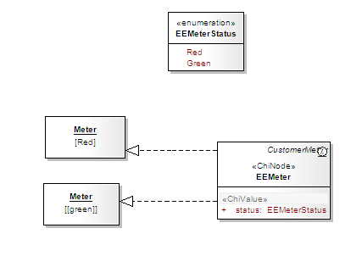
Illustration 82: enumeration are not directly supported by CWM
- Model ChiNodes classes operations: Operations, apart common object manipulation (CRUD), are included only if they govern exclusively the access and modification of the considered ChiNode only .
- Describes the relation between ChiNodes
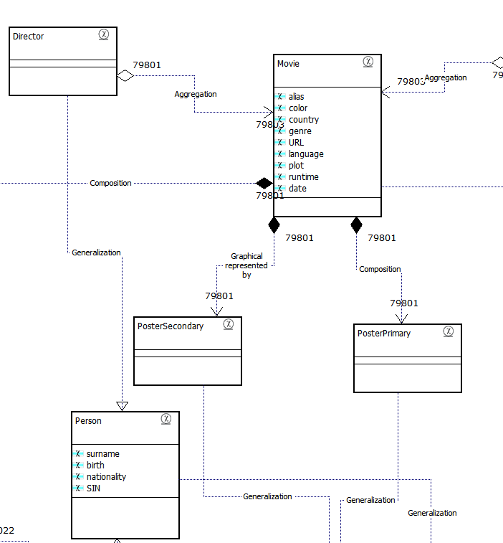
Illustration 83: ChiNodes with different relationships
- set the properties of the nodes
Property | Meaning | Values | Default value
initparams | Name of the configuration file's section, in which the initial parameters for the corresponding mapper are defined |  | database
is_soap | Define if the type should be exposed to the SOAP interface. | true|false | true
orderby | Definition of default sorting. Possible values: 'none' (no order), 'sortkey' (generates a 'sortkey' column, that is used for explicit sorting) or any the name of any ChiValue defined in the node optionally followed by [ASC|DESC] e.g. 'name ASC'" default="none" | none|sortkey|any value | none
is_searchable | Indicates whether this type should be included in the default search. | true|false | true
table_name | The name of the database table. If not given the name of the class will be taken. |  | class name
pk_name | The name of the primary key column. The generator will add this automatically if there is no appropriate attribute. | a single value or '|'- separated list of values (e.g fk_user_id|fk_role_id) | id
child_order | The order of the associated children e.g. for Recipe: Image|Info|AdminInfo. | a single value or '|'- separated list of values
parent_order | The order of the associated parents. | a single value or '|'- separated list of values
display_value | The ChiValue(s) to display in a list. | a single value or '|'- separated list of values
Table 4: fields of ChiNode

- Distribute the ChiNode in packages that reflect the consider domain (see above). A mirrored CIM package structure can be used here as start.
- (Optional) Decide which Domain objects needs to be exposed as services. The domain object that are involved in UC activities are exposed as service.
- Create a new diagram called <USECASENAME> relevant Nodes (see also 2.2.1.2 Relevant nodes )
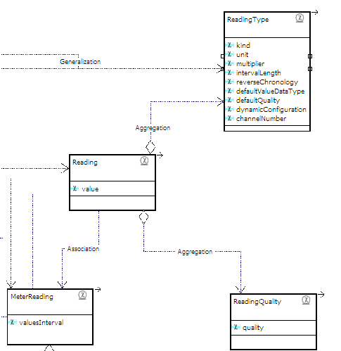
Illustration 84: relevant node diagram example
- (if required) Gather exiting systems, applications, and databases information in a deployment model.
- Plane a deployment model of your servers.
- Gather planned systems, applications, and databases information in a deployment model.

Mapping two ChiNodes
The Chronos Web Modeler supports the mapping of ChiNodes. This is useful in case you need to map between different concepts (E.g. an external and internal system). In the alphaCORE architecture the message broker is responsible for the physical mapping between the internal and the external system.

In the model the mapping is done by linking two ChiValues with each other. By doing this an additional stereotype, call ChiValueRef, is applied to the source ChiValue.

How to Maps Two Domain
- Model the Source Domain.
- Create a Container that hosts the Source Domain (see #2.2.1.2.Relevant nodes).
- Model the Target domain.
- Create a Container that hosts the Target Domain.
- Create a new mapping diagram (see 2.2.1.5 Mapping).
- Drag and drop in the Diagram a class from the Source and one from the target Model in the new created mapping diagram.
- Select an attribute as source, drag the arrow to the target attribute. Your diagram will looks like this:
- In the source Attribute 2 additional tagged values are automatically inserted: reference_type contains the Entity type, whose attribute is referenced; reference_value contains the entity type's referenced attribute.
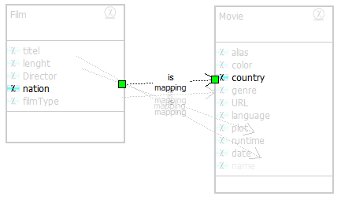
Illustration 85: example of mapping between properties: “nation” is mapped to “country”
- Describe in the diagram “notes” special characteristics of the mapping.
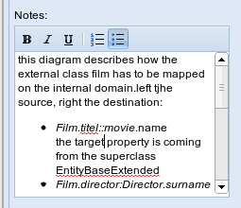

Create the Service model
A service model is a part of the Domain model. Following steps needs to be accomplished:
- Develop common semantic based service payload definition in the form of the UML diagram
- Write model to services transformations in WSDL form.
- Document the service definition artifacts in one document for a given business integration (interface) area
- Develop/Elaborate To-Be service orchestration aggregating existing ChiControllers

Behavioral modeling

The challenge of the behaviour
Since the start of the Model Driven approach, modeling the behavior of a system has been a major challenge.

Structure of the Metamodel
To understand how this is solve in the Chronos Metamodel, let's examine his structure: a ChiRequirement is realizes by a ChiFeature. The ChiFeature is refined by a ChiBusinessUseCase (or ChiBusinessUseCaseCore). The ChiBusinessUseCase (or ChiBusinessUseCaseCore) that contains an ActivitySet and is implemented by a ChiController. Use cases and controllers are behavioral types.
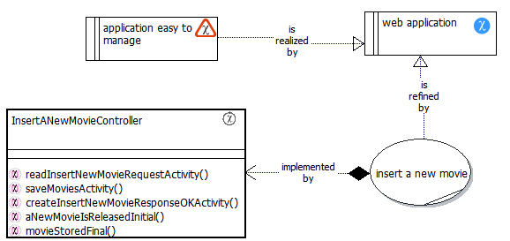
Illustration 86: flow of the implementation from a Requirement up to his Controller
A ChiController hosts one or more Operations where one (or more) ChiNodes are manipulated. It can contain a ChiRule that sub-intends a fork and is the atomic component of behavior.

Attribution to different types of Behaviour
In the domain submodel we divide behaviour in 3 parts:
- External Workflows: a.k.a. Business process, are long, asynchronous activities, executed by multiple actors that typically include gaps in time
- Internal Workflows: ak.a. Business Use Case are shorter, executed by one main actor only.
- Rules: are decision point inside the workflows.

External Workflows
The External workflow is the implementation of a Business process, as a sequence of ChiController linked by an association with the stereotype ChiActionKey. This special class diagram is the way that Chronos uses to describe the implementation of a ChiBusinessProcess, or sequence of Use cases (see below).

Internal Workflow
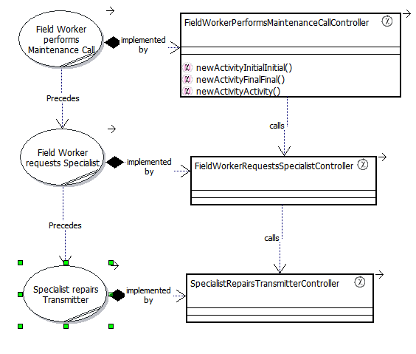
Illustration 87: use cases implemented by controllers
An internal Workflow is a sequence steps with forks points represented by decisions.
the ActivitySet represent the model element.
Illustration 1: ActivitySet for the insert Good Movie Use case
This is translated in the calls' sequence inside a Controller.
See this example in pseudo code
Main(Container insertMovieRequest)
{
Movie myMovie = ReadInsertMovieRequest(insertMovieRequest);
String response = saveMovie( myMovie);
Container InsertNewMovieResponse = createInsertMovieResponse ( response);
}

Rule
The next level is a sequence of rules that are present implemented within the activity.
The atomic rule part is expressed in a single Method within a class. This is modeled as Action with a CallOperation. An Action cannot be further broken down or decomposed.

ChiRequirements Model | ChiAnalysis Model | ChiDomain Model | Java / C#
Package | ChiBusinessProcess | Sequence of ChiControllers | A sequence of Calls defined in a main Controller, BPEL or XML Configuration file .
ChiFeature | ChiBusinessUseCase | ChiController | A Class that extend a Controller Class
ChiFeature | ChiActivity | Operation | Method within the class above
ChiFeature | Text in a ChiBusinessUseCase | Production Rule | IF... THEN in code. Or call to an external rule engine.
Table 5: definition of logic in different stages

Modeling business rules
This part is not yet (CWM 0.9) full implemented in the tool. it is included here for future reference only.
An ChiRule in a Chronos model hosts a place a in which one (or more) ChiNode may be transformed following certain constrains.

Following business rules are partially supported:
- Production Rules

Following business rules are not yet supported:
- Integrity Rules
- Derivation Rules
- Reaction Rules

Definition of ChiRule (a.k.a. PRR)
A Production Rule consist of two parts: a sensory precondition (or "IF" statement) and one or more actions (or "THEN"). The condition evaluated SHOULD be part of a business variable (a property of a business object.
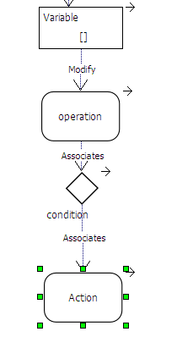
Illustration 88: example of Production rule modeled with activity elements
for example: If the Movie rating is more that 75 THEN save the movie ELSE trow error “only good Movies are allowed”

Production Rule Limits
Production Rules DON’T support AND – OR operators.
One or more Production rules can be embedded in a RuleSet.

modeling controllers walk trough
- In the appropriate package based on Universal company URI, project specific definition , Business Process, use case Name. for example: org.olympos.filmologycreate a new diagram

- Right click on a Use case.
- Select “Generate Controller” a new controller is generated that refines the Use case
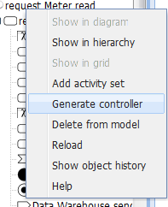
Illustration 89: the Use case context menu offers a generate controller feature
- Draw the original Use case and the Controller on the diagram
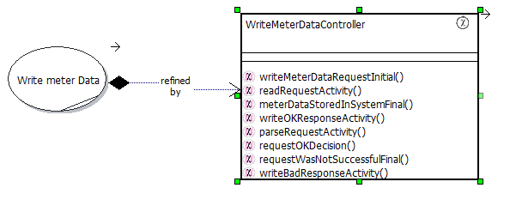
Illustration 90: Use Case refined by a ChiController
- Move the generated controller with drag and drop in an appropriate package (see above)
- Set the controller “visibility” field as Public
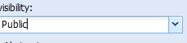
- (If necessary) change the names of the Operation in the new ChiController
- NOTE: Before you change the Controller information check if would be possible to remodel the parent Use case and regenerate the Children ChiController.

Additional Tools
This chapter covers the use of the Model browser, the Document generator and the Code generator.

The Model Browser
The Model browser is you ally in determination the next steps model's completion.
It starts automatically when you login in CWM, displaying the last report you generated. This is cached and don't reflect the last changes, so you can decide to regenerate the report. Depending from the power of your server and the dimension of the model this can require some time. CWM supports the generation of reports using chron jobs. Ask your administrator if this function is available on your installation.
The first information you should check out regards the “most recently edited objects” list. This notify you over modification in the model.
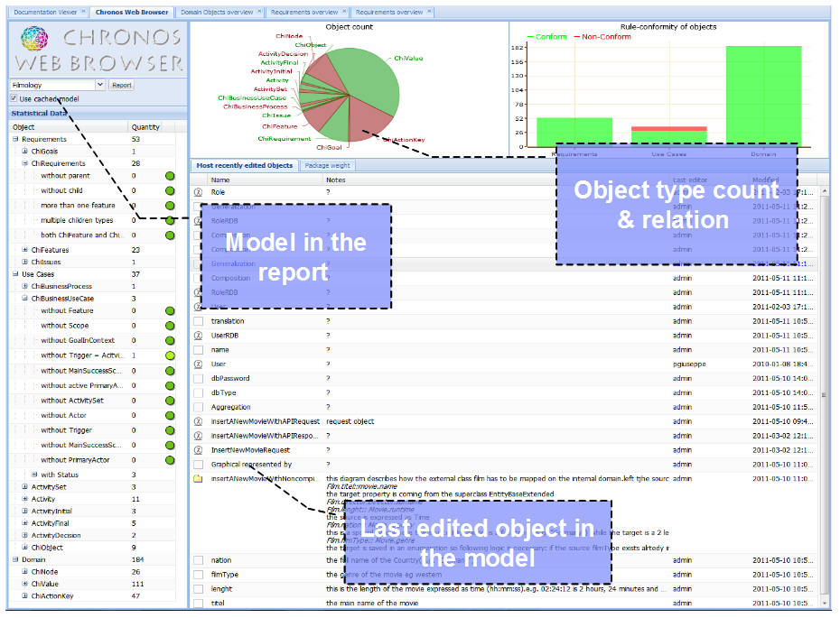
Illustration 91: example of a good model report, most of the checks are green
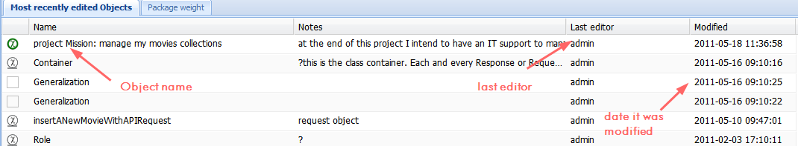
Illustration 92: most recently edited objects” list with the standard information. You can customize it as needed.

Customizing lists
The list can be customized by clicking on the small arrow near the heading. A list of all the available fields will appear.
Notice that certain columns are relevant for special types of objects. For example GoalType is a field for goals only. For the remaining objects will be empty. By clicking on any element in a list the “”model Tree” opens for editing.
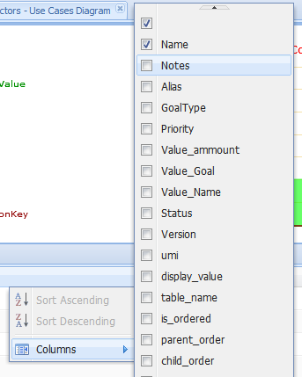
Illustration 93: customization of the list's field
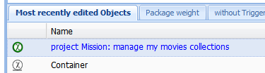Illustration 94: by clicking on a element on the most recently edited objects open in his location on the tree.
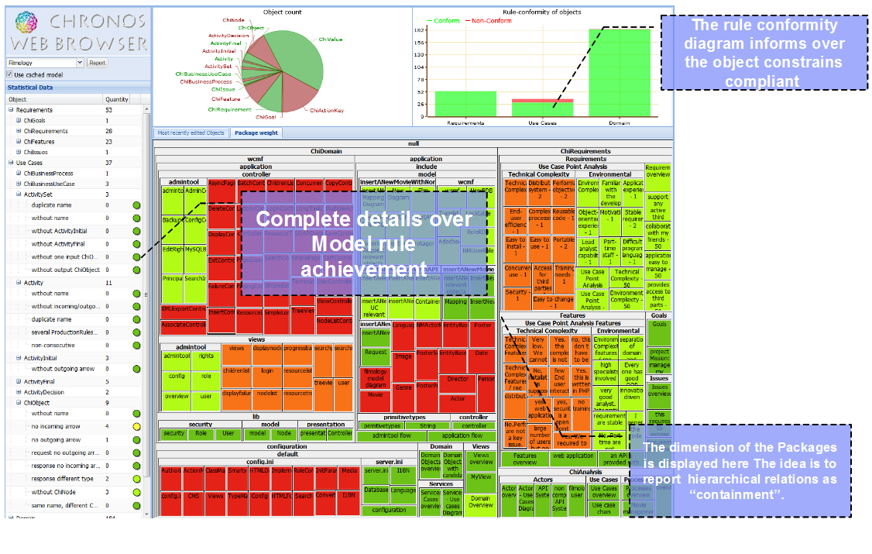Illustration 95: Web Browser: the package distribution in this screen shot reflect that too many elements are in to few packages. this is an hint for restructuring your model
The rule conformity diagram give an overview over the all object constrains compliant, organized in the 3 sub models. By navigating over the red part you get the amount of rules that are actually violated over the total
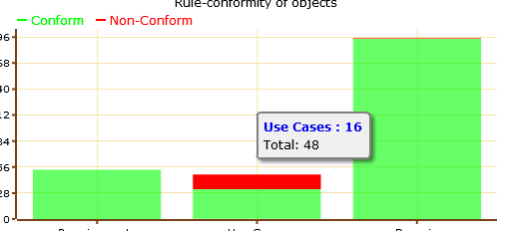
Illustration 96: In this example Use Case sub model a total of 48 objects exists of which 16 are not rule conform.
Complete details over Model rule achievement is listed to the left in the “statistical Data”.
The checks are again organized in the 3 Chronos sub models but then in the associated objects (see #10.Appendix 1: List of Model Checks ).
Within the objects the list of checked rules. By clicking on a Rule a new tab open displaying the relevant objects.
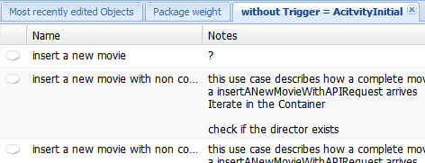
Illustration 97: in this example 3 use cases don't have an ActivityIntial with a name equals to the trigger
The dimension of the Packages is displayed in the package weight tab. With larges models this requires some time to load. The idea is to report hierarchical relations as “containment”.

The document's generator
CWM integrates a powerful document generator that permits to creates Microsoft Word, OpenOffice and PDF files based on templates.

How to generate a document
To generate a document:
- Click on any package
- select “export documentation”
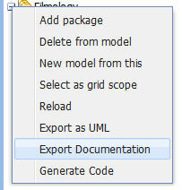
- a list of the installed templates appear:
- the document format can be selected in this screen.
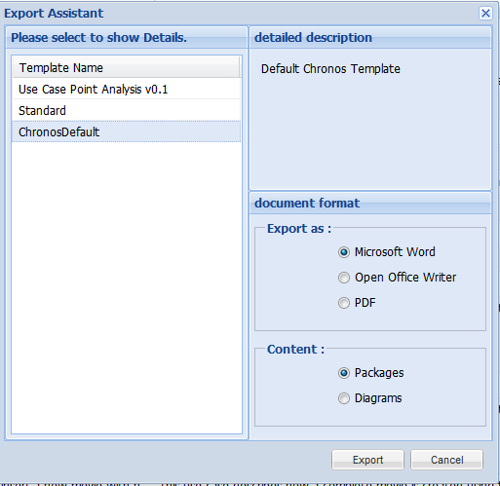
Illustration 98: the list of available templates can be expanded for your project needs.
- See below for the use of “content”.
- If your project require a certain document, with layout, projecproofreadert logo, etc you will need to create a new template. This requires some programming. See the “HelloWorld_DocumentGeneration” in the “additional reading” appendix for more information.

Diagram as virtual packages
- Normally all package's and children elements are exported in the documentation. This is useful to generate a complete sub model
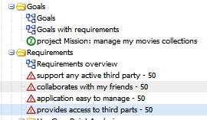Illustration 99: by exporting the documentation starting from package "Goals" only the elements in this package will be present in the document.
- In some case a certain collection of elements need to be documented that are distributed trough multiple packages. CWM supports “virtual packages” to accomplish this.
- By selecting the in content option “diagrams” you can generate a document with all the elements in a certain diagram also in there are hosted by parallel packages.
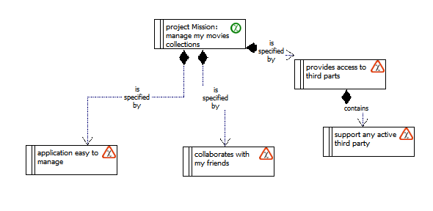
Illustration 100: the diagram "Goals with requirements" shows requirements from another package. If the option "diagrams" has been selected the documentation will include those elements
- In this way, you can build a very flexible documentation. Notice that if you export a package where an element is phisically present and the is also shown in a diagram this will exported two times.
- The best way to use this functionality is to create a separate structure of packages containing diagrams only.

Use case documentation
CWM provide a convenient way to generate use case documentation. By selecting a use case element in the tree right click you get a special “export Documentation”:
in the resulting document contains Use Case Description, Objects instantiated, Object to Node mapping, Request & Response Containers, Participating Domain Classes, Use Case Scenario & Hierarchy.
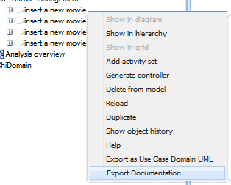
Illustration 101: the Use case element has a special menu for exporting the documentation

The code generator
CWM has very mighty generation features: It is able to connect directly with a component called chiGEN (Chronos Generator) which supports several transformations (cartridges).
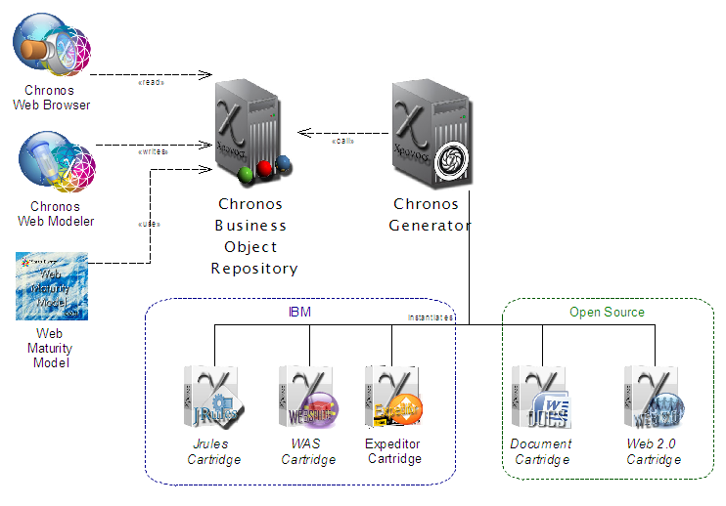Illustration 102: Architecture of a CWM installation. CWM is a front end for the Chronos BOR that calls the generator. This can execute a certain transformation
The generator is in fact a completely independent program. In alternative to use it embedded in the CWM, you can export a valid UML model, created with any tool and pass it to the generator offline. This is the suggested way in a large scale project.
A complete documentation about the cartridges is available separately (see #2.Additional reading).

Appendix 1: List of Model Checks
In this section all the constrains are listed that the CWB checks.

Requirements
- ChiObject has no associated type
- A goal Must have a child requirement or goal
- a goal cannot have both requirement or goal as children
- A goal must have a priority
- A goal must have a Value that’s of integer type
- Every goal with a requirement must be realized by a feature.
- A requirement must have a parent (goal or requirement)
- A requirement must have at least one Child (Feature Issue or requirement)
- A requirement can have a feature Child only
- a requirement cannot have both a feature and an issue as a children
- a feature must have a parent requirement
- a feature with the status implemented must have a children use case
- an issue must have a parent requirement

Chi Analysis
A ChiBusinessProcess must have at least a Uce case within

Use Case
- a ChiBusinessUseCase Must have a feature
- a ChiBusinessUseCase should have a Scope
- a ChiBusinessUseCase should have a GoalInContext
- a ChiBusinessUseCase MUST have a Trigger
- a ChiBusinessUseCase MUST have a MainSuccessScenario
- a ChiBusinessUseCase MUST have a PrimaryActor

Activity
- ActivitySet must have globally unique name
- ActivitySet must have a non-empty name
- ActivitySet must have exactly one ActivityInitial
- ActivitySet must have at least one ActivityFinal
- AcitivtySet must have exactly one Input ChiObject
- AcitivtySet must have at least one Output ChiObject
- AcitivtySet must have at least one Output ChiObject
- Activity must have a non-empty name
- Activity must have at least one incoming and one outgoing arrow
- Activity must have a unique name within its ActivitySet
- Activity must have at least one incoming and one outgoing arrow
- Activity must have at most one ProductionRuleSet
- ActivityIntial must have at least one outgoing arrow
- ActivityIntial must have the same name as the “trigger” field in the corresponding use case
- ActivityFinal must have at least one incoming arrow
- at least one ActivityFinal must have the same name as the “main success scenario” field in the corresponding use case
- All Activites associated with the same ProductionRuleSet must be consecutive
- ActivityDecision must have a non-empty name
- ActivityDecision must have a unique name within its ActivitySet
- ActivityDecision must have at least one incoming and two outgoing arrows
- All arrows exiting from an ActivityDecision must have unique names
- ActivityDecision must have at most one ProductionRuleSet
- An ActivityDecision with no ProductionRuleSet must be preceded by an Activity
- All ActivityDecision associated with the same ProductionRuleSet must be consecutive
- At most one ActivityDecision may be associated with the same ProductionRuleSet
- Loop type ActivityDecision must have at least one incoming LoopContinue and exactly one outgoing LoopStart arrow
- Loop type ActivityDecision must have the following predecessors: Activity('get list') -> ChiObject('list') -> Activity('evaluate list') -> ActivityDecision
- Loop type ActivityDecision must have the following successors: ActivityDecision -> Activity('get list element') -> ChiObject('list element')
- Loop type ActivityDecision must be in same ProductionRuleSet as its required predecessors and successors: Activity('get list') -> ChiObject('list') -> Activity('evaluate list') -> ActivityDecision -> Activity('get list element')
- ChiObject must have a non-empty name
- ChiObject must have a unique name within its ActivitySet
- ChiObject must have at least one outgoing arrow
- ChiObject must have at least one incoming arrow
- Input ChiObject must have at least one outgoing arrow
- Output ChiObject must have at least one incoming arrow
- All Output ChiObjects must be of the same type
- ChiObject has no associated type

Domain
- ChiNode must inherit from Node superclass
- ChiController must inherit from Controller superclass
- ChiNode must have a name
- ChiNode.orderby must be "none", "sortkey" or an attribute name
- ChiNode.initparams must be the name of a ChiSystem class
- ChiNode attributes must not have the name "type", "state", "oid", "value", "none" or "sortkey"
- ChiValueRef.reference_type must be the name of a ChiNode class
- ChiValueRe.reference_value must be an attribute name in the referenced ChiNode class
- ChiActionKey.config must not be empty
- ChiValue must have a name
- ChiValue must have a valid name

Appendix 2: Keywords and Graphic conventions

Keywords
Keyword with a special meaning.
Word with italic are used
words with underline are required and are checked by the generator.
Words between "()" are aliases or previous keywords

Use cases
- retrieve: the considered system starts an active data request to a passive external system
- query: the considered system passively offers a response for external systems to query data from the System.
- Send: the considered system receives external data and persist them.
- Create: the considered system get a request to create certain data. Those are created, persisted and send back.

Activities
- create: create a domain object in the memory. If parameters are present a new object is created with those parameters. if not present an empty object is created.
- store: Store a domain object persistently.
- read (get): Read a domain object from a variable (e.g. a Container)
- load: Load a certain domain object from the persistence.
- destroy: delete a certain domain object
- iterate (evaluate) : start a loop (see #4.3.1.1.Modeling loops )over a list
- Invoke: execute a certain action.
- this: the domain object in context
- [RS???]: (at the end of the name): Linked to the RuleSet given by the number, e. g. [RS1] or [RS123]

Decisions
- LoopStart: required by a Loop, outgoing arrow pointing to the first Activity in the loop
- LoopContinue: required by a Loop, incoming arrow pointing from the last Activity in each thread in the loop back to the loop Decision
- [RS???]: (at the end of the name): Linked to the RuleSet given by the number, e. g. [RS1] or [RS123]

ChiObjects
- <USECASENAME>Request: Name of the container with import paramenter
- <USECASENAME>Response: Name of the container with export paramenter
- list: a collection of elements, in alternative use name[] to indicate a list.
- <ChiObjectName>.<ChiValueInstanceName>: reference to the instance of a property.

chiObject Statuses
- created
- stored
- ok
- error

Graphic conventions
- The Primary actor should be placed to the left and the other actors to the right of the Use case.

Formatting convention
- Sub titles: Capital, bold and under lines
- Actors: underline
- Use Cases: Italic
- ChiNodes: Bold

Appendix: 4 Additional reading

Tool | Description | Role
Chronos Doc Package | This mind map that can be run in a browser provide a hierarchical view of all the documents listed below organized by role. | ALL
chiGEN Xtend API | JavaDoc style documentation of all the Xtend methods and classes used by the ChiGen. | Architects,  IT specialists
CWM API | JavaDoc style documentation of all the PHP methods and classes used by the Chronos Business Object Repository. | IT specialists
Metamodel | UML class model of the Chronos Profile. | Architects,  IT specialists
PIM Model | UML Class model of the CWM application | Architects
PSM Model | This document in UML format describes the tooling and generators from an architectural point of view using a subset of the UMF | Architects,  IT specialists
wCMF API | this is the documentation of the PHP framework used by the CWM | IT specialists
Draw2D | Documentation of this framework
extJS API 3.0 | Documentation of this framework | IT specialists
CWE API | The Chronos Web Editor API. CWE is a framework for creating rich Internet Application in Java script format. | IT specialists
Chronos Business Object Repository | This document introduce how to administrate the Chronos Business Repository. | Admins,  IT specialists
Chronos Business Manual | this comprehensive manual presents the Chronos system and lead the user step by step in the creation of a valid model. | Business Analysts
What do I need to know about Chronos. | This documents contains frequent asked questions about the Chronos methodology, the Chronos Web Modeler (CWM), the Chronos Generator chiGEN and their use. | ALL
Rational tools and Chronos | This document present the difference between the standard Rational Tools and the Chronos offer . This is addressed to go-to market and managers. | Proj. Manager, Go-to-market
alphaCORE: model Driven utility | This article describes a model-based approach for utilities creating IT smart grid solutions based on computation independent definition CIM. This means that the definition of the solution is keepen separated from the implementation. It illustrates how do we speed up the development and bring agile enterprises flexibility in handling and usage. This approach has a positive effect on the price and time of solution development cycle of customized Smart Grid application. | Proj. Manager, Go-to-market, Architects
Building_Chronos_Web_Modeller | This document describes how to build the Chronos Web Tools from source. | Architects, It Specialist
Building And Running Code generators | This document leads through the steps of: checking out the subversion repository, setting up the Eclipse Tooling, building the chiGEN, running a cartridge with test models (headless), running the cartridge from CWM | IT specialist
Chronos Web Modeller Installation | This document helps to configure and install the Chronos Web Tools, including the Chronos Web Modeller and the Chronos web Browser. It is addressed to system administrators. | Admins
HelloWorld_CWM | This document lead to the creation of a simple web application without writing a single line of code. The application is completely defined in UML and is generated using a Model Driven approach. | IT specialists, Business analysts
HelloWorld_generator.odt | This document lead to the creation of a simple cartridge for the Chronos generator. | IT specialists
HelloWorld_DocumentGeneration.odt: | This document explains how to create a document template for the Chronos document generator. A document template can host any formatting and information coming from the model. | IT specialists,
Chronos Generator, features list | this spreadsheet contains a list chiGEN of features. | Proj. Manager, Go-to-market, Architects
Chronos Programming Guide.odt: | This document describes best practices for programming new cartridges for the chiGEN. | Architects, Businesses Analysts
Chronos Asset Report | this presentation aims to document the Chronos assets in terms of scope, functionality, applicability, completion, documentation and level of work effort to get to an asset that reusable by other IBMers | Proj. Manager, Go-to-market, Architects
CartridgeDocumentation.odt: | This document contains the documentation for each Chronos cartridge. It includes: cartridge's purpose, how to run a cartridge from CWM, how to run a cartridge from command line. | IT specialists, Architects
CWM_VS_restOfTheWorld_RequirementToolComparison.xls | This Excel file contains one tab that consolidates thirty-four responses to the Requirements Management survey as of August 8, 2010 with an extra tab to define the features of the CWM. | Proj. Manager, Go-to-market, Architects
Chronos Profile specification | This document explain in details the components of the Chronos Metamodel in form of an UML profile | IT specialists. Architects, Business Analysts
Ouranos Profile Specification | This document explain in details the components of the Ouranos Metamodel in form of an UML profile. Its explain especially its links and differences to the Chronos Metamodel above. | IT specialists. Architects, Business Analysts
Dionysos Programming Guide.odt: | This document explains how to create Dionysos client applications. | IT specialists
Dionysos JSON Interface Specification | This document describes the Specification  of a client working with a specific server  called Aphrodites | IT specialists. Architects
Aphodites Specification | This document describes the requirements for a Aphrodites framework to be used with a of a Chronos Model within a Model Driven Software Development | Architects, IT specialists,
White paper CWM | Reusable ontologies are becoming increasingly important for tasks such standardization bodies that use knowledge-base development. IBM has realized a set of tools and a methodology to support the process of achieving consensus on common shared ontology by geographically distributed groups. These tools make use of the world-wide web to enable wide access and provide users with the ability to publish, browse, create, and edit models stored on an server. In this paper we present shortly some features of the both methodology and tools. | Proj. Manager, Go-to-market, Architects, Business Analysts
Methodik Workshop Deutsch.odp | This presentation in German language should be use to introduce the concepts of Chronos to German modeler and/or business consultants | Business Analysts
Energy & Utilities made easy with Chronos | This presentation introduce the use of Chronos in the context of the E&U industry. It is addressed to industry consultant and decision makers | Business Analysts, Proj. Managers
Chronos introduction for Managers | this presentation introduces Chronos from the corresponding role. It contains all the slides produced during the project that matter for this role. | Business Analysts, Proj. Managers
Chronos: introduction for Programmers | this presentation introduces Chronos from the corresponding role. It contains all the slides produced during the project that matter for this role. | IT specialists
Chronos Introduction for Programmierer | this German presentation introduce the methodology and tooling approach for technical oriented people. | IT specialists, Architects
Chronos: introduction for Architects: | this presentation introduces Chronos from the corresponding role. It contains all the slides produced during the project that matter for this role. | Architects
Wenn Das Business „laufen Lernt: | this high level presentation in German language introduces Olympos for managers with a special focus on the “mobile” aspect. | Business Analysts, Proj. Managers
Chronos: Use Case Point Estimation | this presentation introduces the Use Case Point analysis for estimating effort | Business Analysts, Proj. Managers
Chronos: Integration mit Jrules | This presentation in mix German and English introduces to the (unfinished ) work for supporting rule engines trough JRules. | IT specialists, Architects
- Contents
Table of Contents
Some suppositions about the reader 8
How this book is organized 8
How to read it 8
About MDE 8
the Chronos methodology 9
About the Chi Metamodel 10
About the name “Chronos” 11
Introducing the Chronos Web Modeler 11
Models and Meta-models 12
About diagrams 12
Diagrams types in a Chronos Model 13
Work diagram 13
Relevant nodes 13
Package Overview 13
Chain Inheritance 14
Deep View 16
Mapping 16
The “seven” rule 16
Traceability 17
CWM Special Fields and Features 17
difference between "Author" and “Creator”. 17
Rich text area 18
Status types and management 19
Chronos Stereotypes and relationships overview 22
Sequence of use 24
walk-trough the Chronos stereotypes 25
Before the project start 29
Creating a Request for Proposal 29
Introduction 29
RfP: walk-trough 29
working with the Response to Proposal 30
Introduction to estimation 30
How Use Case estimation works 30
Use Cases Complexity Definition 31
Actors complexity definition 31
Technical factor complexity definition 31
Environmental Factor complexity definition 32
Use Case point Analysis Walk trough 32
Estimating the Functional requirements 32
Estimating the Non-functional and environmental requirements 33
Generating a UCPA spread sheet 35
UCPA estimated tasks 36
UCPA Conclusion 36
Starting a project by selecting a model 37
Structure 37
The Chronos Default model 37
Configuring the model 38
creating ChiGoals 39
Creating ChiRequirements 43
Creating ChiFeatures 43
Modeling the Requirements and Feature in the correct way 44
Manage Issues 46
Modeling Features and Use Case in the correct way 47
the Analysis sub model 50
Use cases 50
Modeling the actors 50
Finding candidates for Use Cases 51
From candidates to final Use cases 52
Scenarios 53
Completing the Use case 54
The Use Case's activity 56
Modeling loops 58
Use case Check List 59
Modeling services 60
Introduction: Model View Controller 63
Create the domain model 64
Mapping ChiObjects to ChiNodes 64
Using the alphaCORE default model 65
Mapping two ChiNodes 71
How to Maps Two Domain 71
Create the Service model 72
Chronos and Logic 73
External Workflows 73
Internal Workflow 74
Rule 74
Modeling business rules 75
Definition of ChiRule (PRR) 75
Production Rule Limits 76
modeling controllers walk trough 76
The Model Browser 78
Customizing lists 79
The document's generator 81
How to generate a document 81
Diagram as virtual packages 82
Use case documentation 83
The code generator 84
Requirements 86
Chi Analysis 86
Use Case 86
Activity 87
Domain 88
Keywords 89
Use cases 89
Activities 89
Decisions 89
ChiObjects 90
chiObject Statuses 90
Graphic conventions 90
Formatting convention 90

- Illustration Index
- Illustration 1: in a MDE system all the knowledge in his complexity is stored in a special kind of ontology: the UML model. The artifacts, including code and documents, are generated from a model. 15
- Illustration 2: Today most IT projects suffers of poor understanding between different roles 16
- Illustration 3: Diagrams are views over dir complexity 18
- Illustration 4: Example of relevant nodes diagram 19
- Illustration 5: Package overview example 20
- Illustration 6: CWM menu for creating a Package overview 20
- Illustration 7: Chain Inheritance diagram example 20
- Illustration 8: Show in Hierarchy menu 21
- Illustration 9: Show in Hierarchy example 21
- Illustration 10: example of the seven rule 22
- Illustration 11: the object history allow to trace every single change that was performed on a model element. 23
- Illustration 12: author and creator fields compared 24
- Illustration 13: a list of stati provided in the Chronos Default Model 25
- Illustration 14: transition workflow between stati 26
- Illustration 15: a version umber is added if a released object is changed. 27
- Illustration 16: Stereotypes and relationships for the Requirement and Analysis model 28
- Illustration 17: Stereotypes and relationships Domain Model 29
- Illustration 18: this goal is specified by 3 different ChiRequirements 31
- Illustration 19: elements of the Requirement sub model 31
- Illustration 20: two use cases refining the same Feature 31
- Illustration 21: Example of a Process for movie management containing two Use cases 32
- Illustration 22: Activity of the "insert new movie" Use case 32
- Illustration 23: the ChiController that implement the Use case has operations that correspond to the UC's the activity elements. 32
- Illustration 24: a ChiObject instantiated by a ChiNode 33
- Illustration 25: Example of requirement model 37
- Illustration 26: a standard list of Non functional requirements and their weight is available in the default model. 38
- Illustration 27: Standard technical factors are included in the default Model 38
- Illustration 28: requirements for the UCPA must be of type "Technical" or "Environmental" 38
- Illustration 29: environmental factor tab of the Use case point generated documentation 39
- Illustration 30: the Use Case Point Analysis document template 39
- Illustration 31: sum up tab of the Use case point generated documentation 40
- Illustration 32: the "model upload tab" in the "admin" perspective allows to import a valid Chronos model 41
- Illustration 33: components of the Energy Template Model for alphaCORE 42
- Illustration 34: the structure of the alphaCORE template model is given by the Chronos organization. 42
- Illustration 35: ChiRequirements packages within the requirement model 43
- Illustration 36: ChiFeatures packages within the requirement model 43
- Illustration 37 The analysis model contains the e-energy, maturity model, open smart grid and smart home use cases 43
- Illustration 38: position of the CIM 13 ontology 44
- Illustration 39: location of the e-energy domain objects 44
- Illustration 40: A goal of type vision is an abstract inner representational of the project scopes. 45
- Illustration 41: a Goal of type Mission is the project slogan, how the Vision is communicated to the outside 45
- Illustration 42: in this example of goal value the actual effectiveness in % the actual level of 20 should be increased by 5 % 46
- Illustration 43: a Hierarchy of goals. the top element of it must be the Vision 46
- Illustration 44: a UMTS connection is a valid feature that cover the requirement of connecting mobile workers 47
- Illustration 45: to create scenarios use the requirements type field 48
- Illustration 46: In this example A and B are alternative scenarios. But we seek a way to realize botth feature in any case. 48
- Illustration 47: In this diagram a Requirement is relized by two different features. This is not allowed by the Metamodel. 49
- Illustration 48: A ChiRequirement has a ChiFeature only. A ChiFeature can satisfy multiple requirements 49
- Illustration 49: In this diagram the feature BB is realized in both scenarios A and B 50
- Illustration 50: a requirement with two feature attached cannot become true 50
- Illustration 51: each Issue must have an author and a responsible 50
- Illustration 52: Chronos prescribes that each feature must be realized by an use case apart the non functional ones 51
- Illustration 53: A feature can have multiple realizing use cases 51
- Illustration 54: a Use case cannot realize two different features 52
- Illustration 55: while a requirement can have both a requirement and a feature as children this is not suggested. 52
- Illustration 56: two use cases are created that belong to the same process 52
- Illustration 57: ChiExternalWorkers are one of six different types of Chronos actors 53
- Illustration 58: Use case diagram with candidates. The use case name contains the primary actor. 55
- Illustration 59: Chain of Feature and Use Case with a linked external worker 55
- Illustration 60: Hierarchy of Use Case, Feature and Actor 56
- Illustration 61: a scenario describing a field sale business process 56
- Illustration 62: an actor description is necessary to understand how implement this role 57
- Illustration 63: as a graphic convention the primary actor is placed to the left 57
- Illustration 64: fields of the use case 58
- Illustration 65: Use cases can be organized in ChiBusinessProcesses, that are special kind of packages. 59
- Illustration 66: 2 actors participating in an UC 59
- Illustration 67: Activity diagrams are visualized with a special symbol and stored within the Use Case 60
- Illustration 68: Example of Use case activity 60
- Illustration 69: a ChiObject with a "created" status 61
- Illustration 70: Example of a loop 62
- Illustration 71: each Request or Response ChiObject must be an instance of a ChiNode that inherits from the class Container. 63
- Illustration 72: A Request ChiObject transports the import parameters for the service 64
- Illustration 73: a finished activity diagram. It include a start, Request and response containers, a decision main success scenario and an extension. 64
- Illustration 74: CIM domain objects as ChiNodes 65
- Illustration 75: required Diagrams in the Use case package. 66
- Illustration 76: the CIM lib in the default model 67
- Illustration 77: example of instantiating a ChiNode from CIM library with a ChiObject 67
- Illustration 78: a new meter ChiNode is created to support the instance of the ChiObject 67
- Illustration 79: IdentifiedObject Inheritance from Node 68
- Illustration 80: In this example EEproducts extend the CIM class EnergyProduct to add the property "price" 68
- Illustration 81: EntityBase contains the same properties as the CIM class IdentifiedObject. Must be the super Class of all the new created ChioNode within a Energy & Utility project. 69
- Illustration 82: enumeration are not directly supported by CWM 70
- Illustration 83: ChiNodes with different relatioships 71
- Illustration 84: relevant node diagram example 73
- Illustration 85: example of mapping between properties: “nation” is mapped to “country” 74
- Illustration 86: flow of the implementation from a Requirement up to his Controller 75
- Illustration 87: use cases implemented by controllers 76
- Illustration 88: example of Production rule modeled with activity elements 78
- Illustration 89: the Use case context menu offers a generate controller feature 79
- Illustration 90: Use Case refined by a ChiController 79
- Illustration 91: example of a good model report, most of the checks are green 80
- Illustration 92: most recently edited objects” list with the standard information. You can customize it as needed. 81
- Illustration 93: customization of the list's field 81
- Illustration 94: by clicking on a element on the most recently edited objects open in his location on the tree. 81
- Illustration 95: Web Browser: the package distribution in this screen shot reflect that too many elements are in to few packages. this is an hint for restructuring your model 82
- Illustration 96: In this example Use Case sub model a total of 48 objects exists of which 16 are not rule conform. 82
- Illustration 97: in this example 3 use cases don't have an ActivityIntial with a name equals to the trigger 83
- Illustration 98: the list of available templates can be expanded for your project needs. 83
- Illustration 99: by exporting the documentation starting from package "Goals" only the elements in this package will be present in the document. 84
- Illustration 100: the diagram "Goals with requirements" shows requirements from another package. If the option "diagrams" has been selected the documentation will include those elements 85
- Illustration 101: the Use case element has a special menu for exporting the documentation 85
- Illustration 102: Architecture of a CWM installation. CWM is a front end for the Chronos BOR that call the generator. This can execute a certain transformation 86

Appedix 5: Glossary
Term | Definition
Analysis sub model | Part of the Chronos model containing the Use cases.
BOR | Business Object Repository
Cartridge | A set of workflows, constrains, M2M and M2T transformation that can be run by the ChiGen.
Chi | the Greek letter  (see http://en.wikipedia.org/wiki/Chi_(letter) initial of the name Chronos (Χρόνος). See Chronos
Chi Metamodel | Also Chronos Metamodel. A collection of UML stereotypes and their relationship.
ChiController | A UML class that describes a certain behavior.
ChiGEN | The Chronos Generator. this is a Java program that runs Cartridges for M2M or M2T. It can be executed with or without the CWM.
ChiGoal | A goal is a desirable (and measurable!) status.
ChiNode | A UML class with some additional properties describing the Domain objects. It describes a certain structure.
ChiObject | An instance of a ChiNode
ChiRequirement | A requirement is a condition that can be true or false.
Chronos | In Greek mythology Chronos was the father of Zeus. Name of the Metamodel and the related methodology.
ChronosBusinessUseCases | a short story, a step by step descriptions how a feature works.
CIM | Common Information Model
Container | A special class that transports domain objects in an use case.
CWB | Chronos Web Browser a web tool that shows the actual completition status of a Chronos Model.
CWM | Chronos Web Modeler, a program in the cloud for the creation of Chronos UML models
Domain sub model | Part of the Chronos model containing the Requirements.
E&U | Energy and utilities. The industry where Chronos was extensively applied.
Features | A Feature is a fact that set his requirement to true
Goal | A desirable (and measurable!) status
Issues | A fact that set the Requirement to false.
IT | Information technology
M2M | Model to Model. A transformation of a Model in another model. For example an XML model can be transformed in a UML model. Or a plan UML model can be enhanced with the stereotypes of Chronos.
M2T | Model to Text. A transformation where a Model is transformed to Text. For example a Chronos Model can be transformed in a Java Class, in a HTML file or in a Word Document.
MDE | Model Driven Enterprise. A conception where all the knowledge is hosted in a model.
NfR | Non functional Requirements
PRR | Production Rule Representation
Requirement | A Requirement is a condition that can be true or false.
Requirements sub model | Part of the Chronos model containing the Requirements.
RfP | Request for Proposal
stereotype | An additional information that can be applied to any UML classifier adding additional information.
UC | Use case. A part of a process.
UCPA | Use Case Point Analysis. A way to forecast project's effort using a collection of Use Cases.
UML | Unified Markup Language. A language that describe how to create valid models
Table 6: Glossary

see https://secure.wikimedia.org/wikipedia/en/wiki/Profile_%28UML%29 for information about profiles
See also http://www-128.ibm.com/developerworks/rational/library/2870.html
The interpretation of the display_type is done by DefaultValueRenderer or its subclasses.

