Error: Reference source not found

Error: Reference source not found

Author: Giuseppe Platania

Customer: IBM

Document History
Document Location
This is a snapshot of an on-line document. Paper copies are valid only on the day they are printed. Refer to the author if you are in any doubt about the currency of this document.
The source of the document will be found in /tmp/lo/0000.doc
Revision History
Date of this revision: | Date of next revision (date)

Revision Number | Revision Date | Summary of Changes | Changes marked
0.1 | 10/03/08 | Created | (N)
0.2
0.3 | 14/04/08
0.4 | 13/10/08 | review
Approvals
This document requires following approvals. Signed approval forms are filed in the Quality section of the PCB.
Name | Title
(name) | (title)
Distribution
This document has been distributed to
Name | Title
(name) | (title)

Table of Contents
1. Licence 6
2. Introduction 7
2.1 Goal 7
2.1.1 Differences with Chronos. 8
3. Implementation 9
3.1 Language 9
3.2 Validation 9
4. Parts of Ouranos 10
4.1.1 Discovery Strategy 10
4.2 Static structural View 10
4.3 Dynamic behavior View 12
4.3.1 Definition of Method 12
4.3.1.1 Integrity Rules 12
4.3.1.2 Derivation Rules 12
4.3.1.3 Production Rules 13
4.3.1.4 Reaction Rules 13

Contents

Licence
this document is under the Creative Commons Attribution 3.0 United States License
You are free:
* to copy, distribute, display, and perform the work
* to make derivative works

Under the following conditions:
Attribution. You must give the original author credit.
* For any reuse or distribution, you must make clear to others the licence terms of this work.
* Any of these conditions can be waived if you get permission from the copyright holder.
* Nothing in this license impairs or restricts the author's moral rights.

Note:
Parts of this work are based on material that is under the LGPL license.

Introduction
Ouranos is a metametamodel (M3) that aims to describe metamodels (M2) instantiating abstractions of any possible programming language.
From Ouranos you can describes specific language Metamodel that are able to instantiates a model representation of a specific language.

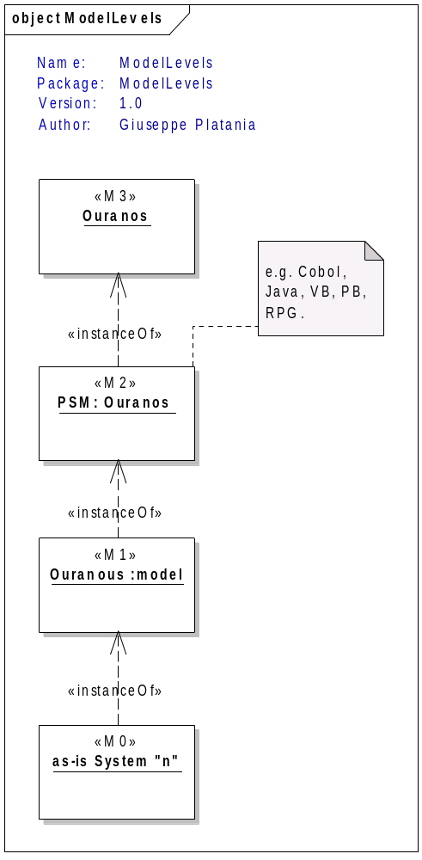Illustration 1: Hierarchy of Models

Goal
Goal of Ouranos is the description of any possible programming language within the model space.
This includes the Static structural view that “Emphasizes the static structure of the system using objects, attributes and relationships”
and
the Dynamic behavior view “Emphasizes the dynamic behavior of the system by showing collaborations among objects (e.g. Workflows), operations that executes a logic [based on conditions] (e.g. Methods with return) and changes to the internal states of objects (e.g. void Methods).”
Typically Ouranos models support the mapping of procedural code inside a Object oriented definition.
This include the fact that the basic concept of Object Oriented thinking can be not explicit expressed inside the physical representation (the code).
The Ouranos metamodel serves to map the existing concepts and make assumptions abouth the missing ones.

Differences with Chronos.
Ouranos and Chronos are part of the Olympos family.
While the first aims to support the description of Discovery activities the second is targeted to Modeling and transforming activities.
The scope of Chronos is to describe the whole enterprise. Chronos can be the target PIM of a Ouranos PSM.

Implementation

Language
Ouranos can be implemented with any Metamodel system. The actual implementation is based on eCore Metamodel. Those models may easily be serialized in (and from) any XML dialect that include RDF.

Validation
The validation consistency of Ouranos Metamodel is profen with oAW Check, which describes a formal language that can be used to define model constraints in terms of predicate logic.

Transformation
The Xtend language is used for:
• Reducing Complexity by transforming a language specific Instance of a Ouranous Model in his abstract representation.
• Reducing Complexity by porting a M2 instance to a M3 instance (inverse of the above).
• Extraction of Semantic information
• Modularization and Reuse

Structure of Ouranos
Ouranos is divided in a Static structural and in a Dynamic behaviors view that are complementary. They are described in detail below.

Static structural View

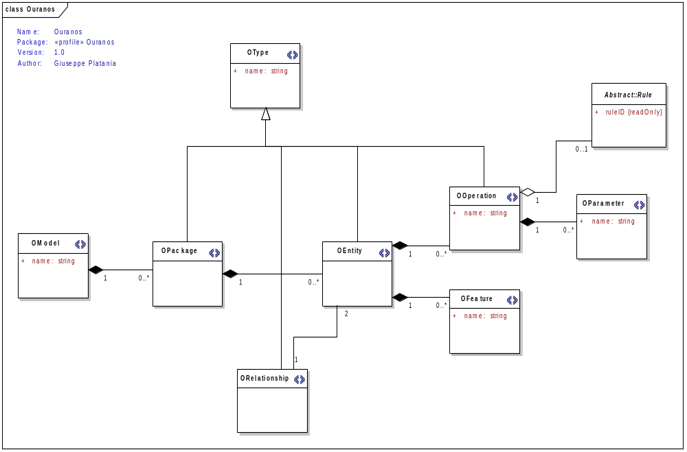
An OModel contains Opackages or Oentities. An entity is composed by OOperations and OFeatures.
An Operation can contains (shared aggregation) a Rule (see below).

OEntity
description

Attribute

Check to be performed:

Example:
Code example
Discovery strategy:

OFeature
description

Attribute
name

Check to be performed:

Example:
Code example
Discovery strategy:

OModel
description

Attribute
name

Check to be performed:

Example:
Code example
Discovery strategy:

OOperation
description

Attribute
name

Check to be performed:

Example:
Code example
Discovery strategy:

OPackage
description

Attribute

Check to be performed:

Example:
Code example
Discovery strategy:

OParameter
description

Attribute
name

Check to be performed:

Example:
Code example
Discovery strategy:

ORelationship
description

Attribute

Check to be performed:

Example:
Code example
Discovery strategy:

OType
description

Attribute
name

Check to be performed:

Example:
Code example
Discovery strategy:

Dynamic behavior View
The dynamic behaviours description of Ouranos is based on the work of the REWERSE group.
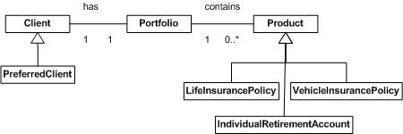
The basic Idea is to hold in a separate model a set of rules that references a Vocabulary (UML representation).
Illustration 2: UML vocabulary example with a Domain description

Definition of OOperation
An OOperation represents a condition in which one (or more) OEntity is modified. It can contain a Rule.
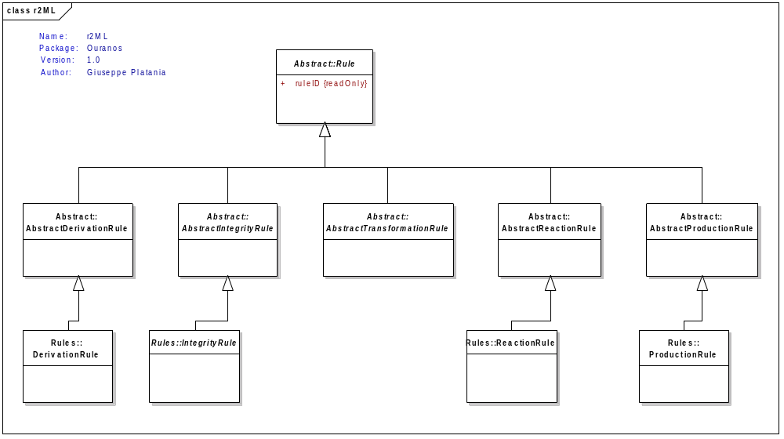
      - Integrity Rules
It specialize into two kind of constraints r2ml:AlethicIntegrityRule and r2ml:DeonthicIntegrityRule.
Note: constraint must not contain any free variable.
The UML Metamodel is:
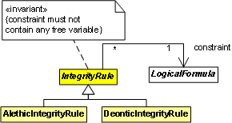

      - Derivation Rules

Any derivation rule consists from a condition part and a conclusion part.
In R2ML the conditions of a derivation rule are r2ml:qf.AndOrNafNegFormula.
Conclusions are restricted to quantifier-free disjunctive normal forms without NAF.
The UML metamodel is:
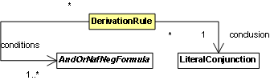
      - Production Rules
Represents a production rule. Any production rule has a condition part a produced action expression part and an optional r2ml:postcondition.
The UML metamodel is:
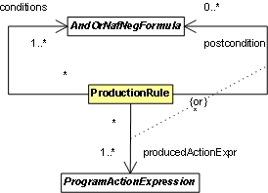
      - Reaction Rules
The R2ML model of a reaction rule (ECA rule) consists in a rule triggering an event expression a condition part a produced action expression part and an optional r2ml:postcondition. Both action expression and postcondition have the same meaning as in ProductionRule.
The UML metamodel is:
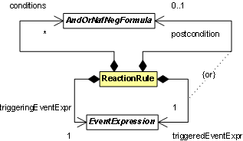

Ouranos in the daily life

Discovery Strategy
The following picture describes the general approach in a modernization project using Ouranos and Chronos.
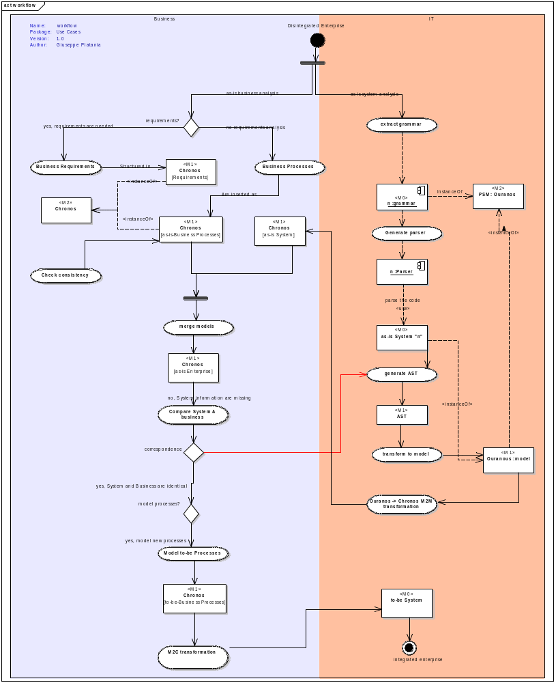

- Grammar is extracted as Ouranos M2 Model.
- a parsed is generated from the grammar
- the parser creates the AST files.
- First step is to create model with oEntities by identify they Identity (name)
- The second step is to identify oFeatures (properties). This is done by data tracing that is expected to produce the output described in the above section.
- OEntity with Ofeatures are the base for the vocabulary.
- At this stage a PIM (Platform Independent Business Model) is built.
- ARC generates the R2ML serialization of UServ Business Rules, which includes the rules together with their vocabularies.
- Next step is to use the R2ML-to-JBossRules translator and R2ML-to-Jena translator in order to obtain JBoss Rules translation, respectively Jena rules implementation.
- Finally we use JBoss Rules and JenaRules executional platforms to execute the obtained UServ business rules.

References
- Chronos
http://olympos.sf.net
- ORMF
http://www.eclipse.org/proposals/ormf/
- Jazz
http://www.jazz.net
- OOSE
http://www.eclipse.org/proposals/osee/
- Telelogic Doors
http://www.embeddedplus.com/EmbPlusDoorKeeperEclipse.php
- CaliberRM
http://www.borland.com/de/products/caliber/rm.html
- The AtlantEcore zoo
http://www.eclipse.org/gmt/am3/zoos/atlantEcoreZoo/
- RIF Core
http://www.w3.org/TR/rif-core/
- SysML
http://www.sysml.org/
- Eclipse MDT
http://www.eclipse.org/modeling/mdt/?project=uml2
- SysML
http://www.sysml.org
- TOPCASED
http://www.topcased.org
- KM3
http://wiki.eclipse.org/index.php/KM3
- Eclipse TMF (Xtext)‏
http://www.eclipse.org/proposals/tmf/
- Eclipse GMF
http://www.eclipse.org/gmf/
- oAW Check Integration
http://apps.itemis.de/roller/itemislabkiel/entry/evalidator_
- EMF Validation Framework
http://www.eclipse.org/modeling/emf/?project=validation
- OCL
http://www.eclipse.org/modeling/mdt/?project=ocl#ocl
- Generating an EMF Model using XML Schema (XSD)
http://help.eclipse.org/help33/index.jsp?topic=/org.eclipse.emf.doc/tutorials/xlibmod/xlibmod.html
- Eclipse M2M
http://www.eclipse.org/m2m/
- ATL
http://www.eclipse.org/m2m/atl/
- Xtend
http://www.eclipse.org/gmt/oaw/doc/4.2/html/contents/core_reference.html
- Fujaba
http://ag-schaefer.upb.de/Lehre/PG/Fujaba/publications/main.html
- SmartQVT
http://smartqvt.elibel.tm.fr/

