Building and Running chiGEN
setting up the development for the chronos Generator

Table of Contents
ABSTRACT 4
Building and Running Codegenerators 5
Preparation 5
Chronos Codegenerators 5
Running Codegenerators from CWM 7
Preconditions 7
Create Link to your Repository 7
Configure CWM 7
Start and Use CWM 7

Document Informations
Author: | Thomas Schuetz
Version: | 0.9.9.5
Created: | 11/02/11
Source | The actual version of this document can be found under:
http://wcmf.svn.sourceforge.net/viewvc/wcmf/trunk/olympos/chronos/docs

History
date | author | changes
11/02/11 | Thomas Schuetz | Created
05/03/11 | Giuseppe Platania | Review consolidation
20/01/16 | Giuseppe Platania | Update for Windows

ABSTRACT
This document leads through the steps of: - checking out the subversion repository - setting up the Eclipse Tooling - building the chiGEN - running a cartridge with testmodels (headless) - running the cartridge from CWM

License
The code of the CWT and the accompanying materials are made available under the terms of the Eclipse Public License v1.0 which accompanies this distribution, and is available at http://www.eclipse.org/legal/epl-v10.html.

The concept of Chronos is made available under the Creative Common license.
You are free:
* to Share — to copy, distribute and transmit the work
* to Remix — to adapt the work
Under the following conditions:
* Attribution. You must attribute the work in the manner specified by the author or licensor (but not in any way that suggests that they endorse you or your use of the work).
* For any reuse or distribution, you must make clear to others the license terms of this work. The best way to do this is with a link to this web page.
* Any of the above conditions can be waived if you get permission from the copyright holder.
* Nothing in this license impairs or restricts the author's moral rights.

Building and Running ChiGEN
This process has been written and tested for windows (see also the Ubuntu version of it).

Preparation

Download and unpack OAW 4.3
Download: http://sourceforge.net/projects/olympos/files/Chronos/openArchitectureWare/itemis-oaw-distribution-I20090514-1901-win32-win32-x86.zip/download

Chronos ChiGEN

Setup Eclipse Workspace
- Check out trunk of Olympos Subversion repository (https://olympos.svn.sourceforge.net/svnroot/olympos)
- Create empty Eclipse Workspace
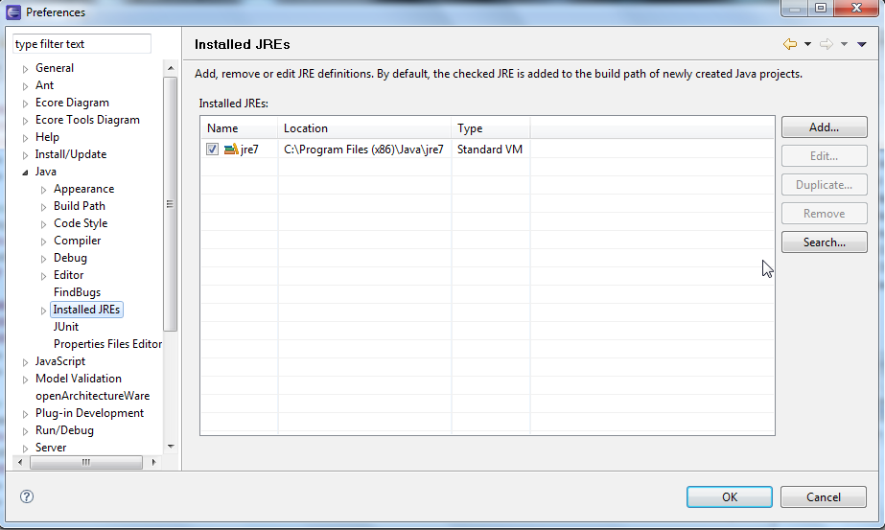
- Add the right Java SDK in Eclipse: Window → Preferences → Java → Installed JREs → Add → Standard VM → directory: e.g. C:\Program Files (x86)\Java\jdk1.8.0_71
Make sure the sdk is checked under Window → Preferences → Java → Installed JREs
- Import Projects into Eclipse Workspace: File → Import → General → Existing Projects into Workspace
  - path: <your checkout path>/olymposSVN/olympos/chronos/scr/workspace/generator
  - In the List Projects, select all projects
  - Attention: Copy projects into workspace has to be deactivated!
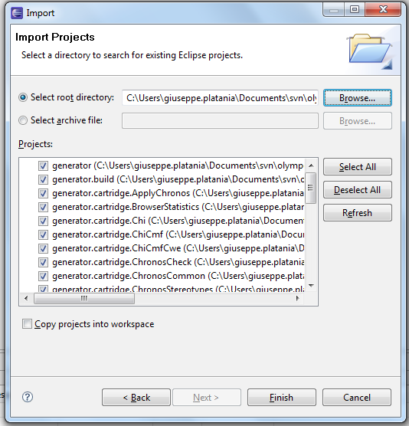
- Check the workspace folder: The only content should be the folder .metadata

Trouble Shooting
- If your XPand files (.xpt) display the escape sequences wrong (Â«IMPORT umlÃ‚Â» instead of «IMPORT uml»)
select Edit → Set Encoding → Other: UTF-8
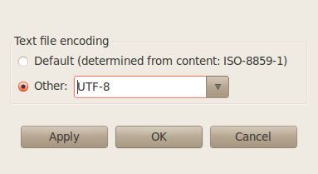
- If you get lots of error markers in Xtend (.ext) and Check (.chk) files (e.g. “Couldn't resolve type for ...”) make sure that you configured the corresponding metamodel: Project → Properties → openArchitectureWare : Select EMF Metamodels and UML2 Profiles.
Important: UML2 Profiles has to be first. If not, you get error messages like “couldn't find operation '+(uml::String)' for type String”.

Build all cartridges
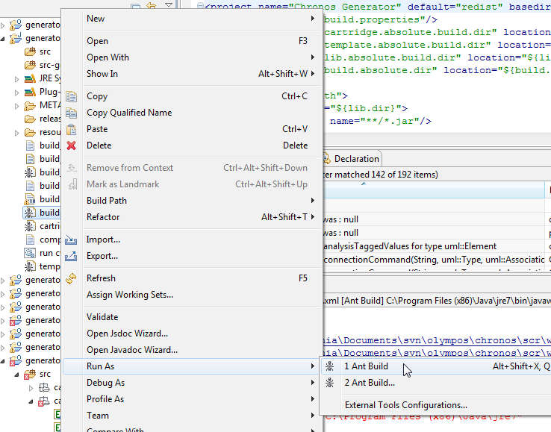
- in the project generator.build
- configure the generator version in the file build properties.
- Run generator.build/build.xml (Right Click → Run as → Ant Build)
- Attention: If two menu items “Ant Build” show up, only one works
- A successful run looks like this:
(...)
redist:
[copy] Copying 107 files to /home/tschuetz/projects/eenergy/development/olymposSVN/trunk/olympos/chronos/scr/workspace/generator/dist/lib
[jar] Building jar: /home/tschuetz/projects/eenergy/development/olymposSVN/trunk/olympos/chronos/scr/workspace/generator/dist/ChronosGenerator.jar
[copy] Copying 21 files to /home/tschuetz/projects/eenergy/development/olymposSVN/trunk/olympos/chronos/scr/workspace/generator/dist
[copy] Copying 321 files to /home/tschuetz/projects/eenergy/development/olymposSVN/trunk/olympos/chronos/scr/workspace/generator/dist/cartridge
[copy] Copying 2 files to /home/tschuetz/projects/eenergy/development/olymposSVN/trunk/olympos/chronos/scr/workspace/generator/dist
[zip] Building zip: /home/tschuetz/projects/eenergy/development/olymposSVN/trunk/olympos/chronos/scr/workspace/generator/ChronosGenerator-0.9.9.3.zip
BUILD SUCCESSFUL
Total time: 10 seconds

a zip file is created under /generator

Run the generators with the testmodels
- The test models are in project testmodels/models/sourcemodels
- scripts to run them are in the testmodels/scripts
- run the scripts in a shell or create a run configuration in Eclipse
- make sure the scripts are executable after checkout (e.g. chmod a+x run_cwm2uml.sh)

Scripts and Models
script | sourcemodel | result
run_cwm2uml.sh | cim14/cwm-export.xml | models/tmp/cwm-export.zip
run_uml2cwm.sh | cim14/cwm-export.uml | models/tmp/cwm-export.xml

Running ChiGEN from CWM

Preconditions
- LAMPP Installation (XAMPP)

Create Link to your Repository
- Open shell as root (sudo su)
- Create symbolic link to the workspace folder of your repository in the htdocs folder of your lampp installation (e.g. /opt/lampp/htdocs):
ln -s <your-repository-path>/trunk/olympos/chronos/scr/workspace ./cwm-olympos-repo
- check the link in the shell: ll
result (with your path):
lrwxrwxrwx 1 root root 90 2011-02-14 09:57 cwm-olympos-repo -> /home/tschuetz/projects/eenergy/development/olymposSVN/trunk/olympos/chronos/scr/workspace/
- restart your lampp installation:
Example:
- /opt/lampp/lampp stop
- /opt/lampp/lampp start

Configure CWM
Configure CWM according to Chronos_Web_Modeller_Installation.pdf

Start and Use CWM
  - Open in Web-Browser: http://localhost/cwm-olympos-repo/gui/ and log in
  - Start Work with CWM

