Cartridge Documentation
description of all cartridges

Table of Contents
ABSTRACT 4
Introduction 5
Data flow for Cartridges 5
Metamodels 5
Cartridges 6

Document Informations
Author: | Thomas Schuetz
Version: | 0.9.9.5
Created: | 08/03/11
Source | The actual version of this document can be found under:
http://wcmf.svn.sourceforge.net/viewvc/wcmf/trunk/olympos/chronos/docs

History
date | author | changes
08/03/11 | Thomas Schuetz | Created
01/05/11 | Thomas Schuetz | Cleaned up and translated informations to english

ABSTRACT
documentation for each cartridge: - purpose - running cartridge from CWM - running cartridge from command line

Introduction
The model to model (M2M) and model to text (M2T) transformations for the Chronos Web Modeler (CWM) tool set are implemented as cartridges with Open Architecture (OAW) Ware, Version 4.3.
Most cartridges can be run from the CWM front end as well as from command line.

Data flow for Cartridges
The data flow shows the Transformations with their input and output artifacts:

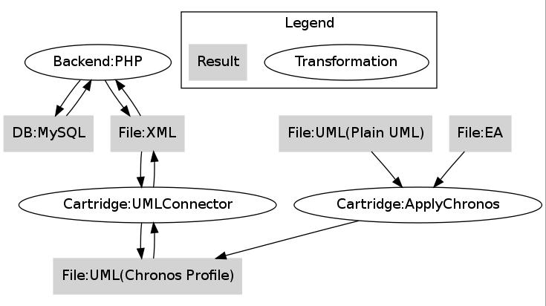

Metamodels
Path to metamodels: /generator/src/metamodel
metamodel | purpose
chronos.profile.uml | UML-Profile for export and import models between CWM and UML
cim13.uml | Common Information Model, Version 13 as UML model. This model is e.g. used to weave in enumerations into a cwm export einzuweben.  This is an Export from Enterprise Architect.
cwm.xsd
diagrams.xsd | For DiagramImageExporter
jaxb.xsd | ?
Olympos4Profiles.profile.uml | profile for profiles, incomplete
ouranos.profile.uml | ?
soap.xsd | For validation of WSDL
wcmf_profile.eap | old
wcmf.profile.uml | old
wsdl.xsd | For validation of WSDL
XMLSchema.xsd | Used by cartridges that import or export XSDs ?

Cartridges

Core Cartridges

cartridge | purpose
ApplyChronos | Applies Chronos Stereotypes to convert uml models into Chronos models that can be imported into cwm
ChronosStereotypes | Applies Chronos Stereotypes to convert uml models into Chronos models that can be imported into cwm  Which one should be used? Why are there two Cartridges? (ApplyChronos and ChronosStereotypes)
ChronosCommon | API for Chronos UML interpretation
ChronosCheck | checks for chronos models (e.g for BowserStatistics)
UmlConnector | Transformation between xml and uml in both directions  This Cartridge implements the UML export and import
GenerateUmlConnector | Cartridge for generation of parts of the UmlConnector

Application Cartridges

cartridge | purpose
ModelCompare | compares 2 models (classes, attributes, associations)  -> unclear if complete
BrowserStatistics | Produces PHP code that is used by Chronos Web Browser (CWB) to show model statistics

Documentation Cartridges

cartridge | purpose
DiagramImageExport | Converts the exported diagrams (in XML file created by CWM) into graphics  Integrates Java Project DiagramImageExporter
DocumentGeneration | Comment by Niko or Ingo:  Anmerkung: custom code: Index-/Verzeichnisaktualisierung, Connection close am Ende  -> deshalb immer Verwendung des Converters (auch für OO Format)
Freemind | Export of UML model to the XML format of Freemind

Code Cartridges
(platforms)
cartridge | purpose
Chi | creates CWE (generic Packages, for reuse in other projects)  Chronos Web Editor (Cwe), only Java Script  Generic Java Script Editor for domain model instances  generates from a Chronos Model (used as Meta Model)  should not be called directly
ChiCmf | Generates WCMF Backend in PHP and a little PHP frontend similar to CWE  in CWM only the generated backend is used
Cwe | Call frame for Chi
ChiCmfCwe | calls ChiCmf (PHP) and Cwe (JS)  no logic, only build
Expeditor | Generates Expeditor Domain Classes as Backend Application for alphaCell
ExpeditorCwe | creates Expeditor and Cwe
ExpeditorCweUpdateSite | creates Expeditor, Cwe and update site
Grails | Generates Grails Domain Classes in Groovy as Backend Application for alphaCore
GrailsService | Generates grails service classes
Wcmf | deprecated

Interface Cartridges

cartridge | purpose
Wsdl | Generates WSDL from a use case with an activity diagram  uses the XSD cartridge
XmlSchema | creates XSD from a UML model  is using namespaces and other informations from properties → those informations could also be extracted from model like in WSDL cartridge

