Chronos first steps
How to install and configure google Chrome for Chronos

Author: Giuseppe Platania
Owner: Giuseppe Platania
Customer:

Document History
Document Location
This is a snapshot of an on-line document. Paper copies are valid only on the day they are printed. Refer to the author if you are in any doubt about the currency of this document.
The source of the document will be found in /home/eeadmin/Documents/my projects/Olympos/scr/trunk/olympos/chronos/docs/Install_a_browser_for_CWM.odt
Revision History
Date of this revision: 27/04/11 | Date of next revision (date)

Revision Number | Revision Date | Summary of Changes | Changes marked
(#) | (-) | (Describe change) | (N)
Approvals
This document requires following approvals. Signed approval forms are filed in the Quality section of the PCB.
Name | Title
(name) | (title)
Distribution
This document has been distributed to
Name | Title
(name) | (title)
Contents
1. Installing Chrome for CWM 4
1.1 Introduction 4
1.2 Prerequisite 4
1.3 Install Chrome 4
1.4 Configure chrome for CWM 5

Installing Chrome for CWM

Introduction
This document will lead you in the installation of Google Chrome for Windows, to be used as client for the Chronos Web Modeler (CWM). CWM is a collaborative tool for the creation of UML models. See https://sourceforge.net/projects/olympos/ for more information.

In some company very old version of the browser are installed. CWM requires a browser with Just In time compiler to works smoothly.
The solution is to install a modern browser like Goggle Chrome.
Google Chrome can transform it self in an "application" on the desktop that will execute CWM only.

Prerequisite
- Windows OS (XP or better): The screenshot are for Windows XP. Other version of Windows should works also.
- Normal user: Because Chrome don't need modify the computer can be also installed without administration rights
- Internet connection: the CWM server is located in Internet, you should be able to connect to the provided URL
- Connection Information: You need information regarding the location of the server, your user name and password. This will be provided in a separate email.

Install Chrome
- Download the installation file from the provided URL: http://dl.dropbox.com/u/25873984/G00gleChr0meStandaloneEnterprise..zip
- Unzip the file “G00gleChr0meStandaloneEnterprise.zip”
- Double click on this file “GoogleChromeStandaloneEnterprise.msi”
- On the security warning answer “Run”
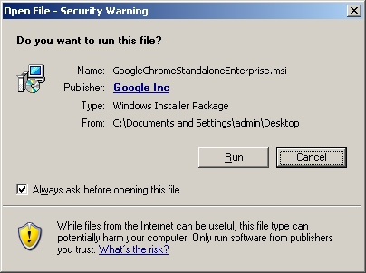
- select you preferred search engine.
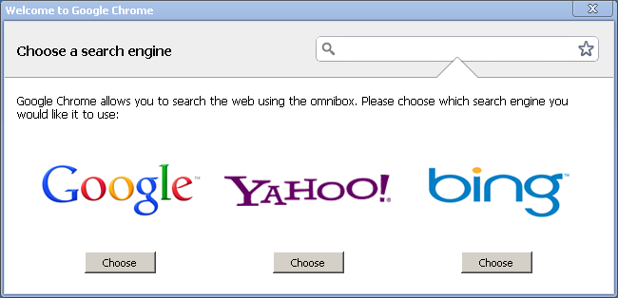
- Chrome is now installed

Configure chrome for CWM
- The URL input field in chrome is called “omnibox”
- Type in the omnibox the CWM URL that you got from your administrator. The URL provided in the example below will NOT works and is for demonstration only.
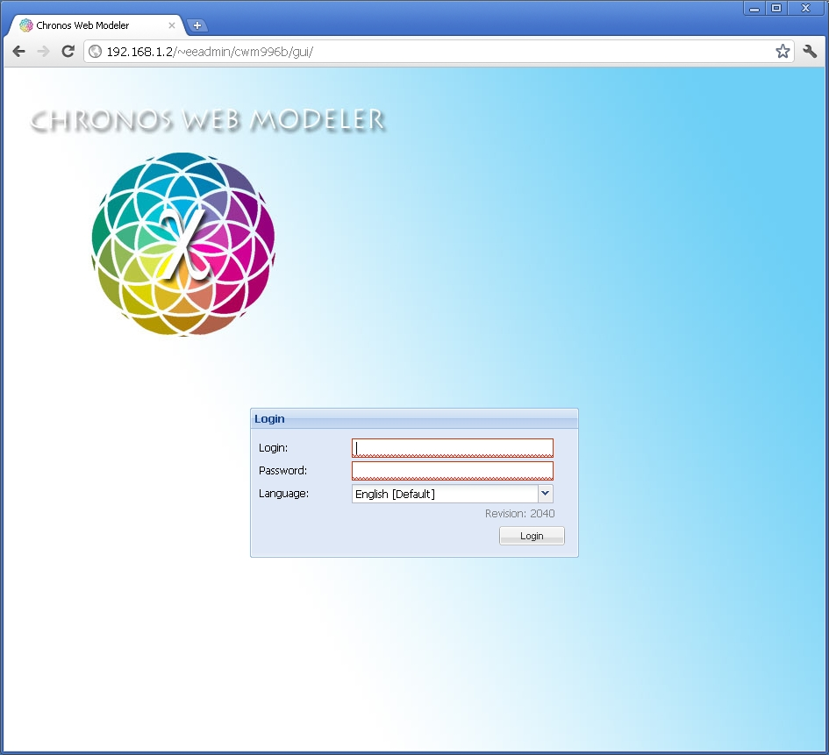
- Click on the “tool Icon” on the top right
- Then the “tools” menu item
- Select “create application shortcut”
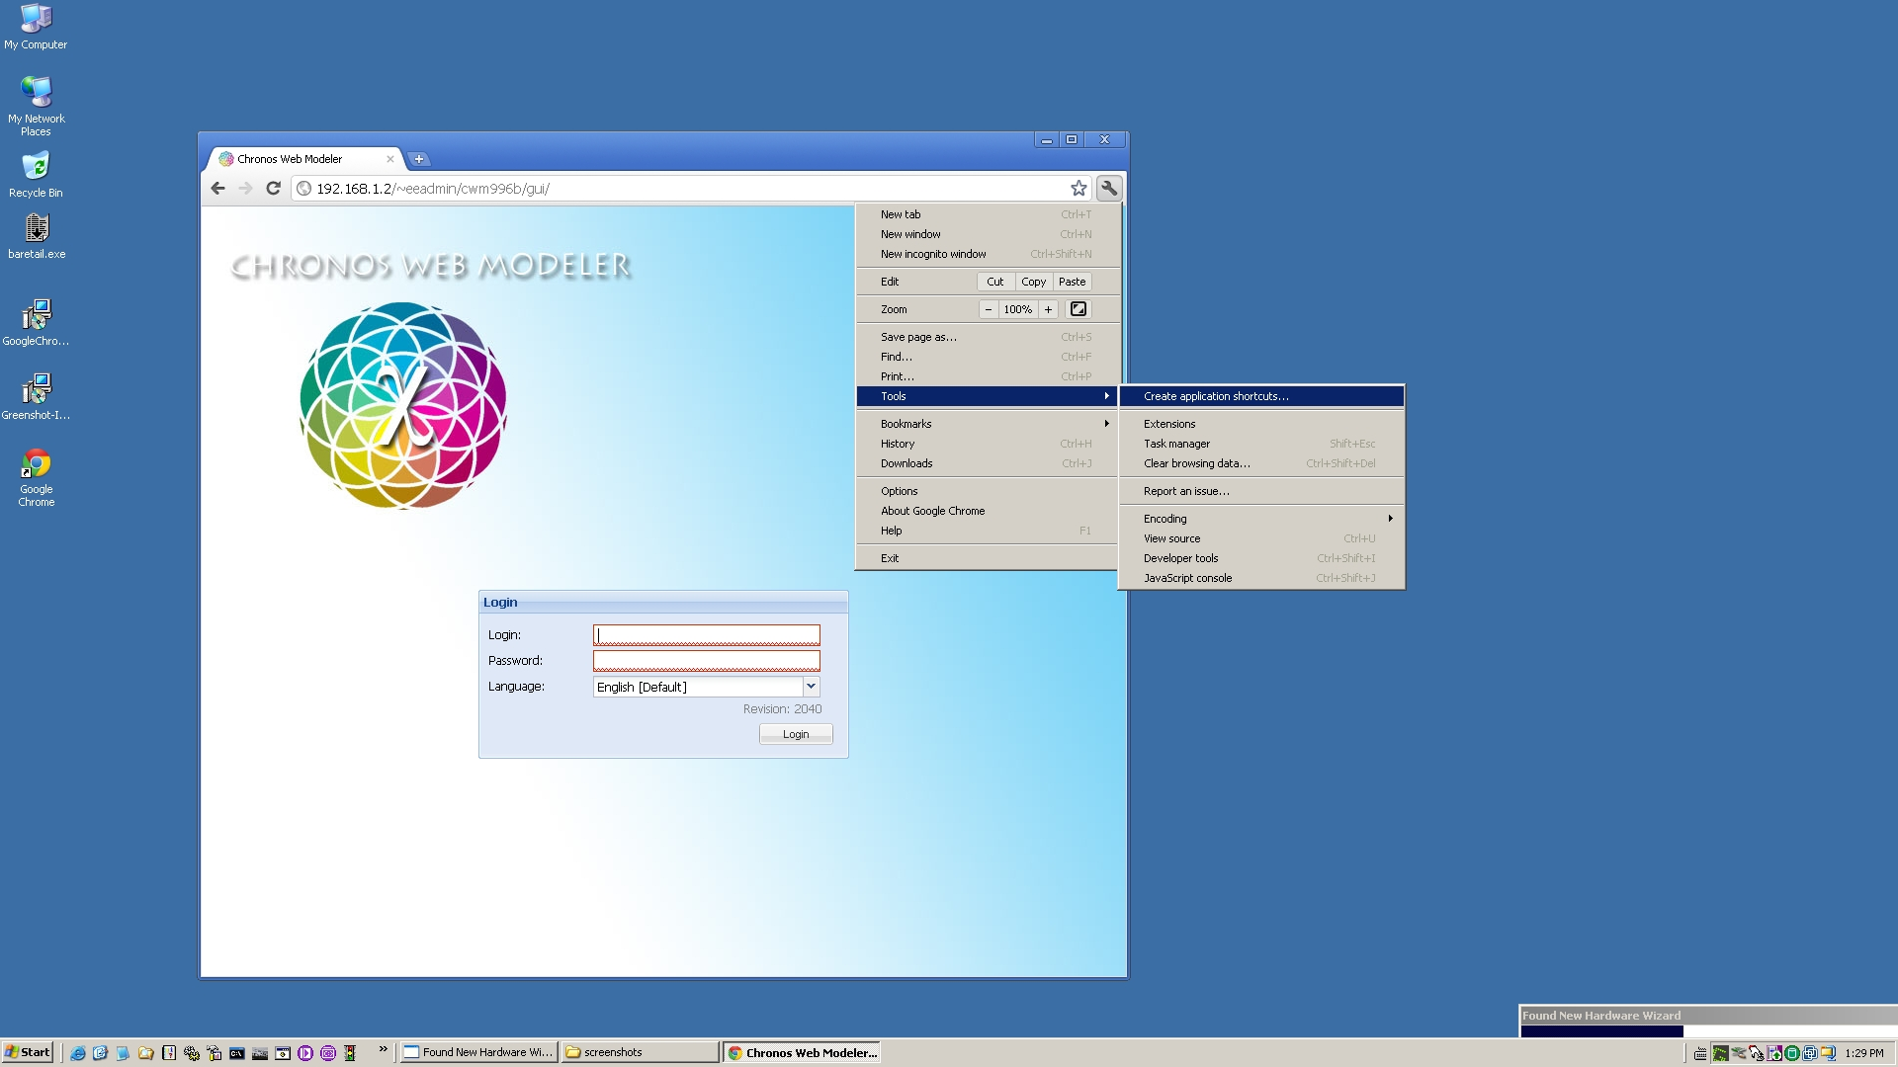
a new window pop up: click on “create”
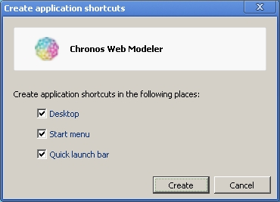
- A CWM icon will be created on your desktop, on your quick launch bar and on the start menu.
- The next time you want to start CWM simply use one of those icons.

