Building and Running chiGEN
setting up the development for the chronos Generator

Table of Contents
ABSTRACT 4
Building and Running Codegenerators 5
Preparation 5
Chronos Codegenerators 5
Running Codegenerators from CWM 7
Preconditions 7
Create Link to your Repository 7
Configure CWM 7
Start and Use CWM 7

Document Informations
Author: | Thomas Schuetz
Version: | 0.9.9.5
Created: | 11/02/11
Source | The actual version of this document can be found under:
http://wcmf.svn.sourceforge.net/viewvc/wcmf/trunk/olympos/chronos/docs

History
date | author | changes
11/02/11 | Thomas Schuetz | Created
05/03/11 | Giuseppe Platania | Review consolidation

ABSTRACT
This document leads through the steps of: - checking out the subversion repository - setting up the Eclipse Tooling - building the chiGEN - running a cartridge with testmodels (headless) - running the cartridge from CWM

Building and Running ChiGEN
This process has been written and tested for Linux only (Ubuntu 10.4).

Preparation

Download and unpack OAW 4.3
Download: ftp://ftp.itemis.de/oaw/distro/eclipse/oAW4.3.1/itemis-oaw-distribution-I20090514-1901-linux-gtk-x86.tar.gz
known error with ubuntu 10.04: oaw-eclipse does not start with an empty workspace directory -> create an empty workspace with another eclipse version and use that one

Chronos ChiGEN

Setup Eclipse Workspace
- Check out trunk of Olympos Subversion repository (https://olympos.svn.sourceforge.net/svnroot/olympos)
- Create empty Eclipse Workspace (on error check chapter “Download and unpack OAW 4.3”)
- Add the right Java SDK in Eclipse: Window → Preferences → Java → Installed JREs → Add → Standard VM → directory: e.g. /usr/lib/j2sdk1.6-ibm
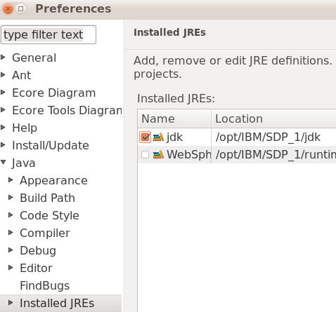
Make sure the sdk is checked under Window → Preferences → Java → Installed JREs
- Import Projects into Eclipse Workspace: File → Import → General → Existing Projects into Workspace
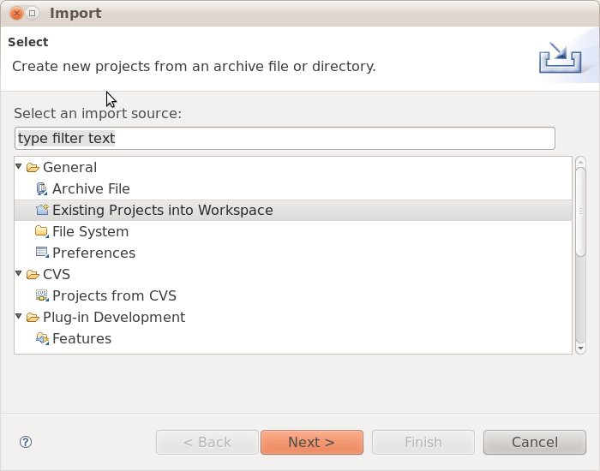
  - path: <your checkout path>/olymposSVN/olympos/chronos/scr/workspace/generator
  - In the List Projects, select all projects
  - Attention: Copy projects into workspace has to be deactivated!

- Check the workspace folder: The only content should be the folder .metadata

Trouble Shooting
- If your XPand files (.xpt) display the escape sequences wrong (Â«IMPORT umlÃ‚Â» instead of «IMPORT uml»)
select Edit → Set Encoding → Other: UTF-8
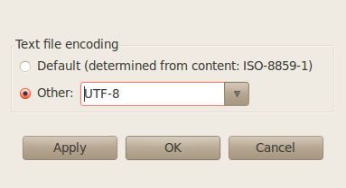
- If you get lots of error markers in Xtend (.ext) and Check (.chk) files (e.g. “Couldn't resolve type for ...”) make sure that you configured the corresponding metamodel: Project → Properties → openArchitectureWare : Select EMF Metamodels and UML2 Profiles.
Important: UML2 Profiles has to be first. If not, you get error messages like “couldn't find operation '+(uml::String)' for type String”.

Build all generators
- Run generator.build/build.xml (Right Click → Run as → Ant Build)
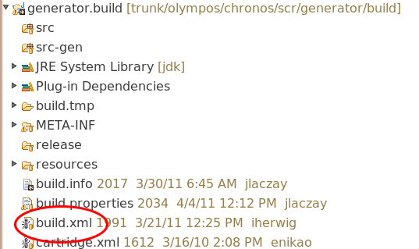
- Attention: If two menu items “Ant Build” show up, only one works
- A successful run looks like this:
(...)
redist:
[copy] Copying 107 files to /home/tschuetz/projects/eenergy/development/olymposSVN/trunk/olympos/chronos/scr/workspace/generator/dist/lib
[jar] Building jar: /home/tschuetz/projects/eenergy/development/olymposSVN/trunk/olympos/chronos/scr/workspace/generator/dist/ChronosGenerator.jar
[copy] Copying 21 files to /home/tschuetz/projects/eenergy/development/olymposSVN/trunk/olympos/chronos/scr/workspace/generator/dist
[copy] Copying 321 files to /home/tschuetz/projects/eenergy/development/olymposSVN/trunk/olympos/chronos/scr/workspace/generator/dist/cartridge
[copy] Copying 2 files to /home/tschuetz/projects/eenergy/development/olymposSVN/trunk/olympos/chronos/scr/workspace/generator/dist
[zip] Building zip: /home/tschuetz/projects/eenergy/development/olymposSVN/trunk/olympos/chronos/scr/workspace/generator/ChronosGenerator-0.9.9.3.zip
BUILD SUCCESSFUL
Total time: 10 seconds

Run the generators with the testmodels
- The test models are in project testmodels/models/sourcemodels
- scripts to run them are in the testmodels/scripts
- run the scripts in a shell or create a run configuration in Eclipse
- make sure the scripts are executable after checkout (e.g. chmod a+x run_cwm2uml.sh)

Scripts and Models
script | sourcemodel | result
run_cwm2uml.sh | cim14/cwm-export.xml | models/tmp/cwm-export.zip
run_uml2cwm.sh | cim14/cwm-export.uml | models/tmp/cwm-export.xml

Running ChiGEN from CWM

Preconditions
- LAMPP Installation (XAMPP)

Create Link to your Repository
- Open shell as root (sudo su)
- Create symbolic link to the workspace folder of your repository in the htdocs folder of your lampp installation (e.g. /opt/lampp/htdocs):
ln -s <your-repository-path>/trunk/olympos/chronos/scr/workspace ./cwm-olympos-repo
- check the link in the shell: ll
result (with your path):
lrwxrwxrwx 1 root root 90 2011-02-14 09:57 cwm-olympos-repo -> /home/tschuetz/projects/eenergy/development/olymposSVN/trunk/olympos/chronos/scr/workspace/
- restart your lampp installation:
Example:
- /opt/lampp/lampp stop
- /opt/lampp/lampp start

Configure CWM
Configure CWM according to Chronos_Web_Modeller_Installation.pdf

Start and Use CWM
  - Open in Web-Browser: http://localhost/cwm-olympos-repo/gui/ and log in
  - Start Work with CWM

