Olympos

Chronos Web Modeler

Installation

Author: Giuseppe Platania
Owner: Giuseppe Platania
Customer: eEnergy

Document History
Document Location
This is a snapshot of an on-line document. Paper copies are valid only on the day they are printed. Refer to the author if you are in any doubt about the currency of this document.
The source of the document will be found in C:\Documents and Settings\Administrator\My Documents\my projects\Olympos\scr\trunk\olympos\chronos\scr\applications\requirements\Chronos_Web_Modeller_Installation.doc
Revision History
Date of this revision: 03/06/2008 | Date of next revision (date)

Revision Number | Revision Date | Summary of Changes | Changes marked
(#) | (-) | (Describe change) | (N)
0.1 | 18/12/08 | created
0.2 | 03/02/09 | Update installation steps
Distribution
This document has been distributed to
Fehler: Referenz nicht gefunden | Fehler: Referenz nicht gefunden
(name) | (title)
Contents
1. Abstract 4
2. License 5
3. Requirements 6
3.1 Server hardware 6
3.2 Server Software stack 6
3.3 CWM Application Libraries 7
3.4 Client 7
3.4.1 Hardware 7
3.4.2 Software 8
Installation 9
3.5 Install the LAMP or WAMP stack 9
3.6 Configure PHP 9
3.7 Install phpMyAdmin 9
3.8 Create the CWM database 9
3.9 Install Java 11
3.10 Install OpenOffice 11
3.11 Configure the generator 11
3.12 Deploy the CWM package 11
3.13 Configure the application 12
3.13.1.1 Optional in case of Upgrade only 12

Abstract
This file helps to configure and install the Chronos Web Modeller.

License
The CWM and the accompanying materials are made available under the terms of the Eclipse Public License v1.0 which accompanies this distribution, and is available at http://www.eclipse.org/legal/epl-v10.html.

The concept of Chronos is made available under the Creative Common license.
You are free:
* to Share — to copy, distribute and transmit the work
* to Remix — to adapt the work
Under the following conditions:
* Attribution. You must attribute the work in the manner specified by the author or licensor (but not in any way that suggests that they endorse you or your use of the work).
* For any reuse or distribution, you must make clear to others the license terms of this work. The best way to do this is with a link to this web page.
* Any of the above conditions can be waived if you get permission from the copyright holder.
* Nothing in this license impairs or restricts the author's moral rights.

You can download the most recent CWM version from: http://sourceforge.net/projects/olympos/

Requirements
Please consider the following list of requirements before installing the Chronos Web Modeler

Server hardware

Minimal configuration (development)
CPU | 2,5 GHz
RAM | 1 GB
HD | 1 x 500 GB
RAID Level | 0

Suggested (productive)
CPU | 4 x 2 GHz
RAM | 8 GB
HD | 2 x 1000 GB
RAID Level | 5

Server Software stack
The development was tested under Windows XP SP2, Linux Ubuntu Server 64 and Linux Debian (Etch 4.0 Kernelname: 2.6.18-6-686-bigmem). Other Linuxes distribution (like SUSE or Redhat) should also works (but until now where not tested) .
The server needs following components:
- Apache (2.2.11) [Linux]
- Apache (2.2.10) [Windows]
- MySQL (5.0.00)
- PHP (5.2.8) (with JSON library active)
- Java 1.6
- phpMyAdmin (3.1.1) [Linux]
- phpMyAdmin (3.1.0) [Windows]
- unzip

CWM Application Libraries
The CWM application uses the libraries depicted below:

Client
The client need to be able to run a supported browser.

Hardware
Minimal :
CPU | Celeron 900 MHz Class
RAM | 752 MB
Monitor | 15''

Suggested:
CPU | CORE2 2 GHz class
RAM | 2 GB
Monitor | 21''

Software
The client runs in following browsers with activated JavaScript:
- Firefox 3 or better (Preferred)
Not (yet) supported:
- IE 7
- Google Chrome 2
- Opera

Installation
The installation of the CWM needs following steps:
  - Install the LAMP or WAMP stack
  - configure PHP
  - Install phpMyAdmin
  - create the CWM database
  - Install Java
  - deploy the CWM package
  - Configure the application

Install the LAMP or WAMP stack
Follows the specific installation instruction of your Operating system or distribution.

Configure PHP
Configure the resource limit for PHP
find the position of your php.ini

edit php.ini as following:
;;;;;;;;;;;;;;;;;;;
; Resource Limits ;
;;;;;;;;;;;;;;;;;;;
max_execution_time = 90
max_input_time = 90
memory_limit = 128M

Install phpMyAdmin
Php my admin is a supported package in many Linux distribution.
Under Ubuntu you can install it by using the following command:
sudo apt-get install phpmyadmin

Create the CWM database
- Open PHPMyAdmin
- Create a BD name “cwm”:
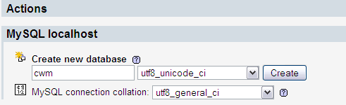
- Create an User for the cwm database
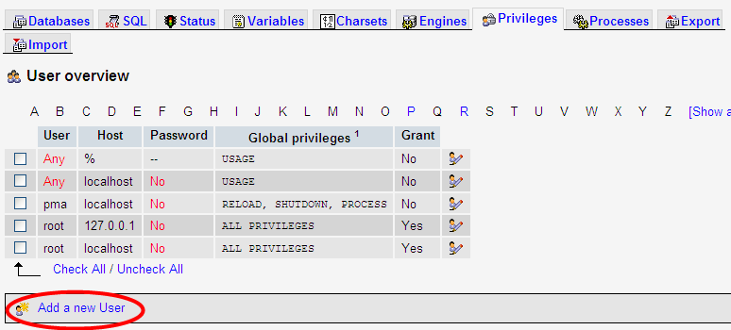
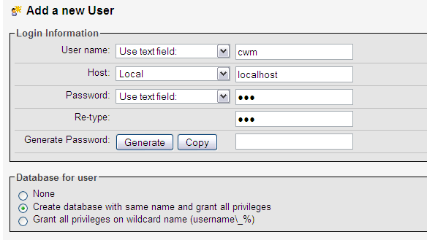

Install Java
- Check if the correct java version is installed: type in a console “java -version”

Install OpenOffice

Install the package
openoffice.org

must be 2.0,4 or better.

- Type in a bash shell:
soffice -headless -accept="socket,host=localhost,port=8100;urp;" -nofirststartwizard

Note: if you receive the error "X11 error: Can't open display:" when running the above command, then you may need to install the "headless" OpenOffice.org package from your Linux distribution. On Ubuntu/Debian, this package is called openoffice.org-headless.

Configure the generator

- Browse to /var/www/cwm/wcmf_generator/workflow
- manually edit the file
- modify the generator section to point out to the position of your wCMFGenerator.jar.
[generator]
executable = /var/www/cwm/wcmf_generator/wCMFGenerator.jar

Deploy the CWM package
- The CWM is provided as single zip file.
- Unzip the package (e.g. CWM_alpha_05.zip) in the apache http directory e.g. /var/www directory
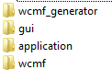
- following structure is created:

Configure the application
- Browse to cwm\application\include
- Open with an editor the server.ini file
- Edit the section [database] with your DB information
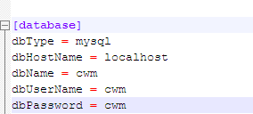
- Open Firefox 3 and browse to http://localhost/cwm/application

Optional in case of Upgrade only
- Click on upgrade
- Click on install to create a standard admin user

- Click on start application to start the backend application
- Use the standard user:admin with the password:admin to login
- Click on admin to manage users and roles
- Change immediately the password for the user admin
- Create so many users and roles as necessary.
- Browse to http://localhost/cwm/gui/
- Login
- welcome to the CWM!!!
