Cartridge Documentation
description of all cartridges

Table of Contents
ABSTRACT 4
Introduction 5
Data flow for Cartridges 5
Metamodels 5
Cartridges 6

Document Informations
Author: | Thomas Schuetz
Version: | 0.9.9.5
Created: | 08/03/11
Source | The actual version of this document can be found under:
http://wcmf.svn.sourceforge.net/viewvc/wcmf/trunk/olympos/chronos/docs

History
date | author | changes
08/03/11 | Thomas Schuetz | Created
01/05/11 | Thomas Schuetz | Cleaned up and translated informations to english

ABSTRACT
This document contains the documentation for each Chronos cartridge. It includes: - cartridge's purpose - how to run a cartridge from CWM - how to run a cartridge from command line

Introduction
The model to model (M2M) and model to text (M2T) transformations for the Chronos Web Modeler (CWM) tool set are implemented as cartridges with Open Architecture (OAW) Ware, Version 4.3.
Most cartridges can be run from the CWM front end as well as from command line.

Data flow for Cartridges
The data flow shows the Transformations with their input and output artifacts:

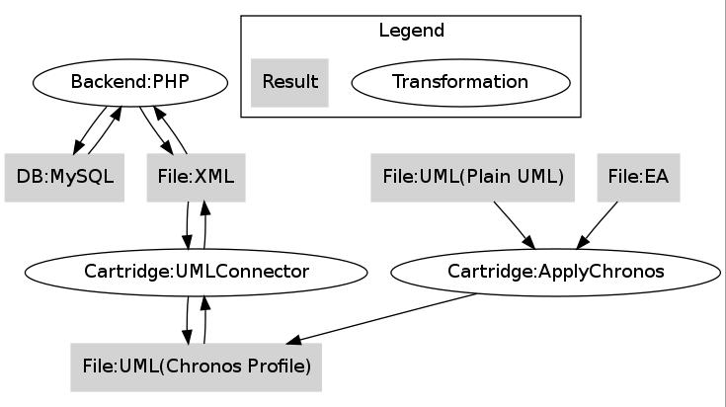

The information is initially created in the CWM front end – javascript component. In the second step it's send to a backend system - PHP component - called Chronos Business Object Repository (BOR). The BOR store it in a database (mySQL).

When you decide to generate information, the BOR reads the MYSQL DB and transforms the information in a plain XML format. Then it pass the XML to the Chi GEN itself - a Java program.
the Chi Gen first transform the XML in UML (ECORE metamodel). Now you have a valid UML file. This could be achieved also by using other UML model program like Sparx Enterprise Architect (file EA to the right).

Having a valid UML file, you can apply any cartridge (transformation in a special technology). An example is generating a complete application in PHP as in the tutorial "Hello world". The generated code is exactly what you will write down manually in an ideal case, because is coming from a “Reference Implementation” that was previously written by an experience developer. In this case, the task of creating the single files are repeated for the amount of the objects in the model.

Metamodels
Path to metamodels: /generator/src/metamodel
metamodel | purpose
chronos.profile.uml | UML-Profile for export and import models between CWM and UML
cim13.uml | Common Information Model, Version 13 as UML model. This model is e.g. used to weave in enumerations into a cwm export.  This is an Export from Enterprise Architect.
cwm.xsd
diagrams.xsd | For DiagramImageExporter
jaxb.xsd | ?
Olympos4Profiles.profile.uml | profile for profiles, incomplete
ouranos.profile.uml | This is the ouranos metamodel in Uml format. It was created with the scope of extracting a model from existing code.
soap.xsd | For validation of a WSDL file
wcmf_profile.eap | old
wcmf.profile.uml | old
wsdl.xsd | For validation of WSDL
XMLSchema.xsd | Used by cartridges that import or export XSDs ?

Cartridges

Core Cartridges

cartridge | purpose
ApplyChronos | Applies Chronos Stereotypes to convert standar Ecore uml models into Chronos models that can be imported into cwm
ChronosStereotypes | Applies Chronos Stereotypes to convert uml models into Chronos models that can be imported into cwm  Which one should be used? Why are there two Cartridges? (ApplyChronos and ChronosStereotypes)
ChronosCommon | API for Chronos UML interpretation
ChronosCheck | checks for chronos models (e.g for BowserStatistics)
UmlConnector | Transformation between xml and uml in both directions  This Cartridge implements the UML export and import
GenerateUmlConnector | Cartridge for generation of parts of the UmlConnector

Application Cartridges

cartridge | purpose
ModelCompare | compares 2 models (classes, attributes, associations)  -> unclear if complete
BrowserStatistics | Produces PHP code that is used by Chronos Web Browser (CWB) to show model statistics

Documentation Cartridges

cartridge | purpose
DiagramImageExport | Converts the exported diagrams (in XML file created by CWM) into graphics  Integrates Java Project DiagramImageExporter
DocumentGeneration | Comment by Niko or Ingo:  Anmerkung: custom code: Index-/Verzeichnisaktualisierung, Connection close am Ende  -> deshalb immer Verwendung des Converters (auch für OO Format)
Freemind | Export of UML model to the XML format of Freemind

Code Cartridges
(platforms)
cartridge | purpose
Chi | creates CWE (generic Packages, for reuse in other projects)  Chronos Web Editor (Cwe), only Java Script  Generic Java Script Editor for domain model instances  generates from a Chronos Model (used as Meta Model)  should not be called directly
ChiCmf | Generates WCMF Backend in PHP and a little PHP frontend similar to CWE  in CWM only the generated backend is used
Cwe | Call frame for the Chi cartridge
ChiCmfCwe | calls ChiCmf (PHP) and Cwe (JS)  no logic, only build
Grails | Generates Grails Domain Classes in Groovy as Backend Application for alphaCore
GrailsService | Generates grails service classes
Wcmf | deprecated

Interface Cartridges

cartridge | purpose
Wsdl | Generates WSDL from a use case with an activity diagram  uses the XSD cartridge
XmlSchema | creates XSD from a UML model  Note:  it is using namespaces and others information from properties. this information could also be extracted from the model, like in WSDL cartridge.

