Olympos

Chronos Web Tools

Installation guide 0.9.9.5

Author: Giuseppe Platania
Owner: Giuseppe Platania

Document History
Document Location
This is a snapshot of an on-line document. Paper copies are valid only on the day they are printed. Refer to the author if you are in any doubt about the currency of this document.
The source of the document will be found in the Subversion repository on Source Forge.
https://olympos.svn.sourceforge.net/svnroot/olympos/trunk/olympos/chronos/scr/applications/requirements/Chronos_Web_Modeller_Installation.pdf
Revision History
Date of this revision: 24/02/11 | Date of next revision TBD

Revision Number | Revision Date | Summary of Changes
(#) | (-) | (Describe change)
0.1 | 18/12/08 | created
0.2 | 03/02/09 | Update installation steps
0.8.1 | 04/02/09 | Update for 0.8.1
0.9 | 04/30/09 | Update for 0.9
0.9.5 | 02/24/11 | Update for 0.9.5
0.9.7 | 09/04/09 | Update for 0.9.7
0.9.7.1 |  | Review
0.9.8.4 | 01/11/10 | Review
0.9.9 | 05/03/10 | Added cron job section
0.9.9.2 | 06/16/10 | Added pdo settings
0.9.9.2 | 07/05/10 | UMI setting added
0.9.9.5 | 02/18/11 | Added PHP config 'upload_max_filesize'
0.9.9.5 | 02/24/11 | Added step for creation of folder generated
Contents
1. Abstract 4
2. License 5
3. Requirements 6
3.1 Server hardware 6
3.2 Server Software stack 6
3.3 CWM Application Libraries 7
3.4 Client 7
3.4.1 Hardware 7
3.4.2 Software 7
Installation 8
3.5 Install the LAMP or WAMP stack 8
3.6 Configure PHP 8
3.7 Install phpMyAdmin 9
3.8 Create the CWM database 9
3.9 Fill the database 10
3.10 Install Java 11
3.11 Install OpenOffice 11
3.12 Test the access to the Metamodel 12
3.13 Deploy the CWM package 12
3.14 Ensure write access for web server user 12
3.15 Configure the application 12
3.16 Configure the standard Model language 13
3.17 Configure the generator 13
3.18 give Apache rights to the generated folder 13
3.19 Install cron Job 14
3.20 Install the standard Models and Users 14
3.21 Connecting 2 CWM instances 14
4. Get started 17
4.1 Administrate users and roles 17
4.2 Test the CWM 17
4.3 Test the CWB 18

Abstract
This file helps to configure and install the Chronos Web Tools, including the Chronos Web Modeller and the Chronos web Browser. It is addressed to system administrators only. If you are an user start with the CWM online help.

You can download the most recent CWT version from: http://sourceforge.net/projects/olympos/

License
The code of the CWT and the accompanying materials are made available under the terms of the Eclipse Public License v1.0 which accompanies this distribution, and is available at http://www.eclipse.org/legal/epl-v10.html.

The concept of Chronos is made available under the Creative Common license.
You are free:
* to Share — to copy, distribute and transmit the work
* to Remix — to adapt the work
Under the following conditions:
* Attribution. You must attribute the work in the manner specified by the author or licensor (but not in any way that suggests that they endorse you or your use of the work).
* For any reuse or distribution, you must make clear to others the license terms of this work. The best way to do this is with a link to this web page.
* Any of the above conditions can be waived if you get permission from the copyright holder.
* Nothing in this license impairs or restricts the author's moral rights.

Requirements
Please consider the following list of requirements before installing the Chronos Web Modeler

Server hardware

Minimal configuration (development)
CPU | 1x2,5 GHz
RAM | 1 GB
HD | 1 x 500 GB
RAID Level | 0

Suggested (productive)
CPU | 4 x 2,5 GHz
RAM | 8 GB
HD | 2 x 1000 GB
RAID Level | 5

Server Software stack
The development was tested under Windows XP SP2, Linux Ubuntu Server 64 and Linux Debian (Etch 4.0 Kernelname: 2.6.18-6-686-bigmem). Other Linux distributions (like e.g SUSE or Redhat) should also work, but have not been tested .
The server requires the following components:
- Apache (2.2.11) [Linux]
- Apache (2.2.10) [Windows]
- MySQL (5.0.00)
- PHP (5.2.8) (with JSON library active)
- Java 1.6
- phpMyAdmin (3.1.1) [Linux]
- phpMyAdmin (3.1.0) [Windows]
- unzip
- OpenOffice version 2.4 until 3.0

XAMPP for Linux or Windows, includes most of them.
Download and install XAMPP for Linux or Windows from http://www.apachefriends.org/en/xampp.html

CWM Application Libraries
The CWM application uses the libraries depicted below:

Client
The client need to be able to run a supported browser.

Hardware
Minimal :
Key | Value
CPU | Celeron 900 MHz Class
RAM | 752 MB
Monitor | 15''

Suggested:
Key | Value
CPU | CORE2 2 GHz class
RAM | 2 GB
Monitor | 21''

Software
The client runs in following browsers with activated JavaScript:
- Firefox 3 or better (Preferred)
- Google Chrome 3 or better
Not (yet) supported:

- Opera
- IE 8

Installation

The installation of the CWM needs following steps:
  - Install the LAMP or WAMP stack.
  - Configure PHP.
  - Install phpMyAdmin.
  - Create the CWM database.
  - Install Java.
  - Install OpenOffice
  - Deploy the CWM package.
  - Configure the application.

This document is oriented to a productive installation under Linux.

Install the LAMP or WAMP stack
Follows the specific installation instruction of your Operating System or distribution.

Configure PHP
1. find the position of your php.ini
2. edit php.ini as following:
;;;;;;;;;;;;;;;;;
; Data Handling ;
;;;;;;;;;;;;;;;;;
variables_order = "GPCSE"

;;;;;;;;;;;;;;;;;;;
; Resource Limits ;
;;;;;;;;;;;;;;;;;;;
max_execution_time = 7200
max_input_time = 7200
memory_limit = 1024M

;;;;;;;;;;;;;;;;
; File Uploads ;
;;;;;;;;;;;;;;;;
upload_max_filesize = 20M

;;;;;;;;;;;;;;;;;;
; Fopen wrappers ;
;;;;;;;;;;;;;;;;;;
default_socket_timeout = 300

;;;;;;;;;;;;;;;;;;;
; Module Settings ;
;;;;;;;;;;;;;;;;;;;
[Pdo_mysql]
pdo_mysql.default_socket = /opt/lampp/var/mysql/mysql.sock

[Session]
session.gc_maxlifetime = 7200

Install phpMyAdmin
Phpmyadmin is a supported package in many Linux distribution.
Under Ubuntu you can install it by using the following command:
sudo apt-get install phpmyadmin

Create the CWM database
- Only in case of a new installation
- Open PHPMyAdmin by browsing to lhttp://localhost/xampp/
- Create a Database name “cwm”:

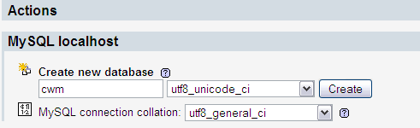
- Create an user with name “cwm” for the new created “cwm” database
- set the password to “cwm” all lowercase for this user
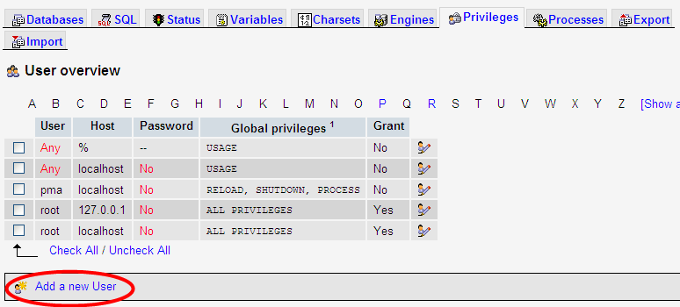
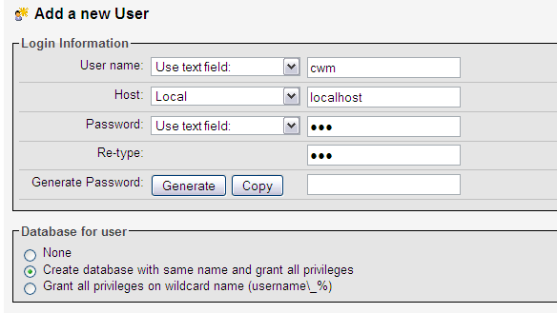

Fill the database
Only in case of a new installation:
- execute on the created CWM database the provided cwm.sql.gz. This will install the default users and roles as well as the standard models.
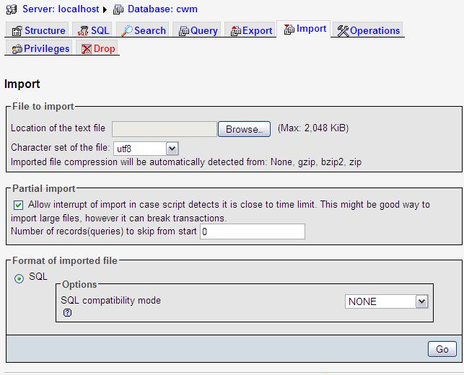Illustration 1:

Install Java
- Check if the correct java version is installed: type in a console “java -version”
- If 1.6 is not available, install java 1.6 or better

Install OpenOffice
Install the package
openoffice.org
the version number must be 2.0.4 until 3.0.

- Type in a bash shell:
soffice -headless -accept="socket,host=localhost,port=8100;urp;" -nofirststartwizard

Note: if you receive the error "X11 error: Can't open display:" when running the above command, then you may need to install the "headless" OpenOffice.org package from your Linux distribution. On Ubuntu/Debian, this package is called openoffice.org-headless.

Test the access to the Metamodel
To be able to export the CWM need to dynamically read the Metamodel that in this version is under:
http://cwm.nikostotz.de/chronos.profile.uml
check that your server or firewall can access to this file by typing
wget http://cwm.nikostotz.de/chronos.profile.uml

Deploy the CWM package
- The CWT are provided as single zip file.
    - NOTE Optional in case of Upgrade only
remove the server.ini file from cwm/application/include before unzip the file to avoid overwrite your actual configuration.
- Unzip the package (e.g. cwm.zip) in the apache http directory e.g. /var/www directory
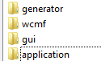
- following structure is created:

Ensure write access for web server user
Make sure the user running the web server (www-data on Debian / Ubuntu) has write access to the following directories:
- cwm/application/log
- cwm/application/statistics
- cwm/application/searchIndex
- cwm/application/include/views/smarty/templates_c
- cwm/application/include/views/smarty/cache

Configure the application
Only in case of a new installation:
- Browse to cwm\application\include
- Open with an editor the server.ini file
- Edit the section [database] with your DB information
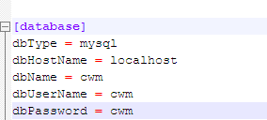

Configure the standard Model language
in the same file
application/include/server.ini

configure your default language for the backend model. Use the 2 letter international code (en for English, de for German, it for Italian, ….)
[i18n]
defaultLanguage = de

now browse to
gui/js/uwm/Config.js :

to configure the front end model language.

...
/**
* The default modelling.
*
* @type String
*/
uwm.Config.defaultLanguage = 'de';

Configure the generator
Only in case of a new installation:
- on the same file server.ini modify the [generator] section to point to the position of your ChronosGenerator.jar.
...
[generator]
executable = /var/www/cwm/generator/ChronosGenerator.jar

give Apache rights to the generated folder
From the version 0.9.8 the CWM can generate a complete application.
Create the folder generated in the cwm directory and give the Apache user all right for this folder:
mkdir /var/www/cwm/generated/
chmod 666 /var/www/cwm/generated/

Install cron Job
Starting with version 0.9.9, a cron job is provided for the Chronos Web Browser. It's supposed to preprocess large models on a regular basis, so the users can view the CWB contents without waiting for the full generation process.
The configuration for the cron job resides in /var/www/cwm/application/jobs/config.ini. The URL must point to the web path to CWM main.php. The login and password must be a user with read access to all models. You should create a special user for this task.
An example config.ini looks like:
[server]
url = http://localhost/cwm/application/main.php
login = cronuser
password = Sup3rSECretPAssWorD
The cron job must use /var/www/cwm/application/jobs/ as working directory. The script to be called is /var/www/cwm/application/jobs/statistics.php with a PHP5 interpreter. It should be run with the web server user. The user must have write access to /var/www/cwm/application/jobs/log. All output of the cron job is written to this directory. For tracking installation issues, you still should monitor the standard output of the job. An example cron job file looks like:
HOME=/var/www/cwm/application/jobs/
25 2 * * * www-data /usr/bin/php5 -q /var/www/jobs/application/jobs/statistics.php 2>&1 >> /var/log/cwm.log
This would run the script each day at 2:25 AM. Be sure to have an additional line break after the line.

Install the standard Models and Users
In case of Upgrade:
- Open Firefox 3 and browse to http://localhost/cwm/application
- Click on upgrade to upgrade your database

Connecting 2 CWM instances
Requirements: 2 CWM instances with at least version 0.9.9.2
Server: CWM instance that provides a library model to the client instance.
Client: CWM instance that references parts of the library model in it's local models.
Server configuration:
- nothing to do here
Client configuration:
- In server.ini add the following sections
[remoteserver]
cim = http://url.of.server.cwm/application/main.php
[remoteuser]
cim = cimuser
For each remote server add an entry in the remoteserver section, where the key (e.g. "lib" or "cim") is an arbitrary system wide unique name for the server and the value is the url of the remote CWM instance. To log into the remote application the appropriate user denoted in the remoteuser section will be used. The user must exist in both instances.
- Check with PHPmyadmin the database of the Server CWM.
  - Look in the table Model or Package for the ID.
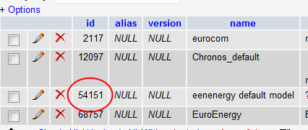
- Log into the backend application of the CWM client.
- create a new Model instance.
- Set the umi property of the instance to an umi of a remote Model or Package, e.g.
urn:umi:cim:Model:54151
or
urn:umi:cim:Package:54151
[umi notation: urn:umi:{remote server key}:{object id of referenced Model or Package}]
- Save the Model instance.
- Log into the CWM. The referenced Model is contained in the model tree.

Get started

Administrate users and roles

- Click on start application to start the backend application
- Use the standard user:admin with the password:admin to login
- Click on Administration to manage users and roles
- Change immediately the password for the user admin
- Create so many users and roles as necessary.

Test the CWM
- Browse to http://localhost/cwm/gui/
- Login
- welcome to the CWM!!!
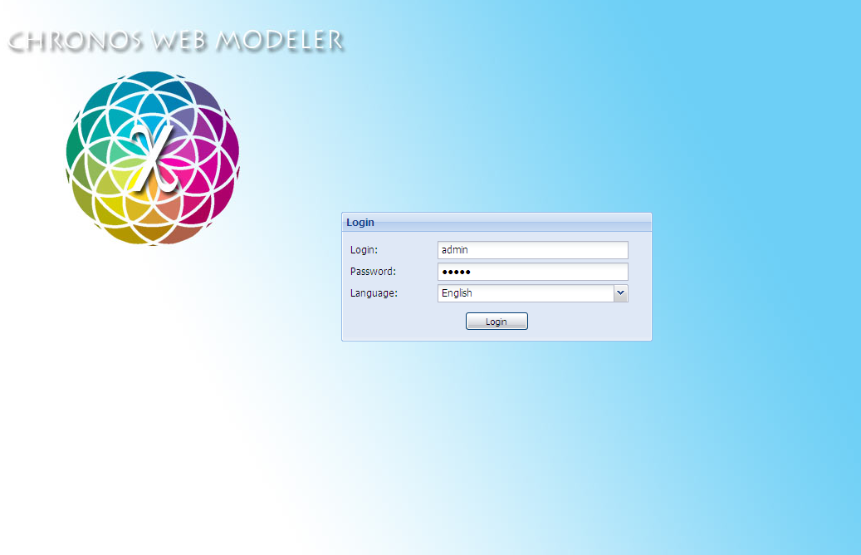

Test the CWB
NOTE the CWB is now integrated as start window of the CWM
- Browse to http://localhost/cwm/Browser
- Login
- select a model
- welcome to the CWB!!!
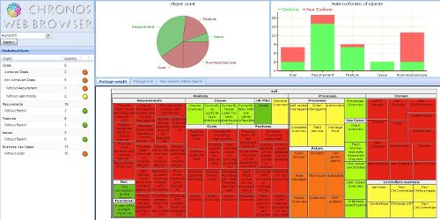

The actual 0.9.9.2 release don't support

