
Ingo Herwig <ingo@wemove.com>
Giuseppe Platania <gplatani@de.ibm.com>

Aphodites Specification

This document describes the requirements for a Aphrodites framework
to be used with a of a Chronos Model
within the a Model Driven Software Development

TABLE OF CONTENTS
1 INTRODUCTION 4
1.1 Abstract 4
1.2 Definition of Aprodite 4
1.3 About the name 5
2 Choicing a framework that fit for Aphrodite 5
2.1 What is a framework … 5
2.2 How to use a framework within a MDSD approach 5
2.3 Top 10 rules 6
2.3.1 1. KISS Keep It Simple Stupid 6
2.3.2 2. Convention vs Configuration 6
2.3.3 3. (Good) Object Orientation 7
2.3.4 4. Aspect-oriented programming (AOP) support 7
2.3.5 5. Remote Access support 7
2.3.6 6. Modular design 7
2.3.7 7 MVC 8
2.3.8 8. CRUD 8
2.3.9 9. Tools Support 8
2.3.10 10. Summa Summarum 8
3 FUNDAMENTALS 10
3.1 Model View Controller 10
3.2 MODEL 11
3.2.1 STEREOTYPES FOR MODELLING THE DATA 11
3.2.2 INHERITANCE 15
3.2.3 ASSOCIATIONS 16
3.2.3.1 Navigability 16
3.2.3.2 Association types 17
3.2.3.3 Multiple associations 17
3.2.3.4Multiplicity 17
3.2.4 Methods 18
3.3 Controller 22
3.3.1 Definition of ChiRule 23
3.3.1.1 Integrity Rules 23
3.3.1.1.1Example 24
3.3.1.1.1.1Chononos Model 24
3.3.1.1.2Aphrodite realizations 24
3.3.1.1.2.1Jrules 24
3.3.1.1.2.2Expeditor 24
3.3.1.1.2.3wcmf 24
3.3.1.2 Derivation Rules 24
3.3.1.2.1Example 24
3.3.1.2.1.1Chononos Model 24
3.3.1.2.2Aphrodite realizations 25
3.3.1.2.2.1Jrules 25
3.3.1.2.2.2Expeditor 25
3.3.1.2.2.3wcmf 25
3.3.1.3 Production Rules 25
3.3.1.3.1PR Example 1 26
3.3.1.3.1.1Ouranos Model 26
3.3.1.3.2Aphrodite realizations 26
3.3.1.3.2.1Jrules 26
3.3.1.3.2.2Expeditor 27
3.3.1.3.2.3Wcmf 27
3.3.1.3.3Example 2 27
3.3.1.3.3.1Chononos Model 27
3.3.1.3.4Aphrodite realizations 27
3.3.1.3.4.1Jrules 27
3.3.1.3.4.2Expeditor 27
3.3.1.3.4.3Wcmf 27
3.3.1.4 Reaction Rules 27
3.3.1.4.1Example 28
3.3.1.4.1.1Chononos Model 28
3.3.1.4.2Aphrodite realizations 28
3.3.1.4.2.1Jrules 28
3.3.1.4.2.2Expeditor 28
3.3.1.4.2.3wcmf 28
3.4 View 29
4 Conditions 29
4.1 Two Unconnected Objects 29
4.2 Two Connected Objects 29
4.3 Three Connected Objects with Role 29
4.4 Many Connected Objects: Exists 29
4.5 Many Connected Objects: Count 30
5 Aphodite abstract methods 30
5.1 (Domain) Object 30
5.1.1 Create Domain Object 30
5.1.2 Load Domain Object by Id 30
5.1.3 Load Domain Object by Single Criteria 31
5.1.4 Load Domain Object by Multiple Criteria 31
5.1.5 Load Domain Object by Connected Object 31
5.1.6 Read and Update Different Domain Objects 31
5.1.7 Delete Domain Object 32
5.2 Link 32
5.2.1 Associate Two Domain Objects 32
5.2.2 Disassociate Two Domain Objects 32
5.2.3 Add Domain Object to Many Relation 33
5.2.4 Remove Domain Object from Many Relation 33
5.2.5 Iterate over Many Relation 33
5.3 Variables 34
5.4 Feature 34
5.5 Operation 34
5.6 Complex Arithmetic Calculation 34
5.7 Conditional Execution 34

Copyright
This document is under the Creative Commons Attribution 3.0 United States License
You are free:
* to copy, distribute, display, and perform the work
* to make derivative works

Under the following conditions:
Attribution. You must give the original authors credit.
* For any reuse or distribution, you must make clear to others the licence terms of this work.
* Any of these conditions can be waived if you get permission from the copyright holder.
* Nothing in this license impairs or restricts the author's moral rights.

INTRODUCTION

Abstract
The Chronos (Chi) Metamodel is a UML profile which defines the notation for all elements used in the different stages of the project life cycle from the requirement to the application. Chronos is made to be used within a Model Driven Enterprise approach (MDE).
The aim of the MDE is to hold the business knowledge of the enterprise in a single place: the model.
All the products of this knowledge (text documents or code) are generated from the model rather that produced, managed and stored separately.
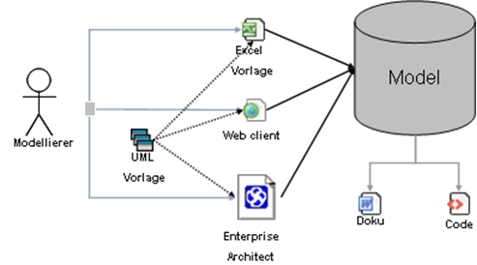

To be able to transform this abstract model in running code the support of a special class of frameworks is required, this is called Aphodite (alfa). This document provide the specification for a Aphodite class server.
It is divided in 2 parts: in the first guide to the choice of a suited existing framework.
In the second part describes in details which kind of functions you need eventually to extend.

Definition of Aphrodite
An Aphrodite server is a piece of software that support part of all of the following specification.
The technology used don't matter until the architectural pattern are present.
Typically frameworks (or collection of them) are used as base for Aphrodite servers.

About the name
Aphrodite and Chronos are part of the Olympos family. In Greek mythology Chronos was the father of Zeus. The prefix of all the Chronos objects is the Greek letter χ (see http://en.wikipedia.org/wiki/Chi_(letter) initial of the name Chronos (Χρόνος). Aphodite ((Αφροδιτη) was the goddness of love. The prefix for all Aphodite objects is the Greek letter Alfa α.

Choicing a framework that fit for Aphrodite
A fundamental step of the Model Driven Software Development approach is to find supporting frameworks.
Such a component is not always necessary, but it makes the task of code generation development significantly easier.
In fact the generated part of a code is only 10-20% of the code that is really deployed. The rest is composed by frameworks. If you decide to don’t have any support you will mostly generate stubs rather that running code.

What is a framework …
A software framework, in computer programming, is an abstraction in which common code providing generic functionality can be selectively overridden or specialized by user code providing specific functionality.
Frameworks are similar to software libraries in that they are reusable abstractions of code wrapped in a well-defined API. Unlike libraries, however, the overall program's flow of control is not dictated by the caller, but by the framework.
Source http://en.wikipedia.org/wiki/Software_framework
So a framework provides not only a set of functions but suggest a way to use them. A framework can be specialized in providing a special functionality or aims to cover the entire effort required for describe an application (general-purpose frameworks). While you can decide to write the perfect new one, typically is easier to leverage an existing framework.

Well know frameworks of the first type are Spring, Hibernate or EJB. Example of general-purpose frameworks are Ruby on Rails (ruby), Jboss Seams (java). A good candidate for Aphrodite belong to this category.

How to use a framework within a MDSD approach
According to Pree,software frameworks consist of frozen spots and hot spots. On the one hand, frozen spots define the overall architecture of a software system, that is to say its basic components and the relationships between them. These remain unchanged (frozen) in any instantiation of the application framework. On the other hand, hot spots represent those parts where the programmers using the framework add their own code to add the functionality specific to their own project.
Source http://en.wikipedia.org/wiki/Software_framework
Bold mine.
The aim of a MDSD is to generate the hot spot from an abstract definition (the model).

Top 10 rules
The Decalogue how to find the right framework for Aphrodite consists in:

- KISS (Keep It Simple Stupid)
- Convention vs Configuration
- Good Object orientation
- Aspect-oriented programming support
- Remote Access support
- Modular design
- MVC
- CRUD
- Tools Support
- Summa Summarum
As you can see the difference from a generic “very good framework for plain programming” is not so big. We can say that any good framework for MDSD is an optimal framework for the “old way”. But keep in mind: with a MDSD approach you do this only ONE time.

1. KISS Keep It Simple Stupid
No. this is not about “how easy the Hello World example is” rather “How long you need to understand enough to use it”. Design simplicity should be a key goal and unnecessary complexity avoided. A good framework hides the complexity behind a clear defined, simple API.

2. Convention vs Configuration
A lesson learned from “Ruby on rails” in positive and the typical old J2EE application in negative sense.
Your framework supports to run with minimal or no configuration. Even if a configurable entity was not configured, there should be some proper default to attach it with.

3. (Good) Object Orientation
The framework must provide a technical way to describes concepts like “Domain Object” (e.g. POJO. EJB, ...), Services (Controller, services, …), View (screens, GUI, ... ). See also the MVC point below.
Each of those concept should described by a class or equivalent that extends a framework class.
Class MyClass extend FrameworkDomainClass
{
//Some code
}

4. Aspect-oriented programming (AOP) support
Aspect-oriented programming (AOP) is a programming paradigm that increases modularity by allowing the separation of cross-cutting concerns.
Source http://en.wikipedia.org/wiki/Aspect-oriented_programming

5. Remote Access support
Remote access allows external component to use and call the internal functionalities of the framework without instantiating it directly. While many different implementation of a remote concept exists, today web services are the foundation of Remote access.
With remote access is easier to integrate many different component in a single application. This is the foundation of the mash ups programming style.
Questions to the framework: Look for remote access support.

6. Modular design
Modular design is a generally recognized “Good Thing(tm)” in software engineering. As in science in general, breaking a problem down to smaller, bite-sized pieces makes it easier to solve. It also allows different people to solve different parts of the problem and still have it all work correctly in the end. Each component is then self-contained and, as long as the interface between different components remains constant, can be extended or even gutted and rewritten as needed without causing a chaotic mess.
Plugins are typical implementation of modular design.

7 MVC
Model-view-controller (MVC) is an architectural pattern used in software engineering. Successful use of the pattern isolates business logic from user interface considerations, resulting in an application where it is easier to modify either the visual appearance of the application or the underlying business rules without affecting the other.

8. CRUD
Create, read, update and delete (CRUD) are the four basic functions of persistent storage,[1] a major part of nearly all computer software. Sometimes CRUD is expanded with the words retrieve instead of read or destroy instead of delete. It is also sometimes used to describe user interface conventions that facilitate viewing, searching, and changing information; often using computer-based forms and reports.
Our candidate framework should support CRUD for the Domain objects.

9. Tools Support
Many frameworks (e.g. Seams) have a built generator that is able to create a basic application starting from a single description (e.g. a database definition). Such a feature is a indication that you easily use within a MDSD context.

10. Summa Summarum
At theoretical level the framework code must have “places” to host all the concept of Chronos. Consult the actual Metamodel documentation for in deep information.
But at the end of the day, what you intent to realize is to provide a way to create templates for code generations.
See the example below.
Seam entity definition:
@Entity
@Name("person")
public class Person implements Serializable {
private long id;
private String name;
@Id @GeneratedValue
public long getId() { return id;}
public void setId(long id) { this.id = id; }
public String getName() { return name; }
public void setName(String name) {this.name = name;}
}
Example XPAND Transformation template (in Pseudo code):
@Entity
@Name("«this.name»")
public class Person implements Serializable {
private long «this.id»;
private String name;
@Id @GeneratedValue
public long getId() { return «this.id»;}
public void setId(long id) { this.«this.id»; = «this.id»; }
public String get«this.name»() { return «this.name»; }
public void set«this.name» (String «this.name») {this. «this.name»= «this.name»;}
}

FUNDAMENTALS

Model View Controller
As already introduced above the Chronos Metamodel uses Model View Controller as an approach to conceptual model a knowledge.
Chronos expand this pattern to use it outside from a technological environment so that can describe an abstract domain.

The MVC pattern is a widely used approach for describe concepts separating functionality among objects as to minimize the degree of coupling between them. To achieve this, it divides the domain into three layers: Model, View, and Controller.

Each layer handles specific tasks and has responsibilities to the other layers:

- The b (Model) is used to represent domain objects. It describes the identity and the properties of the domain objects. Operations, apart common object manipulation (CRUD), are included only if they govern exclusively the access and modification of the considered ChiNode .
- The ChiView (view) display the contents of a Model. Any kind of visualization can be modelled in a view.
It gets data from the model and specifies how that data should be presented. It updates data presentation when the model changes. A view also forwards user input to a controller. A view cannot execute business logic apart syntactical validation.
- The ChiController (controller) defines application behavior and the Business Logic that involve more that one ChiNode. It dispatches requests and selects views for presentation. It interprets user inputs and maps them into actions. Controllers are also used for support a base services in a Service Oriented Architecture. This is done by setting the A ChiController that is has the visibility set as “public” exposes a service to external system (for a detailed specification see below).

MODEL
A Chronos application is generally used to maintain any types of content. The different types of content (articles, images etc.) are defined in the so called Domain Object model.
To make the implementation of hierarchical organized content easier, a class Node should exists in the Aphrodite framework, which inherits from a persistence strategy. Node instances can contain other Node instances (children) and can be contained in other Node instances, respectively (parent). In this way trees can be defined.
The persistence strategy connect the data storage (database, XML files) with the entity objects. They contain the entity definitions, i.e. the type, it's attributes and the relations between different entity types.

STEREOTYPES FOR MODELLING THE DATA
The Metamodel knows the following stereotypes for domain modeling:
Name | UML meta class | Meaning | Example
ChiNode | Class | Entity type ChiNodes must inherit from the framework class Node. | Article
ChiValue | Attribute | A Node value type used in Chronos. Those values are persistent. | an Article's headline
ChiValueRef | Attribute | ReadOnly-Reference to an attribute of another entity type. Advantage: The referenced entity type doesn't have to be loaded completely. ValueRefs are not persistent. | If the node Author has Article nodes as children, the Author's name can be referenced in the Article node.
ChiManyToMany | Class | It is used to realize a many to many relation between 2 ChiNodes. It must inherit from the framework class Node. | To allow one Author to have different Articles and one Article to have different Authors.
ChiAssociation | Association | An association used in Chronos used to define a foreign key name. | The name of a foreign key column.
For each stereotype tagged values are defined, which are displayed in the following table.
Stereotype | Tagged value | Meaning |  | Values |  | Default value
ChiNode / ChiManyToMany | initparams |  | Name of the configuration file's (config.ini) section, in which the initial parameters for the corresponding mapper are defined |  |  |  | database
ChiNode / ChiManyToMany | is_soap |  | Define if the type should be exposed to the SOAP interface. |  | true|false |  | true
ChiNode / ChiManyToMany | orderby |  | Definition of default sorting. Possible values: 'none' (no order), 'sortkey' (generates a 'sortkey' column, that is used for explicit sorting) or any the name of any ChiValue defined in the node optionally followed by [ASC|DESC] e.g. 'name ASC'" default="none" |  | none|sortkey|any value |  | none
ChiNode / ChiManyToMany | is_searchable |  | Indicates whether this type should be included in the default search. |  | true|false |  | true
ChiNode / ChiManyToMany | table_name |  | The name of the database table. If not given the name of the class will be taken. |  |  |  | class name
ChiNode / ChiManyToMany | pk_name |  | The name of the primary key column. The generator will add this automatically if there is no appropriate attribute. |  | a single value or '|'- separated list of values (e.g fk_user_id|fk_role_id) |  | id
ChiNode / ChiManyToMany | child_order |  | The order of the associated children e.g. for Recipe: Image|Info|AdminInfo. |  | a single value or '|'- separated list of values
ChiNode / ChiManyToMany | parent_order |  | The order of the associated parents. |  | a single value or '|'- separated list of values
ChiNode / ChiManyToMany | display_value |  | The ChiValue(s) to display in a list. |  | a single value or '|'- separated list of values
ChiValue | app_data_type | The attribute's application datatype. This can be used in the application to group attributes and execute special logic on them. |  | DATATYPE_DONTCARE,  DATATYPE_ATTRIBUTE, DATATYPE_ELEMENT, DATATYPE_IGNORE |  | DATATYPE_ATTRIBUTE
ChiValue | db_data_type | The atribute's database type. This will be used in the table definition. |  | according to the database  e.g. INT, VARCHAR, TEXT, ... |  | VARCHAR(255)
ChiValue | is_editable | Declares, if the attribute is editable. |  | true|false |  | true
ChiValue | input_type | Definition of the attribute's input control in the HTML form. |  | text, password, textarea, select, radio, checkbox, file, fileex, fckeditor, filebrowser, linkbrowser, date  + additional definitions |  | text
ChiValue | display_type | The HTML display type for the attribute e.g. image. |  | image, text, link |  | text
ChiValue | restrictions_match | Regular expression, which must be matched by the attribute value. |  | e.g. '[0-3][0-9]\.[0-1][0-9]\.[0-9][0-9][0-9][0-9]' for date values
ChiValue | restrictions_not_match | Regular expression, which must not be matched by the attribute value. |  | See above
ChiValue | restrictions_description | A text describing the restrictions, which will be shown in case of an error.
ChiValue | column_name | The name of the database column. If not given the attribute name will be used. |  |  |  | attribute name

Stereotype | Tagged value | Meaning | Values | Default value
ChiAssociation | fk_name | The name of the foreign key column. The generator will add this if there is no appropriate attribute. If not given the generator will add 'fk_[parent]_id' |  | fk_[parent]_id
ChiValueRef | reference_type | Entity type, whose attribute is referenced
ChiValueRef | reference_value | The entity type's referenced attribute
Figure 1 illustrates the part of the Chronos UML profile, which is relevant for the modeling of the entity types. As the figure shows, the stereotype ChiNode and ChiManyToMany are used for classes while the stereotypes ChiValue and ChiValueRef are used for attributes. ChiNodes can contain other ChiNodes, their attributes are ChiValues or ChiValueRefs, of which they can contain as many as required.
Figure 1 Part of the Chronos UML Profile (data modeling)

An example of a simple data model is shown in Figure 2. Each of the entity types Author, Article and Image is modeled as ChiNode stereotypes, their attributes as ChiValue stereotypes. The only exception is the attribute author_name, which is a reference to the Author's name attribute and therefore is of the stereotype ChiValueRef. As the relations between the classes show, one Author can own several Articles and one Article in turn can contain several Images.
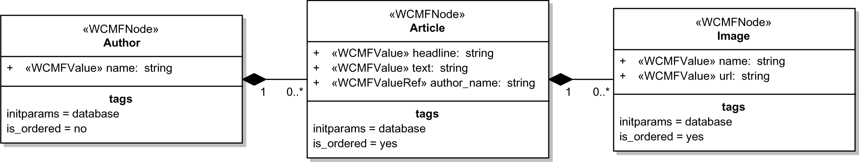Figure 2 Example of a data model

INHERITANCE
If different entity types should have the same attributes, one may define a common base class that makes these available to inheriting classes. An example may be a EntityBase type, which defines meta information like creation date and last modification date for all entity types (see Figure 3).
The generator expect to have a target class/mapper definitions for each class in the model. In case of inheritance the subclasses will contain the attributes of the parent classes too. For abstract base classes no mapper class will be generated.
Figure 3 Example of a data model using inheritance

ASSOCIATIONS
Associations are an important concept in a Chronos model, since they describe the relations between entities, namely the parent-child relation. There are three different types of associations supported: Composite, shared and one-directional normal associations (see Figure 4).
It is important to understand how Chronos recognizes parents and children in an association. In the case of composite and shared associations the parent is always the class, that is connected with the diamond end of the association. Normal associations are treated as parent-child relation, if they are only navigable in one direction, which is then defined as the child to parent direction.
Associations differ in the treatment of children in case of deletion of the parent. In shared and normal associations children are not deleted, while composite children are deleted on parent deletion. On the other hand the default Chronos application allows creation of child nodes in an composite association, while the other two only allow association of existing nodes. Note, that the multiplicity of children is taken into account when adding children. For example a 2 at the child's end means that the maximum number of children to add is two.
Inheritance will cause the generator to draw new relations in the following cases:
- Subclasses of parent classes of the current entity will become parents too.
- Parent classes of the superclass of the current entity will become parents too.
- Subclasses of child classes of the current entity will become children too.
- Child classes of super classes of the current entity will become children too.

Navigability
Another aspect of associations is the use of arrow ends that describe the navigability. If an arrow end is omitted on one end, that means that the appropriate entity type is not seen from the other end.
This association information will be written into the generated mapper classes.
Figure 4 Supported association types

Association types
In an Aphrodite application the different association types shown in Figure 4 result in different behaviors regarding the operations allowed on child entities.

Association type | Delete children | Create children | Associate children
Composite association | Yes | Yes | No
Shared association | No | Yes | Yes
Association | No | No | Yes

Multiple associations
Another question that may arise is how to model multiple associations between two types. Given that you have person and task entity types and you want to associate tasks with persons. To achieve this, you'll draw a shared association between them and place the aggregation (diamond) end at the project class.
But what if you want to have a task a task owner and a task creator?
In this case you'll have to draw a second association.
The next question is now how the generator can distinguish between a task creators and task owners. This is, where the concept of roles comes into play. To resolve this conflict, you'll have to assign role names to the person and task association ends. The generator will generate different entity and mapper classes for each role, which allows Chronos to know which role a person has in relation to a given task.

Multiplicity
Figure 5 Using roles in multiple associtions

Multiplicity is supported between Domain object only. In those cases the maximal ammount of objects is checked and if necessary new objects are created. In the example below a task cannot have more that a module attached.

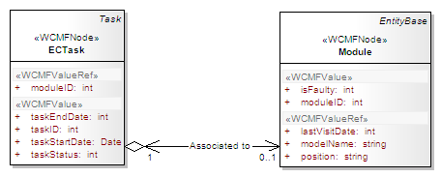
Figure 6 multiplicity support

Methods
A Aphrodite compilant framework should supports following operation or similar. If the operation needs to be implemented it SHOULD use those Standard names.

Name | Ret. Type | Params | Notes
acceptVisitor | boolean | visitor,String; | Accept a Visitor. For use with the 'Visitor Pattern'.
addChild | boolean | child,Node;  addtype,; | Add a Node to the Nodes childrenlist.
deleteChild | boolean | childOID,String;  reallyDelete,Boolean; | Delete a Node's child.
filter | Node | nodeList[],Node;  oid,String;  type,Node;  values[],String;  properties[],String; | Get Nodes that match given conditions from a list.  @return An Array holding references to the Nodes that matched.
getChildren | Node |  | Get the Node's children.  @return An Array holding references to the children.
getChildrenEx | Node | oid,String;  type,String;  values[],String;  properties[],String; | Get the children that match given conditions.  @return An Array holding references to the children that matched.
getDepth | integer |  | Get the Nodes depth.  @return The number of parents of the Node.
getDisplayValue | String | useDisplayType,String; | @see PersistentObject::getDisplayValue() Delegates to NodeUtil::getDisplayValue
getDisplayValues | String | useDisplayType,String; | Delegates to NodeUtil::getDisplayValues
getFirstChild | Node | type,Node;  values[],String;  properties[],String; | Get the first child that matches given conditions.  @return A reference to the first child that matched or null.
getFirstParent | Node | type,Node;  values[],String;  properties[],String; | Get the first parent that matches given conditions.  @return An reference to the first parent that matched or null.
getNextSibling | Node |  | Get the next sibling of the Node.  @return The next sibling of the node or NULL if it does not exists.
getNumChildren | Integer | memOnly,Boolean;  type,Node; | Get the number of children of the Node.  @return The number of children.
getNumParents | Integer | memOnly,Boolean;  type[],Node; | Get the number of parents of the Node.  @return The number of parents.
getParent | Node |  | Get the Nodes parent. This method exists for compatibility with previous versions. It returns the first parent.  @return A reference to the Nodes parent.
getParents | Node |  | Get the Nodes parents.  @return An array of references to the Nodes parents.
getParentsEx | Node | oid,var;  type,var;  values,var;  properties,var; | Get the parents that match given conditions.  @return An Array holding references to the parents that matched.
getPath | String |  | Get the Nodes path (to root).  @return The Node path.
getPreviousSibling | Node |  | Get the previous sibling of the Node.  @return The previous sibling of the node or NULL if it does not exists.
loadChildren | Boolean | type[],Node;  buildDepth,String;  forceUpdate,Boolean; | Load the children of a given type and add them. If all children should be loaded, set the type parameter to null.  @note This method relies on the property childoids, that should be set by the mapper, when loading the node
loadParents | Boolean | type[],Node;  forceUpdate,Boolean; | Load the parents of a given type and add them. If all parents should be loaded, set the type parameter to null.  @note This method relies on the property childoids, that should be set by the mapper, when loading the node
Node | Node | type,Node;  oid,String; | Constructor from the persistence strategy.
Save | Boolean |  | save the object current status to the persistence
setState | String | state,String;  recursive,Boolean; | Set the state of the node.  @return a string with the status
sort | Node | nodeList[],Node;  criteria,String;  recursive,Boolean;  changeSortkey,Boolean;  sortFunction,String; | Sort Node list by a given criteria.  @note static method  @note If criteria is only a string we will sort by this criteria with SORTTYPE_ASC  @return The sorted array of Nodes
sortChildren | var | criteria,String;  recursive,Boolean;  changeSortkey,Boolean;  sortFunction,String; | Sort children by a given criteria.  @note If criteria is only a string we will sort by this criteria with SORTTYPE_ASC
toString | String | verbose,boolean; | Get a string representation of the Node.  @return The string representation of the Node.
updateParent | Node | parent,Node;  recursive,Boolean; | Set a given parent. Works recursively.  @attention Internal use only.

Parent- Child versus Associated

Near the concept of parent/child we have also associated relationship that is expressed by an UML::Association. .
While Associations are used to build Graphs , Parent/ Childrens is used for Trees.
- Parent/Child relations are only defined in case of Composite/Shared associations
(Not in normal associations).

The parent is always on the side of the Composite/aggregation (diamond).

New Methods
This makes new generic methods for retrieving related objects necessary:
  - getParents()
  - getChildren()
  - getAssociated() NEW! (returns all related objects that are no parents or children)
  - getRelated() NEW! (returns all related objects, not mandatory)
  - addrelated() NEW! (insert an association not mandatory)

Validation of object constraints
Validation of object constraints (simple properties or relation properties) is not done until the objects are stored using the save method.

- This solves the problems of
- creating initial objects without being able to provide dependent objects
- temporarily breaking the multiplicity constraints while (dis-)associating
dependent objects

Generator check navigability
- In Composite/Shared relations navigability is given at least from Child to Parent.
This will be enforced by a constrain on the the ChiGenerator.
The generator produces an ERROR if this condition is true.
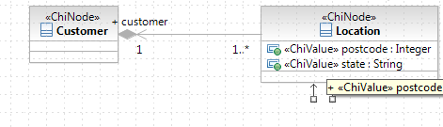Image 1: ok: navigability from Child to Parent in RSA

Image 2: Navigability on both Sides is allowed

NOTICE:
the same model of navigability on RSA don't show the arrows

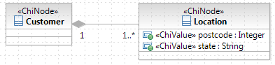Image 3: Navigation on both ends in RSA

Image 4: Navigability from Parent to Child is not allowed

Image 5: No Navigability is not allowed

Constructors

MRID Constructor
Every Aphrodite framework must implement a special constructor for MRIDs.

Object with no mRID
String MRID = “”;
Meter myMeter = New Meter(MRID);
If the system receives an object with no mRID (i. e. mRID entry does not exist or is of length 0), it assigns a new mRID to the object. This is done at the earliest possible place where the system has sufficient information for checking the received object against objects already existing in the system. This place is use case specific.
An object with no mRID cannot be referenced by any other object in the XML communication stream. If this is still required, the use case must explicitly state so (see below).

Object with mRID known to the receiver
String MRID = “fab470c2-5948-473b-aaa4-14c7143be2ce”;
Meter myMeter = New Meter(MRID);
If the system receives an object with an mRID and the mRID is known to the system, the received object and the internal one are considered identical.
The properties of the internal object are set them to the external if they are different from null.

Object with mRID not known to the receiver
String MRID = “fab470c2-5948-473b-aaa4-14c7143be2ce”;
Meter myMeter = New Meter(MRID);
If the system receives an object with an mRID and this is not known to the system, it is considered a new object.

Resulting activity
The above text is illustrated is illustrated by the following activity

constructor for associations
We had the idea to create special constructors for classes that have relations to other classes with a minimum multiplicity greater than 0. Example:

Image 6: Customer 1<---->1 CustomerConsumer

The constructor would be:
class Customer {

public Customer(String objectId, String customerConsumerObjectId) {
super(objectId);

// add the customerConsumer reference
...
}
}

Note that we need to have one parameter for each related object with a minimum multiplicity greater than 0 and in case of a multiplicity greater than 1 we need to have arrays of object ids.

I'm not sure if we need this, if we have the "construct-in-memory-evaluate-on-crud" paradigma together with the standard Aphrodite method addChild. From my point of view it was just a workaround for the problem of initially adding mandatory objects.

Delete / add objects
Before an object is added or deleted the upperValue and lowerValue need to be checked on the Related objects. If the constrain is violated a message error is send.
- In case of a one-to-one relation between two objects, the associate action
(e.g. addChild) will override an already associated object.

In case of a
one-to-many relation the new object is associated additionally, while the already associated objects stay associated.

Controller
A ChiController represents the realization of a ChiBusinessUseCase.

As convention every realization ends with the “Controller” keyword (eg manageWorkerController).
A sequence of ChiController realizes a ChiBusinessProcess and is realized from another ChiController.

Within a ChiController you have UML::Operations (e.g. Java Methods)

representing the realization of UML Actions (callOperationAction).

and within methods ChiRules.

The UML Metamodel is:

Definition of ChiRule
An ChiRule hosts a place a in which one (or more) ChiNode is modified following a condition.
Within the Chronos Metamodel 4 types of rules exist:
- Integrity Rules
- Derivation Rules
- Production Rules
- Reaction Rules

The UML Metamodel is:

In this version the Production rule only is supported.

Integrity Rules
It specialize into two kind of constraints r2ml:AlethicIntegrityRule and r2ml:DeonthicIntegrityRule.
Note: constraint must not contain any free variable.
The UML Metamodel is:

Example
A preferred client must have a portfolio that includes at least three energy products

Chononos Model

Aphrodite realizations

Jrules

Expeditor

wcmf

Derivation Rules
Any derivation rule consists from a condition part and a conclusion part.
In R2ML the conditions of a derivation rule are r2ml:qf.AndOrNafNegFormula.
Conclusions are restricted to quantifier-free disjunctive normal forms without NAF.
The UML metamodel is:

Example
If the following are not true, then eligible driver:
• Young driver,
• Senior driver.

Chononos Model

Aphrodite realizations

Jrules

Expeditor

wcmf
Production Rules
Represents a OMG Production Rule Rappresentation (see specification in appendix). In this text the details of PRR is not explained, please refer to the original specification for further details.
A production rule has zero or more ORulevariables , a condition part, a produced action expression part. Additionally can reference and modify zero or more domain objects.

The UML metamodel is:

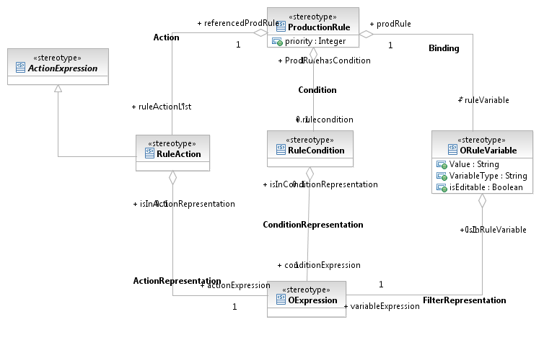
Modeling elements in Ouranos
a PRR in Ouranos is modeled as following:
the stereotype <<ProductionRuleSet>> is applied to an UML::Activity.
The steps in a business activity are UML::Call behaviour Actions that reference to the activity with stereotype <<ProductionRuleSet>> .
Within a ProductionRuleSet it is possible to model one or more PRR.
PRR is modelled as following:
input variables are Modelled as

PR Example 1
For orders under $100.00 a discount of 3% should be applied, for orders over $100.00 but under $1000.00 the discount should be 6%, for orders worth $1000.00 or more the discount should be 10%.
Assume order is a variable (local or global) or ruleset parameter

Ouranos Model
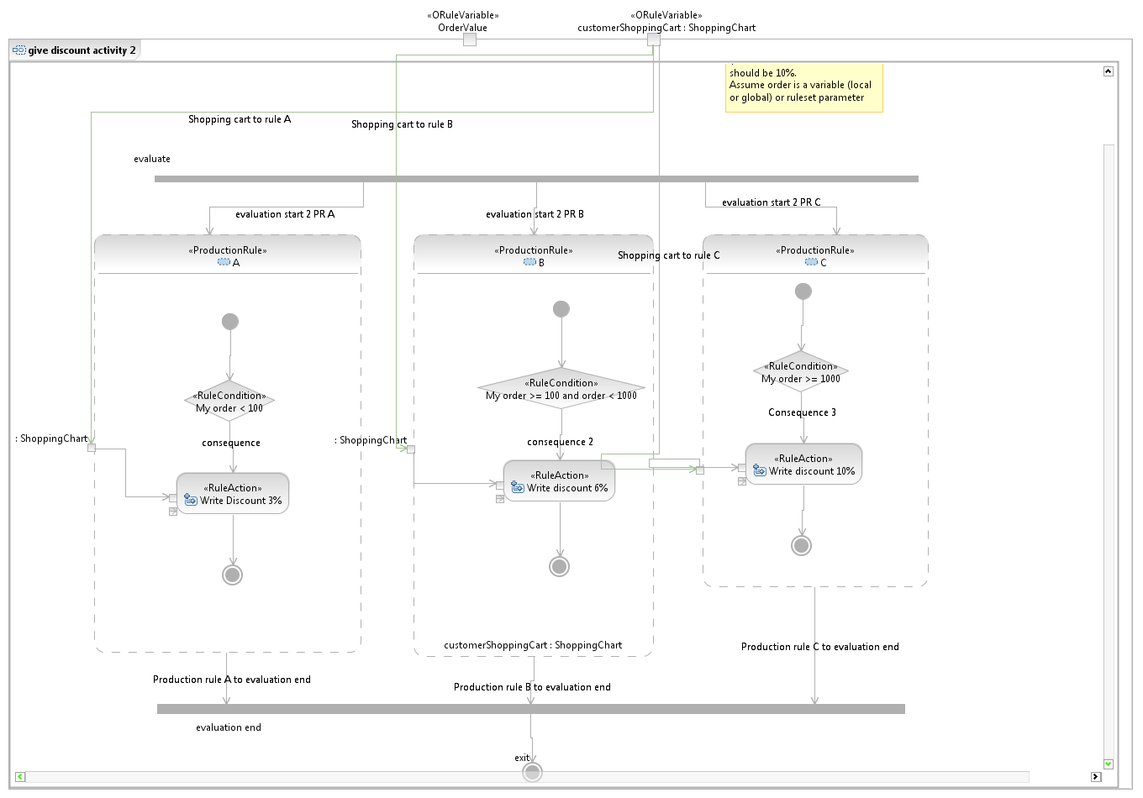

Aphrodite realizations

Jrules

ruleset GiveDiscountActivity2 {
in String orderValue, ShoppingCart customerShoppingCart;
out ShoppingCart customerShoppingCart;
}

package givediscountactivity2
{

rule a {
when {
IlrContext() from ?context;
evaluate(My order < 100);
}
then {
customerShoppingCart.discountValue = 3;
updateContext();
}
}

rule b {
when {
IlrContext() from ?context;
evaluate(My order >= 100 and order < 1000);
}
then {
customerShoppingCart.discountValue = 6;
updateContext();
}
}

rule c {
when {
IlrContext() from ?context;
evaluate(My order >= 1000);
}
then {
customerShoppingCart.discountValue = 10;
updateContext();
}
}

}

Expeditor

Wcmf

Example 2
If young driver and married and not located in CA, NY or VA, then increase premium by $300.

Chononos Model

Aphrodite realizations

Jrules

Expeditor

Wcmf

Reaction Rules

The R2ML model of a reaction rule (ECA rule) consists in a rule triggering an event expression a condition part a produced action expression part and an optional postcondition. Both action expression and postcondition have the same meaning as in ProductionRule.
The UML metamodel is:

Example
If there is a valid CheckAvailability event (i.e. checkInDate < checkOutDate) and a room is available then send a CheckAvailabilityResponse message

Chononos Model

Aphrodite realizations

Jrules

Expeditor

wcmf

View

Conditions

Two Unconnected Objects
Test for conditions in two unconnected objects.
class A {
String name
}

class B {
int age
}

condition: A.name == “Hugo” && B.age == 17

Two Connected Objects
Test for conditions in two connected objects.
class A {
String name
B b
}

class B {
int age
}

condition: A.name == “Hugo” && A.b.age == 17

Three Connected Objects with Role
Test for conditions in three objects, two of the same type connected to the third.
class A {
String name
B born
B died
}

class B {
Date date
}

condition: A.name == “Hugo” && A.born < “1900-01-01” && A.died <= “1999-12-31”

Many Connected Objects: Exists
Test for existence of at least one object in a many relation.
Class A {
String name
List[B] b
}

class B {
int age
}

condition: A.name == “Hugo” && A.b.exists(e|e.age >= 18)

Many Connected Objects: Count
Test for number of objects in a many relation.
class A {
String name
List[B] b
}

class B {
int age
}

condition: A.name == “Hugo” && A.b.select(e|e.age >= 18).size == 2

Aphodite abstract methods
In Aphrodite methods are standard functions actions are organized by the following UMLcriteria:
- (Domain) Object
- Link
- Variables
- Feature
- Operation

for each of them the basic CRUD operation is implemented.
Create, Read, Update and Delete.

(Domain) Object

Create Domain Object
Create a new domain object, persist it.

Pseudo Code
class A {
String name
}

action:
A a = new A()
a.save()

Load Domain Object by Id
Load a domain object from persistence by its id.

Pseudo Code
class A {
String name
}

action:
A a = A.loadById(7411)

Load Domain Object by Single Criteria
Load domain objects from persistence by single a criteria.

Pseudo Code
class A {
String name
}

action:
List[A] a = A.load(name == “Hugo”)

Load Domain Object by Multiple Criteria
Load domain objects from persistence by several criteria.
Pseudo Code
class A {
String name
int age
}

action:
List[A] a = A.load(name == “Hugo” && age >= 18)

Load Domain Object by Connected Object
Load domain objects from persistence by criteria applied to connected objects.
Pseudo Code
class A {
String name
B b
}

class B {
int age
}

action:
List[A] a = A.load(name == “Hugo” && b.age < 18)

Read and Update Different Domain Objects
Read property of one domain object, write it to another domain object, save it.
Pseudo Code
class A {
String firstName
}

class B {
String lastName
String fullName
}

action:
B.fullName = A.firstName + B.fullName
B.save()

Delete Domain Object
Delete a domain object.
Pseudo Code
class A {
String name
}

action:
A a = A.loadById(4711)
a.delete()

Link

Associate Two Domain Objects
Assign an domain object to another one.
Pseudo Code
class A {
String name
B b
}

class B {
int age
}

action:
a.b = b
a.save()

Disassociate Two Domain Objects
Remove the link between two domain objects.

Pseudo Code
class A {
String name
B b
}

class B {
int age
}

action:
a.b = null
a.save()

Add Domain Object to Many Relation
Add a domain object to list contained in other domain object.
Pseudo Code
class A {
String name
List[B] b
}

class B {
int age
}

action:
a.b.add(b)
a.save()

Remove Domain Object from Many Relation
Remove a domain object from a list contained in other domain object.
Pseudo Code
class A {
String name
List[B] b
}

class B {
int age
}

action:
a.b.remove(b)
a.save()

Iterate over Many Relation
Execute action for each object contained in other domain object list.
Pseudo Code
class A {
String name
List[B] b
}

class B {
int age
}

action:
foreach (a.b as currentB) {
currentB.age += 1
currentB.save()
}

Variables

Feature

Operation

Complex Arithmetic Calculation
Assign result of complex arithmetic calculation to domain object attribute.

Pseudo Code
class A {
int price
int vat
}

action:
a.vat = a.price * (0.07 + 0.19)

Conditional Execution
Evaluate condition.
Pseudo Code
class A {
int price
int vat
boolean isFlower
}

action:
if (a.isFlower) {
a.vat = a.price * 0.07;
} else {
a.vat = a.price * 0.19;
}

The referenced entity type must be directly related to the type holding the reference, i.e. it must be a child or parent node. If the relation isn't clear, unexpected behaviour could be the result (for instance, if Image instances are referenced by the name attribute of an Article and one Article is allowed to contain more than one Image, the reference holds the name of the first Image).
The application's data types are globally defined e.g. In PersistentObject.
The interpretation of the input_type is done by DefaultControlRenderer or its subclasses.
The interpretation of the display_type is done by DefaultValueRenderer or its subclasses.
The PHP function preg_match is used for comparison.
The PHP function preg_match is used for comparison.
Please see the MRID document for more information related to it

