Olympos

Chronos Web Tools

Build guide 0.9.9.6

Author: Ingo Herwig
Owner: Giuseppe Platania

Document History
Document Location
This is a snapshot of an on-line document. Paper copies are valid only on the day they are printed. Refer to the author if you are in any doubt about the currency of this document.
The source of the document will be found in the Subversion repository on Source Forge.
https://olympos.svn.sourceforge.net/svnroot/olympos/trunk/olympos/chronos/scr/applications/requirements/Building_Chronos_Web_Modeller.odt
Revision History
Date of this revision: 05/05/11 | Date of next revision TBD

Revision Number | Revision Date | Summary of Changes
(#) | (-) | (Describe change)
0.1 | 18/01/11 | Created
0.2 | 05/04/11 | review
Contents
1. Abstract 4
2. License 5
3. Requirements 6
3.1 Software 6
Build 7
3.2 Download the source files 7
3.3 Adjust release and revision numbers 7
3.4 Run the build process 7
Running CWT from source 8

Abstract
This file describes how to build the Chronos Web Tools from source.

License
The code of the CWT and the accompanying materials are made available under the terms of the Eclipse Public License v1.0 which accompanies this distribution, and is available at http://www.eclipse.org/legal/epl-v10.html.

The concept of Chronos is made available under the Creative Common license.
You are free:
* to Share — to copy, distribute and transmit the work
* to Remix — to adapt the work
Under the following conditions:
* Attribution. You must attribute the work in the manner specified by the author or licensor (but not in any way that suggests that they endorse you or your use of the work).
* For any reuse or distribution, you must make clear to others the license terms of this work. The best way to do this is with a link to this web page.
* Any of the above conditions can be waived if you get permission from the copyright holder.
* Nothing in this license impairs or restricts the author's moral rights.

Requirements
Please consider the following list of requirements before building the Chronos Web Modeler

Software
The build process requires the following components:
- Java SDK 1.6
- Apache Ant
- Subversion client

setup eclipse workspace

Download the source files
Checkout the source files from the Olympos Subversion repository using the following command:
svn co https://olympos.svn.sourceforge.net/svnroot/olympos/trunk/olympos/chronos/scr/workspace/ olympos

Configure eclipse
Select “import”, then “existing project in workspace.”
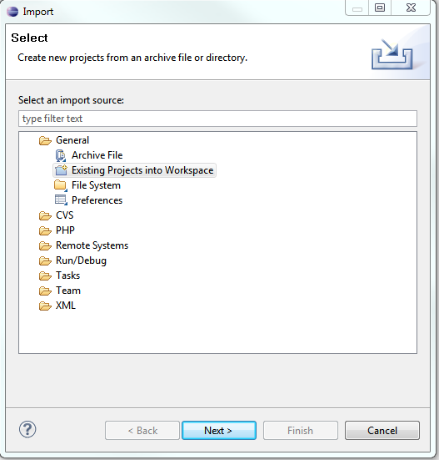
import the eclipse projects:

Build

Building CWT requires the following steps:
  - Download the source files
  - Adjust release and revision numbers (optional)
  - Run the build process

Adjust release and revision numbers
If you want to create a release, you have to adjust the build and revision numbers to match the next release number. This needs to be done in the following files:
- olympos/Build/build.properties: Set the version property to the next release number
- olympos/DiagramImageExporter/build.properties: Set the version property to the next release number
- olympos/generator/build/build.properties: Set the version property to the next release number
- olympos/gui/welcome/welcome.html: Search for Welcome to the Chronos Web Modeler (line 21) and replace the old release number with the next release number
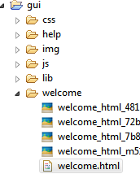
- olympos/gui/js/uwm/Constants.js: Set the uwm.Constants.SVN_REVISION property to the current svn revision number

Run the build process
Change to the olympos/Build directory and run the build process with the following command:
ant zip
This will create a file named ChronosWebTools-<release number>-<date>.zip in the same directory, which contains the CWT release.

Running CWT from source
You can also run CWT from the source tree after accomplishing the following steps:
- Checkout the source files from the Olympos Subversion repository (see 4.1)
- Make the olympos directory available under your webserver
- Create the CWM database and adjust the configuration in olympos/application/server.ini according to the installation manual (see http://olympos.svn.sourceforge.net/viewvc/olympos/trunk/olympos/chronos/scr/applications/requirements/Chronos_Web_Modeller_Installation.pdf)
- Since the source directory structure of the generator is not the same as the final deployment structure, you have to create a generator build. Change to the olympos/generator/build directory and run ant. This will create a file named ChronosGenerator-<release number>.zip that contains the generator. Unpack the archive to a directory of your choice and change olympos/application/server.ini according to that directory.
- Point your webbrowser to olympos/gui/index.html in order to run CWM. All changes made in the PHP and Javascript/HTML sources will be visible in CWM.

