Chronos Web Modeler


Welcome to Chronos Web Modeler! This document describes the usage of the application.
Table of Contents
1 Introduction
1.1 About the Chronos Web Modeler
1.2 License
1.3 Compatible Browsers
2 Terminology
3 User Interface
3.1 About the user interface paradigm
3.2 Login
3.3 Workbench
3.3.1 New Objects
3.3.2 Model Tree
3.3.2.1 Models
3.3.2.2 Packages
3.3.2.3 Diagrams
3.3.2.4 Model Objects
3.3.2.5 Object history
3.3.3 Hierarchy Tree
3.3.4 Object Grids
3.3.5 Diagram
3.3.6 Properties
3.3.6.1 Text Input Fields
3.3.6.2 Dropdown Lists
3.3.6.3 Rich Text Edit Boxes
3.3.6.4 Read-Only Fields
3.4 Administration perspective
3.5 Model upload
3.6 Enumerations tabs
4 Model Description
4.1 ChiGoal
4.2 ChiRequirement
4.3 ChiFeature
4.4 ChiIssue
4.5 ChiBusinessProcess
4.6 ChiBusinessUseCase
4.7 ChiWorkerExternal
5 Howto
5.1 Get started
5.2 How to create an activity

Introduction

About the Chronos Web Modeler
The Chronos Web Modeler (CWM) aims to provide an collaborative environment to create and manage models. The resulting models can be exported to be used in other editors or directly transformed in code and/or a documentation.

We are developing the CWM with simplicity in mind.
Especially for the gathering of requirements and use cases a complete modeling tool can be an over kill. A web client, featuring zero installation, allows multiple users to works on the same model contemporaneously.

License
The CWM and the accompanying materials are made available under the terms of the Eclipse Public License v1.0 which accompanies this distribution, and is available at http://www.eclipse.org/legal/epl-v10.html.

The concept of Chronos is made available under the Creative Common license.
You are free:
* to Share — to copy, distribute and transmit the work
* to Remix — to adapt the work
Under the following conditions:

* Attribution. You must attribute the work in the manner specified by the author or licensor (but not in any way that suggests that they endorse you or your use of the work).

* For any reuse or distribution, you must make clear to others the license terms of this work. The best way to do this is with a link to this web page.
* Any of the above conditions can be waived if you get permission from the copyright holder.
* Nothing in this license impairs or restricts the author's moral rights.

You can download the most recent CWM version from: http://sourceforge.net/projects/olympos/

Compatible Browsers
At the moment (Beta version), the only browser with extensive test coverage is Firefox 3. Occasional tests with other modern browsers show no principal incompatibilities. If you decide to use others browser you can face errors or erratical behaviour.

Terminology
Term | Description
Model | A model is a an abstraction of a domain of interest.
Package | A package is a container of objects.
Diagram | A diagram is a visual representation of a model part. Object that are in diagrams are also contained in the model. Not all the object in a model are necessarily contained in a diagram.
Model Object | Object which is part of the model. Figurative: Everything you can put on a diagram.
Model Object Type | Each model object has a type, depicted by its icon. Each model object type has a different set of properties, to be reviewed in properties view.
Metamodel | A metamodel describes the concepts necessary to describes a model.  While a model is an abstraction of phenomena in the real world; a metamodel is yet another abstraction, highlighting properties of the model itself.

User Interface

About the user interface paradigm
Although this application runs in a web browser, it behaves much like a desktop application. For example, the paradigms of drag&drop and context menus are used throughout the application.
A very large monitor is suggested to be able to display the workplace and the diagrams. To maximize the available urface you can switch your browser to “full screen” (press “F11”).

Login
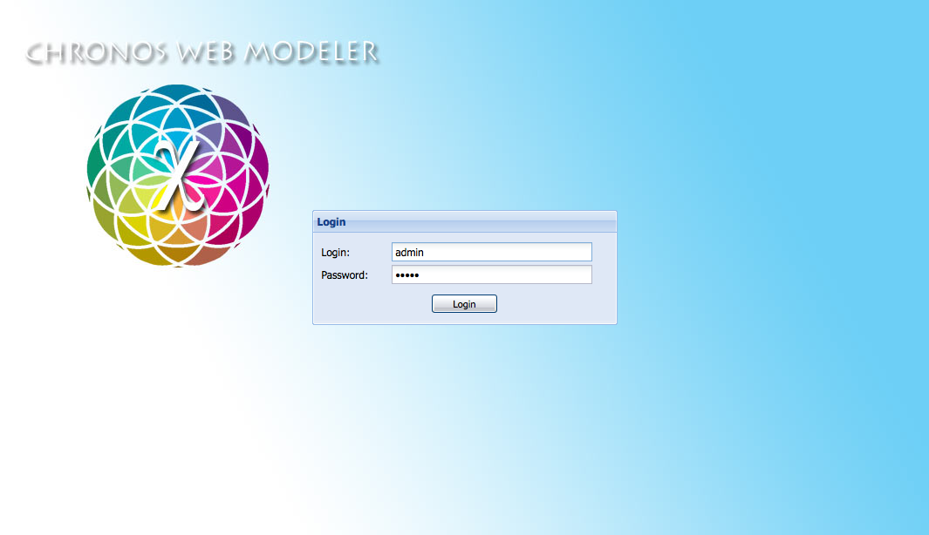
At the login screen, the login and password credentials are entered. They are checked against the system database. If successful, The user is automatically forwarded to the workbench. Otherwise, an error message is displayed.

Workbench
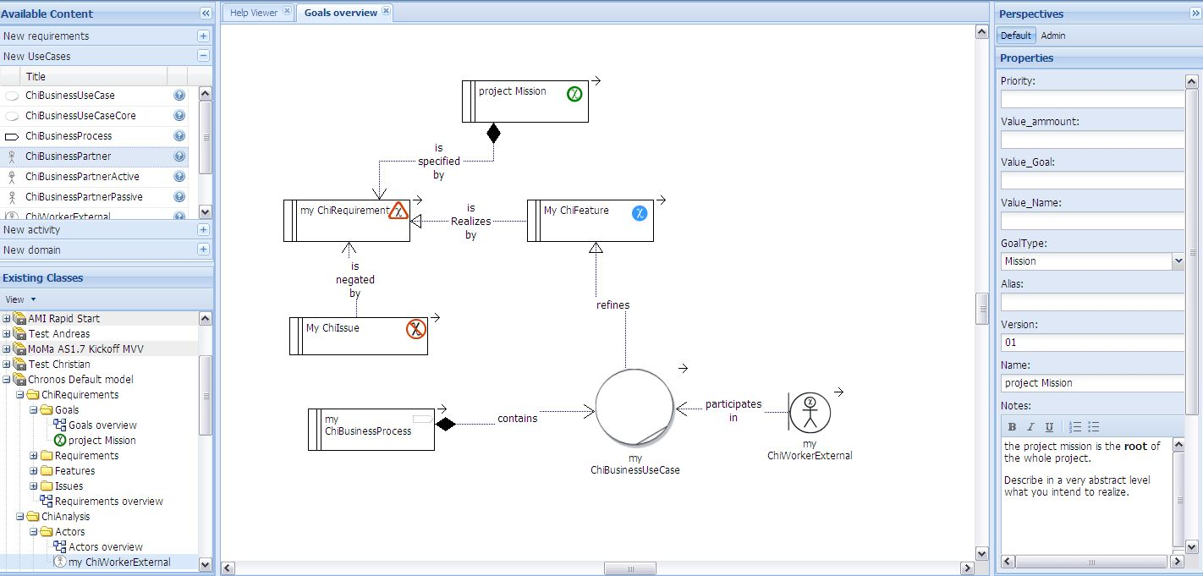
The workbench consists of several areas, called views. All views except the main model view can be collapsed by the » buttons in the title bar.

New Objects
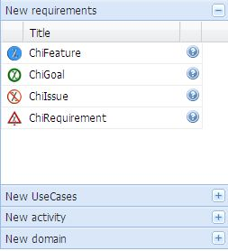
The new objects view is located in the upper left part of the workbench. It lists all model objects the user may add to a diagram. For each object, an icon, the title and a description is listed.
Task | Action | Description
Visualize a toolbox | Click on the + Button. | This display a toolbox with the related objects.
Add new model object to diagram | Drag new object from new objects view, drop on diagram view | Adds a new model object of the selected type to the model at the dropped location. The model object is automatically added to the package containing the model the user dropped the new object on.
Get help | Move the mouse over the ? Icon | Return a tooltip with information about the object (if available)

Model Tree
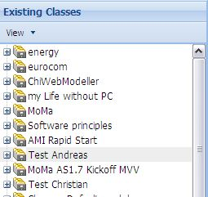
The model tree view is the first tab in the lower left part of the workbench. It contains all models of this application. It shows the logical position of each object in the application.
Task | Action | Description
Create new model in application | Right-click on empty space in model tree, select “Create model” in context menu | Creates a new model in the application. The default name is assigned to the new model.

Models
Models are the root elements in the model tree.
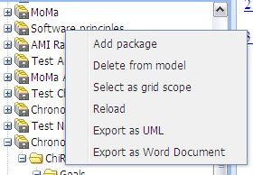
Task | Action | Description
View model properties | Single-click on the model | All properties of a model can be reviewed in the properties view.
Change label of a model | Single-click on the model, change name in properties view, leave name field | If you change the model name in properties view, the model tree is automatically updated.
Add package to model | Right-click on the model, select “Add package” from context menu | Adds a package below the selected model. The default name is assigned to the new package.
Delete model | Right-click on the model, select “Delete from application” from context menu | Deletes the model and all contained packages, diagrams and model objects from the application.
List all model objects of specific types contained in this model | Right-click on the model, select “Select as grid scope” from the context menu | For some model object types, lists of all model objects of this type are available. This action selects a model (and all directly and indirectly contained packages) as scope for the lists.
Download a model. | Right-click on the model, select “Download as UML” from the context menu | Export the model and all the contained objects as a UML file with reference to the Chronos metamodel stereotypes.  This can be imported in any UML tool (e.g. IBM Rational Software modeler, TopCased, Sparx EnterpriseArchtect, etc.).  Diagrams are not exported.
Reload the model from the server. | Right-click on the model, select “reload” from the context menu | If you are collaborating on a model it is useful to reload the contains from the server to have the same view as your co workers.
Export documentation | Right-click on the Model, select “Export as Word Document” from the context menu | Export the complete and all the contained objects as a Word file using a certain document template.

Packages
Packages allow structuring complex models, like folders in the file system.
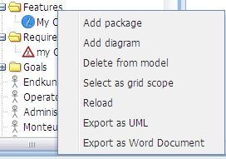
Task | Action | Description
View package properties | Single-click on the package | All properties of a package can be reviewed in the properties view.
Change label of a package | Single-click on the package, change name in properties view, leave name field | If you change the package name in properties view, the model tree is automatically updated.
Add sub-package to package | Right-click on the package, select “Add package” from context menu | Adds a package below the selected package. The default name is assigned to the new package.
Delete package from model | Right-click on the package, select “Delete from model” from context menu | Deletes the package and all contained packages, diagrams and model objects from the model.
Add diagram to package | Right-click on the package, select “Add diagram” from context menu | Adds a new diagram below the selected package. The default name is assigned to the new diagram. The new diagram is automatically opened in diagram view.
List all model objects of specific types contained in this package | Right-click on the package, select “Select as grid scope” from the context menu | For some model object types, lists of all model objects of this type are available. This action selects a package (and all directly and indirectly contained packages) as scope for the lists.
Move package to different parent package or model | Drag the package, drop it on the target package or model | Moves the package to a different parent package or model.
Download a Package. | Right-click on the Packge, select “Download as UML” from the context menu | Export the Package and all the contained objects as a UML file with reference to the Chronos metamodel stereotypes.
Export documentation | Right-click on the Package, select “Export as Word Document” from the context menu | Export the package and all the contained objects as a Word file using a document template.

Diagrams
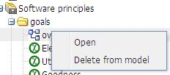
Diagrams show graphical depictions of a part of a model.
Task | Action | Description
View diagram properties | Single-click on the diagram | All properties of a diagram can be reviewed in the properties view.
Change label of a diagram | Single-click on the diagram, change name in properties view, leave name field | If you change the diagram name in properties view, the model tree is automatically updated.
Delete diagram from model | Right-click on the diagram, select “Delete from model” from context menu | Deletes the diagram from the model.
Move diagram to different package | Drag the diagram, drop it on the target package | Moves the diagram to a different package.
Open diagram | Double-click the diagram  OR  Right-click on the diagram, select “Open” from context menu | Opens the diagram in diagram view or selects the diagram's tab in diagram view if already opened.

Model Objects
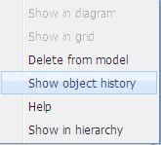
Model Objects are the building blocks of the modeled system.
Task | Action | Description
View model object properties | Single-click on the model object | All properties of a model object can be reviewed in the properties view.
Change label of a model object | Single-click on the model object, change name in properties view, leave name field | If you change the model object name in properties view, the model tree is automatically updated.
Delete model object from model | Right-click on the model object, select “Delete from model” from context menu | Deletes the model object from the model.
Move model object to different package | Drag the model object, drop it on the target package | Moves the model object to a different package.
Add existing model object to a diagram | Drag the model object, drop it on the diagram in diagram view | Adds the dragged model object at the dropped position to the diagram. If the model object is already contained in the diagram, it cannot be added again.
Show model object in current diagram | Right-click on the model object, select “Show in diagram” from context menu | Scrolls the current diagram to the position of the selected model object. Only available if the model object is contained in the current model.
Show model object in grid | Right-click on the model object, select “Show in grid” from context menu | Shows the appropriate grid and selects the selected model object. Only available if a grid of the selected model object type is available and the model object is within currently selected grid scope.
Show model object in hierarchy view | Right-click on the model object, select “Show in hierarchy” from context menu | Shows the selected model object as root element of the hierarchy tree view.
Get help about this object | Right-click on the model object, select “Help” from context menu | Shows the Help file.
Get previous Object Properties | Right-click on the model object, select “show object History” from context menu | Shows the object history windows (see below).

Object history
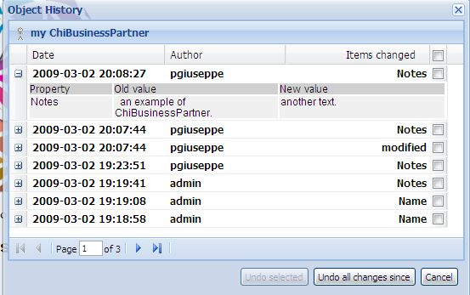
The object history offer a complete history of all changes made on an object.

Task | Action | Description
Check the change made in a date | Click on the button + | Visualize the property name, the old and the new value.
Select a point on the history to be restored. | Mark all the checkbox you intend to restore. Click on the “undo all changes since” button. | Restored all the properties values to the previous state.

Hierarchy Tree
The hierarchy tree view is the second tab in the lower left part of the workbench. It shows all dependencies of a selected model object. In deeper dependency levels, the dependencies directly above are omitted for clarity.
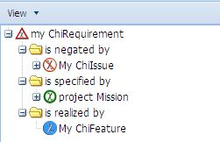
Task | Action | Description
Show model object in hierarchy tree | Right-click on the model object in model tree, grid, or diagram, select “Show in hierarchy” from context menu | Shows the selected model object as root element of the hierarchy tree view.
View model object properties | Single-click on the model object | All properties of a model object can be reviewed in the properties view.
Change label of a model object | Single-click on the model object, change name in properties view, leave name field | If you change the model object name in properties view, the model tree is automatically updated.
Delete model object from model | Right-click on the model object, select “Delete from model” from context menu | Deletes the model object from the model.
Add existing model object to a diagram | Drag the model object, drop it on the diagram in diagram view | Adds the dragged model object at the dropped position to the diagram. If the model object is already contained in the diagram, it cannot be added again.
Show model object in current Diagram | Right-click on the model object, select “Show in diagram” from context menu | Scrolls the current diagram to the position of the selected model object. Only available if the model object is contained in the current model.
Show model object in grid | Right-click on the model object, select “Show in grid” from context menu | Shows the appropriate grid and selects the selected model object. Only available if a grid of the selected model object type is available and the model object is within currently selected grid scope.
Show model object in model tree | Right-click on the model object, select “Show in model tree” from context menu | Selects the model object in context menu. If any of the containing packages are currently not opened, they are automatically extended.

Object Grids
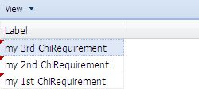
Object grid views are one tab per model object type in the lower left part of the workbench. Not all model object types have an object grid. The object grids list all objects of the appropriate model object type within the selected scope.
Task | Action | Description
Select object grid scope | Right-click on a model or a package in model tree, select “Select as grid scope” from the context menu | Selects a model or a package (and all directly and indirectly contained packages) as scope for the grids.
View model object properties | Single-click on the model object | All properties of a model object can be reviewed in the properties view.
Change label of a model object | Single-click on the model object, change name in properties view, leave name field | If you change the model object name in properties view, the model tree is automatically updated.
Delete model object from model | Right-click on the model object, select “Delete from model” from context menu | Deletes the model object from the model.
Add existing model object to a diagram | Drag the model object, drop it on the diagram in diagram view | Adds the dragged model object at the dropped position to the diagram. If the model object is already contained in the diagram, it cannot be added again.
Show model object in current diagram | Right-click on the model object, select “Show in diagram” from context menu | Scrolls the current diagram to the position of the selected model object. Only available if the model object is contained in the current model.
Show model object in model tree | Right-click on the model object, select “Show in model tree” from context menu | Selects the model object in context menu. If any of the containing packages are currently not opened, they are automatically extended.
Show model object in hierarchy view | Right-click on the model object, select “Show in hierarchy” from context menu | Shows the selected model object as root element of the hierarchy tree view.

Diagram
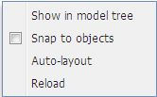
The diagram view takes the center space of the workbench. It shows the diagrams, containing of model objects and their connections.
Task | Action | Description
Show diagram in model tree. | Right-click on empty space in diagram, select “Show in model tree” from context menu. | Selects the diagram in the tree. If any of the containing packages are currently not opened, they are automatically extended.
Toggle snap to objects. | Right-click on empty space in diagram, select “Snap to objects” from context menu. | If enabled, model objects “snap in” to other model objects at a nearby horizontal or vertical axis when moving them.
Auto-layout diagram. | Right-click on empty space in diagram, select “Auto-layout” from context menu. | Automatically relocates the model objects contained in the diagram so connected model objects are close to each other and connections do not overlap.
Add existing model object to a diagram. | Drag the model object from model tree, hierarchy tree, or object grid, drop it on the diagram in diagram view. | Adds the dragged model object at the dropped position to the diagram. If the model object is already contained in the diagram, it cannot be added again.
Add new model object to diagram. | Drag new object from new objects view, drop on diagram view. | Adds a new model object of the selected type to the model at the dropped location. The model object is automatically added to the package containing the model the user dropped the new object on.
Add connection. | Drag the connection arrow of the source model object, drop it on the connection arrow of the target model object. | Connects the two model objects. Only available if the two model object types are connected by the metamodel. Connection direction is automatically reversed if required.
Delete model object from diagram | Right-click on the model object, select “Delete from diagram” from context menu  OR  single-click on the model object, press DEL key | Deletes the model object from the diagram. It is still part of the model.
Delete model object from model | Right-click on the model object, select “Delete from model” from context menu | Deletes the model object from the model.
Delete connection from model | Right-click on the connection, selelct “Delete from model” from context menu  OR  single-click on the connection, press DEL key | Deletes the connection from the model.
Show model object in model tree | Right-click on the model object, select “Show in model tree” from context menu | Selects the model object in context menu. If any of the containing packages are currently not opened, they are automatically extended.
Show model object in hierarchy view | Right-click on the model object, select “Show in hierarchy” from context menu | Shows the selected model object as root element of the hierarchy tree view.
Show model object in grid | Right-click on the model object, select “Show in grid” from context menu | Shows the appropriate grid and selects the selected model object. Only available if a grid of the selected model object type is available and the model object is within currently selected grid scope.

Properties
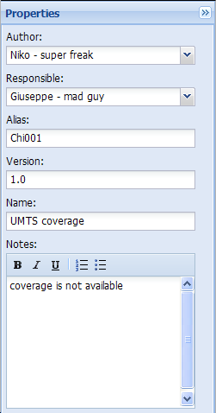
The properties view is located at the right part of the workbench. It shows the properties of a selected object. Each object has different properties. When properties are displayed the object is automatically locked for editing by other users.

Text Input Fields
Text input fields allow a single line of text. Changes are saved to the model when leaving the input field.

Dropdown Lists
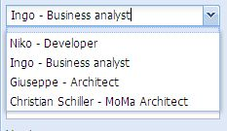
Dropdown lists allow selection of a list of pre-defined values. Changes are saved to the model when leaving the input field.
Some Drop down are dynamic an can be configured in the administration perspective.

Rich Text Edit Boxes
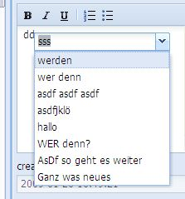
Rich text edit boxes allow multiple lines or paragraphs of formatted text. The formats bold, italic, underline, ordered list and unordered list are available. Changes are saved to the model when a different object's properties are displayed.

Task | Action | Description
Auto complete | Write some keys, press SHIFT + SPACE. Scroll the list with arrow keys. Pick one entry with ENTER. | A list of existing Types with those letters appears. Supported are following types:  - domain objects (chi Node)  - Actors  - Use Cases (ChiBusinessUsecase)  the objects become a standard format as following:  Domain Objects: Bold  actors: underline  Use Cases: italic

Read-Only Fields
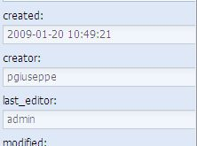
Read-only fields are displayed with a grey background. They cannot be edited.

Administration perspective
The administration perspective allows to the project configuration. To switch to the administration perspective use the “Admin” button located on the top right of your screen.
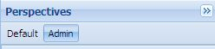

Task | Action | Description
Display the admin perspective. | Click on the button “Admin” | The standard perspective disappear. The administration perspective is displayed.

Model upload
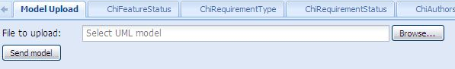
Task | Action | Description
Import a model | - Click on the button “browse”  - select a valid UML file  - click on the “send model” button | This task import a valid Model into the CWM. Valid models are UML2 EMF with a reference to the Chronos profile. Generic UML model are not supported.  See the documentation of other Chronos tools to understand how to create a model for importing.

Enumerations tabs

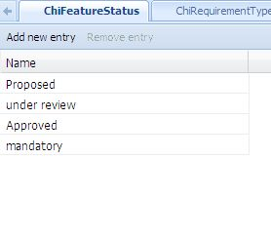
Task | Action | Description
Display the default perspective. | Click on the button “default” | The Administration perspective disappear. The default perspective is displayed.
Display an enumeration | Click on the Tab with the enumeration name you intend to edit. If necessary use the arrows left and right to display more tabs. | An enumeration type is displayed.
View enumeration properties | Single-click on one item on the list. | All properties of the enumeration can be reviewed in the properties view.
Delete enumeration from model. | Select the item on the list. Click on the button “remove entry”. | Deletes the enumeration from the list.

Model Description
This part of the help describes in details the Chronos model, their objects (e.g ChiGoal, ChiRequirements, etc) and properties (e.g. Name, text, etc.). Because this structure is generated from a UML model the final information you can find can varies depending from the situation.

ChiGoal

Definition: a Measurable scope that the enterprise (or the project) wants to achieve.
A ChiGoal represent a certain status or valour that a variable in the considered model MUST achieve.
The root Goal of a Chronos Model is called a Vision.

Difference between ChiGoal and ChiRequirement
While a goal represents a wide (but concrete!) scope, a requirement is a specific milestone within this scope that needs to be addressed.
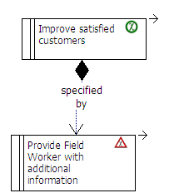
A ChiRequirement underline question “is achieved?” and the answer is “Yes” if a ChiFeature is attached to the requirement. A Goal is considered to be achieved if al the attached requirements are true.

Constrains:
- A ChiGoal should be measurable the Value_Goal SHOULD be an integer. If this is “0” (default) the goal is not valid and the generator produces a WARNING.
- A ChiGoal contains one or more ChiGoals or ChiRequirements. A ChiGoals that contains a child ChiGoals SHOULD NOT contain a ChiRequirement.
- All the ChiGoals “is specified by” (and MUST be linked with) one or more ChiRequirements with a shared or composition link.
- A ChiGoals that contains a child ChiGoals SHOULD NOT contain a ChiRequirement.
- A ChiGoal is considered achieved when all the attached ChiRequirements are realized by a ChiFeature.
- If a Goal hierarchy is present ALL the element of the hierarchy are supposed to be checkef for their values. The fact that a child Goal has achieved his proposed Value_Name DON’T automatically set the parents values.

Tagged Values:
Key | Notice | Value
ID | The unique ID of this object. CHI + 3 numbers + object name. MUST. | CHI 001GOA
Name | A short sentence that give an idea of the sense of this object. MUST
Description | A complete text description of the object. OPTIONAL
Type | Type of goal. MUST | Strategic | Operational | Vision | Mission
Priority | A priority in %. MUST | 1-100
Value_Name | The name of the value this goal intends to alter. OPTIONAL
Value_ammount | The actual amount of the value this goal intends to alter. OPTIONAL | 0
Value_Goal | The amount by which the value is to be altered. OPTIONAL | 0

ChiRequirement

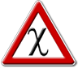
Definition: A Business guide line about the Enterprise or the project.
A ChiRequirement represents a condition that needs to be Satisfied by certain achievement (a ChiFeature ).
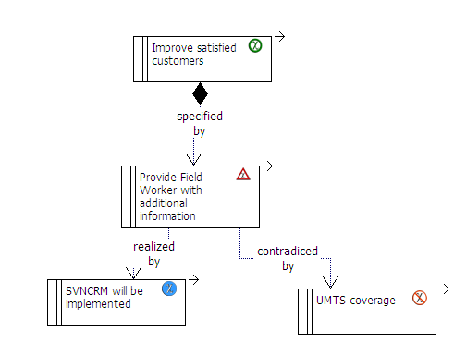
Constrains:
- All the ChiRequirements MUST be linked with a parent ChiGoal either directly or in a hierarchy of further requirements. The sum of all requirements being true () will set the Value_Name of the first Parent ChiGoal in the hierarchy to the expected Value_Goal.
- When is created a ChiRequirement has the status of Proposed until he is checked by a proofreader.
- When the field of the proof reader is filled (with a name) the ChiRequirement take the status
- To achieve the status of “Satisfied” a ChiRequirement MUST be linked with a ChiFeature with the realizazion “is realized by”.
- CAN be linked a ChiIssue wit the stereotype “is negated by”.
- Each requirement needs to be confirmed by a proofreader. If proofreader is “none” (default) the requirement is not valid and the generator produces a WARNING.
- A ChiRequirement becomes “Satisfied” when a ChiFeature is attached to him. Until a requirement has not the status “Validated” the generator produces a warning.
Tagged Values:
Key | Notice | Value
ID | The ID of this object. CHI + 3 numbers + object name. MUST | CHI 001REQ
Name | A short sentence that give an idea of the sense of this object. MUST
Description | A complete text description of the object. OPTIONAL
Type | Type of requirement MUST | Business Rule| Security |Performance |Persistence |Scalability |Transport
Priority | A priority in %. Requirements are ordered by priority. MUST | 1-100
Author | This requirement’s author’s name and role in the project MUST | Name, Role
Proofreader | This requirement’s proofreader’s name and role in the project.  Each requirement needs to be confirmed by a proofreader to become the status Validated or mandatory. OPTIONAL | Name, Role
Status | This requirement’s status. Stati are tipically defined within the project. MUST | Proposed|Mandatory|Validated|Satisfied

ChiFeature

Definition: A characteristic of a (proposed) system that realizes a ChiRequirement.
A ChiFeature is a small, high level, granular function or characteristic expressed in client-valued terms as a satisfaction of a ChiRequirement;
This means that the ChiFeature is an event or condition that set the requirement condition to be true.
A ChiFeature CANNOT exist without a ChiRequirement (“No solution without request”).
ChiFeature have a relationship (of type Implementation) with ChiRequirement.
A ChiFeature might realize one or more ChiRequirements, and one ChiRequirement might be realized by more than one ChiFeature.
ChiFeature also have relationships (of type Realization, stereotype <<Refines>>) with one or more ChiUseCases or ChiBusinessProcess.
A ChiUseCases defines the interaction that a user has with the system in order to satisfy one or more Requirements. The ChiFeature identifies the facility that provides the means for that interaction.
Each feature that has the Status “Implemented” MUST specified by a further ChiUseCases or ChiBusinessProcess objekt. In other case the generator produces a WARNING.

Tagged Values:
Key | Notice | Value
ID | The ID of this object. CHI + 3 numbers + object name. MUST | CHI 001FEA
Name | A short sentence that give an idea of the sense of this object. MUST
Description | A complete text description of the object. OPTIONAL
Author | This feature's author's name and role in the project. MUST | Name, Role
Proofreader | This feature's reviser’s name and role in the project. MUST | Name, Role
Status | This feature's status. MUST | Proposed | Validated | Rejected | Implemented

ChiIssue
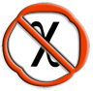
Definition: A characteristic of a system that could slow down or even completely stop the realization of a ChiRequirement.
From a logical point of view a ChiIssue is a condition that disallows a linked ChiRequirement to become true.
A ChiIssue is linked with a ChiRequirement with a “trace” and the stereotype “brakes”.
Constrains:
An Issue MUST be linked to a ChiRequirement element (“no problem without request”). The generator spawns an ERROR if this connection doesn’t exist.

Tagged Values:
Key | Notice | Value
ID | The ID of this object. CHI + 3 numbers + object name. MUST | CHI 001ISS
Author | This issue’s author’s name and role in the project. MUST | Name, Role
Responsible | The responsible to close the present issue. OPTIONAL | Name, Role

ChiBusinessProcess

Definition: A Business Process is a sum of actions that produces a business advantage to the enterprise. It is composed by one or many ChiBusinessUseCases
Constrains:
At lease one ChiBusinessUseCases or ChiBusinessUseCasesCore must linked.
Tagged Values:
Key | Notice | Value

ChiBusinessUseCase

Definition: A Business Use Case is part of a business process that produces an advantage to the enterprise.

Condition:
It SHOULD have a name composed by a Verb and an Object.
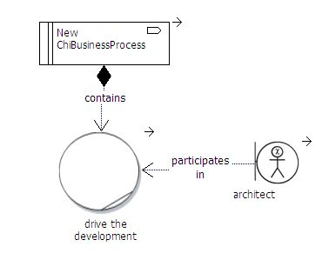
Tagged Values:

Key | Notice | Value
ID | The ID of this object. CHI + 3 numbers + object name. MUST | CHI 001UC
Name | A name of a use case MUST be composed by a Verb and a object. CAN have also the name of the primary actor but this is not a good praxis. MUST | Creates Contract
Description | A complete text description of the Use case. OPTIONAL
Primary Actor | The list of actors associated with the use case. Although this information is contained in the use case itself, it helps to increase the understandability of the use case when the diagram is unavailable.
Other Actors
Goal in Context | The goal should implicitly express the actor's intent or purpose of the use case, such as "Enrol Student in Seminar."
Scope | Boundaries in which the use case is operated when invoked (E.g. CMS) | systemA
Level | Authorizations for operations/actions to be performed against the Chi business objects in scope. Against every object/process 4 CRUD basic operations are possible:  Create (Write)  Read (Open)  Update (Change)  Delete (Destroy) | ObjectNameA(CRUD)| ObjectNameB(CRUD);
Stakeholders and Interests | List of actors that have a special interest (i.e. to be informed every time) in completion of the use case | ActorA|ActorB
Precondition | A list of the conditions, if any, that must be met before a use case may be invoked. Can be a previous Use case or self the presence of the system in Scope. | (ConditionA|ConditionB)
Trigger | Event that is responsible for invocation of the use case
Main Success Scenario | The main path of logic an actor follows through a use case. Often referred to as the “happy path” or the “main path” because it describes how the use case works when everything works as it normally should.
Extensions | The use case that this use case extends (if any). An extend association is a generalization relationship where an extending use case continues the behaviour of a base use case. The extending use case accomplishes this by inserting additional action sequences into the base use-case sequence. | ID

ChiWorkerExternal

Definition: A Chi External Worker is an employee that interacts directly with ChiBusinesPartner outside the enterprise.

Condition: none
Tagged Values:
Key | Notice | Value
OfflineUser | Define if the user require to have a offline access to the system. | true|false

Howto

Get started
Import the provided “Chronos default model” using the model upload functionality in the administration interface. After a restart you will find to have thew following package structure.
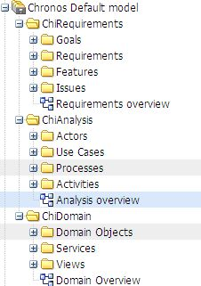
This has demonstrated to be valid for most project.
Under a package you should organize object a that type only.
E.g. under the package Issue all the object of type ChiIssue.
Additional project structure need to be created as sub package.
E.g. Replicate the structure “Release 1” in both packages Issues and Features.
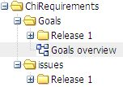
Start now to follow the activity described below.

- Define goals for your project.
- create supporting requirements
- add a new requirement
- requirement is validated by proofreader
- manage Features
  - propose feature satisfing requirement
  - Feature validated by proofreader
  - Confirm feature
- Manage Issues
  - Discover issues provoked by requirements
  - assign responsible to this Issue
  - Responsible evalution:
    - delete the requirement from model
    - change the requirement
- create use case

How to create an activity
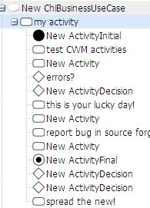
Activities can be only created within an use case. In fact an activity is an enhancement of the Use Case description.

