Introduction to MDA
A step by step tutorial

Table of Contents
ABSTRACT 5
Introduction 6
REQUIREMENTS 6
Skills 6
Goal 6
Time 6
(horror) Scenario 6
How-to 6

Document Informations
Author: | Giuseppe Platania
Version: | 0.67
Created: | 01/17/2007 15:30:15
Source | The actual version of this document can be found under:
http://wcmf.svn.sourceforge.net/viewvc/wcmf/trunk/docs/tutorials/HelloWorld

History
date | author | changes
01/17/2007 15:30:15 | Giuseppe Platania | created
01/27/07 | Giuseppe Platania | Updated with new framework Classes
01/28/07 | Giuseppe Platania | Images and steps updated.
02/02/07 | Giuseppe Platania | New framework classes
02/03/07 | Giuseppe Platania | Final Review
02/05/07 | Giuseppe Platania | Corrections
08/05/07 | Giuseppe Platania | Updated to version 2.1
12/05/07 | Giuseppe Platania | 2.1 review
06/11/07 | Giuseppe Platania | 2.1.0012 update
06/27/07 | Giuseppe Platania | 2.1.0016 update
06/28/07 | Giuseppe Platania | 2.1.0017 review
09/23/07 | Giuseppe Platania | 2.5 Review
03/22/08 | Giuseppe Platania | 2.6 Update
08/09/08 | Giuseppe Platania | 2.6.1 Update
01/19/09 | Giuseppe Platania | 3.0 Update
08/27/09 | Niko Stotz | Adapted to CWM
11/03/10 | Giuseppe Platania | Review and updated to CWM 0.992

ABSTRACT
This document lead to the creation of a simple web application without writing a single line of code. The application is completely defined in UML and is generated using a Model Driven approach. wCMF is the system of choice to demonstrate this methodology.

Introduction
Scope of this document is to give a short overview over the possibilities of the wCMF framework and the Chronos Web Modeler.

wCMF is a lightweight MDA approach to application development based on the Model View Controller pattern. It allows to create any kind of PHP webapp, e.g. CRM, CMS from an UML model. It features an object persistence layer, a soap interface and standard views/controllers.

More information about the wCMF under: http://sourceforge.net/projects/wcmf/

REQUIREMENTS
- Virtualbox version 3.x or better
http://www.virtualbox.org/wiki/Downloads
- CWM Virtual machine

Skills
- Basic UML and Object Oriented thinking.
- some patience :o)~

Goal
At the end of this step by step tutorial you will be able to reproduce all steps for creating a complete Web application without write a single line of code. You need only to configure the generation system.
You will see!!!

Time
You need about 1 hour to complete this step by step tutorial.

(horror) Scenario
Your boss wants to have a web application to manage Customers (Enterprises) and the related person like Bosses, Marketing and Employees. You have one hour to realize it!

How-to

Installation
- Install Virtualbox. Follow the instruction provided by the producers.
- Import the Chronos Web Modeler. Follow the instruction provided in the CWM package.
- If not existing already, create a directory named generated inside the cwm installation.

Modeling
- Start the Chronos Web Modeler by browsing to [YOURIP]/cwm/gui/
- In the model tree you'll see a model called “Chronos_default”.
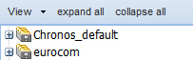
- Right-Click on “Chronos Default” and select “New project from this”
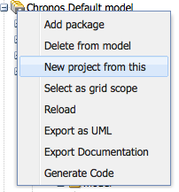
- The model will be copied into a new model also called “Chronos Default”. Don't change this name.
- Browse the new model to Chronos Default/ChiDomain/application/include/model to the class diagram called “model”. Double-Click it. The diagram will open in the main area.
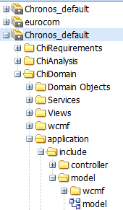
- In the “Available Content” view (upper left-hand side), select the “domain” section. Drag a ChiNode and drop in the diagram area for each new class you want to create.
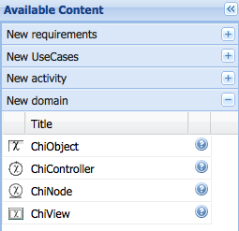

- For the first class you simply need to rename the example MyClass to “Enterprise”

- Right click on Enterprise and create two attributes.
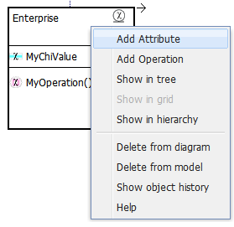
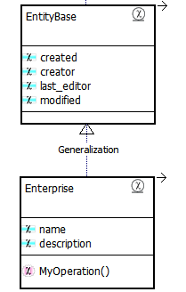
- Call them name and description.

- Now click on “Enterprise” and write in the tag value display_Value: name. This is not necessary but useful when you display a list.
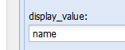
- Check the tagged values for the attributes you created above:

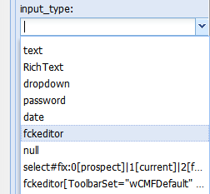
- In the tagged value ”input_type” of the attribute “description” select “fckeditor” from the dropDown menu. This will generate a WYSIWYG editor for describing the Enterprise.
- Now repeat the above steps to add another ChiNode, named 'Worker', to the project that inherits from EntityBase.
- Add to the Worker class two attributes: name and role
- In the tagged value “input_type” of the attribute “role” type “select#fix:Boss|Marketing|Employee”. This will generate a pull down menu with those values.
- Your diagram now must be similar to:
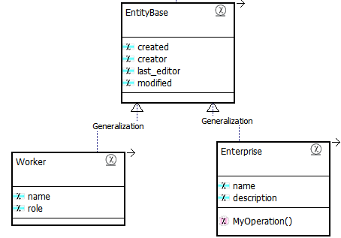
- Create a composition link starting from Enterprise to Worker.
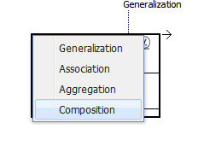
- In composition property set the SourceNavigability and TargetNavigability as Navigable.

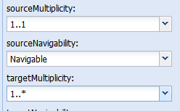
- Set the multiplicity for the Source (Enterprise) to “1..1”; for the target (Worker) “1..*”. This means that an enterprise must have always at least a worker.
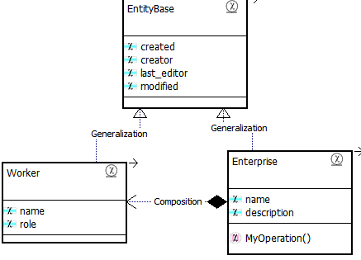
- The results should looks like:

Configuration
- In the project browser go to to the package configuration/default and open the diagram configuration
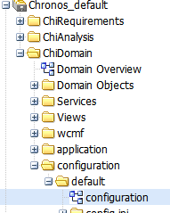
- Edit the existing class CMS, click on the property applicationTitle and setting the default value to: 'HelloWorld'.
- In the same class edit the property rootTypes by setting the default value from {MyClass} to {Enterprise}.
- In Package server.ini open the diagram with the same name and edit the Class Database;click the Property dbName and set setting the default value to the name of a Database 'HelloWorld' (you will create this Database later), additionally set also the property dbUserName to “root” and the dbPassword to “” for that database.
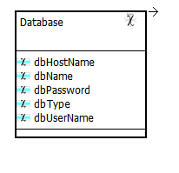
In our case use the Mysql standard “root” and blank. Never use this configuration for productive installations!!

Generation
You are ready with the model! You will Now generate the application.
- in the left pane, Right click on the root of the project hello World. And select “generate code”
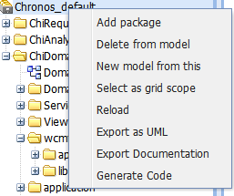

- click select the Chi CMF cartridge and click on “Generate”
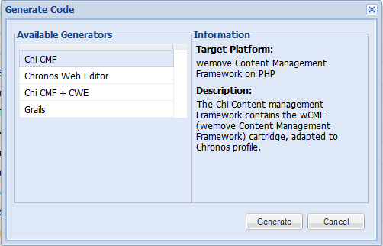
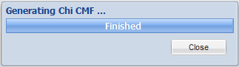
- you will see a following message
- If you have any trouble recheck the previous steps. Also checking the log
[YOURURL]/cwm/application/log/
can be useful. The last message should be
18002 [main] INFO Generator - Written 91 files to outlet [default](../generated/wcmf)
18002 [main] INFO WorkflowRunner - workflow completed in 14613ms!

Running the application
- log in with SSH and browse to the generation target folder:
/opt/lampp/htdocs/cwm0992/generated/wcmf
and check the files the generator created for you.
- In the sub folder .../application/include/model/ folder you must have:
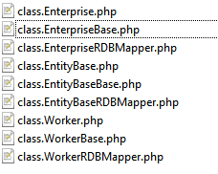
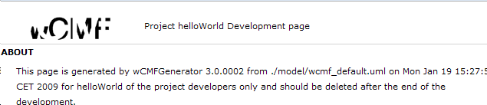
- Browse to http://localhost/helloworld/application/ The development page automatically open. Click on the PHPmyAdmin Link.
- With PHPMyAdmin create a new database called HelloWorld.
- Go back to the development page and click on Upgrade (http://localhost/application/install/dbupdate.php.)
To create the tables in the database.

- Go back in the browser and click on installation.
http://localhost/application/install/install.php
to run the installation script.

- Go back in the browser and click on Start application.
http://localhost/application/main.php.
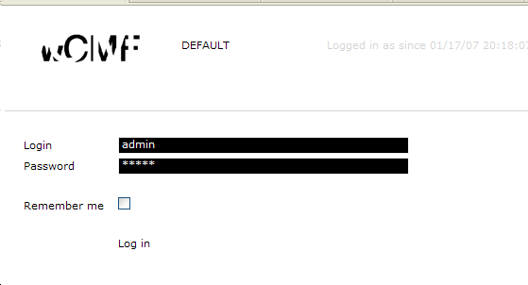
- login with user admin and password admin .
- Create one Enterprise.
- Add 3 workers.
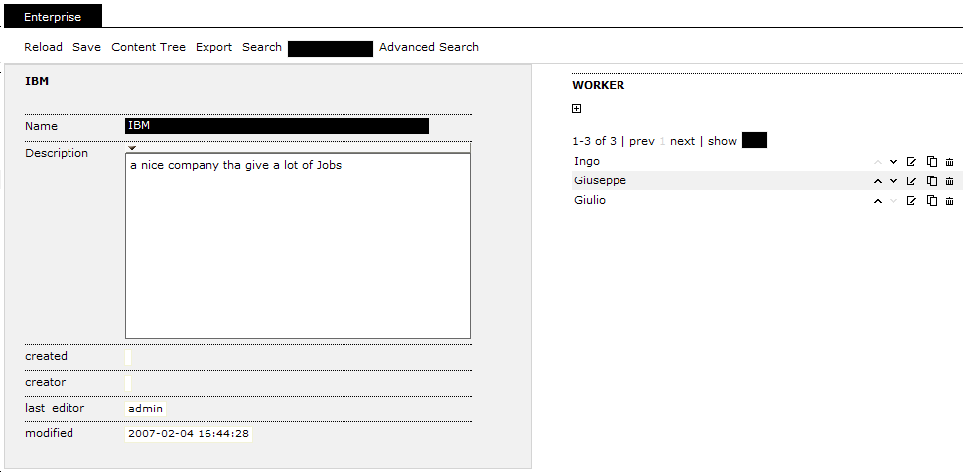
You have finished your WCMF tutorial!!

