- Download virtualbox (https://www.virtualbox.org/wiki/Downloads )
- Install VirtualBOx
  - 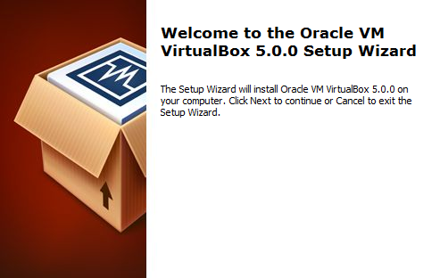
  - 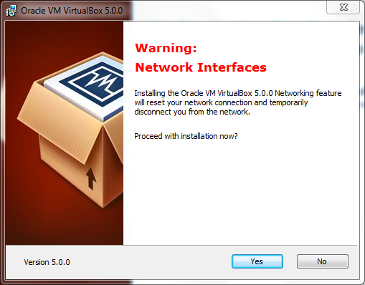
  - Install all the drivers
- Download the VM from source forge (Home / Chronos / Chronos Web Tools Appliance / VM_CWT_0996b)
- Extract the content
- Open the Virtualbox GUI
- Select Import virtual appliance
- 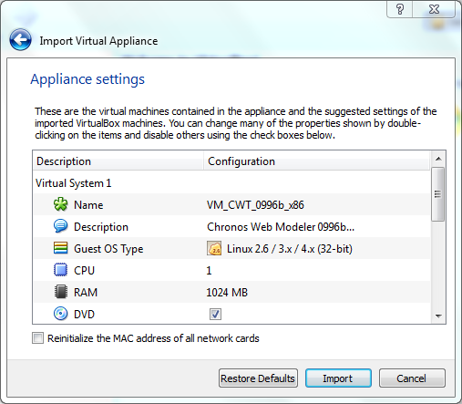
- 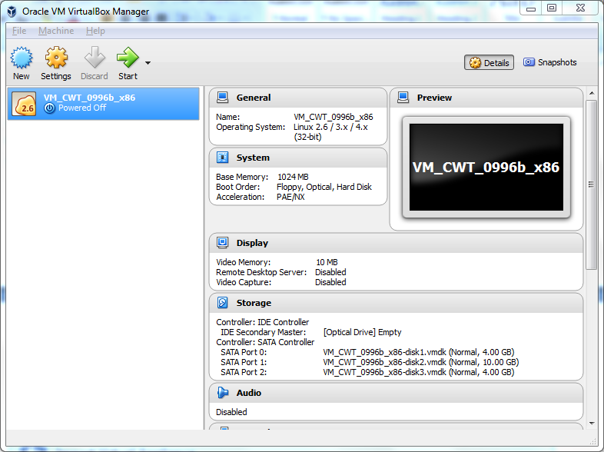
- 3.1 navigate to the folder where you extracted the VM Appliance zip into; select the OVF file supplied; press OK
- 4. check and adjust the settings of the newly created VM
- 5. run the VM
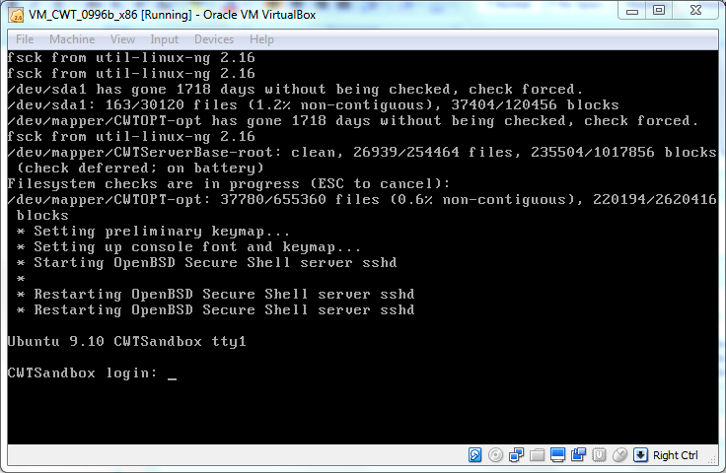
- Login with user chromos password cwt4u
- Open a browser to https://192.168.56.101/cwm/gui/
- Login with admin admin

