ADDER
Internal Data Bus
ADDR1MUX

ADDR2MUX

AMUX

BMUX

CCMUX

PCMUX

ADDMUX

DATA MEM
RAM SAMPLE

MDMUX
INST. MEM
ROM

BUSMUX

Pre-Fetch Unit
IQ
+1/+2

Control Unit

Decoding,

Sequencing

& Signals

Generation

PC
IR
OffSet5

OffSet9
OffSet16
Post/Pre
Relative

Sign
Extension
D/A/B
B

IXL

IYL

SPL

A

IXH

IYH

SPH
ALU
B
A
CCR
MUX1
MUXIN
Imm16
OffSet16I
OffSetDI
OffSetABD
Extend16
Internal Data Bus

MUX2
INH
ِMAR
MAD1
MAD2
MAD
EX
RL
O16
O95
PRE_POST
IM
mm
00
Mask/PG
DP CONTROL SIGNALS
ِMDR

Direct16
DI

DATA PATH CIRCUIT
IXH
IXL
IYH
IYL
SPH
SPL
PCH
PCL
BUS-MUX
MBUS
AMUX
MAA
BMUX
MAB
R1MUX
MR1
R2MUX
MR2
PCMUX
CCMUX
XIMUX
YIMUX
SPMUX
ACCMUX
+1/+2
B
A
ALU
DWB
ALSH
SWAP
S_U
S0-S3
A
B
Internal Data Bus

Internal Data Bus

CCR
CU
CC
SWAP
mm
00
AddressO
Rel
ALUO1
ALUO2

MDLMDH001MDH
IN MUXDH/MUXDL ≠ 0/1
IF MDL =0 THEN MDH =0
LdA
CLK
CLR
MUXDH2

MUXDH1

MUXDL1

MUXDL2

Sign Extend*
M0F
MUX0F
MI=SWAP | IN_Mux | LD
0 | A:B | A,B
1 | SWAP A,B | A,B

MDL B/A | MDH A/0F | M0F | OUT_Mux
0 A | 0 0F | 0 (0) | 00:A
0 A | 0 0F | 1 (F) | 11:A
1 B | 0 0F | 0 (0) | 00:B
1 B | 0 0F | 1 (F) | 11:B
1 B | 1 A | X | D

15 |  |  |  |  |  |  | 0 | 15 |  |  |  |  |  |  | 0

D

D
A
B
Acc-IN-MUX
15 |  |  |  |  |  |  | 8 | 7 |  |  |  |  |  |  | 0

MUXB
MUXA
MI
MDH2
MDH1
AccIN
AccOUT1
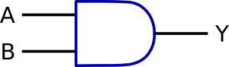
MUXAO
MUXBO
* M0F= (A(7) AND NOT(MDL) ) OR (B(7) AND MDL)
MDL2
MDL1
AccOUT2
LdB
00
FF
8-bit and 16-bit General Purpose Registers (GRP)
The primary task of the general-purpose register (GPR) is to store address or data for an indefinite amount of time, then to be able to retrieve the data when needed.
An 8-bit General Purpose Register
q₇
q₆
q₅

q₄

q₃

q₂

q₁

q₀

DFF
DFF
DFF
DFF
DFF
DFF
DFF
DFF
x₇
x₆
x₅

x₄

x₃

x₂

x₁

x₀

CLK
CLR
En
The Basic Cell [DFF]
Enable
CLK
CLR
X_{i}

DFF
q_{i}

16
8
8
8
16
16
16
8
8
16
16
16
16
16
16
16
16
CLR
CLR
Ld
Ld
Ld
Ld
Ld
Ld
En
ALU B
ALU A

CLRA
CLRB
MACC
MX
MY
MSP
MCC
MPC
MR1
MR2
00000000CC
BUSL
ALUL
MI
MDL1
MDL2
MDH2
MDH1
MAD1
R_Block
Acc_{in}
Acc_{out}
A(D_High)
D
B (D_Low)
XI
CC
RA
RB
RCC
RSP
RXI
RYI
RPC
RD
YI
SP
PC
ALU
BUS-MUX
ALU
BUS-MUX
CTRLUNIT
ADDMUX
BUS-MUX
ALU
ADDMUX
ADDMUX

8
BUS
ALU1
ALU2

CLK

LdA
LdB
LdX
LdY
LdSP
LdCC
LdPC
CAL_CCR
CU_CCR
REL
AddressO
ALU
Plus2
PC+1/+2

Y0
Y1
Y2
Y3
Y4
Y5
Y6
Y7
Y8
Y9
Y10
Y11
Y12
Y13
Y14
Y15

16BITALU
0000
Y
DWB10
A0
B0
A1
B1
A2
B2
A3
B3
A4
B4
A5
B5
A6
B6
A7
B7
A8
B8
A9
B9
A10
B10
A11
B11
A12
B12
A13
B13
A14
B141
A15
B15
S1
S2
S1
S0
MUXO2
MUXO1
MUX
F
CCR
COMP
THEN CHECK Z FLAG
OR CHECK DIFF
0
0
1
1
Z
C
GT
GE
LE
LT
F
C_out(4)
A(0)
A(15)
C_out(8)
B(7)
C_out(16)
C_out(15)
C_out(7)
A(0) OR A(15) SET C AND C ROTATES
B(7)/B(15) IS MULTIPLICATION CARRY
HC IS H

CCR CALCULATIONS

DWB 16/8
S3
S2
S1
S0
RL
RR
ALUO1
ALUO2
DIV
DIV_O0 DIV_O15 16-31

1BIT
ALSU

F

1BIT
ALSU

F

1BIT
ALSU

F

1BIT
ALSU

F

1BIT
ALSU

F

1BIT
ALSU

F

1BIT
ALSU

F

1BIT
ALSU

F

1BIT
ALSU

F

1BIT
ALSU

F

1BIT
ALSU

F

1BIT
ALSU

F

1BIT
ALSU

F

1BIT
ALSU

F

1BIT
ALSU

F

1BIT
ALSU

F

O(0) C_out(1) …. C_out(4) C_out(16) O(15)
C_LA

A
B
STATUS (CCR)
MUL
MUL_P0 MUL_P15 16-31

SWAP
S0
S_U
ALSH
B(15)
INSTRUCTION SAMPLES:
Function | #C | Add  Mod | ALU Ctrl |  |  |  | ALU OPR |  |  |  | ALU IN |  |  |  | ALU O |  |  | MRead/  Write |  | ALU IN Mux |  | Reg Out Mux |  | MBUS | Acc Muxs |  | Registers IN Muxs |  |  |  |  | PC |  | Address Muxs |  |  | Acc CLR |  | HNZVC
Function | #C | Add  Mod | U_S | DWB_{1,0} | SW | ALS | S3 | S2 | S1 | S0 |  | A | B | Y |  | O1 | O2 | Ld1 | Ld2 | MAA_{1,0} | MAB_{1,0} | MR1_{1,0} | MR2_{1,0} | MBUS_{1,0} | MD1_{H,L} | MD2_{H,L} | MACC | MX | MY | MSP | MCC_{1,0} | MPC_{1,0} | Plus2 | MAD1_{1,0} | MAD2_{1,0} | MAD_{1,0} | CLA | CLB | HNZVC
ABA | 2 | IH | - | 00 | 0 | - | 0 | 0 | 0 | 0 |  | A | B | - |  | A | - | A | - | 01 | 01 | 00 | 00 | 01 | 00 | 10 | 1 | X | X | X | X | ? |  | ? | ? |  | - | - | ^^^^^
ABX | 3 | ID? | - | 01 | 0 | - | 0 | 0 | 0 | 0 |  | B | X | - |  | X | - | X | - | 01 | 01 | 00 | 11 | 01 | 10 | XX | X | 1 | X | X | X | ? |  | ? | ? |  | - | - | ^^^^^
ADDA # | 1 | IM | - | 00 | 0 | - | 0 | 0 | 0 | 0 |  | A | M | - |  | A | - | A | - | 01 | 00 | 00 | XX | 01 | 00 | XX | 1 | X | X | X | X | ? |  | ? | ? |  | - | - | ^^^^^
ADDA o | 3 | DI | - | 00 | 0 | - | 0 | 0 | 0 | 0 |  | A | M | - |  | A | - | A | MR | 01 | 00 | 00 | XX | 01 | 00 | XX | 1 | X | X | X | X | ? |  | ? | ? |  | - | - | ^^^^^
ADDA o | 3 | EX | - | 00 | 0 | - | 0 | 0 | 0 | 0 |  | A | M | - |  | A | - | A | MR | 01 | 00 | 00 | XX | 01 | 00 | XX | 1 | X | X | X | X | ? |  | ? | ? |  | - | - | ^^^^^
ADDA o | 3 | ID | - | 00 | 0 | - | 0 | 0 | 0 | 0 |  | A | M | - |  | A | - | A | MR | 01 | 00 | 00 | XX | 01 | 00 | XX | 1 | X | X | X | X | ? |  | ? | ? |  | - | - | ^^^^^
ADDA o | 3 | ID1 | - | 00 | 0 | - | 0 | 0 | 0 | 0 |  | A | M | - |  | A | - | A | MR | 01 | 00 | 00 | XX | 01 | 00 | XX | 1 | X | X | X | X | ? |  | ? | ? |  | - | - | ^^^^^
ADDA o | 4 | ID2 | - | 00 | 0 | - | 0 | 0 | 0 | 0 |  | A | M | - |  | A | - | A | MR | 01 | 00 | 00 | XX | 01 | 00 | XX | 1 | X | X | X | X | ? |  | ? | ? |  | - | - | ^^^^^
ADDA o | 6 | IDI | - | 00 | 0 | - | 0 | 0 | 0 | 0 |  | A | M | - |  | A | - | A | MR | 01 | 00 | 00 | XX | 01 | 00 | XX | 1 | X | X | X | X | ? |  | ? | ? |  | - | - | ^^^^^
ADDA o | 6 | IDII | - | 00 | 0 | - | 0 | 0 | 0 | 0 |  | A | M | - |  | A | - | A | MR | 01 | 00 | 00 | XX | 01 | 00 | XX | 1 | X | X | X | X | ? |  | ? | ? |  | - | - | ^^^^^
ASL | 4 | EX | - | 00 | 0 | 1 | 1 | 1 | 0 | 1 |  | M | - | - |  | M | - | W | MR | 00 | XX | XX | XX | 01 | XX | XX | X | X | X | X | X | ? |  | ? | ? |  | - | - | ^^^^^
ASLA | 1 | IH | - | 00 | 0 | 1 | 1 | 1 | 0 | 1 |  | A | - | - |  | A | - | A | - | 01 | XX | 00 | XX | 01 | 00 | XX | 1 | X | X | X | X | ? |  | ? | ? |  | - | - | ^^^^^
BCC rl8 | 31 | RL | - | -- | - | - | - | - | - | - |  | - | - | - |  | - | - | - | - | XX | XX | XX | XX | XX | XX | XX | X | X | X | X | X | ? |  | ? | ? |  | - | - | ^^^^^
BCLR | 4 | DI | - | 00 | - | - | 1 | 0 | 0 | 0 |  | M | M | - |  | M | - | W | MR | 00 | 11 | XX | XX | 01 | XX | XX | X | X | X | X | X | ? |  | ? | ? |  | - | - | ^^^^^
BITB # | 1 | IM | - | 00 | - | - | 1 | 0 | 0 | 0 |  | B | M | - |  | - | - | - | - | 01 | 00 | 00 | XX | 10 CC | 10 | XX | X | X | X | X | ? | ? |  | ? | ? |  | - | - | ^^^^^
BLT | 31 | RL | 1 | -- | - | - | - | - | - | - |  | - | - | - |  | - | - | - | - | XX | XX | XX | XX | XX | XX | XX | X | X | X | X | X | ? |  | ? | ? |  | - | - | ^^^^^
BRA | 3 | RL | - | -- | - | - | - | - | - | - |  | - | - | - |  | - | - | - | - | XX | XX | XX | XX | XX | XX | XX | X | X | X | X | X | ? |  | ? | ? |  | - | - | ^^^^^
CBA | 2 | INH | - | 00 | 0 | - | 0 | 0 | 1 | 1 |  | A | B | - |  | - | - | - | - | 01 | 01 | 00 | 00 | 10 CC | 00 | 10 | X | X | X | X | ? | ? |  | ? | ? |  | - | - | ^^^^^
CLR | 3 | ID1 | - | 00 | - | - | ? | ? | ? | ? |  | M | 0 | - |  | M | - | W | MR | 00? | 10? | XX | XX | 01 | XX | XX | X | X | X | X | X | ? |  | ? | ? |  | - | - | ^^^^^
CLRA | 1 | IH | - | 00 | 0 | - | - | - | - | - |  | A | - | - |  | A | - | A | - | XX | XX | XX | XX | XX | XX | XX | X | X | X | X | X | ? |  | ? | ? |  | 0 | - | ^^^^^
CMPA # | 1 | IM | - | 00 | 0 | - | 0 | 0 | 1 | 1 |  | A | M | - |  | - | - | - | - | 01 | 00 | 00 | XX | 10 CC | 00 | XX | X | X | X | X | X | ? |  | ? | ? |  | - | - | ^^^^^
DBEQ | 33 | RL9 | - | 01 | 0 | - | 0 | 1 | 1 | 0 |  | ? | ? | - |  | R | - | R | - | 01 | XX | R | XX | 01 | R? | XX | R | R | R | R | X | ? |  | ? | ? |  | - | - | ^^^^^
EDIVS | 12 | IH | 1 | 10 | 0 | - | 0 | 1 | 0 | 0 |  | D | X | Y |  | Y | D | Y | D | 01 | 01 | 01 | 00 | 01 | XX | 11 | 1 | X | 1 | X | X | ? |  | ? | ? |  | - | - | ^^^^^
EMAXD | 4 | ID | - | 01 | 1 | - | 0 | 0 | 1 | 1 |  | D | M | - |  | D | - | D | MR | 01 | 00 | 00 | XX | 00? | 11 | XX | 1 | X | X | X | X | ? |  | ? | ? |  | - | - | ^^^^^
EMINM | 4 | ID | - | 01 | 1 | - | 0 | 0 | 1 | 1 |  | M | D | - |  | M | - | W | MR | 00? | 01? | XX | 00 | 00? | XX | 11 | X | X | X | X | X | ? |  | ? | ? |  | - | - | ^^^^^
EMULS | 3 | IH | 1 | 01 | 0 | - | 0 | 1 | 1 | 1 |  | D | Y | - |  | Y | D | Y | D | 01 | 01 | 01 | 00 | 01 | XX | 11 | 1 | X | 1 | X | X | ? |  | ? | ? |  | - | - | ^^^^^
EXG | 1 | IH | - | 01 | 1 | - | - | - | - | - |  | ? | ? | - |  | R1 | R2 | R2 | R1 | 01 | 01 | R1 | R2 | 00 | R1 | R2 | R_{1,0} | R_{1,0} | R_{1,0} | R_{1,0} | R_{1,0} | ? |  | ? | ? |  | - | - | ^^^^^
LDAA # | 1 | IM | - | 00 | 0 | - | - | - | - | - |  | M | A | - |  | A | - | A | - | XX | XX | XX | XX | XX | XX | XX | 1 | X | X | X | X | ? |  | ? | ? |  | - | - | ^^^^^
LDAA o | 4 | ID2 | - | 00 | 0 | - | - | - | - | - |  | M | A | - |  | A | - | A | MR | XX | XX | XX | XX | XX | XX | XX | 1 | X | X | X | X | ? |  | ? | ? |  | - | - | ^^^^^
LEAS | 2 | ID | - | 01 | - | - | - | - | - | - |  | SP | - | - |  | SP | - | SP | - | XX | XX | XX | XX | XX | XX | XX | X | X | X | 1 | X | ? |  | ? | ? |  | - | - | ^^^^^
MUL | 3 | IH | 0 | 00 | 0 | - | 0 | 1 | 1 | 1 |  | A | B | - |  | D | - | D | - | 01 | 01 | 00 | 00 | 01 | 00 | 10 | 1 | X | X | X | X | ? |  | ? | ? |  | - | - | ^^^^^
NEG | 4 | EX | - | 00 | - | - | 0 | 0 | 0 | 0 |  | M | 0 | - |  | M | - | W | MR | 00 | 10 | XX | XX | 01 | XX | XX | X | X | X | X | X | ? |  | ? | ? |  | - | - | ^^^^^
NEGA | 1 | IH | - | 00 | 0 | - | 0 | 0 | 0 | 0 |  | A | 0 | - |  | A | - | A | - | 01 | 10 | 00 | XX | 01 | 00 | XX | 1 | X | X | X | X | ? |  | ? | ? |  | - | - | ^^^^^
PSHA | 2 | IH | - | 00 | 0 | - | 0 | 0 | 0 | 0 |  | A | S | - |  | S | - | SW | - | XX | XX | XX | XX | XX | XX | XX | X | X | X | X | X | ? |  | ? | ? |  | - | - | ^^^^^
PULA | 3 | IH | - | 00 | 0 | - | 0 | 0 | 0 | 0 |  | S | A | - |  | A | - | A | - | XX | XX | XX | XX | 00 | 00 | XX | 1 | X | X | X | X | ? |  | ? | ? |  | - | - | ^^^^^
SEX | 1 | IH | - | 01 | 1 | - | 0 | 0 | 0 | 0 |  | ? | ? | - |  | R2 | - | R2 | - | 01? | --? | R1 | XX | 00? | R1 | XX | R2 | R2 | R2 | R2 | X | ? |  | ? | ? |  | - | - | ^^^^^
STAA o | 5 | IDI | - | 00 | 0 | - | 0 | 0 | 0 | 0 |  | A | M | - |  | M | - | W | MR | XX | XX | XX | 00 | 00 | XX | 00 | X | X | X | X | X | ? |  | ? | ? |  | - | - | ^^^^^
TFR | 1 | IH | - | 01 | 1 | - | 0 | 0 | 0 | 0 |  | ? | ? | - |  | R2 | - | R2 | - | 01? | --? | R1 | XX | 00? | R1 | XX | R2 | R2 | R2 | R2 | R2 | ? |  | ? | ? |  | - | - | ^^^^^

Function | #C | Add  Mod | ALU Ctrl |  |  |  | ALU OPR |  |  |  | ALU IN |  |  |  | ALU O |  |  | MRead/  Write |  | ALU IN Mux |  | Reg Out Mux |  | MBUS | Acc Muxs |  | Registers IN Muxs |  |  |  |  | PC |  | Address Muxs |  |  | Acc CLR |  | HNZVC
Function | #C | Add  Mod | U_S | DWB_{1,0} | SW | ALS | S3 | S2 | S1 | S0 |  | A | B | Y |  | O1 | O2 | Ld1 | Ld2 | MAA_{1,0} | MAB_{1,0} | MR1_{1,0} | MR2_{1,0} | MBUS_{1,0} | MD1_{H,L} | MD2_{H,L} | MACC | MX | MY | MSP | MCC_{1,0} | MPC_{1,0} | Plus2 | MAD1_{1,0} | MAD2_{1,0} | MAD_{1,0} | CLA | CLB | HNZVC
ABA | 2 | IH | - | 00 | 0 | - | 0 | 0 | 0 | 0 |  | A | B | - |  | A | - | A | - | 01 | 01 | 00 | 00 | 01 | 00 | 10 | 1 | X | X | X | X | ? |  | ? | ? |  | 0 | 0 | ^^^^^
ADDA # | 1 | IM | - | 00 | 0 | - | 0 | 0 | 0 | 0 |  | A | M | - |  | A | - | A | - | 01 | 00 | 00 | XX | 01 | 00 | XX | 1 | X | X | X | X | ? |  | ? | ? |  | 0 | 0 | ^^^^^
ADDA o | 3 | DI | - | 00 | 0 | - | 0 | 0 | 0 | 0 |  | A | M | - |  | A | - | A | MR | 01 | 00 | 00 | XX | 01 | 00 | XX | 1 | X | X | X | X | ? |  | ? | ? |  | 0 | 0 | ^^^^^
ADDA o | 3 | EX | - | 00 | 0 | - | 0 | 0 | 0 | 0 |  | A | M | - |  | A | - | A | MR | 01 | 00 | 00 | XX | 01 | 00 | XX | 1 | X | X | X | X | ? |  | ? | ? |  | 0 | 0 | ^^^^^
ADDA o | 3 | ID | - | 00 | 0 | - | 0 | 0 | 0 | 0 |  | A | M | - |  | A | - | A | MR | 01 | 00 | 00 | XX | 01 | 00 | XX | 1 | X | X | X | X | ? |  | ? | ? |  | 0 | 0 | ^^^^^
ADDA o | 3 | ID1 | - | 00 | 0 | - | 0 | 0 | 0 | 0 |  | A | M | - |  | A | - | A | MR | 01 | 00 | 00 | XX | 01 | 00 | XX | 1 | X | X | X | X | ? |  | ? | ? |  | 0 | 0 | ^^^^^
ADDA o | 4 | ID2 | - | 00 | 0 | - | 0 | 0 | 0 | 0 |  | A | M | - |  | A | - | A | MR | 01 | 00 | 00 | XX | 01 | 00 | XX | 1 | X | X | X | X | ? |  | ? | ? |  | 0 | 0 | ^^^^^
ADDA o | 6 | IDI | - | 00 | 0 | - | 0 | 0 | 0 | 0 |  | A | M | - |  | A | - | A | MR | 01 | 00 | 00 | XX | 01 | 00 | XX | 1 | X | X | X | X | ? |  | ? | ? |  | 0 | 0 | ^^^^^
ADDA o | 6 | IDII | - | 00 | 0 | - | 0 | 0 | 0 | 0 |  | A | M | - |  | A | - | A | MR | 01 | 00 | 00 | XX | 01 | 00 | XX | 1 | X | X | X | X | ? |  | ? | ? |  | 0 | 0 | ^^^^^

$18 | OpCode
PostByt
OffSetH
offSetL
Mask/PG
Bits Clear / CALL
Relative
Conditional Branch
xb0 xb0 xb0 xb0 xb0 xb0 xb0 xb0 OffSetH
xb4 xb4 xb4 xb4 xb4 xb4 xb4 xb4 xb4 xb4 xb4 xb4 xb3 xb2 xb1 xb0

xb4

xb4

xb4

xb4

xb4

xb4

xb4

xb4

xb4

xb4

xb4

15 14 13 12 11 10 9 8 7 6 5 4 3 2 1 0
OffSet16 Indirect
OffSet5 signed xb(4-0)
OffSet9 Signed OffsetH + xb(0)
Acc Offset
Unsigned
aa:(ABD)

InD (D)

Post/Pre
xb(4-0)
Sign Extension
Decoding Unit
OffsetL

PostByte (xb)

Mask/PG/Rel
OffsetH

$18 | OpCode
xb(7 downto 0) = 111XX1XX
xb(7 downto 0) = 111XX111
xb(7 downto 0) = 111XX011
xb(5) = 1
xb(7 downto 0) = 111XXX01
xb(7 downto 0) = 111XXX00
xb(5) = 0
OffSet16
Signed

OffsetH|L
5
9

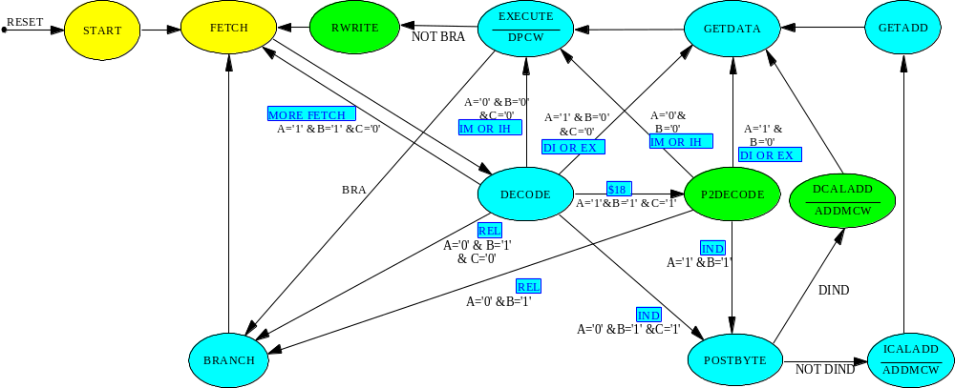

CORRECT SIMULATIONS:
1- IMM — Immediate (0000) 2- DIR — Direct (0001)
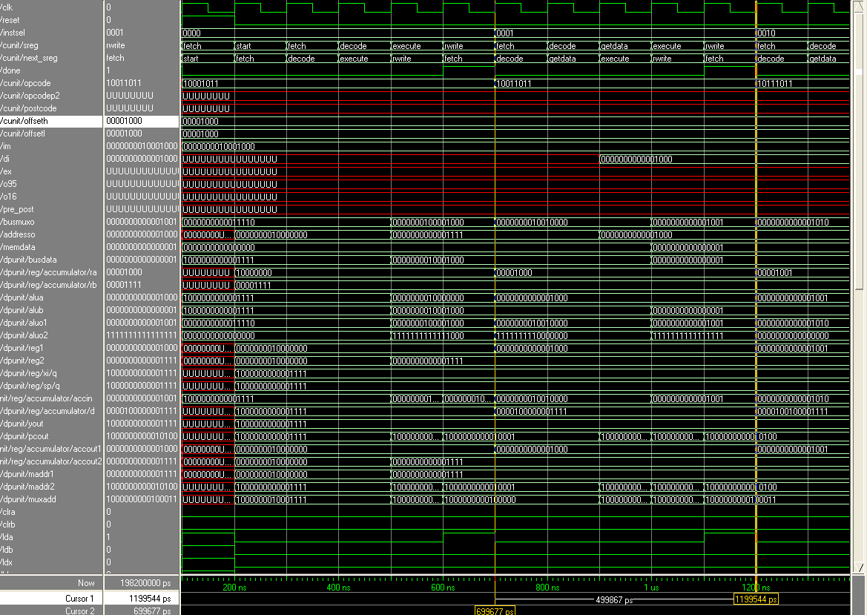
3- EXT — EXTEND (0010) 4- IDX: 5-bit constant offset from X, Y, SP, or PC (0011)

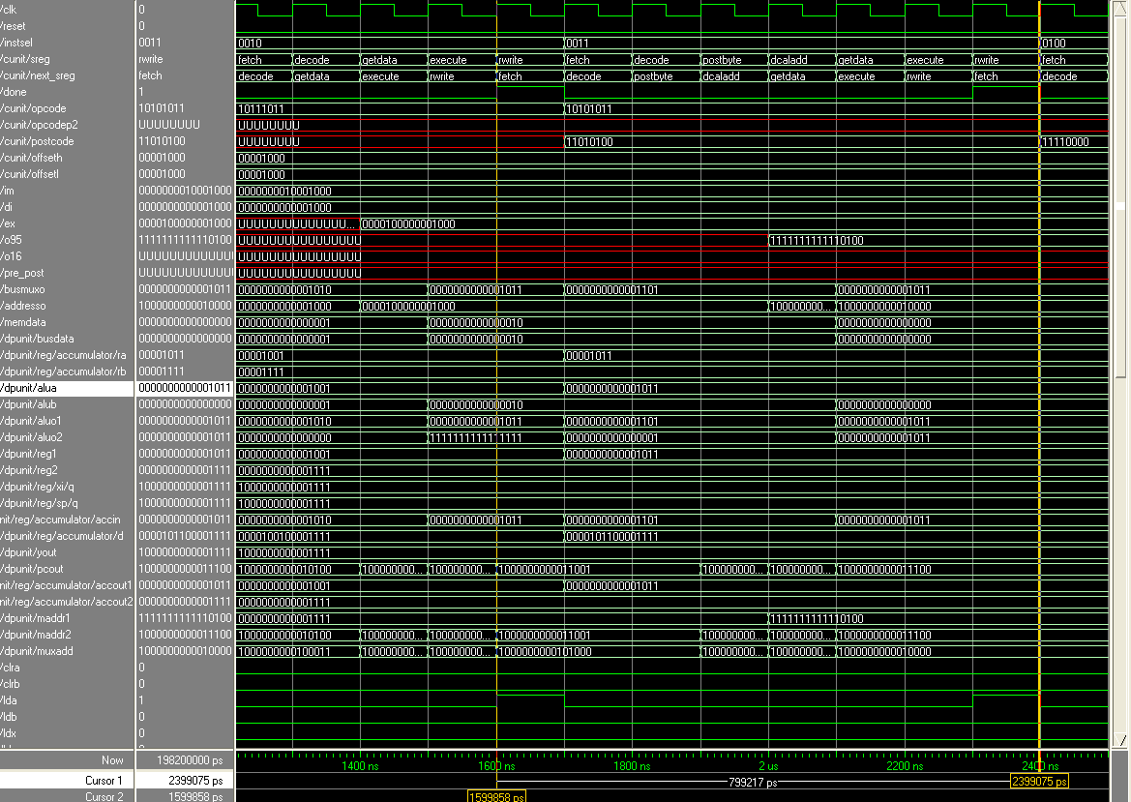
5- IDX1 — 9-bit signed offset from X, Y, SP, or PC (0100)
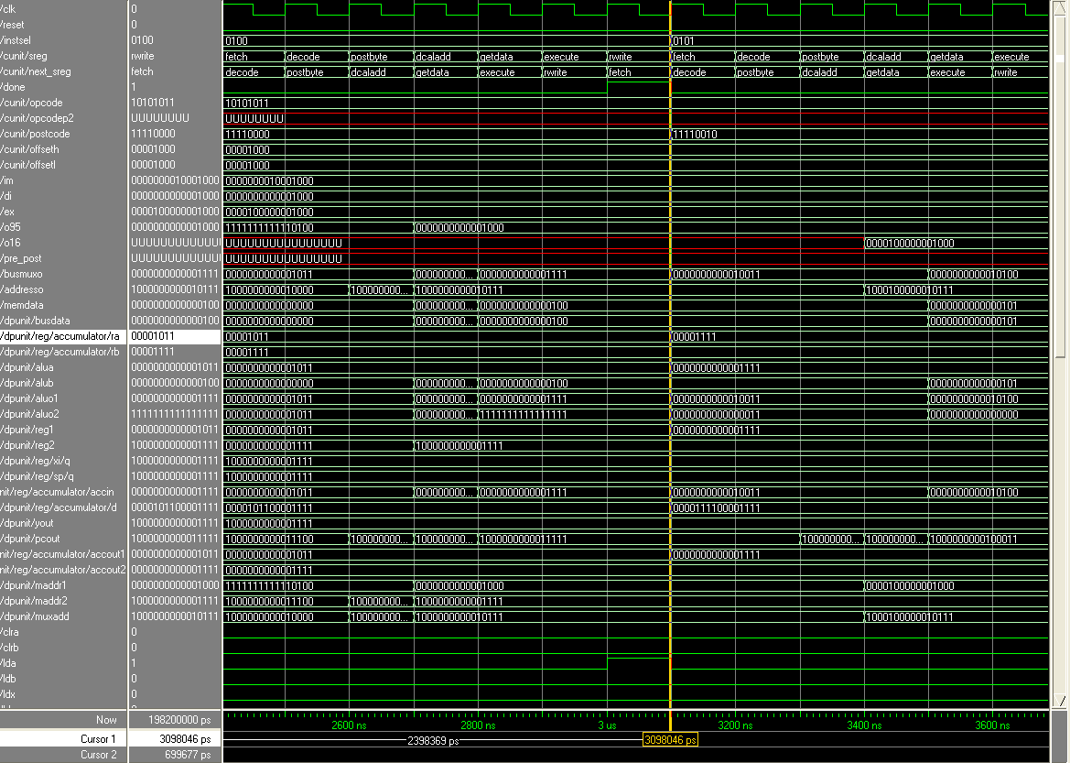
6- IDX2 — 16-bit signed offset from X, Y, SP, or PC (0101)
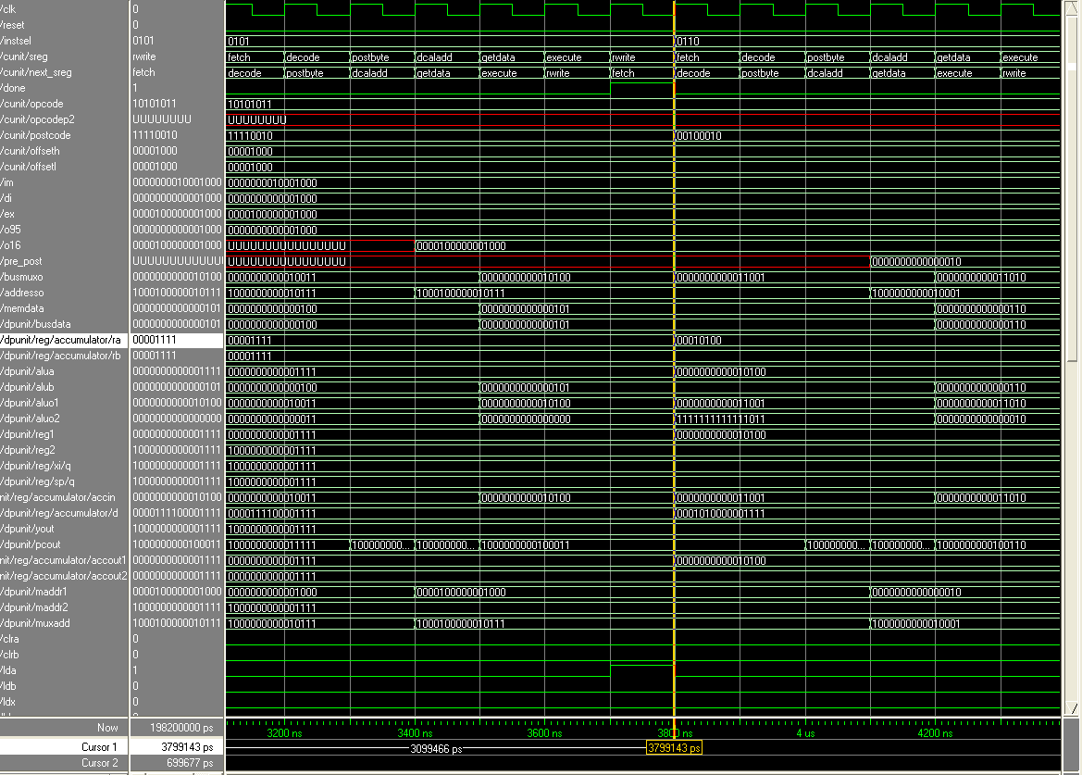
7- Pre/post increment/decrement by (10) (0110)
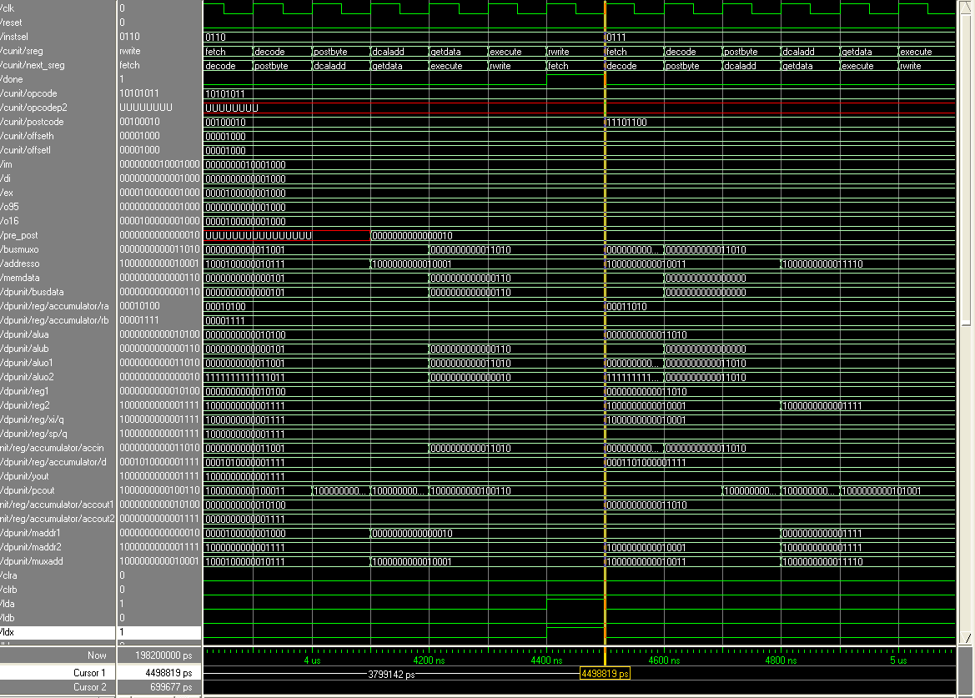
8- Accumulator A OFFSET (0111)
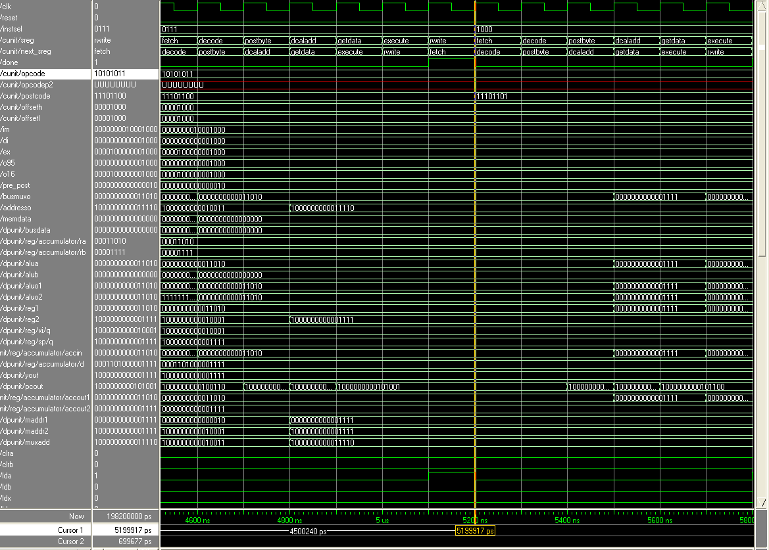
9- Accumulator B offset (1000)
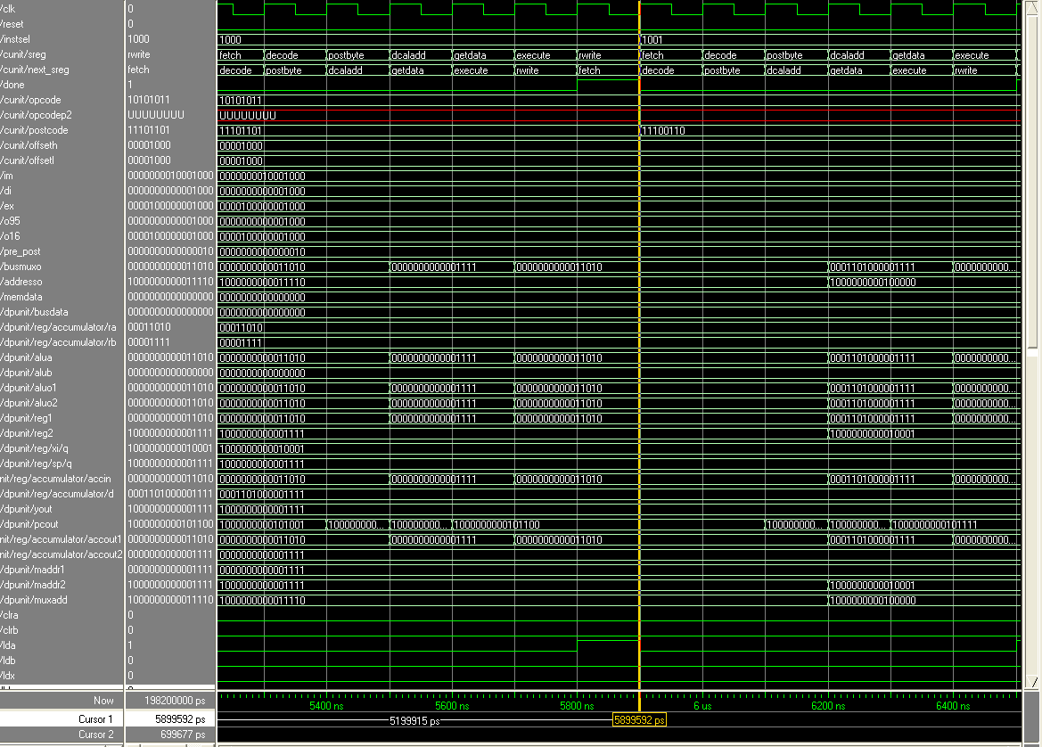
10- Accumulator B offset (1001)
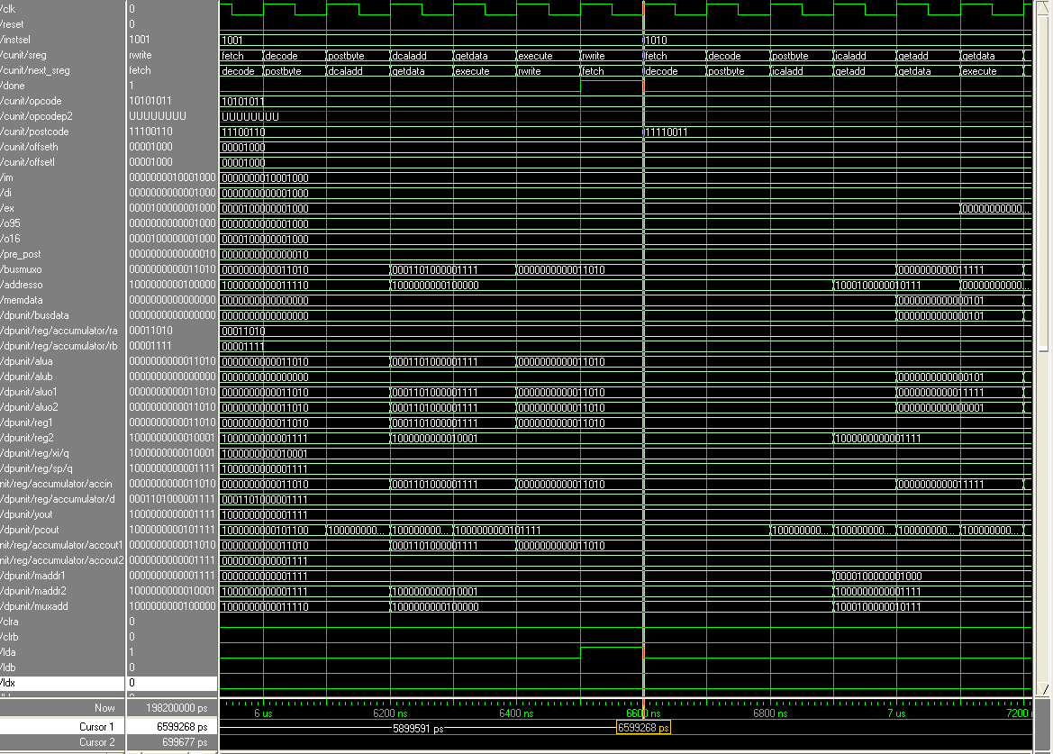
11- [IDX2] — Indexed-indirect; 16-bit offset from X, Y, SP, or PC (1010)
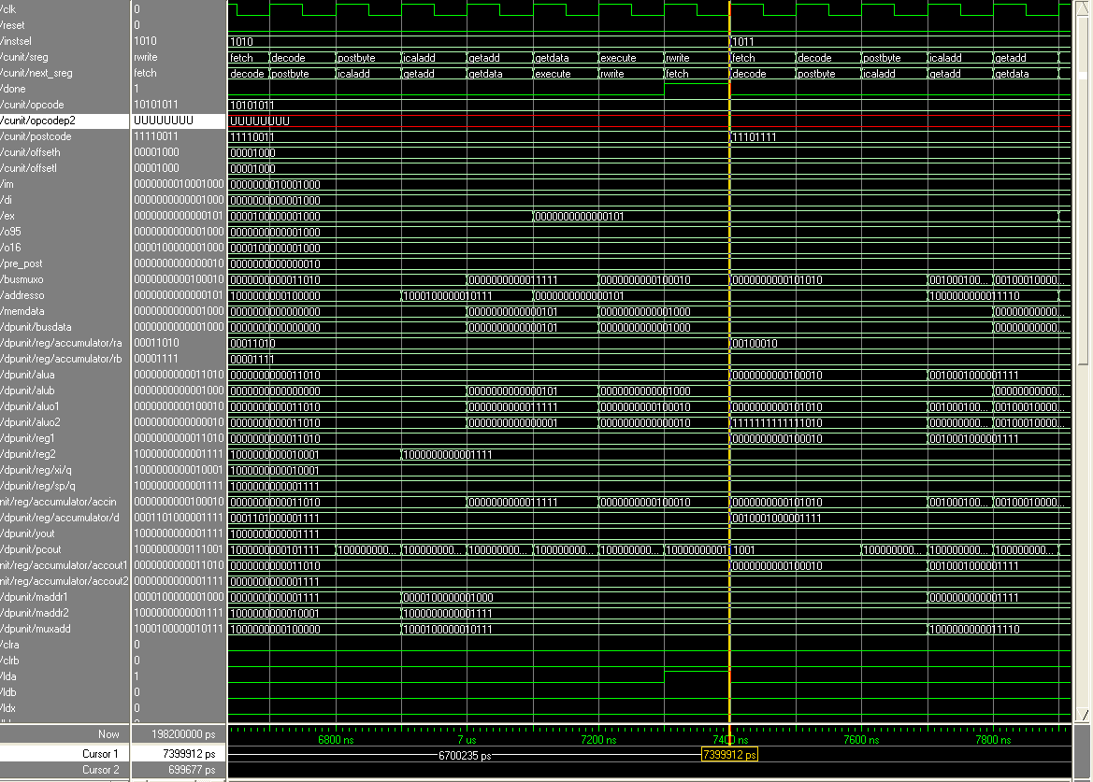
12- [D, IDX] — Indexed-indirect; accumulator D offset from X, Y, SP, or PC (1011)
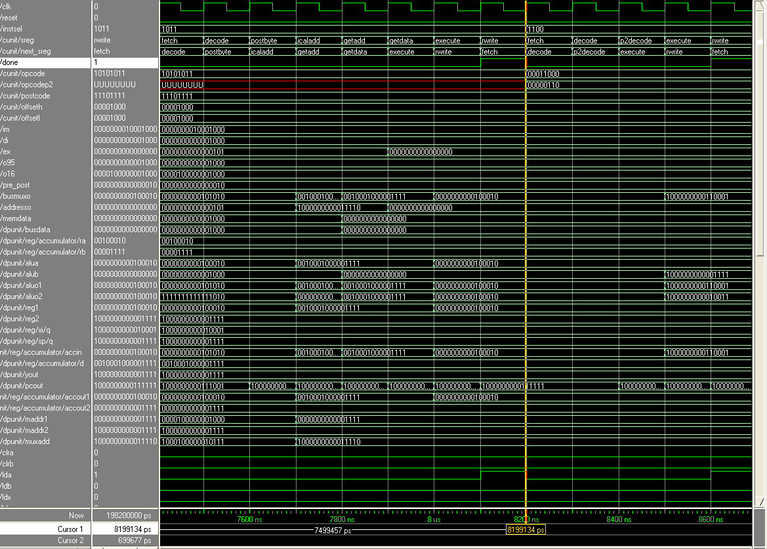
13- INH — Inherent; no operands in object code (1100)
