Normal Incrementer
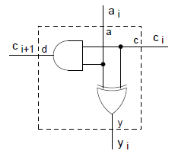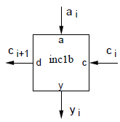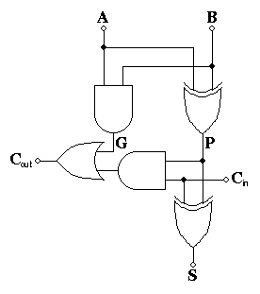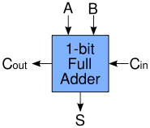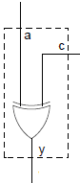
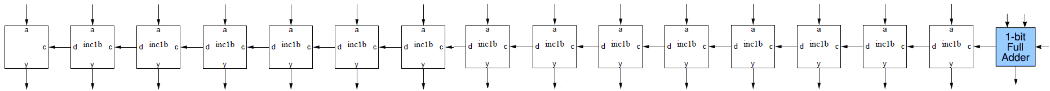

c | a | b | a xor b | S | ca | (a xor b)c | Co
0 | 0 | 0 | 0 | 0 | 0 | 0 | 0
0 | 0 | 1 | 1 | 1 | 0 | 0 | 0
0 | 1 | 0 | 1 | 1 | 0 | 0 | 0
0 | 1 | 1 | 0 | 0 | 0 | 0 | 0
1 | 0 | 0 | 0 | 1 | 0 | 0 | 0
1 | 0 | 1 | 1 | 0 | 0 | 1 | 1
1 | 1 | 0 | 1 | 0 | 1 | 1 | 1
1 | 1 | 1 | 0 | 1 | 1 | 0 | 1
a’bc + ‘abc + abc + ab’c = ac(b+’b) + b(‘ac+a’c) = ac +
ab + ‘b(ac) + ’aa + ‘a(bc) + ’bb = ab + a(‘bc + ‘a) + b(‘ac + ‘b) = a(b + ‘bc +’a) + b(‘ac + ‘b)
