**THE CHOCOLATE ROOM**

A Project-II Report

Submitted in partial fulfillment of requirement of the

Degree of

**BACHELOR OF TECHNOLOGY   
in   
COMPUTER SCIENCE AND ENGINEERING**

BY

**Ishika Jain(EN16CS301116)**

Under the Guidance of

**Mrs Indrajeet Kaur Chhabra**



**Department of Computer Science and Engineering**

**Faculty of Engineering**

**MEDI-CAPS UNIVERSITY, INDORE- 453331**

**2019-2020**

**Report Approval**

The project work **“The Chocolate Room”** is hereby approved as a creditable study of an engineering/computer application subject carried out and presented in a manner satisfactory to warrant its acceptance as a prerequisite for the Degree for which it has been submitted.

It is to be understood that by this approval the undersigned do not endorse or approve any statement made, opinion expressed, or conclusion drawn there in; but approve the “Project Report” only for the purpose for which it has been submitted.

Internal Examiner

**Mrs Indrajeet Kaur Chhabra**

External Examiner

Name:

Designation:

Affiliation:

**Declaration**

I hereby declare that the project entitled **“The Chocolate Room”** submitted in partial fulfillment for the award of the degree of Bachelor of Technology/Master of Computer Applications in ‘Computer Science’ completed under the supervision of **Mrs Indrajeet Kaur Chhabra, Assistant Professor(CSE),** Faculty of Engineering, Medi-Caps University Indore is an authentic work.

Further, I declare that the content of this Project work, in full or in parts, have neither been taken from any other source nor have been submitted to any other Institute or University for the award of any degree or diploma.

**Ishika Jain**

**Certificate**

I, **Mrs Indrajeet Kaur Chhabra** certify that the project entitled **“The Chocolate Room”** submitted in partial fulfillment for the award of the degree of Bachelor of Technology of Computer Applications by Ishika Jain (EN16CS301116)is the record carried out by them under my guidance and that the work has not formed the basis of award of any other degree elsewhere.

**Internal Guide. External Guide.**

Mrs Indrajeet Kaur Chhabra Mr Sagar Pandit

(Assistant Professor CSE) CEO

Medi-caps University, Indore Qualwebs

_____________________

Dr. Suresh Jain

Head of the Department

Computer Science and Engineering

Medi-Caps University, Indore

**Acknowledgements**

I would like to express my deepest gratitude to Honorable Chancellor, **Shri R C Mittal,** who has provided me with every facility to successfully carry out this project, and my profound indebtedness to **Prof. (Dr.) Sunil K Somani,** Vice Chancellor, Medi-Caps University, whose unfailing support and enthusiasm has always boosted up my morale. I also thank **Prof. (Dr.) D K Panda,** Dean, Faculty of Engineering, Medi-Caps University, for giving me a chance to work on this project. I would also like to thank my Head of the Department **Prof. (Dr.) Suresh Jain** for his/her continuous encouragement for betterment of the project.

I express my heartfelt gratitude to my **External Guide, Mr Sagar Pandit , CEO ,Qualwebs** as well as to my Internal Guide, **Mrs Indrajeet Kaur Chhabra**, Assistant Professor ,Department of Computer Science and Engineering, MU, without whose continuous help and support, this project would ever have reached to the completion.

It is their help and support, due to which we became able to complete the design and technical report.

Without their support this report would not have been possible.

**Ishika Jain**

B.Tech. IV Year

Department of Computer Science Engineering

B. Tech

Medi-Caps University, Indore

**Abstract**

The Chocolate Room Project is a single page client application which is been made for the The Chocolate Room franchise of Indore which is a web application in which customers orders are recorded based on their table number.The customers can add items based on their choice and had certain features such as adding the quantities ,instructions and certain add ons based on their requirements and after delivering the order at certain table ,the manager can delete the order from the storage and keeps up the entry of new order for the new customer on the table.

The whole web application can help the manager and the team to easily provide the service to the customers and can also reduce their time in delivering the orders by faster retrieval of data by application.

**Table of Contents**

|  |  |  |
| --- | --- | --- |
|  |  | **Page No.** |
|  | Report Approval | Ii |
|  | Declaration | Iii |
|  | Certificate | Iv |
|  | Acknowledgement | V |
|  | Abstract | Vi |
|  | Table of Contents | Vii |
|  | List of figures | Viii |
|  | List of tables | Ix |
| Chapter 1 | Introduction |  |
|  | 1.1 Introduction of Company | 10 |
|  | 1.2 Introduction of Project | 10 |
|  | 1.3 Objectives | 10 |
| Chapter 2 | System Requirement Analysis | 11 |
|  | 2.1 Information Gathering | 12 |
|  | 2.2 Tools and Technology Used | 12 |
|  | 2.2.1 HTML | 12 |
|  | 2.2.2 CSS | 12 |
|  | 2.2.3 Javascript | 12 |
|  | 2.3.2 Angular | 13 |
| Chapter 3 | UML Diagrams | 14 |
|  | 3.1 Angular Architecture Overview | 15 |
| Chapter 4 | Implementation | 16 |
|  | 4.1 Front-end | 17 |
|  | 4.2 Local Storage | 19 |
| Chapter 5 | Learning Outcomes | 20 |
|  | 5.1 Learning Outcomes | 21 |
| Chapter 6 | Conclusion | 22 |
|  | 6.1 Conclusion | 23 |
| Chapter 7 | References | 24 |
|  | 7.1 References | 25 |

**List of Figures**

|  |  |  |
| --- | --- | --- |
| **Figure No.** | **Figure Names** | **Page No** |
| **3.1** | Angular Architecture Overview | 15 |
| **4.1.1** | Table Book Page | 17 |
| **4.1.2** | Items Order Page | 17 |
| **4.1.3** | Items Quantity Modal | 18 |
| **4.1.4** | Cart Details | 18 |
| **4.2.1** | Local Storage Data | 19 |

**Chapter-1**

**INTRODUCTION**

**1.1 Introduction of Company**

At Qualwebs, We proud ourselves on being leading industry experts, Qualwebs is your dedicated offshore team for website & mobile application design and development. We love emerging technologies and have experience in many platforms- WordPress, Magento, Shopify, Java, CodeIgniter, Symfony, Laravel, NodeJS, MongoDB, Elastic Search, Salesforce & Apex customization, Native and Hybrid applications, and similar.

We have the ability to think critically who drives execution. Highly knowledgeable in a wide variety of professional disciplines that maximize brand growth including finance, marketing and all facets of business operations from development to customer engagement.

**1.2 Introduction of Project**

The Chocolate Room Project is a single page client application which is been made for the The Chocolate Room franchise of Indore which is a web application in which customers orders are recorded based on their table number.The customers can add items based on their choice and had certain features such as adding the quantities ,instructions and certain add ons based on their requirements and after delivering the order at certain table ,the manager can delete the order from the storage and keeps up the entry of new order for the new customer on the table.

The whole web application can help the manager and the team to easily provide the service to the customers and can also reduce their time in delivering the orders by faster retrieval of data by application.

**1.3 Objective**

The Chocolate Room web application can help managers and the team to easily provide the service to the customers and can also reduce their time in delivering the orders by faster retrieval of data by application. The application helps the customer to specify their needs and their urgency of order and extra add on features can also be known by the restaurant members which are being required by the customers.

**CHAPTER -2**

**SYSTEM REQUIREMENT ANALYSIS**

**2.1 Information Gathering-**

In information gathering, we had gathered all the items which are being served by the restaurants and how many tables are availables for the customers to seat in the restaurant and also what add-ons can be added in the each items for the customers to add on their menu and how much quantity can be availed by the customers during the order based on the availability.

**2.2 Tools and Technology Used**

**2.2.1 HTML**

Hypertext Markup Language (HTML) is the standard markup language for documents designed to be displayed in a web browser. It can be assisted by technologies such as Cascading Style Sheets (CSS) and scripting languages such as JavaScript. Web browsers receive HTML documents from a web server or from local storage and render the documents into multimedia web pages. HTML describes the structure of a web page semantically and originally included cues for the appearance of the document.

HTML elements are the building blocks of HTML pages. With HTML constructs, images and other objects such as interactive forms may be embedded into the rendered page. HTML provides a means to create structured documents by denoting structural semantics for text such as headings, paragraphs, lists, links, quotes and other items. HTML elements are delineated by tags, written using angle brackets.

**2.2.2 CSS**

Cascading Style Sheets (CSS) is a style sheet language used for describing the presentation of a Document written in a markup language like HTML. CSS is a cornerstone technology of the World Wide Web, alongside HTML and JavaScript. Separation of formatting and content also makes it possible to present the same markup page in different styles for different rendering methods, such as on-screen, in print, by voice (via speech based browser or screen reader), and on Braille-based tactile devices. CSS also has rules for alternate formatting if the content is accessed on a mobile device.

The name cascading comes from the specified priority scheme to determine which style rule applies if more than one rule matches a particular element. This cascading priority scheme is predictable. The CSS specifications are maintained by the World Wide Web Consortium (W3C).

**2.2.3 Javascript**

JavaScript is a programming language commonly used in web development. It was originally developed by Netscape as a means to add dynamic and interactive elements to websites. .Like server-side scripting languages, such as PHP and ASP, JavaScript code can be inserted anywhere within the HTML of a webpage.JavaScript is a client scripting language which is used for creating web pages. It is a standalone language developed in Netscape. It is used when a webpage is to be made dynamic and add special effects on pages like rollover, roll out and many types of graphics.

**2.2.3 Angular**

Angular is a platform and framework for building single-page client applications using HTML and TypeScript. Angular is written in TypeScript. It implements core and optional functionality as a set of TypeScript libraries that you import into your apps.

The architecture of an Angular application relies on certain fundamental concepts. The basic building blocks are *NgModules*, which provide a compilation context for *components*. NgModules collect related code into functional sets; an Angular app is defined by a set of NgModules. An app always has at least a *root module* that enables bootstrapping, and typically has many more *feature modules*.

**CHAPTER 3**

**UML DIAGRAMS**

**3.1 Angular Architecture Overview**

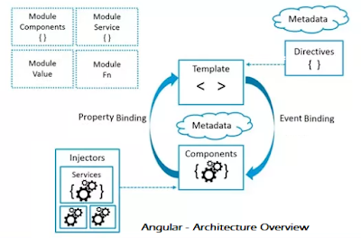

**CHAPTER 4**

**IMPLEMENTATION**

**4.1 Front-end**

**4.1.1 Main Page**

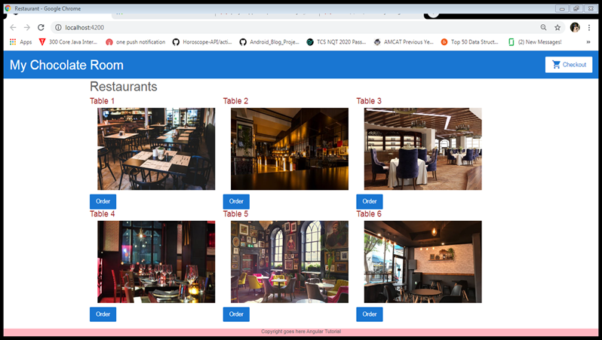

**4.1.2 Items Page**

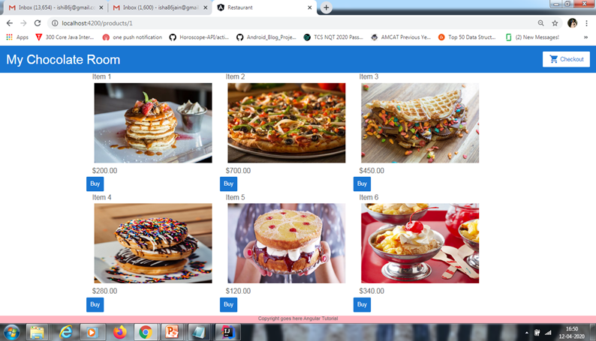

**4.1.3 Items details**

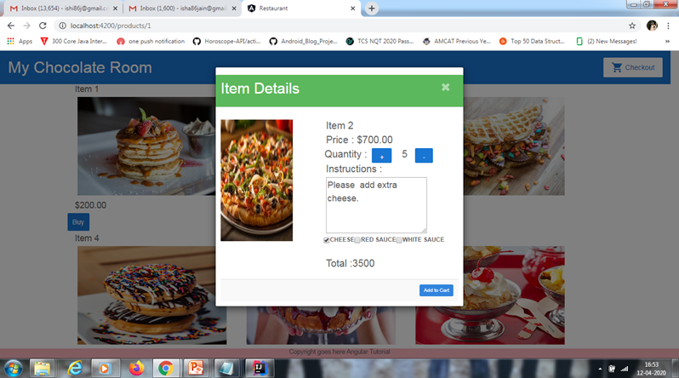

**4.1.4 Cart Details**

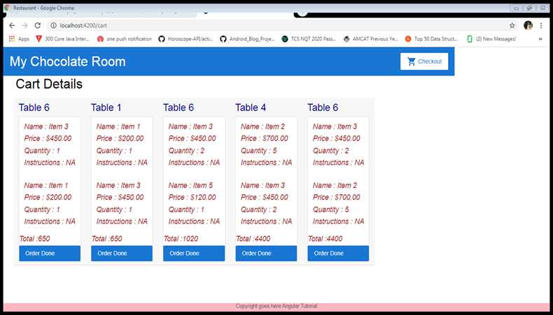

**4.2 Data at Local Storage**

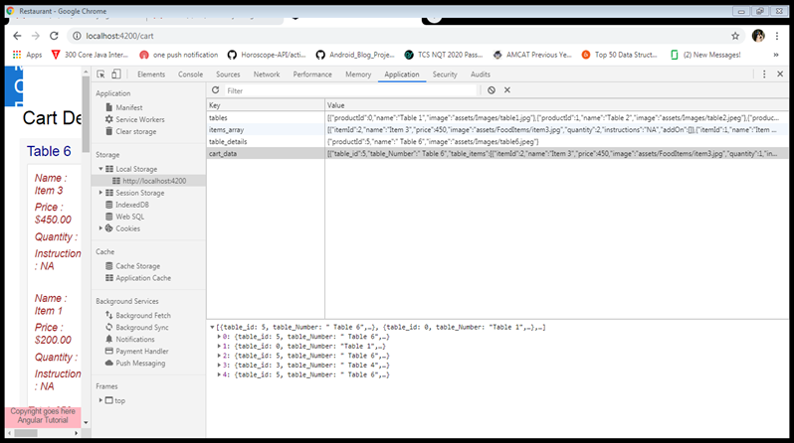

**Chapter 5**

**LEARNING OUTCOMES**

**5.1 Learning Outcomes**

This Internship was a full package of lots of learning it. With the help of this internship we had an opportunity to apply what we have learnt in our course curriculum.Also this internship helped in soft skills as well as I was exposed to the office culture it made me learn about the corporate culture. Some of the key leanings of this internship

* Improvement in communication skills.
* Time Management
* Introduction to Angular
* Learned about deployment of websites.
* Learned how to cooperate with the team.
* Learn how to maintain a Client relationship.

It also helped me in my personality development as I was exposed to the office culture of the organization as well.

**CHAPTER 6**

**CONCLUSION**

**6.1 Conclusion**

This angular web application is very handy, user friendly and efficient . It is a very stable, and ensures security and features like

* Fast to access.
* Easy for modify and add data into local storage.
* Highly sophisticated and user friendly.
* Customers has the facility to add quantities when adding the order and can also specify extra add-ons in the orders.
* It has also has the facility to remove the order from the storage when it’s been ordered to the customers.

**Chapter 7**

**References**

**7.1 References**

* <https://angular.io/docs>
* <https://www.w3schools.com/html/>
* <https://www.w3schools.com/css/default.asp>
* <https://www.w3schools.com/js/js_intro.asp>