Isaac Hinckley
000636849
Bachelor of Science, Computer Science
C950 – Task 1

- Screenshots
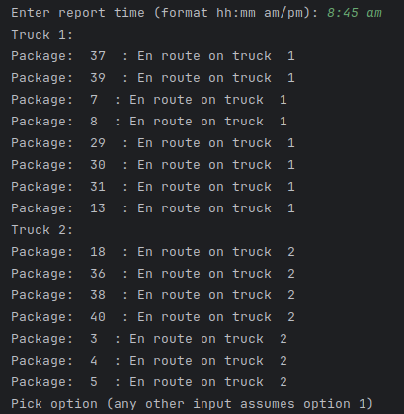
  - Provide screenshots to show the status of all packages loaded onto each truck at a time between 8:35 a.m. and 9:25 a.m.
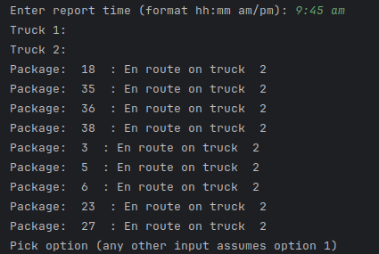
  - Provide screenshots to show the status of all packages loaded onto each truck at a time between 9:35 a.m. and 10:25 a.m.
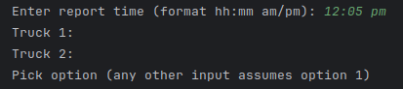
  - Provide screenshots to show the status of all packages loaded onto each truck at a time between 12:03 p.m. and 1:12 p.m.
Last package was delivered at 12:01 PM
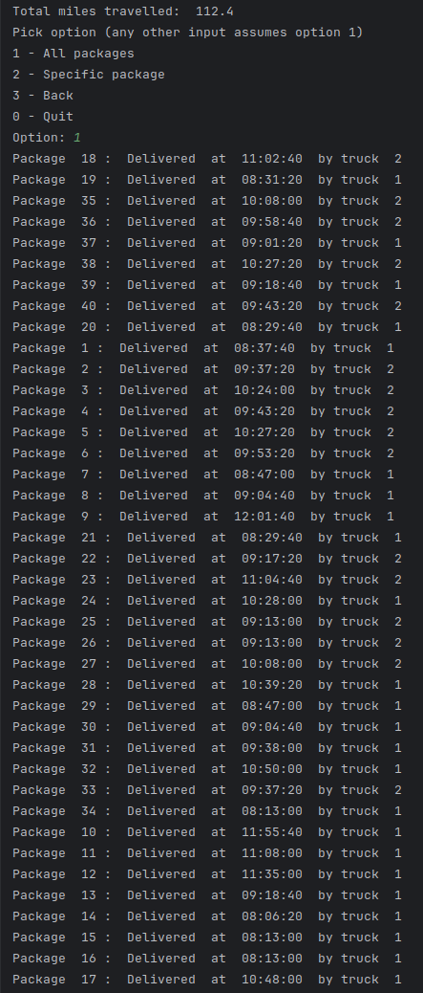
- Provide screenshots showing successful completion of the code that includes the total mileage traveled by all trucks.

- Justify the package delivery algorithm used in the solution as written in the original program by doing the following:
  - An advantage of the nearest neighbor algorithm is the approximation of the shortest distance to travel.
It’s other advantage over path planning algorithms is its simplicity to implement, less calculations needed to perform, and smaller usage space.
  - Verify that the algorithm used in the solution meets all requirements in the scenario.
The Nearest Neighbor algorithm ensures that the trucks travel less than 140 combined miles and that all the packages are delivered by expected times.
  - Identify two other named algorithms that are different from the algorithm implemented in the solution and would meet all requirements in the scenario.
A* search algorithm, Dijkstra algorithm,
    - Describe how both algorithms identified in part F3 are different from the algorithm used in the solution.
Both algorithms are used to provide the shortest distance between two nodes specifically well on a weighted graph. The data provided does not build a weighted graph and therefore the nearest neighbor is an excellent choice.
- Describe what you would do differently, other than the two algorithms identified in part F3, if you did this project again, including details of the modifications that would be made.
While adding the comments I identified some locations where for loops were used where a filter would work better. I would also use the nearest algorithm more. In my solution I only used it to determine the next location of the trucks. It would be used well in determining which packages to load onto the truck as well.
- Verify that the data structure used in the solution meets all requirements in the scenario.
The HashTable allows for simple and quick record insertion as well as retrieval of both package data and location data.
  - Identify two other data structures that could meet the same requirements in the scenario.
A binary search tree and an array.
    - Describe how each data structure identified in H1 is different from the data structure used in the solution.
A binary search tree would organize the data in a method that a search algorithm could traverse it until it found the correct node. Perhaps based on the id number to determine left/right. And array would be an extremely simple data structure to contain the data but would require iterating over the entire array quite often to fetch data.

