


S-164
Published by the
International Hydrographic Organization
4b quai Antoine 1er
Principauté de Monaco
Tel: (377) 93.10.81.00
Fax: (377) 93.10.81.40
info@iho.int
www.iho.int
IHO Test Datasets for ECDIS

Draft Edition 2.0.1 – July xx^{rd} 2026

Instruction Manual for the Use of IHO Test Datasets in ECDIS

© Copyright International Hydrographic Organization 2025
This work is copyright. Apart from any use permitted in accordance with the Berne Convention for the Protection of Literary and Artistic Works (1886), and except in the circumstances described below, no part may be translated, reproduced by any process, adapted, communicated or commercially exploited without prior written permission from the Secretariat of the International Hydrographic Organization (IHO). Copyright in some of the material in this publication may be owned by another party and permission for the translation and/or reproduction of that material must be obtained from the owner.
This document or partial material from this document may be translated, reproduced or distributed for general information, on no more than a cost recovery basis. Copies may not be sold or distributed for profit or gain without prior written agreement of the IHO Secretariat and any other copyright holders.
In the event that this document or partial material from this document is reproduced, translated or distributed under the terms described above, the following statements are to be included:
“Material from IHO publication [reference to extract: Title, Edition] is reproduced with the permission of the IHO Secretariat (Permission No ……./…) acting for the International Hydrographic Organization (IHO), which does not accept responsibility for the correctness of the material as reproduced: in case of doubt, the IHO’s authentic text shall prevail. The incorporation of material sourced from IHO shall not be construed as constituting an endorsement by IHO of this product.”
“This [document/publication] is a translation of IHO [document/publication] [name]. The IHO has not checked this translation and therefore takes no responsibility for its accuracy. In case of doubt the source version of [name] in [language] should be consulted.”
The IHO Logo or other identifiers shall not be used in any derived product without prior written permission from the IHO Secretariat.

S-164 – Part 1

Overview

Page intentionally left blank

Table of Contents

Pages

1 Introduction 1
1.1 Acknowledgements 1
1.2 Acronyms and Terms 1
1.3 References 2
1.4 Normative References: 2
1.5 Preface to Edition 2.0.0 2
1.6 Key Documents Organizations and Relationships 2
1.7 Structure of the Instruction Manual 3
1.8 Screenshots 4
1.9 Organization and Coverage of the TDS 5
1.10 Required Test Items and Use of the TDS 6
1.11 Testing of SECOM requirements 6

Document History
Changes to this Specification are coordinated by the S-98/S-164 Sub-Group, a Project Team under the IHO S-100 Working Group. New editions will be made available via the IHO website. Maintenance of the Specification shall conform to IHO Resolution 2/2007 (as amended).
Version Number | Date of Issue | Author(s) | Brief Description of Change(s)
1.0.0 | 01/03/2023 | S100WG | Initial Draft
1.1.0 | 31/03/2023 | S100WGTSM9 | Updated following feedback from TSM9 meeting.
1.2.0 | 31/12/2023 | J. Pritchard | Updated following new datasets and S-100WG meetings.
1.3.0 | 14/06/2024 | J. Pritchard | Updated with v1.2.0 dataset content, and new form.
1.4.0 | 04/10/2024 | J. Pritchard | Updates following S-98 review and implementation of new settings form.
1.9.0 | 31/01/2025 | J. Pritchard | Updates following latest S-98 revision and reorganisation. Version for HSSC submission and finalisation with test dataset construction.
1.9.1 | 30/09/2025 | J. Pritchard | Updates including global revision of the screenshots and integration of new tests for non-S-101 products.
1.9.2 | 16/02/2026 | J. Pritchard | Updates including addition tests for non ENC products, revision of existing tests and general review (but non exhaustive) of the document content.
2.0.0 |  | J. Pritchard
2.0.1 | xx/07/2026 | J. Pritchard

Page intentionally left blank

Introduction
The International Hydrographic Organization (IHO) Test Datasets (TDS) for Electronic Chart and Display Information System (ECDIS) have been produced to fulfil the requirement for data necessary to accomplish all ECDIS testing requirements as outlined in the IEC 61174 standard. The TDS has been published as IHO Publication Number 164 and consists of numerous data sets required for testing as well as this guide, the TDS Instruction Manual. This Instruction Manual provides supporting documentation about the organization, understanding, and use of the ENC TDS and is intended to be used along with the data sets included in the TDS. It aims to provide appropriate comments about each test including the information about the most suitable data elements, their location and the expected test results.

Acknowledgements
Edition 2.0.0 and its subsequent clarifications have been produced with assistance from many expert contributors and members of the IHO S-100 WG, the ENC Working Group (ENCWG), testbed developers, early S-100 OEM adopters, and associated expert contributors; their input during the drafting and revision process has been invaluable.

Acronyms and Terms
This publication makes extensive use of terms and acronyms described in the IHO S-32 Standard. Additionally, the following acronyms are frequently used:

EUT – Equipment Under Test
HMI – Human Machine Interface
TDS – Test Datasets

References
This publication provides tests based on the requirements documented in IHO standards. References to the source for a specific test are provided within this document. As specified in the IEC 61174 standard the tests provided are used to ensure conformance to the ECDIS requirements laid out in the IMO performance standard for ECDIS.

Normative References
S-100 Universal Hydrographic Data Model, IHO Publication S-100, Edition 5.2.1.
S-98 S-100 ECDIS and Interoperability Specification, Edition 3.0.
IEC 61174 Maritime navigation and radiocommunication equipment and systems - Electronic chart display and information system (ECDIS) - Operational and performance requirements, methods of testing and required test results, 2015.
IEC 63173-2 Maritime navigation and radiocommunication equipment and systems - Data interfaces - Part 2: Secure communication between ship and shore (SECOM), 2022.

Preface to Edition 2.0.0
IHO S-164 is dependent for some of its content on the existence of comprehensive TDS (which it documents) and systems which have implemented correctly the requirements of IHO S-100 (and allied) standards.

As 2.0 is the initial operational version of S-164 there are few fully developed S-100 systems in place, and some datasets are still under development. Therefore, some of the tests documented may not contain reference screenshots from S-100 implementations – where this is the case screenshots have been noted with “[TBD]” (“to be determined”).

As version 2.0 is refined, and implementation of S-100 matures these gaps will be filled in this manual. Additional tests reflecting the complete functionality specified as mandatory in the operational edition of S-98 may need to be added as refinements and clarifications to this operational edition of S-164. Such refinements will be noted in the clarification number of this document. Tests may be marked with a “To do” planned enhancement where this is the case.

This version of the manual is accompanied by named exchange sets available from the IHO for use in type approval testing. Additions to such exchange sets will also be added as tests are refined as required.

References to both IEC61174 and IHO S-98 are definitive in this operational version of S-164. The scope of S-164 is fully constrained by the requirements set out in S-98. For all test cases, S-98 contains the expected and definitive behaviour.

As portrayal and feature catalogue contents are updated for the relevant product specifications screenshots will be updated with the latest portrayal images and, if necessary, tests for complex portrayal will be enhanced.

With the advent of updated feature and portrayal catalogues, and the finalisation of the ECDIS performance standard for ECDIS, it is finally possible to state the complete “scope” of IHO S-164 as that which implements the requirements laid out in S-98. Where such requirements are optional in S-98, they will be similarly noted in this operational edition of S-164. The complete text of many of the newly introduced tests introduced in this edition will be finalised as the TDS are completed, and as implementations of ECDIS make available the complex functionality contained in the S-100 standards.

Key Documents Organizations and Relationships
The development and application of the TDS involves several organizations and related specifications (see Figure 1). The TDS was produced by the IHO to allow for the complete testing of ECDIS equipment (hardware and software) in respect of the ECDIS Performance Standard. The ECDIS Performance Standard is specified by the International Maritime Organization (IMO) in MSC.530(106), and methods for testing this standard are the responsibility of the International Electrotechnical Commission (IEC) which publishes these requirements in document IEC 61174.

All standards are subject to revision. Therefore, users of these standards must use the most recent editions of the standards indicated below. Members of IEC and ISO maintain registers of currently valid international standards.

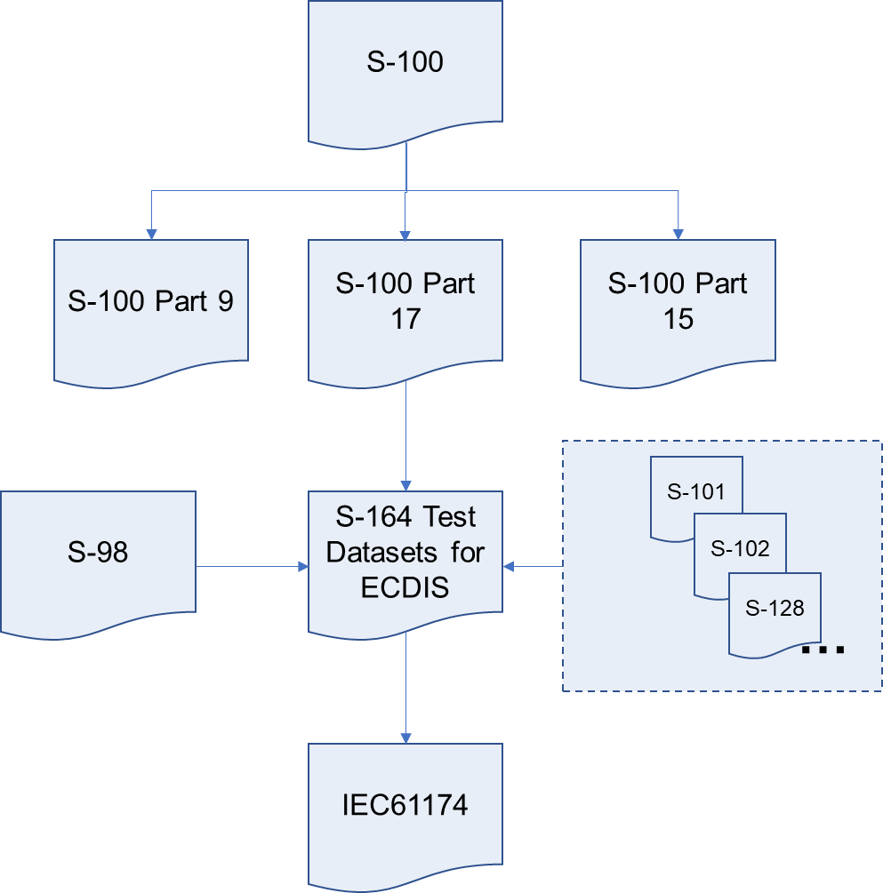
Figure 1 - The TDS and its relationship to other standards.

The S-164 TDS contain both encrypted and unencrypted data. The inclusion of an encrypted dataset, conforming to S-100 Part 15, is so that ECDIS data loading and management operations can be tested under IEC 61174. There are also unencrypted datasets which test visualisation and operational aspects of the ECDIS in respect of its compatibility with S-100 data in various forms. S-164 also now contains datasets which test the dual fuel mode of ECDIS, mixing S-57 and S-101 electronic navigational charts.

Structure of the Instruction Manual
This document consists of an introduction followed by tests grouped into major sections in a task-based layout. All tests are listed in a common format which is shown in the test template below:

Test Reference |  | S-164 Test Name |  |  |  | IHO Reference  IEC Reference |  | IHO Standard reference  IEC Standard reference
Test Description
A short description of what the test covers.
Setup
The configuration required before performing the test. Generally, starts with reference to another test: “As per end (or possibly “start”) of test xxxxxx (test name)” and mentions exchange sets to be loaded, specific settings to be applied and any other information required.
Display Mode |  |  |  |  | Independent Mariner’s Selections  (Default = On)
Displaybase, Standard or Other |  |  |  |  | Accuracy
Context Parameters (Default = On) |  |  |  |  | Contour label
Safety contour |  |  |  |  | Highlight date dependent
Safety depth |  |  |  |  | Highlight document
Deep contour |  |  |  |  | Highlight info
Shallow contour |  |  |  |  | Shallow pattern
Four shades |  |  |  |  | Unknown objects
Radar overlay |  |  |  |  | Update review
Plain boundaries |  |  |  |  | Chart text
Simplified symbols |  |  |  |  | Important text
Full light lines |  |  |  |  | Other Text
Ignore scale minimum |  |  |  |  | Names
Shallow water dangers |  |  |  |  | Light description
Palette |  |  |  |  | All other chart text
Day, Dusk or Night
Viewing Date (or Date Range) |  |  |  |  | Display
Start viewing date |  |  |  |  | Centre |  | The position at which the display must be centred.
End viewing date |  |  |  |  | Scale |  | Dataset viewing scale.
Viewing Groups (Default = On)
Standard Display |  |  |  |  |  | Other
Drying lines |  |  |  |  |  | Spot soundings
Buoys. beacons, aids to navigation |  |  |  |  |  | Submarine cables and pipelines
Buoys, beacons, structures |  |  |  |  |  | All isolated dangers
Lights |  |  |  |  |  | Magnetic variation
Boundaries and limits |  |  |  |  |  | Depth contours
Prohibited and restricted areas |  |  |  |  |  | Seabed
Chart scale boundaries |  |  |  |  |  | Tidal
Cautionary notes |  |  |  |  |  | Miscellaneous (Other)
Ships’ routeing systems and ferry routes
Archipelagic sea lanes
Miscellaneous (Standard)
Chart (Standard)
Alert Highlights (Standard)
Action
The action which the test executor must perform after the setup is in place and before checking the expected results.
Results
The result which the test executor must observe to complete the test.

Screenshots
Screenshots are widely used in this manual to show the expected results of the test on the EUT graphics window. The window of the EUT must have the minimal characteristics as described in S-98 and the applicable ECDIS testing standards – these are not documented here.

Organization and Coverage of the TDS
The TDS contains a named directory for each section of the Instruction Manual which requires test data. Depending on the test requirement, the named folder contains an S100_ROOT directory containing the files of the exchange set (e.g., CATALOG.XML), plus any required catalogues, updates or other optional/related files, e.g., .TIF, .TXT necessary.

The TDS data for encrypted data, located in section 2.6, contains multiple named exchange sets, each with their own S100_ROOT directory and full test scripts describing how to use the data.

The location (or path) of the exchange sets will be indicated using bold italic notation, e.g., Powerup. Tests are structured so that data is imported from standard S-100 (and S-57 for dual fuel tests) exchange sets only, with no individual datasets requiring import. Datasets themselves are sometimes named individually in the tests for reference where necessary. Exchange sets do not contain all necessary catalogues. These should be pre-loaded from the Catalogues exchange set with the exception of tests in Section 2.1 which test the loading of catalogues themselves. Once installed, catalogues should not require re-installation but testers may find it helpful to delete the system database contents between tests.

TDS are arranged in a number of spatially disjoint schemes, with S-57 and S-100 datasets located in close proximity (to facilitate dual fuel testing). Examples of the schemes, and individual dataset names are illustrated in the following diagrams. These show the extent of the S-101 charts comprising the TDS. Other S-100 products are layered on top of these datasets and are integrated with the named exchange sets referenced in each individual test.

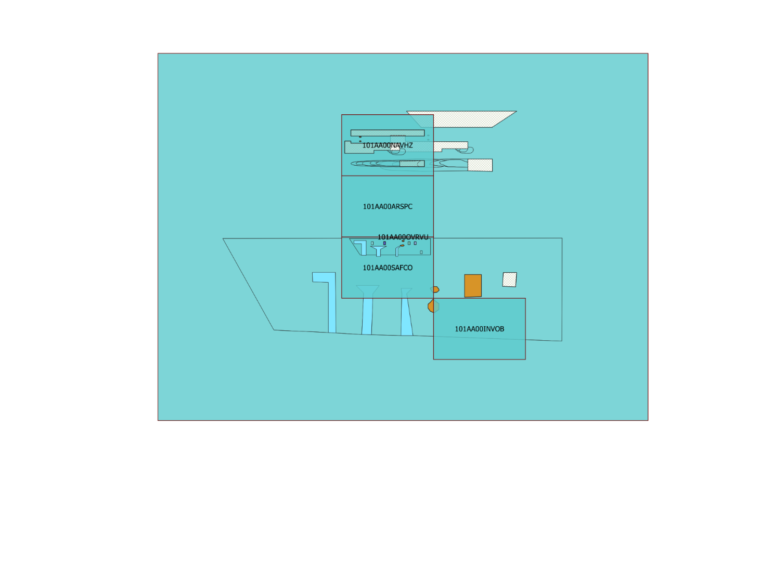
Figure 2 - Data Scheming for Alert and Indication Tests

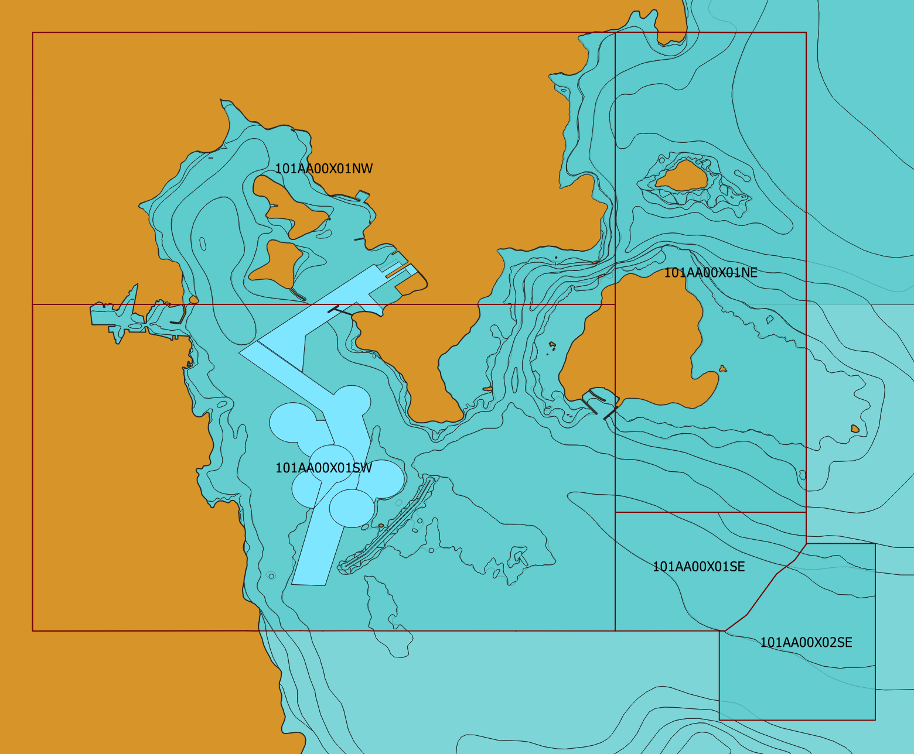
Figure 3 - Cartographic cell overview

Required Test Items and Use of the TDS
This section lists the items required for the execution of Tests specified in this document and how the TDS should be used. The following items are required:

- IHO S-98

- IHO S-164 test datasets for ECDIS which includes both encrypted and unencrypted datasets, and updates, together with the associated instruction manual.

ECDIS Chart 1 and colour differentiation diagrams must also be acquired and installed on the EUT by the manufacturer, prior to the beginning of the tests.

The second item, the IHO TDS, is provided as part of S-164, including the encrypted data and its test scripts. This document is to be considered the “Instruction Manual”. The IHO TDS may be upgraded from time to time to correct residual anomalies and ensure that the results of the tests conform to the description in this Manual.

It is important to ensure that the tests are conducted with the latest version posted on the IHO web site at http://www.iho.int > (ENCs & ECDIS). The version number will remain the same as long as the corrections do not impact this document.

[All tests using data assume the system has preloaded the correct catalogues. Aside from Section 1 of this manual, all systems should pre-install the necessary catalogues, contained in exchange set “PowerUpCatalogues” as a pre-requisite. This will ensure the correct portrayal. Section 1 of this manual is concerned with correct behaviour of catalogue installation.]

Testing of SECOM requirements
S-164 contains tests to satisfy the requirement for unidirectional data transfer using the SECOM standard (IEC63173-2). This requirement is contained in S-98 and is optional in the current edition of S-98 2.0.0.

Unlike the other tests specified in this manual, the SECOM interfaces are not tested exclusively with test data but are performed by connecting the ECDIS to a conformant SECOM network service and executing the documented test scripts.

The infrastructure for executing SECOM tests is hosted by the IHO and instructions for its use are available from the S-100 ECDIS IHO web page. This manual contains instructions for test procedures and confirmation of correct receipt of the SECOM test data.

For testing of SECOM requirements, refer to Annex A of this document.

