S-164 – Part 4

Chart Related Functions

Table of Contents
Pages

4.1 Mode and orientation 1
4.2 Scale bar 2
4.2.1 Display of scale bar 2
4.2.2 Display of scale bar 3
4.3 Feature information 3
4.4 Radar and Plotting Information 16
4.5 Accuracy 23
4.5.1 Distance and azimuth between geographical positions 23
4.5.2 Geographical position from a known position and distance/azimuth 24
4.5.3 Rhumb line distance and azimuth between geographical positions 25
4.5.4 Geodesics 26
4.5.5 Rhumb Lines 27
4.5.6 Positions for use in Accuracy Tests - Geodesics 29
4.5.7 Positions for use in Accuracy Tests – Rhumb Lines 35
4.6 Symbols 39
4.6.1 Symbol Size 39
4.6.2 Display of ECDIS chart 1 symbols of correct size 39
4.6.3 Size in pixels of the check symbol CHKSYM01 39
4.6.4 Display of text at the correct size 40
4.6.5 ECDIS Chart 1 40
4.6.6 Display redraw 40
4.7 Units and Legend 41
4.7.1 Legend – Multiple Product Specifications. 42
4.8 Other ECDIS and Chart Related Functionality 43
4.8.1 ECDIS Chart 1 43
4.8.2 Use of the Colour Differentiation Diagram 45
4.8.3 Data Quality Indicators and Portrayal 47
4.8.4 Miscellaneous encoding 47

Page intentionally left blank

Mode and orientation
Test Reference | ModeOrientation1 | IHO Reference
Test description
Display of the north arrow symbol.
Setup
Load the exchange set PowerUp
Action
Observe the display.
If the EUT offers the capability to show other than north-up presentation; Change the presentation to non-north up and observe the display.

Results
Confirm that the north arrow symbol is always displayed at the top left corner of the chart area, not overlapping the scale or latitude bar when the scale bar extends to the full height of the display

If the EUT supports changing to non-north up presentations confirm that the symbol realigns to north.

Test Reference | ModeOrientation2 | IHO Reference
Test description
True motion operation.
Setup
As for ModeOrientation1

Action
Ensure that true motion is provided.
Reset the display and check that the generation of the neighbouring area takes place automatically at a distance selected by the Mariner.
Results
Confirm that true motion operation is provided and that the generation of the neighbouring area takes place automatically at a distance selected by the Mariner.

Test Reference | ModeOrientation3 | IHO Reference
Test description
Manual adjustment of chart display area and own ship position.
Setup
As for ModeOrientation

Action
Manually adjust the chart display area.
Change the position of own ship relative to the edge of the display.
Results
Confirm that it is possible to change manually the chart area and the position of own ship relative to the edge of the display.

Test Reference | NoDataAvailable | IHO Reference
Test description
No ENC data available.
Setup
As for ModeOrientation

Ship position as follows: 32°27.88’S 061°20.66’E (an area with no ENC)
Action
Observe the display.
Results
Confirm that a “No ENC available” indication is provided.

Test Reference | NonNorthUp | IHO Reference
Test description
Display in non ‘north-up’ orientation.
Setup
As for ModeOrientation

Action
For each bearing-stabilised orientation other than ‘north-up’ that may be provided, confirm by analytical evaluation that for turning rates between 0 deg/s and 20 deg/s the displayed chart symbols and text do not re-orient more often than 2 times per second and remain legible if they do not remain fixed.
Results
Confirm that the displayed symbols and text do not re-orient more often than 2 times per second and remain legible. The symbols and text may remaining fixed and in this case will not re-orientate.

Scale bar

Display of scale bar
Test Reference | ScaleBar | IHO Reference | S-98 12.10.1
Test description
Display of scale bar at appropriate scales.
Setup
Load exchange set PowerUp
Set Display Category Base Display.
Action
Zoom to a display scale greater than 1:80 000 (such as 1:25 000), observe the display.
Results
Confirm that a scale bar is displayed. Also confirm that the scale bar is displayed between 2mm and 4mm from the left side of the chart display area.

Display of scale bar
Test Reference | LatitudeBar | IHO Reference | S-98 12.10.1
Test description
Display of latitude bar at appropriate scales.
Setup
Load exchange set PowerUp
Set Display Category Base Display.
Action
Zoom to a display scale less than 1:80 000 (such as 1:300 000), observe the display.
Results
Confirm that a latitude bar is displayed. Also confirm that the scale bar is displayed between 2mm and 4mm from the left side of the chart display area.

Feature information
Test Reference | FeatureInformation1 | IHO Reference | S-98 15.1
Test description
General rules for cursor pick report
Setup
Load exchange set PowerUp
Select Display Category Other.
Action
1. Select several features of
- depth area;
- restricted area;
- sea area;
- depth contour;
- ferry route;
- recommended track;
- buoy (for example buoy and light at 32°29.50’S - 061°00.46’E);
- light;
- wreck.
2. Observe feature information.
3. Remove feature information from display.
Results

- The following rules shall be applied to the pick report:
- Full feature and attribute names must be displayed. If a language pack is installed then the feature and attribute names must use the translated names contained in the language pack according to user preference – user language preferences are described in clause Erreur ! Source du renvoi introuvable.
- Listed value names must be displayed instead of the numerical code.
- There must not be any padding of attribute values, for example, a height of 10 metres must not be padded to 10.000000 metres as this could potentially confuse or mislead the Mariner.
- Units of measure must be included after all attribute values when available.
- Cursor pick report must extend to include both information associations and feature associations, including aggregations and compositions, which may link to information types or features that carry additional information such as a featureName.
- Dates must be given in the form “Day Month Year” DD-MMM-YYYY.
  - Month abbreviations must be: JAN, FEB, MAR, APR, MAY, JUN, JUL, AUG, SEP, OCT, NOV, DEC.
- The Pick Report must only return information about the visible features on the ECDIS display. If the viewing group is turned on all features, even “no symbol” features without visible presentation within that viewing group, must be provided in the cursor Pick Report, i.e. only active drawing instructions must be included.
- Pick Report must include the information associated with the spatial object limited to the area of the cursor pick. For example, information related to accuracy.
- Complex or Simple Attributes with private visibility must not be included.
- Descriptions of attributes and their values, available in the feature catalogue, must be shown on demand.

2. Text associated with chart features must be removed from the display.

Note: The text and background colour of pick report is specified by the OEM

[This test needs to also include other data products (particularly S-124 where the area covered by NW is not portrayed]

Test Reference | FeatureInformation2 | IHO Reference | S-98 15.1
Test description
Pick report descriptions and sorting
Setup
As for test FeatureInformation1.
Action
Select several features as mentioned in 4.3

Results
- A plain language explanation of each symbol shall be used as included in portrayal catalogue to provide quick and understandable information which is not always obvious from the feature class and attribute information.
- Attribute values provided in addition to the above explanation shall be connected to their meaning, and the definitions shall also be available.
- The feature information shall be sorted by the drawing priority of the feature as defined in the portrayal catalogue. When the drawing priority of features is equal, the geometric primitive shall be used to order the information (points followed by curves and finally surfaces).
- Check that the content displayed in the pick report is configurable by the user.

Test Reference | FeatureInformation3 | IHO Reference | S-98 15.2.2
Test description
User defined cursor pick parameters, if available

Setup
As for test FeatureInformation1.
Action
1. Configure the cursor pick parameter as available.
2. Select several features as mentioned in 4.3

Results
1. The cursor pick parameters may be configurable by the user and available for presentation.
2. The content of the pick report shall be presented as configured.

Test Reference |  | FeatureInformation4 |  | IHO Reference |  | S-98 15.1
Test description
Hover-over function for feature information (optional)
Test shall only be performed if a hover-over function for feature information is provided.
Setup
As for test FeatureInformation1.
Action
1. Configure the hover-over function OFF.
2. Move cursor to one of the features in the table below and to features where additional information is available or date dependent features:
3. Configure the hover-over function ON.
4. Move cursor to one of the features mentioned in 2.
5. Move cursor to any other features.

 | Features |  | S-101 Acronym
 | Lights |  | AllRoundLight
 | Beacon, cardinal |  | BuoyCardinal
 | Beacon, isolated danger |  | BuoyIsolatedDAnger
 | Beacon, lateral |  | BeaconLateral
 | Beacon, safe water |  | BeaconSafeWater
 | Beacon, special purpose/general |  | BeaconSpecialPurpose
 | Buoy, cardinal |  | BuoyCardinal
 | Buoy, installation |  | BuoyInstallation
 | Buoy, isolated danger |  | BuoyIsolatedDanger
 | Buoy, lateral |  | BuoyLateral
 | Buoy, safe water |  | BuoySafeWater
 | Buoy, special purpose/general |  | BuoySpecialPurpose
 | Landmarks |  | Landmark
Results
1. It shall be possible to switch OFF the hover-over function.
2. There shall be no information of chart features displayed when hovering over it.
3. It shall be possible to switch ON the hover-over function.
4. Important information of chart features shall be displayed when hovering over it.
5. When hovering over other chart features no information shall be displayed.

Test Reference | FeatureInformation5 | IHO Reference | S-98 15.1
Test description
Presentation of unknown attributes
There is no generic special presentation for unknown attributes. Some presentations may indicate question mark, but that is because something mandatory is missing for the feature. The main purpose of this test is to check
that ECDIS is able to accept ENC datasets which contain unknown attributes. The real use case is when ECDIS is not upgraded for latest IHO standard and therefore the
ECDIS does not understand all attributes.
Setup
Load the exchange set InvalidFeatures dataset 101AA00INVOB.000 :
- Select Display Category Other
- Set the Safety contour value to 0 m
- Select Symbolized Boundaries
- Set symbolized symbols to Off

Action
Select chart features with unknown attribute for cursor pick report.
Results
Check ENC symbols shown in the ECDIS against the corresponding graphical plot. Select one by one each of 6 features for cursor pick report.
The result of cursor pick shall be:
a) Wreck with attribute Water level effect (covers and uncovers);
b) Obstruction with attribute Value of Sounding (no value) and Water Level Effect (no value);
c) Restricted area without any attribute;
d) Buoy, cardinal with attributes Buoy shape (spar (spindle)), Category of cardinal mark (north cardinal mark), Colour, Colour pattern (horizontal stripes), Topmark and UnknownAtt2;
e) Cable, submarine with attribute UnknownAtt1;
f) Silo/Tank with attribute UnknownAtt2.

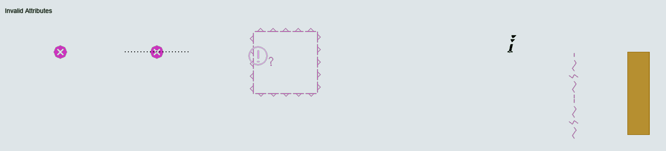

TBD

Test Reference | InteroperabilityIdentifer | IHO Reference | 15.1 (10)
Test description
TODO:
- Test pick report function where the feature picked has an interoperabilityIdentifier which is referred to by an S-124 featureReference.interoperabilityIdentifier. This tests that NW can link to ENC features.
- This is accomplished by setting interoperabilityIdentifier in S-101 features then setting featureReference.interoperabilityIdentifier in S-124 to the same value and executing a pick report on the S-101.

Test Reference | TidalStreamPanelData | IHO Reference | S-98 15.4
Test description
Display of tidal stream panel Data
Setup
Load exchange set PowerUp
Action
1. Select an example of TidalStreamPanelData (tidal stream panel information)
1a. select the complex attribute tidal stream panel values at 32°31.45’S 60°56.35’E for
display;
2. Select an example of TidalAStreamPanelData (tidal stream prediction by harmonic methods)
2a. select tidal stream prediction by harmonic methods feature at 32°32.57’S 60°57.69’E for display;
3. Repeat step 1 and 2 for different light conditions (DAY, DUSK, NIGHT).

Results
1a. The data must be displayed in a way that it can be easily read and is logically presented, in a format as follows:
TODO: replace with S-98 Updated Image.
3. The data must be displayed as appropriate for the selected light condition (DAY, DUSK, NIGHT).

Test Reference | Tidal panels (2) | IHO Reference | S-98 15.4
Test description
Show multiple tidal panels when more than one is included in the feature.

Test Reference | SupplementaryFile2 | IHO Reference | S-98 15.2.2
Test description
Display of supplementary text file
Setup
As for test FeatureInformation1.
Action
1. Select an example of a note encoded using information attributes (for example Caution Area at approximately 32°34.74’S 061°08.92’E);
2. Repeat step 1 for different light conditions (DAY, DUSK, NIGHT).
Results
1. The note must be displayed within the light level of the current display and in a way that it can be easily read, for example by displaying the note as it might appear on a paper chart (for example content of 10100AAIECTMP.TXT file as contained in the directory of loaded ENCs).
2. The note must be displayed as appropriate for the selected light condition (DAY, DUSK, NIGHT).
3. The content of the note must commence at the location specified by the fileLocator reference, as shown in the image

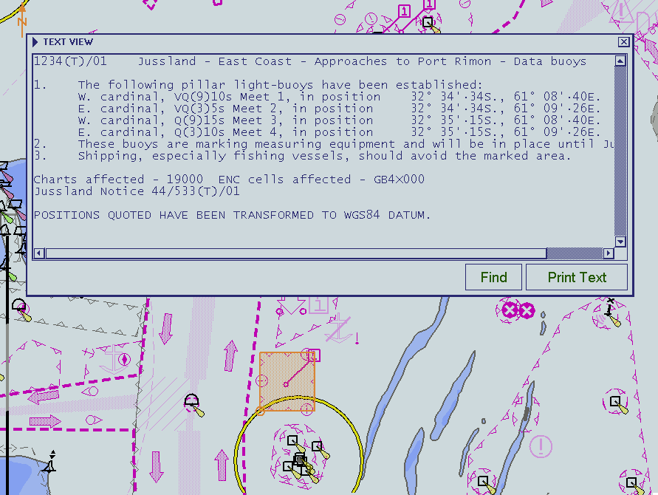
Example of Text 101AA00IECTMP.TXT over cell 10100AA_X0000.000, Day palette tbd

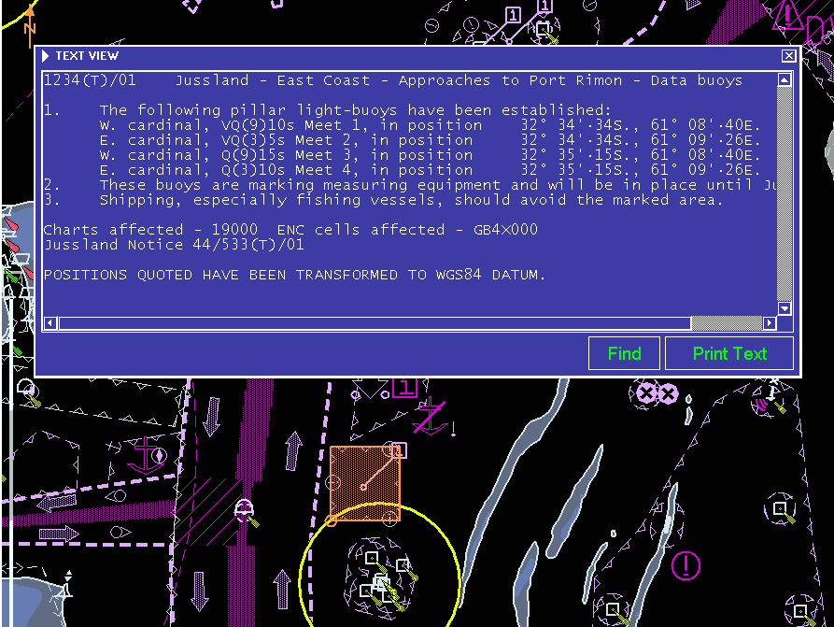
Example of Text 101AA00IECTMP.TXT over cell 10100AA_X0000.000, Dusk palette
TBD

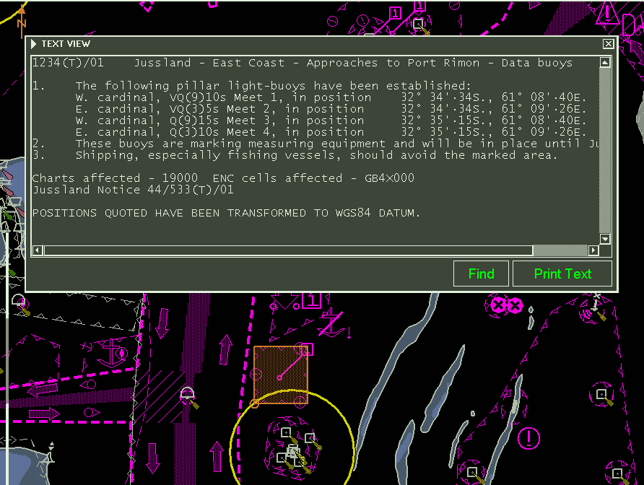
Example of Text 101AA00IECTMP.TXT over cell 10100AA_X0000.000, Night palette tbd

Test Reference | PictorialRepresentation | IHO Reference | S-98 15.2.2
Test description
Display of picture representation
Setup
As for test FeatureInformation
Action
1. Select an example of the attribute pictorialRepresentation
1a. select landmark feature at 32°31.95’S 60°54.34’E and select picture representation for display;
1b. select area feature of 32°30.25’S 60°54.64’E with NauticalInformation and select picture representation for display;
2. Repeat step 1a and b for different light conditions (DAY, DUSK, NIGHT).
Results
1a. The picture 101AA00TESTPC.TIF must be displayed;
1b. The picture 101AA00X4000T.TIF must be displayed;
2. The pictures must be displayed as appropriate for the selected light condition (DAY, DUSK, NIGHT). It shall not affect the user’s night vision.
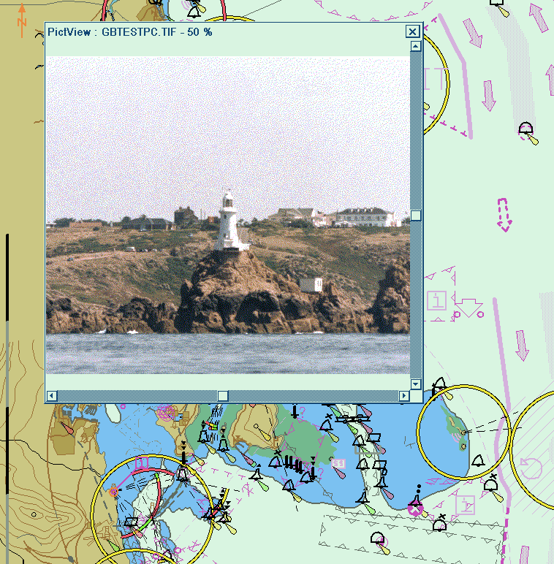
Example of Picture 101AA00TESTPC.TIF over cell 10100AA_X0000.000, Day palette
TBD

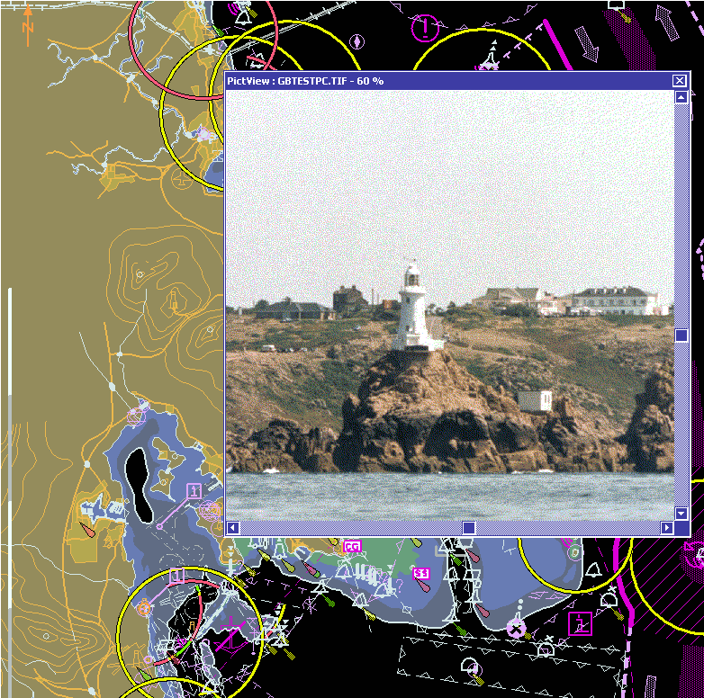
Example of Picture 101AA00TESTPC.TIF over cell 10100AA_X0000.000, Dusk palette
TBD

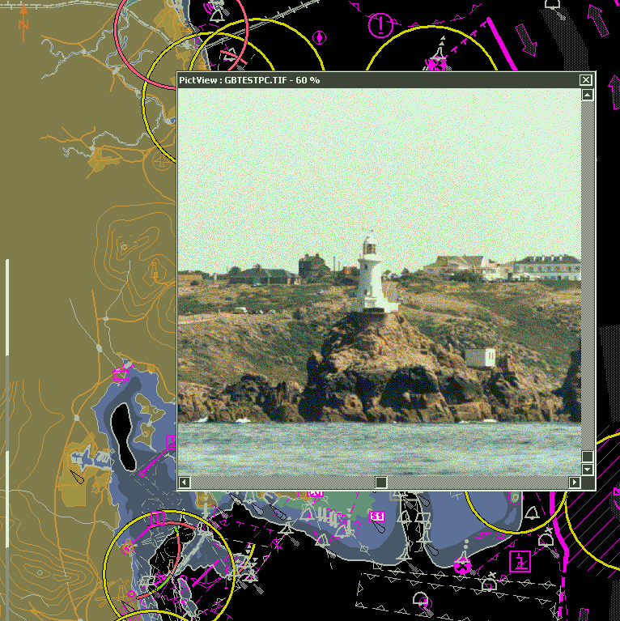
Example of Picture 101AA00TESTPC.TIF over cell 10100AA_X0000.000, Night palette
TBD

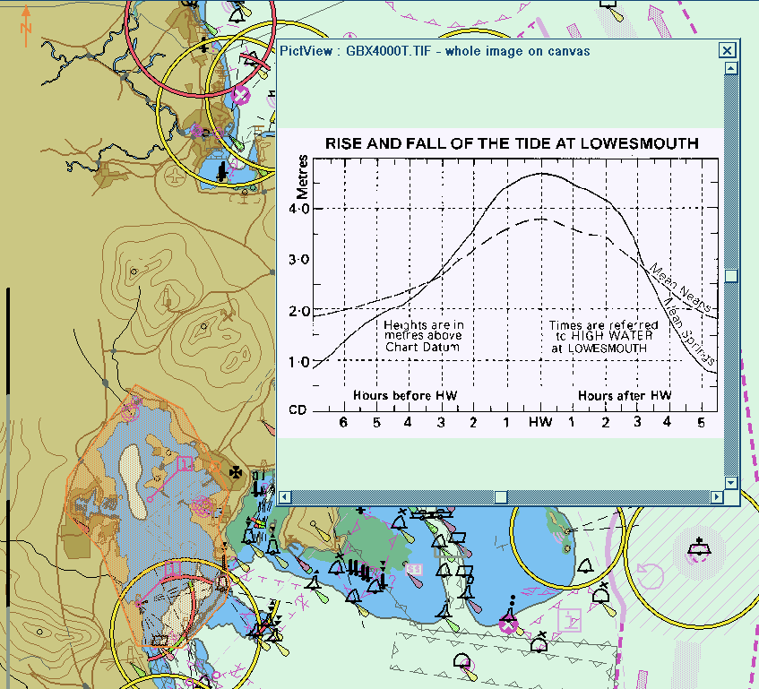
Example of Picture 101AA00X4000T.TIF over cell 10100AA_X0000.000, Day palette
TBD

Radar and Plotting Information
Where the capability for displaying radar or radar tracks is provided, in addition to the requirements of IEC 62288 for radar displays and presentation of target information, perform the following:

Test Reference |  | RadarOverlay |  |  |  | IHO Reference |  |  | S-98 9.2
Test Description
Display of Radar overlays with System Database information

Loaded Data
Exchange Set Name
Display Mode |  |  |  |  | Independent Mariner’s Selections (default=On)
Other |  |  |  |  | Accuracy
Context Parameters |  |  |  |  | Contour label
Safety contour |  |  |  |  | Highlight date dependent
Safety depth |  |  |  |  | Highlight document
Deep Contour |  |  |  |  | Highlight info
Shallow contour |  |  |  |  | Shallow pattern
Four shades |  |  |  |  | Unknown
Radar overlay |  |  |  |  | Update review
Plain boundaries |  |  |  |  | Text Groups
Simplified symbols |  |  |  |  | Chart Text
Full light lines |  |  |  |  | Important text
Ignore scale minimum |  |  |  |  | Other Text
Shallow water dangers |  |  |  |  | Names
Palette |  |  |  |  | Light description
Day |  |  |  |  | All other chart text
Date Dependent Objects |  |  |  |  | Display
Start Date |  |  |  |  | Centre
End Date |  |  |  |  | Scale |  | 1:60000
 |  |  |  |  | Orientation
Viewing Groups (Default = On)
Standard Display |  |  |  |  |  | Other
Drying lines |  |  |  |  |  | Spot soundings
Buoys. Beacons, aids to navigation |  |  |  |  |  | Submarine cables and pipelines
Buoys, beacons, structures |  |  |  |  |  | All isolated dangers
Lights |  |  |  |  |  | Magnetic variation
Boundaries and limits |  |  |  |  |  | Depth contours
Prohibited and restricted areas |  |  |  |  |  | Seabed
Chart scale boundaries |  |  |  |  |  | Tidal
Cautionary notes |  |  |  |  |  | Miscellaneous (Other)
Ships’ routeing systems and ferry routes
Archipelagic sea lanes
Miscellaneous (Standard)
Chart (Standard)
Alert Highlights (Standard)
Additional
Setup
Load exchange set PowerUp
Display cell 10100AA_X01NE at 3 NM range scale
- Select Safety contour value to 8 m
- Select Safety depth value to 8 m
- Select Plain boundaries
Set symbolized symbols to Off..

Action
Switch on the following (where available):
- Radar image overlay
- Radar tracked target information
AIS information

Results
Confirm by observation that same System Database features are under or over radar echoes as in the example pictures. Note that some examples contain intentionally a lot of radar echo noise in order to give many examples of the System Database features which shall be over or under radar echoes

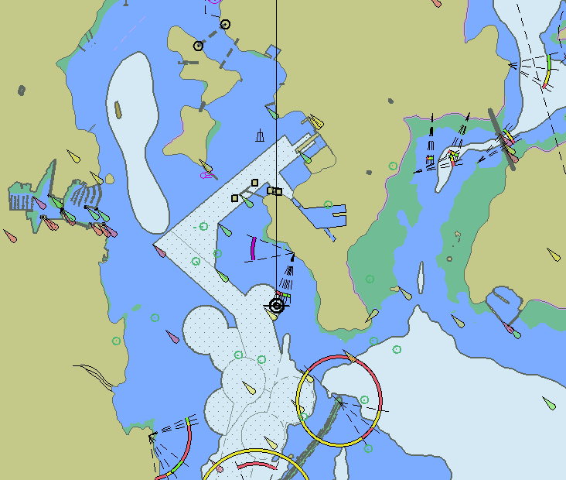
Day with radar tracked targets. Display Category Display Base + Lights
TBD

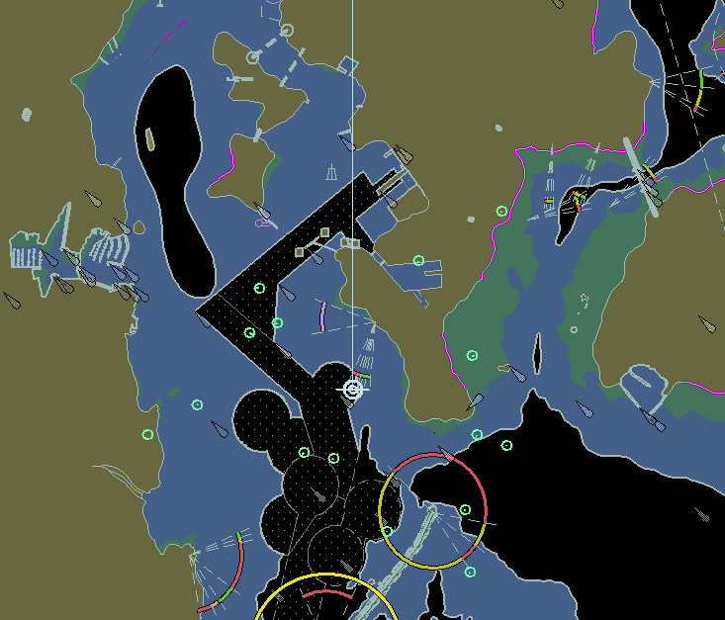
Dusk with radar tracked targets. Display Category Display Base + Lights
TBD

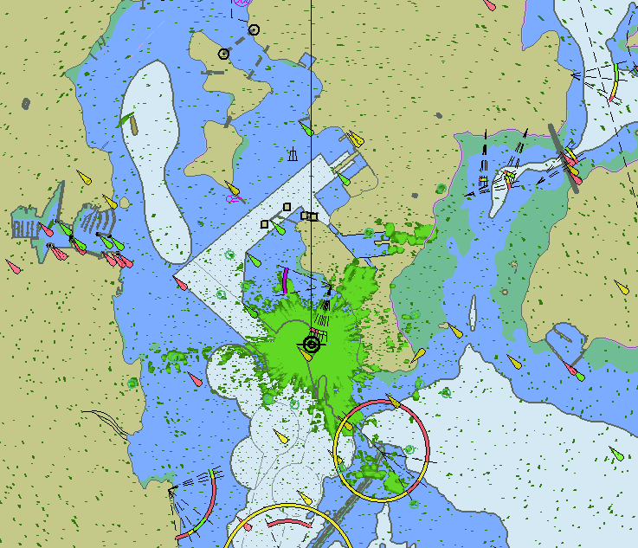
Day with radar echoes and tracked targets. Display Category Display Base + Lights
TBD

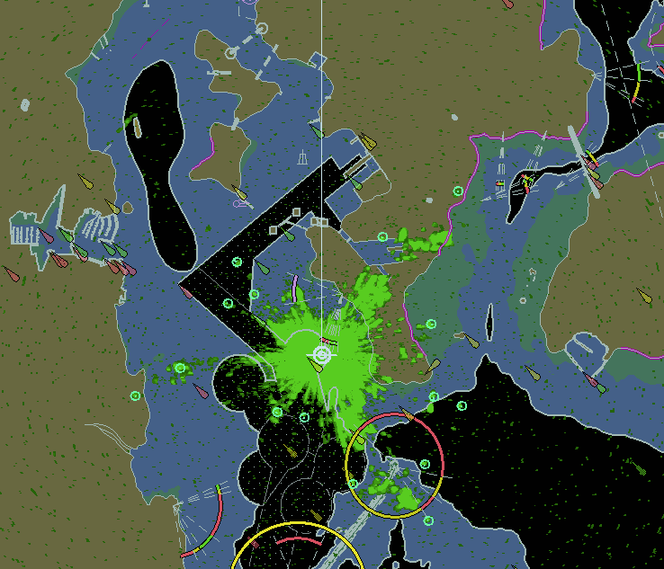
Dusk with radar echoes and tracked targets. Display Category Display Base + Lights
TBD

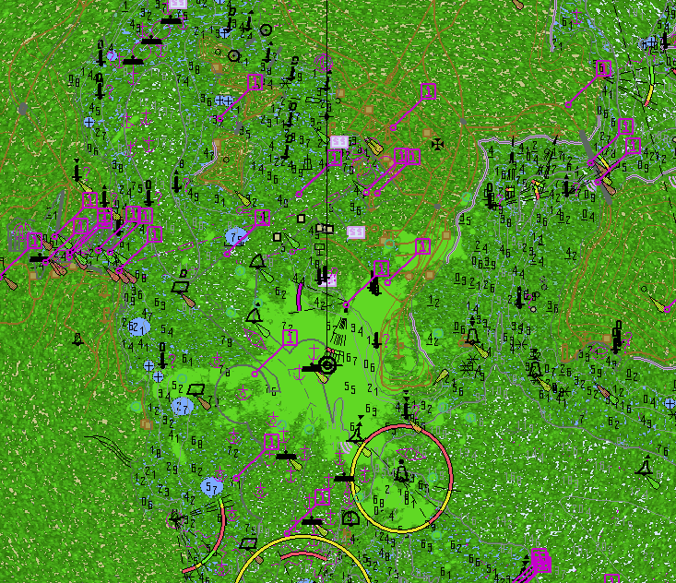
Day with very noisy radar echoes and tracked targets. Display Category Other, Select Highlight info, Select Shallow water dangers.

Note: This example clearly shows which SYSTEM DATABASE features are above radar echoes
TBD

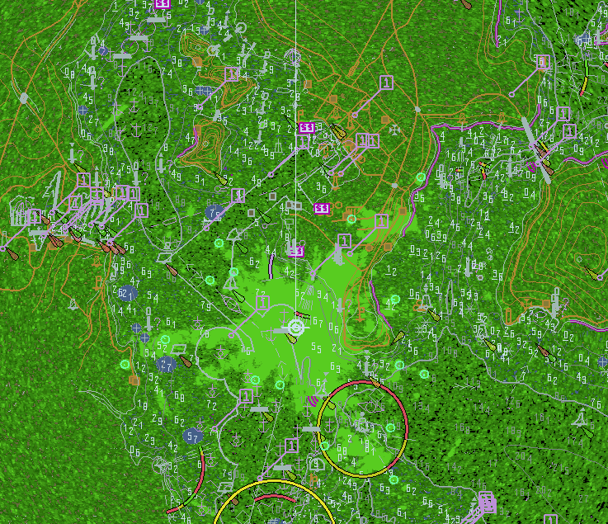
Dusk with very noisy radar echoes and tracked targets. Display Category Other, Select Highlight info, Select Shallow water dangers.

Note: This example clearly shows which SYSTEM DATABASE features are above radar echoes
TBD

Accuracy
Note:
In this section calculations are based on the WGS-84 spheroid:
Semi-major axis 6378137.0000m
Semi-minor axis 6356752.3142m
Eccentricity squared 0.00669437999013
Flattening 298.257223563

The WGS-84 spheroid is defined by its semi-major axis and flattening 1/f = 1/298.257223563.
The other parameters are derived from a and f.

Conversion of metres (m) to nautical miles (NM) uses
1 NM = 1852 m.

The tests contained within this section shall be executed using the Electronic Bearing Line (EBL) and Variable Range Marker (VRM) tools provided by the ECDIS system.

The tolerance for distances is 1% or 30m whichever is greater. The tolerance for bearings is 1º.

The positions used in this section are also included in the files “4.6 Accuracy-Geodesic.doc” and “4.6 Accuracy-Rhumb Lines.doc” in the “4.6 Accuracy” folder within the TDS.

Distance and azimuth between geographical positions
Test Reference | Accuracy1 | IHO Reference
Test description
True distance and azimuth between two geographical positions a).
Setup
Load the exchange set PowerUp
Action
Measure the distance and azimuth between the following two features:

Viking 49/27-B 32º35.224’S 061º17.710’E
Corund Cape Light 32º27.436’S 060º58.609’E
Results
Confirm that the results are as follows:

True Distance 33193.554 m / 17.9231 NM
Bearing from Viking 49/27-B to Corund Cape Light is 295.614 degrees
Bearing from Corund Cape Light to Viking 49/27-B is 115.785 degrees

Test Reference | Accuracy2 | IHO Reference | -
Test description
True distance and azimuth between two geographical positions b).
Setup
As for test Accuracy1
Action
Measure the distance and azimuth between the following two features:

Viking 49/27-B 32º35.224’S 061º17.710’E
Castlerigg Light 32º23.280’S 060º58.496’E
Results
Confirm that the results are as follows:

True Distance 37326.351 m / 20.1546 NM
Bearing from Viking 49/27-B to Castlerigg Light is 306.172 degrees
Bearing from Castlerigg Light to Viking 49/27-B is 126.344 degrees

Test Reference | Accuracy3 | IHO Reference | -
Test description
True distance and azimuth between two geographical positions c).
Setup
As for test Accuracy1
Action
Measure the distance and azimuth between the following two features:

Corund Cape Light 32º27.447’S 060º58.599’E
Worm Head Light 32º31.958’S 060º54.337’E
Results
Confirm that the results are as follows:

True Distance 10680.859 m / 5.7672 NM
Bearing from Corund Cape Light to Worm Head Light is 218.665 degrees
Bearing from Worm Head Light to Corund Cape Light is 38.703 degrees

Geographical position from a known position and distance/azimuth
Test Reference | Accuracy4 | IHO Reference | -
Test description
Geographical position from known position and distance/azimuth a).
Setup
As for test Accuracy1.
Action
From the following position:
Viking 49/27-B 32º35.224’S 061º17.710’E
Enter a distance and bearing of:
True Distance 33193.554 m / 17.9231 NM
Bearing 295.614 degrees
Results
Confirm that the end geographical position is:
Corund Cape Light 32º27.436’S 060º58.609’E

Test Reference | Accuracy5 | IHO Reference | -
Test description
Geographical position from known position and distance/azimuth b).
Setup
As for test Accuracy1
Action
From the following position:
Viking 49/27-B 32º35.224’S 061º17.710’E
Enter a distance and bearing of:
True Distance 37326.351 m / 20.1546 NM
Bearing 306.172 degrees
Results
Confirm that the end geographical position is:
Castlerigg Light 32º23.280’S 060º58.496’E

Test Reference | Accuracy6 | IHO Reference | -
Test description
Geographical position from known position and distance/azimuth c).
Setup
As for test Accuracy1
Action
From the following position:
Corund Cape Light 32º27.447’S 060º58.599’E
Enter a distance and bearing of:
True Distance 10680.859 m / 5.7672 NM
Bearing 218.665 degrees
Results
Confirm that the end geographical position is:
Worm Head Light 32º 31.958’S 60º 54.337’E

Rhumb line distance and azimuth between geographical positions
Test Reference | Accuracy7 | IHO Reference | -
Test description
Rhumb line distance and azimuth between two geographical positions a).
Setup
Load the exchange set PowerUp
Action
Measure the distance and azimuth between the following two features:

Viking 49/27-B 32º35.224’S 061º17.710’E
Corund Cape Light 32º27.436’S 060º58.609’E
Results
Confirm that the results are as follows:

True Distance 33193.567 m / 17.9231 NM
Bearing from Viking 49/27-B to Corund Cape Light is 295.699 degrees
Bearing from Corund Cape Light to Viking 49/27-B is 115.699 degrees

Test Reference | Accuracy8 | IHO Reference | -
Test description
Rhumb line distance and azimuth between two geographical positions b).
Setup
As for test Accuracy1
Action
Measure the distance and azimuth between the following two features:

Viking 49/27-B 32º35.224’S 061º17.710’E
Castlerigg Light 32º23.280’S 060º58.496’E
Results
Confirm that the results are as follows:

True Distance 37326.365 m / 20.1546 NM
Bearing from Viking 49/27-B to Castlerigg Light is 306.258 degrees
Bearing from Castlerigg Light to Viking 49/27-B is 126.258 degrees

Test Reference | Accuracy9 | IHO Reference | -
Test description
Rhumb line distance and azimuth between two geographical positions c).
Setup
As for test Accuracy1
Action
Measure the distance and azimuth between the following two features:

Corund Cape Light 32º27.447’S 060º58.599’E
Worm Head Light 32º31.958’S 060º54.337’E
Results
Confirm that the results are as follows:

True Distance 10680.859 m / 5.7672 NM
Bearing from Corund Cape Light to Worm Head Light is 218.684 degrees
Bearing from Worm Head Light to Corund Cape Light is 38.684 degrees

Geodesics

Test Reference | Accuracy10 | IHO Reference | -
Test description
Geodesic lines and circle, northern quadrant.
Setup
As for test Accuracy1
Action
Plot positions listed in sets 2-6 of the positions listed in section “Positions for use in Accuracy Tests – Geodetics”.
Results
Confirm that the lines drawn pass through or sufficiently close to the listed positions and that the Geodesic circle corresponds to range rings at 2 000 000 m intervals.

Test Reference | Accuracy11 | IHO Reference | -
Test description
Geodesic lines and circle, crossing the equator.
Setup
As for test Accuracy1
Action
Plot positions listed in sets 7-11 of the positions listed in section “Positions for use in Accuracy Tests – Geodetics”.
Results
Confirm that the lines drawn pass through or sufficiently close to the listed positions and that the Geodesic circle corresponds to range rings at 2 000 000 m intervals.

Test Reference | Accuracy12 | IHO Reference | -
Test description
Geodesic lines southern quadrant.
Setup
As for test Accuracy1
Action
Plot positions listed in sets 12-16 of the positions listed in section “Positions for use in Accuracy Tests – Geodetics”.
Results
Confirm that the lines drawn pass through or sufficiently close to the listed positions and that the Geodesic circle corresponds to range rings at 2 000 000 m intervals.

Rhumb Lines
Test Reference | Accuracy13 | IHO Reference | -
Test description
Rhumb lines, northern quadrant.
Setup
As for test Accuracy1
Action
Plot positions listed in sets 2-5 of the positions listed in section “Positions for use in Accuracy Tests – Rhumb Lines”.
Results
Confirm that the lines drawn pass through or sufficiently close to the listed positions.

Test Reference | Accuracy14 | IHO Reference | -
Test description
Rhumb lines, crossing the equator.
Setup
As for test Accuracy1.
Action
Plot positions listed in sets 6-9 of the positions listed in section “Positions for use in Accuracy Tests – Rhumb Lines”.
Results
Confirm that the lines drawn pass through or sufficiently close to the listed positions.

Test Reference | Accuracy15 | IHO Reference | -
Test description
Rhumb lines, southern quadrant.
Setup
As for test Accuracy1.
Action
Plot positions listed in sets 10-13 of the positions listed in section “Positions for use in Accuracy Tests – Rhumb Lines”.
Results
Confirm that the lines drawn pass through or sufficiently close to the listed positions.

Positions for use in Accuracy Tests - Geodesics
The following sections contain a series of latitudes and longitudes which define a number of geodesics.
These points are intended to allow type approval authorities to test the ability of ECDIS to calculate geodesics correctly.

Conversion of metres (m) to nautical miles (NM) uses
1 NM = 1852 m.

Set 1 Micklefirth

Usage Band 4

Viking 49/27-B 32º35.224S 061º17.710E
Corund Cape Light 32º27.436S 060º58.609E
True Distance 33193.554 m / 17.9231 NM
Forward Bearing 295.614 degrees
Reverse Bearing 115.785 degrees

Viking 49/27-B 32º35.224S 061º17.710E
Castlerigg Light 32º23.280S 060º58.496E
True Distance 37326.351 m / 20.1546 NM
Forward Bearing 306.172 degrees
Reverse Bearing 126.344 degrees

Usage Band 5

Corund Cape Light 32º27.447S 060º58.599E
Worm Head Light 32º31.958S 060º54.337E
True Distance 10680.859 m / 5.7672 NM
Forward Bearing 218.665 degrees
Reverse Bearing 38.703 degrees

Long Geodesics - North West Quadrant.

Set 2 Long Diagonal (30ºN, 60ºW to 60ºN, 30ºW)

Point1 30º00.0000N 060º00.0000W
Point2 31º38.1452N 059º05.9571W
Point3 33º15.8706N 058º09.9924W
Point4 34º53.1348N 057º11.9156W
Point5 36º29.8923N 056º11.5178W
Point6 38º06.0926N 055º08.5692W
Point7 39º41.6796N 054º02.8166W
Point8 41º16.5909N 052º53.9805W
Point9 42º50.7564N 051º41.7515W
Point10 44º24.0976N 050º25.7868W
Point11 45º56.5257N 049º05.7067W
Point12 47º27.9409N 047º41.0895W
Point13 48º58.2294N 046º11.4681W
Point14 50º27.2626N 044º36.3244W
Point15 51º54.8937N 042º55.0855W

Point16 53º20.9554N 041º07.1195W
Point17 54º45.2565N 039º11.7330W
Point18 56º07.5789N 037º08.1699W
Point19 57º27.6730N 034º55.6135W
Point20 58º45.2547N 032º33.1935W
Point21 60º00.0000N 030º00.0000W

Set 3 Long Diagonal (30ºN, 30ºW to 60ºN, 60ºW)

Point1 30º00.0000N 030º00.0000W
Point2 31º38.1452N 030º54.0429W
Point3 33º15.8706N 031º50.0076W
Point4 34º53.1348N 032º48.0844W
Point5 36º29.8923N 033º48.4822W
Point6 38º06.0926N 034º51.4308W
Point7 39º41.6796N 035º57.1833W
Point8 41º16.5909N 037º06.0195W
Point9 42º50.7564N 038º18.2485W
Point10 44º24.0976N 039º34.2132W
Point11 45º56.5257N 040º54.2933W
Point12 47º27.9409N 042º18.9105W
Point13 48º58.2294N 043º48.5319W
Point14 50º27.2626N 045º23.6756W
Point15 51º54.8937N 047º04.9145W
Point16 53º20.9554N 048º52.8805W
Point17 54º45.2565N 050º48.2670W
Point18 56º07.5789N 052º51.8301W
Point19 57º27.6730N 055º04.3865W
Point20 58º45.2547N 057º26.8065W
Point21 60º00.0000N 060º00.0000W

Set 4 Long Horizontal (45ºN, 60ºW to 45ºN, 30ºW)

Point1 45º00.0000N 060º00.0000W
Point2 45º11.2519N 058º31.7916W
Point3 45º21.3608N 057º03.0317W
Point4 45º30.3133N 055º33.7738W
Point5 45º38.0973N 054º04.0740W
Point6 45º44.7022N 052º33.9908W
Point7 45º50.1188N 051º03.5849W
Point8 45º54.3397N 049º32.9185W
Point9 45º57.3588N 048º02.0555W
Point10 45º59.1720N 046º31.0608W
Point11 45º59.7767N 045º00.0000W
Point12 45º59.1720N 043º28.9392W
Point13 45º57.3588N 041º57.9446W
Point14 45º54.3397N 040º27.0815W
Point15 45º50.1188N 038º56.4152W
Point16 45º44.7022N 037º26.0092W
Point17 45º38.0973N 035º55.9260W
Point18 45º30.3133N 034º26.2263W
Point19 45º21.3608N 032º56.9684W
Point20 45º11.2519N 031º28.2085W
Point21 45º00.0000N 030º00.0000W

Set 5 Long Vertical (30ºN, 45ºW to 60ºN, 45ºW)

The geodesic runs along the 45ºW meridian.

Set 6 Circle (Centre 45ºN, 45ºW Radius 2 000 000 m Points every 15 degrees)

Point1 62º58.1482N 045º00.0000W
Point2 62º02.9175N 035º13.1324W
Point3 59º29.7703N 027º21.3716W
Point4 55º47.3417N 022º13.6842W
Point5 51º25.6105N 019º41.1668W
Point6 46º49.0062N 019º14.2861W
Point7 42º16.1548N 020º24.1958W
Point8 38º1.4970N 022º48.2871W
Point9 34º16.6609N 026º09.5368W
Point10 31º11.2085N 030º14.5458W
Point11 28º52.8672N 034º51.8044W
Point12 27º27.4359N 039º50.5197W
Point13 26º58.5455N 045º00.0000W
Point14 27º27.4359N 050º09.4803W
Point15 28º52.8672N 055º08.1956W
Point16 31º11.2085N 059º45.4542W
Point17 34º16.6609N 063º50.4632W
Point18 38º01.4970N 067º11.7129W
Point19 42º16.1548N 069º35.8042W
Point20 46º49.0062N 070º45.7139W
Point21 51º25.6105N 070º18.8332W
Point22 55º47.3417N 067º46.3158W
Point23 59º29.7703N 062º38.6284W
Point24 62º02.9175N 054º46.8676W
Point25 62º58.1482N 045º00.0000W

Long Geodesics (Crossing Equator).

Set 7 Long Diagonal (15ºN, 60ºW to 15ºS, 30ºW)

Point1 15º00.0000N 060º00.0000W
Point2 13º31.8194N 058º26.4185W
Point3 12º03.0524N 056º53.9818W
Point4 10º33.7708N 055º22.5552W
Point5 09º04.0440N 053º52.0065W
Point6 07º33.9393N 052º22.2057W
Point7 06º03.5224N 050º53.0251W
Point8 04º32.8574N 049º24.3384W
Point9 03º02.0073N 047º56.0210W
Point10 01º31.0343N 046º27.9492W
Point11 00º00.0000N 045º00.0000W
Point12 01º31.0343S 043º32.0508W
Point13 03º02.0073S 042º03.9789W
Point14 04º32.8574S 040º35.6615W
Point15 06º03.5224S 039º06.9749W
Point16 07º33.9393S 037º37.7942W
Point17 09º04.0440S 036º07.9935W
Point18 10º33.7708S 034º37.4447W
Point19 12º03.0524S 033º06.0182W
Point20 13º31.8194S 031º33.5815W
Point21 15º00.0000S 030º00.0000W

Set 8 Long Diagonal (15ºN, 30ºW to 15ºS, 60ºW)

Point1 15º00.0000N 030º00.0000W
Point2 13º31.8194N 031º33.5815W
Point3 12º03.0524N 033º06.0182W
Point4 10º33.7708N 034º37.4448W
Point5 09º04.0440N 036º07.9935W
Point6 07º33.9393N 037º37.7943W
Point7 06º03.5224N 039º06.9749W
Point8 04º32.8574N 040º35.6616W
Point9 03º02.0073N 042º03.9790W
Point10 01º31.0343N 043º32.0508W
Point11 00º00.0000N 045º00.0000W
Point12 01º31.0343S 046º27.9492W
Point13 03º02.0073S 047º56.0211W
Point14 04º32.8574S 049º24.3385W
Point15 06º03.5224S 050º53.0251W
Point16 07º33.9393S 052º22.2058W
Point17 09º04.0440S 053º52.0065W
Point18 10º33.7708S 055º22.5553W
Point19 12º03.0524S 056º53.9819W
Point20 13º31.8194S 058º26.4185W
Point21 15º00.0000S 060º00.0000W

Set 9 Long Horizontal (0ºN, 60ºW to 0ºN, 30ºW)

The geodesic runs along the Equator.

Set 10 Long Vertical (15ºS, 45ºW to 15ºN, 45ºW)

The geodesic runs along the 45ºW meridian.

Set 11 Circle (Centre 0ºN, 45ºW Radius 2 000 000 m Points every 15 degrees)

Point1 18º04.8887N 045º00.0000W
Point2 17º26.7433N 040º12.0936W
Point3 15º35.6306N 035º47.3375W
Point4 12º40.8191N 032º05.0570W
Point5 08º55.8234N 029º18.7826W
Point6 04º36.5608N 027º36.4877W
Point7 00º00.0000N 027º02.0217W
Point8 04º36.5608S 027º36.4877W
Point9 08º55.8234S 029º18.7826W
Point10 12º40.8191S 032º05.0570W
Point11 15º35.6306S 035º47.3375W
Point12 17º26.7433S 040º12.0936W
Point13 18º04.8887S 045º00.0000W
Point14 17º26.7433S 049º47.9064W
Point15 15º35.6306S 054º12.6625W
Point16 12º40.8191S 057º54.9430W
Point17 08º55.8234S 060º41.2174W
Point18 04º36.5608S 062º23.5123W
Point19 00º00.0000N 062º57.9783W
Point20 04º36.5608N 062º23.5123W
Point21 08º55.8234N 060º41.2174W
Point22 12º40.8191N 057º54.9430W
Point23 15º35.6306N 054º12.6625W
Point24 17º26.7433N 049º47.9064W
Point25 18º04.8887N 045º00.0000W

Long Geodesics - South West Quadrant.

Set 12 Long Diagonal (30ºS, 60ºW to 60ºS, 30ºW)

Point1 30º00.0000S 060º00.0000W
Point2 31º38.1452S 059º05.9571W
Point3 33º15.8706S 058º09.9924W
Point4 34º53.1348S 057º11.9156W
Point5 36º29.8923S 056º11.5178W
Point6 38º06.0926S 055º08.5692W
Point7 39º41.6796S 054º02.8166W
Point8 41º16.5909S 052º53.9805W
Point9 42º50.7564S 051º41.7515W
Point10 44º24.0976S 050º25.7868W
Point11 45º56.5257S 049º05.7067W
Point12 47º27.9409S 047º41.0895W
Point13 48º58.2294S 046º11.4681W
Point14 50º27.2626S 044º36.3244W
Point15 51º54.8937S 042º55.0855W
Point16 53º20.9554S 041º07.1195W
Point17 54º45.2565S 039º11.7330W
Point18 56º07.5789S 037º08.1699W
Point19 57º27.6730S 034º55.6135W
Point20 58º45.2547S 032º33.1935W
Point21 60º00.0000S 030º00.0000W

Set 13 Long Diagonal (30ºS, 30ºW to 60ºS, 60ºW)

Point1 30º00.0000S 030º00.0000W
Point2 31º38.1452S 030º54.0429W
Point3 33º15.8706S 031º50.0076W
Point4 34º53.1348S 032º48.0844W
Point5 36º29.8923S 033º48.4822W
Point6 38º06.0926S 034º51.4308W
Point7 39º41.6796S 035º57.1833W
Point8 41º16.5909S 037º06.0195W
Point9 42º50.7564S 038º18.2485W
Point10 44º24.0976S 039º34.2132W
Point11 45º56.5257S 040º54.2933W
Point12 47º27.9409S 042º18.9105W
Point13 48º58.2294S 043º48.5319W
Point14 50º27.2626S 045º23.6756W
Point15 51º54.8937S 047º04.9145W
Point16 53º20.9554S 048º52.8805W
Point17 54º45.2565S 050º48.2670W
Point18 56º7.5789S 052º51.8301W
Point19 57º27.6730S 055º04.3865W
Point20 58º45.2547S 057º26.8065W
Point21 60º00.0000S 060º00.0000W

Set 14 Long Horizontal (45ºS, 60ºW to 45ºS, 30ºW)

Point1 45º00.0000S 060º00.0000W
Point2 45º11.2519S 058º31.7916W
Point3 45º21.3608S 057º03.0317W
Point4 45º30.3133S 055º33.7738W
Point5 45º38.0973S 054º04.0740W
Point6 45º44.7022S 052º33.9908W
Point7 45º50.1188S 051º03.5849W
Point8 45º54.3397S 049º32.9185W
Point9 45º57.3588S 048º02.0555W
Point10 45º59.1720S 046º31.0608W
Point11 45º59.7767S 045º00.0000W
Point12 45º59.1720S 043º28.9392W
Point13 45º57.3588S 041º57.9446W
Point14 45º54.3397S 040º27.0815W
Point15 45º50.1188S 038º56.4152W
Point16 45º44.7022S 037º26.0092W
Point17 45º38.0973S 035º55.9260W
Point18 45º30.3133S 034º26.2263W
Point19 45º21.3608S 032º56.9684W
Point20 45º11.2519S 031º28.2085W
Point21 45º00.0000S 030º00.0000W

Set 15 Long Vertical (30ºS, 45ºW to 60ºS, 45ºW)

The geodesic runs along the 45ºW meridian.

Set 16 Circle (Centre 45ºS, 45ºW Radius 2 000 000 m Points every 15 degrees)

Point1 62º58.1482S 045º00.0000W
Point2 62º02.9175S 035º13.1324W
Point3 59º29.7703S 027º21.3716W
Point4 55º47.3417S 022º13.6842W
Point5 51º25.6105S 019º41.1668W
Point6 46º49.0062S 019º14.2861W
Point7 42º16.1548S 020º24.1958W
Point8 38º01.4970S 022º48.2871W
Point9 34º16.6609S 026º09.5368W
Point10 31º11.2085S 030º14.5458W
Point11 28º52.8672S 034º51.8044W
Point12 27º27.4359S 039º50.5197W
Point13 26º58.5455S 045º00.0000W
Point14 27º27.4359S 050º09.4803W
Point15 28º52.8672S 055º08.1956W
Point16 31º11.2085S 059º45.4542W
Point17 34º16.6609S 063º50.4632W
Point18 38º01.4970S 067º11.7129W
Point19 42º16.1548S 069º35.8042W
Point20 46º49.0062S 070º45.7139W
Point21 51º25.6105S 070º18.8332W
Point22 55º47.3417S 067º46.3158W
Point23 59º29.7703S 062º38.6284W
Point24 62º02.9175S 054º46.8676W
Point25 62º58.1482S 045º00.0000W

Positions for use in Accuracy Tests – Rhumb Lines
The following sections contain a series of latitudes and longitudes which define a number of rhumb lines. These points are intended to allow type approval authorities to test the ability of ECDIS to calculate rhumb lines correctly.

All calculations are based on the WGS-84 spheroid:

Semi-major axis 6378137.0000m
Semi-minor axis 6356752.3142m
Eccentricity squared 0.0066943800
Flattening 298.25722356

Conversion of metres (m) to nautical miles (NM) uses
1 NM = 1852 m.

Set 1 – not applicable

Long Rhumb Lines - North West Quadrant.

Set 2 Long Diagonal (30ºN, 30ºW to 60ºN, 60ºW)

Point1 30º00.0000N 030º00.0000W
Point2 31º30.2165N 031º11.4806W
Point3 33º00.4119N 032º24.1146W
Point4 34º30.5854N 033º37.9913W
Point5 36º00.7368N 034º53.2065W
Point6 37º30.8656N 036º09.8628W
Point7 39º00.9713N 037º28.0713W
Point8 40º31.0539N 038º47.9519W
Point9 42º01.1129N 040º09.6347W
Point10 43º31.1484N 041º33.2615W
Point11 45º01.1601N 042º58.9871W
Point12 46º31.1481N 044º26.9812W
Point13 48º01.1124N 045º57.4306W
Point14 49º31.0531N 047º30.5417W
Point15 51º00.9704N 049º06.5435W
Point16 52º30.8645N 050º45.6910W
Point17 54º00.7358N 052º28.2698W
Point18 55º30.5845N 054º14.6010W
Point19 57º00.4111N 056º05.0479W
Point20 58º30.2161N 058º00.0234W
Point21 60º00.0000N 060º00.0000W

Set 3 Long Diagonal (60ºN, 30ºW to 30ºN, 60ºW)

Point1 60º00.0000N 030º00.0000W
Point2 58º30.2161N 031º59.9767W
Point3 57º00.4111N 033º54.9521W
Point4 55º30.5845N 035º45.3990W
Point5 54º00.7358N 037º31.7302W
Point6 52º30.8645N 039º14.3090W
Point7 51º00.9704N 040º53.4565W
Point8 49º31.0531N 042º29.4583W
Point9 48º01.1124N 044º02.5694W
Point10 46º31.1481N 045º33.0188W
Point11 45º01.1601N 047º01.0129W
Point12 43º31.1484N 048º26.7385W
Point13 42º01.1129N 049º50.3653W
Point14 40º31.0539N 051º12.0481W
Point15 39º00.9713N 052º31.9287W
Point16 37º30.8656N 053º50.1372W
Point17 36º00.7368N 055º06.7935W
Point18 34º30.5854N 056º22.0087W
Point19 33º00.4119N 057º35.8854W
Point20 31º30.2165N 058º48.5194W
Point21 30º00.0000N 060º00.0000W

Set 4 Long Horizontal (45ºN, 60ºW to 45ºN, 30ºW)

The rhumb line runs along the 45ºN parallel.

Set 5 Long Vertical (30ºN, 45ºW to 60ºN, 45ºW)

The rhumb line runs along the 45ºW meridian.

Long Rhumb Lines (Crossing Equator).

Set 6 Long Diagonal (15ºN, 60ºW to 15ºS, 30ºW)

Point1 15º00.0000N 060º00.0000W
Point2 13º30.0344N 058º28.2185W
Point3 12º00.0581N 056º57.0084W
Point4 10º30.0722N 055º26.3012W
Point5 09º00.0778N 053º56.0303W
Point6 07º30.0761N 052º26.1306W
Point7 06º00.0683N 050º56.5384W
Point8 04º30.0555N 049º27.1908W
Point9 03º00.0391N 047º58.0260W
Point10 01º30.0202N 046º28.9826W
Point11 00º00.0000N 045º00.0000W
Point12 01º30.0202S 043º31.0173W
Point13 03º00.0391S 042º01.9740W
Point14 04º30.0555S 040º32.8092W
Point15 06º00.0683S 039º03.4616W
Point16 07º30.0761S 037º33.8694W
Point17 09º00.0778S 036º03.9697W
Point18 10º30.0722S 034º33.6988W
Point19 12º00.0581S 033º02.9916W
Point20 13º30.0344S 031º31.7815W
Point21 15º00.0000S 030º00.0000W

Set 7 Long Diagonal (15ºN, 30ºW to 15ºS, 60ºW)

Point1 15º00.0000N 030º00.0000W
Point2 13º30.0344N 031º31.7815W
Point3 12º00.0581N 033º02.9916W
Point4 10º30.0722N 034º33.6988W
Point5 09º00.0778N 036º03.9697W
Point6 07º30.0761N 037º33.8694W
Point7 06º00.0683N 039º03.4616W
Point8 04º30.0555N 040º32.8092W
Point9 03º00.0391N 042º01.9740W
Point10 01º30.0202N 043º31.0174W
Point11 00º00.0000N 045º00.0000W
Point12 01º30.0202S 046º28.9827W
Point13 03º00.0391S 047º58.0260W
Point14 04º30.0555S 049º27.1908W
Point15 06º00.0683S 050º56.5384W
Point16 07º30.0761S 052º26.1306W
Point17 09º00.0778S 053º56.0303W
Point18 10º30.0722S 055º26.3012W
Point19 12º00.0581S 056º57.0084W
Point20 13º30.0344S 058º28.2185W
Point21 15º00.0000S 060º00.0000W

Set 8 Long Horizontal (0ºN, 60ºW to 0ºN, 30ºW)

The rhumb line runs along the Equator.

Set 9 Long Vertical (15ºS, 45ºW to 15ºN, 45ºW)

The rhumb line runs along the 45ºW meridian.

Long Rhumb Lines - South West Quadrant.

Set 10 Long Diagonal (30ºS, 30ºW to 60ºS, 60ºW)

Point1 30º00.0000S 030º00.0000W
Point2 31º30.2165S 031º11.4806W
Point3 33º00.4119S 032º24.1146W
Point4 34º30.5854S 033º37.9913W
Point5 36º00.7368S 034º53.2065W
Point6 37º30.8656S 036º09.8628W
Point7 39º00.9713S 037º28.0713W
Point8 40º31.0539S 038º47.9519W
Point9 42º01.1129S 040º09.6347W
Point10 43º31.1484S 041º33.2615W
Point11 45º01.1601S 042º58.9871W
Point12 46º31.1481S 044º26.9812W
Point13 48º01.1124S 045º57.4306W
Point14 49º31.0531S 047º30.5417W
Point15 51º00.9704S 049º06.5435W
Point16 52º30.8645S 050º45.6910W
Point17 54º00.7358S 052º28.2698W
Point18 55º30.5845S 054º14.6010W
Point19 57º00.4111S 056º05.0479W
Point20 58º30.2161S 058º00.0234W
Point21 60º00.0000S 060º00.0000W

Set 11 Long Diagonal (60ºS, 30ºW to 30ºS, 60ºW)

Point1 60º00.0000S 030º00.0000W
Point2 58º30.2161S 031º59.9767W
Point3 57º00.4111S 033º54.9521W
Point4 55º30.5845S 035º45.3990W
Point5 54º00.7358S 037º31.7302W
Point6 52º30.8645S 039º14.3090W
Point7 51º00.9704S 040º53.4565W
Point8 49º31.0531S 042º29.4583W
Point9 48º01.1124S 044º02.5694W
Point10 46º31.1481S 045º33.0188W
Point11 45º01.1601S 047º01.0129W
Point12 43º31.1484S 048º26.7385W
Point13 42º01.1129S 049º50.3653W
Point14 40º31.0539S 051º12.0481W
Point15 39º00.9713S 052º31.9287W
Point16 37º30.8656S 053º50.1372W
Point17 36º00.7368S 055º06.7935W
Point18 34º30.5854S 056º22.0087W
Point19 33º00.4119S 057º35.8854W
Point20 31º30.2165S 058º48.5194W
Point21 30º00.0000S 060º00.0000W

Set 12 Long Horizontal (45ºS, 60ºW to 45ºS, 30ºW)

The rhumb line runs along the 45ºS parallel.

Set 13 Long Vertical (30ºS, 45ºW to 60ºS, 45ºW)

The rhumb line runs along the 45ºW meridian.

Symbols

Symbol Size
Test Reference | SymbolSize | IHO Reference | S-98 10.2.3
Test description
Display of symbols in size shown in the IHO Presentation Library.
Setup
Load the exchange set PowerUp
Action
Perform zoom-in and zoom-out operations in each Display Category.
Results
Confirm that the symbols do not decrease in size below that shown in the IHO Presentation Library.

Display of ECDIS chart 1 symbols of correct size
Test Reference | Chart1Symbols | IHO Reference | S-98 19.6.1  S-98 10.2.2
Test description
Display of the check symbol of the correct size (in mm).
Setup
Use the ECDIS to access Chart 1 OR Load the exchange set Chart1

Action
Observe the CHKSYM01 symbol within the Information about the chart display (A,B) section.
Results
Confirm that the height of the CHKSYM01 symbol is not less than 5.0mm and not greater than 5.5mm.

Size in pixels of the check symbol CHKSYM01
Test Reference | CheckSym | IHO Reference | S-98 10.2.2
Test description
Display of the check symbol of the correct size (in pixels).
Setup
As for test Chart1Symbols
Action
Observe the CHKSYM01 symbol within the Information about the chart display (A,B) section.
Results
Confirm that the number of pixels (lines) which comprise the vertical extent of the symbol CHKSYM01 is not less than 16.

This test may be conducted by calculation based on the properties of the EUT.

Display of text at the correct size
Test Reference | TextSize | IHO Reference | S-52 [3.1.5]
Test description
Display of text within the chart display and pick report.
Setup
Load the exchange set PowerUp
Action
Observe the chart display.
Pick a feature and observe the text within the pick report.
Create a Mariner’s note with text and observe its display.
Results
Based on viewing distance specified in manufacturer manuals, confirm that for all text observed the height of upper-case characters is not less than 3.5 mm per 1 metre viewing distance

ECDIS Chart 1
Test Reference | Chart 1 | IHO Reference | S-98 Chart 1
Test description
Access to chart 1 datasets
Setup
Load the exchange set Chart 1
Action
Monitor the display at a viewing scale of 1:20,000
Results
TODO: Align these tests with full S-98 text
Confirm correct display of Chart 1 datasets

Display redraw
Test Reference | Redraw | IHO Reference | S-98 19.1
Test description
Display of text within the chart display and pick report.
Setup
Load the exchange set PowerUp
- Select North up true motion
- Select Display Category Other
- Select All Independent Mariner selectors
- Simulate the own ship’s movement from Micklefirth through the Mickelfirth channel and to the Mickleden TSS roundabout.
Action
Monitor the display at a viewing scale of 1:20,000
Results
Confirm that the display redraws in less than 5 seconds for the duration of the own ship movement.
Select the display of the area north of the Lowesmore Oilfield and confirm that the display redraws in 5 seconds or informs the user and retains the previous display until ready.

Units and Legend
Test Reference |  | UnitsLegend |  | IHO Reference | S-98 9.1.5
Test description
Display units and chart legend.
Setup
Load the exchange set PowerUp
Action
Select a position for display applicable chart legend
Results
As a minimum the information listed below must be presented clearly (the complete list needs not always to be shown). Examples from the dataset loaded are listed in bold text where appropriate.
 | ECDIS Legend |  | Values
 | Units for depth |  | m
 | Units for height |  | m
 | Note: Units for depth and height: Although the ENC Product Specification, S-101 does not allow any other than metric depths and heights, these two elements shall be stated for clarity for the Mariner.
 | Scale of display |  | Selected by Mariner. (The default display scale is defined by the optimum display scale)  Overscale indication where appropriate.
 | Data quality indicator |  | a. category of zone of confidence attribute of the Quality of Bathymetric Data feature for bathymetric data.  b. Quality of Non Bathymetric Data attribute (if available) for non-bathymetric data.
 | Note: Due to the way quality is encoded in the ENC, both values (a. and b.) shall be used.
 | Sounding/vertical datum |  | Sounding datum – Lowest astronomical tide Vertical datum – Mean high water springs (VERDAT attributes of individual features shall not be used for the legend).
 | Horizontal datum |  | HDAT subfield of the DPSM field.  WGS 84
 | Value of safety depth |  | Selected by Mariner (default is 30 m).
 | Value of safety contour |  | Selected by Mariner (default is 30 m).
 | Note: If the Mariner has selected a contour that is not available in the ENC and the EUT displays a default contour, both the contour selected and the contour displayed shall be quoted.
 | Magnetic variation |  | Value of Magnetic variation, RYRMGV and VALACM of the MAGVAR feature shall be displayed as:  VALMAG RYRMGV (VALACM)  For example, 4°15W 1990 (8’E)
 | Edition number and date of issue of the datasets currently in use |  | Edition number and date of issue of the datasets currently in use  Edition Number –  Issue date -
 | Date and number of latest update affecting chart cells currently in use |  | Issue date and update number of the last update cell update file (ER data set) applied.  Issue Date – 20010409  Update Number - 0
 | Projection |  | The ENC chart projection in use
 | WLA Method |  | The method of water level adjustment (if used)
In addition, the following units shall be indicated:
- position;
- distance;
- speed.

Legend – Multiple Product Specifications.
Test Reference | LegendItems | IHO Reference | S-98 9.1.5
Test description
Multiple product specifications (particularly gridded data) may have an effect on the Legend and the interpretation of the requirement in S-98: This test adds those elements.

- Test behaviour of the legend with multiple product specifications loaded.

Other ECDIS and Chart Related Functionality

ECDIS Chart 1
Test Reference |  | ChartOne |  |  |  | IHO Reference |  |  | S-52 19.6.1
Test Description
Display of ECDIS chart 1

Loaded Data
Exchange Set Name
Display Mode |  |  |  |  | Independent Mariner’s Selections (default=On)
Other |  |  |  |  | Accuracy
Context Parameters |  |  |  |  | Contour label |  |  |  |  | On
Safety contour |  |  | 10 |  | Highlight date dependent
Safety depth |  |  | 8 |  | Highlight document
Deep Contour |  |  | 30 |  | Highlight info
Shallow contour |  |  | 5 |  | Shallow pattern
Four shades |  |  | On |  | Unknown |  |  |  |  | On
Radar overlay |  |  |  |  | Update review
Plain boundaries |  |  | Off |  | Text Groups |  |  |  |  | On
Simplified symbols |  |  | Off |  | Chart Text
Full light lines |  |  |  |  | Important text
Ignore scale minimum |  |  |  |  | Other Text
Shallow water dangers |  |  |  |  | Names
Palette |  |  |  |  | Light description
Day |  |  |  |  | All other chart text
Date Dependent Objects |  |  |  |  | Display
Start Date |  |  |  |  | Centre
End Date |  |  |  |  | Scale |  | 1:60000
 |  |  |  |  | Orientation
Viewing Groups (Default = On)
Standard Display |  |  |  |  |  | Other
Drying lines |  |  |  |  |  | Spot soundings
Buoys. Beacons, aids to navigation |  |  |  |  |  | Submarine cables and pipelines
Buoys, beacons, structures |  |  |  |  |  | All isolated dangers
Lights |  |  |  |  |  | Magnetic variation
Boundaries and limits |  |  |  |  |  | Depth contours
Prohibited and restricted areas |  |  |  |  |  | Seabed
Chart scale boundaries |  |  |  |  |  | Tidal
Cautionary notes |  |  |  |  |  | Miscellaneous (Other)
Ships’ routeing systems and ferry routes
Archipelagic sea lanes
Miscellaneous (Standard)
Chart (Standard)
Alert Highlights (Standard)
Additional
Setup
Ensure the ECDIS has a feature to allow Chart 1 to be displayed

Action
Navigate to ECDIS chart 1.

Compare the displayed image with the plots shown below

[any other instructions for display? NFN?]

Screen plots are as displayed by compilation scale, that is 1:60 000 or 1:14 000. Screen plot number 1 is 1:60 000 and all others are 1:14 000.

- Two of the screen plots (numbers 11 and 13) use “Select Simplified Point Symbols”
- One screen plot (number 6) use “Select Accuracy”.

Results
Confirm that ECDIS chart 1 is displayed and fills the screen when first displayed
Confirm that the displayed images are consistent with the plots provided
Ensure Chart 1 is labelled Not For Navigation
Confirm Revision information of Chart 1 – issue date and edition number should be 2.0.0

Test Reference | ChartOne2 | IHO Reference | S-52 19.6.1
Test description
Interrogation of ECDIS chart 1.
Setup
With ECDIS chart 1 displayed.
Action
Interrogate 3 symbols by cursor pick.
Results
[Requires input from the Chart 1 datasets according to S-98]

Upon interrogation the description of the feature is presented.

Use of the Colour Differentiation Diagram
The following preparatory text has been brought from S-98 into S-164 and provides instructions for testers carrying out ECDIS type approval.
These procedures should be carried out prior to executing the tests on the colour differentiation diagram.
The dusk and night tables should be checked by means of the colour differentiation test diagram, which is provided as an S-101 file.
Prior to the test:
(1) The person carrying out the test should have passed the Isihara colour blindness test, or other test used to qualify bridge watch keepers, and should adapt to night viewing for 10 minutes before checking the night display;
(2) The controls should be set to their calibrated settings;
(3) While the display is off, adjust the ambient light reflected from white paper positioned on the display screen to the following values:
Colour profile Light level
Day 200 cd/sq. m
Dusk 10 cd/sq. m
Night darkness (the ECDIS display is the predominant light source)
Preferably use natural daylight for the day table;
The tester should also ensure that the colour differentiation diagram has the correct issue date and edition number (from IHO).
The Colour Test must be applied on the day and dusk colour tables.
Before the Colour Test diagram is used, the black-adjust symbol BLKADJ01 must be brought up on the screen and the contrast and brightness controls (or equivalent controls for an LCD) must be adjusted as follows:
1 First, set contrast to a maximum, brightness to a minimum. Look at the black-adjust symbol. Then either:
2A If the centre square is not visible, turn up the brightness until it just appears;
or
2B If the centre square is clearly visible (with contrast at maximum, brightness at minimum), turn the contrast down until the inner square disappears, then turn contrast back up until the inner square is just visible again.
(If the above adjustment is not successful, select a more appropriate colour table and repeat this procedure).
The "black level" is then correctly set. If a brighter display is required use the contrast control, but preferably do not adjust the controls unless lighting conditions on the bridge change.
The test consists of being able to distinguish the background colours and to pick out the like foreground colours, that is to say that squares 3, 5, 11, 15, 18 and 20 all have a shallow water blue background, and that squares 3, 10 and 17 have a grey line.

Test Reference | ColourDifferentiation | IHO Reference | S-98 19.6.2
Test description
Under each of the conditions described in the introduction, display the colour differentiation test diagram for the colour profiles.
Select each table in turn and ensure that:
- Each foreground diagonal line is clearly distinguished from its background; and
- The foreground lines representing yellow, orange, magenta (purple), green, blue and grey may be clearly identified.

Test Reference | ColourCalibration | IHO Reference | S-98 19.3.5
Test description
- Relocated test from S-98 on colour calibration.
- Ensure the ECDIS has instructions for colour calibration, as per S-98 19.3.5
- Check colour calibration controls have a provision to return to the calibrated settings.
- Check for a warning that uncalibrated settings may adversely affect visibility of information on the display.
- For instance:

First, set brilliance to calibration position. Look at the black-adjust symbol.
Then either:
- If the centre square is not visible, turn up the brilliance until it just appears;
or
- If the centre square is clearly visible, turn down the brilliance until the inner square disappears, then turn brilliance back up until the inner square is just visible again.
(If the above adjustment is not successful, select a more appropriate colour table and repeat this procedure.)
The "black level" is now correctly set. If a brighter display is required use the brilliance control, but it is better not to re-adjust the controls unless lighting conditions on the bridge change.
Note that the black-adjust symbol should be displayed to check that the inner square remains visible on the following occasions:
  - Every time that the brightness or contrast controls are adjusted.
  - Every time that the display is switched to the night colour table.

Data Quality Indicators and Portrayal
Test Reference | DataQualityPortrayal | IHO Reference | S-98 12.10.10
Test description
- Test for existence of Data Quality selector.
- Test that Data quality is taken into consideration, can be configured, and meets the S-98 requirement, particularly when moving between different Data Quality areas.
- Test that different combinations of data quality portrayal behave correctly.
- Include all situations from Figure 11.1 in S-101PS.
- Vertically overlapping QoBD features.

These tests test horizontal quality portrayal.
The use of vertical uncertainty in safety contour and water level adjustment processing is included in the WLA tests later

Setup
Action
Results

Miscellaneous encoding
Test Reference | ENC encoding | IHO Reference | S-98 DC Annex  S-101PC  S-100 Part 10a Part 10b
Test description
TODO: Complete lists of tests from S-98 relating to dataset encoding.

- Tests for complex portrayal of ENC – from portrayal catalogue.
- Long record test for ISO8211 00000 header
- Multiple spatial associations (in pick reports)
- Composite curves and others as multiple records/repeated subfields
- Exhaustive ISO8211 tests according to S-101’s profile of Part 10a
- Portrayal of Shared Edges
- GML encoding as per S-98 Data Constraints Annex

