S-164 – Part 5

Detection and Notification of Navigational Hazards

Table of Contents
Pages

5.1 Detection and Notification of Navigational Hazards - Basic test 1
5.1.1 User selection of prohibited areas 33
5.2 Detection and Notification of Navigational Hazards – Use of largest scale available 34
5.3 Detection and Notification of Navigational Hazards – Basic test Monitoring Mode 37
5.4 Detection and Notification of Navigational Hazards – Use of largest scale available – Monitoring Mode 39
5.5 Use of Data Quality Information. 42

Page intentionally left blank

Detection and Notification of Navigational Hazards - Basic test
Test Reference |  | NavigationalHazards |  |  |  | IHO Reference |  |  | S-98 12.10.6
Test Description
The purpose of this test is to verify by observation that ECDIS provides an appropriate indication when the Mariner plans a route closer than a user-specified distance from any features satisfying the conditions for this test as listed in the S101 alert and indications catalogue and included in the test dataset 10100AA_NAVHZ.000.
Loaded Data
Exchange Set Name
Display Mode |  |  |  |  | Independent Mariner’s Selections (default=On)
Other |  |  |  |  | Accuracy
Context Parameters |  |  |  |  | Contour label
Safety contour |  |  |  |  | Highlight date dependent
Safety depth |  |  |  |  | Highlight document
Deep Contour |  |  |  |  | Highlight info
Shallow contour |  |  |  |  | Shallow pattern
Four shades |  |  |  |  | Unknown
Radar overlay |  |  |  |  | Update review
Plain boundaries |  |  |  |  | Text Groups
Simplified symbols |  |  |  |  | Chart Text
Full light lines |  |  |  |  | Important text
Ignore scale minimum |  |  |  |  | Other Text
Shallow water dangers |  |  |  |  | Names
Palette |  |  |  |  | Light description
Day |  |  |  |  | All other chart text
Date Dependent Objects |  |  |  |  | Display
Start Date |  |  |  |  | Centre
End Date |  |  |  |  | Scale |  | 1:60000
 |  |  |  |  | Orientation
Viewing Groups (Default = On)
Standard Display |  |  |  |  |  | Other
Drying lines |  |  |  |  |  | Spot soundings
Buoys. Beacons, aids to navigation |  |  |  |  |  | Submarine cables and pipelines
Buoys, beacons, structures |  |  |  |  |  | All isolated dangers
Lights |  |  |  |  |  | Magnetic variation
Boundaries and limits |  |  |  |  |  | Depth contours
Prohibited and restricted areas |  |  |  |  |  | Seabed
Chart scale boundaries |  |  |  |  |  | Tidal
Cautionary notes |  |  |  |  |  | Miscellaneous (Other)
Ships’ routeing systems and ferry routes
Archipelagic sea lanes
Miscellaneous (Standard)
Chart (Standard)
Alert Highlights (Standard)
Additional
Setup
This test is performed by loading the test cell 10100AA_NAVHZ.000, manually creating a route connecting all way points between features marked as WP1 through WP18 and checking display against the corresponding graphical plot

View dataset 101AA00NAVHZ.000 from exchange set NavigationalHazards
- Select Display Category Other
- Set the Safety contour value to 0 m
- Set the Safety depth value to 30 m
- Set Plain Boundaries to On
- Set Simplified symbols to Off
- Select all Text groups
- Manually create a route connecting all way points between features marked WP1 through WP18
Set user-specified distance for indication navigational hazards as 0.1 NM

Action
Check ENC symbols shown in the ECDIS against the corresponding graphical plot.

Repeat sequentially with a Safety contour value of 0m, 2m, 4m, 5m, 6m, 8m, 9m, 10m, 11m, 16m, 21m, 31m, 42m, 50m, 51m

Results
The ENC in the ECDIS should match the corresponding graphical plot shown below.
Note: To increase the prominence of dangers in unsafe waters it is permitted to highlight features with an isolated danger mark when they are wholly located in this area

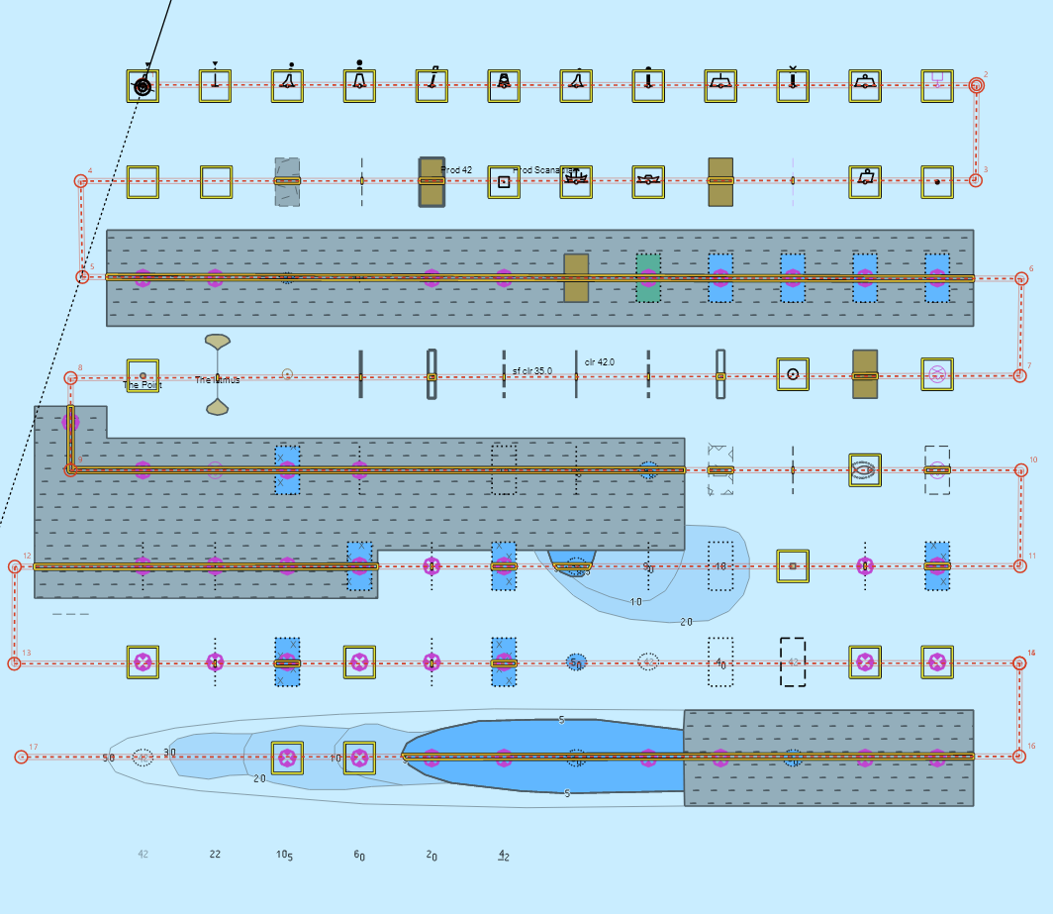
Safety contour = 0 m, Alternative 1

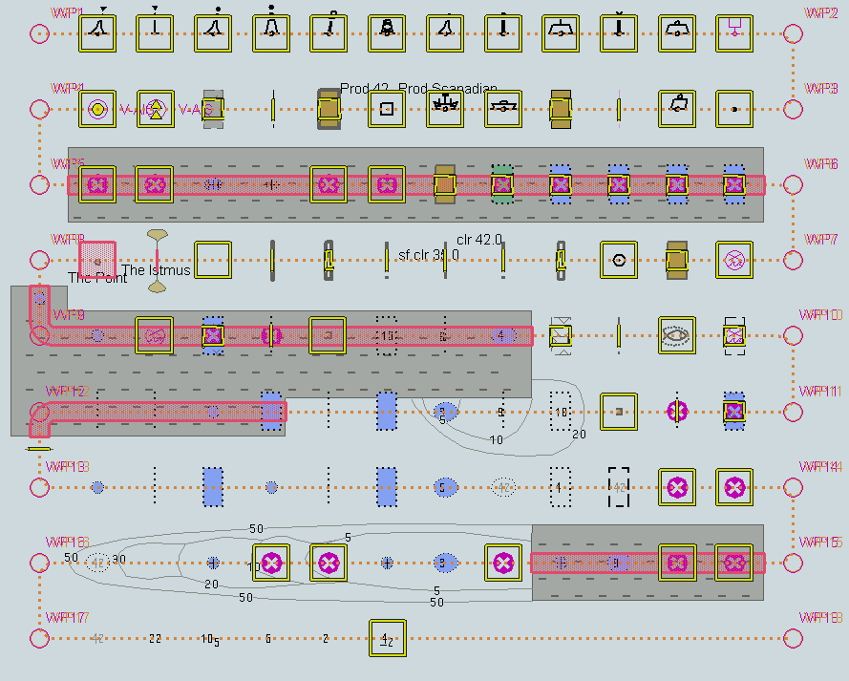
Safety contour = 0 m, Alternative 2

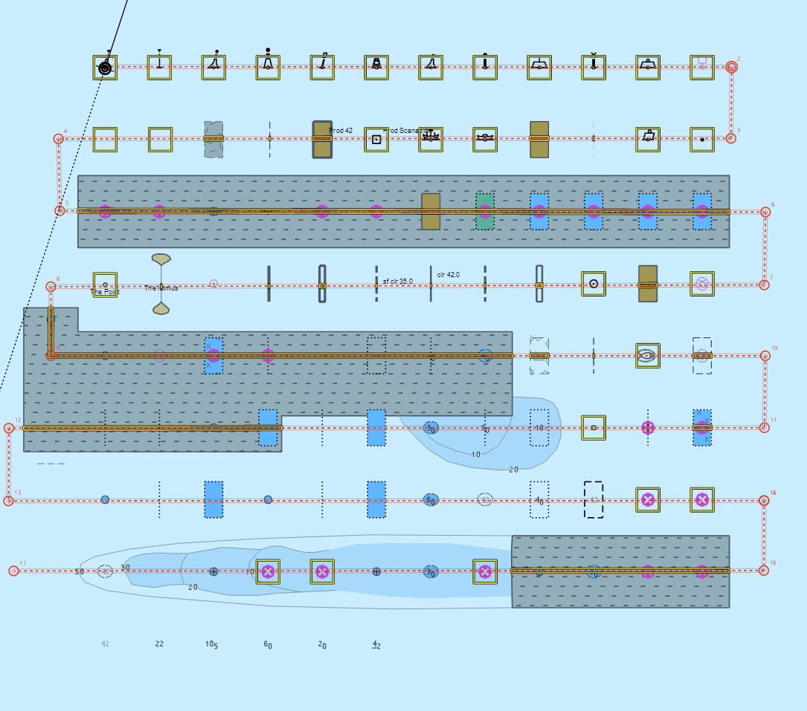
Safety contour = 2 m, Alternative 1
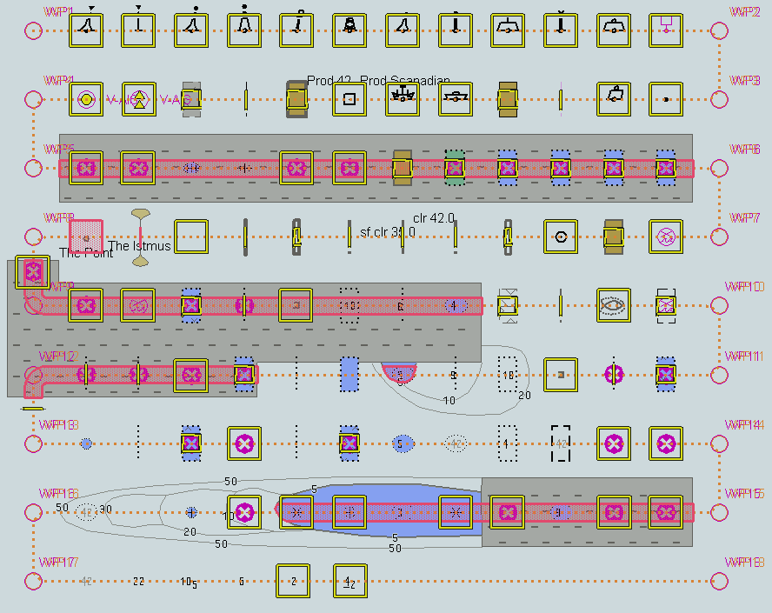
Safety contour = 2 m, Alternative 2

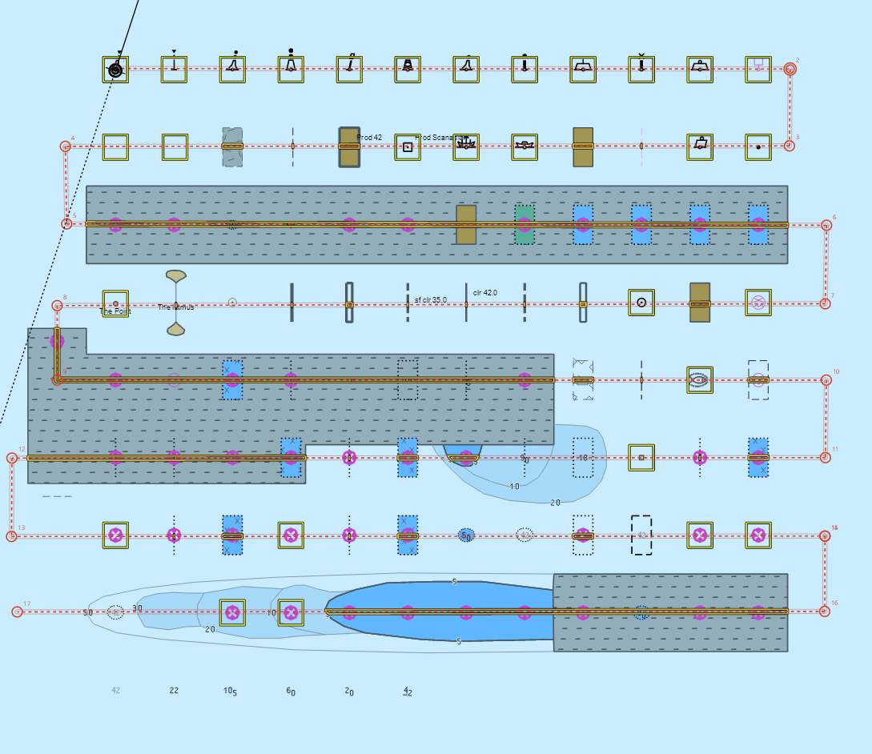
Safety contour = 4 m, Alternative 1
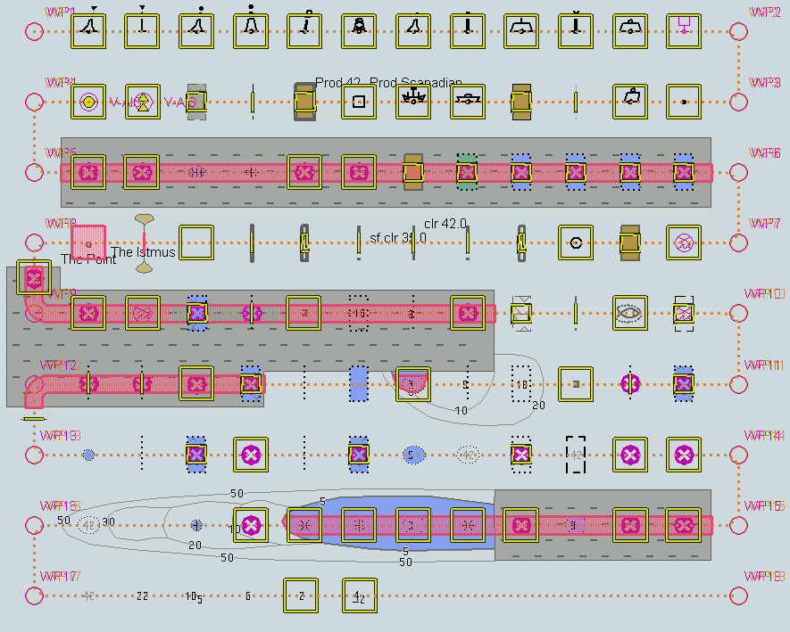
Safety contour = 4 m, Alternative 2

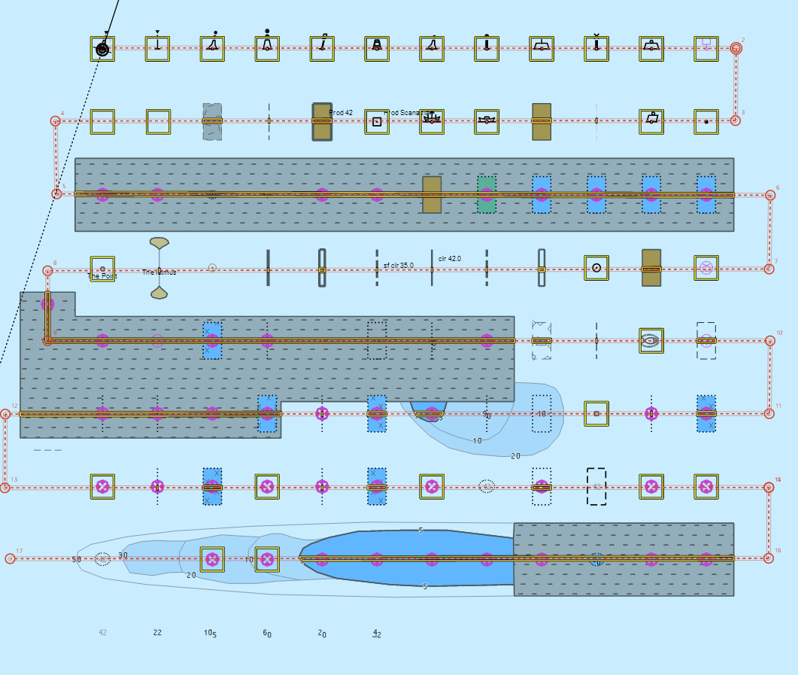
Safety contour = 5 m, Alternative 1
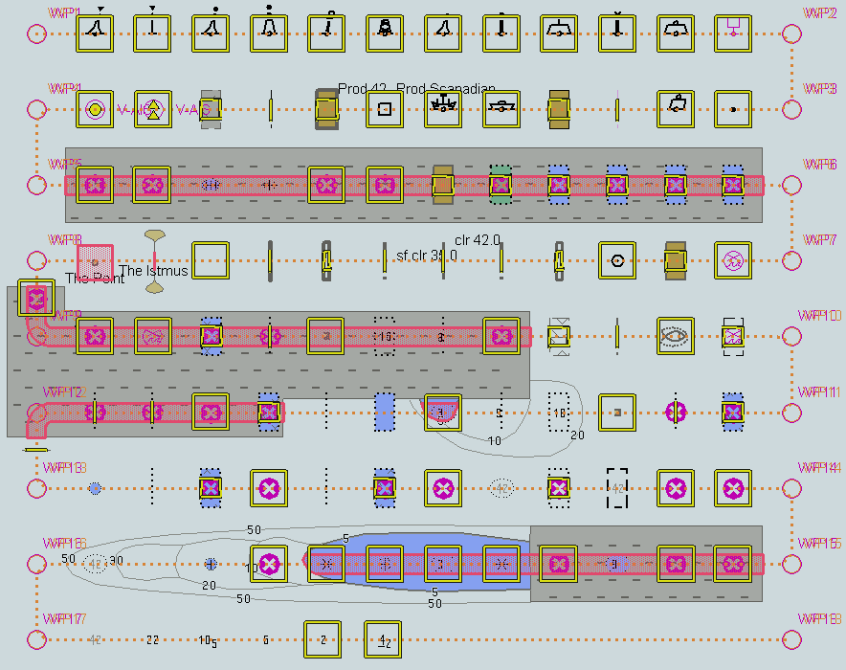
Safety contour = 5 m, Alternative 2

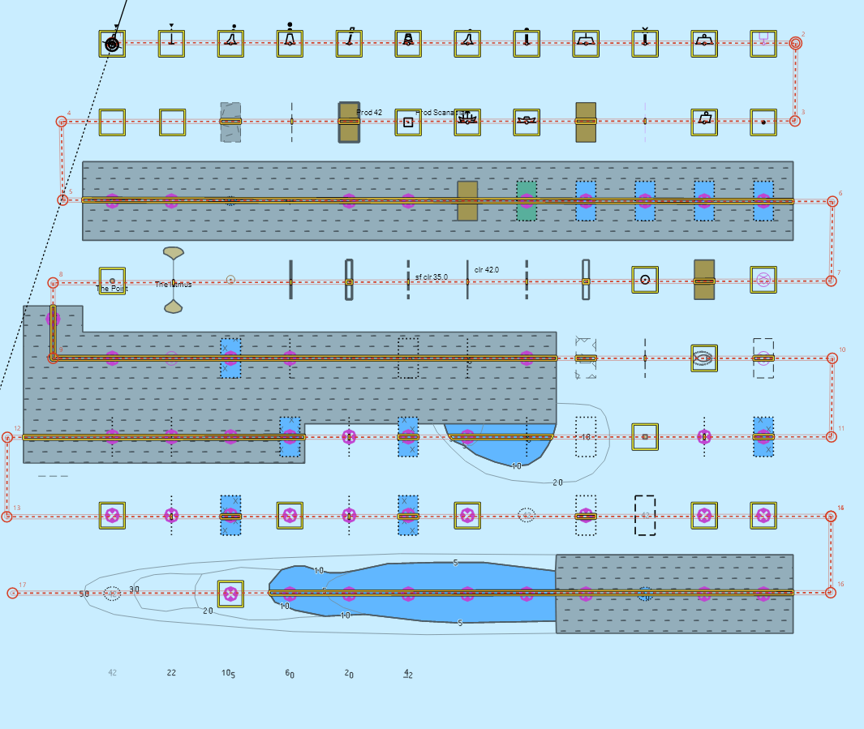
Safety contour = 6 m, Alternative 1
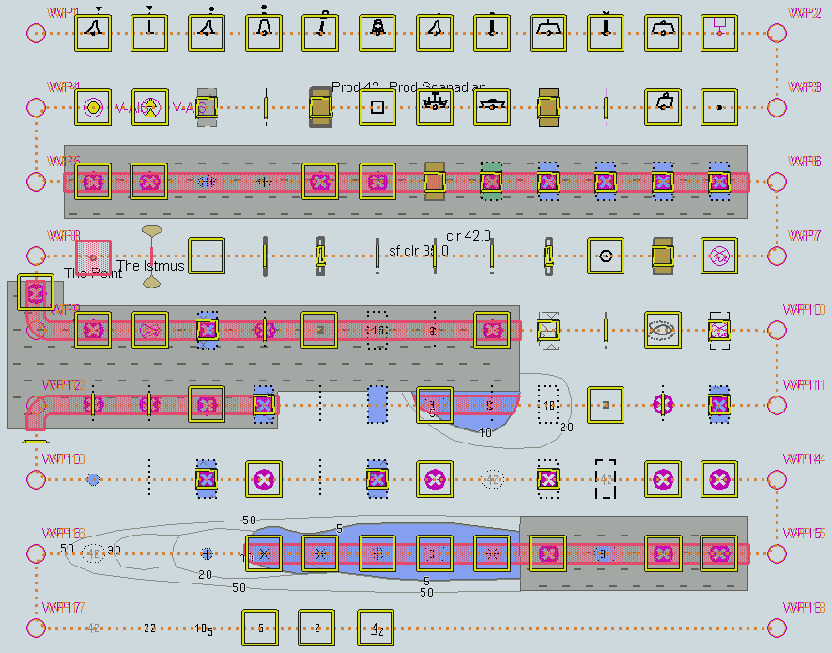
Safety contour = 6 m, Alternative 2

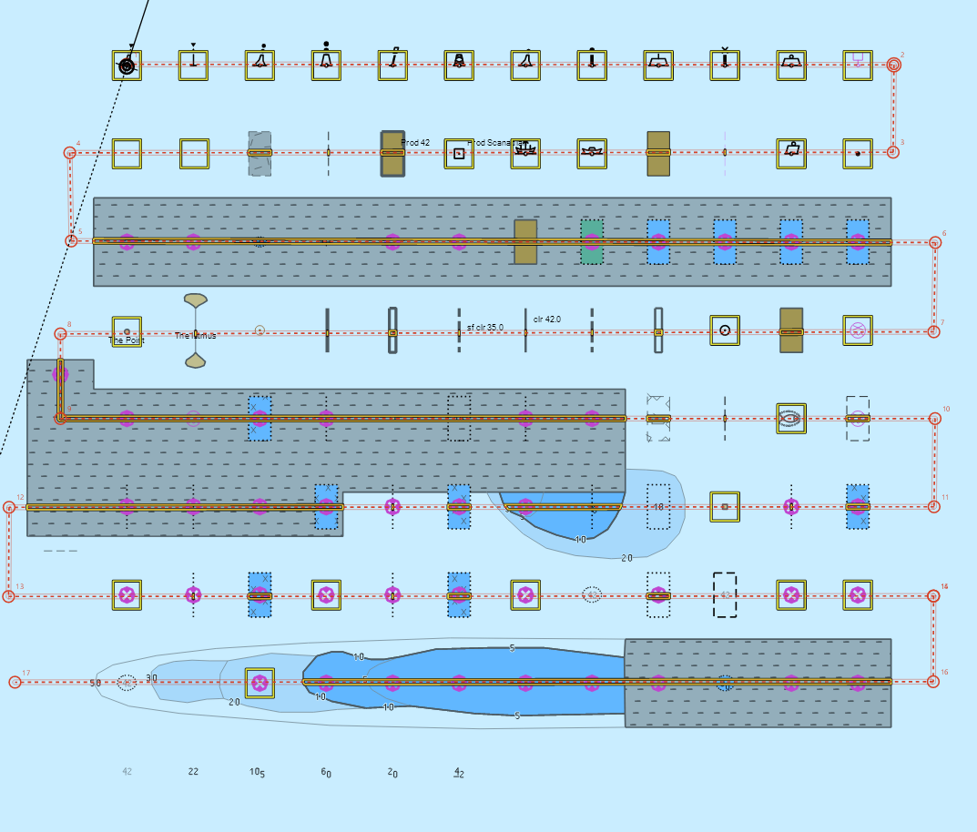
Safety contour = 8 m, Alternative 1
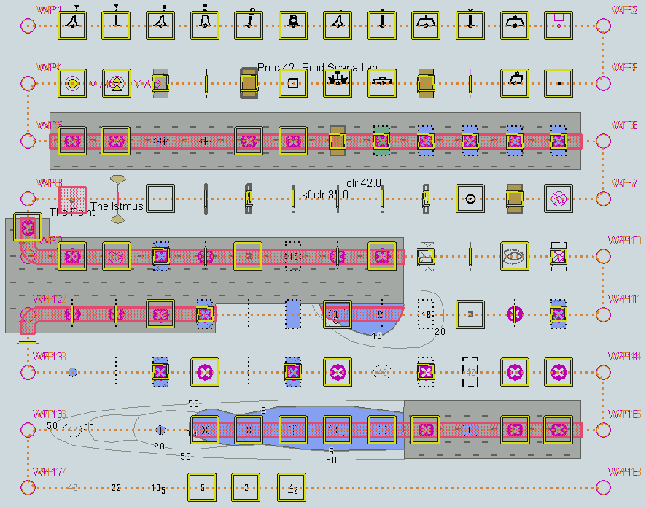
Safety contour = 8 m, Alternative 2

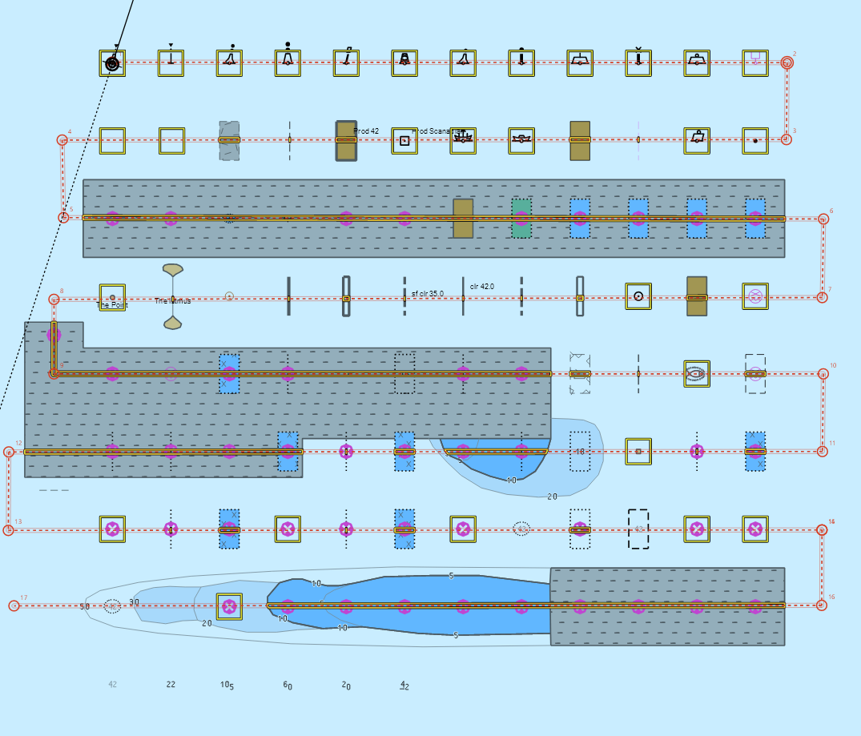
Safety contour = 9 m, Alternative 1
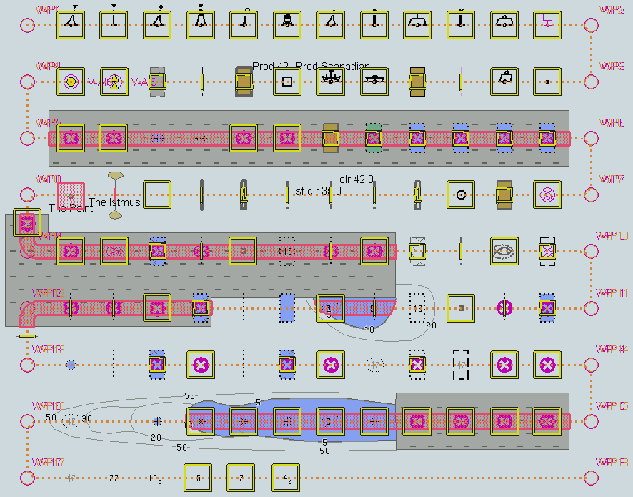
Safety contour = 9 m, Alternative 2

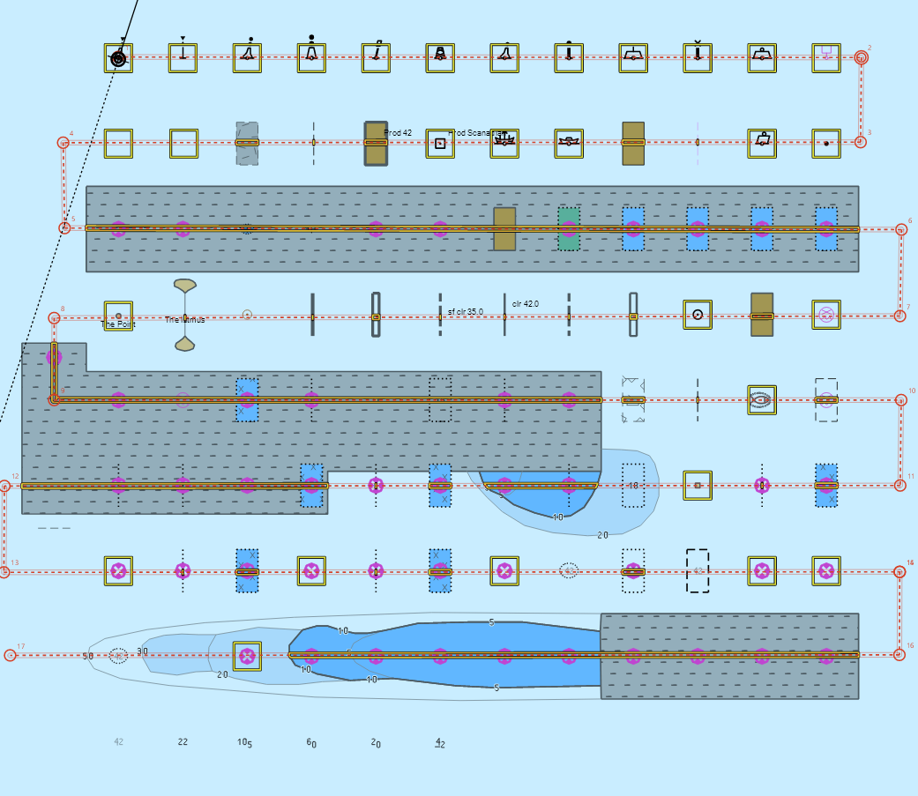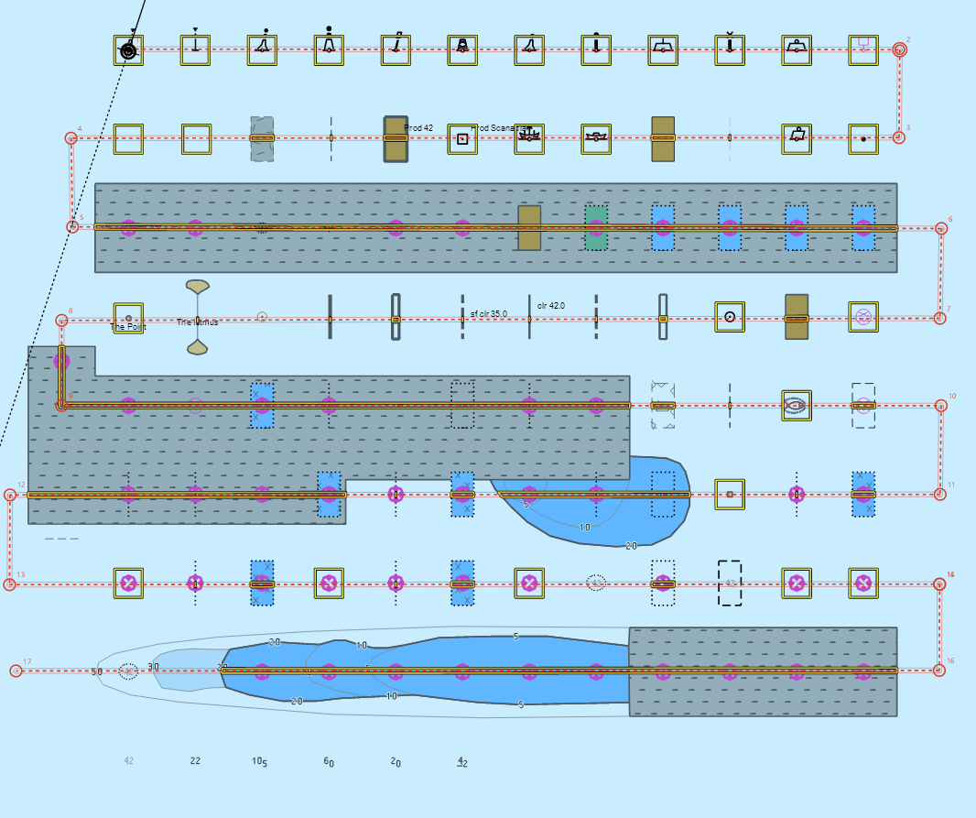
Safety contour = 10 m, Alternative 1
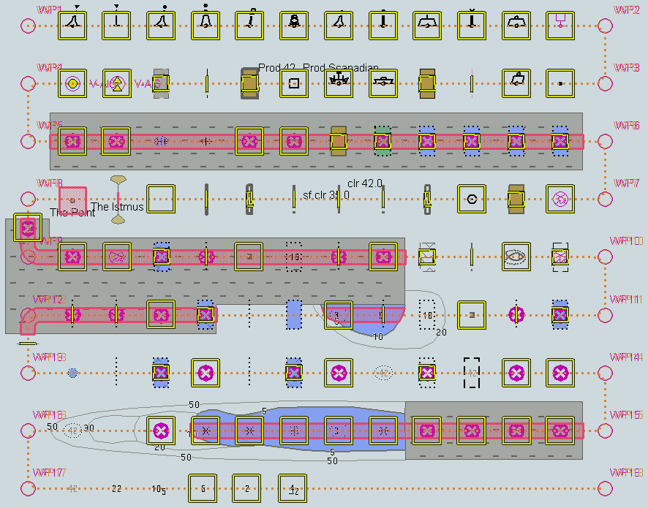
Safety contour = 10 m, Alternative 2

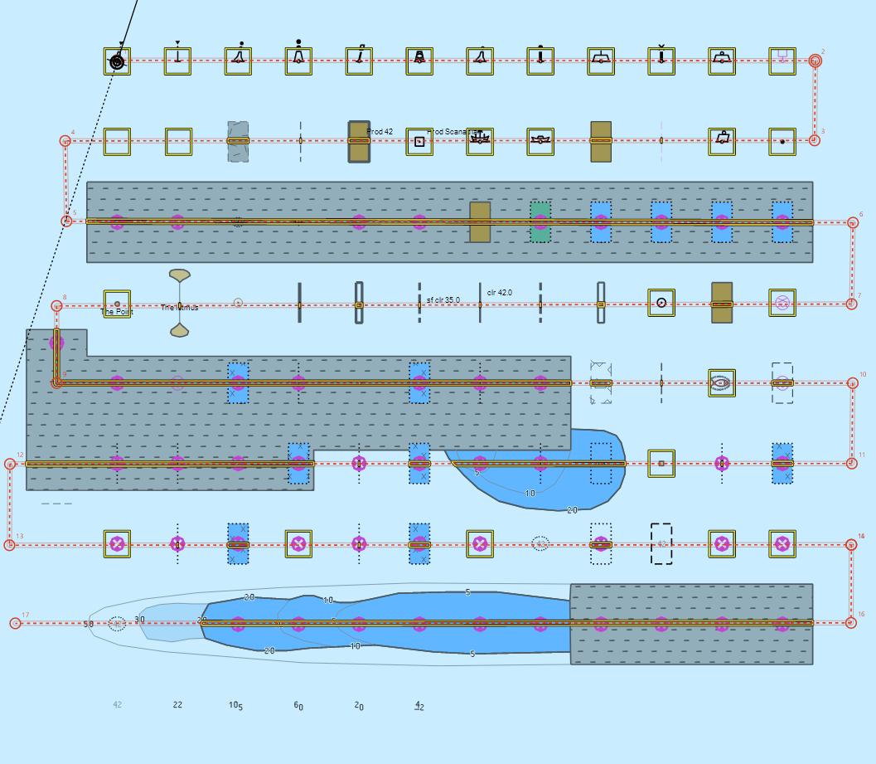
Safety contour = 11 m, Alternative 1
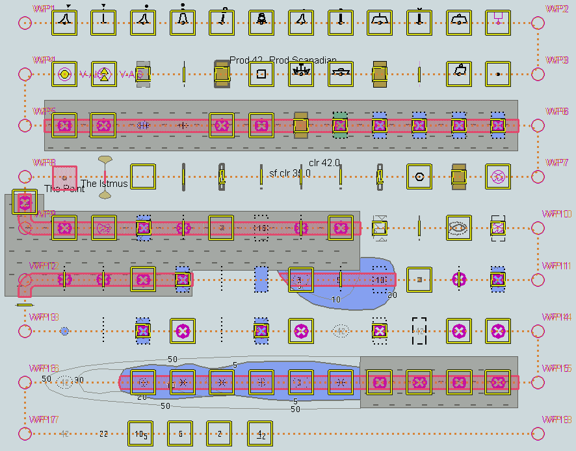
Safety contour = 11 m, Alternative 2


Safety contour = 16 m, Alternative 1
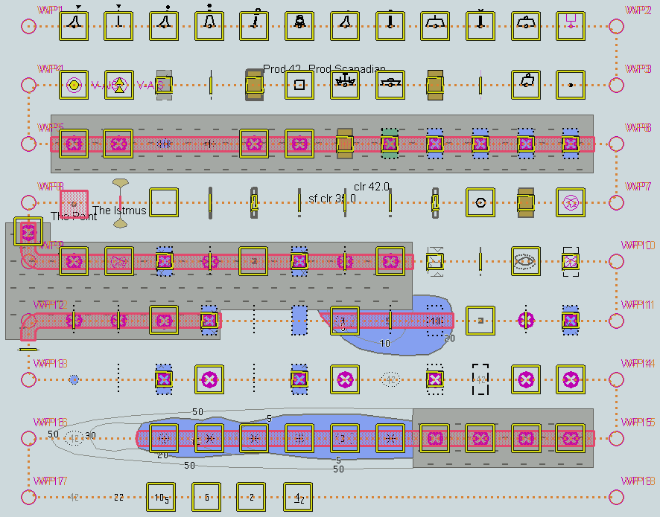
Safety contour = 16 m, Alternative 2

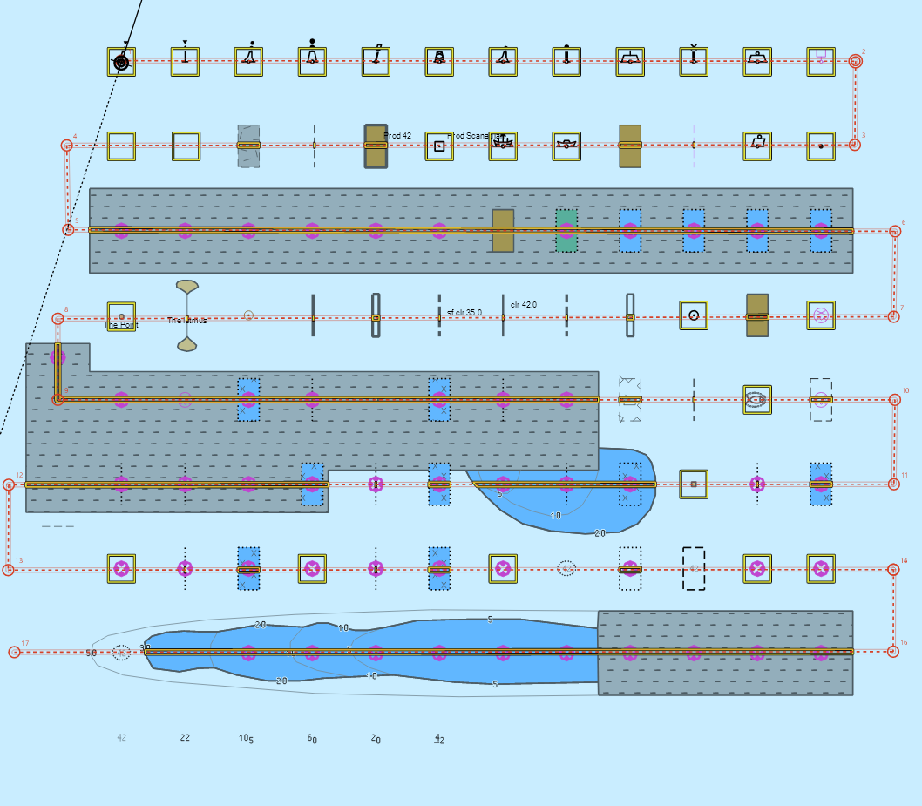
Safety contour = 21 m, Alternative 1
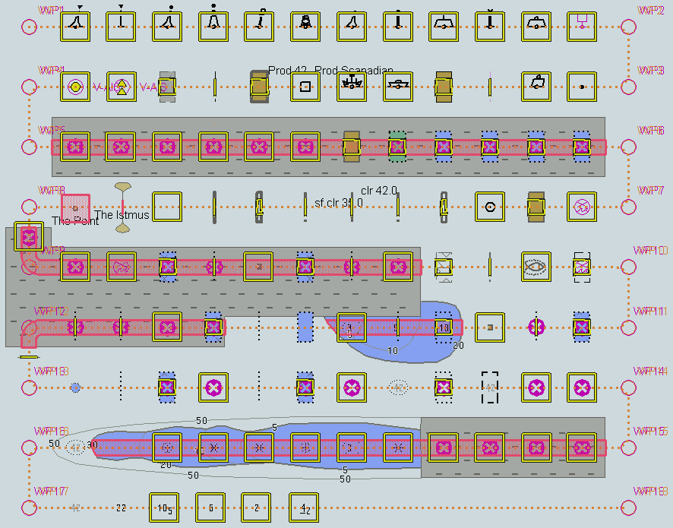
Safety contour = 21 m, Alternative 2

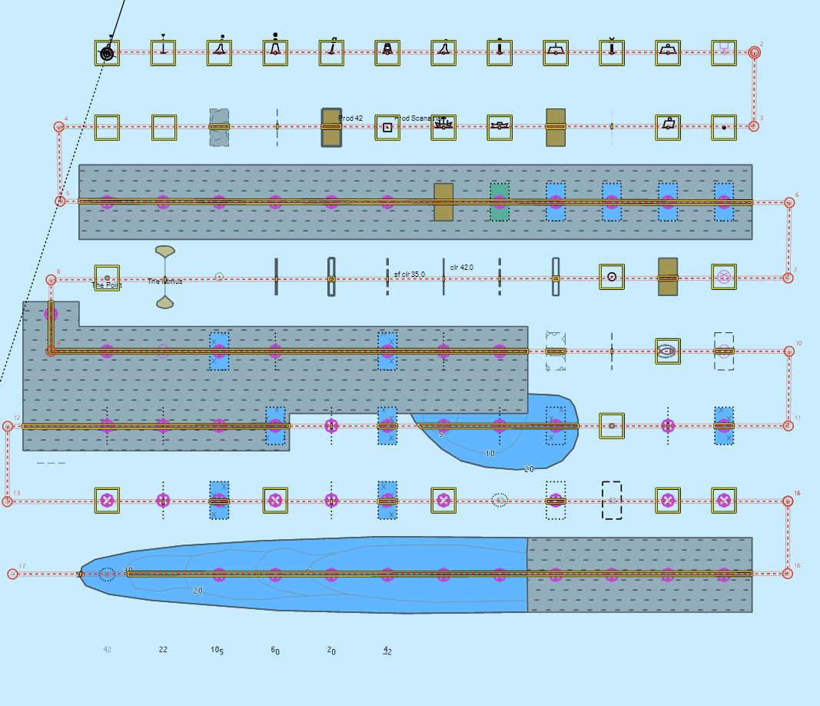
Safety contour = 31 m, Alternative 1
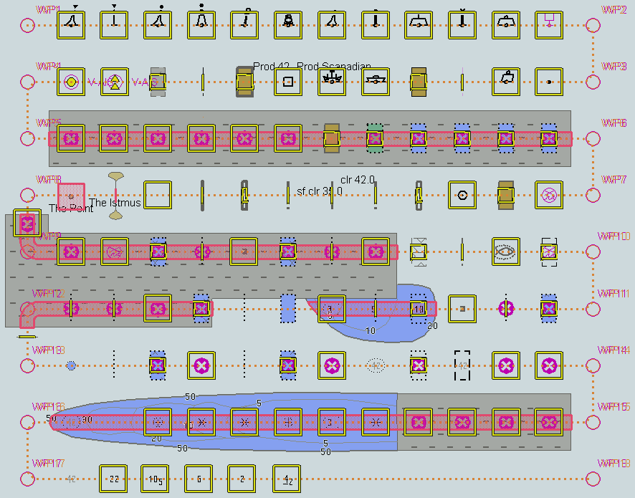
Safety contour = 31 m, Alternative 2

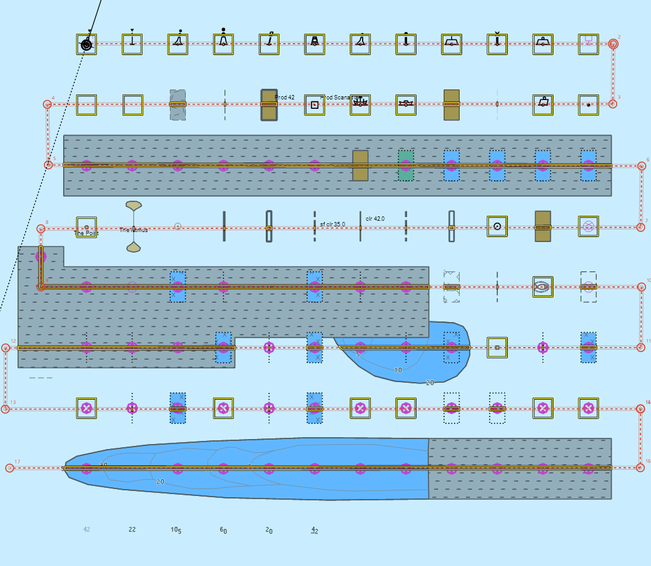
Safety contour = 42 m, Alternative 1
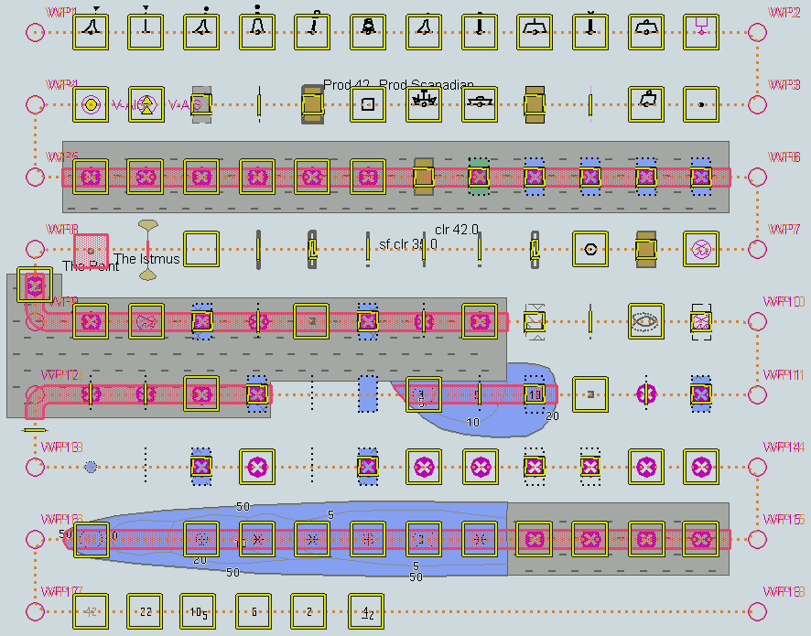
Safety contour = 42 m, Alternative 2

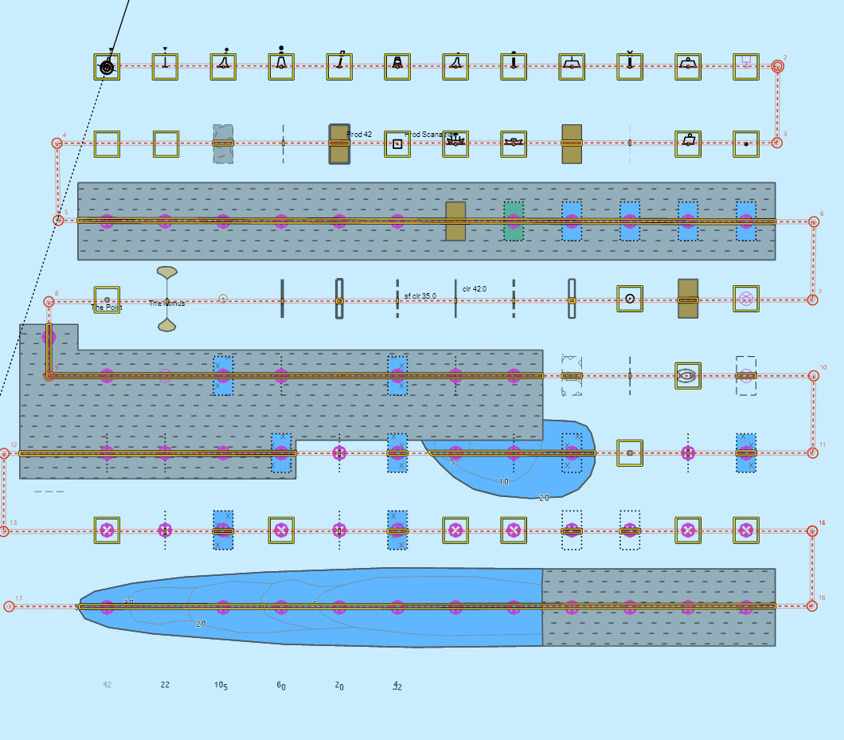
Safety contour = 50 m, Alternative 1
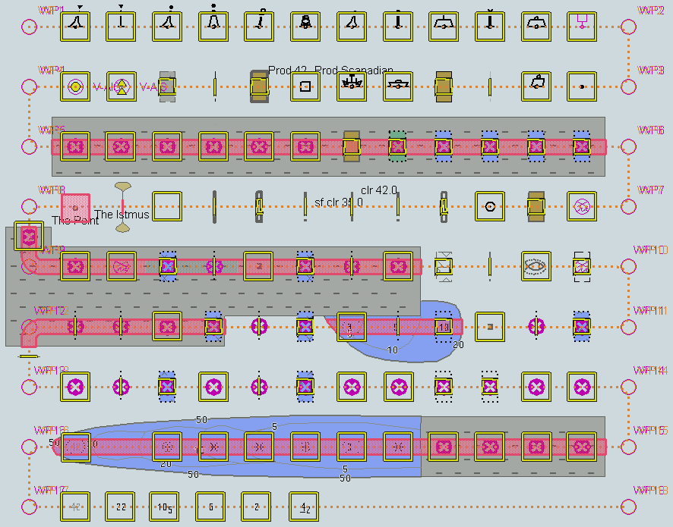
Safety contour = 50 m, Alternative 2

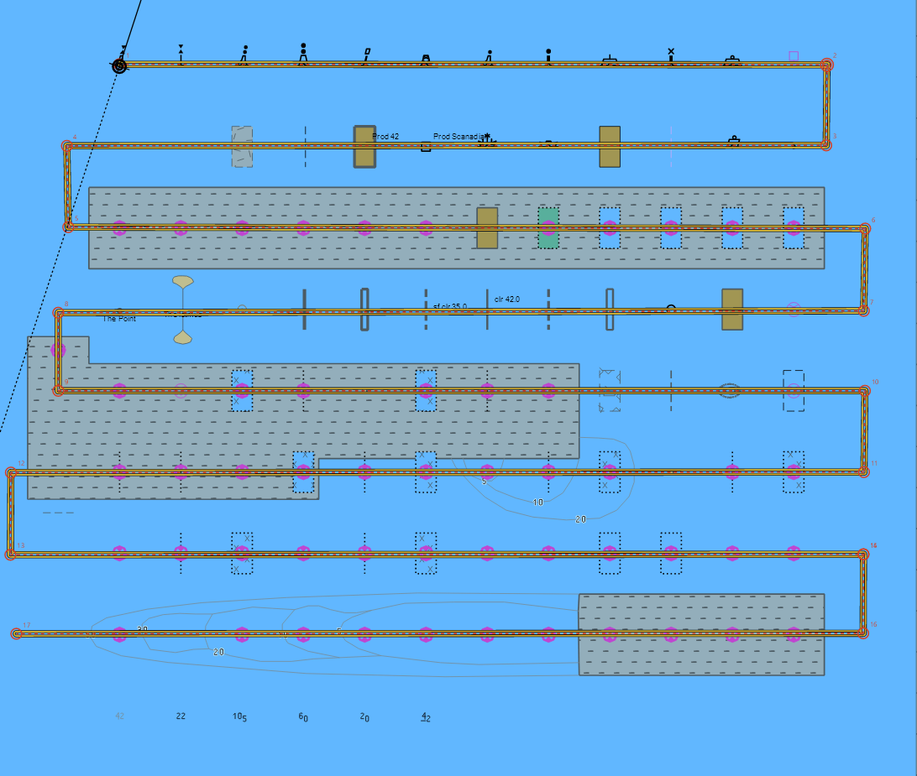
Safety contour = 51 m, Alternative 1
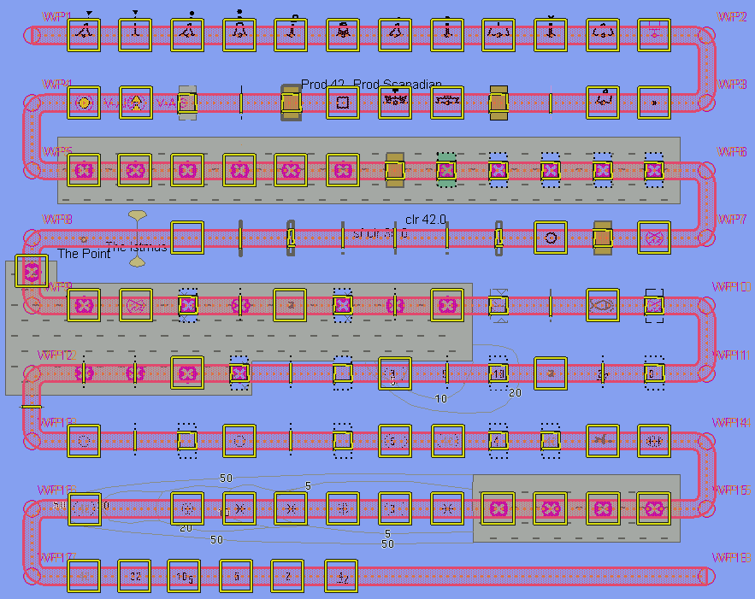
Safety contour = 51 m, Alternative 2

User selection of prohibited areas

Test Reference | UserSelectionProhibited Areas | IHO Reference
Test description
- From PC (Github Isse 136)
- Need to test selectors exist for each individual type of prohibited area.

Detection and Notification of Navigational Hazards – Use of largest scale available
Test Reference |  | NavigationalHazardsLS |  |  |  | IHO Reference |  |  | S-98 12.10.6
Test Description
The purpose of this test is to verify by observation that ECDIS uses the largest scale available for detection of navigational hazards.

Loaded Data
Exchange Set Name
Display Mode |  |  |  |  | Independent Mariner’s Selections (default=On)
Other |  |  |  |  | Accuracy
Context Parameters |  |  |  |  | Contour label
Safety contour |  |  |  |  | Highlight date dependent
Safety depth |  |  |  |  | Highlight document
Deep Contour |  |  |  |  | Highlight info
Shallow contour |  |  |  |  | Shallow pattern
Four shades |  |  |  |  | Unknown
Radar overlay |  |  |  |  | Update review
Plain boundaries |  |  |  |  | Text Groups
Simplified symbols |  |  |  |  | Chart Text
Full light lines |  |  |  |  | Important text
Ignore scale minimum |  |  |  |  | Other Text
Shallow water dangers |  |  |  |  | Names
Palette |  |  |  |  | Light description
Day |  |  |  |  | All other chart text
Date Dependent Objects |  |  |  |  | Display
Start Date |  |  |  |  | Centre
End Date |  |  |  |  | Scale |  | 1:60000
 |  |  |  |  | Orientation
Viewing Groups (Default = On)
Standard Display |  |  |  |  |  | Other
Drying lines |  |  |  |  |  | Spot soundings
Buoys. Beacons, aids to navigation |  |  |  |  |  | Submarine cables and pipelines
Buoys, beacons, structures |  |  |  |  |  | All isolated dangers
Lights |  |  |  |  |  | Magnetic variation
Boundaries and limits |  |  |  |  |  | Depth contours
Prohibited and restricted areas |  |  |  |  |  | Seabed
Chart scale boundaries |  |  |  |  |  | Tidal
Cautionary notes |  |  |  |  |  | Miscellaneous (Other)
Ships’ routeing systems and ferry routes
Archipelagic sea lanes
Miscellaneous (Standard)
Chart (Standard)
Alert Highlights (Standard)
Additional
Setup
This test is performed by loading the TDS 101AA00OVRVU.000 and 101AA00NAVHZ.000, manually creating a route connecting all way points between features marked as WP1 through WP8 and checking display against the corresponding graphical plot

.. Load the exchange set NavigationalHazards and the exchange set NavigationalHazardsOverview
- Select Display Category Other
- Set the Safety contour value to 30 m
- Set the Safety depth value to 30 m
- Set Plain boundaries to On
- Set Simplified symbols to Off
- Select all Text groups to On

Action
Select position 39°57.000’N 104°49.000’W at optimum display scale (1:350 000) of 101AA00OVRVU.
1) View chart before route planning.
2) Manually create a route connecting all way points between features marked WP1 through WP8. Set user-specified distance for indication navigational hazards as 0.5 NM. Check ENC symbols shown in the ECDIS against the corresponding graphical plot

Results
The ENC in the ECDIS should match the corresponding graphical plot shown below
1) Situation before route planning. Chart 101AA00OVRVU displayed as it is
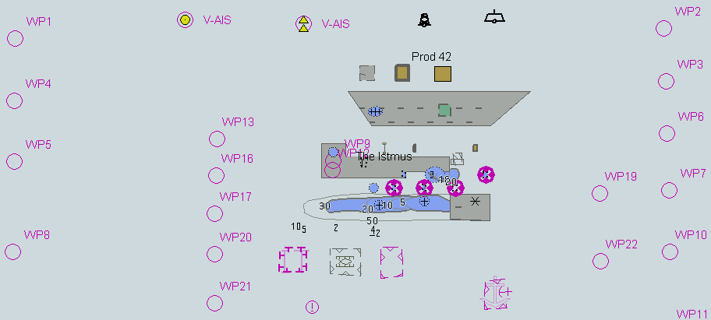
TBD
2) Situation after route planning. Alerts indicated from largest scale available for each location

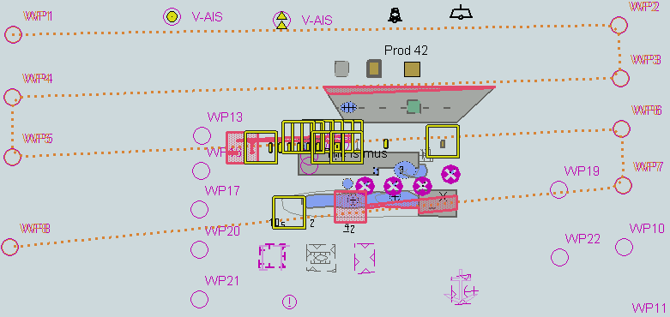
TBD

Detection and Notification of Navigational Hazards – Basic test Monitoring Mode
Test Reference |  | NavigationalHazardsMon |  |  |  | IHO Reference
Test Description
The purpose of this test is to verify by observation that ECDIS provides an appropriate indication if, continuing on its present course and speed, over a specified time or distance set by the Mariner, own ship will pass closer than a user-specified distance from any features satisfying the conditions for this test (as listed in section 10.5.9 of IHO S-52 and included in the test cell 101AA00NAVHZ.000) that is shallower than the Mariner's safety contour.

Loaded Data
Exchange Set Name
Display Mode |  |  |  |  | Independent Mariner’s Selections (default=On)
Other |  |  |  |  | Accuracy
Context Parameters |  |  |  |  | Contour label
Safety contour |  |  |  |  | Highlight date dependent
Safety depth |  |  |  |  | Highlight document
Deep Contour |  |  |  |  | Highlight info
Shallow contour |  |  |  |  | Shallow pattern
Four shades |  |  |  |  | Unknown
Radar overlay |  |  |  |  | Update review
Plain boundaries |  |  |  |  | Text Groups
Simplified symbols |  |  |  |  | Chart Text
Full light lines |  |  |  |  | Important text
Ignore scale minimum |  |  |  |  | Other Text
Shallow water dangers |  |  |  |  | Names
Palette |  |  |  |  | Light description
Day |  |  |  |  | All other chart text
Date Dependent Objects |  |  |  |  | Display
Start Date |  |  |  |  | Centre
End Date |  |  |  |  | Scale |  | 1:60000
 |  |  |  |  | Orientation
Viewing Groups (Default = On)
Standard Display |  |  |  |  |  | Other
Drying lines |  |  |  |  |  | Spot soundings
Buoys. Beacons, aids to navigation |  |  |  |  |  | Submarine cables and pipelines
Buoys, beacons, structures |  |  |  |  |  | All isolated dangers
Lights |  |  |  |  |  | Magnetic variation
Boundaries and limits |  |  |  |  |  | Depth contours
Prohibited and restricted areas |  |  |  |  |  | Seabed
Chart scale boundaries |  |  |  |  |  | Tidal
Cautionary notes |  |  |  |  |  | Miscellaneous (Other)
Ships’ routeing systems and ferry routes
Archipelagic sea lanes
Miscellaneous (Standard)
Chart (Standard)
Alert Highlights (Standard)
Additional
Setup
This test is performed by loading the test cell 101AA00NAVHZ.000, sailing with a simulated ship over the test area, setting the Safety contour to the appropriate values (0m, 2m, 5m, 6m, 8m, 9m, 10m, 11m, 16m, 21m, 31m, 42m, 50m, 51m) and checking display against the graphical plots of test 5.1 (Route plan) corresponding to each set of Safety contour settings

As for test NavigationalHazards.

Action
Select all Text groups
Check ENC symbols shown in the ECDIS for each Safety contour setting against the corresponding graphical plot.

Results
The ENC in the ECDIS should match the corresponding graphical plot of test 5.1.

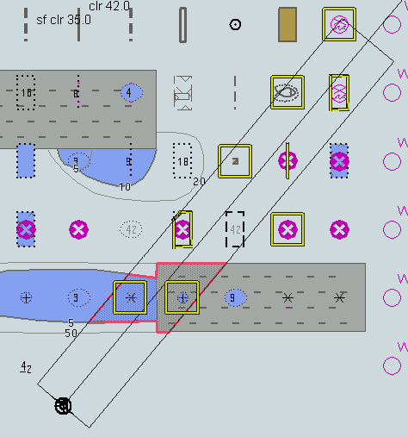
An example with Safety contour = 10 m.
TBD

Detection and Notification of Navigational Hazards – Use of largest scale available – Monitoring Mode
Test Reference |  | NavigationalHazardsMonLS |  |  |  | IHO Reference
Test Description
The purpose of this test is to verify by observation that ECDIS uses the largest scale available for detection of navigational hazards. This test is performed by loading the test cells 101AA00OVRVU.000 and 101AA00NAVHZ.000, manually creating a route connecting all way points between features marked as WP1 through WP8 and checking display against the corresponding graphical plot.

Loaded Data
Exchange Set Name
Display Mode |  |  |  |  | Independent Mariner’s Selections (default=On)
Other |  |  |  |  | Accuracy
Context Parameters |  |  |  |  | Contour label
Safety contour |  |  |  |  | Highlight date dependent
Safety depth |  |  |  |  | Highlight document
Deep Contour |  |  |  |  | Highlight info
Shallow contour |  |  |  |  | Shallow pattern
Four shades |  |  |  |  | Unknown
Radar overlay |  |  |  |  | Update review
Plain boundaries |  |  |  |  | Text Groups
Simplified symbols |  |  |  |  | Chart Text
Full light lines |  |  |  |  | Important text
Ignore scale minimum |  |  |  |  | Other Text
Shallow water dangers |  |  |  |  | Names
Palette |  |  |  |  | Light description
Day |  |  |  |  | All other chart text
Date Dependent Objects |  |  |  |  | Display
Start Date |  |  |  |  | Centre
End Date |  |  |  |  | Scale |  | 1:60000
 |  |  |  |  | Orientation
Viewing Groups (Default = On)
Standard Display |  |  |  |  |  | Other
Drying lines |  |  |  |  |  | Spot soundings
Buoys. Beacons, aids to navigation |  |  |  |  |  | Submarine cables and pipelines
Buoys, beacons, structures |  |  |  |  |  | All isolated dangers
Lights |  |  |  |  |  | Magnetic variation
Boundaries and limits |  |  |  |  |  | Depth contours
Prohibited and restricted areas |  |  |  |  |  | Seabed
Chart scale boundaries |  |  |  |  |  | Tidal
Cautionary notes |  |  |  |  |  | Miscellaneous (Other)
Ships’ routeing systems and ferry routes
Archipelagic sea lanes
Miscellaneous (Standard)
Chart (Standard)
Alert Highlights (Standard)
Additional
Setup
Load the exchange set NavigationalHazards
Load the exchange set NavigationalHazardsOverview
- Select Display Category Other
- Set the Safety contour value to 30 m
- Set the Safety depth value to 30 m
- Select Symbolized Boundaries
Set symbolized symbols to Off
Select all Text groups
..

Action
Select position 39°57.000’N 104°49.000’W at the maximum display scale (1:350 000) of 101AA00OVRVU.
Set simulated own ship for 39°49.587’N 104°54.930’W with heading set for 10.0°
Select size of own ship check area as 1.0 NM width and 8.0 NM length.

Results
The ENC in the ECDIS should match the corresponding graphical plot shown below.

TBD
1) Situation before route monitoring. Chart 101AA00OVRVU displayed as it is. Presentation alternative 1
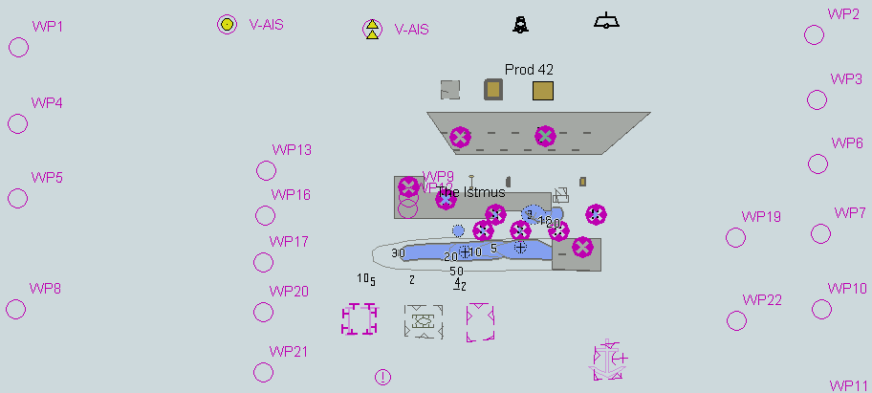
TBD
Situation before route monitoring. Chart 101AA00OVRVU displayed as it is. Presentation alternative 2

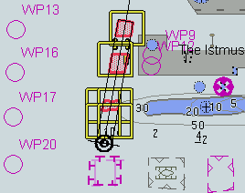
TBD
2) Situation during route monitoring. Alerts indicated from largest scale available for each location Presentation alternative 1
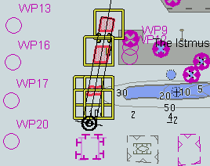
TBD
Situation during route monitoring. Alerts indicated from largest scale available for each location. Presentation alternative 2

Note: The parameters and shapes of the ship's check area are examples

Use of Data Quality Information.
Test Reference | DataQuality | IHO Reference
Test description
This new test could be located in the Data Quality section or left here.

- Test use of data quality mode.
- Test for offset of lookahead for alerts and indications.
- Also test for different CATZOC zones.

