S-164 – Part 6

Detection of Areas for which Special Conditions Exist

Table of Contents

Pages

6.1 Detection of Areas for which Special Conditions Exist - Basic test 1
6.1.1 User selection of Areas with Special Conditions 4
6.2 Detection of Areas for which Special Conditions Exist - Use of largest scale available 5
6.3 Detection of Areas for which Special Conditions Exist - Monitoring Mode 7
6.4 Detection of Areas for which Special Conditions Exist - Use of largest scale available – Monitoring Mode 9

Page intentionally left blank

Detection of Areas for which Special Conditions Exist - Basic test
Test Reference |  | SpecialConditions |  |  |  | IHO Reference |  |  | S-98 12.10.7
Test Description
The purpose of this test is to verify by observation that ECDIS provides an appropriate indication when the Mariner plans a route closer than a user-specified distance from the boundary of a prohibited area or a geographic area for which special conditions exist. The features satisfying the conditions for this test are listed the S-101 Alerts and indications catalogue and are included in the test cell 101AA00ARSPC.000.

Loaded Data
Exchange Set Name
Display Mode |  |  |  |  | Independent Mariner’s Selections (default=On)
Other |  |  |  |  | Accuracy
Context Parameters |  |  |  |  | Contour label
Safety contour |  |  |  |  | Highlight date dependent
Safety depth |  |  |  |  | Highlight document
Deep Contour |  |  |  |  | Highlight info
Shallow contour |  |  |  |  | Shallow pattern
Four shades |  |  |  |  | Unknown
Radar overlay |  |  |  |  | Update review
Plain boundaries |  |  |  |  | Text Groups
Simplified symbols |  |  |  |  | Chart Text
Full light lines |  |  |  |  | Important text
Ignore scale minimum |  |  |  |  | Other Text
Shallow water dangers |  |  |  |  | Names
Palette |  |  |  |  | Light description
Day |  |  |  |  | All other chart text
Date Dependent Objects |  |  |  |  | Display
Start Date |  |  |  |  | Centre
End Date |  |  |  |  | Scale |  | 1:60000
 |  |  |  |  | Orientation
Viewing Groups (Default = On)
Standard Display |  |  |  |  |  | Other
Drying lines |  |  |  |  |  | Spot soundings
Buoys. Beacons, aids to navigation |  |  |  |  |  | Submarine cables and pipelines
Buoys, beacons, structures |  |  |  |  |  | All isolated dangers
Lights |  |  |  |  |  | Magnetic variation
Boundaries and limits |  |  |  |  |  | Depth contours
Prohibited and restricted areas |  |  |  |  |  | Seabed
Chart scale boundaries |  |  |  |  |  | Tidal
Cautionary notes |  |  |  |  |  | Miscellaneous (Other)
Ships’ routeing systems and ferry routes
Archipelagic sea lanes
Miscellaneous (Standard)
Chart (Standard)
Alert Highlights (Standard)
Additional
Setup
This test is performed by loading the test cell 101AA00ARSPC.000, manually creating a route connecting all way points between features marked as WP1 through WP4 and checking display against the corresponding graphical plot

Load the exchange set SpecialConditions
- Select Display Category Other
- Set the Safety contour value to 0 m
- Set the Safety depth value to 30 m
- Select Symbolized Boundaries
- Set symbolized symbols to Off
- Manually create a route connecting all way points between features marked WP1 through WP4
Set user-specified distance for indication of areas with special condition as 0.1 NM

Action
Check ENC symbols shown in the ECDIS against the corresponding graphical plot. selecting one by one each special condition for the test

Results
The ENC in the ECDIS should match the corresponding graphical plot shown below.

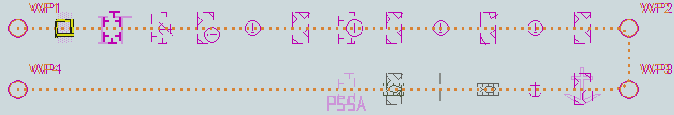
Selected: Traffic separation zone

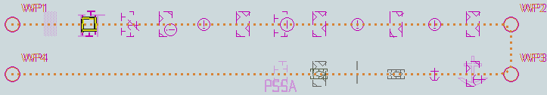
Selected: Inshore traffic zone

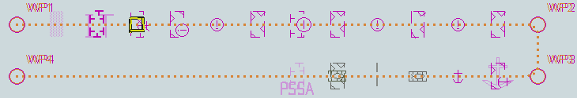
Selected: Restricted area

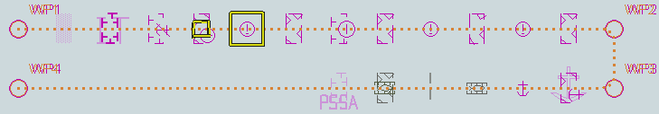
Selected: Caution area

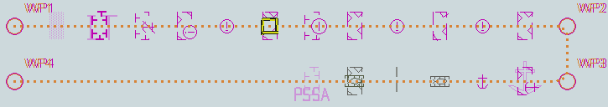
Selected: Offshore production area

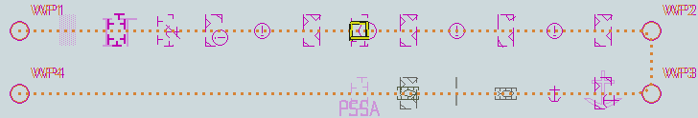
Selected: Area to be avoided

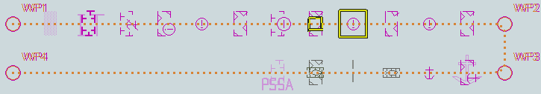
Selected: Military practice area

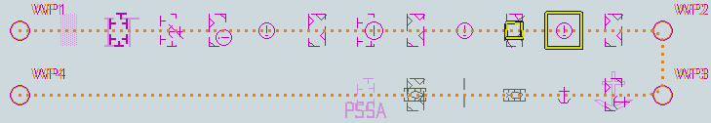
Selected: Seaplane landing area

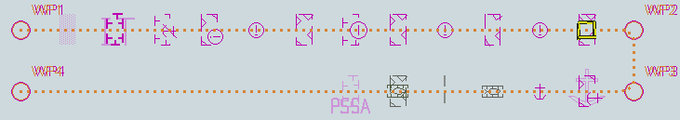
Selected: Submarine transit lane

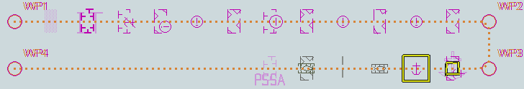
Selected: Anchorage area

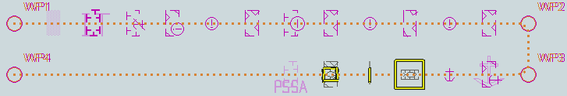
Selected: Marine farm/aquaculture

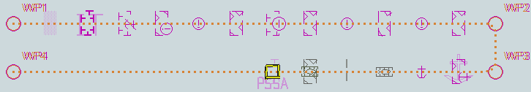
Selected: PSSA (Particularly Sensitive Sea Area)
tbd

User selection of Areas with Special Conditions

Test Reference | UserSelectionProhibited Areas | IHO Reference
Test description
- From PC (Github Isse 136)
- Need to test selectors exist for each individual type areas with special conditions..

[check that an S-98 requirement exists? Or is this all in the S-101PC?]

Detection of Areas for which Special Conditions Exist - Use of largest scale available
Test Reference |  | SpecialConditionsLS |  |  |  | IHO Reference |  |  | S-98 12.10.7
Test Description
The purpose of this test is to verify by observation that ECDIS uses the largest scale available for detection of areas with special condition.

This test is performed by loading the test cells 101AA00OVRVU.000 and 10100AA_ARSPC.000, manually creating a route connecting way points between features marked as WP20 and WP22 and checking display against the corresponding graphical plot

Loaded Data
Exchange Set Name
Display Mode |  |  |  |  | Independent Mariner’s Selections (default=On)
Other |  |  |  |  | Accuracy
Context Parameters |  |  |  |  | Contour label
Safety contour |  |  |  |  | Highlight date dependent
Safety depth |  |  |  |  | Highlight document
Deep Contour |  |  |  |  | Highlight info
Shallow contour |  |  |  |  | Shallow pattern
Four shades |  |  |  |  | Unknown
Radar overlay |  |  |  |  | Update review
Plain boundaries |  |  |  |  | Text Groups
Simplified symbols |  |  |  |  | Chart Text
Full light lines |  |  |  |  | Important text
Ignore scale minimum |  |  |  |  | Other Text
Shallow water dangers |  |  |  |  | Names
Palette |  |  |  |  | Light description
Day |  |  |  |  | All other chart text
Date Dependent Objects |  |  |  |  | Display
Start Date |  |  |  |  | Centre
End Date |  |  |  |  | Scale |  | 1:60000
 |  |  |  |  | Orientation
Viewing Groups (Default = On)
Standard Display |  |  |  |  |  | Other
Drying lines |  |  |  |  |  | Spot soundings
Buoys. Beacons, aids to navigation |  |  |  |  |  | Submarine cables and pipelines
Buoys, beacons, structures |  |  |  |  |  | All isolated dangers
Lights |  |  |  |  |  | Magnetic variation
Boundaries and limits |  |  |  |  |  | Depth contours
Prohibited and restricted areas |  |  |  |  |  | Seabed
Chart scale boundaries |  |  |  |  |  | Tidal
Cautionary notes |  |  |  |  |  | Miscellaneous (Other)
Ships’ routeing systems and ferry routes
Archipelagic sea lanes
Miscellaneous (Standard)
Chart (Standard)
Alert Highlights (Standard)
Additional
Setup
As for test SpecialConditions and in addition load the exchange set NavigationalHazardsOverview

- Select Display Category Other
- Set the Safety contour value to 0 m
- Set the Safety depth value to 30 m
- Set Plain Boundaries to Off
- Set Simplified symbols to On
Select all Text groups

Action
Select position 39°45′•000N 104°49′•000W at compilation scale (1:350 000) of 101AA00OVRVU.
1) View chart before route planning.
2) Manually create a route connecting two way points between features marked WP20 and WP22. Set user-specified distance for indication of areas with special conditions as 0.5 NM. Check ENC symbols shown in the ECDIS against the corresponding graphical plot

Results
The ENC in the ECDIS should match the corresponding graphical plot shown below

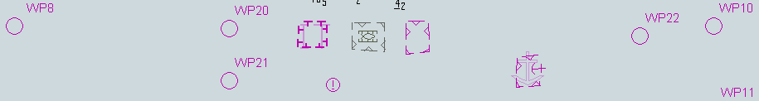

1) Situation before route planning. Chart 101AA00OVRVU displayed as it is

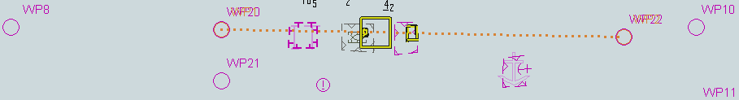

2) Situation after route planning. Alerts indicated from largest scale available for each location. An example with Seaplane landing area and Marine farm/culture area as selected.
TBD

Detection of Areas for which Special Conditions Exist - Monitoring Mode
Test Reference |  | SpecialConditionsMon |  |  |  | IHO Reference |  |  | S-98 12.10.7
Test Description
The purpose of this test is to verify by observation that ECDIS provides an appropriate alarm or indication, as selected by the Mariner, if, within a specified time set by the Mariner, own ship will cross the boundary of a prohibited area or area for which special conditions exist. The features satisfying the conditions for this test are listed in the Alerts and Indications section of the portrayal catalogue and are included in the test cell 101AA00ARSPC.000.

This test is performed by loading the test cell 101AA00ARSPC.000, sailing with a simulated ship over the test area, selecting one by one each special condition for the test and checking display against the graphical plots of test 6.1 (Route plan) corresponding to each set of Safety contour settings
Loaded Data
Exchange Set Name
Display Mode |  |  |  |  | Independent Mariner’s Selections (default=On)
Other |  |  |  |  | Accuracy
Context Parameters |  |  |  |  | Contour label
Safety contour |  |  |  |  | Highlight date dependent
Safety depth |  |  |  |  | Highlight document
Deep Contour |  |  |  |  | Highlight info
Shallow contour |  |  |  |  | Shallow pattern
Four shades |  |  |  |  | Unknown
Radar overlay |  |  |  |  | Update review
Plain boundaries |  |  |  |  | Text Groups
Simplified symbols |  |  |  |  | Chart Text
Full light lines |  |  |  |  | Important text
Ignore scale minimum |  |  |  |  | Other Text
Shallow water dangers |  |  |  |  | Names
Palette |  |  |  |  | Light description
Day |  |  |  |  | All other chart text
Date Dependent Objects |  |  |  |  | Display
Start Date |  |  |  |  | Centre
End Date |  |  |  |  | Scale |  | 1:60000
 |  |  |  |  | Orientation
Viewing Groups (Default = On)
Standard Display |  |  |  |  |  | Other
Drying lines |  |  |  |  |  | Spot soundings
Buoys. Beacons, aids to navigation |  |  |  |  |  | Submarine cables and pipelines
Buoys, beacons, structures |  |  |  |  |  | All isolated dangers
Lights |  |  |  |  |  | Magnetic variation
Boundaries and limits |  |  |  |  |  | Depth contours
Prohibited and restricted areas |  |  |  |  |  | Seabed
Chart scale boundaries |  |  |  |  |  | Tidal
Cautionary notes |  |  |  |  |  | Miscellaneous (Other)
Ships’ routeing systems and ferry routes
Archipelagic sea lanes
Miscellaneous (Standard)
Chart (Standard)
Alert Highlights (Standard)
Additional
Setup
..
Action
Check ENC symbols shown in the ECDIS for each special condition against the corresponding graphical plot

Results
The ENC in the ECDIS should match the corresponding graphical plot of test 6.1.

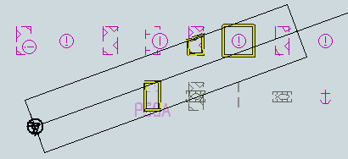

An example with PSSA and Military practice area as selected.
TBD

Detection of Areas for which Special Conditions Exist - Use of largest scale available – Monitoring Mode
Test Reference | SpecialConditionsMonLS | IHO Reference | S-98 12.10.7
Test description
The purpose of this test is to verify by observation that ECDIS uses the largest scale available for detection of areas with special condition.

This test is performed by loading the test cells 101AA00OVRVU.000 and 101AA00ARSPC.000, sailing with a simulated ship over the test area, selecting one by one each special condition for the test and checking display against the graphical plots of tests 6.1 and 6.2 (Route plan) corresponding to each special condition settings.
Setup
As for test SpecialConditionsLS
Action
Select position 39°45′•000N 104°49′•000W at compilation scale (1:350 000) of 101AA00OVRVU. Heading approximately 100°.
Set vessel position to 39°47.877'N 104°57.590'W, heading 94.3°.
Check ENC symbols shown in the ECDIS for each special condition against the corresponding graphical plot.
Results
The ENC in the ECDIS should match the corresponding graphical plot of test 6.1 and 6.2.

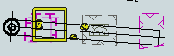
An example with Caution area, Military practice area and PSSA as selected
TBD

