S-164 – Part 7

Detection and Notification of the Safety Contour

Table of Contents
Pages

7.1 Detection and Notification of the Safety contour - Basic test 1
7.2 Detection and Notification of the Safety contour – Use of largest scale available 4
7.3 Detection and Notification of Safety contour Next Leg - Planning Mode 7
7.4 Detection and Notification of Safety contour – Water Level Adjustment. 8
7.5 Detection and Notification of the Safety contour - Basic test – Monitoring Mode 9
7.6 Detection and Notification of the Safety contour – Use of largest scale available – Monitoring Mode 11

Page intentionally left blank

Detection and Notification of the Safety contour - Basic test
Test Reference |  | SafetyContour |  |  |  | IHO Reference |  |  | S-98 12.10.9
Test Description
The purpose of this test is to verify by observation that ECDIS provides an appropriate indication when the Mariner plans a route across an own ship's safety contour. The features satisfying the conditions for this test are listed in the alerts and indications catalogue in the S-101 Portrayal Catalogue and are included in the test dataset 10100AA_SAFCO.000.

Loaded Data
Exchange Set Name
Display Mode |  |  |  |  | Independent Mariner’s Selections (default=On)
Other |  |  |  |  | Accuracy
Context Parameters |  |  |  |  | Contour label
Safety contour |  |  |  |  | Highlight date dependent
Safety depth |  |  |  |  | Highlight document
Deep Contour |  |  |  |  | Highlight info
Shallow contour |  |  |  |  | Shallow pattern
Four shades |  |  |  |  | Unknown
Radar overlay |  |  |  |  | Update review
Plain boundaries |  |  |  |  | Text Groups
Simplified symbols |  |  |  |  | Chart Text
Full light lines |  |  |  |  | Important text
Ignore scale minimum |  |  |  |  | Other Text
Shallow water dangers |  |  |  |  | Names
Palette |  |  |  |  | Light description
Day |  |  |  |  | All other chart text
Date Dependent Objects |  |  |  |  | Display
Start Date |  |  |  |  | Centre
End Date |  |  |  |  | Scale |  | 1:60000
 |  |  |  |  | Orientation
Viewing Groups (Default = On)
Standard Display |  |  |  |  |  | Other
Drying lines |  |  |  |  |  | Spot soundings
Buoys. Beacons, aids to navigation |  |  |  |  |  | Submarine cables and pipelines
Buoys, beacons, structures |  |  |  |  |  | All isolated dangers
Lights |  |  |  |  |  | Magnetic variation
Boundaries and limits |  |  |  |  |  | Depth contours
Prohibited and restricted areas |  |  |  |  |  | Seabed
Chart scale boundaries |  |  |  |  |  | Tidal
Cautionary notes |  |  |  |  |  | Miscellaneous (Other)
Ships’ routeing systems and ferry routes
Archipelagic sea lanes
Miscellaneous (Standard)
Chart (Standard)
Alert Highlights (Standard)
Additional
Setup
This test is performed by loading the test cell 10100AA_SAFCO.000, manually creating a route connecting all way points between features marked as WP1 through WP4 and checking display against the corresponding graphical plot

Action
Load the exchange set SafetyContour
- Select Display Category Other
- Set the Safety contour value to 0 m
- Set the Safety depth value to 30 m
- Select Symbolized Boundaries
- Set symbolized symbols to Off
- Select all Text groups
- Select Contour label
- Manually create a route connecting all way points between features marked WP1 through WP4
Set user-specified distance for detecting of Safety contour as 0.1 NM

Check ENC symbols shown in the ECDIS against the corresponding graphical plot.

Repeat sequentially for Safety contour value 0m, 6m, 11m, 13m, 43m

Results
The ENC in the ECDIS should match the corresponding graphical plot shown below.
Note: To increase the prominence of dangers in unsafe waters it is permitted to highlight features with an isolated danger mark when they are wholly located in this area.

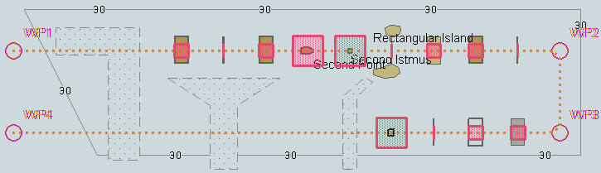
Safety contour = 0 m

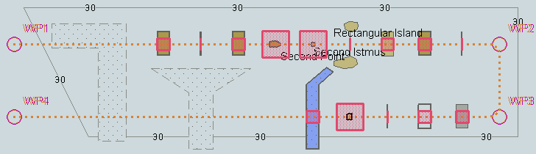
Safety contour = 6 m

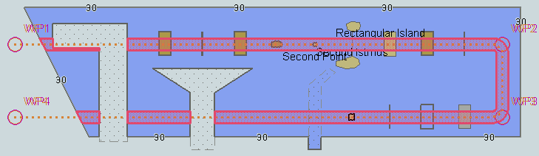
Safety contour = 11 m

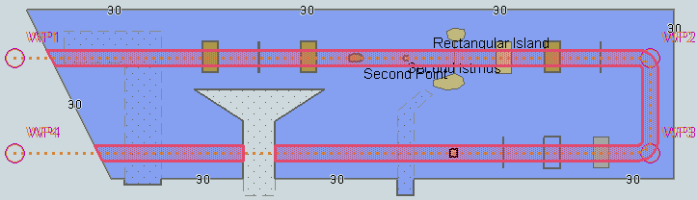
Safety contour = 13 m

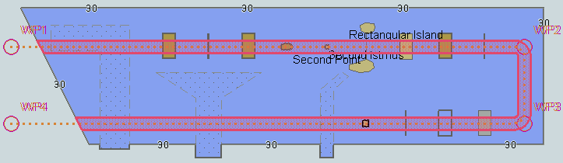
Safety contour = 43 m
tbd

Detection and Notification of the Safety contour – Use of largest scale available
Test Reference |  | SafetyContourLS |  |  |  | IHO Reference |  |  | S-98 12.10.9
Test Description
The purpose of this test is to verify by observation that ECDIS uses the largest scale available for detecting that the route crosses an own ship’s safety contour.

Loaded Data
Exchange Set Name
Display Mode |  |  |  |  | Independent Mariner’s Selections (default=On)
Other |  |  |  |  | Accuracy
Context Parameters |  |  |  |  | Contour label
Safety contour |  |  |  |  | Highlight date dependent
Safety depth |  |  |  |  | Highlight document
Deep Contour |  |  |  |  | Highlight info
Shallow contour |  |  |  |  | Shallow pattern
Four shades |  |  |  |  | Unknown
Radar overlay |  |  |  |  | Update review
Plain boundaries |  |  |  |  | Text Groups
Simplified symbols |  |  |  |  | Chart Text
Full light lines |  |  |  |  | Important text
Ignore scale minimum |  |  |  |  | Other Text
Shallow water dangers |  |  |  |  | Names
Palette |  |  |  |  | Light description
Day |  |  |  |  | All other chart text
Date Dependent Objects |  |  |  |  | Display
Start Date |  |  |  |  | Centre
End Date |  |  |  |  | Scale |  | 1:60000
 |  |  |  |  | Orientation
Viewing Groups (Default = On)
Standard Display |  |  |  |  |  | Other
Drying lines |  |  |  |  |  | Spot soundings
Buoys. Beacons, aids to navigation |  |  |  |  |  | Submarine cables and pipelines
Buoys, beacons, structures |  |  |  |  |  | All isolated dangers
Lights |  |  |  |  |  | Magnetic variation
Boundaries and limits |  |  |  |  |  | Depth contours
Prohibited and restricted areas |  |  |  |  |  | Seabed
Chart scale boundaries |  |  |  |  |  | Tidal
Cautionary notes |  |  |  |  |  | Miscellaneous (Other)
Ships’ routeing systems and ferry routes
Archipelagic sea lanes
Miscellaneous (Standard)
Chart (Standard)
Alert Highlights (Standard)
Additional
Setup
This test is performed by loading the test cells 101AA00OVRVU.000 and 101AA00ARSPC.000, manually creating a route connecting way points between features marked as WP11, WP24, WP25 and WP26 and checking display against the corresponding graphical plot

As for test 7.1 and in addition load the exchange set NavigationalHazardsOverview

- Select Display Category Other
- Set the Safety contour value to 11 m
- Set the Safety depth value to 30 m
- Select Symbolized Boundaries
- Select Simplified Point Symbols = false
Select Contour label

Action
Select position 39°27′•000N 104°49′•000W at maximum display scale (1:350 000) of 101AA00OVRVU.
1) View chart before route planning.
2) Manually create a route connecting way points between features marked WP11, WP24, WP25 and WP26. Set user-specified distance for indication navigational hazards as 0.5 NM. Check ENC symbols shown in the ECDIS against the corresponding graphical plot.

Results
The ENC in the ECDIS should match the corresponding graphical plot shown below.

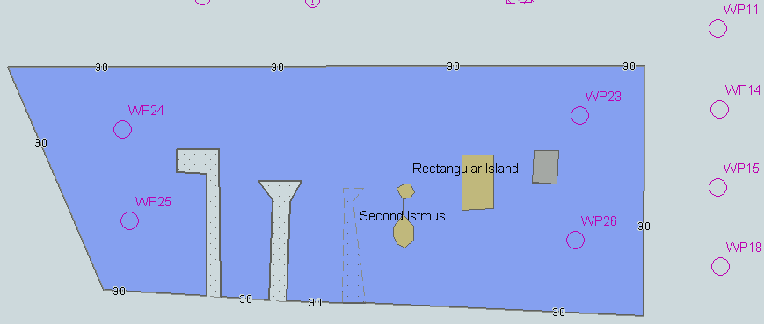
- Situation before route planning. Chart 101AA00OVRVU displayed as it is
TBD

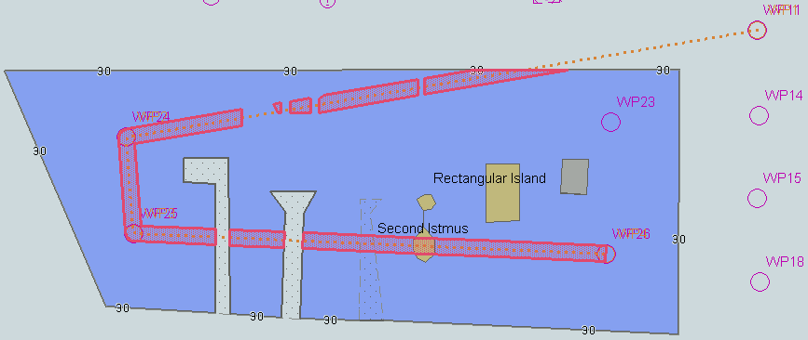
2) Situation after route planning. Alerts indicated from largest scale available for each location. An example with Safety contour = 11 m.

Detection and Notification of Safety contour Next Leg - Planning Mode
Test Reference | SafetyContourNextLeg | IHO Reference | S-98 12.10.9
Test description
TBD – New Requirement in S-98 requires a new test.

The purpose of this test is to verify by observation that ECDIS provides an appropriate indication when the Mariner plans a route where the next leg passes closer than a user-specified distance from the safety contour.

Setup
Action
Check ENC symbols shown in the ECDIS against the corresponding graphical plot.

Results
Verify safety contour detection in next leg of planned route.

Detection and Notification of Safety contour – Water Level Adjustment.
Test Reference | SafetyContourWLA | IHO Reference | S-98 Appendix D-3
Test description
The purpose of this test is to verify by observation that ECDIS provides an appropriate indication when the Mariner plans a route across an own ship's safety contour whilst operating with Water Level Adjustment enabled in areas of S-101, S-102 and S-104 coverage.
Setup
As for test SafetyContour with the additional settings:
- Set User Selected Safety contour = 11.4m
- Select Water Level Adjustment = true
- Set system date = 2022-14-11
Action
Check ENC symbols shown in the ECDIS against the corresponding graphical plot.

Results
Verify correct existence of user selected safety contour in areas without either S-102 or S-104 coverage, areas with only S-102 coverage and areas with both S-102 and S-104 coverage.

Areas should be delimited and permanent indications of WLA mode shown as per test WaterLevelAdjustment.

Detection and Notification of the Safety contour - Basic test – Monitoring Mode
Test Reference |  | SafetyContourMon |  |  |  | IHO Reference |  |  | S-98 12.10.9
Test Description
The purpose of this test is to verify by observation that ECDIS provides an appropriate alarm if the ship, within a specified time set by the Mariner, is going to cross own ship's safety contour. The features satisfying the conditions for this test are listed in the S-101 Alert and indications catalogue and are included in the test cell 101AA00SAFCO.000.

Loaded Data
Exchange Set Name
Display Mode |  |  |  |  | Independent Mariner’s Selections (default=On)
Other |  |  |  |  | Accuracy
Context Parameters |  |  |  |  | Contour label
Safety contour |  |  |  |  | Highlight date dependent
Safety depth |  |  |  |  | Highlight document
Deep Contour |  |  |  |  | Highlight info
Shallow contour |  |  |  |  | Shallow pattern
Four shades |  |  |  |  | Unknown
Radar overlay |  |  |  |  | Update review
Plain boundaries |  |  |  |  | Text Groups
Simplified symbols |  |  |  |  | Chart Text
Full light lines |  |  |  |  | Important text
Ignore scale minimum |  |  |  |  | Other Text
Shallow water dangers |  |  |  |  | Names
Palette |  |  |  |  | Light description
Day |  |  |  |  | All other chart text
Date Dependent Objects |  |  |  |  | Display
Start Date |  |  |  |  | Centre
End Date |  |  |  |  | Scale |  | 1:60000
 |  |  |  |  | Orientation
Viewing Groups (Default = On)
Standard Display |  |  |  |  |  | Other
Drying lines |  |  |  |  |  | Spot soundings
Buoys. Beacons, aids to navigation |  |  |  |  |  | Submarine cables and pipelines
Buoys, beacons, structures |  |  |  |  |  | All isolated dangers
Lights |  |  |  |  |  | Magnetic variation
Boundaries and limits |  |  |  |  |  | Depth contours
Prohibited and restricted areas |  |  |  |  |  | Seabed
Chart scale boundaries |  |  |  |  |  | Tidal
Cautionary notes |  |  |  |  |  | Miscellaneous (Other)
Ships’ routeing systems and ferry routes
Archipelagic sea lanes
Miscellaneous (Standard)
Chart (Standard)
Alert Highlights (Standard)
Additional
Setup
This test is performed by loading the test cell 101AA00SAFCO.000, sailing with a simulated ship over the test area, setting the Safety contour to the appropriate values (0m, 6m, 11m, 13m, 43m) and checking display against the graphical plots of test 7.1 (Route plan) corresponding to each set of Safety contour settings

As for test SafetyContour
Select all Text groups
Select Contour label..

Action
Set vessel position to 39°36.516'N 104°55.737'W, heading 70.3°. Check ENC symbols shown in the ECDIS for each Safety contour setting against the corresponding graphical plot

Results
The ENC in the ECDIS should match the corresponding graphical plot of test 7.1

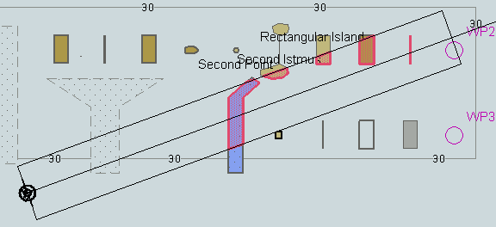

An example with Safety contour = 6 m.
TBD

Detection and Notification of the Safety contour – Use of largest scale available – Monitoring Mode
Test Reference |  | SafetyContourMonLS |  |  |  | IHO Reference |  |  | S-98 12.10.9
Test Description
The purpose of this test is to verify by observation that ECDIS uses the largest scale available for providing an appropriate alarm if the ship, within a specified time set by the Mariner, is going to cross own ship's safety contour. The features satisfying the conditions for this test are listed in the S-101 Alerts and Indications catalogue and are included in the test cell 10100AA_SAFCO.000.

This test is performed by loading the test cells 101AA00OVRVU.000 and 10100AA_SAFCO.000, sailing with a simulated ship over the test area, setting the Safety contour to the appropriate values (0m, 6m, 11m, 13m, 43m) and checking display against the graphical plots of tests 7.1 and 7.2 (Route plan) corresponding to each set of Safety contour settings

Loaded Data
Exchange Set Name
Display Mode |  |  |  |  | Independent Mariner’s Selections (default=On)
Other |  |  |  |  | Accuracy
Context Parameters |  |  |  |  | Contour label
Safety contour |  |  |  |  | Highlight date dependent
Safety depth |  |  |  |  | Highlight document
Deep Contour |  |  |  |  | Highlight info
Shallow contour |  |  |  |  | Shallow pattern
Four shades |  |  |  |  | Unknown
Radar overlay |  |  |  |  | Update review
Plain boundaries |  |  |  |  | Text Groups
Simplified symbols |  |  |  |  | Chart Text
Full light lines |  |  |  |  | Important text
Ignore scale minimum |  |  |  |  | Other Text
Shallow water dangers |  |  |  |  | Names
Palette |  |  |  |  | Light description
Day |  |  |  |  | All other chart text
Date Dependent Objects |  |  |  |  | Display
Start Date |  |  |  |  | Centre
End Date |  |  |  |  | Scale |  | 1:60000
 |  |  |  |  | Orientation
Viewing Groups (Default = On)
Standard Display |  |  |  |  |  | Other
Drying lines |  |  |  |  |  | Spot soundings
Buoys. Beacons, aids to navigation |  |  |  |  |  | Submarine cables and pipelines
Buoys, beacons, structures |  |  |  |  |  | All isolated dangers
Lights |  |  |  |  |  | Magnetic variation
Boundaries and limits |  |  |  |  |  | Depth contours
Prohibited and restricted areas |  |  |  |  |  | Seabed
Chart scale boundaries |  |  |  |  |  | Tidal
Cautionary notes |  |  |  |  |  | Miscellaneous (Other)
Ships’ routeing systems and ferry routes
Archipelagic sea lanes
Miscellaneous (Standard)
Chart (Standard)
Alert Highlights (Standard)
Additional
Setup
As for test SafetyContourLS
..

Action
Set vessel position to 39°40.522'N 105°05.654'W, heading 112°. Check ENC symbols shown in the ECDIS for each Safety contour setting against the corresponding graphical plot

Results
The ENC in the ECDIS should match the corresponding graphical plot of test 7.1 and 7.2

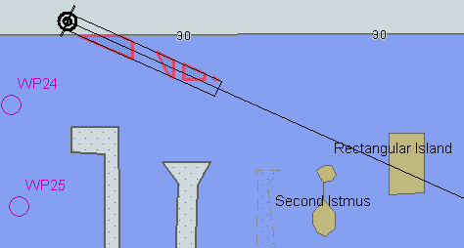

An example with Safety contour = 11 m.
TBD

