S-164 – Part 9

Dual Fuel Mode Testing

Table of Contents
Pages

9.1 Introduction 1
9.2 Data Scheming for Dual Fuel testing 1
9.3 Chart Loading and Update 1
9.3.1 Initial Loading of charts in Dual fuel mode. 1
9.3.2 Update(s) of combined exchange set. 2
9.4 Functions associated with chart display 3
9.4.1 Dual Fuel feature information 3
9.5 Detection and Notification of Navigational Hazards 3
9.5.1 Detection and Notification of Navigational Hazards – basic test 3
9.5.2 Dual Fuel Detection and Notification of Navigational Hazards – Use of largest scale available. 6
9.5.3 Detection and Notification of Navigational Hazards – monitoring mode 7
9.5.4 Detection and Notification of Navigational Hazards – use of largest scale available – monitoring mode 9
9.6 Detection of Areas for which Special Conditions Exist 12
9.6.1 Detection and Notification of Areas for which special conditions exist – basic test 12
9.7 12
9.7.1 Detection and Notification of Areas for which special conditions exist – use of largest scale available 13
9.7.2 Detection and Notification of Areas for which special conditions exist – monitoring mode 14
9.7.3 Detection and Notification of Areas for which special conditions exist – use of largest scale available – monitoring mode 15
9.8 Detection and Notification of the Safety contour 16
9.8.1 Detection and Notification of the safety contour – Basic test 16
9.8.2 Detection and Notification of the safety contour – use of largest scale available. 17
9.8.3 Detection and Notification of the safety contour – use of largest scale available – monitoring mode 18
9.8.4 Detection and Notification of the safety contour – monitoring mode 19

Page intentionally left blank

Introduction
As referenced in the previous section of this manual, during the transition period from S-57 to S-101 ENCs ECDIS will be required to support “Dual Fuel” mode. This entails display of either S-57 or S-101, or both in areas where S-101 is not available yet. The tests in this section verify the ECDIS operation when both S-57 and S-101 are in operation together.

Data Scheming for Dual Fuel testing
In order to simplify the arrangement of test data for Dual Fuel testing, some original S-57 datasets (from IHO S-64) have been used alongside S-101 versions to create the reference TDS. The arrangement of data coverage for these tests is therefore largely unchanged. A notable exception is the data scheming for the tests for navigational hazards, safety contour detection and areas where special conditions exist. These have been created alongside the original S-57 datasets, allowing exhaustive tests to be run across both types of chart format using single routes. All data is arranged in exchange sets to allow for straightforward test setup and execution.

Chart Loading and Update

Initial Loading of charts in Dual fuel mode.
Test Reference | DualFuelSimple | IHO Reference | S-98 18.2
Test description
Initial import of a dual fuel exchange set.
Setup
Load exchange set DualFuelSimple

Action
Ensure exchange set is loaded. Inspect contents of System Database.

Results
The System Database should contain the following entries.

ENC | Edition  (EDTN) | Update number  (UPDN) | Issue Date  (ISDT)
10100AA_X0000.000 | 1 | 0 | 20190409
10100AA_X01NE.000 | 1 | 0 | 20210406
GB5X01NW.000 | 1 | 0 | 20210406

Update(s) of combined exchange set.
Test Reference | DualFuelSimpleUpdate | IHO Reference | S-98 18.2
Test description
This test verifies the ECDIS is able to load updates to Dual Fuel datasets from a combined update exchange set.

[these tests are very basic and may be expanded with more comprehensive exchange sets including ones where S-57 is deleted and S-101 installed instead. Additionally, dual updates, multiple data coverage and exchange sets with multiple datasets at different MSVS will be supplied. The aim is to test all reasonable edge cases when loading and basic portrayal of dual fuel is enabled.

Additionally, the viewing of extra layers on top of dual fuel displays will be tested. This will show interleaving on S-101, not on S-57 – S-98 18.2]

Setup
As per previous test DualFuelSimple

Action
Load exchange set DualFuelSimpleUpdate

Results
System Database contents should show:

ENC | Edition  (EDTN) | Update number  (UPDN) | Update Application  Date (UADT) | Issue Date  (ISDT)
GB5X01NW.000 | 1 | 1 | 20190409 | 20190409
10100AA_X01NE.000 | 1 | 1 | 20210406 | 20210406

Functions associated with chart display

Dual Fuel feature information
Test Reference | DualFuelFeatureInformation | IHO Reference | S-98 18.2
Test description
Cursor picking in an area of DF should result in a unified display of information..

Setup
As per test DualFuelUpdate

Action
- Set position to (60.9277,-32.4966)
- Set display scale = 45,000
- Interrogate features in display

Results
Verify the information available to the user contains information from both S-57 and S-101 sources. The pick report information should contain the following information.

- DRGARE (S-57) from GB5X01NW.000
- DredgedArea (S-101) from 10100AA_X01NW.000

Detection and Notification of Navigational Hazards

Detection and Notification of Navigational Hazards – basic test
Test Reference |  | NavigationalHazardsDF |  |  |  | IHO Reference
Test Description
The purpose of this test is to verify by observation that ECDIS operating in Dual Fuel mode provides an appropriate indication when the Mariner plans a route closer than a user-specified distance from any features satisfying the conditions for this test as listed in S-98 and the S-101 Alerts and Indications Catalogue. These are included in the TDS AA5NAVHZ.000 and 101AA00NAVHZ.000.

Loaded Data
Exchange Set Name
Display Mode |  |  |  |  | Independent Mariner’s Selections (default=On)
Other |  |  |  |  | Accuracy
Context Parameters |  |  |  |  | Contour label
Safety contour |  |  |  |  | Highlight date dependent
Safety depth |  |  |  |  | Highlight document
Deep Contour |  |  |  |  | Highlight info
Shallow contour |  |  |  |  | Shallow pattern
Four shades |  |  |  |  | Unknown
Radar overlay |  |  |  |  | Update review
Plain boundaries |  |  |  |  | Text Groups
Simplified symbols |  |  |  |  | Chart Text
Full light lines |  |  |  |  | Important text
Ignore scale minimum |  |  |  |  | Other Text
Shallow water dangers |  |  |  |  | Names
Palette |  |  |  |  | Light description
Day |  |  |  |  | All other chart text
Date Dependent Objects |  |  |  |  | Display
Start Date |  |  |  |  | Centre
End Date |  |  |  |  | Scale |  | 1:60000
 |  |  |  |  | Orientation
Viewing Groups (Default = On)
Standard Display |  |  |  |  |  | Other
Drying lines |  |  |  |  |  | Spot soundings
Buoys. Beacons, aids to navigation |  |  |  |  |  | Submarine cables and pipelines
Buoys, beacons, structures |  |  |  |  |  | All isolated dangers
Lights |  |  |  |  |  | Magnetic variation
Boundaries and limits |  |  |  |  |  | Depth contours
Prohibited and restricted areas |  |  |  |  |  | Seabed
Chart scale boundaries |  |  |  |  |  | Tidal
Cautionary notes |  |  |  |  |  | Miscellaneous (Other)
Ships’ routeing systems and ferry routes
Archipelagic sea lanes
Miscellaneous (Standard)
Chart (Standard)
Alert Highlights (Standard)
Additional
Setup
This test is performed by loading the dual fuel exchange set NavigationalHazards, WP1 through WP36 and checking the display against the corresponding graphical plot.

Load the exchange set NavigationalHazardsDF
- Select Display Category Other
- Set the Safety contour value to 0 m
- Set the Safety depth value to 30 m
- Select Symbolized Boundaries
- Select Simplified Point Symbols = false
- Select all Text groups
- Manually create a route connecting all way points between features marked WP1 through WP36

Set user-specified distance for indication navigational hazards as 0.1 NM

Action
Check ENC symbols shown in the ECDIS against the corresponding graphical plot.

Repeat sequentially with a Safety contour value of 0m, 2m, 4m, 5m, 6m, 8m, 9m, 10m, 11m, 16m, 21m, 31m, 42m, 50m, 51m.

Results
The ENC in the ECDIS should match the corresponding graphical plot shown below.

Dual Fuel Detection and Notification of Navigational Hazards – Use of largest scale available.
Test Reference | NavigationalHazardsDFLS | IHO Reference | S-101PC
Test description
The purpose of this test is to verify by observation that ECDIS uses the largest scale available for detection of navigational hazards.

This test is performed by loading dual fuel exchange sets, manually creating a route connecting all way points between marked features and checking display against a corresponding graphical plot. The same test is run twice with different overview exchange sets comprising the smaller scale data.
Setup
(A) Load the exchange set NavigationalHazardsDF and the exchange set NavigationalHazardsOverviewDF1

- Select Display Category Other
- Set the Safety contour value to 30 m
- Set the Safety depth value to 30 m
- Select Symbolized Boundaries
- Select Simplfied point symbols = false
- Select all Text groups

(B) Repeat test using exchange sets NavigationalHazardsDF and NavigationalHazardsOverviewDF2

Action
For each of (1) and (2)

Select position 39°57.000’N 104°49.000’W at maximum display scale (1:350 000) of 101AA00OVRVU.
1) View chart before route planning.
2) Manually create a route connecting all way points between features marked WP1 through WP8. Set user-specified distance for indication navigational hazards as 0.5 NM. Check ENC symbols shown in the ECDIS against the corresponding graphical plot.

Results
The ENC in the ECDIS should match the corresponding graphical plot shown below.

A) Situation before route planning. Chart 101AA00OVRVU displayed as it is-

B) Situation before route planning. Chart AA5OVRVU displayed as it is-

Detection and Notification of Navigational Hazards – monitoring mode
Test Reference |  | NavigationalHazardsDFMon |  |  |  | IHO Reference
Test Description
The purpose of this test is to verify by observation that ECDIS provides an appropriate indication if, continuing on its present course and speed, over a specified time or distance set by the Mariner, own ship will pass closer than a user-specified distance from any features satisfying the conditions for this test. These are included in the test cells AA5NAVHZ.000 and 101AA00NAVHZ.000) that is shallower than the Mariner's safety contour.

Loaded Data
Exchange Set Name
Display Mode |  |  |  |  | Independent Mariner’s Selections (default=On)
Other |  |  |  |  | Accuracy
Context Parameters |  |  |  |  | Contour label
Safety contour |  |  |  |  | Highlight date dependent
Safety depth |  |  |  |  | Highlight document
Deep Contour |  |  |  |  | Highlight info
Shallow contour |  |  |  |  | Shallow pattern
Four shades |  |  |  |  | Unknown
Radar overlay |  |  |  |  | Update review
Plain boundaries |  |  |  |  | Text Groups
Simplified symbols |  |  |  |  | Chart Text
Full light lines |  |  |  |  | Important text
Ignore scale minimum |  |  |  |  | Other Text
Shallow water dangers |  |  |  |  | Names
Palette |  |  |  |  | Light description
Day |  |  |  |  | All other chart text
Date Dependent Objects |  |  |  |  | Display
Start Date |  |  |  |  | Centre
End Date |  |  |  |  | Scale |  | 1:60000
 |  |  |  |  | Orientation
Viewing Groups (Default = On)
Standard Display |  |  |  |  |  | Other
Drying lines |  |  |  |  |  | Spot soundings
Buoys. Beacons, aids to navigation |  |  |  |  |  | Submarine cables and pipelines
Buoys, beacons, structures |  |  |  |  |  | All isolated dangers
Lights |  |  |  |  |  | Magnetic variation
Boundaries and limits |  |  |  |  |  | Depth contours
Prohibited and restricted areas |  |  |  |  |  | Seabed
Chart scale boundaries |  |  |  |  |  | Tidal
Cautionary notes |  |  |  |  |  | Miscellaneous (Other)
Ships’ routeing systems and ferry routes
Archipelagic sea lanes
Miscellaneous (Standard)
Chart (Standard)
Alert Highlights (Standard)
Additional
Setup
This test is performed by loading the exchange set NavigationalHazardsDF, sailing with a simulated ship over the test area, setting the Safety contour to the appropriate values (0m, 2m, 5m, 6m, 8m, 9m, 10m, 11m, 16m, 21m, 31m, 42m, 50m, 51m) and checking display against the graphical plots of test NavigationalHazardsDF (Route plan) corresponding to each set of Safety contour settings

As for test NavigationalHazardsDF
Select all Text groups

Action
Check ENC symbols shown in the ECDIS for each Safety contour setting against the corresponding graphical plot

Results
The ENC in the ECDIS should match the corresponding graphical plot of test NavigationalHazardsDF.

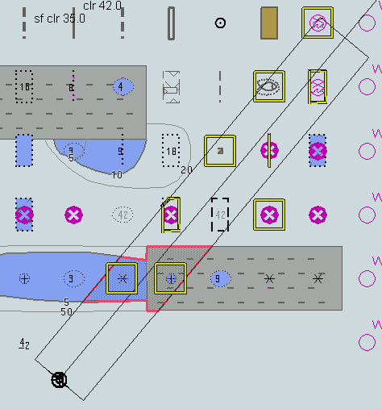

Detection and Notification of Navigational Hazards – use of largest scale available – monitoring mode
Test Reference |  | NavigationalHazardsDFMonLS |  |  |  | IHO Reference
Test Description
The purpose of this test is to verify by observation that ECDIS uses the largest scale available for detection of navigational hazards in dual fuel mode.

Loaded Data
Exchange Set Name
Display Mode |  |  |  |  | Independent Mariner’s Selections (default=On)
Other |  |  |  |  | Accuracy
Context Parameters |  |  |  |  | Contour label
Safety contour |  |  |  |  | Highlight date dependent
Safety depth |  |  |  |  | Highlight document
Deep Contour |  |  |  |  | Highlight info
Shallow contour |  |  |  |  | Shallow pattern
Four shades |  |  |  |  | Unknown
Radar overlay |  |  |  |  | Update review
Plain boundaries |  |  |  |  | Text Groups
Simplified symbols |  |  |  |  | Chart Text
Full light lines |  |  |  |  | Important text
Ignore scale minimum |  |  |  |  | Other Text
Shallow water dangers |  |  |  |  | Names
Palette |  |  |  |  | Light description
Day |  |  |  |  | All other chart text
Date Dependent Objects |  |  |  |  | Display
Start Date |  |  |  |  | Centre
End Date |  |  |  |  | Scale |  | 1:60000
 |  |  |  |  | Orientation
Viewing Groups (Default = On)
Standard Display |  |  |  |  |  | Other
Drying lines |  |  |  |  |  | Spot soundings
Buoys. Beacons, aids to navigation |  |  |  |  |  | Submarine cables and pipelines
Buoys, beacons, structures |  |  |  |  |  | All isolated dangers
Lights |  |  |  |  |  | Magnetic variation
Boundaries and limits |  |  |  |  |  | Depth contours
Prohibited and restricted areas |  |  |  |  |  | Seabed
Chart scale boundaries |  |  |  |  |  | Tidal
Cautionary notes |  |  |  |  |  | Miscellaneous (Other)
Ships’ routeing systems and ferry routes
Archipelagic sea lanes
Miscellaneous (Standard)
Chart (Standard)
Alert Highlights (Standard)
Additional
Setup
This test is performed by loading the exchange sets NavigationalHazardsOverviewDF1 and NavigationalHazardsDF, manually creating a route connecting all way points between features marked as WP1 through WP8 and checking the display against a corresponding graphical plot

A) Load the exchange set NavigationalHazardsDF
Load the exchange set NavigationalHazardsOverviewDF1
- Select Display Category Other
- Set the Safety contour value to 30 m
- Set the Safety depth value to 30 m
- Select Symbolized Boundaries
Set symbolized symbols to Off
Select all Text groups

(B) The test should then be repeated using the exchange sets NavigationalHazardsDF and NavigationalHazardsOverviewDF2

Action
Select position 39°57.000’N 104°49.000’W at the maximum display scale (1:350 000) of 101AA00OVRVU (or AA5OVRVU).
Set simulated own ship for 39°49.587’N 104°54.930’W with heading set for 10.0°
Select size of own ship check area as 1.0 NM width and 8.0 NM length

Results
The ENC in the ECDIS should match the corresponding graphical plots shown below (A).

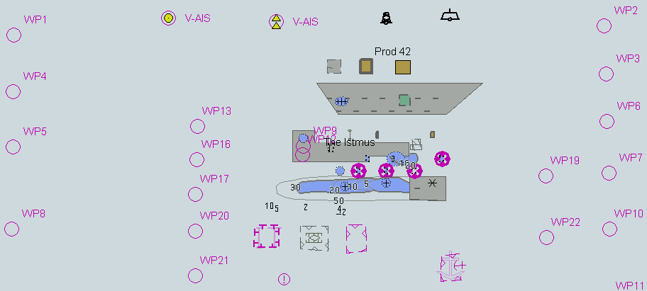

Detection of Areas for which Special Conditions Exist

Detection and Notification of Areas for which special conditions exist – basic test
Test Reference | SpecialConditionsDF | IHO Reference
Test description
The purpose of this test is to verify by observation that ECDIS provides an appropriate indication when the Mariner plans a route closer than a user-specified distance from the boundary of a prohibited area or a geographic area for which special conditions exist whilst operating in Dual Fuel mode. The features satisfying the conditions for this test are listed in the alerts and indications catalogue within the S-101 Portrayal Catalogue and are included in the test cells AA5ARSPC.000 and 101AA00ARSPC.000.

Setup
This test is performed by loading the exchange set SpecialConditionsDF, manually creating a route connecting all waypoints between features marked as WP1 through WP4 and checking the display against the corresponding graphical plot

Load the exchange set SpecialConditionsDF
- Select Display Category Other
- Set the Safety contour value to 0 m
- Set the Safety depth value to 30 m
- Select Symbolized Boundaries
- Set symbolized symbols to Off
- Manually create a route connecting all way points between features marked WP1 through WP4
Set user-specified distance for indication of areas with special condition as 0.1 NM

Action
Check ENC symbols shown in the ECDIS against the corresponding graphical plot. selecting one by one each special condition for the test
Results
The ENC in the ECDIS should match the corresponding graphical plot shown below.

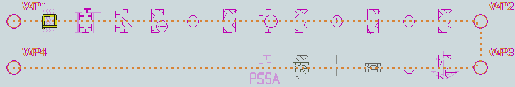
Selected: Traffic separation zone

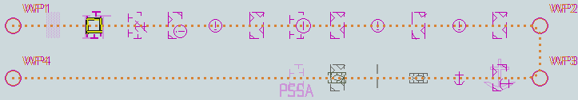
TBD

Detection and Notification of Areas for which special conditions exist – use of largest scale available
Test Reference | SpecialConditionsDFLS | IHO Reference
Test description
The purpose of this test is to verify by observation that ECDIS uses the largest scale available for detection of areas with special conditions whilst operating in Dual Fuel mode.

Setup
This test is performed by loading test exchange sets, manually creating a route connecting way points between features marked as WP20 and WP22 and checking the display against a corresponding graphical plot.

(A) As for test SpecialConditionsDF and in addition load the exchange set NavigationalHazardsOverviewDF1

- Select Display Category Other
- Set the Safety contour value to 0 m
- Set the Safety depth value to 30 m
- Select Symbolized Boundaries
- Select Simplified symbols
Select all Text groups

(B) Repeat test using exchange sets SpecialConditionsDF and NavigationalHazardsOverviewDF2

Action
Select position 39°45′•000N 104°49′•000W at compilation scale (1:350 000) of 101AA00OVRVU (or AA2OVRVU).
1) View chart before route planning.
2) Manually create a route connecting two way points between features marked WP20 and WP22. Set user-specified distance for indication of areas with special conditions as 0.5 NM. Check ENC symbols shown in the ECDIS against the corresponding graphical plot.
Results
The ENCs in the ECDIS should match the corresponding graphical plot shown below.

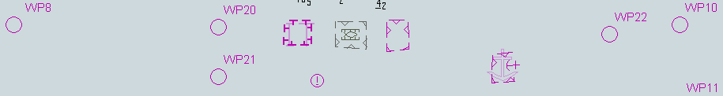
tbd
1) Situation before route planning. Chart 101AA00OVRVU displayed as it is

Detection and Notification of Areas for which special conditions exist – monitoring mode
Test Reference | SpecialConditionsMonDF | IHO Reference
Test description
The purpose of this test is to verify by observation that ECDIS provides an appropriate alarm or indication, as selected by the Mariner, if, within a specified time set by the Mariner, own ship will cross the boundary of a prohibited area or area for which special conditions exist whilst operating in Dual Fuel mode.

The features satisfying the conditions for this test are listed in listed in the alerts and indications catalogue within the S-101 Portrayal Catalogue and are included in the test cells AA5ARSPC.000 and 101AA00ARSPC.000.

Setup
This test is performed by loading the exchange set SpecialConditionsDF, sailing with a simulated ship over the test area, selecting one by one each special condition for the test and checking display against the graphical plots of test SpecialConditions (Route plan) corresponding to each set of Safety contour settings..

As for test SpecialConditionsDF

Action
Check ENC symbols shown in the ECDIS for each special condition against the corresponding graphical plot
Results
The ENC in the ECDIS should match the corresponding graphical plot of test 6.1.
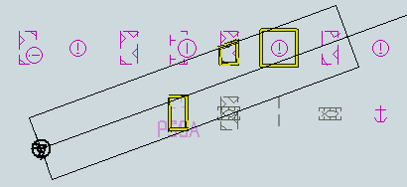
An example with PSSA and Military practice area as selected.
TBD

Detection and Notification of Areas for which special conditions exist – use of largest scale available – monitoring mode
Test Reference | SpecialConditionsDFLSMon | IHO Reference
Test description
The purpose of this test is to verify by observation that ECDIS uses the largest scale available for detection of areas with special condition whilst operating in Dual Fuel mode..

Setup
This test is performed by loading test exchange sets, sailing with a simulated ship over the test area, selecting one by one each special condition for the test and checking display against the graphical plots of tests SpecialConditionsDF and SpecialConditionsDFLS (Route plan) corresponding to each special condition settings.

As for test SpecialConditionsDFLS

Action
- Select position 39°45′•000N 104°49′•000W at compilation scale (1:350 000) of 101AA00OVRVU. Heading approximately 100°.
- Set vessel position to 39°47.877'N 104°57.590'W, heading 94.3°.
- Check ENC symbols shown in the ECDIS for each special condition against the corresponding graphical plot
- Repeat test as described in SpecialConditionsDFLS

Results
The ENC in the ECDIS should match the corresponding graphical plot of tests SpecialConditionsDF and SpecialConditionsDFLS.

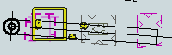 TBD
An example with Caution area, Military practice area and PSSA as selected

Detection and Notification of the Safety contour

Detection and Notification of the safety contour – Basic test
Test Reference | SafetyContourDF | IHO Reference
Test description
The purpose of this test is to verify by observation that ECDIS provides an appropriate indication when the Mariner plans a route across an own ship's safety contour whilst operating in Dual Fuel mode. The features satisfying the conditions for this test are listed in listed in the alerts and indications catalogue within the S-101 Portrayal Catalogue and are included in the TDS AA5SAFCO.000 and 101AA00SAFCO.000.

Setup
This test is performed by loading the test exchange set, manually creating a route connecting all way points between features marked as WP1 through WP4 and checking the display against the corresponding graphical plot.

Load the exchange set SafetyContourDF
- Select Display Category Other
- Set the Safety contour value to 0 m
- Set the Safety depth value to 30 m
- Select Symbolized Boundaries
- Select Simplified Point Symbols = true
- Select all Text groups
- Select Contour label
- Manually create a route connecting all way points between features marked WP1 through WP4
Set user-specified distance for detecting of Safety contour as 0.1 NM
Action
Check portrayal shown in the ECDIS against the corresponding graphical plot.
Repeat sequentially for Safety contour value 0m, 6m, 11m, 13m, 43m.
Results
The ENC in the ECDIS should match the corresponding graphical plot shown below..
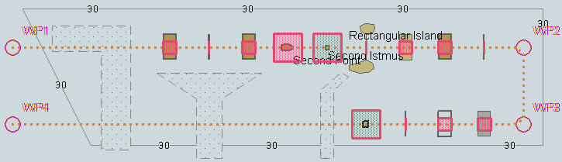
Safety contour = 0 m
TBD

Detection and Notification of the safety contour – use of largest scale available.
Test Reference | SafetyContourDFLS | IHO Reference
Test description
The purpose of this test is to verify by observation that ECDIS uses the largest scale available for detecting that the route crosses an own ship’s safety contour whilst operating in Dual Fuel mode.

Setup
This test is performed by loading the test exchange sets, manually creating a route connecting way points between features marked as WP11, WP24, WP25 and WP26 and checking display against the corresponding graphical plot. The same test is run twice with different overview exchange sets comprising the smaller scale data

(A) As for test SafetyContourDF and in addition load the exchange set NavigationalHazardsOverview1
- Select Display Category Other
- Set the Safety contour value to 11 m
- Set the Safety depth value to 30 m
- Select Symbolized Boundaries
Set symbolized symbols to Off
Select Contour label

(B) Repeat test using exchange sets SafetyContourDF and NavigationalHazardsOverview2
Action
Select position 39°27′•000N 104°49′•000W at maximum display scale (1:350 000) of 101AA00OVRVU.
1) View chart before route planning.
2) Manually create a route connecting way points between features marked WP11, WP24, WP25 and WP26. Set user-specified distance for indication navigational hazards as 0.5 NM. Check ENC symbols shown in the ECDIS against the corresponding graphical plot.

Results
The ENC in the ECDIS should match the corresponding graphical plot shown below [Images To Follow]
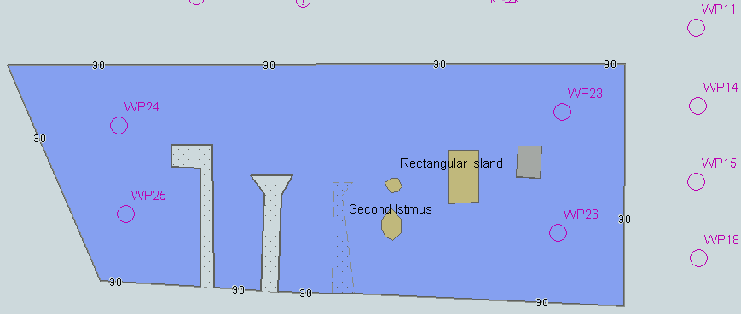
TBD

Detection and Notification of the safety contour – use of largest scale available – monitoring mode
Test Reference | SafetyContourDFMonLS | IHO Reference
Test description
The purpose of this test is to verify by observation that ECDIS provides an appropriate alarm if the ship, within a specified time set by the Mariner, is going to cross own ship's safety contour whilst operating in monitoring mode. The features satisfying the conditions for this test are listed listed in the alerts and indications catalogue within the S-101 Portrayal Catalogue and are included in the TDS AA5SAFCO.000 andl 101AA00SAFCO.000.

.

Setup
This test is performed by loading the exchange set SafetyContourDFMon, sailing with a simulated ship over the test area, setting the Safety contour to the appropriate values (0m, 6m, 11m, 13m, 43m) and checking display against the graphical plots of test SafetyContourDF (Route plan) corresponding to each set of Safety contour settings

Load exchange set SafetyContourDFMon

Action
Set vessel position to 39°40.522'N 105°05.654'W, heading 112°. Check ENC symbols shown in the ECDIS for each Safety contour setting against the corresponding graphical plot.

Results
The ENC in the ECDIS should match the corresponding graphical plot of test 7.1 and 7.2.
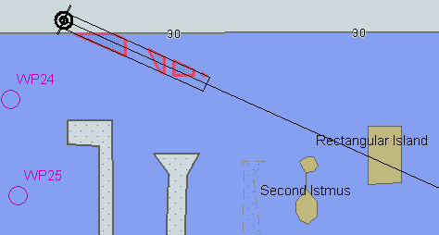
TBD

Detection and Notification of the safety contour – monitoring mode
Test Reference | SafetyContourDFMon | IHO Reference
Test description
The purpose of this test is to verify by observation that ECDIS provides an appropriate alarm if the ship, within a specified time set by the Mariner, is going to cross own ship's safety contour. The features satisfying the conditions for this test are listed in listed in the alerts and indications catalogue within the S-101 Portrayal Catalogue and are included in the test cells AA5SAFCO.000 and 101AA00SAFCO.000.

Setup
This test is performed by loading the exchange set SafetyContourDFMon, sailing with a simulated ship over the test area, setting the Safety contour to the appropriate values (0m, 6m, 11m, 13m, 43m) and checking display against the graphical plots of test SafetyContourDF (Route plan) corresponding to each set of Safety contour settings.

- As for test SafetyContourDF
- Select all Text groups
- Select Contour label
Action
Set vessel position to 39°36.516'N 104°55.737'W, heading 70.3°. Check ENC symbols shown in the ECDIS for each Safety contour setting against the corresponding graphical plot
Results
The ENC in the ECDIS should match the corresponding graphical plot of SafetyContourDF
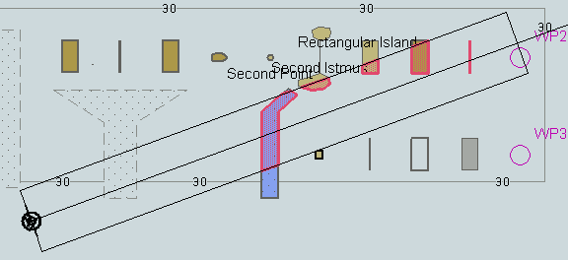
TBD
An example with Safety contour = 6 m.

ANNEX A: Automatic Updates via Telecommunications networks (SECOM)

As described in the introduction to this manual, S-164 now contains specifications for tests of updates using online services implemented using the SECOM specification (IEC 63173-2).

If the EUT has implemented the capability of receiving S-124 and/or S-129 official updates via a SECOM based telecommunications network, then the following tests should be executed.

These tests are executed using the following IHO standard access details:

To Be Added:
- UserName(s)
- Addresses
- Authentication key information

Connection
Test Reference | SECOMSelection | IHO Reference  IEC Reference | S-98: 20.4.3 (i)  63173-2:
Test Description
Check SECOM identity.
Safety contourSafety depthShallow contourShallow patternFour shadesRadar overlayUpdate reviewPlain boundariesSimplified symbolsFull light linesShallow water dangersSetup
Action
Connect User to SECOM network (IHO hosted, or locally hosted depending on resources)
- Connect the ECDIS to the IHO based SECOM service using the details provided in this section.
- Select the update data service for S-124 and S-129 data.
- Verify that the identity is correctly authenticated on the ECDIS. The details are listed below:
Insert User Details available through the SECOM network.
Results

Service Management
Test Reference | SECOMManagement | IHO Reference  IEC Reference |  | S-98: 20.4.3 (i)
Test Description
Check SECOM management.
Loaded Data
Exchange Set Name
Safety contourSafety depthShallow contourShallow patternFour shadesRadar overlayUpdate reviewPlain boundariesSimplified symbolsFull light linesShallow water dangersSetup
Action
Verify user is able to “manage” the SECOM connection / status [it may be that other mandatory functionality is able to be added here]
- Verify SECOM status is available to the ECDIS user.
- Reference details are listed below:
- Ensure that an update is available to the following datasets within the System Database
- 129AA00XXXX, 124AA00XXXX
- [user details, history and subscription status – these should all be viewable to the user]
Results

Update and Acknowledgment.
Test Reference | SECOMAcknowledgment | IHO Reference  IEC Reference |  | S-98: 20.4.3 (iii)
Test Description
Check SECOM acknowledgment.
Loaded Data
Exchange Set Name
Safety contourSafety depthShallow contourShallow patternFour shadesRadar overlayUpdate reviewPlain boundariesSimplified symbolsFull light linesShallow water dangersSetup
Action
Perform and acknowledge an update to the system database through the SECOM network.
- Perform an update through the SECOM network to the S-129 and S-124 datasets as listed in the resources available.
- Ensure an acknowledgment of receipt and verification of data integrity is observed on the ECDIS.
- Ensure the data is correctly ingested into the System Database.
- Interrogate the ECDIS System Database and ensure the following revision information is correct.
Results
Dataset | Edition | Update number | Issue Date  (ISDT)
129AA00XXXA | 1 | 0 | 20240409
124AA00NEWA | 1 | 0 | 20240406
124AA00UPDB | 1 | 0 | 20240406

