X§

S-164 – Part 2

Catalogue and Dataset Loading and Updating

Table of Contents
Pages
2.1 Catalogue Loading and System Initialisation 1
2.1.1 Initial Catalogues 1
2.1.2 Out of Catalogue Sequence Dataset 2
2.1.3 Valid Catalogue Update and Data 2
2.1.4 Multiple Revision Portrayal 3
2.2 Dataset Loading 4
2.2.1 Preparation and Initial Power Up 4
2.2.2 Number and date in System Database 7
2.2.3 Load additional dataset and check System Database 8
2.2.4 Remove dataset and check the System Database 8
2.3 Automatic updates of Unencrypted ENCs 8
2.3.1 Loading sequential updates 8
2.3.2 Loading update in an invalid sequence 13
2.3.3 Loading update of newer edition 13
2.3.4 Update Information 17
2.3.5 Importing update of older edition 18
2.3.6 Importing a re-issue and an update of a dataset 18
2.3.7 Rejection of automatic update 20
2.4 Manual Updates 23
2.4.1 Creation of a Manual Update 23
2.4.2 Manual Update - Dates 24
2.4.3 Manual Update - retrieval 25
2.4.4 Manual Update - Alerts and indications 26
2.5 Loading, Updating and Authentication of datasets 28
2.5.1 Organization of encrypted datasets 28
2.5.2 ENC Licensing – Permit Management 29
2.6 Dataset Authentication 37
2.6.1 Missing Catalogue Signature 37
2.6.2 Invalid Catalogue Signature 38
2.6.3 Authentication against a non-SA certificate 38
2.6.4 Authentication via a domain coordinator 39
2.6.5 ENC signature validation 39
2.6.6 Check authentication is continuous and complete 40
2.6.7 Single exchange set with datasets signed by multiple data servers 41
2.6.8 Missing Certificate 42
2.6.9 ENC Decryption 43
2.7 Dataset Management 47
2.7.1 Encrypted ENCs supplied by different Data Servers 47
2.7.2 Loading additional dataset permits and cells from a different data provider 48
2.7.3 Test that the system operates correctly in a multiple data provider environment 49
2.8 ECDIS management of data services. 51
2.8.1 ECDIS management of cancelled cells 51
2.8.2 ECDIS management of ENC re-issued datasets 54
2.8.3 ECDIS management of Exchange Sets 55
2.8.4 Update of Supplementary Files 56
2.8.5 Fileless Cancellation 57
2.9 ECDIS Update Status Report 57
2.9.1 ENC Update Status Report 57
2.9.2 ENP Update Status Report 58
2.9.3 Missing Revision information. 58
2.9.4 Multiple Revision Information 59
2.9.5 Product Independence 59
2.9.6 Adequate and Complete Tests 60
2.10 Loading and update of non-ENC S-100 datasets. 62
2.10.1 Bathymetric Surface Datasets (S-102) 62
2.10.2 Water Levels (S-104) 65
2.10.3 Tidal Streams (S-111) 68
2.10.4 Marine Protected Areas (S-122) 70
2.10.5 Navigational Warnings (S-124) 73
2.10.6 Marine traffic Management (S-127) 78
2.10.7 Under Keel Clearance Management Areas (S-129) 80
2.10.8 Marine Harbour Infrastructure (S-131) 82

Page intentionally left blank

Catalogue Loading and System Initialisation

Initial Catalogues
Test Reference | InitialCatalogues | IHO Reference  IEC Reference | S-98: 20.1
Test description
This test ensures the EUT supports the import of initial Feature and Portrayal Catalogues and checks they are persistent in the EUT.
Setup
Clear all EUT catalogue and data contents.
Action
Import the exchange set InitialCatalogues. [Note: the method by which catalogues are installed is not prescribed by S-164 and may be by any method developed by the OEM].
Results
Verify the versions of the S-100 Feature Catalogues and Portrayal Catalogues is correct. The correct information is shown in the following table:
Catalogue | Product | Version
Feature Catalogue | S-101 | 1.9.0
Portrayal Catalogue | S-101 | 1.9.0
Feature Catalogue | S-102 | 3.0.0
Portrayal Catalogue | S-102 | 3.0.0
Feature Catalogue | S-104 | 2.0.0
Feature Catalogue | S-111 | 1.9.0
Portrayal Catalogue | S-111 | 1.9.0
Feature Catalogue | S-122 | 2.0.0
Portrayal Catalogue | S-122 | 2.0.0
Feature Catalogue | S-124 | 1.9.0
Portrayal Catalogue | S-124 | 1.9.0
Feature Catalogue | S-127 | 2.0.0
Portrayal Catalogue | S-127 | 2.0.0
Feature Catalogue | S-128 | 2.0.0
Portrayal Catalogue | S-128 | 2.0.0
Feature Catalogue | S-129 | 2.0.0
Portrayal Catalogue | S-129 | 2.0.0
Feature Catalogue | S-131 | 2.0.0
Portrayal Catalogue | S-131 | 2.0.0

Out of Catalogue Sequence Dataset
Test Reference | OutOfCatalogueSequence Dataset | IHO Reference  IEC Reference | S-98: 20.1 and B-1
Test description
This test ensures the EUT detects mismatches between Product Specification versions of installed Catalogues and imported Datasets.
Setup
As per completion of test InitialCatalogues (exchange set InitialCatalogues loaded).
Action
Import the exchange set OutOfCatalogueSequenceDataset.
Results
The dataset installation process shall stop, issuing the user with the error message SSE133 “Version mismatch between 10100AA_X01NE and S-101 Feature Catalogue 1.9.0. Only version 2.0.0 is supported for data of this type (S-101 ENC)”.

Valid Catalogue Update and Data
Test Reference | UpdateCatalogues | IHO Reference  IEC Reference | S-98: 20.1 and B-1
Test description
This test ensures the EUT supports the management and update of Feature and Portrayal Catalogues.
Setup
As per completion of test OutOfCatalogueSequenceDataset (exchange set InitialCatalogues loaded).
Action
- Import the following exchange sets:
- PowerUpCatalogues
- UpdatedCatalogueData
- Verify the versions of all catalogues installed.
Results
- The exchange sets shall install without any warning messages.
- The EUT shall allow at least the following catalogue versions to be listed:
Catalogue | Product | Version
Feature Catalogue | S-101 | 2.0.0
Portrayal Catalogue | S-101 | 2.0.0
Feature Catalogue | S-101 | 2.5.0
Portrayal Catalogue | S-101 | 2.5.0
Feature Catalogue | S-101 | 2.6.0
Portrayal Catalogue | S-101 | 2.6.0
Feature Catalogue | S-101 | 2.7.0
Portrayal Catalogue | S-101 | 2.7.0
Feature Catalogue | S-101 | 2.8.0
Portrayal Catalogue | S-101 | 2.8.0
Feature Catalogue | S-111 | 2.0.0
Portrayal Catalogue | S-111 | 2.0.0
Feature Catalogue | S-124 | 2.0.0
Portrayal Catalogue | S-124 | 2.0.0

Multiple Revision Portrayal
Test Reference |  | MultipleRevisions |  |  |  | IHO Reference  IEC Reference |  |  | S-98: 20.1 and B-1
Test Description
This test ensures the EUT supports the correct display of Datasets based on different versions of a Product Specification (S-101).
Display Mode |  |  |  |  | Independent Mariner’s Selections  (Default = On)
Other |  |  |  |  | Accuracy |  |  |  |  | Off
Context Parameters (Default = On) |  |  |  |  | Contour label
Safety contour |  |  | 20 |  | Highlight date dependent
Safety depth |  |  | 8 |  | Highlight document
Deep contour |  |  | 30 |  | Highlight info
Shallow contour |  |  | 2 |  | Shallow pattern |  |  |  |  | Off
Four shades |  |  | Off |  | Unknown objects |  |  |  |  | Off
Radar overlay |  |  | Off |  | Update review |  |  |  |  | Off
Plain boundaries |  |  |  |  | Text Groups
Simplified symbols |  |  | Off |  | Chart text
Full light lines |  |  |  |  | Important text
Ignore scale minimum |  |  | Off |  | Other Text
Shallow water dangers |  |  |  |  | Names
Palette |  |  |  |  | Light description
Day |  |  |  |  | All other chart text
Date Dependent Objects |  |  |  |  | Display
Start Date | N/A |  |  |  | Centre |  |  | 42°30.00’S 61°35.76’E
End Date | N/A |  |  |  | Scale |  |  | 1:60 000
Viewing Groups (Default = On)
Standard Display |  |  |  |  |  |  | Other
Drying lines |  |  |  |  |  |  | Spot soundings
Buoys. Beacons, aids to navigation |  |  |  |  |  |  | Submarine cables and pipelines
Buoys, beacons, structures |  |  |  |  |  |  | All isolated dangers
Lights |  |  |  |  |  |  | Magnetic variation
Boundaries and limits |  |  |  |  |  |  | Depth contours
Prohibited and restricted areas |  |  |  |  |  |  | Seabed
Chart scale boundaries |  |  |  |  |  |  | Tidal
Cautionary notes |  |  |  |  |  |  | Miscellaneous (Other)
Ships’ routeing systems and ferry routes
Archipelagic sea lanes
Miscellaneous (Standard)
Chart (Standard)
Alert Highlights (Standard)
Setup
As per completion of test UpdateCatalogues.
Action
- Import exchange set MultipleRevisions.
- Verify installation of the datasets 10100AASPLIT01, 10100AASPLIT02, 10100AASPLIT03 and 10100AASPLIT04 and the versions of the Feature Catalogues and Portrayal Catalogues for each of the datasets.
- Navigate to the position and at the viewing scale indicated and verify the symbols used for each of the shown landmarks. These are specific to the different revisions of the Portrayal Catalogues.
- Verify the existence of the “Alternative Landmarks” context parameter (defined in Portrayal Catalogue 2.7.0).
Results
- The exchange set shall install without any warning messages.
- The information in the System Database shall show the presence of the datasets and their associated Catalogue versions as follows:
Dataset | Associated Feature Catalogue | Associated Portrayal Catalogue
10100AASPLIT01 | 2.5.0 | 2.5.0
10100AASPLIT02 | 2.6.0 | 2.6.0
10100AASPLIT03 | 2.7.0 | 2.7.0
10100AASPLIT04 | 2.8.0 | 2.8.0
- At the defined position the following image shall be observed:
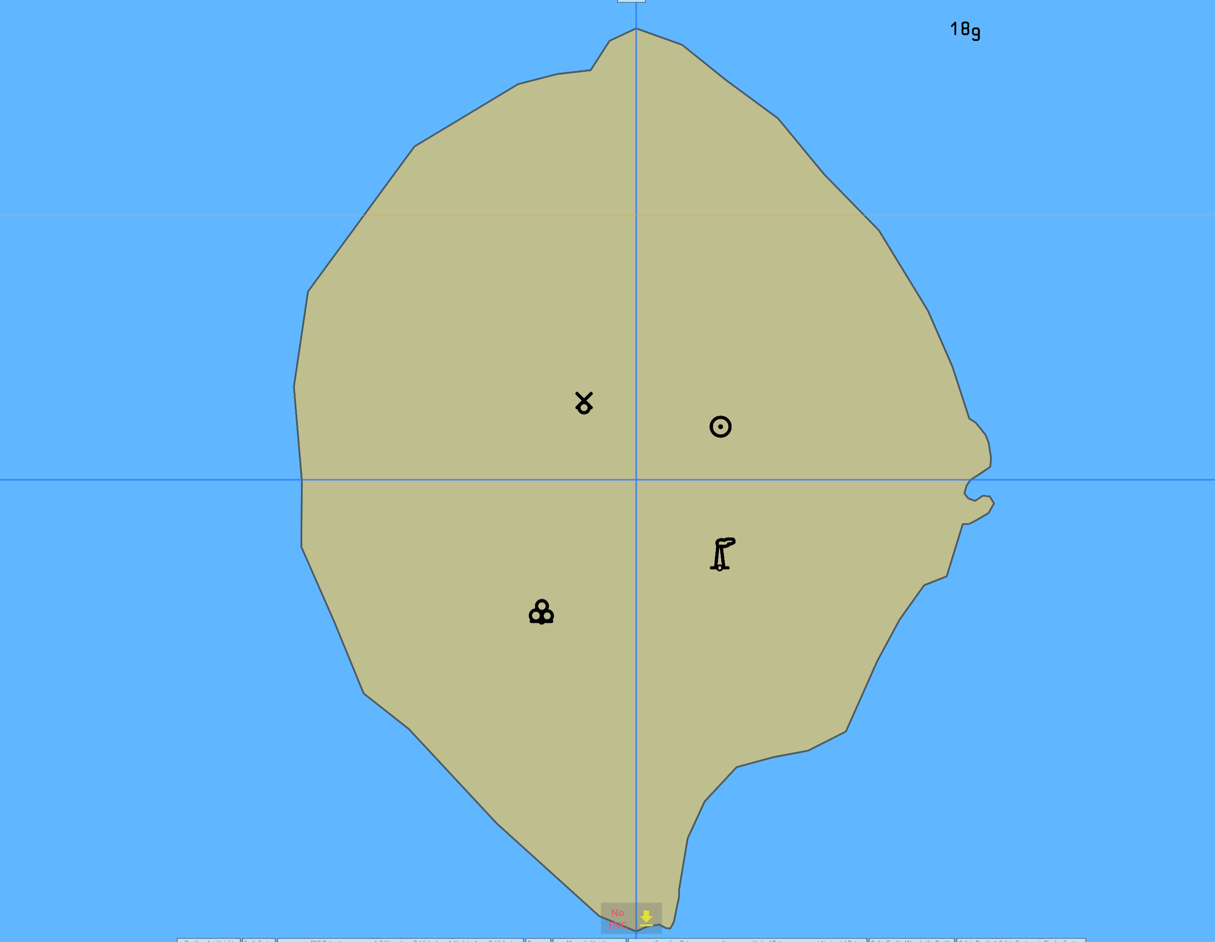
- The EUT shall show context parameter (defined in Portrayal Catalogue 2.7.0) – “Alternative Landmarks”.

Dataset Loading

Preparation and Initial Power Up
Test Reference |  |  | InitialPowerUp |  |  | IHO Reference  IEC Reference |  |  | S-98: 6.1.1  61174: 4.4.1
Test Description
This test ensures the EUT supports the import of initial datasets and indication of own ship stationary position.
Display Mode |  |  |  |  | Independent Mariner’s Selections
Other |  |  |  |  | Accuracy |  |  |  |  | On
Context Parameters |  |  |  |  | Contour label |  |  |  |  | Off
Safety contour |  | 10 |  |  | Highlight date dependent |  |  |  |  | On
Safety depth |  | 8 |  |  | Highlight document |  |  |  |  | Off
Deep Contour |  | 30 |  |  | Highlight info |  |  |  |  | On
Shallow contour |  | 2 |  |  | Shallow pattern |  |  |  |  | Off
Four shades |  | Off |  |  | Unknown objects |  |  |  |  | Off
Radar overlay |  | Off |  |  | Update review |  |  |  |  | Off
Plain boundaries |  | Off |  |  | Text Groups
Simplified symbols |  | Off |  |  | Chart text |  |  |  |  | On
Full light lines |  | Off |  |  | Important text |  |  |  |  | On
Ignore scale minimum |  | Off |  |  | Other Text |  |  |  |  | On
Shallow water dangers |  | Off |  |  | Names |  |  |  |  | On
Palette |  |  |  |  | Light description |  |  |  |  | On
Day |  |  |  |  | All other chart text |  |  |  |  | On
Date Dependent Objects |  |  |  |  | Display
Start Date | N/A |  |  |  | Centre |  |  | 32°29.66’S 60°55.86’E
End Date | N/A |  |  |  | Scale |  |  | 1:60 000
 |  |  |  |  | Orientation
Viewing Groups
Standard Display |  |  |  |  |  |  | Other
Drying lines |  |  |  | On |  |  | Spot soundings |  |  | On
Buoys. Beacons, aids to navigation |  |  |  | On |  |  | Submarine cables and pipelines |  |  | On
Buoys, beacons, structures |  |  |  | On |  |  | All isolated dangers |  |  | On
Lights |  |  |  | On |  |  | Magnetic variation |  |  | On
Boundaries and limits |  |  |  | On |  |  | Depth contours |  |  | On
Prohibited and restricted areas |  |  |  | On |  |  | Seabed |  |  | On
Chart scale boundaries |  |  |  | On |  |  | Tidal |  |  | On
Cautionary notes |  |  |  | On |  |  | Miscellaneous (Other) |  |  | On
Ships’ routeing systems and ferry routes |  |  |  | On
Archipelagic sea lanes |  |  |  | On
Miscellaneous (Standard) |  |  |  | On
Chart (Standard) |  |  |  | On
Alert Highlights (Standard) |  |  |  | On
Setup
As per InitialCatalogues.
Action
- Import the exchange set InitialPowerUp.
- - Set ship position at 32°29.66’S, 060°55.86’E with heading=234.00;
- Set the viewing scale and centre the display as indicated.
Results
- The exchange sets shall install without any warning messages.
- At the defined position the following image shall be observed:
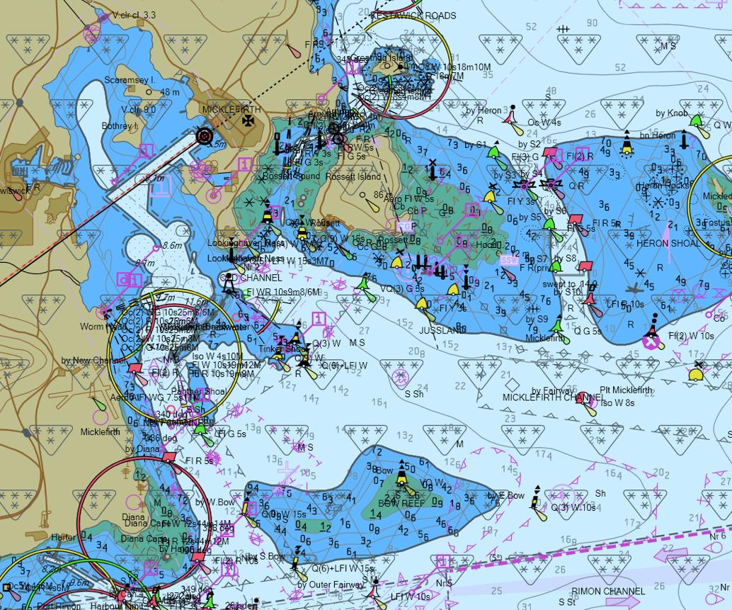
With chart 10100AA_X0000 displayed, the own ship shall be placed at the jetty in Micklefirth.

Note: Within this test dataset there are two omni directional lights co-located at 32º34.688’S, 060º54.955’E, this case is not a real-world example, as such the ECDIS may show a red-light sector.

Action
- Set the viewing scale to 1:20 000.
- Centre the display on own ship.
Results
At the defined position the following image shall be observed: 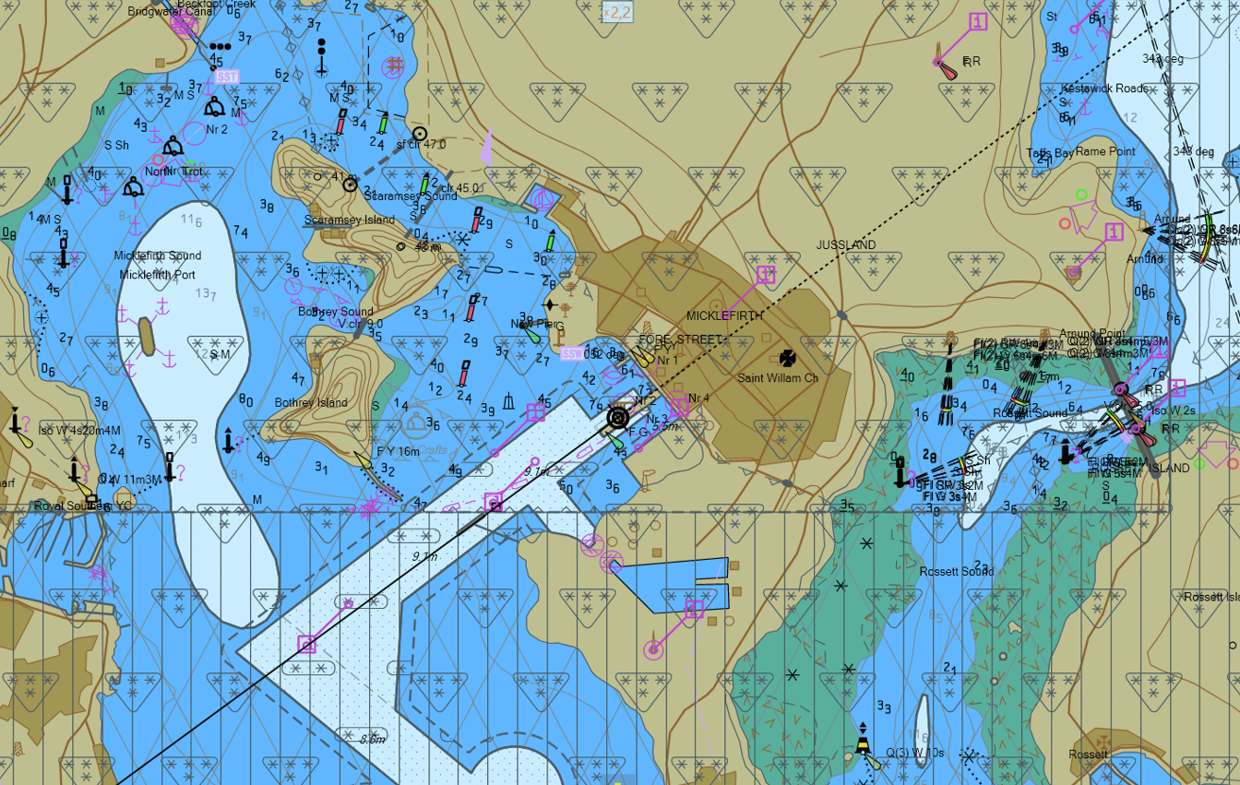
The prison bars shall be displayed out of 10100AA_X01NW.000 coverage.

Number and date in System Database
Test Reference | PowerUp | IHO Reference  IEC Reference | S-98: 6.1.1  61174: 4.4.1
Test description
This test ensures EUT supports the import of initial datasets and confirmation of information in System Database.
Setup
As per InitialPowerUp.
Action
- Import the exchange set PowerUp.
- Check information about the datasets in the System Database.
Results
- The exchange sets shall install without any warning messages.
- The information in the System Database shall be identical to the below table:
ENC | Edition  (EDTN) | Update number  (UPDN) | Update Application  Date (UADT) | Issue Date  (ISDT)
10100AA_X0000.000 | 7 | 0 | N/A | 22 Apr 2018
10100AA_X01NE.000 | 5 | 0 | N/A | 22 Apr 2018
10100AA_X01NW.000 | 3 | 0 | N/A | 22 Apr 2018
101AA00_X01SE.000 | 3 | 0 | N/A | 22 Apr 2018
101AA00_X01SW.000 | 3 | 0 | N/A | 22 Apr 2018
101AA00_X02SE.000 | 4 | 0 | N/A | 22 Apr 2018

Load additional dataset and check System Database
Test Reference | AdditionalCell | IHO Reference  IEC Reference | 61174: 4.4.1
Test description
This test ensures EUT supports import of additional cell and confirmation of its addition to the System Database.
Setup
As for test PowerUp.
Action
- Import the exchange set Settings.
- Check that in the System Database the details of the dataset have been added.
Results
- The exchange sets shall install without any warning messages.
- The information in the System Database shall reflect the cell loaded and the coverage shall have changed accordingly;
ENC | Edition  (EDTN) | Update number  (UPDN) | Update Application  Date (UADT) | Issue Date  (ISDT)
10100AA_X0001.000 | 4 | 0 | N/A | 22 Apr 2022

Remove dataset and check the System Database
Test Reference | RemoveCell | IHO Reference  IEC Reference | S-98: 6.1.1  61174: 4.4.1
Test description
This test ensures EUT supports removing a cell and confirmation of its removal from the System Database.
Setup
As on completion of test AdditionalCell.
Action
Remove the following cell: 10100AA_X0001.000 and check that in the System Database the details of the cell have been removed.
Results
The information in the System Database shall reflect the cell removed and the chart coverage shall have changed accordingly.

Automatic updates of Unencrypted ENCs

Loading sequential updates
Test Reference |  | SequentialUpdates |  |  |  | IHO Reference  IEC Reference |  | S-98: 20.4.3  61174: 4.4.2
Test Description
This test will ensure the EUT supports the import of sequential updates and their review.
Loaded Data
Exchange Set Name
PowerUp
SequentialUpdate1 to 5 (contains datasets for Updates 1 to 5)
Display Mode |  |  |  |  | Independent Mariner’s Selections
Displaybase |  |  |  |  | Accuracy |  |  |  | On
Context Parameters |  |  |  |  | Contour label |  |  |  | Off
Safety contour |  |  | 8 |  | Highlight date dependent |  |  |  | On
Safety depth |  |  | 8 |  | Highlight document |  |  |  | On
Deep Contour |  |  | N/A |  | Highlight info |  |  |  | On
Shallow contour |  |  | N/A |  | Shallow pattern |  |  |  | Off
Four shades |  |  | Off |  | Unknown objects |  |  |  | Off
Radar overlay |  |  | Off |  | Update review |  |  |  | Off
Plain boundaries |  |  | Off |  | Text Groups
Simplified symbols |  |  | Off |  | Chart text |  |  |  | On
Full light lines |  |  | Off |  | Important text |  |  |  | On
Ignore scale minimum |  |  | Off |  | Other Text |  |  |  | On
Shallow water dangers |  |  | Off |  | Names |  |  |  | On
Palette |  |  |  |  | Light description |  |  |  | On
Day |  |  |  |  | All other chart text |  |  |  | On
Date Dependent Objects |  |  |  |  | Display
Start Date | N/A |  |  |  | Centre |  | 32°31.80’S, 60°57.50’E
End Date | N/A |  |  |  | Scale |  | 1:20 000
 |  |  |  |  | Orientation
Viewing Groups
Standard Display |  |  |  |  |  | Other
Drying lines |  |  |  | On |  | Spot soundings |  |  | On
Buoys. Beacons, aids to navigation |  |  |  |  |  | Submarine cables and pipelines |  |  | On
Buoys, beacons, structures |  |  |  | On |  | All isolated dangers |  |  | On
Lights |  |  |  | On |  | Magnetic variation |  |  | On
Boundaries and limits |  |  |  | On |  | Depth contours |  |  | On
Prohibited and restricted areas |  |  |  | On |  | Seabed |  |  | On
Chart scale boundaries |  |  |  | On |  | Tidal |  |  | On
Cautionary notes |  |  |  | On |  | Miscellaneous (Other) |  |  | On
Ships’ routeing systems and ferry routes |  |  |  | On
Archipelagic sea lanes |  |  |  | On
Miscellaneous (Standard)
Chart (Standard) |  |  |  | On
Alert Highlights (Standard) |  |  |  | Off
Setup
As per PowerUp (exchange set PowerUp loaded).
Action
- Import exchange sets SequentialUpdate1 to 5.
- Apply the following 5 updates one by one and check the plots after each successfully applied update to create the same results as the S-164 plots.
- Apply Update .001
Update review date range: 1st May 2011 – 21st May 2011
- Apply Update .002
Update review date range: 1st Dec 2014 – 1st Mar 2015
- Apply Update .003
Update review date range: 1st Sep 2015 – 14th Sep 2015
- Apply Update .004
Update review date range: 15th Sep 2015 – 30th Sep 2015
- Apply Update .005
Update review date range: 1st Oct 2015 – 14th Oct 2015
- Review of updates shall be performed after the update process is completed and the updates have been applied. Review the updates by selecting the given date range and confirm that display is as available in the corresponding screen plot.
Results
- The exchange sets shall install without any warning messages.
- The update process shall install all updates (up to update no. 005) and indicate it in an appropriate summary report which shall contain the following information:
- identification of issuing authority;
- update numbers of the update files;
- identifiers of datasets affected;
- edition number and reference date of involved datasets;
- number of updates in the affected datasets.
Note: Manufacturers can use their own algorithms for calculating the position of centred symbols.
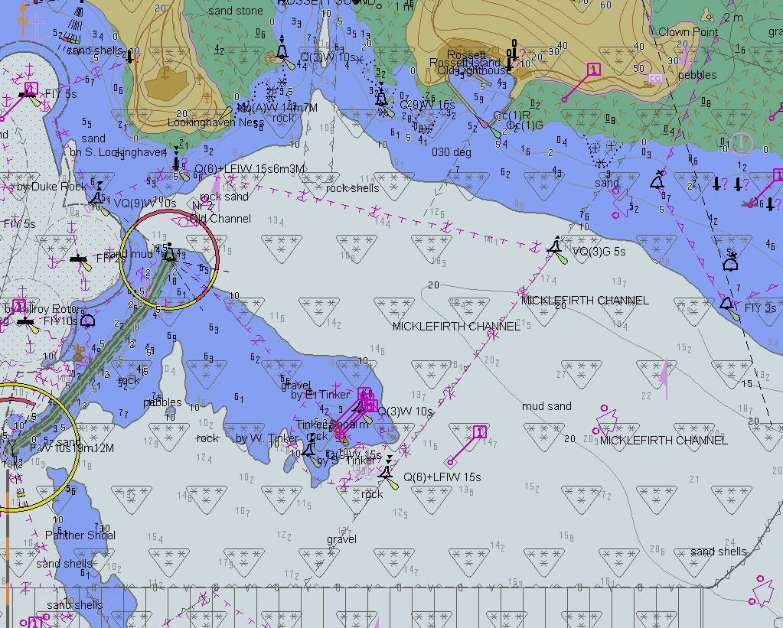
TBD
Before loading of updates, displayed scale 1:20 000
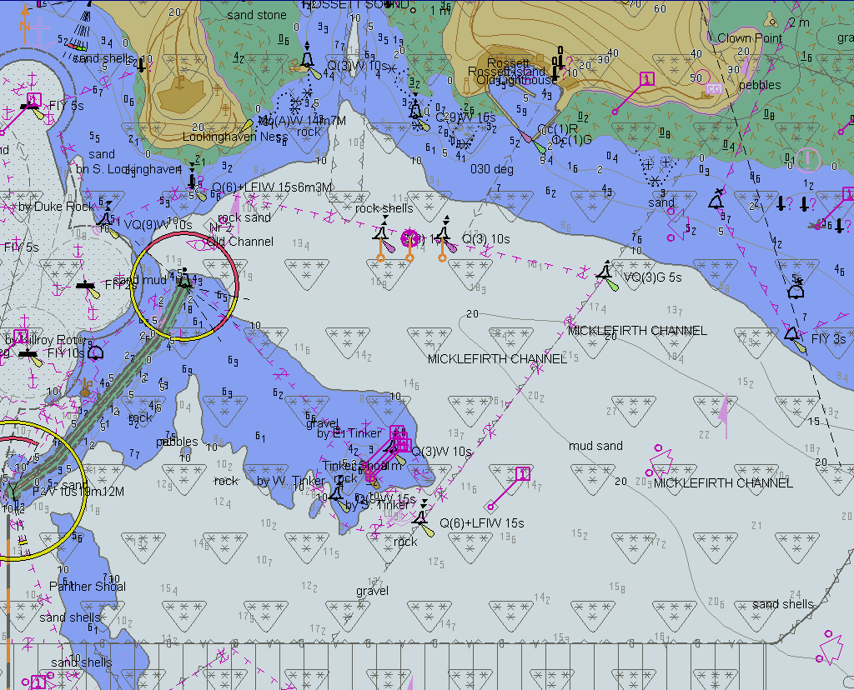
TBD
After loading of 101AA00X01SW.001, displayed scale 1:20 000, date range include 9th May 2011
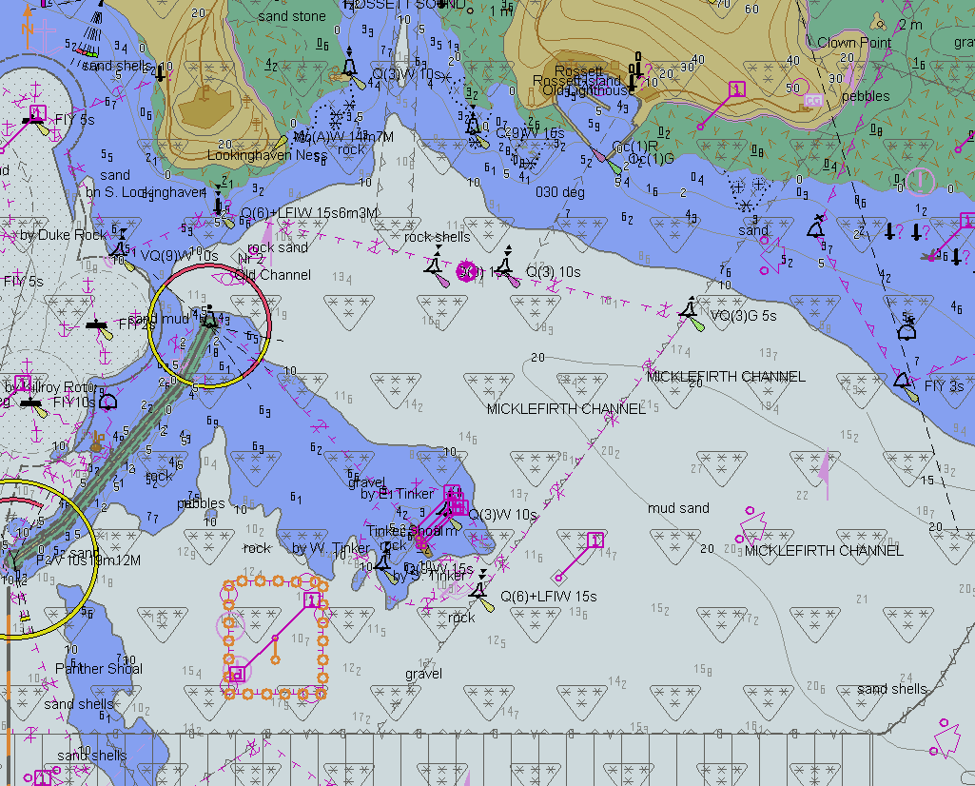
TBD
After loading of 101AA00X01SW.002, displayed scale 1:20 000, date range 1st Jan 2015-21st Feb 2015
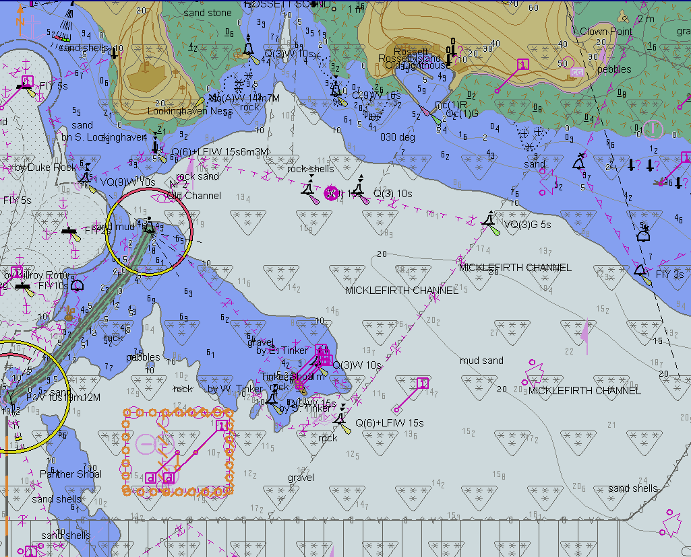
TBD
After loading of 101AA00X01SW.003, displayed scale 1:20 000, date range include 8th Sep 2015
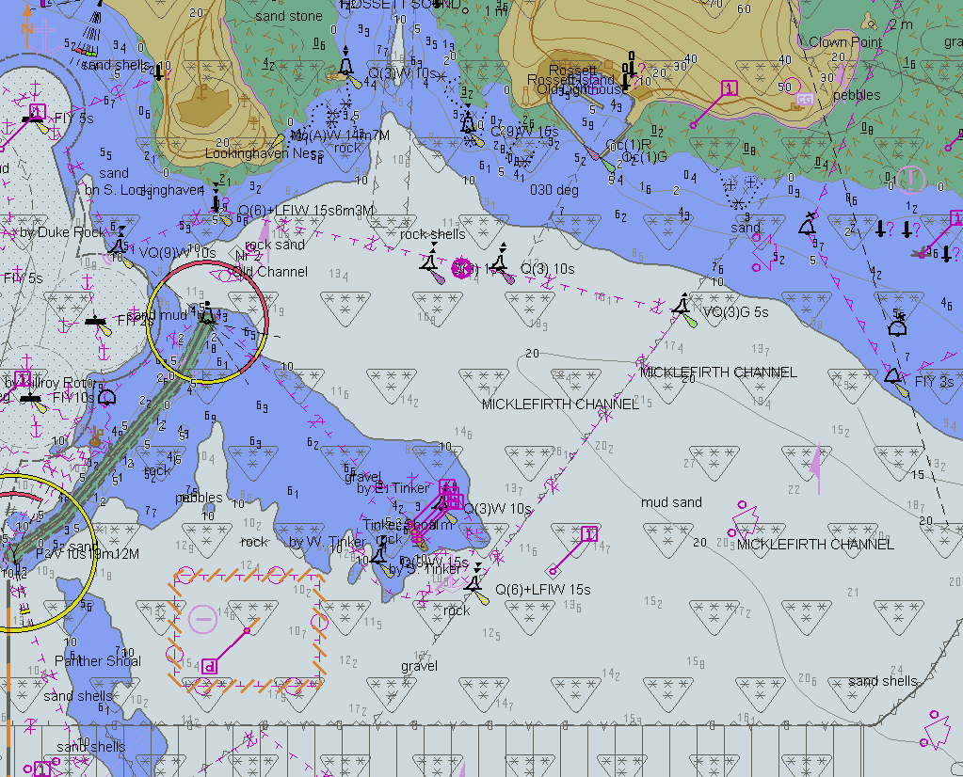
TBD
After loading of 101AA00X01SW.004, displayed scale 1:20 000, date range include 22nd Sep 2015
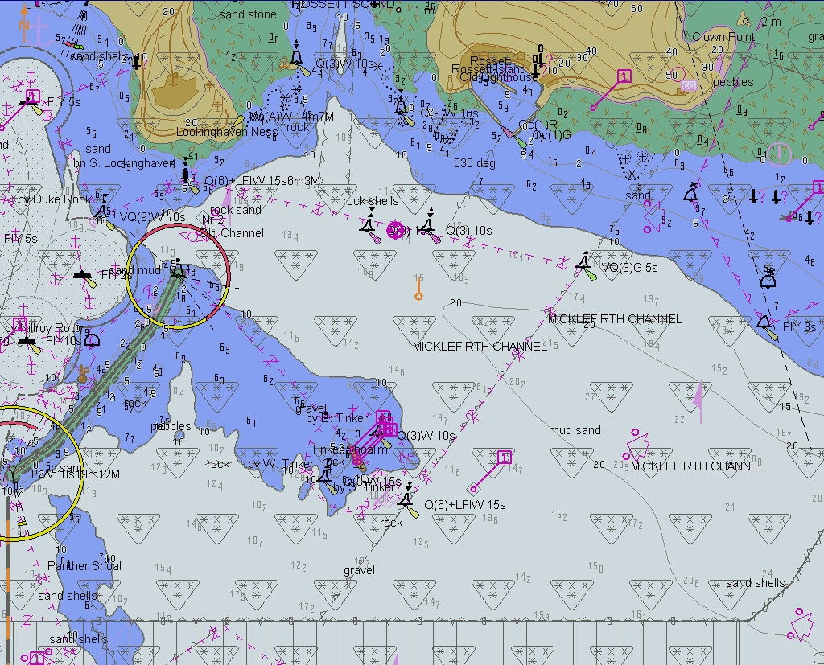
TBD
After loading of 101AA00X01SW.005, displayed scale 1:20 000, date range include 6th Oct 2015

Loading update in an invalid sequence
Test Reference | InvalidSequence | IHO Reference  IEC Reference | S-98: 20.4.3  61174: 4.4.2
Test description
This test will ensure the EUT will reject the import of an update file which is not in the expected sequence.
Setup
As per PowerUp. (PowerUp exchange set loaded, but all previously loaded Update datasets must be removed from the System Database.
Action
Import the following five update exchange sets:
InvalidSequence00x with x=1,2,3
Results
The update process shall install the updates up to update no. 2 and reject the installation of updates no. 4 with a permanent indication, “Non sequential update, previous update(s) missing try reloading from the base media. If the problem persists contact your data supplier (message SSE123)”

Loading update of newer edition
Test Reference |  | NewerEditionUpdate |  |  |  | IHO Reference  IEC Reference |  | 61174: 6.8.16.1
Test Description
This test will ensure the EUT supports the import, display and update review process of an update file of a newer edition than base dataset installed
Loaded Data
Exchange Set Name
NewUpdate
GoodBaseCell
Display Mode |  |  |  |  | Independent Mariner’s Selections
Other |  |  |  |  | Accuracy |  |  |  | On
Context Parameters |  |  |  |  | Contour label |  |  |  | Off
Safety contour |  |  | 8 |  | Highlight date dependent |  |  |  | On
Safety depth |  |  | 8 |  | Highlight document |  |  |  | Off
Deep Contour |  |  | N/A |  | Highlight info |  |  |  | On
Shallow contour |  |  | N/A |  | Shallow pattern |  |  |  | Off
Four shades |  |  | Off |  | Unknown objects |  |  |  | Off
Radar overlay |  |  | Off |  | Update review |  |  |  | Off
Plain boundaries |  |  | Off |  | Text Groups |  |  |  | On
Simplified symbols |  |  | Off |  | Chart text |  |  |  | On
Full light lines |  |  | Off |  | Important text |  |  |  | On
Ignore scale minimum |  |  | Off |  | Other Text |  |  |  | On
Shallow water dangers |  |  | Off |  | Names |  |  |  | On
Palette |  |  |  |  | Light description |  |  |  | On
Day |  |  |  |  | All other chart text |  |  |  | On
Date Dependent Objects |  |  |  |  | Display
Start Date | N/A |  |  |  | Centre |  | 32°31.80’S, 60°57.50’E
End Date | N/A |  |  |  | Scale |  | 1:20 000
 |  |  |  |  | Orientation
Viewing Groups (Default = On)
Standard Display |  |  |  |  |  | Other
Drying lines |  |  |  | On |  | Spot soundings |  |  | On
Buoys. Beacons, aids to navigation |  |  |  |  |  | Submarine cables and pipelines |  |  | On
Buoys, beacons, structures |  |  |  | On |  | All isolated dangers |  |  | On
Lights |  |  |  | On |  | Magnetic variation |  |  | On
Boundaries and limits |  |  |  | On |  | Depth contours |  |  | On
Prohibited and restricted areas |  |  |  | On |  | Seabed |  |  | On
Chart scale boundaries |  |  |  | On |  | Tidal |  |  | On
Cautionary notes |  |  |  | On |  | Miscellaneous (Other) |  |  | On
Ships’ routeing systems and ferry routes |  |  |  | On
Archipelagic sea lanes |  |  |  | On
Miscellaneous (Standard) |  |  |  | On
Chart (Standard)
Alert Highlights (Standard)
Setup
As per PowerUp (dataset 101AA00X01SW.000 (edition 3) loaded.
Action
1. Import the following update exchange set:
NewUpdate, contains 101AA00X01SW.001 (update 1 of edition 4)
2. Display installed chart.
3. Import exchange sets:
GoodBaseCells 101AA00X01SW.000 (edition 4)
NewUpdate 101AA00X01SW.001 (edition 4)
4. Display installed chart.
Results
- The update process shall refuse to install the update and inform the user that chart data of a newer edition are available.
- A permanent indication “Chart information not up to date” shall be available in the chart display area when such a chart is in use (either displayed on chart area or used as largest scale available for chart related alerts and indications).
- The EUT shall install Base Cell and Update without any warning or error.
- The “Chart information not up to date” message no longer displayed.
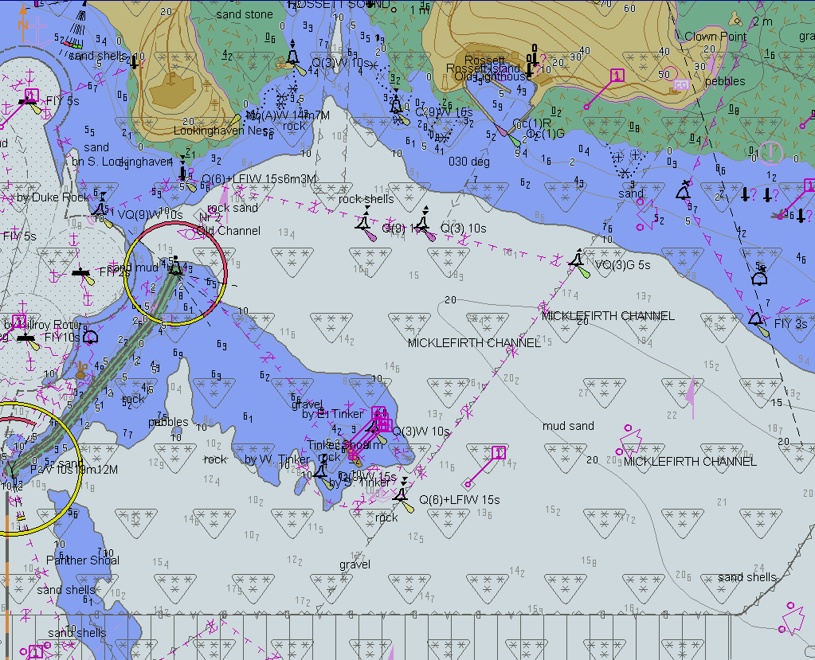
TBD
After loading of 101AA00X01SW.000 4th edition, displayed scale 1:20 000
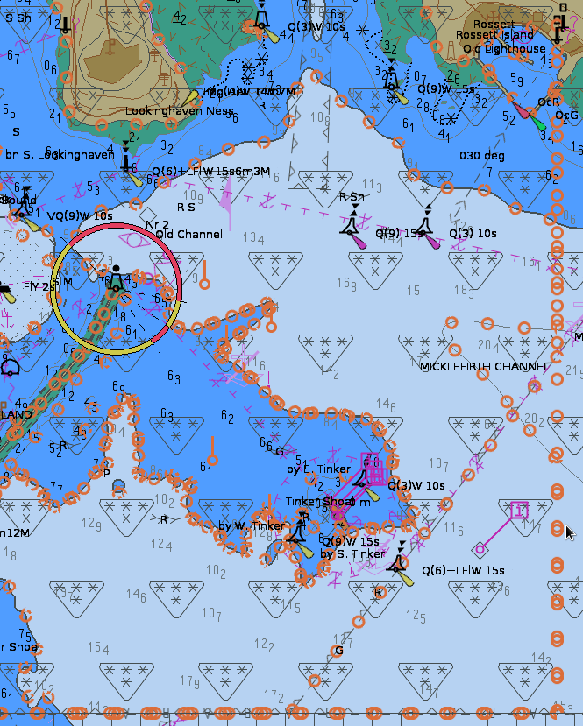
TBD
After loading of 101AA00X01SW.001 4th edition, displayed scale 1:20 000, all features and their geometries being subject to this update review are highlighted.
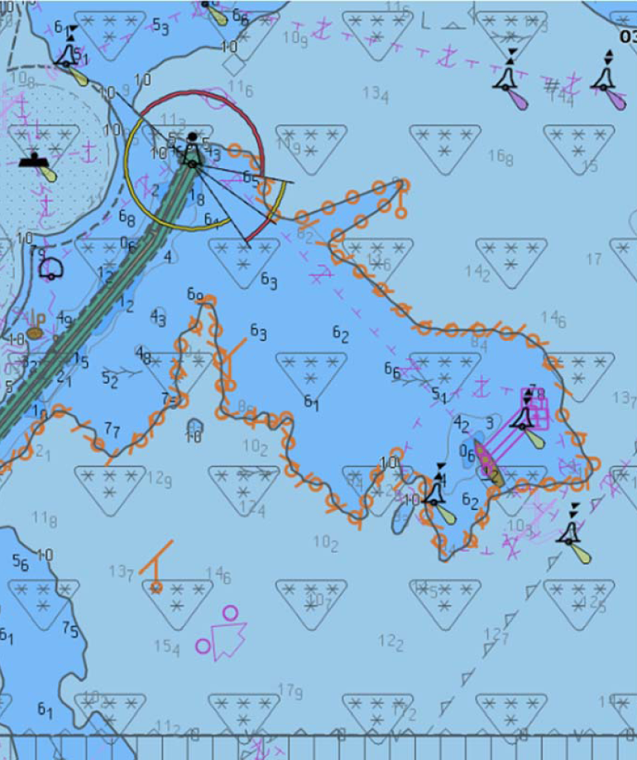
TBD
After loading of 101AA00X01SW.001 4th edition, displayed scale 1:20 000, update review highlight filtered for real changes (example 1).
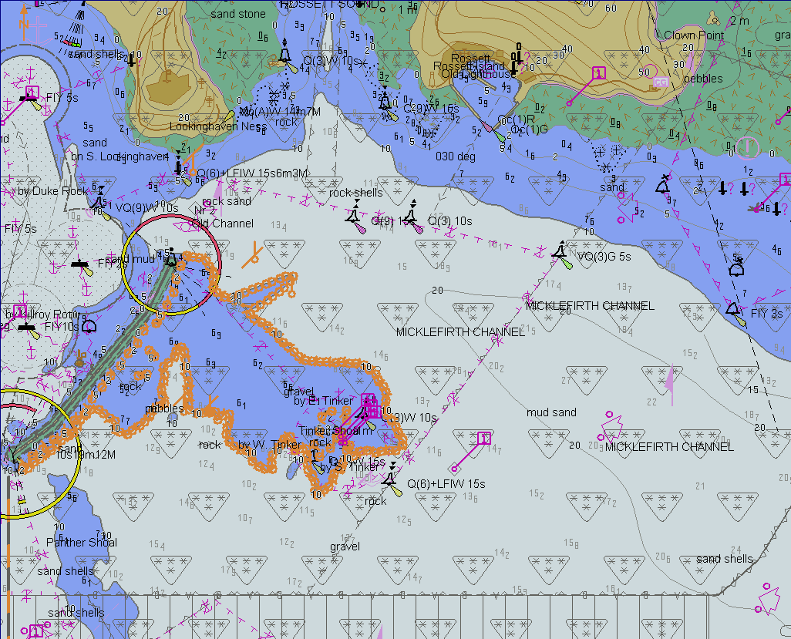
TBD
After loading of 101AA00X01SW.001 4th edition, displayed scale 1:20 000, update review highlight filtered for real changes (example 2).

Update Information
Test Reference |  | UpdateInformation |  |  |  | IHO Reference  IEC Reference |  | S-98 20.4.3  IEC 61174/ 4.4.2
Test Description
This test ensures EUT supports the import and display of S-101 metadata feature Update Information.
Loaded Data
Exchange Set Name
UpdateInformation
Display Mode |  |  |  |  | Independent Mariner’s Selections
Other |  |  |  |  | Accuracy |  |  |  | Off
Context Parameters |  |  |  |  | Contour label |  |  |  | Off
Safety contour |  |  | 10 m |  | Highlight date dependent |  |  |  | Off
Safety depth |  |  | 8 m |  | Highlight document |  |  |  | Off
Deep Contour |  |  | 30 m |  | Highlight info |  |  |  | On
Shallow contour |  |  | 2 m |  | Shallow pattern |  |  |  | Off
Four shades |  |  | Off |  | Unknown objects |  |  |  | Off
Radar overlay |  |  | Off |  | Update review |  |  |  | On
Plain boundaries |  |  | Off |  | Text Groups
Simplified symbols |  |  | On |  | Chart Text |  |  |  | On
Full light lines |  |  | Off |  | Important text |  |  |  | On
Ignore scale minimum |  |  | On |  | Other Text
Shallow water dangers |  |  | On |  | Names |  |  |  | On
Palette |  |  |  |  | Light description |  |  |  | On
Day |  |  |  |  | All other chart text |  |  |  | On
Date Dependent Objects |  |  |  |  | Display
Start Date |  |  |  |  | Centre |  | 32°31.61’S, 60°54.24’E
End Date |  |  |  |  | Scale |  | 1: 12 000
Viewing Groups (On / Off)
Standard Display |  |  |  |  |  | Other
Drying lines |  |  |  | On |  | Spot soundings |  |  | On
Buoys. Beacons, aids to navigation |  |  |  | On |  | Submarine cables and pipelines |  |  | On
Buoys, beacons, structures |  |  |  | On |  | All isolated dangers |  |  | On
Lights |  |  |  | On |  | Magnetic variation |  |  | On
Boundaries and limits |  |  |  | On |  | Depth contours |  |  | On
Prohibited and restricted areas |  |  |  | On |  | Seabed |  |  | On
Chart scale boundaries |  |  |  | On |  | Tidal |  |  | On
Cautionary notes |  |  |  | On |  | Miscellaneous (Other) |  |  | On
Ships’ routeing systems and ferry routes |  |  |  | On
Archipelagic sea lanes |  |  |  | On
Miscellaneous (Standard) |  |  |  | On
Chart (Standard) |  |  |  | On
Alert Highlights (Standard) |  |  |  | Off
Setup
As per PowerUp
Action
- Observe dataset 10100AA_X01SW.000 at indicted position and scale and verify Foul Ground feature is highlighted;
- Cursor pick highlighted Foul Ground area feature and verify information contained in the Update Information feature.
Results
- At the defined position the following image shall be observed:
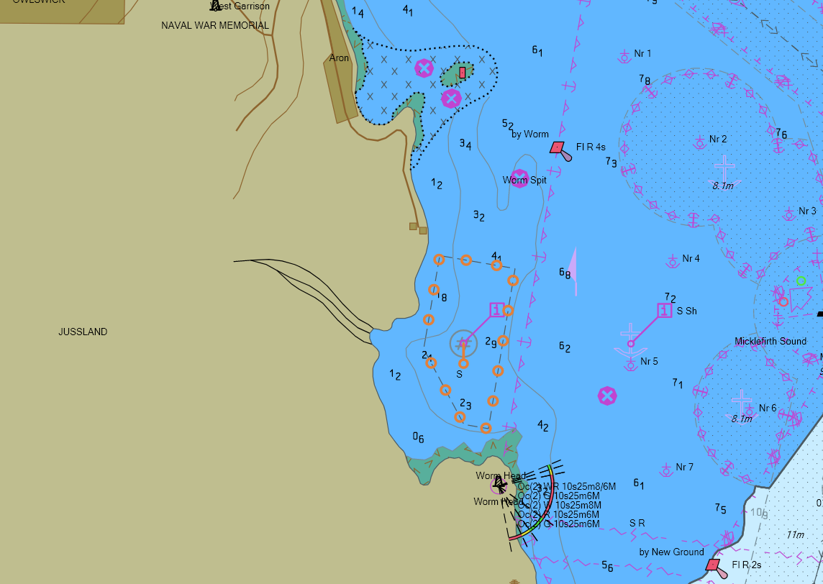
- Cursor pick shall show the following information:
- Update Type = Insert
- Update Number = 0
- Information Text = “Foul Ground is new for this edition of the ENC”

Importing update of older edition
Test Reference | OlderEditionUpdate | IHO Reference  IEC Reference | S-98: 20.4.3  61174: 4.4.2
Test description
This test ensures EUT will reject the import of an update file of an older edition than base dataset installed.
Setup
As per Updated Catalogue Data (all datasets must be removed from the System Database; only catalogue files must be present).
Action
- Import the following exchange set: GoodBaseCell (dataset 10100AA_X01SW.000 (edition 4));
- Import the following exchange set:OldUpdate(dataset 10100AA_X01SW.001 (edition 3))
Results
- The exchange set GoodbaseCell shall install without any warning message.
- The update shall not be applied successfully and the system shall provide an indication (either on screen or in an error log) the reason the update was not applied, for example “Incorrect Edition Number 1 [of update]: expecting 2”.

Importing a re-issue and an update of a dataset
Test Reference |  |  | ReIssueAndUpdate |  |  | IHO Reference  IEC Reference |  |  | S-98: 20.5  61174: 4.4.2
Test Description
This test ensures EUT supports import and display of a re-issue of an unencrypted ENC dataset and a subsequent update.
Loaded Data
Exchange Set Name
Reissue
ReissueUpdate
Display Mode |  |  |  |  | Independent Mariner’s Selections
Other |  |  |  |  | Accuracy |  |  |  |  | On
Context Parameters |  |  |  |  | Contour label |  |  |  |  | Off
Safety contour |  | 10 |  |  | Highlight date dependent |  |  |  |  | On
Safety depth |  | 8 |  |  | Highlight document |  |  |  |  | Off
Deep Contour |  | 30 |  |  | Highlight info |  |  |  |  | On
Shallow contour |  | 2 |  |  | Shallow pattern |  |  |  |  | Off
Four shades |  | Off |  |  | Unknown objects |  |  |  |  | Off
Radar overlay |  | Off |  |  | Update review |  |  |  |  | Off
Plain boundaries |  | Off |  |  | Text Groups
Simplified symbols |  | Off |  |  | Chart text |  |  |  |  | On
Full light lines |  | Off |  |  | Important text |  |  |  |  | On
Ignore scale minimum |  | Off |  |  | Other Text
Shallow water dangers |  | Off |  |  | Names |  |  |  |  | On
Palette |  |  |  |  | Light description |  |  |  |  | On
Day |  |  |  |  | All other chart text |  |  |  |  | On
Date Dependent Objects |  |  |  |  | Display
Start Date | N/A |  |  |  | Centre |  |  | 32°31.80’S, 60°57.50’E
End Date | N/A |  |  |  | Scale |  |  | 1:20 000
 |  |  |  |  | Orientation
Viewing Groups
Standard Display |  |  |  |  |  |  | Other
Drying lines |  |  |  | On |  |  | Spot soundings |  |  | On
Buoys. Beacons, aids to navigation |  |  |  | On |  |  | Submarine cables and pipelines |  |  | On
Buoys, beacons, structures |  |  |  | On |  |  | All isolated dangers |  |  | On
Lights |  |  |  | On |  |  | Magnetic variation |  |  | On
Boundaries and limits |  |  |  | On |  |  | Depth contours |  |  | On
Prohibited and restricted areas |  |  |  | On |  |  | Seabed |  |  | On
Chart scale boundaries |  |  |  | On |  |  | Tidal |  |  | On
Cautionary notes |  |  |  | On |  |  | Miscellaneous (Other) |  |  | On
Ships’ routeing systems and ferry routes |  |  |  | On
Archipelagic sea lanes |  |  |  | On
Miscellaneous (Standard) |  |  |  | On
Chart (Standard) |  |  |  | On
Alert Highlights (Standard) |  |  |  | On
Setup
As per UpdateCatalogues
Action
Display dataset 10100AA_X01SW.000 (Edition 3);
- Import exchange set Reissue;
- Display dataset 10100AA_X01SW.000 (Reissue of Edition 3, update 5);
- Import exchange set ReissueUpdate;
- Display dataset 10100AA_X01SW.000 with update 6 applied).
Results
- After loading of 101AA00X01SW.000 3rd edition, displayed scale 1:20 000
Screenshot TBD
- The exchange set Reissue shall install without any warning messages.
Screenshot TBD
- After loading of 101AA00X01SW.000 (Reissue of Edition 3, update 5) displayed scale 1:20 000.
- The exchange set ReissueUpdate shall install without any warning messages.
- After loading of 101AA00X01SW.000 (Reissue of Edition 3, update 6) displayed scale 1:20 000.
Screenshot TBD

Rejection of automatic update
Test Reference |  | UpdateRejection |  |  |  | IHO Reference  IEC Reference |  | S-98: 20.4.3  61174: 4.4.2
Test Description
This test ensures EUT supports the manual rejection of an automatic update.
Loaded Data
Exchange Set Name
PreReissue
SequentialUpdate1
Display Mode |  |  |  |  | Independent Mariner’s Selections
Other |  |  |  |  | Accuracy
Context Parameters |  |  |  |  | Contour label
Safety contour |  |  |  |  | Highlight date dependent
Safety depth |  |  |  |  | Highlight document
Deep Contour |  |  |  |  | Highlight info
Shallow contour |  |  |  |  | Shallow pattern
Four shades |  |  |  |  | Unknown objects
Radar overlay |  |  |  |  | Update review
Plain boundaries |  |  |  |  | Text Groups
Simplified symbols |  |  |  |  | Chart text
Full light lines |  |  |  |  | Important text
Ignore scale minimum |  |  |  |  | Other Text
Shallow water dangers |  |  |  |  | Names
Palette |  |  |  |  | Light description
Day |  |  |  |  | All other chart text
Date Dependent Objects |  |  |  |  | Display
Start Date |  |  |  |  | Centre
End Date |  |  |  |  | Scale |  | 1:60 000
 |  |  |  |  | Orientation
Viewing Groups
Standard Display |  |  |  |  |  | Other
Drying lines |  |  |  |  |  | Spot soundings
Buoys. Beacons, aids to navigation |  |  |  |  |  | Submarine cables and pipelines
Buoys, beacons, structures |  |  |  |  |  | All isolated dangers
Lights |  |  |  |  |  | Magnetic variation
Boundaries and limits |  |  |  |  |  | Depth contours
Prohibited and restricted areas |  |  |  |  |  | Seabed
Chart scale boundaries |  |  |  |  |  | Tidal
Cautionary notes |  |  |  |  |  | Miscellaneous (Other)
Ships’ routeing systems and ferry routes
Archipelagic sea lanes
Miscellaneous (Standard)
Chart (Standard)
Alert Highlights (Standard)
Setup
As per Update Catalogues
Action
- Import Exchange Set PreReissue and display the dataset at indicated centered position and scale;
- Import Exchange Set SequentialUpdate1;
- Manually annotate the features of the update as rejected using the deletion available in the manual update method.
Results
The features from the update shall remain in display as annotated by the deletion mark of the manual update method.
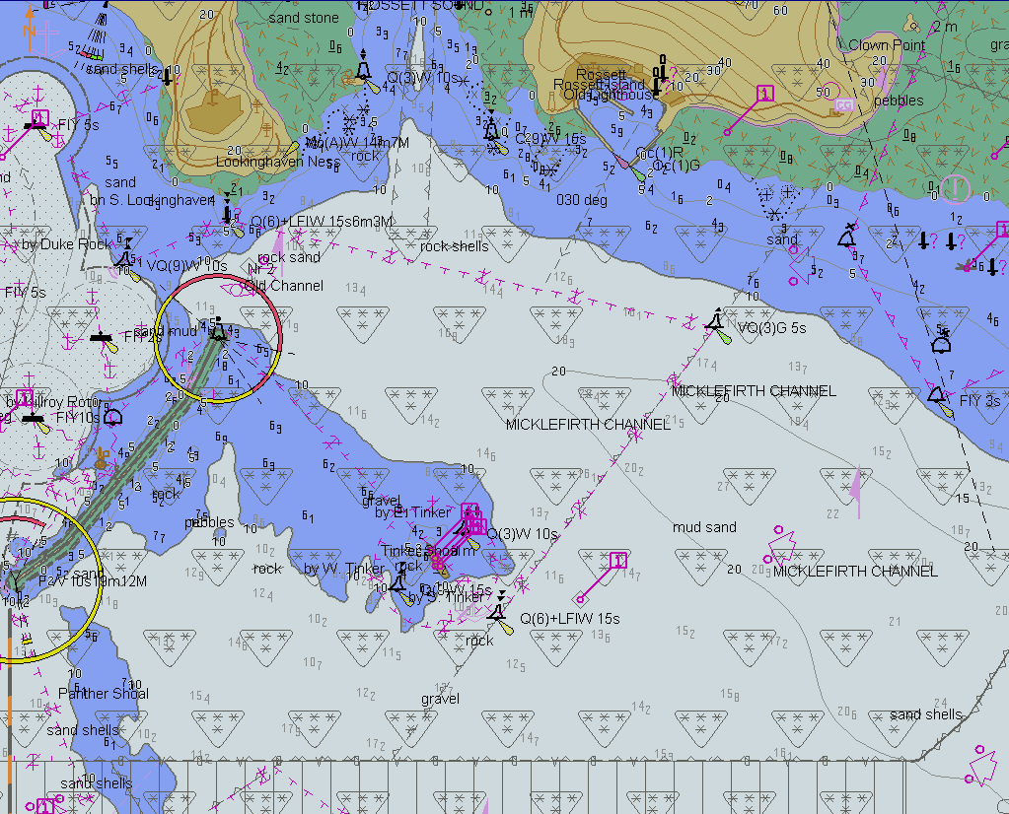
TBD
Before loading of update, displayed scale 1:20 000

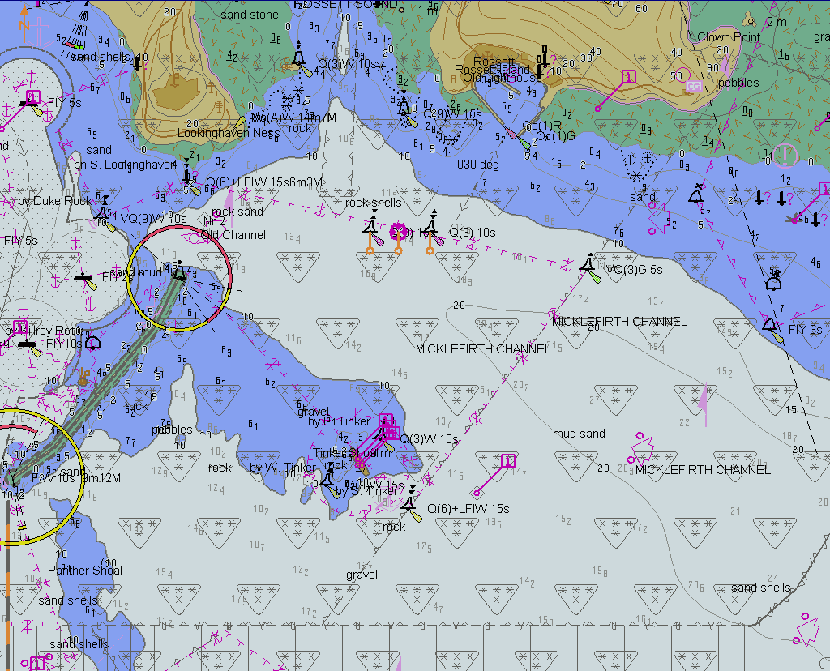
TBD
After loading of 101AA00X01SW.001, displayed scale 1:20 000
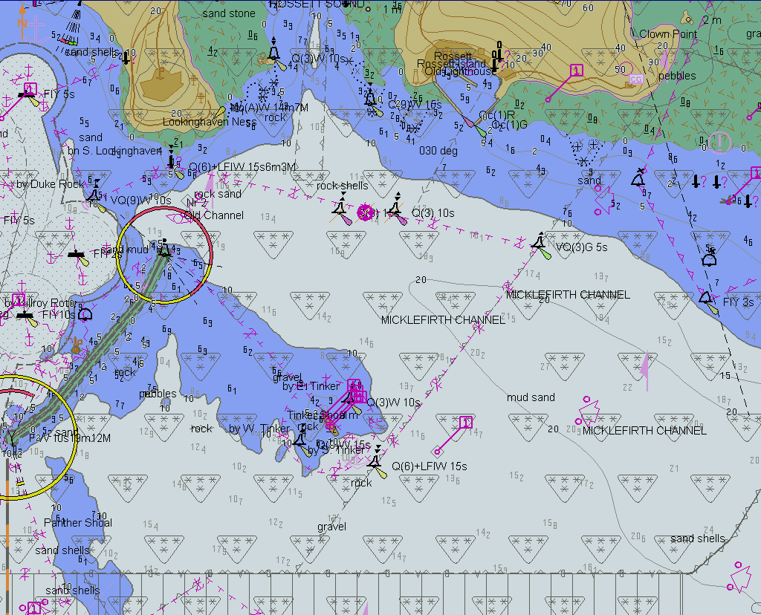
TBD
After update 1 has been manually annotated as rejected by the Mariner, displayed scale 1:20 000

Manual Updates

Creation of a Manual Update
Test Reference |  | ManualUpdateCreation |  |  |  | IHO Reference  IEC Reference |  |  | S-98: 20.4.4  IEC: 61174/ 6.8.17
Test Description
Manual updates.
Loaded Data
Exchange Set Name
Display Mode |  |  |  |  | Independent Mariner’s Selections
Other |  |  |  |  | Accuracy
Context Parameters |  |  |  |  | Contour label
Safety contour |  |  |  |  | Highlight date dependent
Safety depth |  |  |  |  | Highlight document
Deep Contour |  |  |  |  | Highlight info
Shallow contour |  |  |  |  | Shallow pattern
Four shades |  |  |  |  | Unknown objects
Radar overlay |  |  |  |  | Update review
Plain boundaries |  |  |  |  | Text Groups
Simplified symbols |  |  |  |  | Chart Text
Full light lines |  |  |  |  | Important text
Ignore scale minimum |  |  |  |  | Other Text
Shallow water dangers |  |  |  |  | Names
Palette |  |  |  |  | Light description
Day |  |  |  |  | All other chart text
Date Dependent Objects |  |  |  |  | Display
Start Date | N/A |  |  |  | Centre
End Date | N/A |  |  |  | Scale |  | 1:60 000
 |  |  |  |  | Orientation
Viewing Groups
Standard Display |  |  |  |  |  | Other
Drying lines |  |  |  |  |  | Spot soundings
Buoys. Beacons, aids to navigation |  |  |  |  |  | Submarine cables and pipelines
Buoys, beacons, structures |  |  |  |  |  | All isolated dangers
Lights |  |  |  |  |  | Magnetic variation
Boundaries and limits |  |  |  |  |  | Depth contours
Prohibited and restricted areas |  |  |  |  |  | Seabed
Chart scale boundaries |  |  |  |  |  | Tidal
Cautionary notes |  |  |  |  |  | Miscellaneous (Other)
Ships’ routeing systems and ferry routes
Archipelagic sea lanes
Miscellaneous (Standard)
Chart (Standard)
Alert Highlights (Standard)
Setup
Load the exchange set PowerUp
- Select Display Category Standard
- Set the Safety contour value to 8 m
- Set the Safety depth value to 8 m
- Select Symbolized Boundaries
- Select Simplified symbols = false
- Select Highlight date dependent
- Select Spot soundings
Action
These descriptions potentially need editing as they are the original updates. They will need to be updated to the feature model included in S-98.
1. Using the editing tools available with the EUT, make the following changes and include a short textual description of the action to a-g:
a. Insert a dangerous wreck near: 32 31.5S, 60 57.3E;
b. Insert East Cardinal buoys including topmarks near: 32 31.5S, 60 57.46E;
c. Insert West Cardinal buoy including topmark near: 32 31.5S, 60 57.16E;
d. Insert a prohibited entry area between Panther and Tinker Shoals timed to come into force at 20220220;
e. Insert a cautionary area in the same location being in force from date of issue to 20220220;
f. Insert 15 metre sounding at 32 31.7S, 60 57.4E;
g. Delete fog signal of cardinal buoy at 32 31.444S, 60 55.842E.
2. Set viewing date before 20220220. Display chart cell with manual updates.
3. Set viewing date after 20220220. Display chart cell with manual updates.
4. Using the editing tools available with the EUT, make the following changes and include a short textual description of the action to h-j:
h. Extend western limits of the prohibited entry area;
i. Delete cautionary area;
j. Move cardinal buoy at 32 31.444S, 60 55.842E, including top mark and light, to 32 31.500S, 60 55.700E.
5. Set viewing date before 20220220. Display chart cell with manual updates.
6. Set viewing date after 20220220. Display chart cell with manual updates.
7. Review manual updates.
8. Retrieve textual description from record.
9. Remove all manual updates from display and review them (system time and date may need to be adjusted for verification).
Results
[The table from previous editions has been deleted (it will be referred to when creating the screenshots for the operational S-164 TDS Manual. The portrayal of manual updates has changed completely and so these screenshots will need to be completely revised]

Manual Update - Dates
Test Reference |  | ManualUpdatesDates |  |  |  | IHO Reference  IEC Reference |  |  | S-98 20.4.4  61174: 6.8.17
Test Description
Test Manual Updates work with the date settings on the ECDIS.
- Identified by S-98 stakeholders.
- Behaviour should be as specified in S-98 and allow users to create appropriate manual updates which behave correctly as the target date on the ECDIS is configured.
- There are tests in the previous test but they should be re-located here and made exhaustive.
Loaded Data
Exchange Set Name
Display Mode |  |  |  |  | Independent Mariner’s Selections
Other |  |  |  |  | Accuracy
Context Parameters |  |  |  |  | Contour label
Safety contour |  |  |  |  | Highlight date dependent
Safety depth |  |  |  |  | Highlight document
Deep Contour |  |  |  |  | Highlight info
Shallow contour |  |  |  |  | Shallow pattern
Four shades |  |  |  |  | Unknown objects
Radar overlay |  |  |  |  | Update review
Plain boundaries |  |  |  |  | Text Groups
Simplified symbols |  |  |  |  | Chart Text
Full light lines |  |  |  |  | Important text
Ignore scale minimum |  |  |  |  | Other Text
Shallow water dangers |  |  |  |  | Names
Palette |  |  |  |  | Light description
Day |  |  |  |  | All other chart text
Date Dependent Objects |  |  |  |  | Display
Start Date |  |  |  |  | Centre
End Date |  |  |  |  | Scale |  | 1:60 000
 |  |  |  |  | Orientation
Viewing Groups
Standard Display |  |  |  |  |  | Other
Drying lines |  |  |  |  |  | Spot soundings
Buoys. Beacons, aids to navigation |  |  |  |  |  | Submarine cables and pipelines
Buoys, beacons, structures |  |  |  |  |  | All isolated dangers
Lights |  |  |  |  |  | Magnetic variation
Boundaries and limits |  |  |  |  |  | Depth contours
Prohibited and restricted areas |  |  |  |  |  | Seabed
Chart scale boundaries |  |  |  |  |  | Tidal
Cautionary notes |  |  |  |  |  | Miscellaneous (Other)
Ships’ routeing systems and ferry routes
Archipelagic sea lanes
Miscellaneous (Standard)
Chart (Standard)
Alert Highlights (Standard)
Setup
Action
Results

Manual Update - retrieval
Test Reference |  | ManualUpdatesRetrieval |  |  |  | IHO Reference  IEC reference |  |  | S-98: 20.4.4  61174: 6.8.17
Test Description
Test retrieval of manual updates.
Loaded Data
Exchange Set Name
Display Mode |  |  |  |  | Independent Mariner’s Selections
Other |  |  |  |  | Accuracy
Context Parameters |  |  |  |  | Contour label
Safety contour |  |  |  |  | Highlight date dependent
Safety depth |  |  |  |  | Highlight document
Deep Contour |  |  |  |  | Highlight info
Shallow contour |  |  |  |  | Shallow pattern
Four shades |  |  |  |  | Unknown objects
Radar overlay |  |  |  |  | Update review
Plain boundaries |  |  |  |  | Text Groups
Simplified symbols |  |  |  |  | Chart Text
Full light lines |  |  |  |  | Important text
Ignore scale minimum |  |  |  |  | Other Text
Shallow water dangers |  |  |  |  | Names
Palette |  |  |  |  | Light description
Day |  |  |  |  | All other chart text
Date Dependent Objects |  |  |  |  | Display
Start Date | N/A |  |  |  | Centre
End Date | N/A |  |  |  | Scale |  | 1:60 000
 |  |  |  |  | Orientation
Viewing Groups
Standard Display |  |  |  |  |  | Other
Drying lines |  |  |  |  |  | Spot soundings
Buoys. Beacons, aids to navigation |  |  |  |  |  | Submarine cables and pipelines
Buoys, beacons, structures |  |  |  |  |  | All isolated dangers
Lights |  |  |  |  |  | Magnetic variation
Boundaries and limits |  |  |  |  |  | Depth contours
Prohibited and restricted areas |  |  |  |  |  | Seabed
Chart scale boundaries |  |  |  |  |  | Tidal
Cautionary notes |  |  |  |  |  | Miscellaneous (Other)
Ships’ routeing systems and ferry routes
Archipelagic sea lanes
Miscellaneous (Standard)
Chart (Standard)
Alert Highlights (Standard)
Setup
Action
Results

Manual Update - Alerts and indications
Test Reference |  | ManualUpdatesAlerts |  |  |  | IHO Reference  IEC Reference |  |  | S-98: 20.4.4  61174: 6.8.17
Test Description
- Test that manual updates are able to interact with alerts and indications.
- This should exhaustively test that manual updates which are required for creation of alerts/indications work correctly. This should be done by locating them in order, creating them according to the instructions and then running a route over the manual updates to observe the alerts/indications.
- Suggest using the area where the existing navhaz test are located for this test.
Loaded Data
Exchange Set Name
Display Mode |  |  |  |  | Independent Mariner’s Selections
Other |  |  |  |  | Accuracy
Context Parameters |  |  |  |  | Contour label
Safety contour |  |  |  |  | Highlight date dependent
Safety depth |  |  |  |  | Highlight document
Deep Contour |  |  |  |  | Highlight info
Shallow contour |  |  |  |  | Shallow pattern
Four shades |  |  |  |  | Unknown objects
Radar overlay |  |  |  |  | Update review
Plain boundaries |  |  |  |  | Text Groups
Simplified symbols |  |  |  |  | Chart Text
Full light lines |  |  |  |  | Important text
Ignore scale minimum |  |  |  |  | Other Text
Shallow water dangers |  |  |  |  | Names
Palette |  |  |  |  | Light description
Day |  |  |  |  | All other chart text
Date Dependent Objects |  |  |  |  | Display
Start Date | N/A |  |  |  | Centre
End Date | N/A |  |  |  | Scale |  | 1:60 000
 |  |  |  |  | Orientation
Viewing Groups
Standard Display |  |  |  |  |  | Other
Drying lines |  |  |  |  |  | Spot soundings
Buoys. Beacons, aids to navigation |  |  |  |  |  | Submarine cables and pipelines
Buoys, beacons, structures |  |  |  |  |  | All isolated dangers
Lights |  |  |  |  |  | Magnetic variation
Boundaries and limits |  |  |  |  |  | Depth contours
Prohibited and restricted areas |  |  |  |  |  | Seabed
Chart scale boundaries |  |  |  |  |  | Tidal
Cautionary notes |  |  |  |  |  | Miscellaneous (Other)
Ships’ routeing systems and ferry routes
Archipelagic sea lanes
Miscellaneous (Standard)
Chart (Standard)
Alert Highlights (Standard)
Setup
Action
Results

Loading, Updating and Authentication of datasets

Organization of encrypted datasets
The tests for loading encrypted data are stored in the folder “Part15”. The test exchange sets are named and referred to in the tests by the exchange set name. Where permits, certificates or other elements are needed they are provided in the root folder of the exchange set.

This section also includes tests of how the ECDIS performs data management functions for update, cancel/replace and reissued datasets and supplementary files.

[notes for finalization of encrypted data tests: the S-101 test datasets are planned for use with these tests. These are AA / IHO datasets which will be given their own data producer certificates. The test descriptions will therefore change all the dataset names, but the details of the tests will remain the same. Additionally, depending on S-98 reviews and updates some of the SSE codes and messages may change]

Default test data parameters

The S-100 Part 15 data permits that accompany any encrypted TDS have been generated for the User Permit specified below. To carry out the tests described in this document manufacturers will have to create systems compatible with the following manufacturer information and hardware ID (HW_ID) – these are taken from S-100 Edition 5.2.1 Part 15.

Manufacturer ID: (M_ID) = 859868

Manufacturer Key: (M_KEY) = 4D5A79677065774A7343705272664F72

Hardware ID: (HW_ID) = 40384B45B54596201114FE9904220101

USERPERMIT = AD1DAD797C966EC9F6A55B66ED98281599B3C7B1859868

This is the official manufacturer information issued for and by the Scheme Administrator (IHO secretariat) and is provided expressly for the purpose of producing encrypted ENC test data. This data is provided specifically for the following purposes:

• OEM Type approval against the S-164 Test Data for Encrypted ENCs (this document).
• OEM and Data Server self-certification of their systems against S-100 Part 15.
- OEM Type approval against the S-64 Test Data for Encrypted ENCs (this document).
- OEM and Data Server self-certification of their systems against the S-63 Data Protection Scheme.

Test Certificate and Public Key

The TDS IHO Scheme Administrator Certificate (IHO.CRT) should be used in the test data unless a different certificate or public key file is specified in the test description.

ENC Licensing – Permit Management

Check permit string availability
Test Reference | InvalidPermit | IHO Reference  IEC reference | S-98: B-3
Test description
Test how the system performs when loading a non-compliant permit file. Verify that the ECDIS returns the correct error message.
Setup
No pre-installed permits.
Test data used:
1) PERMIT.XML file (empty file)
2) TEXT.XML file (wrong name)
Test data location: InvalidPermitFile
Action
1) Attempt to load a PERMIT.XML file with no cell permits listed.
2) Attempt to load a non-compliant text file.
Results
Security Scheme Error (SSE 111) and accompanying description is displayed in the system at permit installation.
i.e., SSE 111 – Cell permit not found

ENC cell permit string incorrect format
Test Reference | IncorrectPermitFormat | IHO Reference  IEC Reference | S-98: B-3
Test description
ENC Licensing – Permit Management.
ENC cell permit string incorrect format.
Test how the system performs when loading a PERMIT.XML file with an incorrectly formatted permit string. Verify that the ECDIS returns the correct error message.
Setup
No pre-installed permits or ENCs in the System Database.
Test data used:
1) PERMIT.XML
2) b) S100_ROOT (Exchange Set – 101AA0027M5, 101AA002GTBT plus updates)
Test data location:
Action
Load the permit file (PERMIT.XML) and then the exchange set (S100_ROOT) from the location above.
Results
Security Scheme Error (SSE 112) and accompanying description is displayed in the system at permit installation. That is, 101AA0027M5, “SSE 112 – Cell permit format is incorrect” 101AA002GTBT, valid to 31st Dec 2018 installed OK.

(This message is only intended as indication of what should be displayed when a valid permit is installed.) Only 101AA002GTBT (edition #13 update # 5) and updates should be loaded into the System Database. The permit string for 101AA0027M5 is the wrong length [The cell name has the permit string for 101AA002GTBT is the correct length and is valid.

Validate permit checksum
Test Reference | InvalidPermitChecksum | IHO Reference  IEC Reference | S-98: B-3
Test description
ENC Licensing – Permit Management Validate permit CRC:
Test how the system performs when installing an ENC permit with an invalid checksum. Verify the system checks for a valid permit checksum and reports the appropriate message.
Setup
No pre-installed permits.
Test data used:
PERMIT.XML
Test data location:
- ENCLicencingC1
- ENCLicencingC2
Action
Attempt to load the PERMIT.XML file from locations (a) and (b) above into the ECDIS.
Results
The system reports a CRC failure on 101AA0027M5 accompanied by the appropriate error message as follows:
“SSE 113 – Cell Permit is invalid (checksum is incorrect)”
In both cases the permit for 101AA002GTBT imports without any error or warning.

1) Cell 101AA0027M5 has had its permit CRC changed from 760CD6BA8AAEF1A0 to 760CD6BA8AAEE1A0.
2) Cell 101AA0027M5 has had the encrypted cell keys 1 & 2 altered slightly.
3) Cell 101AA002GTBT has a valid permit (CRC value for both tests).

Missing PERMIT.XML signature
Test Reference | MissingPermitSignature | IHO Reference  IEC Reference | S-98: B-3
Test description
This test checks that permits cannot be loaded from a PERMIT.XML without a valid PERMIT.SIG permit signature file also present.
Setup
No pre-installed permits.
Test data used:
PERMIT.XML
Test data location:
- ENCLicencingH
Action
Import PERMIT.XML.
Results
Verify the EUT fails to import the permits contained in PERMIT.XML and a suitable error message is issued.

Multiple Permits
Test Reference | MultiplePermits | IHO Reference  IEC Reference | S-98: B-3
Test description
This test checks that multiple permits contained in a single permit file can be correctly managed by the ECDIS.
Setup
Load the PERMIT.XML from the location MultiplePermits
Action
Import PERMIT.XML.
Results
Verify the ECDIS selects the correct permit from the available permits contained in PERMIT.XML

Invalid PERMIT.XML signature (contained in PERMIT.SIG)
Test Reference | InvalidPermitSignature | IHO Reference  IEC Reference | S-98: B-3
Test description
This test checks that permits cannot be loaded from a PERMIT.XML with an invalid PERMIT.SIG permit signature.
Setup
No pre-installed permits.
Test data used:
PERMIT.XML
Test data location:
- ENCLicencingI
Action
Load PERMIT.XML.
Results
Verify the ECDIS fails to load the permits contained in PERMIT.XML and a suitable error message is issued.

Check remaining permit expiry period
Test Reference | ExpiringPermit | IHO Reference  IEC Reference | S-98: B-3
Test description
Test how the system performs when loading permits that expire within the next 30 days. Verify that the ECDIS returns the correct warning message.
Setup
No pre-installed permits.
Test data used:
PERMIT.XML
The expiry date set in this test permit is 20251231 (31st December 2025).
Test data location:
- ENCLicencingD
Action
Set the computer Date/Time properties to 3rd Dec 2025
Install the PERMIT.XML file:
Results
The system must return an SSE 120 warning message as follows:
“SSE 120 – Subscription service will expire in less than 30 days. Please contact your data supplier to renew the subscription licence.”

Incorrect User Permit in PERMIT.XML
Test Reference | InvalidPermitSignature | IHO Reference  IEC Reference | S-98: B-3
Test description
This test checks that permits cannot be loaded from a PERMIT.XML with the wrong user permit contained.
Setup
No pre-installed permits.
Test data used:
PERMIT.XML
Test data location:
- ENCLicencingJ
Action
Load PERMIT.XML.
Results
Verify the ECDIS fails to load the permits contained in PERMIT.XML with the following message:
“SSE 121 – Permits may be for another system or new permits may be required, please contact your data supplier to obtain a new licence.”

Check for expired permits
Test Reference | ExpiredPermits | IHO Reference  IEC Reference | S-98: B-3
Test description
Test how the system performs when installing permits which have expired. Verify that the ECDIS returns the correct warning message.
Setup
No pre-installed permits.
Test data used:
PERMIT.XML
The expiry date set in this test permit is 20251231 (31st December 2025).
Test data location:
- ENCLicencingE
Action
Load the PERMIT.XML file. [Note The expiry dates for these permits are set to 31st Dec 2025.
Set the computer Date/Time to 1st Jan 2026 and install the PERMIT.XML file]
Results
The system must report the correct SSE 115 warning message as follows:
“SSE 115 – Subscription service has expired. Please contact your data supplier to renew the subscription licence.”
It should be possible to install expired permits but the system must display a permanent warning message to the use as documented in S-98 Appendix B.

Permit installation and reporting
Test Reference | PermitInstallation | IHO Reference  IEC reference | S-98: 15-7.4
Test description
Test how the system performs when a valid set of ENC permits, with more than 30 days until expiry, is loaded. Confirm that the ECDIS installs valid permits and offers the user a meaningful report at the end of the process.
Setup
No pre-installed permits.
Test data used:
PERMIT.XML
Test data location:
- ENCLicencingF
The expiry dates for these permits are set to 31st Dec 2028.
Set the computer Date/Time prior to 1st Dec 2028 and install the PERMIT.XML file.
Action
Load the file PERMIT.XML in the location stated above.
Results
The permit file must import without any errors or warnings. A report dialog should be available to the user so that they can confirm the successful import.
(10 ENC Cell permits are provided for this test created using the IHO manufacturer hardware ID and M_KEY.)

Management of permits from multiple data servers.
Test Reference | MultipleDataServers | IHO Reference  IEC reference | S-98: B-3
Test description
Test how the system performs when loading permit files from two different data servers. Confirm that the ECDIS manages permits supplied from different data servers correctly and stores them independently of one another.
Setup
No pre-installed permits.
Test data used:
PERMIT.XML
Test data location:
- ENCLicencingG1
- ENCLicencingG2
There are two ENC cells common to both PERMIT.XML files. These common permits have been created using different encryption keys.
Action
Load the PERMIT.XML file at the test data location (a) above.
Load the PERMIT.XML file at the test data location (b) above.
Results
The two independently supplied permits should be stored in a Data Server specific location within the ECDIS. These permits must be available to view the contents at the user’s request. (There are two ENC cells common to both PERMIT.XML files. These common permits have been created using different encryption keys.)

Management of installed permits
Test Reference | PermitManagement | IHO Reference  IEC Reference | S-98: 15-7.4
Test description
Test whether the system enables user to manage their permit holdings. Confirm that users have the ability to selectively remove permits from the system.
Setup
Use the pre-installed permits from the previous test MultipleDataServers (2.5.2g).
Test data used:
PERMIT.XML files loaded in the previous test.
Two permit files have been supplied with this test from two different Data Servers (DS). These have been designated GB and PM.
Action
Attempt to remove one of the installed sets of permits from the system leaving the other one intact.
Results
The user must be able to delete permits from the system. Suitable warnings/confirmations must be given.

Change and update installed certificate
Test Reference | InstallSACertificate | IHO Reference  IEC Reference | S-98: B-3
Test description
Confirm that the system can import a new certificate/public key and return a report informing the user of the fact. Validate the supplied exchange set against the SA certificate.
Setup
Use the pre-installed information and data from the previous test.
Test data used:
1) IHO.CRT
2) PERMIT.XML
3) S100_ROOT (Exchange Set)
Test data location:
- Authentication1B
Action
- Install the new IHO.CRT file as the new SA certificate
Install the exchange set from the location above.
Results
1) The new certificate or public key file should load without error or warning, i.e., no SSE 126 message. A message should be displayed informing the user that the new file has been installed successfully.
2) The exchange set loads without any authentication failures.
ENC cell 101AA003555D (Edition #7, Update #1) installed without error or warning;
ENC cell 101AA003LRFD (Edition #3, Update #2) installed without error or warning.

No pre-installed certificate/public key on the system
Test Reference | MissingSACertificate | IHO Reference  IEC reference | S-98: B-3
Test description
Test how the system performs when there is no pre-installed certificate. Confirm that the correct SSE 105 error message is displayed and that the system does not progress to the decompress/decrypt stage.
Setup
No pre-installed certificate, permits or ENC data.
Test data used:
1) PERMIT.XML
2) S100_ROOT (Exchange Set)
Test data location:
- Authentication1C

Action
Install the exchange set stored in the location above.
Results
The system must report an SSE 105 error message similar to the one below.
“SSE 105 – SA Digital Certificate file is not available. A valid certificate can be obtained from the IHO website or your data supplier.”
The system must abort at this point and not continue to install ENCs.
ENC cell 101AA0027M5 (Edition #3, Update #6) not installed. “SSE 105” Error Message;
ENC cell 101AA002GTBT (Edition #13, Update #5) not installed. “SSE 105” Error Message.

Check SA Certificate Expiry Date
Test Reference | CertificateExpiry | IHO Reference  IEC Reference | S-98: B-3
Test description
Test how the system performs if the SA certificate (IHO.CRT) has expired. To confirm that the correct SSE 122 error message is displayed and that the system does not progress to the decompress/decrypt stage.
Setup
No pre-installed certificate, permits or ENC data.
Test data used:
IHO.CRT PERMIT.XML PERMIT.SIG
S100_ROOT (Exchange Set)
Test data location:
- Authentication1DExpired
- Authentication1DCurrent
The IHO.CRT (Expired) certificate expired on 31st December 2014
The IHO.CRT (Current) certificate expires on 29th August 2033
Action
There are two folders one contains an expired certificate and an exchange set, the other a current certificate and an exchange set.

The system date should be set to a date between the expiry dates for (a) and (b) above.

1) Install the SA certificate at location (a) above then attempt to load the exchange set.
2) Then install the SA certificate at location (b) above then attempt to load the exchange set (this test should result in the certificate & ExSet loading correctly).

Results
1) When installing the expired certificate, the system must report an SSE 122 error message similar to the one below.
“SSE 122 – SA Digital Certificate file has expired. A new SA Public Key (certificate) can be obtained from the IHO website or your data supplier.” When attempting to install the exchange set the system must report the required SSE 105 message stating that no valid certificate is installed in the ECDIS.

2) When installing the current certificate this should install OK and load the ExSet without error or warning.
Current
ENC cell 101AA0027M5 (Edition #3, Update #6) installed without errors and warnings.
ENC cell 101AA002GTBT (Edition #13, Update #5) installed without errors and warnings.
Expired
ENC cell 101AA0027M5 (Edition #3, Update #1) not installed. “SSE 122 & 105” Error Messages.
ENC cell 101AA002GTBT (Edition #12, Update #7) not installed. “SSE 122 & 105” Error Messages.

Dataset Authentication

Missing Catalogue Signature
Test Reference | MissingCatalogueSignature | IHO Reference  IEC Reference | S-98: B-3
Test description
This test checks that exchange sets with an invalid catalogue signature file cannot be loaded.
Setup
No pre-installed permits.
Test data used:
CATALOG.XML
Test data location:
- Authentication3A
The exchange set is missing the CATALOG.SIGN catalogue signature file.
Action
Load exchange set MissingCatalogueSignature.
Results
Verify the EUT fails to install the exchange set contents and outputs a suitable error message.

Invalid Catalogue Signature
Test Reference | InvalidCatalogueSignature | IHO Reference  IEC Reference | S-98: B-3
Test description
This test checks that exchange sets with an invalid catalogue signature file cannot be loaded.
Setup
No pre-installed permits.
Test data used:
CATALOG.XML CAT.SIG
Test data location:
- Authentication3B
The signature contained in CATALOG.SIGN is invalid.
Action
Load exchange set InvalidCatalogueSignature.
Results
Verify the ECDIS fails to install the exchange set contents and outputs a suitable error message.

Authentication against a non-SA certificate
Test Reference | NonSASignedData | IHO Reference  IEC reference | S-98: B-3
Test description
Test that the system will correctly reject data which is authenticated against a certificate which is not the Scheme Administrator.
Setup
No pre-installed certificate/public key, permits or ENC data.
Test data used:
1) S100_ROOT (Exchange Set – 101AA_TBD_52, 101AA_TBD_53, 101AA_TBD_54)
Test data location:
- Authentication2B
This test uses an exchange set where the data server certificate is self-signed (not by the SA).
Action
Install certificate and exchange set stored in the location above.
Results
The system must authenticate the exchange set against the certificate and/or public key stored on the system. The system must identify that the data has been authenticated against a public key not issued by the IHO acting as the SA.
An error message must be displayed as follows:
“SSE 126 – ENC is not authenticated by the IHO acting as the SA”

This test should prevent the exchange set from being loaded.

Authentication via a domain coordinator
Test Reference | AuthenticationDomainCoordinator | IHO Reference  IEC Reference | S-98: B-3
Test description
S-100 Part 15 allows for domain coordinators and a chain of certification between the data server certificate and the SA. This test verifies the ECDIS is able to correctly import data which is authenticated by the SA via one or more domain coordinators.
Setup
No pre-installed certificate, permits or ENC data.
Test data used:
1) PERMIT.XML
3) S100_ROOT (Exchange Set – 101AA_TBD_52, 101AA_TBD_53, 101AA_TBD_54)
Test data location:
- AuthenticationDomainControllers
Action
Install the IHO.CRT file, PERMIT.XML and ENC exchange set from the location described.
Results
Verify the ECDIS correctly installs all cells.

ENC signature validation
Test Reference | InvalidDatasetSignature | IHO Reference  IEC Reference
Test description
Test how the system responds when validating an incorrectly signed dataset. Confirm that the correct SSE 109 message is displayed.
Setup
No pre-installed certificate/public key, permits or ENC data.
Test data used:
1) IHO.CRT
2) S100_ROOT (Exchange Set)

Test data location:
- Authentication2C

The digital signature for 101AA00EJ8PM.000 is in the correct format but the signature is invalid. The digital signature for 101AA00EP00S.000 is in the correct format and is valid.
Action
Install the SA IHO.CRT file, PERMIT.XML and ENC exchange set from the location described below.

Check authentication is continuous and complete
Test Reference | ContinuousAuthentication | IHO Reference  IEC Reference
Test description
Tests that the system authenticates all signature files individually and continuously without hanging at an error. Check that the SSE 109 and SSE 124 messages are reported correctly.
Setup
Use data installed from the previous test (with 101AA00EJ8PM & 101AA00FD2Z already installed).
Test data used:
1) S100_ROOT (Exchange Set)

Test data location:
- Authentication2E

101AA00HAOUR.000 (invalid signature) 101AA00I9FJ3.001 (Incorrect signature format)
Action
Load the exchange set from the location above.
Results
The system must authenticate each ENC signature continuously in turn. It must report the following errors at the end of the process:
“101AA00HAOUR.000 – SSE 109 – ENC Signature is invalid.”
“101AA00I9FJ3.001 – SSE 124 – ENC Signature format is incorrect.”

The system must load all ENC data files with authenticated digital signatures but not those that do not.
Some systems may report an SSE 109 (ENC Signature is invalid) error for both 101AA00HAOUR.000 & 101AA00I9FJ3.001. This is acceptable as the expected outcome is the same, i.e. the data file is rejected.

Note: 101AA00I9FJ3.002 should also return a sequential update error as it was not possible to install 101AA00I9FJ3.001.

e.g
ENC cell 101AA00EJ8PM (Edition #3, Update #0) installed without error or warning
ENC cell 101AA00EP00S (Edition #4, Update #0) installed without error or warning
ENC cell 101AA00FD2Z (Edition #5, Update #0) installed without error or warning
ENC cell 101AA00HAOUR (Edition #3, Update #0) is not installed. Error message SSE109
ENC cell 101AA00HC6FD (Edition #8, Update #1) installed without error or warning
ENC cell 101AA00I9FJ3 (Edition #3, Update #2) Base cell is installed without error or warning. Update #1 is not installed. Error message SSE 124

Single exchange set with datasets signed by multiple data servers
Test Reference | MultipleDataServers | IHO Reference  IEC Reference | S-98: B-3
Test description
To test how the system performs when an exchange set contains digital signatures from multiple data servers. That is, datasets signed with different data server private keys and containing different SA signed data server certificates.
Setup
No pre-installed certificates, permits or ENCs.

Test data used:

1) IHO.CRT
2) S100_ROOT (Exchange Set)

Test data location:
- Authentication2F

ENC Signatures ENC Signatures
Signed by Data Server 1 (DS1) Signed by Data Server 2 (DS2)
DS1‟s SA signed certificate DS2‟s SA signed certificate
101AA00EJ8PM.000, 101AA00EP00S.000, 101AA00HC6FD.001
101AA00FD2Z.000, 101AA00HAOUR.000, 101AA00I9FJ3.000,001 & 002
101AA00HC6FD.000 101AA00J9D5.000 & 001
Action
Install the certificate, permits and exchange set from the location above.
Results
The seven cells and accompanying updates must authenticate, decrypt and import to the ECDIS without any error or warning messages.

ENC cell 101AA00EJ8PM (Edition #3, Update #0) installed without error or warning
ENC cell 101AA00EP00S (Edition #4, Update #0) installed without error or warning
ENC cell 101AA00FD2Z (Edition #5, Update #0) installed without error or warning
ENC cell 101AA00HAOUR (Edition #3, Update #0) installed without error or warning
ENC cell 101AA00HC6FD (Edition #8, Update #1) installed without error or warning
ENC cell 101AA00I9FJ3 (Edition #3, Update #2) installed without error or warning
ENC cell 101AA00J9D5 (Edition #4, Update #1) installed without error or warning

Missing Certificate
Test Reference | MissingCertificate | IHO Reference  IEC Reference | S-98: B-3
Test description
This test checks that exchange sets containing signatures but missing a data server certificate may not be loaded.
Setup
No pre-installed permits.
Test data used:
CATALOG.XML CATALOG.SIGN
Test data location:
- Authentication3C

This exchange set contains data signed by two data servers (as in MultipleDataServers) but DS2’s SA signed data server certificate is missing.
Action
Install the certificate, permits and exchange set from the location above.
Results
The four cells signed by DS1 must authenticate, decrypt and import to the ECDIS without any error or warning messages. The cells and updates from DS2 must not be loaded and a suitable error message given.
ENC cell 101AA00EJ8PM (Edition #3, Update #0) installed without error or warning
ENC cell 101AA00EP00S (Edition #4, Update #0) installed without error or warning
ENC cell 101AA00FD2Z (Edition #5, Update #0) installed without error or warning
ENC cell 101AA00HAOUR (Edition #3, Update #0) installed without error or warning
ENC cell 101AA00HC6FD (Edition #8, Update #1) not installed
ENC cell 101AA00I9FJ3 (Edition #3, Update #2) not installed
ENC cell 101AA00J9D5 (Edition #4, Update #1) not installed

ENC Decryption

Install ENCs when pre-installed permits have expired
Test Reference | ExpiredPermits | IHO Reference  IEC Reference | S-98: B-3
Test description
To test how the system performs when importing new ENCs where the previously installed permits have expired.
Setup
Only the PERMIT.XML and IHO.CRT files installed from the location below.
Test data used:
1) IHO.CRT
2) PERMIT.XML
3) S100_ROOT (Exchange Set - 101AA_TBD_52 & 101AA_TBD_53)
Test data location:
- DecryptionA
Action
Install the exchange set from the location above.
Note: The computer clock must be to 1st Jan 2023.
Results
The system must display the SSE 115 warning when importing the exchange set as follows:
“SSE 115 – Subscription service has expired. Please contact your data supplier to renew the subscription licence”, (list affected cells)

The system must display the following SSE 125 warning when viewing cells with expired permits:

“SSE 125 – The ENC permit for this cell has expired. This cell may be out of date and MUST NOT be used for NAVIGATION”.
(Permits for this test are set to expire on 31st Dec 2022.)
101AA_TBD_52 (edition # 1 update # 1) should be installed.
101AA_TBD_53 (edition # 1 update # 1) should be installed.

Permit expiry within 30 days
Test Reference | ExpiringPermits | IHO Reference  IEC Reference | S-98: B-3
Test description
To test how the system performs when importing new ENCs where the installed permits expire within 30 days.
Setup
No ENC data installed but with PERMIT.XML and IHO.CRT installed for previous test (2.5.6a).
Test data used:
1) IHO.CRT (already installed)
2) PERMIT.XML (already installed)
3) S100_ROOT (Exchange Set - 101AA_TBD_52 & 101AA_TBD_53)
Test data location:
- EncryptionB
Action
Set the computer clock between 1st Dec 2022 and 31st Dec 2022.
Install the exchange set from the location above.
Results
The system must import the exchange set but display the appropriate SSE 120 warning message as follows (Permits in this test are set to expire on 31st Dec 2022):
“SSE 120 – Subscription service will expire in less than 30 days. Please contact your data supplier to renew the subscription licence.”
101AA_TBD_52 (edition # 1 update # 1) should be installed (with “SSE 120”).
101AA_TBD_53 (edition # 1 update # 1) should be installed (with “SSE 120”).

Incorrect cell keys encrypted in the ENC permits
Test Reference | IncorrectCellKeys | IHO Reference  IEC Reference | S-63: 10.7.3
Test description
- Test how the system responds when loading ENCs encrypted with cell keys that are different to those used to generate the permits. Confirm that the correct SSE 121 error message is displayed.
- Test that the system does not permanently halt for a single/multiple failures.
- Test that the system reports the number of successful/unsuccessful imports.
Setup
No pre-installed permits or ENCs. Certificate from previous tests, 2.5.6a and 2.5.6b.
Test data used:
1) IHO.CRT (Pre-installed)
2) PERMIT.XML
3) S100_ROOT (Exchange Set - 101AA00XGEH, 101AA00XHTX, 101AA00XPE6, 101AA00XUIH, 101AA00YY4T, 101AA00Z85F & 101AA_TBD_51)
Test data location:
- EncryptionC
Action
Install the permits and load the exchange set from the location above.
Results
The system must check each installed permit in turn to see if there is a valid decryption key. If no valid key is available the system must report the appropriate SSE 121 error message as follows:
“SSE 21 – Decryption failed no valid cell permit found. Permits may be for another system or new permits may be required, please contact your data supplier to obtain a new licence.”
(Permits created from a different set of cell keys from those used to encrypt the test ENCs are as follows:
- 101AA00XPE6 & 101AA00XUIH.)
The system must not halt at an error but continue on to the next ENC.
The system must report on successful/unsuccessful imports.
101AA00XGEH (edition # 1 update # 0) should be installed (without error or warning).
101AA00XHTX (edition # 2 update # 1) should be installed (without error or warning).
101AA00XPE6 (edition # 1 update # 1) should not be installed (with “SSE 121”).
101AA00XUIH (edition # 1 update # 0) should not be installed (with “SSE 121”).
101AA00YY4T (edition # 1 update # 0) should be installed (without error or warning).
101AA00Z85F (edition # 1 update # 0) should be installed (without error or warning).
101AA_TBD_51 (edition # 1 update # 0) should be installed (without error or warning).

Validate ENC data integrity
Test Reference | DataIntegrity | IHO Reference  IEC Reference | S-98: B-3
Test description
Confirm that the system correctly validates decrypted ENCs and checks the integrity of each ENC data file. Confirm that the system reports the correct SSE 116 error message when the digital signature is incorrect or does not agree with the value contained in the corresponding CATALOG.XML record for the dataset. Also determine whether the system correctly reports the SSE 123 (sequential update error).
Setup
IHO.CRT from previous test (2.5.6c) but no pre-installed permits or ENCs.
Test data used:
1) IHO.CRT (Pre-installed)
3) S100_ROOT (Exchange Set – 101AA00P860, 101AA00PTU4K, 101AA00QYVK & 101AA00R5ZR)
Test data location:
- EncryptionD
Action
Install the ENC cell permits and exchange set from the location above.
Results
1) The system must validate the digital signature of each dataset in the exchange set. The system must report the appropriate error message for all ENC files (see additional comments below) which fail to validate as follows: “SSE 116 – Dataset <Dataset Name> Signature is incorrect. Contact your data supplier as ENC(s) may be corrupt or missing data”.
2) The system must also report an error message for any validated ENC files that cannot be imported resulting from (1) as follows: “SSE 123 – Non sequential update, previous update(s) missing try reloading from the base media. If the problem persists contact your data supplier”.
(101AA00PTU4K.000 – digital signature altered manually in CATALOG.XML file
101AA00R5ZR.003 – ENC data intentionally corrupted.)
101AA00P860 (edition # 9 update # 3) should be installed (without error or warning).
101AA00PTU4K (edition # 2 update # 1) should not be installed (with “SSE 116” followed by “SSE 123”).
101AA00QYVK (edition # 1 update # 1) should be installed (without error or warning).
101AA00R5ZR (edition # 1 update # 5) should be installed with only two updates (edition # 1 update # 2) (with “SSE 116” followed by “SSE 123”).

Dataset Management

Encrypted ENCs supplied by different Data Servers
Test Reference | DataManagement | IHO Reference  IEC Reference | S-98: B-3
Test description
To test how the system performs when loading datasets from two different data servers who have their own unique SA signed certificates and encrypt using their own unique encryption keys.
Setup
IHO.CRT from previous test but no pre-installed permits or ENCs.
a) Data Server 1 (DS1)
Test data used:
1) IHO.CRT [Pre-installed]
2) PERMIT.XML
3) S100_ROOT (Exchange Set - 101AA008GJO, 101AA008M4D, 101AA008RXF0 & 101AA009SKHX)
Test data location:
- DataManagementA1
b) Data Server 2 (DS2)
Test data used:
4) IHO.CRT [Pre-installed]
5) PERMIT.XML
6) S100_ROOT (Exchange Set - 101AA009SKHX, 101AA00B5MV, 101AA00D1AZO & 101AA00E356)
Test data location:
- DataManagementA2
Action
Install the permits and exchange set for Data Server 1 (DS1), then install the permits and exchange set for DS2 from locations above.
Results
Both exchange sets authenticate against the same installed SA certificate and contain the correct data server certificate. The DSs’ permits must be stored independently and decrypt the relevant exchange sets when loaded.
(In this test both Data Servers (DS) have ENC cell 101AA009SKHX common to both. DS1 has 101AA009SKHX.000 – 002 and DS2 has 101AA009SKHX.000 – 004.
This test scenario considers how the ECDIS performs when a user obtains ENCs from two independent data providers.)

The system should be up to date as follows:

after installation of cells from DS1 (a):
101AA008GJO (edition # 1 update # 1)
101AA008M4D (edition # 1 update # 0)
101AA008RXF0 (edition # 1 update # 0)
101AA009SKHX (edition # 1 update # 2)

after installation of cells from DS2 (b):
101AA008GJO (edition # 1 update # 1)
101AA008M4D (edition # 1 update # 0)
101AA008RXF0 (edition # 1 update # 0)
101AA009SKHX (edition # 1 update # 4)
101AA00B5MV (edition # 1 update # 3)
101AA00D1AZO (edition # 1 update # 0)
101AA00E356 (edition # 1 update # 0)

Loading additional dataset permits and cells from a different data provider
Test Reference | AdditionalPermits | IHO Reference  IEC Reference | S-98: B-3
Test description
Check that a pre-existing licence subscription is not overwritten by the ECDIS for any subsequent additions. Confirm that any data already stored on the system is unaffected by any newly imported permits.
Setup
Use the data installed for test 2.5.7a for DS1 & 2 (assuming that the data loaded as per the expected results)
Test data used:
1) IHO.CRT [Pre-installed]
2) PERMIT.XML
3) S100_ROOT (Exchange Set - 101AA006EC2, 101AA006TF9N, 101AA008GJO, 101AA008M4D, 101AA008RXF0 & 101AA009SKHX)
Test data location:
- DataManagementB
Action
Install the permit file from the location above followed by the exchange set at the same location.
Results
The permit file must be merged with the previously installed one for the correct data server [DS1 - GB]. The exchange set must install all new cells as well as the updates for the previously installed ones [101AA008GJO & 101AA008M4D]. The expected Status within the ECDIS is listed below.

The ENC cells loaded during test 2.5.7a for data server 2 [DS2] must still be viewable in the ECDIS to their expected state of correctness. The expected SYSTEM DATABASE status listed below shows the expected results against 2.5.7a [DS2].
The permit file only contains new permits for cells 101AA006EC2 & 101AA006TF9N. The exchange set contains the new cells and the cells from the previous test, DataManagementA] plus additional updates.
This test scenario considers how the ECDIS performs when presented with a subset of new additional ENC permits from a specific data provider.
The system should be up to date as follows:

after installation of cells from DS1:
101AA006EC2 (edition # 3 update # 3) new cell should be installed.
101AA006TF9N (edition # 1 update # 1) new cell should be installed.
101AA008GJO (edition # 1 update # 2) updated.
101AA008M4D (edition # 1 update # 1) updated.
101AA008RXF0 (edition # 1 update # 0)
101AA009SKHX (edition # 1 update # 4)

installation of cells from DS2 unchanged from 2.5.7a:
101AA008GJO (edition # 1 update # 2)
101AA008M4D (edition # 1 update # 1)
101AA008RXF0 (edition # 1 update # 0)
101AA009SKHX (edition # 1 update # 4)
101AA00B5MV (edition # 1 update # 3)
101AA00D1AZO (edition # 1 update # 0)
101AA00E356 (edition # 1 update # 0)

Test that the system operates correctly in a multiple data provider environment
Test Reference | ProviderChange | IHO Reference  IEC Reference | S-98: B-3
Test description
Check that ENCs existing within both subscriptions do not cause corruption across service providers. Confirm that both providers information is managed independently without conflict.
Setup
IHO certificat installed from previous tests 2.5.7a & 2.5.7b. No pre-installed permits or ENCs.

a) Data Server 1 (DS1)
Test data used:
IHO.CRT [Pre-installed] PERMIT.XML
S100_ROOT (Exchange Set - 101AA008GJO, 101AA008M4D, 101AA008RXF0 & 101AA009SKHX)
Test data location:
- DataManagementC1
b) Data Server 2 (DS2)
Test data used:
IHO.CRT [Pre-installed] PERMIT.XML
S100_ROOT (Exchange Set - 101AA008GJO, 101AA008M4D, 101AA008RXF0, 101AA009SKHX, 101AA00B5MV & 101AA00D1AZO)
Test data location:
- DataManagementC2
2
Action
- Install the PERMIT.XML from location (a) above.
- Load the Exchange Set (S100_ROOT) from (a).
- Load the Exchange Set (S100_ROOT) from (b).
- Install the PERMIT.XML from location (b).
- Load the Exchange Set (S100_ROOT) from (b). This exchange set contains new base datasets and updates to previously installed cells. One cell is already installed with no updates. This test scenario considers how the ECDIS performs when the user changes from one data provider to another.
Results
- Permits at (a) shall install without error or warning.
- Exchange Set (S100_ROOT) at (a) shall load without error or warning.
- Exchange Set (S100_ROOT) at (b) must not load as there are no valid permits for data server 2 [DS2] installed in the ECDIS. A SSE 110 warning must be displayed stating “SSE 110 – Permits not available for this data provider”.
- Permits at (b) shall install without error or warning.
- Exchange Set (S100_ROOT) at (b) shall install the new bases and updates. Warning messages relating to “cells/updates already installed” may be displayed.
The content of the ECDIS SYSTEM DATABASE must be the same as that described below.

The system should be up to date as follows:
after installation of cells from DS1:
101AA008GJO (edition # 1 update # 1)
101AA008M4D (edition # 1 update # 0)
101AA008RXF0 (edition # 1 update # 0)
101AA009SKHX (edition # 1 update # 2)

After installation of cells from DS2:
101AA008GJO (edition # 1 update # 2)
101AA008M4D (edition # 1 update # 1)
101AA008RXF0 (edition # 1 update # 0)
101AA009SKHX (edition # 1 update # 4)
101AA00B5MV (edition # 1 update # 3)
101AA00D1AZO (edition # 1 update # 0)

ECDIS management of data services.

ECDIS management of cancelled cells
Test Reference | CancelledDatasets | IHO Reference  IEC Reference
Test description
This test ensures EUT responds correctly when a dataset is cancelled.
Setup
IHO certificate/public key installed from previous test ProviderChange. No pre-installed permits or ENCs.
Test data used:
- IHO.CRT [Pre-installed]
- PERMIT.XML
- S100_ROOT (2 Exchange Sets - 101AA00572C 101AA006EC2, 101AA007I3I, 101AA00EJ8PM)
Test data location:
- DataManagementCancelBase
- DataManagementCancelUpdate
Action
- Install the ENC permits.
- Load the exchange set DataManagementCancelBase
- Update using the exchange set DataManagementCancelUpdate
- Attempt to view all imported cells in the ECDIS and determine their status.
Results
The system shall report any cell(s) that have been identified as cancelled at load time.
(Cell 101GB00280200 is cancelled.)
A message shall be displayed informing the user of the cell name.
Depending on the method adopted by the OEM for managing cancelled cells one of the following conditions shall be observed:
- The cancelled cell cannot be viewed in the ECDIS
- The cancelled cell can be viewed in the ECDIS with the warning message defined in S-63 and specified below:
“Cell <name> has been cancelled and may not be up to date. Under no circumstances should it be used for primary navigation”.
Clarification: Systems that remove cells without consulting the user do not have to provide a warning message at load time.
The system should be up to date as follows: after installation of cells from 2.5.7d [Base]:

101AA00572C (edition # 1 update # 4)
101AA006EC2 (edition # 2 update # 2)
101AA007I3I (edition # 2 update # 0)
101AA00EJ8PM (edition # 2 update # 1)

After installation of cells from 2.5.7d [Update]:

101AA00572C (edition # 1 update # 8)
101AA006EC2 (edition # 3 update # 0)
101AA007I3I cancelled cell (101AA007I3I) should be reported by the system and either removed from the system database or displayed with the appropriate warning.
101AA00EJ8PM (edition # 2 update # 4)

ECDIS Display of Replacement ENC CellsTest Reference |  |  | CancelReplace |  |  | IHO Reference  IEC Reference
Test description
To test how the system responds when a cell is cancelled and replaced in a service.

101AA00MTG2 is cancelled and replaced by 101AA00NYPC & 101AA00NYWT [Fileless Cancel]
101AA00NF2KE is cancelled and replaced by 101AA00P46I [by Cancellation Update]
Setup
Status as per successful completion of test 2.5.7 d)
Test data used:
- IHO.CRT [Pre-installed]
- PERMIT.XML
- S100_ROOT (2 Exchange Sets - 101AA00MTG2, 101AA00NF2KE, 101AA00P860, 101AA00PTU4K & 101AA00RACV)
Test data location:
- DataManagementCancelReplaceBase
- DataManagementCancelReplaceUpdate
Action
Install the ENC permits. Load the exchange set DataManagementCancelReplaceBase then update using the exchange set DataManagementCancelReplaceUpdate.

Attempt to view all imported cells in the ECDIS and determine their status.
Results
The system must report any cell(s) that have been identified as cancelled at load time. A message must be displayed as specified in test 2.5.7 d). Replacement cells must be presented to the user as follows:
“Cell <name> has been cancelled and has been replaced by cell(s), <name1>; <name2>.”
.
 | Test | Cell Name | Exchange Set Content |  | Expected SYSTEM DATABASE Content |  |  | Notes
 | Test | Cell Name | Edition N° | Update N° | Edition N° |  | Update N°
 | Base | 101AA00MTG2 | 2 | 0 | 2 |  | 0 | All ENC cells installed without error or warning
 | Base | 101AA00NF2KE | 2 | 0 | 2 |  | 0
 | Base | 101AA00P860 | 8 | 3 | 8 |  | 3
 | Base | 101AA00PTU4K | 1 | 1 | 1 |  | 1
 | Base | 101AA00RACV | 1 | 4 | 1 |  | 4
 | Update | 101AA00572C | 1 | 8 | 1 |  | 8 | Cells from the previous test (same status)
 | Update | 101AA006EC2 | 3 | 0 | 3 |  | 0
 | Update | 101AA007I3I | 2 | 1 | 2 |  | 1
 | Update | 101AA00EJ8PM | 2 | 4 | 2 |  | 4
 | Update | 101AA00MTG2 | 2 | 1 | cancelled |  |  | Messages should be displayed as for previous test plus message relating to replaced cells:  101AA00MTG2 is cancelled and replaced by 101AA00NYPC & 101AA00NYWT  101AA00NF2KE is cancelled and replaced by 101AA00P46I
 | Update | 101AA00NF2KE | 2 | 1 | cancelled
 | Update | 101AA00P860 | 9 | 0 | 9 |  | 0
 | Update | 101AA00PTU4K | 2 | 1 | 2 |  | 1
 | Update | 101AA00RACV | 1 | 5 | 1 |  | 5

ECDIS management of ENC re-issued datasets
Test Reference |  |  | Reissues |  |  | IHO Reference  IEC Reference
Test description
To test how the system responds when a cell is published as a re-issue. Confirm that the system operates correctly as defined in the S-63 standard. (The PRODUCTS.TXT file has “Base cell update number” field in each cell record that identifies and flags the update that carries any re-issued cell)
Setup
IHO certificate/public key installed from previous test
No pre-installed permits or ENCs.
Test data used:
1) IHO.CRT [Pre-installed]
2) PERMIT.XML
3) Base [Exchange Set – 101AA00L75N]
4) Update [Exchange Set – 101AA00L75N & 101AA00WOV3]
Test data location:
- DataManagementF1
- DataManagementF2
Action
Install the ENC permits. Load the exchange set DataManagementF1 then update using the exchange set DataManagementF2.
Results
The system must load the base exchange set and then the re-issued cells.
(101AA00L75N & 101AA00WOV3) on the update as though they were a new data set or a new edition of a data set. The system must also install the subsequent updates 101AA00L75N [Ed 11 Up10] and 101AA00WOV3 [Ed 6 Up 6].

101AA00WOV3 is a re-issue with no previous history, i.e., new cell. 101AA00L75N is a re-issued cell with history, i.e., base cell already installed in the ECDIS. Both re-issued cells have subsequent updates to test the loading sequence is continuous.

 | Test | Cell Name | Exchange Set Content |  | Expected SYSTEM DATABASE Content |  |  | Comments
 | Test | Cell Name | Edition N° | Update N° | Edition N° |  | Update N°
 | 2.5.7f  [Base] | 101AA00L75N | 11 | 9 | 11 |  | 9 | Edition 11 of 101AA00L75N installed with updates 1-9
 | 2.5.7f [Update] | 101AA00L75N | 11 | 10 | 11 |  | 10 | 101AA00WOV3 is straight re-issue with no previous history, i.e. new cell. 101AA00L75N is a re-issued cell with history, i.e. base cell already installed in the ECDIS.
 | 2.5.7f [Update] | 101AA00WOV3 | 6 | 6 | 6 |  | 6

ECDIS management of Exchange Sets
Test Reference |  |  | ECDISManagement |  |  | IHO Reference  IEC Reference
Test description
To confirm the user is informed when there is incompatibility between installed ENCs and an applied update exchange set.
Setup
No permits or ENCs installed
Test data used:
1) IHO.CRT [Pre-installed from previous tests]
2) PERMIT.XML
3) Exchange Sets DataManagementG1, DataManagementG2, DataManagementG3
4) Update exchange set DataManagementG4
Test data location:
- DataManagementG1, DataManagementG2, DataManagementG3, DataManagementG4
7g
Action
Install permits and load the exchange sets listed.
Results
DataManagementG1, DataManagementG2 and DataManagementG3 should load without error. However, when loading DataManagementG4 the system should install some ENC updates without error but the system must return an appropriate error message that the exchange set is incompatible with existing installed data.
Note: Systems must appropriately manage the import of data from different Data Servers and store
information of installed data. When loading new data systems should check that the S-128 revision information is compatible with that which is already installed and report any inconsistencies.
Users should only be prompted to install licenced datasets
[The system will also display continuity errors as a result of non sequential loading when attempting to load and install the updates for 101AA00P860, 101AA00RY93F, 101AA00S8YN & 101AA00101AA00SA35K.]

DataManagementG4 used in this test is dated 20 July 2016 and pre dates DataManagementG3

 | Test | Cell Name |  | Exchange Set Content |  |  | Expected ECDIS Content |  |  | Comments
 | Test |  |  | Edition N° | Update N° |  | Edition N° | Update N° |  | Comments
 | DataManagementG1 | 101AA00JQS3A |  | 22 | 16 |  | 22 | 16
 | DataManagementG1 | 101AA00LR0Z |  | 4 | 6 |  | 4 | 6
 | DataManagementG1 | 101AA00LXFQ0 |  | 3 | 9 |  | 3 | 9
 | DataManagementG1 | 101AA00LXJSN |  | 11 | 0 |  | 11 | 0
 | DataManagementG2 | 101AA00P860 |  | 9 | 0 |  | 9 | 0 |  | Cells installed for this exchange set but with the incompatibility warning
 | DataManagementG2 | 101AA00RY93F |  | 2 | 3 |  | 2 | 3
 | DataManagementG2 | 101AA00S8YN |  | 1 | 1 |  | 1 | 1
 | DataManagementG2 | 101AA00SA35K |  | 4 | 0 |  | 4 | 0
 | DataManagementG3 | 101AA00SH6I7 |  | 10 | 7 |  | 10 | 7
 | DataManagementG3 | 101AA00TJHYR |  | 9 | 5 |  | 9 | 5
 | DataManagementG3 | 101AA00WOV3 |  | 5 | 2 |  | 5 | 2
 | DataManagementG3 | 101AA00X8SFR |  | 2 | 1 |  | 2 | 1
 | DataManagementG4 | 101AA00JQS3A |  | 23 | 4 |  | 23 | 4 |  | NE installed from WK37/07 DataManagementG4
 | DataManagementG4 | 101AA00LR0Z |  | 4 | 7 |  | 4 | 7
 | DataManagementG4 | 101AA00LXFQ0 |  | 3 | 12 |  | 3 | 12
 | DataManagementG4 | 101AA00LXJSN |  | 11 | 1 |  | 11 | 1
 | DataManagementG4 | 101AA00P860 |  | 9 | 5 |  | 9 | 0 |  | Cells not updated due to incompatible S-128
 | DataManagementG4 | 101AA00RY93F |  | 3 | 5 |  | 2 | 3 |  | Cells not updated due to incompatible S-128
 | DataManagementG4 | 101AA00S8YN |  | 1 | 7 |  | 1 | 1 |  | Cell not updated due to non-sequential update
 | DataManagementG4 | 101AA00SA35K |  | 5 | 2 |  | 4 | 0 |  | Cell not updated due to incompatible S-128
 | DataManagementG4 | 101AA00SH6I7 |  | 11 | 0 |  | 11 | 0 |  | NE installed from DataManagementG4
 | DataManagementG4 | 101AA00TJHYR |  |  |  |  |  |  |  | No updates for this cell
 | DataManagementG4 | 101AA00WOV3 |  |  |  |  |  |  |  | No updates for this cell
 | DataManagementG4 | 101AA00X8SFR |  | 2 | 2 |  | 2 | 2

Update of Supplementary Files
Test Reference | SupplementaryFiles | IHO Reference  IEC Reference | S-98: Appendix C
Test description
This test ensures the EUT supports the update of dataset support files.
Setup
No pre-installed permits or ENCs.
Test data used:
1) IHO.CRT [Pre-installed]
2) PERMIT.XML
3) Base DataManagementSF1
4) UpdateDataManagementSF2
Test data location:
- DataManagementSF1
- DataManagementSF2
Action
Install permits and load the exchange sets listed.
Results
1. Select the note encoded using TXTDSC (text description) (Caution area at 32°34.74’S - 061°08.92’E);
2. The content of the note should be as follows:

[Updated note content]

This note content is updated via a direct replacement in the Update exchange set, without an explicit update to the ENC dataset.

Fileless Cancellation
Test Reference | Fileless Cancellation | IHO Reference  IEC Reference | S-98: 21.2
Test description
Test that the ECDIS correctly processes fileless cancellation.
Setup
No pre-installed permits or ENCs.
Test data used:
1) IHO.CRT [Pre-installed]
2) Base DataManagement1
3) Update FilelessCancellation1

Action
  - Install Exchange Set DataManagement1
  - Inspect the system to ensure installation of 102AA00WOV3 and 102AA00X8SFR
  - Install FilelessCancellation1
Results
- Ensure that 102AA00WOV3 is cancelled (successful processing of a fileless cancellation)
- Ensure 102AA00X8SFR is not cancelled due to incorrect formatting of the dataset discovery metadata

ECDIS Update Status Report

ENC Update Status Report
Test Reference | UpdateStatusReportENC | IHO Reference  IEC Reference | S-98: Appendix C
Test description
Confirm that the ECDIS is capable of executing the ENC Update status report as documented in S-98, Appendix C.
Setup
Load the exchange set PowerUp.
Set system time to 10th February 2019.
Action
Ensure ECDIS has data installed. Locate and execute the Update Status Report and inspect output. If ECDIS also supports route filtering of the Status Report then construct a route intersecting with the cells loaded and run the Status Report with the route filtered option.
Results
Verify that the update Status Report can be filtered to display only Electronic Navigational Charts (S-101).

The ECDIS should report the status of all ENCs loaded in accordance with S-98 XXX-XXX. It should use the issue date of the latest delivered S-128 dataset as the reference date and should display its reference date as 9th February 2019.

The datasets should show in the report as “up to date”. Then reset the system time to a 1st April 2019 –rerun the report, all the datasets should show as “not up to date”.

ENP Update Status Report
Test Reference | UpdateStatusReportENP | IHO Reference  IEC Reference | S-98: Appendix C
Test description
Confirm that the ECDIS is capable of executing the ENP Update status report as documented in S-98, Appendix C.
Setup
As for UpdateStatusReportENC.
Action
Ensure ECDIS has data installed. Locate and execute the Update Status Report and inspect output. Select ENP Update Status report.

If ECDIS also supports route filtering of the Status Report then construct a route intersecting with the cells loaded and run the Status Report with the route filtered option.
Results
Verify that the update Status Report can be filtered to display only Electronic Navigational Publications with the following products shown
- S-124
- S-129

The ECDIS should report the status of the ENP datasets loaded in accordance with S-98, Appendix C. It should use the issue date of the latest delivered S-128 dataset as the reference date and should display its reference date as 9th February 2019.

The datasets should show in the report as “up to date”. Then reset the system time to a 1st April 2019 –rerun the report, all the datasets should show as “not up to date”.

Missing Revision information.
Test Reference | MissingRevisionInformation | IHO Reference | S-98, Appendix C
Test description
This test checks that the ECDIS correctly marks datasets as unknown when no revision information is available).
Setup
Load the exchange set MissingRevisionInformation.
This exchange set contains no revision information.
Action
Ensure ECDIS has data installed. Locate and execute the Update Status Report and inspect output.
Results
Verify that all cells are marked as “Unknown” in accordance with S-98 Appendix C.

Multiple Revision Information
Test Reference | MultipleRevisionInformation | IHO Reference | S-98, Appendix C
Test description
This test checks that the ECDIS is able to merge multiple sources of revision information (encoded in the S-128 datasets) together.
Setup
Load the following exchange sets:
- MultipleRevisionInformation1
- MultipleRevisionInformation2
These exchange sets contain multiple S-128 revision information. The ECDIS must merge the revision information together to give the user a harmonised view of their data holdings. A single S-124 dataset is common to both services and the revision information shows it has been updated but is not contained in the delivered exchange set.

Data server is the producer code of the S-128, multiple data servers = multiple reports.
Action
Ensure ECDIS has data installed. Locate and execute the Update Status Report and inspect output.
Results
Verify that all S-101 datasets are marked as “up to date” in the ENC up to date status report. The ENP Up to date Status report should show S-124 dataset 124AA00X01NE.GML marked as “not up to date”.

Product Independence
Test Reference | RevisionInformation | IHO Reference | S-98, Appendix C
Test description
TODO:

Latest updates in S-98 will place new test requirements for update status report.

- Product independence. Delivery of one product only should not invalidate other products. The reference to use is S-104 / S-101, so a delivery of S-104 only should not invalidate S-101

- Also, check data producer is valid. Under S-98 the data producer is the producer code of the S-128 dataset.
- Scenario is S-104 revision independent of S-101.

Setup
Action
Results

Test Reference | RevisionUpdate | IHO Reference | S-98, Appendix C
Test description
- Check it is possible to update revision information using GML updates as stated in S-98
- Simple S-128 update, new/modified objects added.
- This should also check for filenames of GML update files (to be added to S-98)
Setup
Action
Results

Adequate and Complete Tests

Test Reference | RevisionCompleteness | IHO Reference | S-98, Appendix C
Test description
TODO:
- Check that S-124 in-force bulletins can be replicated by inspecting an S-124 only S-128 dataset and identifying gaps (in S-128, not on ECDIS, on ECDIS cancelled/not present in S-128)

Setup
Action
Results

Loading and update of non-ENC S-100 datasets.

Bathymetric Surface Datasets (S-102)
Test Reference | S-102 | IHO Reference | S-98 6.1  S-98 13
Test description
Tests of S-101 ENC and S-102 loading and portrayal:

TODO: Add tests for correctly disallowing interoperability based on producer codes [S-98 8.1.1/Appendix D-1]
TODO: S-102 should only be displayed according to scale values in CATALOG.XML [S-98]

Setup
As per test Initial Catalogues (exchange set InitialCatalogues loaded).
Action
Ensure enhanced Safety Contour is enabled and Water Level Adjustment is disabled.
Results
- Navigate to the specified position
- Turn on Enhanced Safety Contour
- Ensure the blue border appears as shown in the following image denoting the limit of the area for which enhanced safety contour is available.

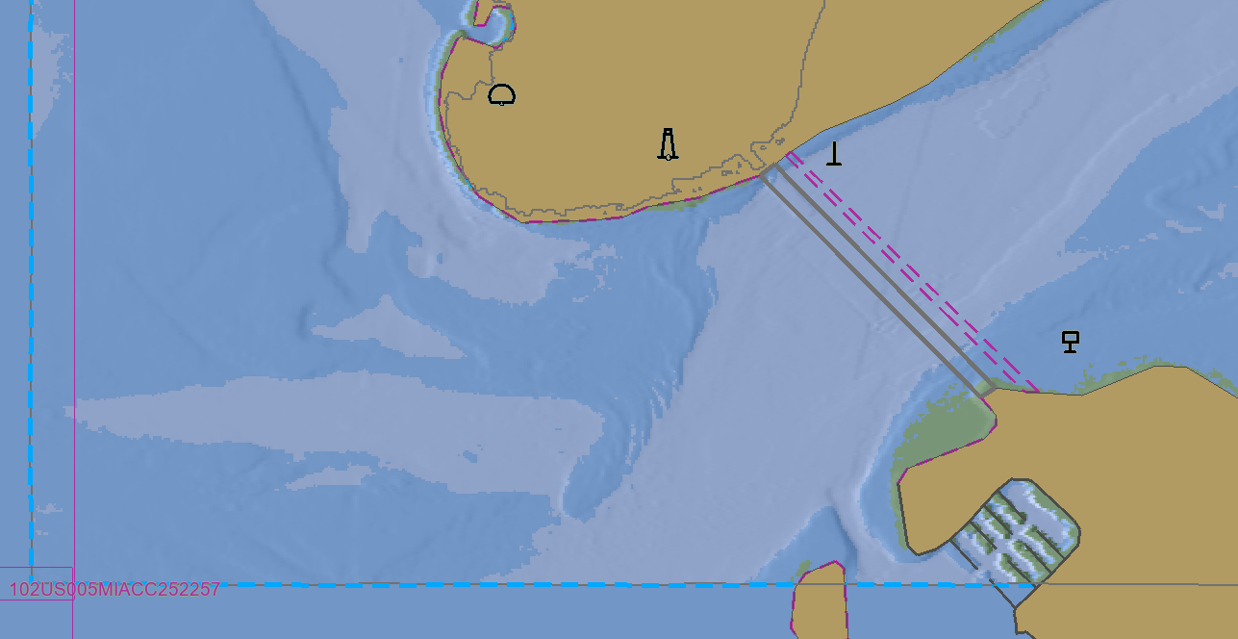

- [Show new safety contour] Set safety contour value to 7.5m
- Ensure display shows the enhanced safety contour constructed from the S-102 data, at position XXX.XXX, YYY.XXX
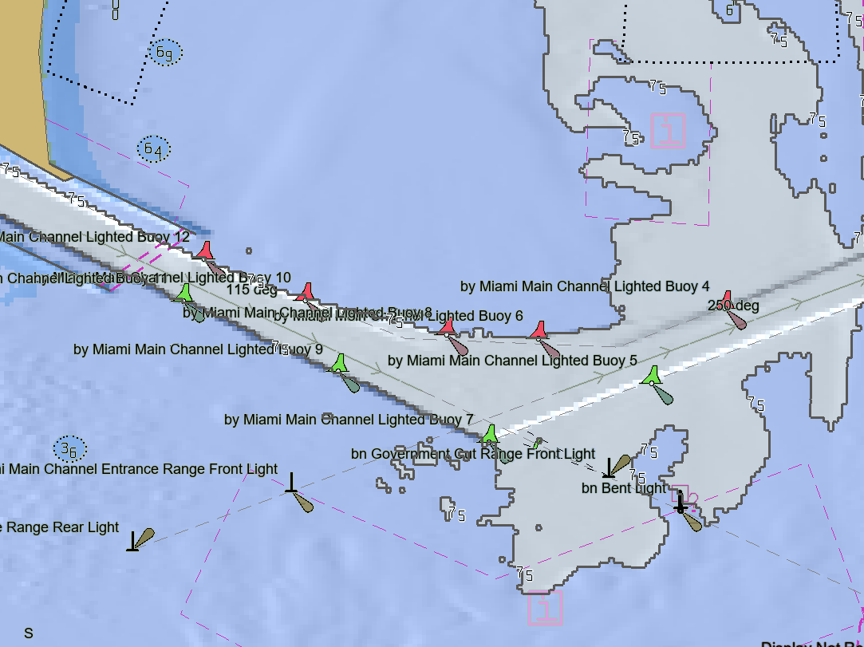

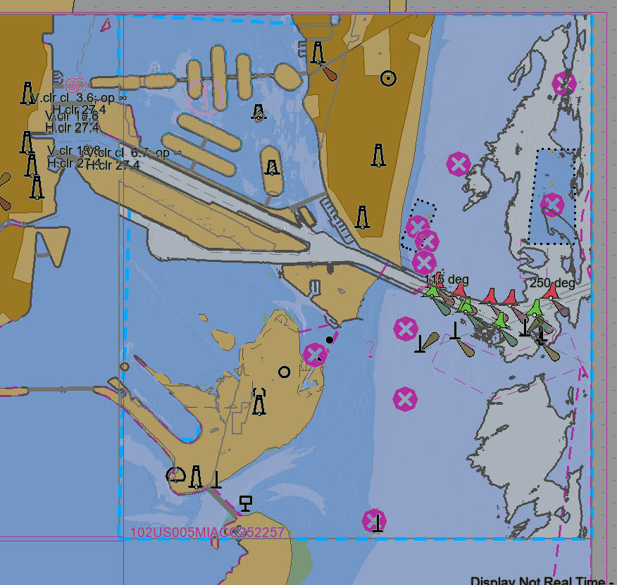

Water Levels (S-104)
Test Reference |  | Water Level Adjustment  S-104 |  |  |  | IHO Reference |  |  | S-98 Appendix D-2
Test Description
TODO: Water Level permission for producer codes [S-98 8.1.1 / Appendix D1]
TODO: More detailed tests for vertical clearance adjustment
Loaded Data
Exchange Set Name
Display Mode |  |  |  |  | Independent Mariner’s Selections (default=On)
Other |  |  |  |  | Accuracy
Context Parameters |  |  |  |  | Contour label |  |  |  |  | On
Safety Contour |  |  | 10 |  | Highlight date dependent
Safety Depth |  |  | 8 |  | Highlight document
Deep Contour |  |  | 30 |  | Highlight info
Shallow Contour |  |  | 5 |  | Shallow Pattern
Four Shades |  |  | On |  | Unknown |  |  |  |  | On
Radar Overlay |  |  |  |  | Update Review
Plain Boundaries |  |  | Off |  | Text Groups |  |  |  |  | On
Simplified Symbols |  |  | Off |  | Chart Text
Full Light Lines |  |  |  |  | Important text
Ignore scale minimum |  |  |  |  | Other Text
Shallow Water Dangers |  |  |  |  | Names
Palette |  |  |  |  | Light description
Day |  |  |  |  | All other chart text
Date Dependent Objects |  |  |  |  | Display
Start Date |  |  |  |  | Centre
End Date |  |  |  |  | Scale |  | 1:8000
 |  |  |  |  | Orientation
Viewing Groups (Default = On)
Standard Display |  |  |  |  |  | Other
Drying lines |  |  |  |  |  | Spot soundings
Buoys. Beacons, aids to navigation |  |  |  |  |  | Submarine cables and pipelines
Buoys, beacons, structures |  |  |  |  |  | All isolated dangers
Lights |  |  |  |  |  | Magnetic variation
Boundaries and limits |  |  |  |  |  | Depth contours
Prohibited and restricted areas |  |  |  |  |  | Seabed
Chart scale boundaries |  |  |  |  |  | Tidal
Cautionary notes |  |  |  |  |  | Miscellaneous (Other)
Ships’ routeing systems and ferry routes
Archipelagic sea lanes
Miscellaneous (Standard)
Chart (Standard)
Alert Highlights (Standard)
Additional
Setup
- As per test Initial Catalogues (exchange set InitialCatalogues loaded).
- Ensure enhanced Safety Contour and Water Level Adjustment is disabled.
- Load exchange set EnhancedSafetyContour
- Load exchangbe set WaterLevelAdjustment

Source Dataset 10100AA164US4FL2, 102US004FL2A125227

Action
- Switch on Enhanced Safety Contour and Water Level Adjustment
- Ensure the blue border is displayed showing the limit where water level adjustment is applied.
- Navigate to the position XXX.XXX YYY.YYY
- Query 0.6m sounding at position XXX.XXX YYY.YYY
- Ensure an adjusted value of sounding is available = 0.9m
- Ensure an unadjusted value is also available = 0.6m
- Switch off Enhanced Safety Contour and WLA
- Ensure the Sounding value available in the pick report is 0.6m

Results
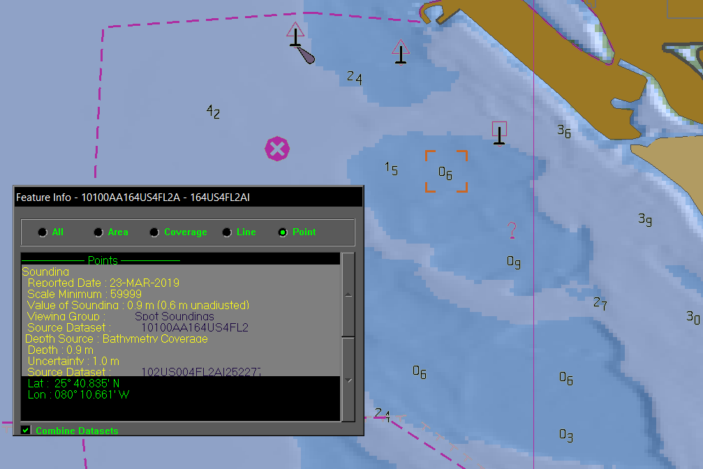

Action
- Turn on Enhanced Safety Contour and Water Level Adjustment
- Turn on Uncertainty – if the ECDIS supports separate horizontal and vertical uncertainty, switch on Vertical Uncertainty
- Query the 0.6m sounding at position XXX.XXX YYY.YYY
- Ensure the vertical uncertainty value of 0.1m is taken into account giving an adjusted value of 0.8m

Results
tbd

Action
- Switch off Enhanced Safety contour, Water Level Adjustment and Uncertainty
- Load exchange set WLAOverlap
- Switch on Water Level Adjustment
- Navigate to position XXX.XXX YYY.YYY
- Ensure an indication of “Overlap” is shown on the display and the user is prompted to choose which datasets to use as the source for Water Level Adjustment

Results

Tidal Streams (S-111)
Test Reference |  | S-111 |  |  |  | IHO Reference |  |  | S-98 6.1  S-98 13
Test Description
Loaded Data
Exchange Set Name
Display Mode |  |  |  |  | Independent Mariner’s Selections (default=On)
Other |  |  |  |  | Accuracy
Context Parameters |  |  |  |  | Contour label |  |  |  |  | On
Safety Contour |  |  | 10 |  | Highlight date dependent
Safety Depth |  |  | 8 |  | Highlight document
Deep Contour |  |  | 30 |  | Highlight info
Shallow Contour |  |  | 5 |  | Shallow Pattern
Four Shades |  |  | On |  | Unknown |  |  |  |  | On
Radar Overlay |  |  |  |  | Update Review
Plain Boundaries |  |  | Off |  | Text Groups |  |  |  |  | On
Simplified Symbols |  |  | Off |  | Chart Text
Full Light Lines |  |  |  |  | Important text
Ignore scale minimum |  |  |  |  | Other Text
Shallow Water Dangers |  |  |  |  | Names
Palette |  |  |  |  | Light description
Day |  |  |  |  | All other chart text
Date Dependent Objects |  |  |  |  | Display
Start Date |  |  |  |  | Centre
End Date |  |  |  |  | Scale |  | 1:8 000
 |  |  |  |  | Orientation
Viewing Groups (Default = On)
Standard Display |  |  |  |  |  | Other
Drying lines |  |  |  |  |  | Spot soundings
Buoys. Beacons, aids to navigation |  |  |  |  |  | Submarine cables and pipelines
Buoys, beacons, structures |  |  |  |  |  | All isolated dangers
Lights |  |  |  |  |  | Magnetic variation
Boundaries and limits |  |  |  |  |  | Depth contours
Prohibited and restricted areas |  |  |  |  |  | Seabed
Chart scale boundaries |  |  |  |  |  | Tidal
Cautionary notes |  |  |  |  |  | Miscellaneous (Other)
Ships’ routeing systems and ferry routes
Archipelagic sea lanes
Miscellaneous (Standard)
Chart (Standard)
Alert Highlights (Standard)
Additional
Setup
- As per test Initial Catalogues (exchange set InitialCatalogues loaded).
- Zoom to display scale of 1:8 000
- Switch on portrayal of S-111 Tidal Streams
- Ensure the display shows the S-111 arrows, as shown

Action
Results
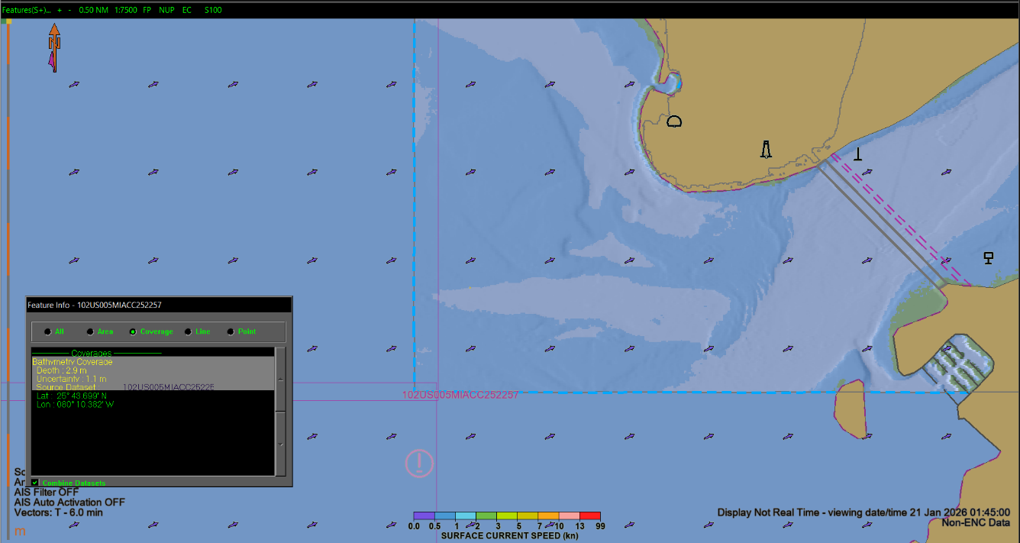

Action
- Zoom to Display Scale 1: 20 000 or smaller

Results
- Ensure the S-111 portrayal remains at a constant density, showing that the portrayal of the S-111 data has been “thinned” to reduce clutter on screen.

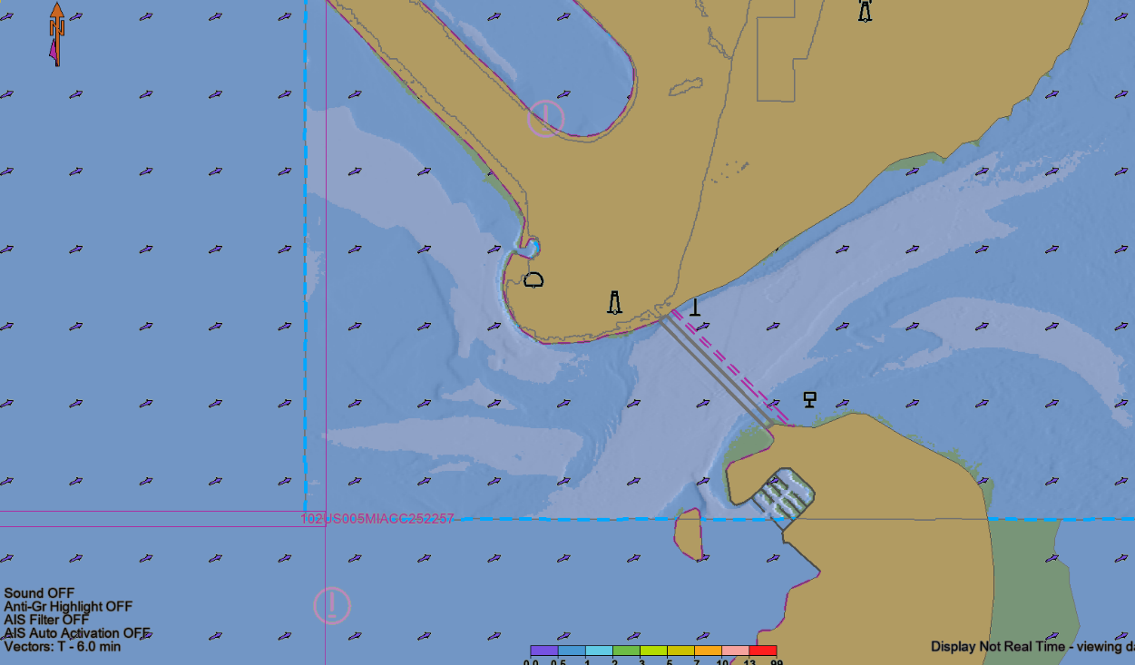

Marine Protected Areas (S-122)
Test Reference |  | Marine Protected Areas. |  |  |  | IHO Reference |  |  | S-98 6.1.1
Test Description
Ensure the ECDIS is capable of displaying the mandatory overlays of S-122
TODO: S-122 (and others) should only display within scale range of MSVS

Loaded Data
Exchange Set Name
Display Mode |  |  |  |  | Independent Mariner’s Selections (default=On)
Other |  |  |  |  | Accuracy
Context Parameters |  |  |  |  | Contour label |  |  |  |  | On
Safety Contour |  |  | 10 |  | Highlight date dependent
Safety Depth |  |  | 8 |  | Highlight document
Deep Contour |  |  | 30 |  | Highlight info
Shallow Contour |  |  | 5 |  | Shallow Pattern |  |  |  |  | Off
Four Shades |  |  | On |  | Unknown
Radar Overlay |  |  |  |  | Update Review
Plain Boundaries |  |  | Off |  | Text Groups |  |  |  |  | On
Simplified Symbols |  |  | Off |  | Chart Text
Full Light Lines |  |  |  |  | Important text
Ignore scale minimum |  |  |  |  | Other Text
Shallow Water Dangers |  |  |  |  | Names
Palette |  |  |  |  | Light description
Day |  |  |  |  | All other chart text
Date Dependent Objects |  |  |  |  | Display
Start Date |  |  |  |  | Centre |  | 32.5465S,60.9387E
End Date |  |  |  |  | Scale |  | 1:45,000
 |  |  |  |  | Orientation
Viewing Groups (Default = On)
Standard Display |  |  |  |  |  | Other
Drying lines |  |  |  |  |  | Spot soundings
Buoys. Beacons, aids to navigation |  |  |  |  |  | Submarine cables and pipelines
Buoys, beacons, structures |  |  |  |  |  | All isolated dangers
Lights |  |  |  |  |  | Magnetic variation
Boundaries and limits |  |  |  |  |  | Depth contours
Prohibited and restricted areas |  |  |  |  |  | Seabed
Chart scale boundaries |  |  |  |  |  | Tidal
Cautionary notes |  |  |  |  |  | Miscellaneous (Other)
Ships’ routeing systems and ferry routes
Archipelagic sea lanes
Miscellaneous (Standard)
Chart (Standard)
Alert Highlights (Standard)
Additional
Setup
- Load the Exchange set PowerUp
- Load the Exchange set Overlays
- Switch off all overlays
- Navigate to the documented position and MSVS

Action
- Observe the Display
Results
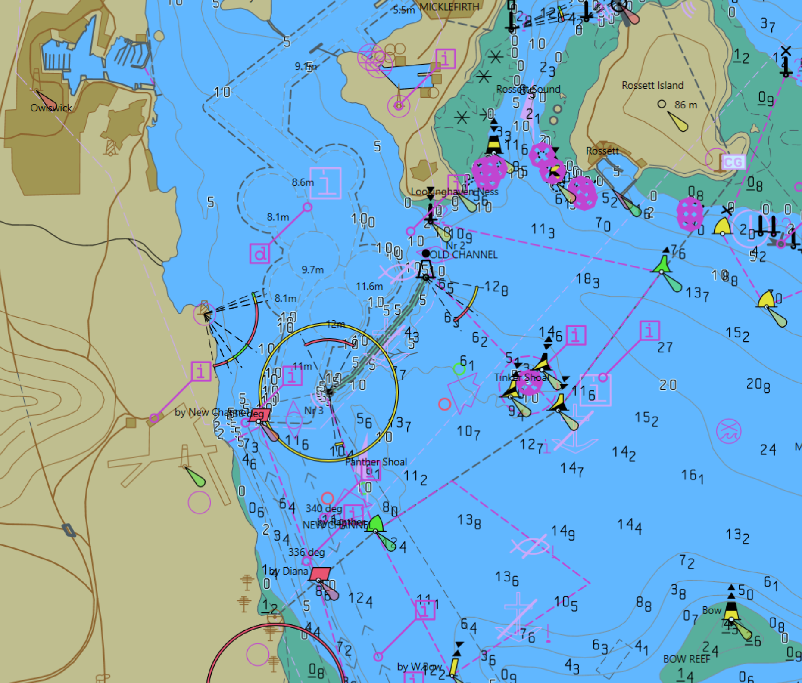

Action
- Switch on S-129 Under Keel Management Areas
Results
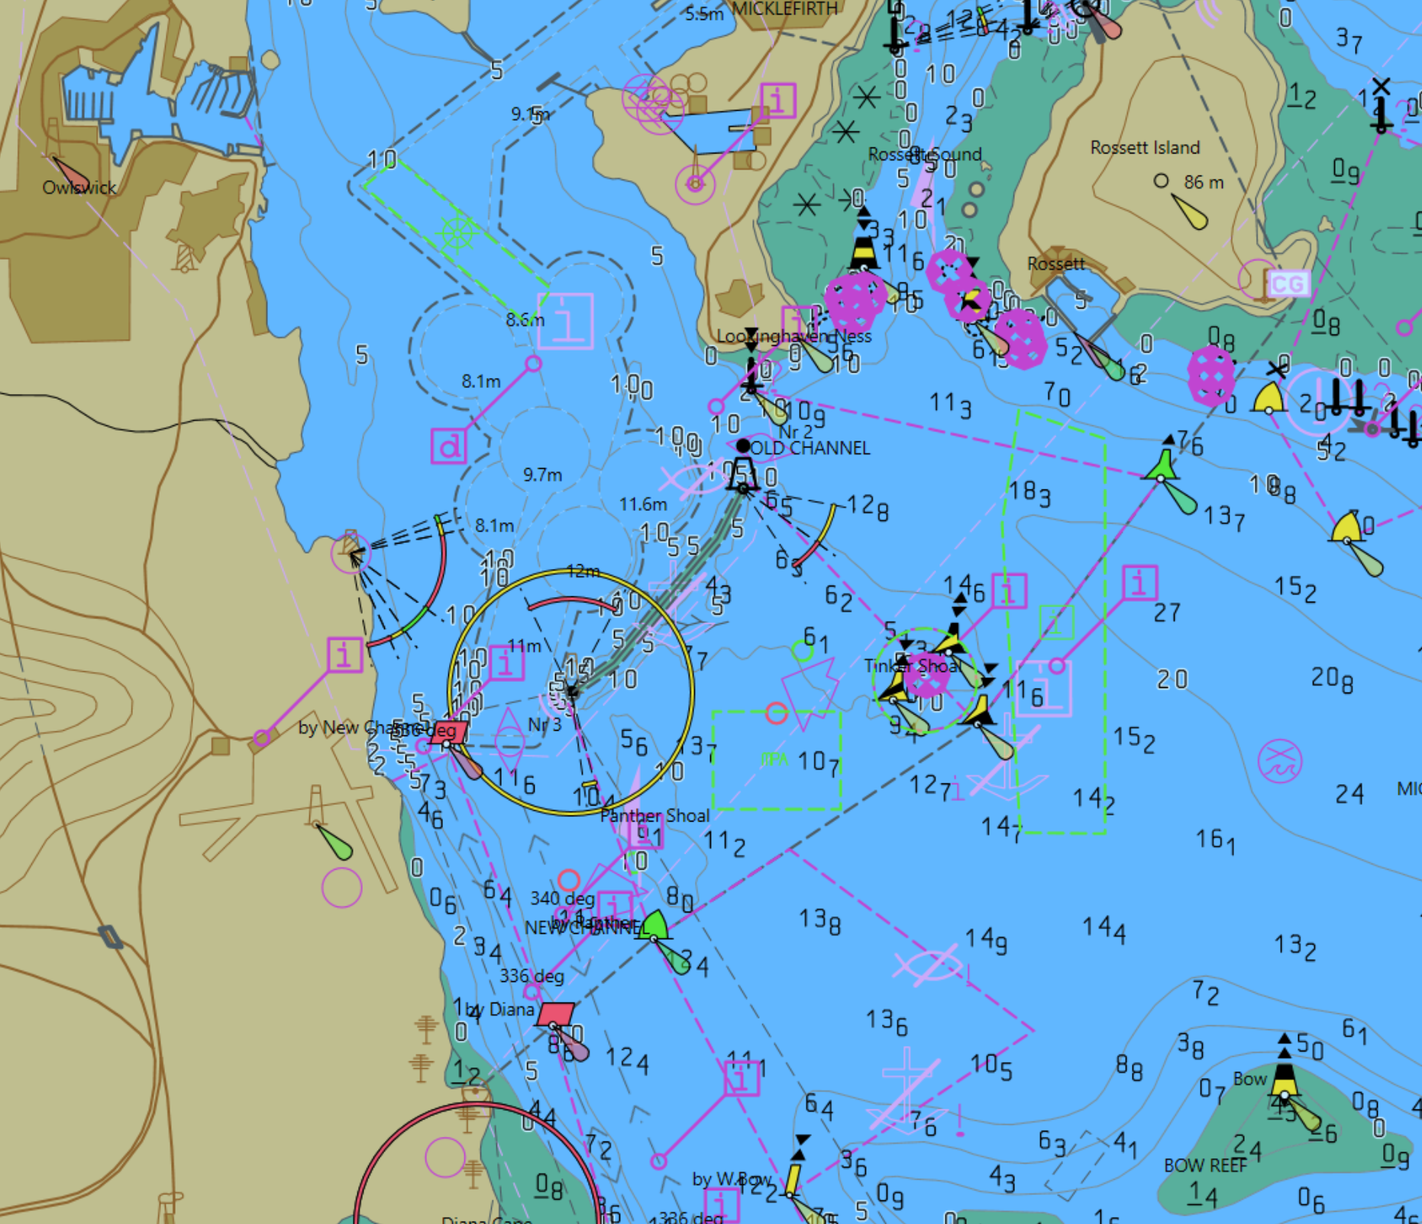

Action
- Query the display at position 32.5465S,60.9387E
Results
- Verify that the S-122 feature “Marine Protected Area” has details as follows:
  - Category Of Marine Protected Area = IUCN IV

Navigational Warnings (S-124)
Test Reference |  | Navigational Warnings |  |  |  | IHO Reference  IEC Reference |  | S-98 11.12.1  S-98 11.2.2
Test Description
This test ensures the EUT is capable of displaying the mandatory overlays of S-124.

Loaded Data
Exchange Set Name
Display Mode |  |  |  |  | Independent Mariner’s Selections
Other |  |  |  |  | Accuracy
Context Parameters |  |  |  |  | Contour label |  |  |  | On
Safety Contour |  |  | 10 |  | Highlight date dependent
Safety Depth |  |  | 8 |  | Highlight document
Deep Contour |  |  | 30 |  | Highlight info
Shallow Contour |  |  | 5 |  | Shallow Pattern |  |  |  | Off
Four Shades |  |  | On |  | Unknown
Radar Overlay |  |  |  |  | Update Review
Plain Boundaries |  |  | Off |  | Text Groups |  |  |  | On
Simplified Symbols |  |  | Off |  | Chart Text
Full Light Lines |  |  |  |  | Important text
Ignore scale minimum |  |  |  |  | Other Text
Shallow Water Dangers |  |  |  |  | Names
Palette |  |  |  |  | Light description
Day |  |  |  |  | All other chart text
Viewing Date or Range |  |  |  |  | Display
Start viewing date |  |  |  |  | Centre |  | 32.5059S,60.9557E
End viewing date |  |  |  |  | Scale |  | 1:8,000
Viewing Groups
Standard Display |  |  |  |  |  | Other
Drying lines |  |  |  |  |  | Spot soundings
Buoys. Beacons, aids to navigation |  |  |  |  |  | Submarine cables and pipelines
Buoys, beacons, structures |  |  |  |  |  | All isolated dangers
Lights |  |  |  |  |  | Magnetic variation
Boundaries and limits |  |  |  |  |  | Depth contours
Prohibited and restricted areas |  |  |  |  |  | Seabed
Chart scale boundaries |  |  |  |  |  | Tidal
Cautionary notes |  |  |  |  |  | Miscellaneous (Other)
Ships’ routeing systems and ferry routes
Archipelagic sea lanes
Miscellaneous (Standard)
Chart (Standard)
Alert Highlights (Standard)
Setup
- Load the Exchange set PowerUp
- Load the Exchange set Overlays
- Switch off all overlays
- Navigate to the documented position and MSVS
Action
- Observe the Display
Results
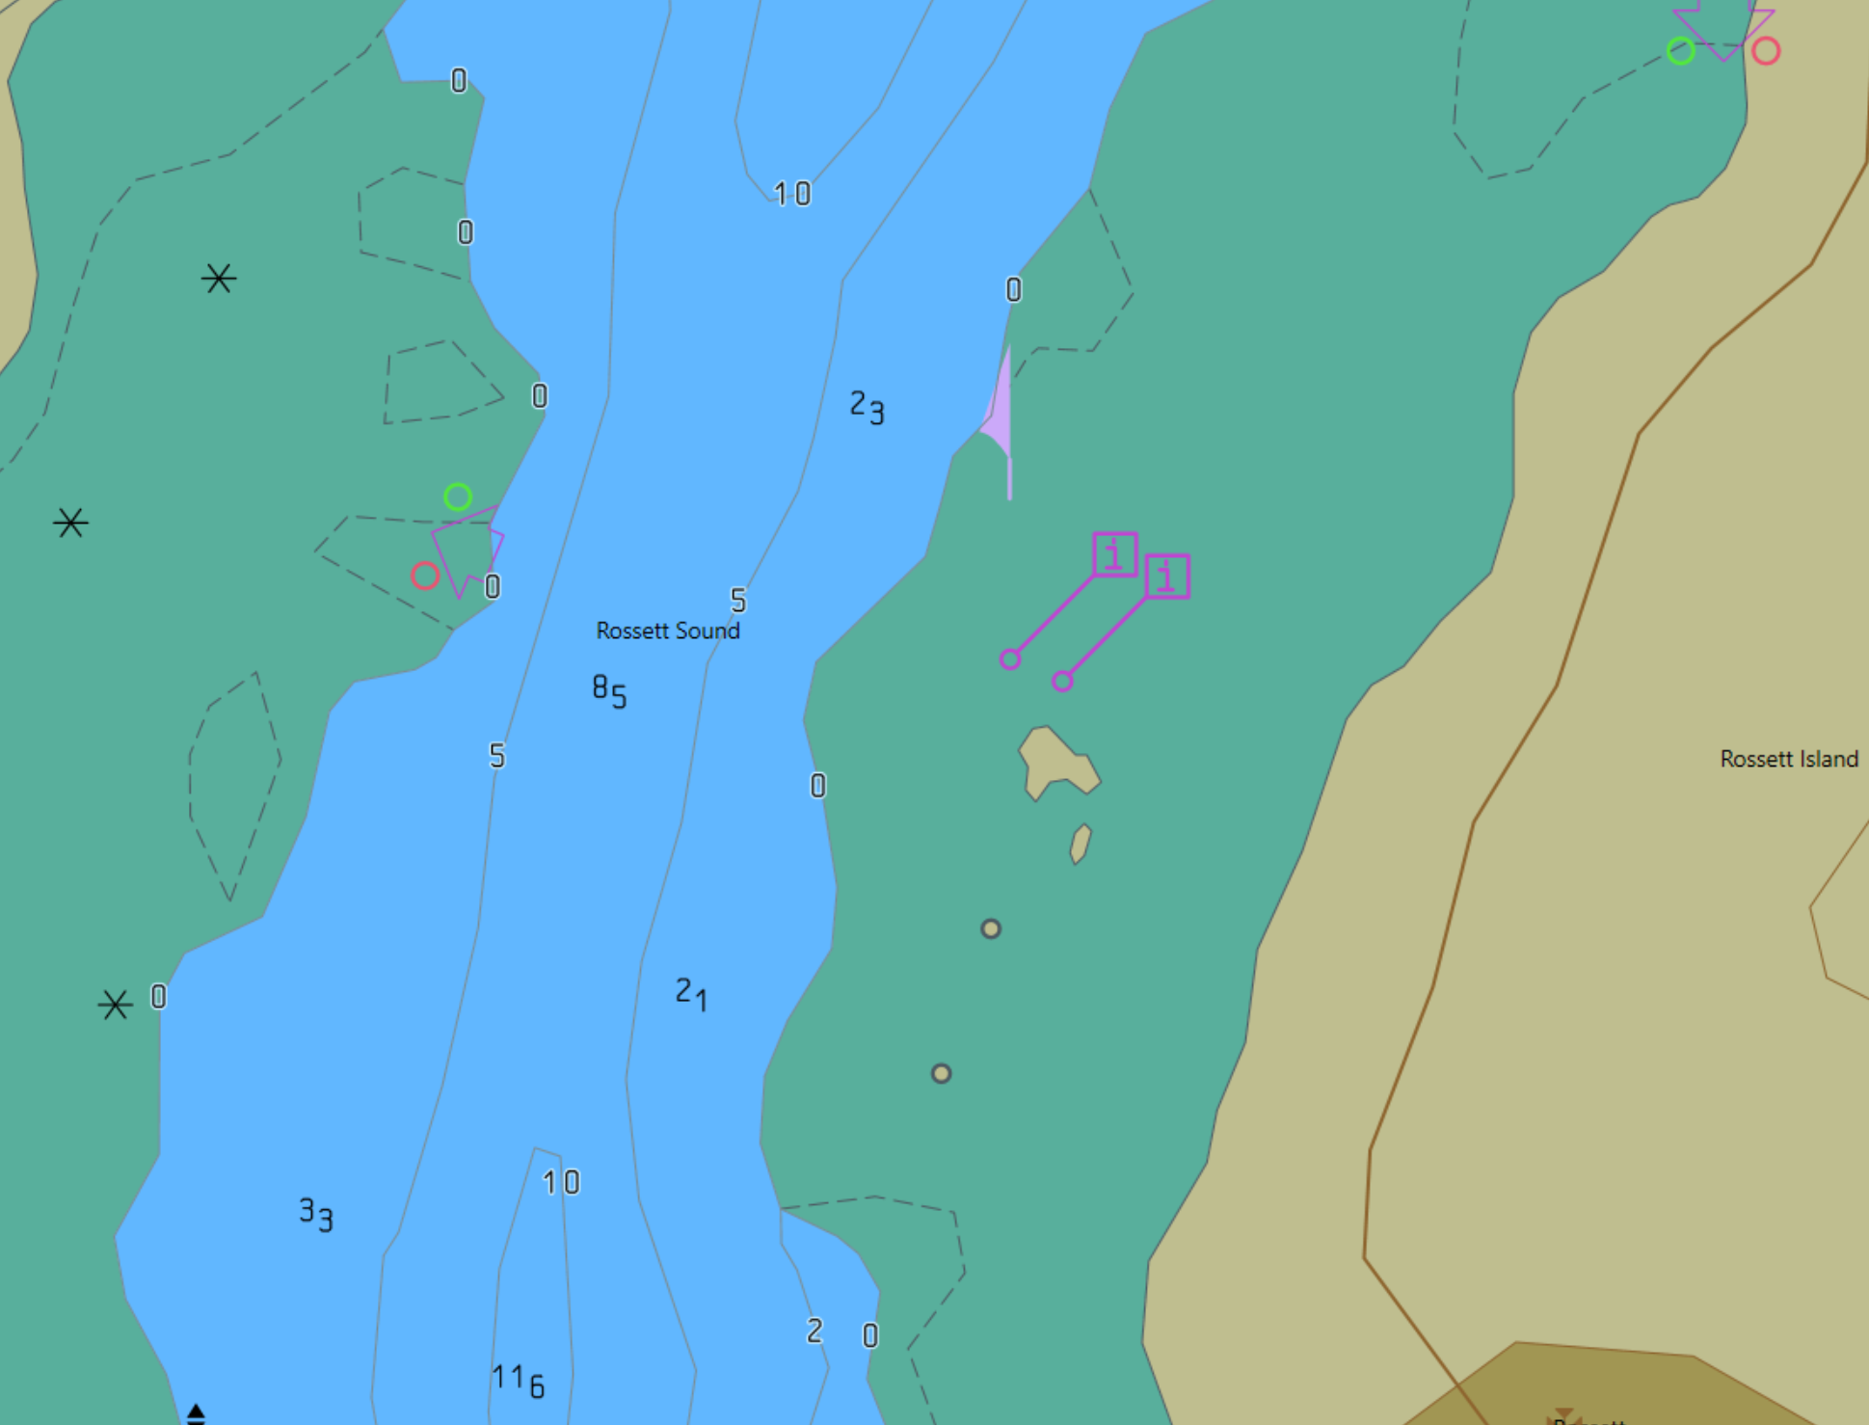

Action
- Switch on S-124 Navigational Warnings
Results
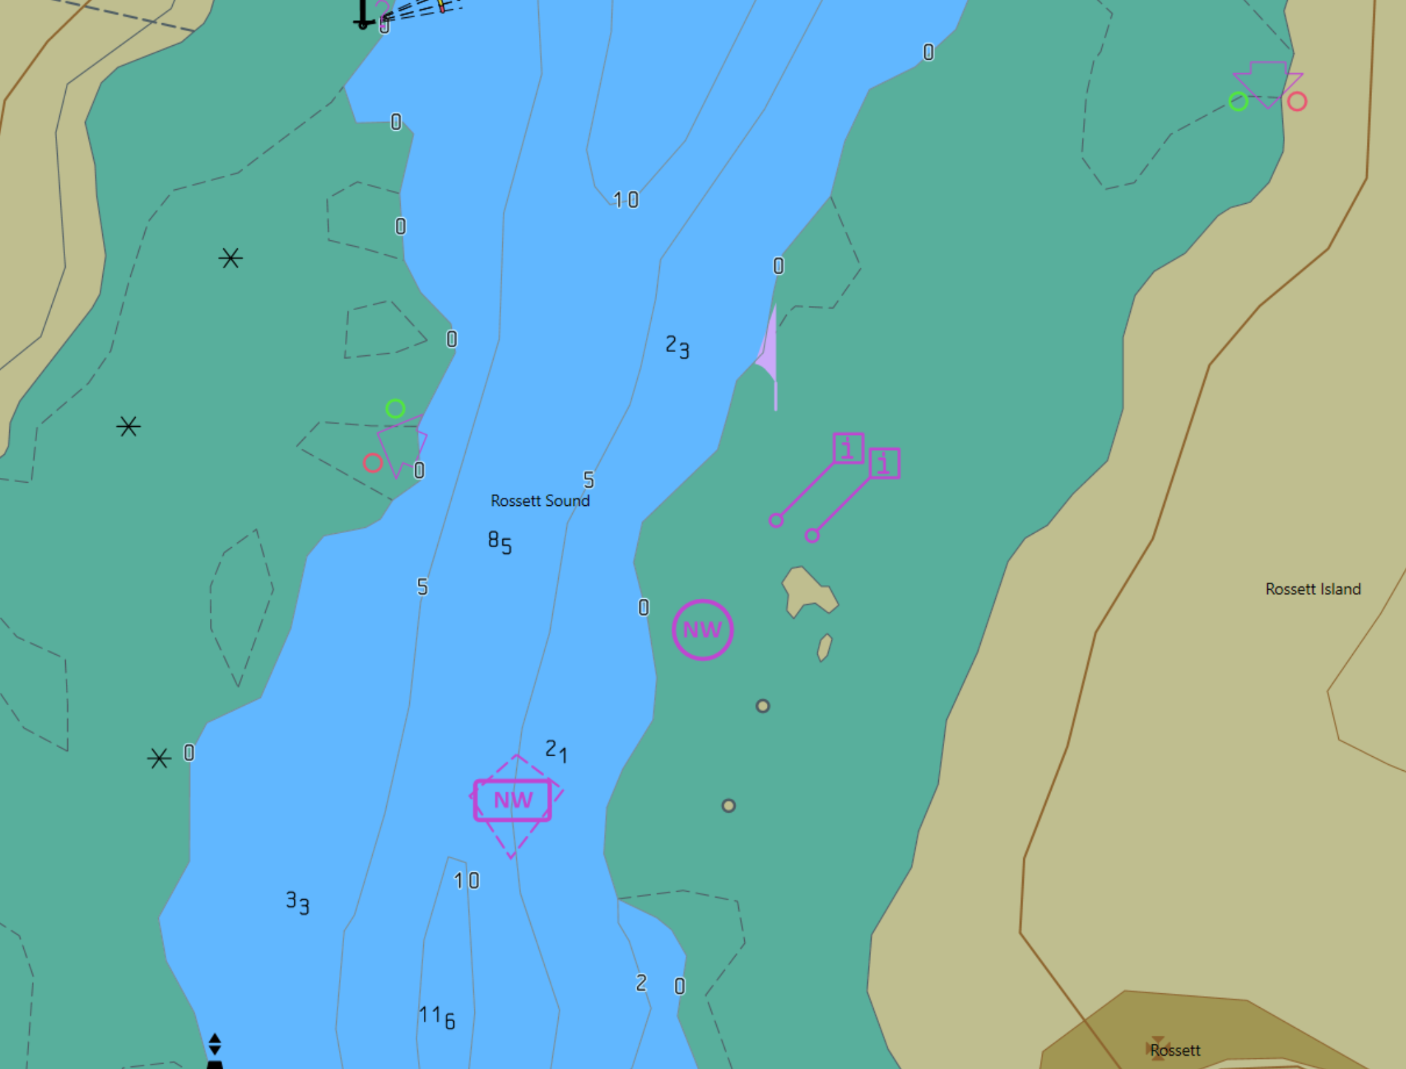

Action
- Query the display at position 32.5069S,60.9551E
Results
- Verify that the Navigational Warning selected has details as follows:
  - Name of Series: NAVAREA 43
  - Warning Number 2025/36
  - Warning Type: Local Navigational Warning
  - Navwarning Type General: Special Operations
Action
Provision of dedicated S-124 user interface

Load exchange set S124NAVARNSelection
Results
Check that a dedicated user interface is provided to allow users to interact with NAVWARN messages:

- Confirm that classification of individual messages is possible
- Confirm that classification ensures an uncluttered screen
- Confirm that the classification functionality enables manual filtering of the display of NAVWARN messages
- Confirm that the manual filtering of the display of NAVWARN messages includes the following criteria:
  - Warning type
  - Producer
  - Series
  - Navigation warning topic (navwarnTypeGeneral)
  - Date range
  - Valid time

Test Reference | S-124 Detail 2 | IHO Reference | S-98 11.12.1
Test description
Lat -32.507020 Lon = 60.950072
Scale = 12k

(Other)

Pick the circular NW as shown and observe in the pick report the following details:

Name of Series: NAVAREA 43
Warning Number 2025/36
Warning Type: Local Navigational Warning
Navwarning Type General: Special Operations

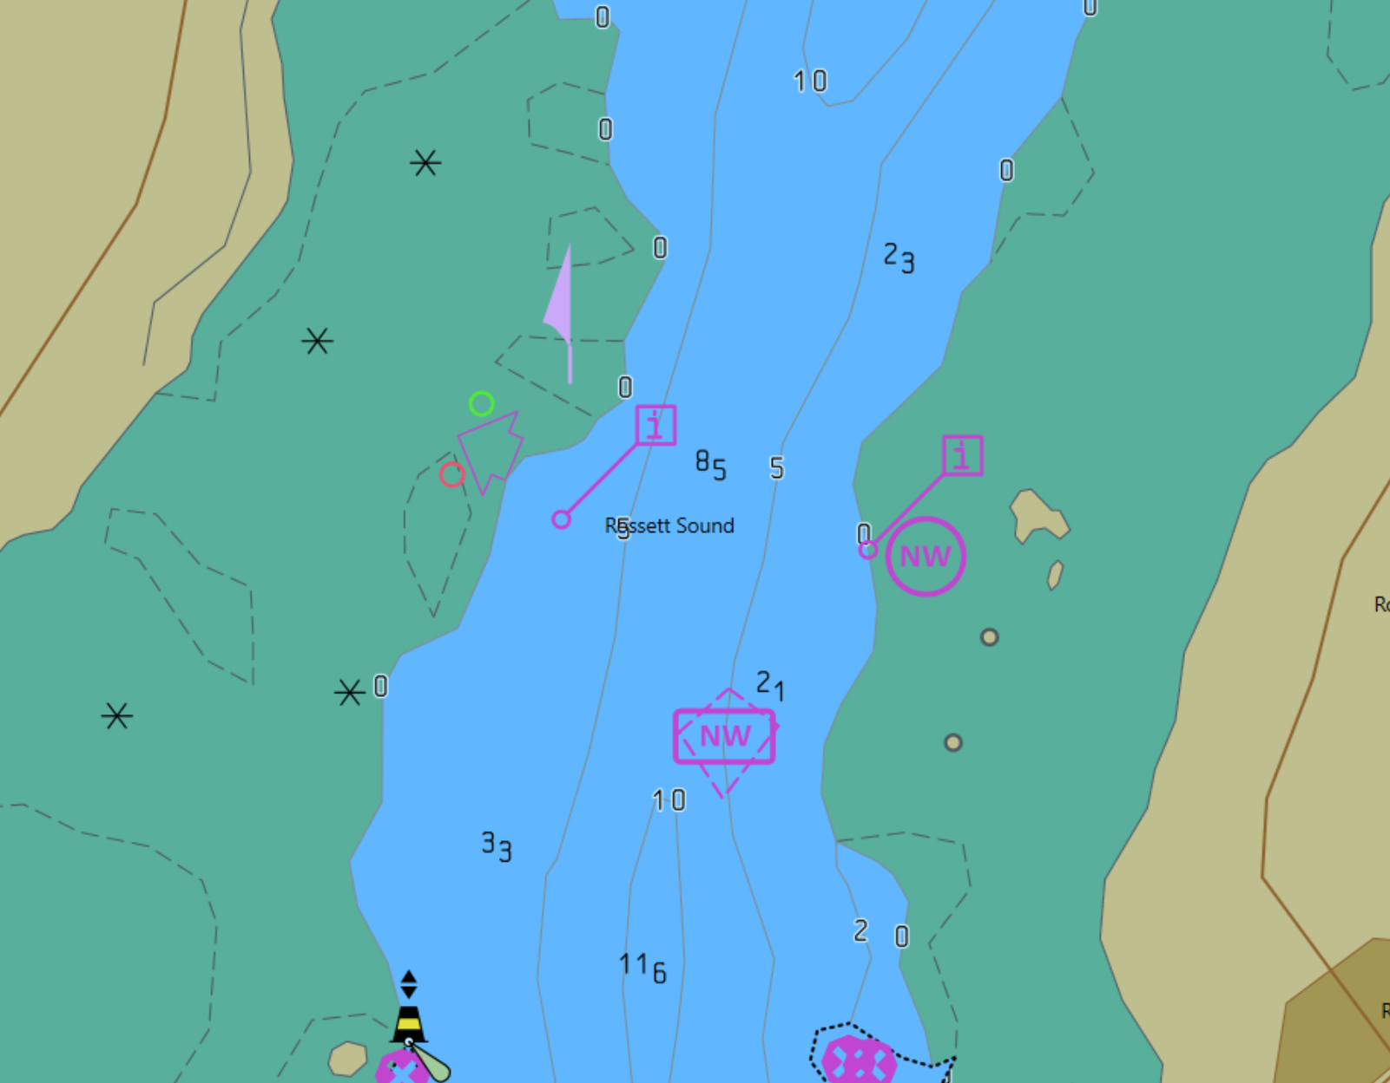

Action
Results
On-demand listing of S-124 NavWARN messages:

- Confirm that an on-demand listing of all S-124 NAVWARN messages is provided. Confirm the on-demand listing allows sorting according to:
  - Installed date and time
  - Issue date and time (publicationTime)
  - Warning type
  - Producer, series and message classification
- Confirm the on-demand listing includes means for viewing an abbreviated view of any NAVWARNPart warningInformation attributes consisting of a minimum of the Issue Date (publicationTime), warning type (navwarnTypeGeneral) and the first 64 characters of the warningInformation attributes.
- Confirm it is possible to view the most recent message and the full list of past messages

Action
Message cancellation.

Load exchange set S124MessageManagement

Results
Confirm that the two messages [2025/36] and [2025/37] are no longer displayed, but are still listed, and marked as “cancelled” in the on-demand listing

Action
New NAVWARN indications

Load exchange set S124NewNAVWARN (containing NewNAVWARN1 and NewNAVWARN2)

Results
- Confirm an indication is provided to show the new NAVWARN message has been loaded.
- Confirm the indication disappears when NAVWARN NewNAVWARN1 is displayed
- Set the system clock to +24 hours from current time
- Confirm the indication disappears for NewNAVWARN2

Marine traffic Management (S-127)
Test Reference |  | Marine Traffic Management. |  |  |  | IHO Reference |  |  | S-98 6.1.1
Test Description
Ensure the ECDIS is capable of displaying the mandatory overlays of S-127

Loaded Data
Exchange Set Name
Display Mode |  |  |  |  | Independent Mariner’s Selections (default=On)
Other |  |  |  |  | Accuracy
Context Parameters |  |  |  |  | Contour label |  |  |  |  | On
Safety Contour |  |  | 10 |  | Highlight date dependent
Safety Depth |  |  | 8 |  | Highlight document
Deep Contour |  |  | 30 |  | Highlight info
Shallow Contour |  |  | 5 |  | Shallow Pattern |  |  |  |  | Off
Four Shades |  |  | On |  | Unknown
Radar Overlay |  |  |  |  | Update Review
Plain Boundaries |  |  | Off |  | Text Groups |  |  |  |  | On
Simplified Symbols |  |  | Off |  | Chart Text
Full Light Lines |  |  |  |  | Important text
Ignore scale minimum |  |  |  |  | Other Text
Shallow Water Dangers |  |  |  |  | Names
Palette |  |  |  |  | Light description
Day |  |  |  |  | All other chart text
Date Dependent Objects |  |  |  |  | Display
Start Date |  |  |  |  | Centre |  | 32.5521S,61.0432E
End Date |  |  |  |  | Scale |  | 1:45,000
 |  |  |  |  | Orientation
Viewing Groups (Default = On)
Standard Display |  |  |  |  |  | Other
Drying lines |  |  |  |  |  | Spot soundings
Buoys. Beacons, aids to navigation |  |  |  |  |  | Submarine cables and pipelines
Buoys, beacons, structures |  |  |  |  |  | All isolated dangers
Lights |  |  |  |  |  | Magnetic variation
Boundaries and limits |  |  |  |  |  | Depth contours
Prohibited and restricted areas |  |  |  |  |  | Seabed
Chart scale boundaries |  |  |  |  |  | Tidal
Cautionary notes |  |  |  |  |  | Miscellaneous (Other)
Ships’ routeing systems and ferry routes
Archipelagic sea lanes
Miscellaneous (Standard)
Chart (Standard)
Alert Highlights (Standard)
Additional
Setup
- Load the Exchange set PowerUp
- Load the Exchange set Overlays
- Switch off all overlays
- Navigate to the documented position and MSVS

Action
- Observe the Display
Results
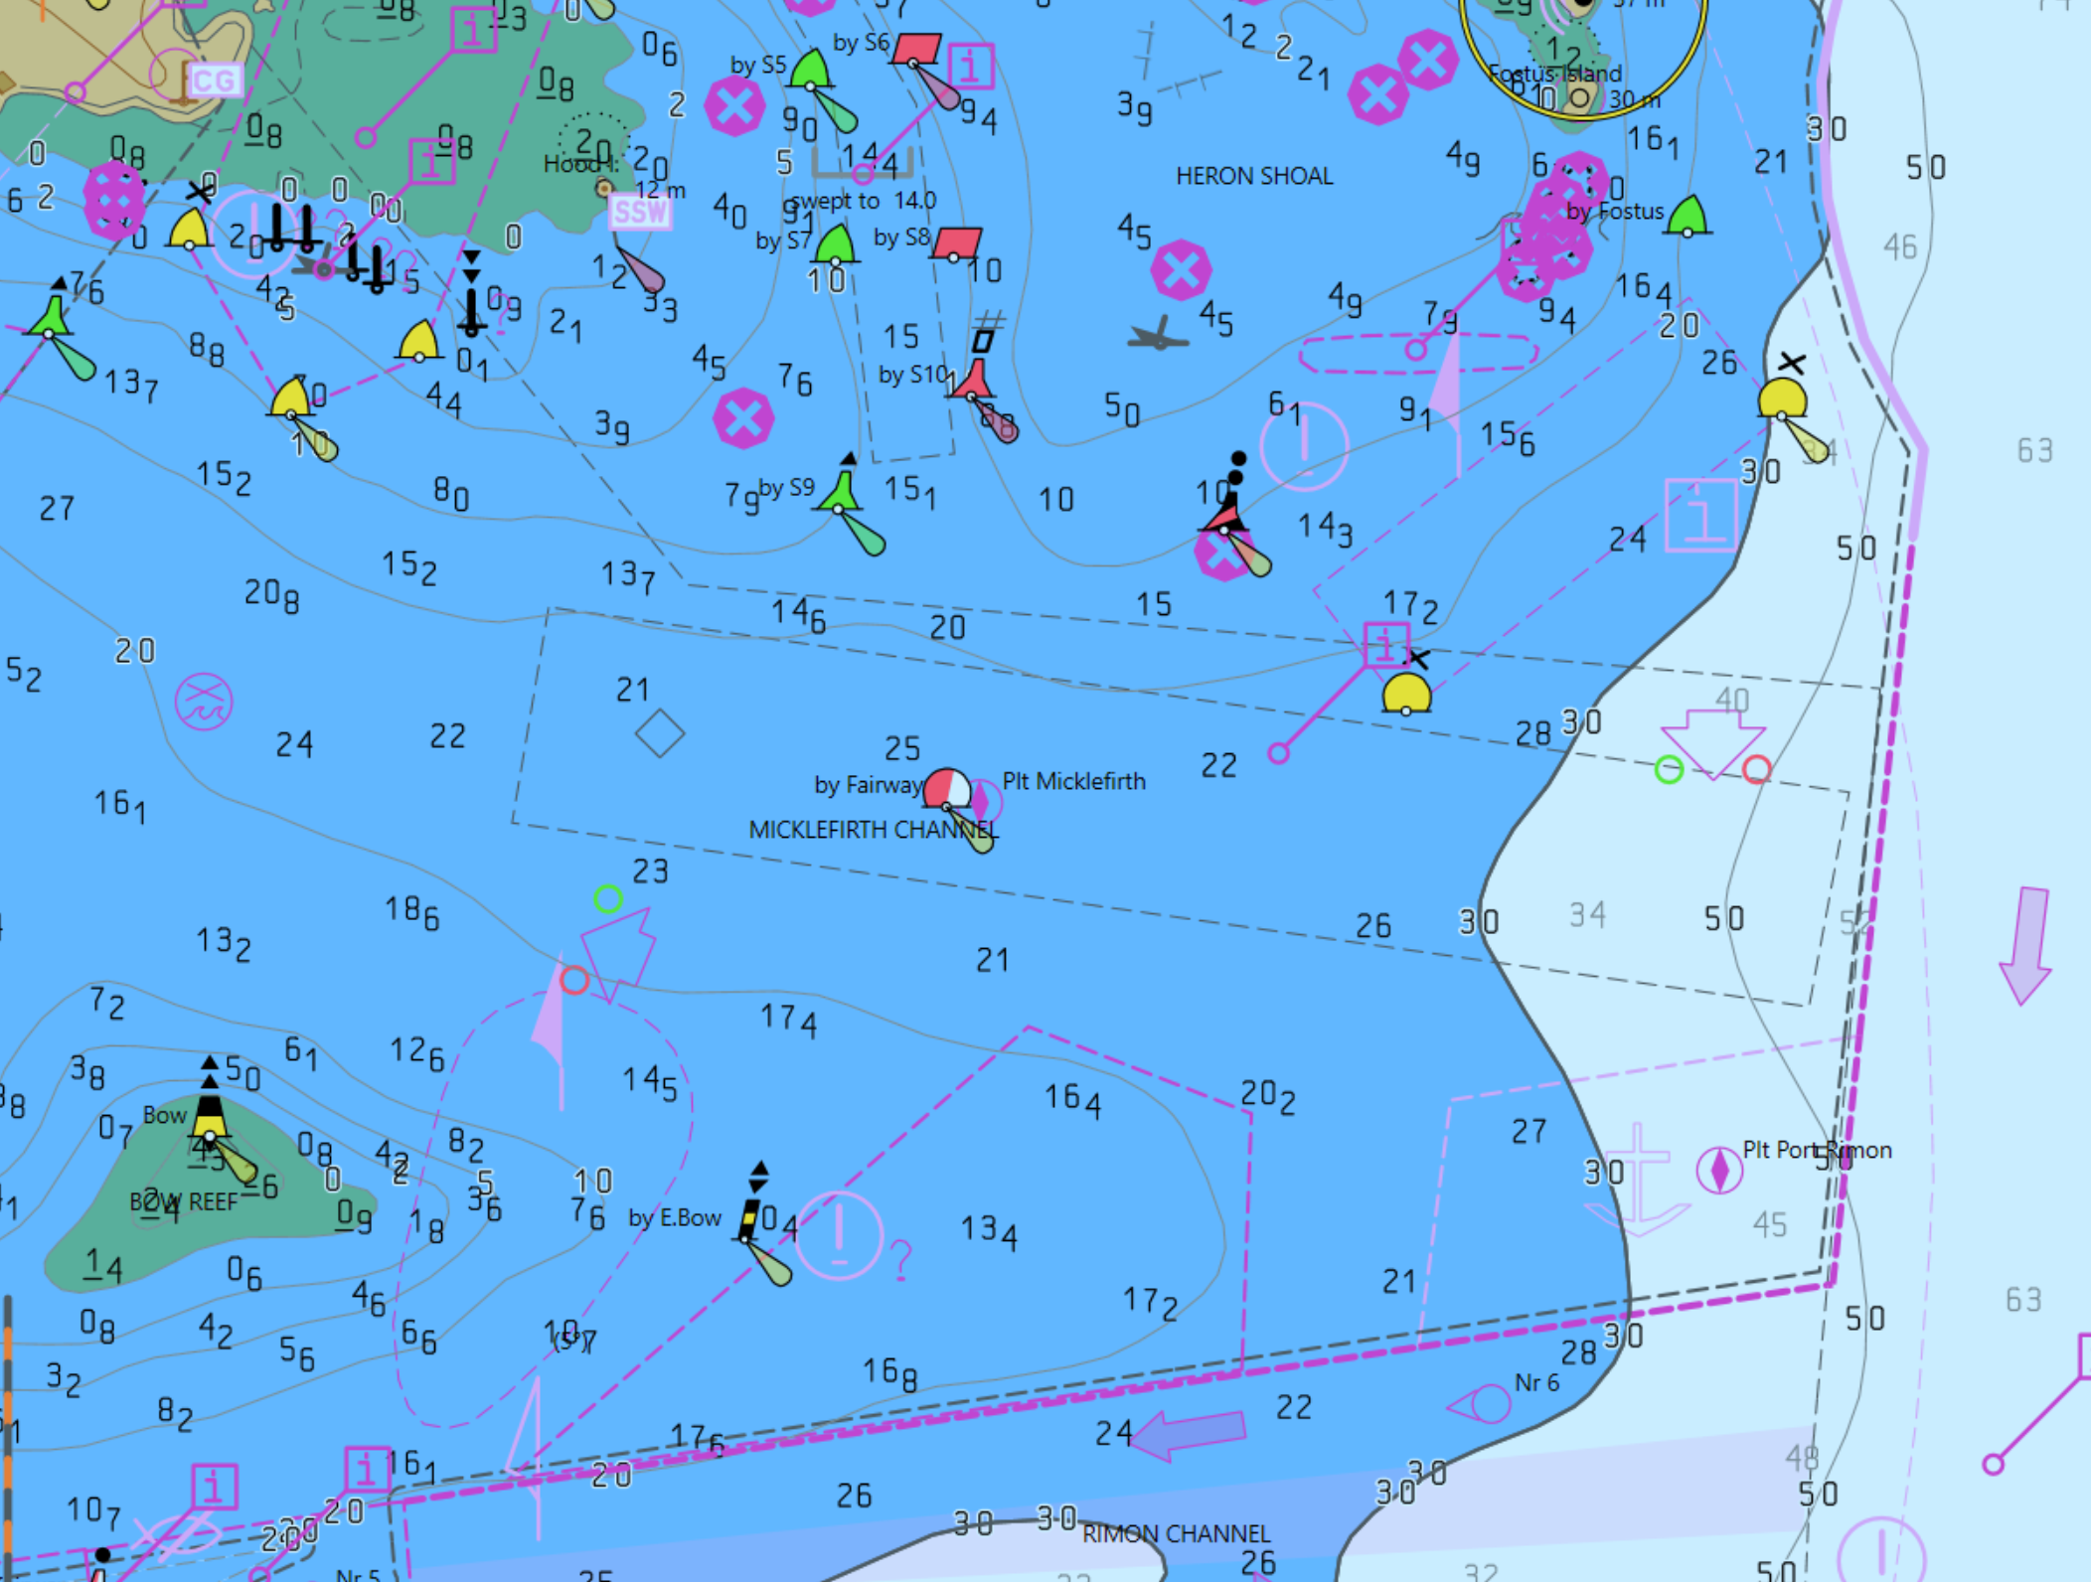

Action
- Switch on S-129 Under Keel Management Areas
Results
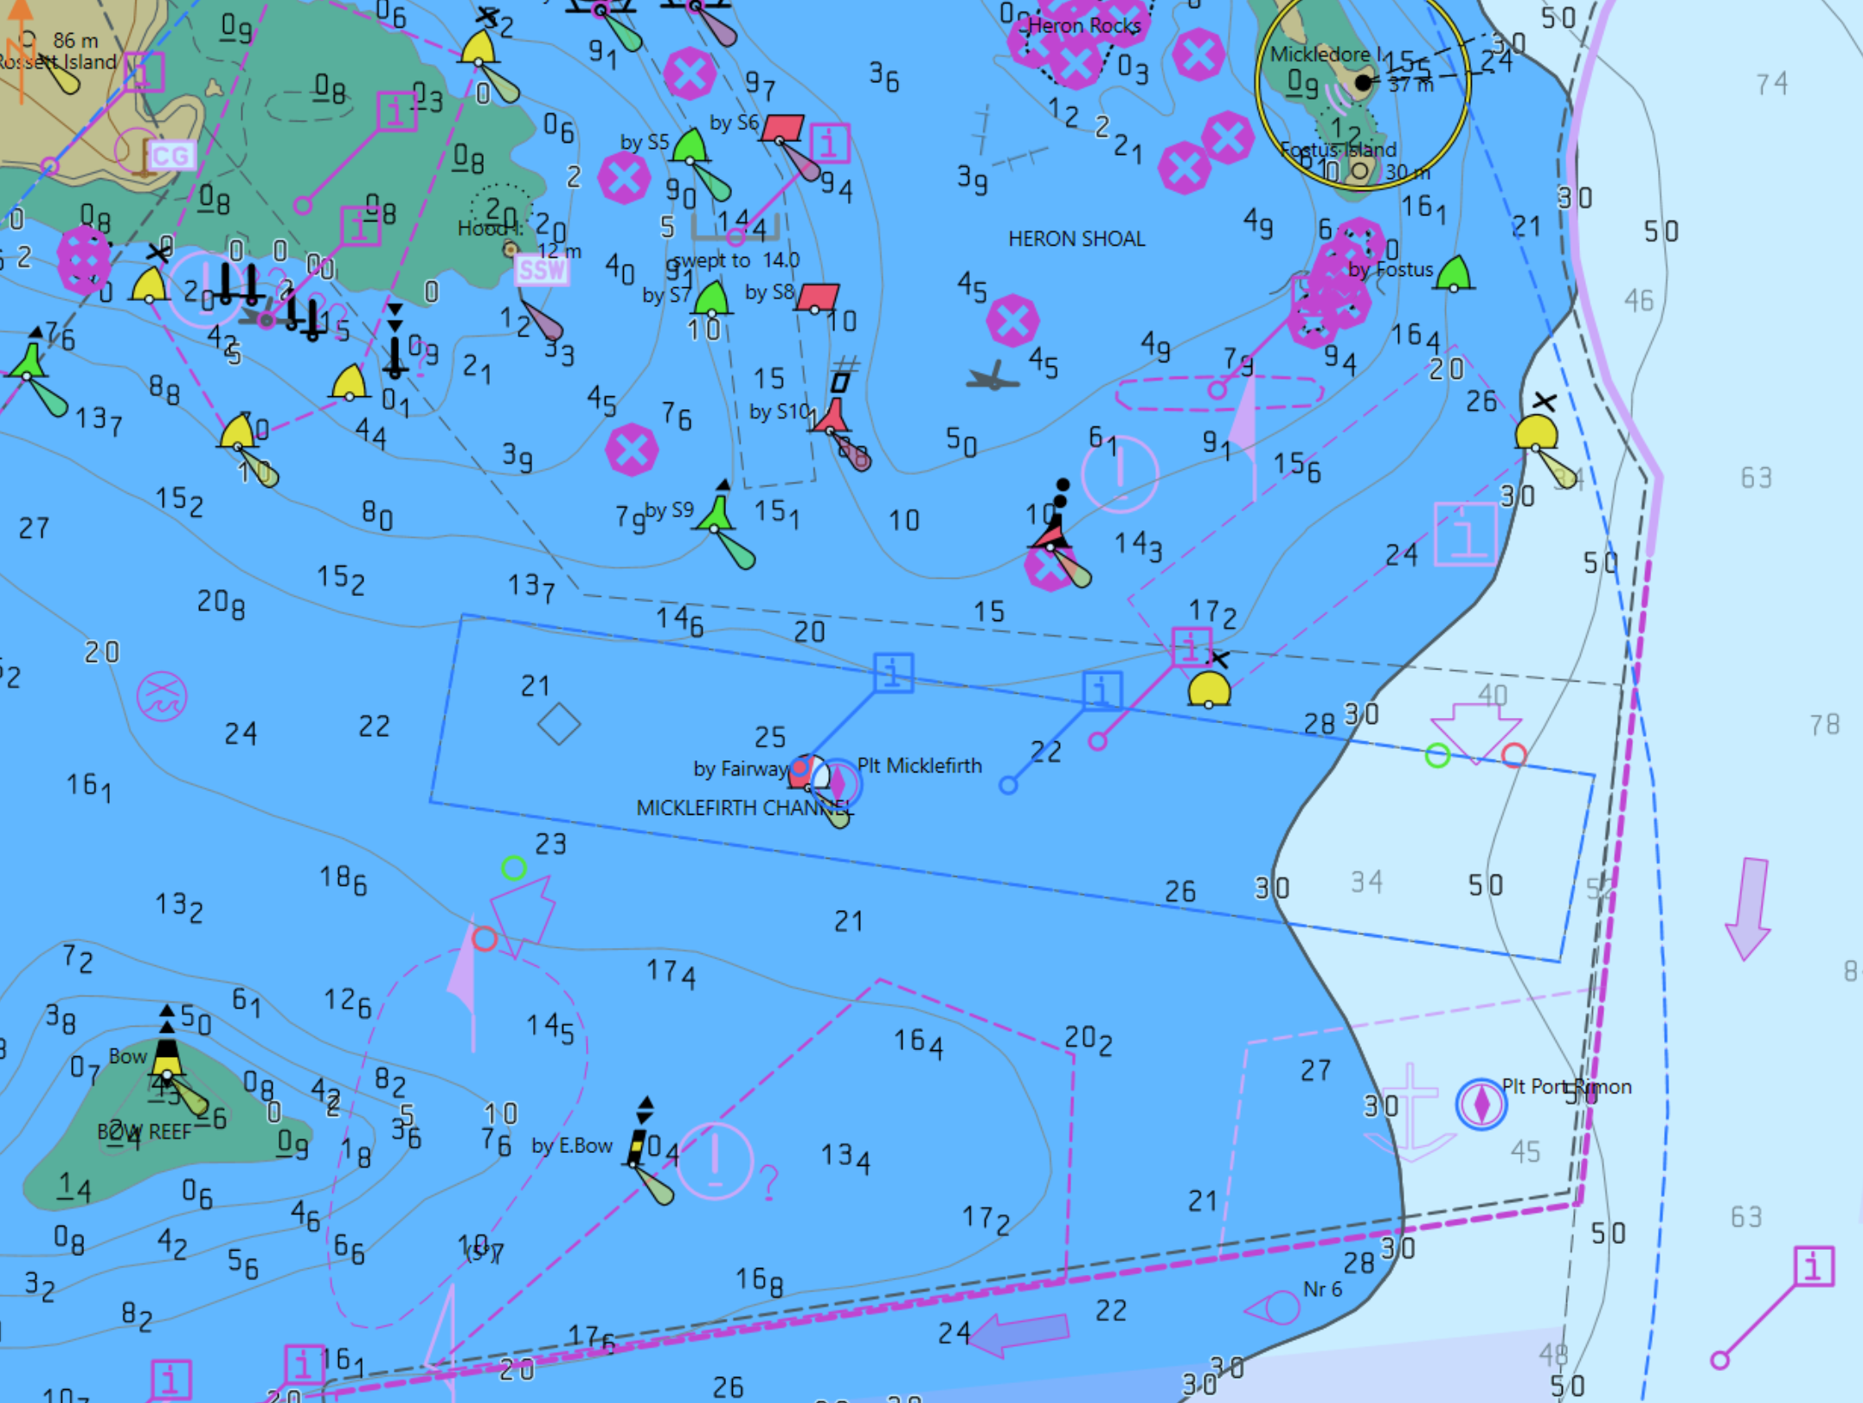

Action
- Query the display at position 32.5521S,61.0432E
Results
- Verify that the S-127 feature “Routing Measure” has details as follows:
  - Category Of Routing Measure = Fairway system

Under Keel Clearance Management Areas (S-129)
Test Reference |  | UnderKeelClearance |  |  |  | IHO Reference  IEC Reference |  | S-98 6.1.1
Test Description
This test ensures the EUT is capable of displaying the mandatory overlays of S-129.
Loaded Data
Exchange Set Name
Display Mode |  |  |  |  | Independent Mariner’s Selections
Other |  |  |  |  | Accuracy
Context Parameters |  |  |  |  | Contour label
Safety contour |  |  | 10 m |  | Highlight date dependent
Safety depth |  |  | 8 m |  | Highlight document
Deep contour |  |  | 30 m |  | Highlight info
Shallow contour |  |  | 5 m |  | Shallow Pattern
Four shades |  |  | Off |  | Unknown
Radar overlay |  |  | Off |  | Update Review
Plain boundaries |  |  | Off |  | Text Groups
Simplified symbols |  |  | Off |  | Chart Text
Full light lines |  |  |  |  | Important text
Ignore scale minimum |  |  |  |  | Other Text
Shallow water dangers |  |  |  |  | Names
Palette |  |  |  |  | Light description
Day |  |  |  |  | All other chart text
Date Dependent Objects |  |  |  |  | Display
Start Date |  |  |  |  | Centre
End Date |  |  |  |  | Scale |  | 1:30000
Viewing Groups
Standard Display |  |  |  |  |  | Other
Drying lines |  |  |  | On |  | Spot soundings |  |  | On
Buoys. Beacons, aids to navigation |  |  |  | On |  | Submarine cables and pipelines |  |  | On
Buoys, beacons, structures |  |  |  | On |  | All isolated dangers |  |  | On
Lights |  |  |  | On |  | Magnetic variation |  |  | On
Boundaries and limits |  |  |  | On |  | Depth contours |  |  | On
Prohibited and restricted areas |  |  |  | On |  | Seabed |  |  | On
Chart scale boundaries |  |  |  | On |  | Tidal |  |  | On
Cautionary notes |  |  |  | On |  | Miscellaneous (Other) |  |  | Off
Ships’ routeing systems and ferry routes |  |  |  | On
Archipelagic sea lanes |  |  |  | On
Miscellaneous (Standard) |  |  |  | Off
Chart (Standard) |  |  |  | Off
Alert Highlights (Standard) |  |  |  | Off
Setup
As per PowerUp.
Action
- Import exchange set Overlay-S129;
- Switch off all overlays and observe the display at indicated scale and position.
Results
- The exchange set shall install without any warning message;
- At the defined position the following image shall be observed:
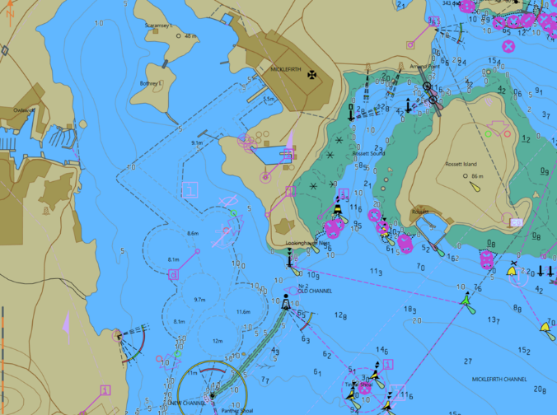

Action
Switch on S-129 Under Keel Management Areas
Results
At the defined position the following image shall be observed:
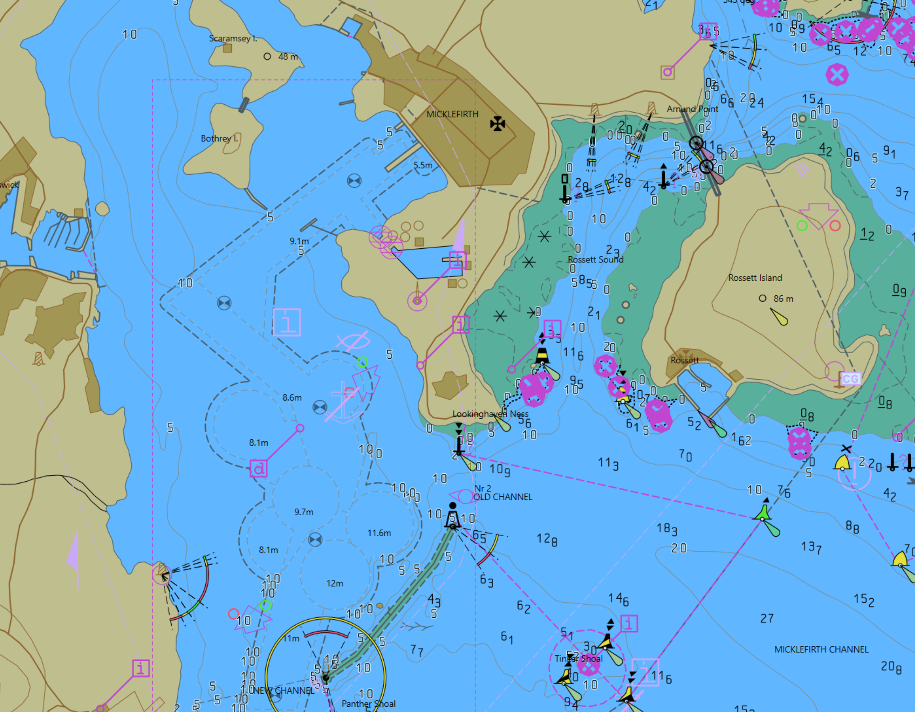

Action
Query the display at position 32.5078S,60.9123E
Results
The Under Keel Clearance Control Point must have details as follows:
  - Name: CP02
  - Expected Passing Time: 2025-10-30T01:30:00Z
  - Expected Passing Speed: 10
  - Distance Above UKC Limit: 1.0

Marine Harbour Infrastructure (S-131)
Test Reference |  | Marine Harbour Infrastructure. |  |  |  | IHO Reference |  |  | S-98 6.1.1
Test Description
Ensure the ECDIS is capable of displaying the mandatory overlays of S-131
TODO: Portrayal of S-131 has been updated for 2.0.0

Loaded Data
Exchange Set Name
Display Mode |  |  |  |  | Independent Mariner’s Selections (default=On)
Other |  |  |  |  | Accuracy
Context Parameters |  |  |  |  | Contour label |  |  |  |  | On
Safety Contour |  |  | 10 |  | Highlight date dependent
Safety Depth |  |  | 8 |  | Highlight document
Deep Contour |  |  | 30 |  | Highlight info
Shallow Contour |  |  | 5 |  | Shallow Pattern |  |  |  |  | Off
Four Shades |  |  | On |  | Unknown
Radar Overlay |  |  |  |  | Update Review
Plain Boundaries |  |  | Off |  | Text Groups |  |  |  |  | On
Simplified Symbols |  |  | Off |  | Chart Text
Full Light Lines |  |  |  |  | Important text
Ignore scale minimum |  |  |  |  | Other Text
Shallow Water Dangers |  |  |  |  | Names
Palette |  |  |  |  | Light description
Day |  |  |  |  | All other chart text
Date Dependent Objects |  |  |  |  | Display
Start Date |  |  |  |  | Centre |  | 32.494S,60.9314E
End Date |  |  |  |  | Scale |  | 1:45,000
 |  |  |  |  | Orientation
Viewing Groups (Default = On)
Standard Display |  |  |  |  |  | Other
Drying lines |  |  |  |  |  | Spot soundings
Buoys. Beacons, aids to navigation |  |  |  |  |  | Submarine cables and pipelines
Buoys, beacons, structures |  |  |  |  |  | All isolated dangers
Lights |  |  |  |  |  | Magnetic variation
Boundaries and limits |  |  |  |  |  | Depth contours
Prohibited and restricted areas |  |  |  |  |  | Seabed
Chart scale boundaries |  |  |  |  |  | Tidal
Cautionary notes |  |  |  |  |  | Miscellaneous (Other)
Ships’ routeing systems and ferry routes
Archipelagic sea lanes
Miscellaneous (Standard)
Chart (Standard)
Alert Highlights (Standard)
Additional
Setup
- Load the Exchange set PowerUp
- Load the Exchange set Overlays
- Switch off all overlays
- Navigate to the documented position and MSVS

Action
- Observe the Display
Results
Action
- Switch on S-129 Under Keel Management Areas
Results
Action
- Query the display at position 32.494S,60.9314E
Results
- Verify that the S-131 feature “Berth” has details as follows:
  - Available Berthing Length = 56.3m

