C:\Documents and Settings\julia.powell\My Documents\IHO TSMAD\S100-0 main\IHO S-100 Main Oct 1 2007.doc © ISO/IEC 2007 – All rights reservedISO-IEC_ 63Complementary elementIntroductory element — Main elementÉlément introductif — Élément central — Élément complémentaireIntroductory element — Main element — Complementary elementE2007-10-2 ISO/IECISO/IEC 2007 ISO/IEC ISO/IEC _(E). 2Heading 2Heading 1 02 STD Version 2.1c20 4



WD-111
Published by the
International Hydrographic Organization
4b quai Antoine 1er
Principauté de Monaco
Tel: (377) 93.10.81.00
Fax: (377) 93.10.81.40
info@iho.int
www.iho.int

Surface Currents Product Specification

Edition 2.1.0 – October 2026

© Copyright International Hydrographic Organization 2026
This work is copyright. Apart from any use permitted in accordance with the Berne Convention for the Protection of Literary and Artistic Works (1886), and except in the circumstances described below, no part may be translated, reproduced by any process, adapted, communicated or commercially exploited without prior written permission from the International Hydrographic Organization (IHO). Copyright in some of the material in this publication may be owned by another party and permission for the translation and/or reproduction of that material must be obtained from the owner.
This document or partial material from this document may be translated, reproduced or distributed for general information, on no more than a cost recovery basis. Copies may not be sold or distributed for profit or gain without prior written agreement of the IHO Secretariat and any other copyright holders.
In the event that this document or partial material from this document is reproduced, translated or distributed under the terms described above, the following statements are to be included:
“Material from IHO publication [reference to extract: Title, Edition] is reproduced with the permission of the IHO Secretariat (Permission No ……./…) acting for the International Hydrographic Organization (IHO), which does not accept responsibility for the correctness of the material as reproduced: in case of doubt, the IHO’s authentic text shall prevail. The incorporation of material sourced from IHO shall not be construed as constituting an endorsement by IHO of this product.”
“This [document/publication] is a translation of IHO [document/publication] [name]. The IHO has not checked this translation and therefore takes no responsibility for its accuracy. In case of doubt the source version of [name] in [language] should be consulted.”
The IHO Logo or other identifiers shall not be used in any derived product without prior written permission from the IHO Secretariat.

Document History
Changes to this Specification are coordinated by the Tides, Water Levels and Currents Working Group (TWCWG). New editions will be made available via the IHO web site. Maintenance of the Specification shall conform to IHO Resolution 2/2007 (as amended).
Version Number | Date | Author/Editor | Purpose
Draft 1.0 | December 2012 | D. O’Brien, Auth. | Demonstration Version.
Draft 1.1 | April 2014 | L. Maltais, Ed. | Revision for currents.
Draft 1.2 | August 2014 | L. Maltais, Ed | Additional revision of previous version.
Draft 1.3 | December 2014 | L. Maltais, Ed | Additional revision of previous version.
Draft 1.4 | March 2015 | L. Maltais, Ed | Additional revision of previous version.
Draft 1.5 | March 2015 | K. Hess, B. Sullivan,  C. Kammerer, E. Mong, Eds. | Put into template format, numerous changes.
Draft 1.6 | September 2015 | SCWG members, Eds. | Changes as result of SCWG3 discussions.
Draft 1.7 | December 2015 | K. Hess, Ed. | Changes per review of  Draft 1.6.
Draft 1.8 | February 2016 | K. Hess, Ed. | Changes per review of  Draft 1.7.
Draft 1.9 | September 2016 | K. Hess, TWCWG members, Eds. | Changes as result of TWCWG1 discussions.
Draft 1.10 | January 2017 | K. Hess, TWCWG members, Eds.
Draft 1.11 | October 2017 | K. Hess, TWCWG members, Eds. | Changes as result of TWCWG2 discussions.
Draft 1.12 | April 2018 | K. Hess, TWCWG, DQWG members, Eds. | Changes per review of v1.11.
Edition 1.0.0 | December 2018 | K. Hess, TWCWG, Eds. | Changes per review of v1.12  and TWCWG3.
Edition 1.0.1 | June 2019 | K, Hess, TWCWG, Eds. | Changes per TWCWG, review of test HDF5 files.
Edition 1.1.0 | September 2020 | K, Hess, TWCWG, Eds | Edits after JPN, others review. Use enumerations in Tables 12.1, 12.2, 12,3. Add dataCodingFormat=8.
Edition 1.1.1 | February 2021 | G. Seroka, TWCWG, Eds.
Edition 1.2.0-20220831 | August 2022 | R. Malyankar | Aligned with S-100 5.0.0; harmonized document structure and content with S-104 1.1.0 (Aug. 2022); new enumeration dictionary material
Edition 1.2.0-20230131 | February 2023 | R. Malyankar, G. Seroka | Added attribute surfaceCurrentTime for DCF 8; specified datatype size for HDF5 attributes; harmonized structure and text with S-104 1.1.0; updated references; updated rules for dataset and support file names; guidance on (optional) ISO metadata; adjusted language on use of Schematron and digital signatures; added emphasis for differences between S-100 and S-111 exchange catalogues; added productIdentifier metadata attribute; new remarks for depth type index; clarification of attribute dimension in feature type metadata; added Res. 3/1919 as a separate reference; harmonized attribute multiplicity and remarks with S-104 in feature instance metadata (Tables 12.3, 12.4). Figures in Annex E removed.
Edition 1.2.0 | April 2023 | R. Malyankar | Removed DCF4 from DCEG remarks for surface current time; added remark for number of times attribute in values table overriding similar instance attribute; corrected S-100 error in digital signature types in metadata; applied feedback from TWCWG.
Edition 2.0.0 Draft 1 | February 2024 | R. Malyankar | Provide for non-uniform time series with moving platforms (DCF4); update references; registry producer code URL replaced with main page URL; citation of S-100 WG7 paper removed and usage sentences updated (register is now active in the GI registry); date fill value updated (table 10.3); Annex B (add. Terms) removed, selected terms added in 1.4; deleted 4.5.3 (summary of ISO/S-100 spatial types); added new WGS84 realizations and UTM codes (clause 5); aligned to S-100 5.2.0 (esp. Parts 17, 15, 8); added verticalCoordinateBase embedded metadata for S-100 consistency; updated validation check Annex for consistency with S-100 validation group; added information about digital signatures; added material on producing series datasets (7.4); clarifications for S-98 compliance (7.7); fileless cancellation (8.4); increased minimum speed in size formula for portrayal; guidelines for portrayal of time series point data and ungeorectified grids; updated portrayal catalogue structure (9.9); new fill value for date-time attribute; described encoding for optional data value attributes; removed ISO metadata files; added restriction on length of string attributes in metadata (12.3); added use case (Annex F); added paragraph about propelled platforms (G-4); new sample SVG (for new 5.2.0 SVG schema); added tabular pick report outline (J-7); updated UML diagrams.
Ed. 2.0.0 Draft 2 | June 2024 | R. Malyankar | Alignment with S-100 5.2.0; removed Annexes for additional terms, sample datasets, and validation, and updated numbering accordingly, added speed and direction uncertainty attributes, added data offset code for data points in cell centres, feature identification guidance, updated SVG sample arrow, updated data quality section, updated fileless cancellation.
Ed. 2.0.0 Draft 3 | July 2024 | R. Malyankar | Applied PT comments; applied DQWG feedback for clause 6; removed requirement for dynamic harmonization of currents and water levels; relaxed portrayal stringencies for colors and SVG; align principles for classification as new dataset with S-104; citation for portrayal catalogue
Ed. 2.0.0 HSSC draft | September 2024 | R. Malyankar | Changed threshold for arrow size to 2.0 knots; removed provision for omitting optional attributes in Group_F for S-100 5.2.0 conformance; requirement that speed and direction must both be present if one is present; removed “DateTime” as UoM name for surface current time attribute in Group_F; locale constraints corrected (12.2.4).
Ed. 2.0.0 MS draft 1 | October 2024 | R. Malyankar | Applied HSSC comments (removed unused otherLocale (12.2.4); changed name in S100_ProductSpecification to align with GI Registry); updated S-98 reference; updated date in PS metadata (1.7.1).
Edition 2.0.1 Draft 1 | February 2026 | G. Seroka | Corrected dataCodingFormat misspellings (9.2.9)
2.0.1 Draft 2 | July 2026 | R Malyankar | Accumulated clarifications; aligned to S-100 Edition 5.2.1
ED 2.0.1 | September 2026 | R. Malyankar | Applied PT comments; endorsement draft
WD 2.1.0 | October 2026 | R Malyankar | Working draft ed. 2.1.0. Aligned to S-100 5.2.2; modified file-less cancellation for S-100 5.2.2; added guidance for scale ranges, bounding polygon, fallback data, pick reports

Summary of Substantive Changes in Edition 2.1.0
Bold references in the Clauses Affected column indicate the principal sections/clauses that are affected by the described change.
Change Summary | Clauses Affected
Substantive changes in Edition 2.0.1
Corrected three occurrences where “dataCodingFormat” is misspelled as “dataCodingFomat” | 9.2.9
Successor forecasts must be new editions | 8.2.3, 11.1, 11.2.3
Scale ranges for datasets introduced | 7.7.2
Construction of coverages clarified | 7.9
Feature instances in the same data file must not overlap | 10.2.2
Optional attributes must be encoded in Group_F if and only if used in a feature instance | 10.2.2.2
Axis names fixed as latitude, longitude, northing, easting | 10.2.2.3, 10.2.2.6, 10.4
Overrides of values clarified | 10.2.2.4, 10.2.2.5, 12.3
Structure of positioning group clarified | 10.2.2.6
Data types for coordinates | 10.3, 12.3.1, 12.3.2, 12.3.3, A.1
Axis names and order | 10.4
Size limit in terms of the number of value records | 11.1, 11.2.1
File naming convention changed | 11.2.1, 11.2.3
Adjustments to discovery metadata | 12.2.1, 12.2.4, 12.2.6
Storage order clarification | 12.3.2
bounding box mandatory | 12.3.3
Vertical datum added | 12.8
Substantive changes in Edition 2.1.0
Scale ranges and grid resolution | 7.10 (new), 7.7.3, 12.2.6
Bounding polygon guidance | 7.11 (new), 12.2.6
Guidance for fallback data | 7.12 (new)
Updates to metadata for cancellation according to S-100 5.2.2 | 8.2.4.1, 8.2.4.2, 12.2.6
ECDIS legend | 9.5
Guidance for pick reports | 9.9
Added table for data offset code enumeration | 12.3.5
Delete repetitive paragraph about encoding attributes in Group_F | 10.2.2.2

Contents Page
1 Overview 1
1.1 Introduction 1
1.1.1 Data types 1
1.1.2 Display 1
1.1.3 Encoding 1
1.2 Scope 1
1.3 References 2
1.3.1 Normative 2
1.3.2 Informative 2
1.4 Terms, definitions and abbreviations 4
1.4.1 Terms and definitions 4
1.4.2 Abbreviations 9
1.5 Use of language 9
1.6 General data product description 10
1.7 Data Product Specification metadata and maintenance 10
1.7.1 Product Specification metadata 10
1.7.2 IHO Product Specification maintenance 10
2 Specification Scopes 11
3 Dataset Identification 11
4 Data Content and Structure 13
4.1 Introduction 13
4.2 Application Schema 13
4.3 Feature Catalogue 13
4.3.1 Introduction 13
4.3.2 Feature types 13
4.3.3 Feature relationship 14
4.3.4 Attributes 14
4.3.5 Spatial quality 14
4.4 Dataset types 15
4.5 Spatial Schema 15
4.5.1 Coverages 15
4.5.2 Regular grids 16
4.5.3 Points 17
5 Coordinate Reference Systems (CRS) 18
5.1 Horizontal reference system 18
5.2 Vertical reference system 19
5.3 Temporal reference system 20
6 Data Quality 20
6.1 Introduction 20
6.1.1 Data quality indication within datasets 20
6.1.2 Data quality elements and data quality measures (informative) 20
6.1.3 Description of quality elements (informative) 21
6.1.4 Applicable quality measures 22
6.2 Additional components of data quality 26
6.3 Assessment of data quality 26
6.4 Validation checks 27
7 Data Capture and Classification 27
7.1 Data sources 27
7.2 The production process 28
7.2.1 Metadata 28
7.2.2 Surface current data 29
7.2.3 Digital tidal atlas data 29
7.2.4 Validation 29
7.2.5 Digital signatures 29
7.3 Guidance for chunking and compression (informative) 30
7.4 Datasets in a series 30
7.5 Data use purpose 31
7.5.1 Datum requirements 31
7.5.2 Spatial type recommendations 31
7.5.3 Suitability for navigation 31
7.5.4 Use purpose metadata 31
7.6 Compliance categories 31
7.7 Compliance with S-98 31
7.7.1 Requirements for visual interoperability 31
7.7.2 Requirements for harmonised user experience 31
7.8 Vertical datums 32
7.9 Construction of coverages 32
7.10 Scale ranges 32
7.10.1 Maximum, minimum, and optimum display scales in discovery metadata 32
7.10.2 Grid resolutions 32
7.11 Bounding polygon requirements and guidelines 33
7.11.1 Requirements 33
7.11.2 Guidelines 33
7.12 Fallback data 33
8 Maintenance 34
8.1 Maintenance and update frequency 34
8.1.1 Update of tidal atlases and harmonic constants (informative) 34
8.2 Metadata related to dataset maintenance 35
8.2.1 Elements used in S-111 35
8.2.2 New datasets 35
8.2.3 New Editions 36
8.2.4 Cancellations 36
8.2.5 Other S100_Purpose values (Informative) 38
8.2.6 Maintenance of support files 38
8.2.7 Encoding update frequency 38
9 Portrayal 38
9.1 Introduction 38
9.2 Display of current at a single point 39
9.2.1 Arrow shape 39
9.2.2 Arrow direction 40
9.2.3 Arrow colour and speed bands 40
9.2.4 Arrow size 41
9.2.5 Numerical values 42
9.2.6 Transparency 43
9.2.7 Scalable Vector Graphics 43
9.2.8 Symbol placement 43
9.2.9 Application to time series and moving platform data 43
9.3 Display of regularly gridded data 44
9.3.1 High resolution 44
9.3.2 Low resolution 46
9.3.3 Application to ungeorectified grid data 48
9.4 Temporal rules 48
9.5 ECDIS legend 48
9.5.1 Contents of legend 48
9.5.2 Placement of legend 48
9.6 Interoperability 49
9.6.1 Symbol priority 49
9.6.2 Colour discrimination 49
9.7 Sample representation 50
9.8 Portrayal rules 51
9.9 Pick report 51
9.10 Construction and packaging of Portrayal Catalogues 52
9.11 Portrayal Catalogue citation information 53
10 Data Product Format (Encoding) 54
10.1 Introduction 54
10.2 HDF5 product structure 54
10.2.1 Data type definition 54
10.2.2 Product structure 55
10.3 Datatypes for coordinates 64
10.4 Axis names and ordering 65
11 Data Product Delivery 65
11.1 Introduction 65
11.2 HDF5 Dataset Packaging 66
11.2.1 Exchange Sets 66
11.2.2 Exchange Catalogue 68
11.2.3 Dataset file naming 68
11.2.4 Support Files 69
11.2.5 Support File Naming 70
12 Metadata 70
12.1 Introduction 70
12.1.1 Realisation of Exchange Set components and metadata classes (informative) 70
12.1.2 Exchange Set components and related metadata 71
12.2 Discovery metadata 73
12.2.1 S100_ExchangeCatalogue 76
12.2.2 S100_ExchangeCatalogueIdentifier 77
12.2.3 S100_CataloguePointofContact 77
12.2.4 S100_DatasetDiscoveryMetadata 78
12.2.5 S100_NavigationPurpose 81
12.2.6 S100_DataCoverage 81
12.2.7 S100_Purpose 83
12.2.8 S100_TemporalExtent 83
12.2.9 S100_EncodingFormat 83
12.2.10 S100_ProductSpecification 84
12.2.11 S100_CompliancyCategory 84
12.2.12 S100_ProtectionScheme 85
12.2.13 S100_SupportFileDiscoveryMetadata 85
12.2.14 S100_SupportFileFormat 86
12.2.15 S100_SupportFileRevisionStatus 86
12.2.16 S100_SupportFileSpecification 87
12.2.17 S100_ResourcePurpose 87
12.2.18 S100_CatalogueDiscoveryMetadata 87
12.2.19 S100_CatalogueScope 88
12.2.20 MD_MaintenanceInformation 89
12.2.21 MD_MaintenanceFrequencyCode 89
12.2.22 PT_Locale 90
12.2.23 S100_SE_CertificateContainer 90
12.2.24 S100_SE_DigitalSignatureReference 90
12.2.25 S100_SE_DigitalSignature 91
12.2.26 S100_SE_SignatureOnData 91
12.2.27 S100_SE_SignatureOnSignature 91
12.2.28 DataStatus 92
12.2.29 EX_GeographicBoundingBox 92
12.2.30 EX_BoundingPolygon 93
12.3 Carrier metadata 95
12.3.1 General metadata - details 101
12.3.2 Feature Type metadata - details 104
12.3.3 Feature Instance metadata - details 106
12.3.4 Values Group attributes - details 108
12.3.5 Additional enumerations used in carrier metadata 109
E.1 UpperRight 115
E.2 LowerRight 115
E.3 UpperLeft 115
13 Language 115
ANNEX A – Data Classification and Encoding Guide 117
A-1 Features 117
A-2 Feature Attributes 117
ANNEX B – Comprehensive Model Including Application Schema and Carrier Metadata (UML Diagrams) 119
ANNEX C – Feature Catalogue 131
ANNEX D – Use Cases 135
D-1 Ferry Sailing Plan Optimization 135
D-1.1 Summary 135
D-1.2 Additional details 135
D-1.3 Simulation Results 136
D-1.4 Data 136
ANNEX E – Surface Current Data 139
E-1 Data Sources 139
E-2 Data Organization 139
E-2.1 Time series data 139
E-2.2 Gridded data 141
E-3 Digital Tidal Atlas Data 142
E-4 Moving Platform Data 142
E-4.1 Drifting platforms 142
E-4.2 Propelled platforms 143
E-5 Preliminary Data Product Format 143
E-6 Additional Features of the Data 144
E-6.1 Vertical Reference Datums 144
E-6.2 Uncertainty 144
ANNEX F – Colour Tables (Informative) 145
ANNEX G – Scalable Vector Graphics (SVG) Coding (Informative) 147
G-1 Sample SVG Images 147
G-2 Sample SVG File to Display Arrows 147
G-3 Sample CSS File 148
ANNEX H – Surface Current Portrayal Rules 151
H-1 Introduction 151
H-2 The Surface Current Symbol 151
H-3 Symbol Size and Orientation 152
H-4 Placement of the Symbol 153
H-5 Thinning of a Field of Arrows 153
H-6 Temporal Rules 154
H-7 Pick Report for Time Series Data (informative) 154

FOREWORD

The International Hydrographic Organization Tides, Water Level and Currents Working Group (TWCWG) remembers Kurt Hess, and acknowledges his invaluable and significant contributions in developing this Product Specification within the TWCWG.

Page intentionally left blank

Overview
From ancient times of exploration to modern day shipping, surface currents have played an important role in navigation. With the advent of electronic navigation, surface current data and updates are more accessible and easier to integrate into navigation displays. This integration of the chart with other supplemental data improves decision making and results in more efficient navigation.

Introduction
The S-111 Product Specification describes the feature Surface Current and its two attributes Surface Current Speed and Surface Current Direction (see Annex A - Data Classification and Encoding Guide), and the relationships of surface currents and their mapping to a dataset. The Surface Current represents the water velocity at one or more geographic locations at either (a) a given depth relative to a named vertical datum, or (b) an average from the sea surface (that is, air-sea interface) down to a given depth. The ‘surface’ (in the definition of Surface Current) is defined here as roughly the top 25 metres. The current values are obtained through in situ or remote measurement or by analytic methods or hydrodynamic modelling. The Product Specification includes general information for data identification as well as for data content and structure, reference system, data quality aspects, data capture, maintenance, encoding, delivery, metadata and portrayal.

Data types
A dataset containing Surface Current data describes a set of values distributed over an area. The structure containing the values is either a Grid Coverage or a Point Coverage.
- Gridded data consists of a set of attribute values organized in a grid together with metadata to describe the meaning of the attribute values and spatial referencing information to position the data. An essential characteristic of a regular grid is that the geographic position of any node can be computed from the values of the origin and point spacing. Therefore, a Grid Coverage is appropriate for this type of data. A Coverage includes a function which provides values at geographic locations within the extent of the grid. A continuous function provides values at all locations, while a discrete function, which is used for Surface Currents, provides values at only specific points (for example grid nodes).
- Another type of structure is a Point Coverage, which also contains metadata and attribute values, although the locations of the points are not organized into a regular grid. The location of all points must be explicitly specified. There is no coverage function.

Display
This Product Specification describes one way of displaying surface current information, as an arrow shape pointing in the direction of current flow whose colour and size are determined by the velocity of the current. This arrow shape is used by both gridded and point data types. For gridded data, the symbol is placed at the points constituting the grid and represents the speed and direction of currents at the grid point.

Encoding
The Hierarchical Data Format version 5 (HDF5) promotes compatible data exchange due to its common neutral encoding format, and is the format used for this data product. HDF5 is object oriented and suitable for many types of data and forms the basis of the Network Common Data Form (NetCDF), a popular format used for scientific data.

Scope
This document describes an S-100 compliant Product Specification for surface currents and it specifies the content, structure, and metadata needed for creating a fully compliant S-111 product and for its portrayal within an S-100 electronic charting environment. This Product Specification includes the content model, the encoding, the Feature Catalogue and metadata. The surface current product may be used either alone or combined with other S-100 compatible data.

References

Normative
HDF5 Hierarchical Data Format version 5 – www.hdfgroup.org
M-3 Resolutions of the International Hydrographic Organization, IHO Publication M-3, 2nd Edition, 2010 (updated July 2023)
Res. 3/1919 IHO Resolution 3/1919 (as amended), IHO Publication M-3
S-44 IHO Standards for Hydrographic Surveys, 6th Edition, September 2020
S-62 List of Data Producer Codes (online), IHO GI registry, URL: https://registry.iho.int
S-97 IHO Guidelines for Creating S-100 Product Specifications, Edition 2.0.0 (in preparation)
S-98 Data Product Interoperability in S-100 Navigation Systems, Edition 3.0.0 (in preparation)
S-100 IHO Universal Hydrographic Data Model, Edition 5.2.2, in preparation
S-158 Validation Checks – Introduction and Structure, Edition 1.0.0, February 2025.
S-158:100 Validation Checks (Universal Hydrographic Data Model), Edition 1.0.0, February 2025.
S-158:111 Validation Checks – Surface Currents, Edition 1.1.0 (in preparation)
S-158:98 Data Product Interoperability Validation Checks, Edition 1.0.0, February 2025.
NOTE: Titles and numbers for publications in preparation are provisional pending publication by the IHO.

Informative
CO-OPS Tide and Current Glossary 2000
IALA G1143 Unique Identifiers for Maritime Resources, Edition 3.0. International Association of Marine Aids to Navigation and Lighthouse Authorities, June 2021.
IOC 14-4 Manual on Sea-level Measurements and Interpretation, Volume IV : An update to 2006. Paris, Intergovernmental Oceanographic Commission of UNESCO. (IOC Manuals and Guides No.14, vol. IV; JCOMM Technical Report No.31; WMO/TD. No. 1339).
ISO 3166-1:1997 Country Codes
ISO 8601:2004 Data elements and interchange formates - Information interchange - Representation of dates and times. 2004
ISO 19101:2002 Geographic information - Reference model. 2002
ISO/TS 19103:2005 Geographic information – Conceptual schema language
ISO 19105:2000 Geographic information - Conformance and testing. 2000
ISO 19107:2003 Geographic information - Spatial schema. 2003
ISO 19108:2002 Geographic information - Temporal schema. 2002
ISO 19109:2005 Geographic information - Rules for application schema. 2005
ISO 19110:2005 Geographic information - Methodology for feature cataloguing. 2005
ISO 19111:2003 Geographic information – Spatial referencing by coordinates
ISO 19113:2002 Geographic information - Quality principles. 2002
ISO 19115-1 Geographic information – Metadata – Part 1 – Fundamentals. As amended by Amendment 1, 2018
ISO 19115-2:2009 Geographic information – Metadata: Extensions for imagery and gridded data
ISO 19115-3 Geographic information – Metadata - XML schema implementation for fundamental concepts. 2016
ISO 19116:2004 Geographic information - Positioning services. 2004
ISO 19117:2005 Geographic information - Portrayal. 2005
ISO 19118:2005 Geographic information - Encoding. 2005
ISO 19123:2005 Geographic information – Schema for coverage geometry and functions
ISO 19128:2005 Geographic information - Web Map Server interface. 2005
ISO 19129:2009 Geographic information – Imagery gridded and coverage data framework
ISO/TS 19130:2010 Geographic information - Imagery sensor models for geopositioning. 2010
ISO/TS 19130-2:2010 Geographic information - Imagery sensor models for geopositioning - Part 2. 2010
ISO 19131:2007 Geographic information – Data product specifications
ISO 19132:2007 Geographic information - Location-based services – Reference model. 2007
ISO 19133:2005 Geographic Information - Location-based services - Tracking and navigation. 2005
ISO 19136:2007 Geographic information - Geography Markup Language (GML). 2007
ISO/TS 19138:2006 Geographic information - Data quality measures. 2006
ISO 19142:2010 Geographic information - Web Feature Service. 2010
ISO 19144-1:2009 Geographic information - Classification systems – Part 1: Classification system structure. 2009
ISO 19145:2010 Geographic information - Registry of representations of geographic point location. 2010
ISO 19153:2010 Geographic information - Geospatial Digital Rights Management Reference Model (GeoDRM RM) 1). 2010
ISO 19156:2010 Geographic information - Observations and measurements. 2010
ISO 19157:2013 Geographic information – Data Quality. As amended by Amendment 1, 2018
ISO 19158:2010 Geographic Information - Quality assurance of data supply. 2010
ISO/IEC 19501-1 and 19505-2, Information technology — Open Distributed Processing – Unified Modelling Language Version 2.4.1
netCDF Network Common Data Form Unidata - www.unidata.ucar.edu/software/netcdf
NGA 2021 Recent Update to WGS 84 Reference Frame and NGA Transition to IGS ANTEX, NGA Office of Geomatics / GNSS Division, St. Louis, National Geospatial-Intelligence Agency, 2021.
NGA 2023 WGS 84 (G2296) Terrestrial Reference Frame Realization, Office of Geomatics, National Geospatial-Intelligence Agency, NGA-U-2023-02846, 2023.
RFC 3986 Uniform Resource Identifier (URI): Generic Syntax. T. Berners-Lee, R. Fielding, L. Masinter. Internet Standard 66, IETF. URL: http://www.ietf.org/rfc/rfc3986.txt or http://www.rfc-editor.org/info/std66
RFC 2141 URN Syntax. R. Moats. IETF RFC 2141, May 1997. URL: http://www.rfc-editor.org/info/rfc2141
S-32 International Hydrographic Dictionary. URL: http://iho-ohi.net/S32/index.php
S-101 IHO Electronic Navigational Chart Product Specification, Edition 2.1.0 (in preparation)
S-102 IHO Bathymetric Surface Product Specification, Edition 3.1.0 (in preparation)
S-104 IHO Water Level Information for Surface Navigation Product Specification, Edition 2.1.0, (n preparation)
XML Schema Part 2: Datatypes, Second Edition, W3C Recommendation, 28 October 2004, URL: https://www.w3.org/TR/xmlschema-2/

Terms, definitions and abbreviations

Terms and definitions
The S-100 framework is based on the ISO 19100 series of geographic standards. The terms and definitions provided here are used to standardize the nomenclature found within that framework, whenever possible. They are taken from the references cited in clause 1.3; modifications were made when necessary.
accuracy
closeness of agreement between an observed value and the true value or a reference value accepted as true [ISO 19157, ISO 19116]
NOTE 1: A test result can be observations or measurements
NOTE 2: For positioning services, the test result is a measured value or set of values
NOTE 3: For observations and measurements, true values are not obtainable. In their place reference values which are accepted as true values are used
application schema
conceptual schema for data required by one or more applications [ISO 19101]
confidence level
the probability that the value of a parameter falls within a specified range of values
continuous coverage
coverage that returns different values for the same feature attribute at different direct positions within a single geometric object in its spatiotemporal domain [ISO 19123]
NOTE Although the spatiotemporal domain of a continuous coverage is ordinarily bounded in terms of its spatial extent, it can be subdivided into an infinite number of direct positions.
coordinate
one of a sequence of numbers designating the position of a point in N-dimensional space
NOTE: In a coordinate reference system, the coordinate numbers are qualified by units.
coordinate reference system
coordinate system that is related to an object by a datum
NOTE: For geodetic and vertical datums, the object will be the Earth.
coverage
feature that acts as a function to return values from its range for any direct position within its spatial, temporal, or spatiotemporal domain
EXAMPLE: Examples include a raster image, polygon overlay, or digital elevation matrix.
NOTE: In other words, a coverage is a feature that has multiple values for each attribute type, where each direct position within the geometric representation of the feature has a single value for each attribute type.
coverage geometry
configuration of the domain of a coverage described in terms of coordinates
data product
dataset or dataset series that conforms to a data product specification
NOTE: The S-111 data product consists of metadata and one or more sets of speed and direction values.
data quality
a set of elements describing aspects of quality, including a measure of quality, an evaluation procedure, a quality result, and a scope
data quality element
quantitative component documenting the quality of a dataset [ISO 19101:2002]
NOTE: The applicability of a data quality element to a dataset depends on both the dataset’s content and its product specification, the result being that all data quality elements may not be applicable to all datasets
data quality evaluation procedure
the whole of operations used in applying and reporting quality evaluation methods and their results [ISO 19113]
data quality measure
an evaluation of a data quality sub-element [ISO 19113]
data quality overview element
the non-quantitative component documenting the quality of a dataset. Information about the purpose, usage, and lineage of a dataset is non-quantitative quality information
NOTE Information about the purpose, usage and lineage of a dataset is non-quantitative quality information. [ISO 19101]
data quality result
a value or set of values resulting from applying a data quality measure or the outcome of evaluating the obtained value or set of values against a specified conformance quality level
EXAMPLE A data quality result of “90” with a data quality value type of “percentage” reported for the data quality element and its data quality subelement “completeness, commission” is an example of a value resulting from applying a data quality measure to a data specified by a data quality scope. A data quality result of “true” with a data quality value type of “Boolean variable” is an example of comparing the value (90) against a specified acceptable conformance quality level (85) and reporting an evaluation of a kind, pass or fail. [ISO 19113]
data quality scope
the extent or characteristic(s) of the data for which quality information is reported [ISO 19113]
NOTE: A data quality scope for a dataset can comprise a dataset series to which the dataset belongs, the dataset itself, or a smaller grouping of data located physically within the dataset sharing common characteristics. Common characteristics can be an identified feature type, feature attribute, or feature relationship; data collection criteria; original source; or a specified geographic or temporal extent. [S-100 Annex A]
data quality sub-element
a component of a data quality element describing a certain aspect of that data quality element [ISO 19103]
dataset
identifiable collection of data [ISO 19115]
NOTE A dataset may be a smaller grouping of data which, though limited by some constraint such as spatial extent or feature type, is located physically within a larger dataset. Theoretically, a dataset may be as small as a single feature or feature attribute contained within a larger dataset. A hardcopy map or chart may be considered a dataset.
dataset series
collection of datasets sharing the same product specification [ISO 19115]
datum
parameter or set of parameters that define the position of the origin, the scale, and the orientation of a coordinate system [ISO 19111, ISO 19116]
NOTE 1: A datum defines the position of the origin, the scale, and the orientation of the axes of a coordinate system
NOTE 2: A datum may be a geodetic datum, a vertical datum, an engineering datum, an image datum, or a temporal datum
depth-specific current
the water current at a specified depth below the sea surface
direct position
position described by a single set of coordinates within a coordinate reference system
domain
well-defined set. Domains are used to define the domain set and range set of attributes, operators, and functions
NOTE: Well-defined means that the definition is both necessary and sufficient, as everything that satisfies the definition is in the set and everything that does not satisfy the definition is necessarily outside the set.
feature
abstraction of real-world phenomena
EXAMPLE: The phenomenon named Eiffel Tower may be classified with other similar phenomena into a feature type named tower.
NOTE 1: A feature may occur as a type or an instance. Feature type or feature instance shall be used when only one is meant.
NOTE 2: In UML 2, a feature is a property, such as an operation or attribute, which is encapsulated as part of a list within a classifier, such as an interface, class, or data type.
feature attribute
characteristic of a feature
EXAMPLE 1: A feature attribute named colour may have an attribute value green which belongs to the data type text.
EXAMPLE 2: A feature attribute named length may have an attribute value 82.4 which belongs to the data type real.
NOTE 1: A feature attribute may occur as a type or an instance. Feature attribute type or feature attribute instance is used when only one is meant.
NOTE 2: A feature attribute type has a name, a data type, and a domain associated to it. A feature attribute instance has an attribute value taken from the domain of the feature attribute type.
NOTE 3: In a Feature Catalogue, a feature attribute may include a value domain but does not specify attribute values for feature instances.
function
rule that associates each element from a domain (source, or domain of the function) to a unique element in another domain (target, codomain, or range)
geometric object
spatial object representing a geometric set
NOTE: A geometric object consists of a geometric primitive, a collection of geometric primitives, or a geometric complex treated as a single entity. A geometric object may be the spatial representation of an object such as a feature or a significant part of a feature.
georectified
corrected for positional displacement with respect to the surface of the Earth [ISO 19115-2]
georeferenced grid
grid for which cells can be located geographically by the use of specific algorithms or additional data
grid
network composed of a set of elements, or cells, whose vertices, or nodes, have defined positions within a coordinate system. See also georeferenced grid, regular grid, rectangular grid, ungeorectified grid, node and grid point.
grid cell
element of a grid defined by its vertices, or nodes
grid coordinates
sequence of two or more numbers specifying a position with respect to its location on a grid
grid point
point located at the intersection of two or more grid cells in a grid. Also called a node.
gridded data
data whose attribute values are associated with positions on a grid coordinate system [ISO 19115-2]
positional accuracy
closeness of coordinate value to the true or accepted value in a specified reference system
NOTE: The term absolute accuracy is sometimes used for this concept to distinguish it from relative positional accuracy. Where the true coordinate value may not be perfectly known, accuracy is normally tested by comparison with available values that can best be accepted as true [ISO 19116]
layer-averaged surface current
the water current averaged over the vertical, from the surface to a specified depth below the sea surface
EXAMPLE: The current averaged from 0 metres (sea surface) down to 10 metres.
measurement
the (detailed) dimensions of a physical quantity [S-32]
node
a point located at the vertex of a grid cell. Also called a grid point
observation
the act or practice of noting and recording facts and events as for some scientific study. The measure of a quantity whose value is desired. The DATA so noted and recorded. A single measure, at a single setting of an apparatus [S-32]
point
zero-dimensional geometric primitive, representing a position
NOTE: The boundary of a point is the empty set [ISO 19107]
point coverage
coverage that has a domain composed of points [ISO 19123]
point set
set of 2, 3 or n dimensional points in space. [S-100]
point set coverage
coverage function associated with point value pairs in 2 dimensions. [S-100]
NOTE: a coverage function is driven by a set of points (with X, Y position) together with a record of one or more values at that position.
portrayal
presentation of information to humans [ISO 19109, ISO 19117]
portrayal catalogue
collection of defined portrayals for a feature catalogue
NOTE: Content of a portrayal catalogue includes portrayal functions, symbols, and portrayal context. [ISO 19117]
portrayal context
circumstances, imposed by factors extrinsic to a geographic dataset, that affect the portrayal of that dataset.
EXAMPLE: Factors contributing to portrayal context may include the proposed display or map scale, the viewing conditions (day/night/dusk), and the display orientation requirements (north not necessarily at the top of the screen or page), among others
NOTE: Portrayal context may influence the selection of portrayal functions and construction of symbols [ISO 19117]
portrayal function
function that maps geographic features to symbols
NOTE: Portrayal functions can also include parameters and other computations that are not dependent on geographic feature properties [ISO 19117]
portrayal rule
specific kind of portrayal function expressed in a declarative language
NOTE: A declarative language is rule based and includes decision and branching statements [ISO 19117]
positional accuracy
closeness of coordinate value to the true or accepted value in a specified reference system
NOTE: The term absolute accuracy is sometimes used for this concept to distinguish it from relative positional accuracy. Where the true coordinate value may not be perfectly known, accuracy is normally tested by comparison with available values that can best be accepted as true [ISO 19116]
range <coverage>
set of feature attribute values associated by a function with the elements of the domain of a coverage
record
finite, named collection of related items (objects or values)
NOTE: Logically, a record is a set of pairs <name, item>.
rectangular grid
an orthogonal grid whose cells are rectangles
regular grid
a georeferenced rectangular grid with geodetic coordinates, with the X-axis directed eastward, the Y-axis directed northward, and uniform spacing of points in each direction. Spacing units are degrees of arc
result scope
scope of the (data quality) result
NOTE: Result scope is a subset of the data quality scope. [S-97 ed. 1.1]
sea surface
a two-dimensional (in the horizontal plane) field representing the air-sea interface, with high-frequency fluctuations such as wind waves and swell, but not astronomical tides, filtered out
EXAMPLE: sea surface, river surface, and lake surface.
NOTE: This implies marine water, lakes, waterways, navigable rivers, etc.
sequence
finite, ordered collection of related items (objects or values) that may be repeated
NOTE: Logically, a sequence is a set of pairs <item, offset>. LISP syntax, which delimits sequences with parentheses and separates elements in the sequence with commas, is used in this international standard [ISO 19107]
standalone quality report
free text document providing fully detailed information about data quality evaluations, results and measures used [ISO 19157:2013]
surface current
the horizontal motion of water at a navigationally significant depth, or the vertical average over a depth, represented as a velocity vector (that is, speed and direction). Depths may extend from the sea surface down to 25 metres
NOTE: IHO Hydrographic Dictionary: Current, surface: A current that does not extend more than a few (2-3) metres below the surface.
surface current direction
the direction toward which the surface current flows. Units are arc-degrees
NOTE: Measured clockwise from true north. AKA set.
surface current speed
the speed (rate of change of position over time) of a surface current. Units are knots
tessellation
partitioning of a space into a set of conterminous geometric objects having the same dimension as the space being partitioned [ISO 19123] NOTE A tessellation composed of congruent regular polygons or polyhedra is a regular tessellation; One composed of regular, but non-congruent polygons or polyhedra is semi-regular. Otherwise the tessellation is irregular
temporal series
collection of datasets with data for the same geographical area at different times or for successive periods
timestamp
value of time at which an object’s state is measured and recorded [ISO 19132]
uncertainty
the interval (u) about a given value (x) that will contain the true value (v) at a given confidence level (CL).
Thus, CL is the probability that x - u ≤ v ≤ x + u
NOTE: For practical purposes, the confidence level is taken to be 95% and the uncertainty is defined herein as either (a) twice the standard deviation of the differences between observed and predicted values (cf. S-44. IHO Standards for Hydrographic Surveys, 5th Edition, February 2008), or (b) the interval (that is, u) about the mean containing 95% of the differences.
ungeorectified grid
grid with non-uniform point spacing in any coordinate system. Includes triangular and curvilinear coordinate grids whose node positions cannot be calculated from the positions of other nodes
vertical coordinate system
one-dimensional coordinate system used for gravity-related height or depth measurements [ISO 19111]
vertical datum
datum describing the relation of gravity-related heights or depths to the Earth
NOTE: In most cases the vertical datum will be related to mean sea level. Ellipsoidal heights are treated as related to a three-dimensional ellipsoidal coordinate system referenced to a geodetic datum. Vertical datums include sounding datums (used for hydrographic purposes), in which case the heights may be negative heights or depths [ISO 19111]

Abbreviations
This Product Specification adopts the following convention for symbols and abbreviated terms:
DQWG Data Quality Working Group
ECDIS Electronic Chart Display Information System
ENC Electronic Navigational Chart
HDF Hierarchical Data Format
IEEE Institute of Electrical and Electronics Engineers
IHO International Hydrographic Organization
ISO International Organization for Standardization
NetCDF Network Common Data Form
TWCWG Tides, Water Level and Currents Working Group
UML Unified Modelling Language
UTC Coordinated Universal Time

Use of language
Within this document:
- “Must” indicates a mandatory requirement.
- “Should” indicates an optional requirement, that is the recommended process to be followed, but is not mandatory.
- “May” means “allowed to” or “could possibly”, and is not mandatory.

General data product description
NOTE: This clause provides general information regarding the data product.
Title: Surface Currents
Abstract: Encodes information and parameters for use with surface current data.
Content: A conformant dataset may contain features associated with surface currents. The specific content is defined by the Feature Catalogue and the Application Schema.
Spatial Extent: Description: Global, marine areas only.
East Bounding Longitude: 180
West Bounding Longitude: -180
North Bounding Latitude: 90
South Bounding Latitude: -90
Purpose: The data shall be collected/produced for the purpose of providing information about navigationally significant surface currents to ECDIS and other applications.

Data Product Specification metadata and maintenance

Product Specification metadata
This information uniquely identifies this Product Specification and provides information about its creation and maintenance. For further information on dataset metadata see the metadata clause.
Title: Surface Currents
S-100 Version: 5.2.2
S-111 Version: 2.1.0
Date: October 2026
Language: English
Classification: Unclassified
Contact: International Hydrographic Organization.
4 quai Antoine 1er,
B.P.445 MC 98011 MONACO CEDEX
Telephone: +377 93 10 81 00
B.P. 445 Fax: + 377 93 10 81 40
Email: info@iho.int
Role: Owner
URL: https://registry.iho.int
Identifier: S-111
Maintenance: Changes to this Product Specification are coordinated by Tides, Water Level and Currents Working Group (TWCWG) of the IHO and made available via the IHO Publications website. Maintenance of the Product Specification must conform to IHO Technical Resolution 2/2007 (revised 2010). For reporting issues which need correction, use the contact information.

IHO Product Specification maintenance

Introduction
Changes to S-111 will be released by the IHO as a New Edition, revision, or clarification.

New Edition
New Editions of S-111 introduce significant changes. New Editions enable new concepts, such as the ability to support new functions or applications, or the introduction of new constructs or data types. New Editions are likely to have a significant impact on either existing users or future users of S-111. All cumulative revisions and clarifications must be included with the release of approved New Editions.

Revision
Revisions are defined as substantive semantic changes to S-111. Typically, revisions will change S-111 to correct factual errors; introduce necessary changes that have become evident as a result of practical experience or changing circumstances. A revision must not be classified as a clarification. Revisions could have an impact on either existing users or future users of S-111. All cumulative clarifications must be included with the release of approved corrections revisions.
Changes in a revision are minor and ensure backward compatibility with the previous versions within the same Edition. Newer revisions, for example, introduce new features and attributes. Within the same Edition, a dataset of one version could always be processed with a later version of the Feature and Portrayal Catalogues. In most cases a new Feature or Portrayal Catalogue will result in a revision of S-111.

Clarification
Clarifications are non-substantive changes to S-111. Typically, clarifications: remove ambiguity; correct grammatical and spelling errors; amend or update cross references; and insert improved graphics. A clarification must not cause any substantive semantic change to S-111.
Changes in a clarification are minor and ensure backward compatibility with the previous versions within the same Edition.

Version numbers
The associated version control numbering to identify changes (n) to S-111 must be as follows:
New Editions denoted as n.0.0
Revisions denoted as n.n.0
Clarifications denoted as n.n.n

Specification Scopes
This Product Specification outlines the flow of data from inception, through the national Hydrographic Office (HO), to the end user. The data may be observed or modelled. Requirements for data and metadata are provided. This document does not include product delivery mechanisms.
Scope ID: Global
Level: 006 — series
Level name: Surface Current Dataset

Dataset Identification
A surface current dataset that conforms to this Product Specification uses the following general information for distinction:
Title: Surface Current Data Product
Alternate Title: None
Abstract: The data product is a file containing surface water current data for a particular geographic region and set of times, along with the accompanying metadata describing the content, variables, applicable times and locations, and structure of the data product. Surface current data includes speed and direction of the current, and may represent observed or mathematically-predicted values. The data may consist of currents at a small set of points where observations and/or predictions are available, or may consist of numerous points organized in a grid as from a hydrodynamic model forecast. Measures of the quality of position, speed, direction, and time data are included.
Topic Category: Producing Authority to choose the most appropriate from the list below:
Concept Name | ISO 19115-1 Topic Category Number | ISO 19115-1 Topic Category Code | Definition | Remarks
Inland Waters | 012 | inlandWaters | Inland water features, drainage systems and their characteristics  Examples: rivers and glaciers, salt lakes, water utilization plans, dams, currents, floods, water quality, hydrologic information | Use for datasets covering navigation on inland waterways
Oceans | 014 | oceans | Features and characteristics of salt water bodies (excluding inland waters)  Examples: tides, tsunamis, coastal information, reefs | Use for datasets intended for coastal, offshore, or ocean navigation.
Transportation | 018 | transportation | Means and aids for conveying persons and/or goods Examples: roads, airports/airstrips, shipping routes, tunnels, nautical charts, vehicle or vessel location, aeronautical charts, railways | Use for datasets intended for navigation (inland or maritime)

Geographic Description: Areas specific to marine navigation
Spatial Resolution: Varies (for example, 0.1 km to 1000 km). The spatial resolution varies according to the model and the size of grid spacing, or on the number of observing locations adopted by the producer (Hydrographic Office)
Purpose: Surface current data are intended to be used as stand-alone data or as a layer in an ENC.
Language: English (mandatory)
Classification: Data can be classified as one of the following:
1) Unclassified;
2) Restricted;
3) Confidential;
4) Secret;
5) Top Secret;
6) Sensitive but Unclassified;
7) For Official Use Only;
8) Protected; or
9) Limited Distribution.
Spatial Representation Types: Coverage
Point of Contact: Producing Authority.
Use Limitation: Invalid over land. Some datasets may be designated as not for navigation.

Data Content and Structure

Introduction
This clause discusses the Application Schema, which is described in UML; the Feature Catalogue; dataset types, in which there is an extensive discussion of the current data; and geometry.
Surface current data consist of one basic geographic feature type:
- The current speed and direction near the sea surface. The data may either be depth-specific current or layer-averaged surface current. Current data usually are represented as a time series of values for either a single point (that is, one geographic location) or for an array of points. An optional time attribute is also provided for use with certain types of surface current information.
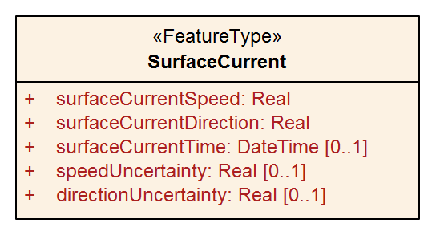
Figure 4-1 – SurfaceCurrent feature class

Attribute surfaceCurrentDirection must be populated if surfaceCurrentSpeed is populated, and vice versa.

Application Schema
This Application Schema shall be expressed in UML. The single feature type, SurfaceCurrent, is depicted in Figure 4-1. The details of the Application Schema are given in Annex B, which also describes its relation to the conceptual model of coverage data described in ISO 19123 and S-100 Part 8.

Feature Catalogue

Introduction
The S-111 Feature Catalogue describes the feature types, information types, attributes, attribute values, associations and roles which may be used in a Surface Current Dataset.
The S-111 Feature Catalogue is available in an XML document which conforms to the S-100 XML Feature Catalogue Schema and can be downloaded from the IHO GI Registry website.

Feature types

Geographic
Geographic (geo) feature types form the principal content of S-111 and are fully defined by their associated attributes and information types.

Meta
Meta features contain information about other features within a dataset. Information defined by meta features override the default metadata values defined by the dataset descriptive records. Meta attribution on individual features overrides attribution on meta features.

Feature relationship
A feature relationship links instances of one feature type with instances of the same or a different feature type. There are three common types of feature relationship: Association, Aggregation and Composition. In S-111 there are no relationships used.

Attributes
S-100 defines feature attributes as either simple or complex. In S-111 there are no complex attributes. S-111 uses two types of simple attributes, described in Table 4-1.
Table 4.1 – Simple feature attribute types
Type | Definition
Real | A signed Real (floating point) number consisting of a mantissa and an exponent
Date and Time | A DateTime is a combination of a date and a time type. Character encoding of a DateTime shall follow ISO 8601:1988  EXAMPLE 19850412T101530

Spatial quality
Spatial quality attributes (Figure 4-2) are encoded as horizontal and vertical uncertainty values. In S-100 they are encoded at the feature type level (see Figure 4-2 and Table 12-2), which means they apply uniformly to all Surface Current feature instances in the dataset and uniformly to all locations (grid points or station locations).
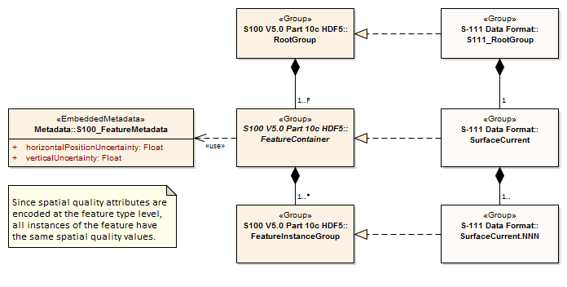
Figure 4-2 Spatial Quality
Note that uncertainty in currents pertains to the quality of data values, not to spatial quality as that term is used in S-100, and is encoded differently and at the instance level (see Table 10-2 and clause 10.2.2.4).
Surface currents are usually defined at one or more individual locations, so spatial quality applies to these locations. Individual uncertainty values apply uniformly to all spatial and temporal points.
NOTE: The Spatial Quality information type used in S-101 and other products is not used in this Edition of S-111 even for station-based data formats.

Dataset types
Datasets for S-111 include one basic type of dataset:
1. HDF5 files, which may contain: (a) time series of predicted or observed current velocities at one or more fixed stations; (b) gridded hydrodynamic model forecast fields; (c) values at multiple locations not in a regular grid (often from hydrodynamic models); or (d) time series of observed current velocities from one or more moving stations such as surface drifters.

Spatial Schema

Coverages
Surface current data are represented in two ways: arrays of points contained in a regular grid, and sets of points not described by a regular grid. Further details on the data product are given in Clause 10 – Data Product Format.
Surface current data has four basic types, based on their sources:
- Observed or predicted values at a number of stationary locations;
- Predicted values (often from hydrodynamic models) arranged in a regular grid;
- Values at multiple locations (often from hydrodynamic models) but not in a regular grid; and
- Observed values at a moving station (such as a surface drifter).
The four types of data have structures that can be described by two S-100 coverages: S100_IF_PointCoverage and S100_IF_GridCoverage (S-100, Clause 8-7).
Grid Coverage: The class S100_IF_GridCoverage represents a set of values assigned to the points in a two-dimensional grid. The spatial structure is a regular grid, described by S100_IF_Grid (S-100, clause 8-7.5). The class S100_IF_Grid is a realization of CV_RectifiedGrid and CV_GridValuesMatrix from ISO 19123 and a component of ISO 19123 continuous quadrilateral grid coverages as realized by S100_IF_GridCoverage.
Point Coverage: The class S100_IF_PointCoverage represents a set of values, such as speed and direction values, assigned to a set of arbitrary X,Y points. The spatial structure is a point set described by S100_IF_PointSet. Each point is identified by a horizontal coordinate geometry pair (X,Y) and assigned one or more values as attribute values. These values are organized in a record for each point.
The types of data and their corresponding coverages are shown in Table 4-1.
Table 4-1 – Surface current data types and their coverages
N | Type of Data | Spatial Structure | Coverage
a | Time series data at one or more stationary locations | S100_IF_PointSet | S100_IF_PointCoverage
b | Regularly-gridded data at one or more times | S100_IF_Grid | S100_IF_GridCoverage
c | Ungeorectified gridded data or point set data at one or more times | S100_IF_PointSet | S100_IF_PointCoverage
d | Time series data for one moving platform | S100_IF_PointSet | S100_IF_PointCoverage

The spatial representations in S-111 are encoded using the implementation specification in S-100 Part 10c, which realises S-100 Part 8 and ISO 19123 conceptual models. The relationships are depicted in Figure 4-3 below.
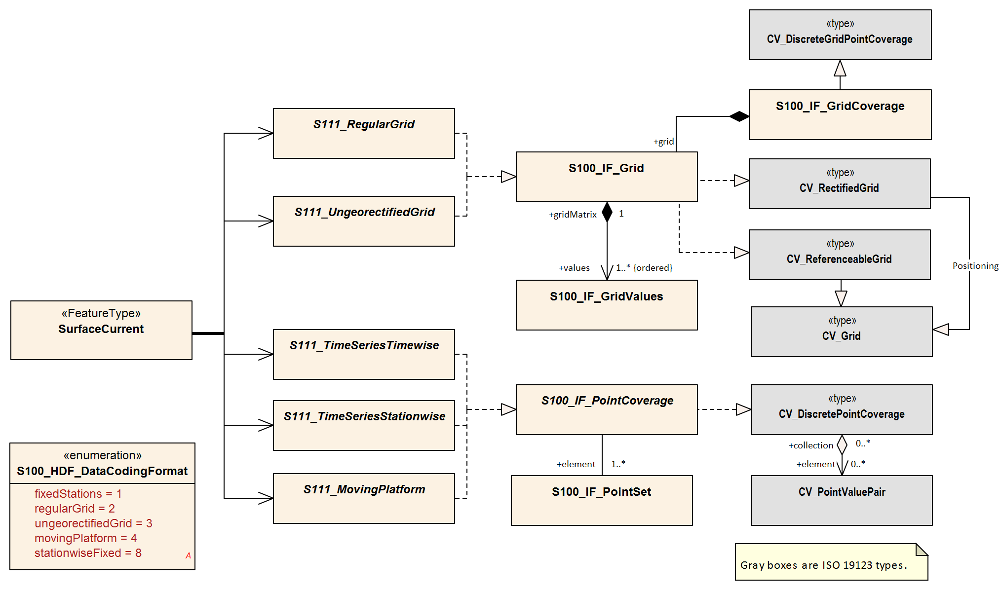
Figure 4-3 – Coverages and their realisation from S-100 Part 8 and ISO 19123

Regular grids
S-111 regular grid geometry is an implementation of S100_IF_Grid (S-100 Part 8 – Imagery and Gridded Data). The spatial grids for the regular grid type are two dimensional, orthogonal, and georeferenced (with the X or longitudinal axis directed toward the east), and are defined by several attributes, including grid origin, spacing, and grid indexing. Current speed and direction values apply at the vertices of the grid; that is, the intersections of the row and column lines. These parameters are explained in more detail below. A typical regular grid and some of its parameters are shown in Figure 4-4.
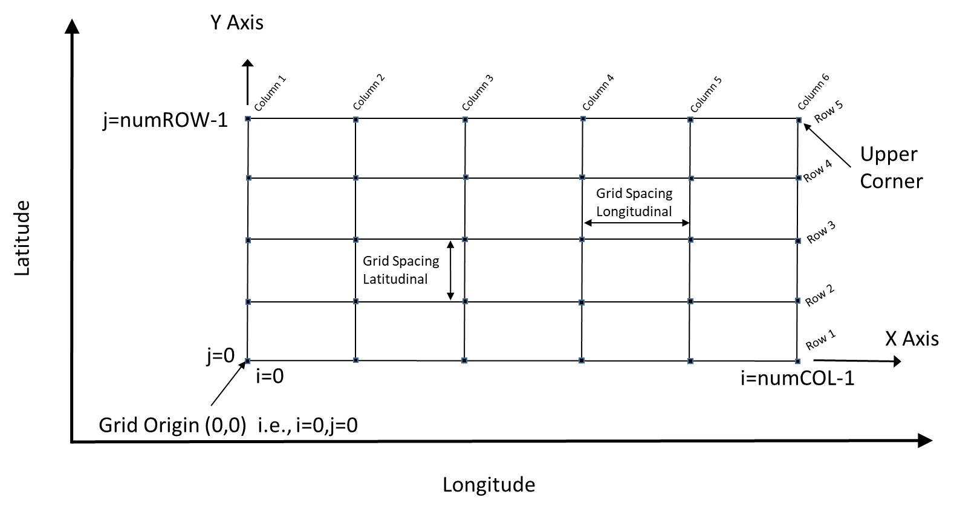
Figure 4-4 - Schematic of the regular grid and some of its attributes
Vertices are shown as the filled squares at the intersections of the rows and columns. The offsetVectors are shown as the Latitudinal Spacing and Longitudinal Spacing. The origin is shown at the lower left corner of the grid.
The grid is oriented to the Earth by the Coordinate Reference System (CRS), with the variable coordinateReferenceSystem. The origin contains the latitude and longitude as a DirectPosition and is located at the point at the lower left (southwest) extent of the grid. The upper corner is the north easternmost point in the grid. The attribute dimension is 2, and the variable interpolationType has the value of ‘discrete’, since there is no spatial interpolation used for surface currents.
S-111 grids allow for different spacing of points along the X (longitudinal) axis and the Y (latitudinal) axis. For rectangular grids the offset vector establishes the cell size. The attribute offsetVectors carries the two vectors for grid spacing (Latitudinal Spacing and Longitudinal Spacing). The first vector is 90 degrees clockwise from CRS north, and represents the distance between grid values on the X axis. The second vector is 0 degrees clockwise from CRS north, and represents the distance between the values on the Y axis. The distances are given in degrees.
The attribute extent effectively defines a bounding rectangle describing where data is provided. The attribute extent carries two sub-attributes; low and high. The sub-attribute low carries the value “0, 0” to indicate the index values at the start of the extent is the southwest (lower left) corner of the grid. The sub-attribute high, carries the value of the highest position along the X axis and the highest position along the Y axis. For example, if the number of rows is numROWS and the number of columns is numCOLS, then the index values for high would be ‘numCOLS-1,numROWS-1’. Together they form the grid coordinate of the upper right corner.
The sequence rule for a regular cell size grid is straightforward. When the cells all have the same dimensions, the cell index can be derived from the position of the Record within the sequence of Records. The attribute sequencingRule has two sub-attributes; type and scanDirection. The sub-attribute type carries the value “linear”, and the sub-attribute scanDirection carries the value “X,Y”. Together with the value “0,0” stored in the attribute startSequence, they indicate that for S-111 the grid values along the X axis at the lowest Y axis position are stored first, starting with the left most value going right, followed by the values along the X axis at the next increment upward along the Y axis, and so on till the top of the Y axis. The last value in the value sequence of the grid will be at the top rightmost position in the grid. In the Figure, first all columns in row 1 are selected, then all columns in row 2, and so on.
NOTE: since the origin is at i_index and j_index value 0, the location of any longitude and latitude in the grid is computed by:
Longitude = GridOriginLongitude + (i_index)(gridSpacingLongitudinal). [Eqn 4.1]
Latitude = GridOriginLatitude + (j_index)(gridSpacingLatitudinal). [Eqn 4.2]

Points
The S-111 Point Coverage is quite flexible and is used herein to describe three broad categories of spatial data: one or more current stations at fixed locations, ungeorectified gridded data, and drifting platform data.
For this type of data (Figure 4-5), the axisNames are the same as for the regular grid. However, the origin is arbitrary, and the extent (cf. the bounding rectangle) may be defined by the minimum and maximum of the geographic positions of the stations. The total number of locations (tidal current stations, ungeorectified grid points, or drifter locations) must be specified. Also, attributes like gridSpacingLongitudinal and scanDirection have no meaning. The position of the locations is carried in the one-dimensional arrays X and Y.
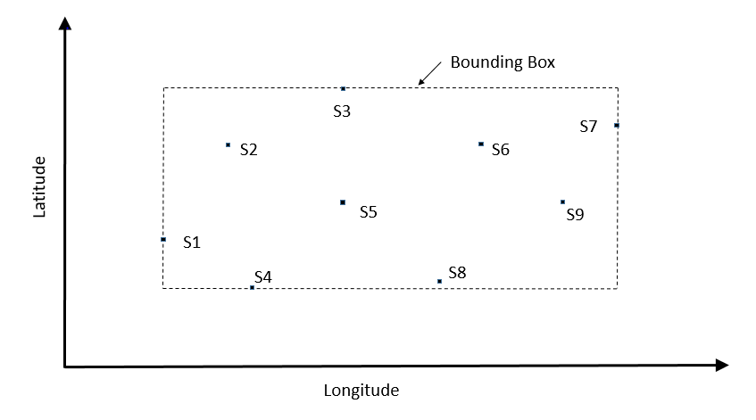
Figure 4-5 – Schematic of the Point Coverage and some of its attributes. Stations or nodes are denoted as “S1”, etc
The points, which may represent fixed stations or nodes in an ungeorectified grid, appear as filled-in rectangles, are labelled and have a format such as ‘S1’.

Coordinate Reference Systems (CRS)
To define the location of features using the S-100 Framework, one first needs to define a Coordinate Reference System (CRS). A Coordinate Reference System in two dimensions uses a coordinate pair, either X and Y for a Cartesian system or latitude and longitude for a geodetic/geographic system to define the location of a feature on a 2-D grid. However, if one wants to plot features in a 3-dimensional Coordinate Reference System, where we now want to include depths on a nautical chart or elevations on a map, one needs to assign the depth or elevation as the third component. For Cartesian systems, one would use X, Y, Z as the triplet or for geodetic/geographic systems, one would use latitude, longitude and height. The height can be the ellipsoid height or any of the other vertical references (see Vertical Reference System below). Geodetic/geographic coordinates are more intuitive for positioning and navigation applications on or near the Earth’s surface while Cartesian coordinates are more appropriate if vectors are needed to accurately illustrate a graphical relationship between two or more points. If geodetic/geographic coordinates are specified, then the IHO recommends using the latest realisation of the World Geodetic System of 1984 (WGS 84).

Horizontal reference system
For products based on the S-100 Framework, including this Standard for S-111 products, the geodetic/geographic Coordinate Reference System must be of the form EPSG:xxxx (with WGS 84 as base datum). The generic form/code for the WGS 84 frame is EPSG:4326 while the latest and most widely adopted realisation of the WGS 84 reference frame as of 2022 was EPSG:9057. The full reference to EPSG can be found at https://epsg.org and other EPSG references for recent WGS 84 realisations are given below:
WGS 84 (generic) ESPG:4326
WGS 84(G2296) EPSG:10606
WGS 84(G2139) EPSG:9755 Valid epoch 2016:0
WGS 84(G1762) EPSG:9057 Valid epoch 2005.0
WGS 84(G1674) EPSG:9056 Valid epoch 2005.0
WGS 84(G1150) EPSG:9055 Valid epoch 2001.0
WGS 84 / UTM Zone 1N to Zone 60N EPSG:32601 – EPSG:32660
WGS 84 / UTM Zone 1S to Zone 60S EPSG:32701 – EPSG:32760
WGS 84 / UPS North (E,N) EPSG:5041
WGS 84 / UPS South (E,N) EPSG:5042

Coordinate Reference System: EPSG:9057 (WGS 84) or another reference system listed above
Datum: WGS 84 defined by NGA
Projection: None / UTM / UPS
Horizontal Units: Decimal degrees / Easting and northing
Coordinate Reference System Registry: EPSG Geodetic Parameter Registry
Date type (according to ISO 19115-1): 002 - publication
Responsible party: International Association of Oil and Gas Producers (IOGP)
Producers of S-111 data must use the same CRS/projection as the underlying S-101 dataset and should endeavour to use the same realisation. (Reference system information encoded in datasets must be such that application software can automatically match reference system information encoded in different data products, especially S-101/S-104.)

Vertical reference system
For positioning and navigation applications, it is desirable to accurately plot depths, bathymetry, elevations and terrain on nautical charts and maps using one or more vertical reference systems. To do so, a vertical datum is defined and serves as a reference surface for vertical positions. Vertical datums come in three categories: 1) those based on Mean Sea Level (MSL); 2) tidal datums; and 3) 3-D datums (ellipsoid) which are realised through space-based systems such as GPS. Vertical datums can be regional (geoid, tidal, chart) or global (ellipsoid) in nature. The vertical axis of a vertical reference system is defined upwards (away from the Earth’s centre) from its origin (EPSG code 6499) or downwards (EPSG code 6498) and is perpendicular to the horizontal surface where the observations or measurements are taken. As an example, a positive value for the level of water above the vertical datum in a vertical reference system with upward orientation (EPSG code 6499) means that the water level is above the vertical reference surface. For nautical charts, depths and tides are measured relative to a chart datum such as Lowest Astronomical Tide (LAT) or Mean Lower Low Water (MLLW).
Coordinate Reference System: Vertical component of a 3-D reference system
Datum: Chart, tidal, geoid, ellipsoid (WGS 84)
Projection: None
Horizontal Units: metres
Coordinate Reference System Registry: EPSG Geodetic Parameter Registry
Date type (according to ISO 19115-1): 002 - publication
Responsible party (vertical datums): National hydrographic and geodetic agencies
The vertical coordinate system is defined by three components. The first component defines the positive vertical direction (either an upward height or a downward depth). The second refers to the base or origin that is, the zero value) of the vertical coordinate; if the base is a tidal datum, the specific datum is defined from either the S-100 list of vertical datums (for example LAT, MLLW, MSL, etc) or the EPSG list. Finally the specific datum number from the appropriate list is given. The components are summarised in Table 5-1.
For surface currents, the vertical reference system would apply to currents at a specific depth/height relative to a vertical datum, but not to vertically-averaged currents; these are an average from the surface down to a given depth.
Table 5.1 – Attributes describing the vertical coordinate system
Name | Remarks
Vertical Coordinate System | EPSG Code; Allowed Values  - 6498 (Depth – Metres – Orientation Down)  - 6499 (Height – Metres – Orientation Up)
Vertical Datum Reference | 1 – S-100 vertical datum  2 – EPSG
Vertical Datum | If verticalDatumReference = 1 this is a value from S100_VerticalAndSoundingDatum  If verticalDatumReference = 2 this is an EPSG code for vertical datum

In S-111, the vertical datum is relevant only if the dataset encodes the nominal depth at which the current values are recorded or predicted. If this nominal depth is encoded, producers should endeavour to use a vertical datum consistent with the CRS in the underlying S-101 and S-102 datasets, except when the S-111 datum is in terms of water surface or sea bottom.

Temporal reference system
The temporal reference system is the Gregorian calendar for date and UTC for time. Time is measured by reference to TM_Calendar dates and TM_Clock time in accordance with ISO 19108:2002, Temporal Schema clause 5.4.4. A date variable will have the following 8-character format (ISO 8601): yyyymmdd. A time variable will have the following 7-character format: hhmmssZ. A date-time variable will have the following 16-character format: yyyymmddThhmmssZ.

Data Quality

Introduction
Quality of surface current data for navigation consists of quality of the observed/predicted/forecast data, quality of the positional data and quality of the time stamp.

Data quality indication within datasets
Data quality may be indicated within datasets in the form of a single uncertainty value applicable to an entire grid or in the data values record as uncertainty values at individual grid points. Clauses 10 (Data Product Format) and 12.3 (Carrier Metadata) describe the encoding of quality indicators within datasets.

Data quality elements and data quality measures (informative)
Data quality allows users and user systems to assess fitness for use of the provided data. Data quality measures and the associated evaluation are reported as metadata of a data product. This metadata improves interoperability with other data products and provides usage by user groups that the data product was not originally intended for. The secondary users can make assessments of the data product usefulness in their application based on the reported data quality measures.
For S-111 the following Data Quality Elements have been included :
- Conformance to this Product Specification;
- Intended purpose of the data product;
- Completeness of the data product in terms of coverage;
- Logical Consistency;
- Positional Uncertainty and Accuracy;
- Thematic Accuracy;
- Temporal Quality;
- Aggregation measures;
- Validation checks or conformance checks including:
  - General tests for dataset integrity;
  - Specific tests for a specific data model.

Description of quality elements (informative)
The description of data quality measures in this clause is based on S-97 Edition 1.1. While this clause describes data quality elements in general, not all of them may be applicable to S-111 data. Clause 6.1.4 indicates the applicability and scope of the data quality elements for this Product Specification.

Completeness
Completeness is defined as the presence and absence of features, their attributes and relationships. It consists of two data quality elements:
- Commission – excess data present in a dataset;
- Omission – data absent from a dataset.

Logical consistency
Logical Consistency is defined as the degree of adherence to logical rules of data structure, attribution and relationships (data structure can be conceptual, logical or physical). If these logical rules are documented elsewhere (for example in a Product Specification) then the source should be referenced (for example in the data quality evaluation). It consists of four data quality elements:
- Conceptual consistency – adherence to rules of the conceptual schema;
- Domain consistency – adherence of values to the value domains;
- Format consistency – degree to which data is stored in accordance with the physical structure of the dataset;
- Topological consistency – correctness of the explicitly encoded topological characteristics of a dataset.

Positional Accuracy
Positional Accuracy is defined as the accuracy of the position of features within a spatial reference system. It consists of three data quality elements:
- Absolute or external accuracy – closeness of reported coordinate values to values accepted as or being true;
- Relative or internal accuracy – closeness of the relative positions of features in a dataset to their respective relative positions accepted as or being true;
- Gridded data positional accuracy – closeness of gridded data spatial position values to values accepted as or being true.

Thematic accuracy
Thematic Accuracy is defined as the accuracy of quantitative attributes and the correctness of non-quantitative attributes and of the classifications of features and their relationships. It consists of three data quality elements:
- Classification correctness – comparison of the classes assigned to features or their attributes to a Universe of Discourse (for example ground truth or reference data);
- Non-quantitative attribute correctness – measure of whether a non-quantitative attribute is correct or incorrect;
- Quantitative attribute accuracy – closeness of the value of a quantitative attribute to a value accepted as or known to be true.
The data quality information provided within datasets may include the following:
For Single station data product:
1) Sigma confidence of predictions/models; or
2) Instrument measuring accuracy for observed.
For Gridded data product:
- Sigma confidence of predictions/model.

Temporal quality
Temporal Quality is defined as the quality of the temporal attributes and temporal relationships of features. It consists of three data quality elements:
- Accuracy of a time measurement – closeness of reported time measurements to values accepted as or known to be true;
- Temporal consistency – correctness of the order of events;
- Temporal validity – validity of data with respect to time.
Temporal accuracy for observational data is normally available in field survey reports or quality controlled analyses. Temporal accuracy for predicted/forecast data is normally described in technical reports.

Aggregation
The aggregated Data Quality result provides a result indicating if the dataset has passed conformance to the Data Product Specification. It consists of a single data quality element:
- Aggregation Measures – a pass/fail indicator and a numeric ratio of the proportion of Product Specification requirements not passed.

Applicable quality measures
Table 6-1 below indicates which of the data quality measures recommended in S-97 Part C have been identified as applicable to S-111. Columns 1-4 are taken as-is from S-97; the contents of column 5 are from S-97, annotated with whether the measure applies to S-111, and the scope if it applies. Note that for attributes which allow fill values (see clause10.2) the presence of a fill value is not counted as an error for the purposes of the data quality measures.
Table 6.1 – Quality measures applicable to S-111 (from S-97 Part C, clause 7)
Data Quality Measure | Definition | DQ measure / description | Evaluation scope | S-111 Applicability
Completeness / Commission | Excess data present in a dataset, as described by the scope. | numberOfExcessItems / This data quality measure indicates the number of items in the dataset, that should not have been present in the dataset. | dataset/dataset series | Yes  (dataset)
Completeness / Commission | Excess data present in a dataset, as described by the scope. | numberOfDuplicateFeatureInstances / This data quality measure indicates the total number of exact duplications of feature instances within the data. | dataset/dataset series | Yes  (dataset)
Completeness / Omission | Data absent from the dataset, as described by the scope. | numberOfMissingItems / This data quality measure is an indicator that shows that a specific item is missing in the data. | dataset/dataset series/spatial object type | Yes  (dataset)  See clause 6.2 below
Logical Consistency / Conceptual Consistency | Adherence to the rules of a conceptual schema. | numberOfInvalidSurfaceOverlaps / This data quality measure is a count of the total number of erroneous overlaps within the data. Which surfaces may overlap and which must not is application dependent. Not all overlapping surfaces are necessarily erroneous. | spatial object / spatial object type | No  (S111 does not define vector surface features)
Logical Consistency / Domain Consistency | Adherence of the values to the value domains. | numberOfNonconformantItems / This data quality measure is a count of all items in the dataset that are not in conformance with their value domain. | spatial object / spatial object type | Yes  (dataset)
Logical Consistency / Format Consistency | Degree to which data is stored in accordance with the physical structure of the dataset, as described by the scope. | physicalStructureConflictsNumber / This data quality measure is a count of all items in the dataset that are stored in conflict with the physical structure of the dataset. | dataset/dataset series | Yes  (dataset)
Logical Consistency / Topological Consistency | Correctness of the explicitly encoded topological characteristics of the dataset, as described by the scope. | rateOfFaultyPointCurveConnections / This data quality measure indicates the number of faulty link-node connections in relation to the number of supposed link-node connections. This data quality measure gives the erroneous point-curve connections in relation to the total number of point-curve connections. | spatial object / spatial object type | No  (Applies only for PS with curves)
Logical Consistency / Topological Consistency | Correctness of the explicitly encoded topological characteristics of the dataset, as described by the scope. | numberOfMissingConnectionsUndershoots / This data quality measure is a count of items in the dataset within the parameter tolerance that are mismatched due to undershoots. | spatial object / spatial object type | No  (Applies only for PS with curves)
Logical Consistency / Topological Consistency | Correctness of the explicitly encoded topological characteristics of the dataset, as described by the scope. | numberOfMissingConnectionsOvershoots / This data quality measure is a count of items in the dataset within the parameter tolerance that are mismatched due to overshoots. | spatial object / spatial object type | No  (Applies only for PS with curves)
Logical Consistency / Topological Consistency | Correctness of the explicitly encoded topological characteristics of the dataset, as described by the scope. | numberOfInvalidSlivers / This data quality measure is a count of all items in the dataset that are invalid sliver surfaces. A sliver is an unintended area that occurs when adjacent surfaces are not digitised properly. The borders of the adjacent surfaces may unintentionally gap or overlap to cause a topological error. | dataset / dataset series | No  (Applies to PS with geometric surfaces)
Logical Consistency / Topological Consistency | Correctness of the explicitly encoded topological characteristics of the dataset, as described by the scope. | numberOfInvalidSelfIntersects / This data quality measure is a count of all items in the dataset that illegally intersect with themselves. | spatial object / spatial object type | No  (Applies to PS with curves / geometric surfaces)
Logical Consistency / Topological Consistency | Correctness of the explicitly encoded topological characteristics of the dataset, as described by the scope. | numberOfInvalidSelfOverlap / This data quality measure is a count of all items in the dataset that illegally self-overlap. | spatial object / spatial object type | No  (Applies to PS with curves / geometric surfaces)
Positional Accuracy / Absolute or External Accuracy | Closeness of reported coordinative values to values accepted as or being true. | RMSError / Standard deviation, where the true value is not estimated from the observations but known a priori. | spatial object / spatial object type | Yes, for data coding formats 1 and 8
Positional Accuracy / Vertical Position Accuracy | Closeness of reported coordinative values to values accepted as or being true. | linearMapAccuracy2Sigma / Half length of the interval defined by an upper and lower limit in which the true value lies with probability 95%. | spatial object / spatial object type | No. S-111 does not contain vertical positions  (Layer depth is nominal, not a measured value)
Positional Accuracy / Horizontal Position Accuracy | Closeness of reported coordinative values to values accepted as or being true. | linearMapAccuracy2Sigma / Half length of the interval defined by an upper and lower limit in which the true value lies with probability 95%. | spatial object / spatial object type | Yes, for data coding formats 1 and 8
Positional Accuracy / Gridded Data Position Accuracy | Closeness of reported coordinative values to values accepted as or being true. | RMSErrorPlanimetry / Radius of a circle around the given point, in which the true value lies with probability P. | spatial object / spatial object type | Yes, for data coding formats 2, 3
Temporal Quality / Temporal Consistency | Consistency with time. | Correctness of ordered events or sequences, if reported. | dataset/dataset series/spatial object type | Yes, for features with time attributes and timestamps
Thematic Accuracy / ThematicClassificationCorrectness | Comparison of the classes assigned to features or their attributes to a universe of discourse. | miscalculationRate / This data quality measure indicates the number of incorrectly classified features in relation to the number of features that are supposed to be there. [Adapted from ISO 19157]  This is a RATE which is a ratio, and is expressed as a REAL number representing the rational fraction corresponding to the numerator and denominator of the ratio.  For example, if there are 1 items that are classified incorrectly and there are 100 of the items in the dataset then the ratio is 1/100 and the reported rate = 0.01. | dataset/dataset series/spatial object type | Yes  (dataset)
Thematic Accuracy / Quantitative Attribute Accuracy | Accuracy of a quantitative attribute | One of attributeValueUncertaintyMean, attributeValueUncertainty68.3, attributeValueUncertainty90, attributeValueUncertainty95, attributeValueUncertainty99, or attributeValueUncertainty99.8 / This data quality measure indicates the attribute value of uncertainty where half the length of the interval defined by an upper and lower limit in which the true value for the quantitative attribute lies with with a probability of 50%, 68.3%, 90%, 95%, 99%, or 99.8% respectively. | dataset / dataset series / spatial object type | Yes  (dataset / spatial object)
Aggregation Measures / AggregationMeasures | In a data Product Specification, several requirements are set up for a product to conform to the Specification. | DataProductSpecificationPassed / This data quality measure is a boolean indicating that all requirements in the referred data Product Specification are fulfilled. | dataset/dataset series/spatial object type | Yes  (dataset)
Aggregation Measures / AggregationMeasures | In a data Product Specification, several requirements are set up for a product to conform to the Specification. | DataProductSpecificationFailRate / This data quality measure is a number indicating the number of data Product Specification requirements that are not fulfilled by the current product/dataset in relation to the total number of data Product Specification requirements. | dataset/dataset series/spatial object type | Yes  (dataset)

Additional components of data quality
A time series is complete when there is a value or a null indicator at every time in the series. A surface current coverage data set is complete when the grid or point set coverage value matrix contains speed and direction values or fill (missing) values for every vertex point defined in the grid, and when all of the mandatory associated metadata is provided. See S-158:111 (Validation Checks – Surface Currents) for related checks.

Assessment of data quality
Data quality allows users and user systems to assess fitness for use of the provided data. Data quality measures and the associated evaluation are reported as metadata of a data product. This metadata improves interoperability with other data products and provides usage by user groups that the data product was not originally intended for. The secondary users can make assessments of the data product usefulness in their application based on the reported data quality measures.
The prescribed precision (see Annex A – Data Classification and Encoding Guide) of current speed (0.01 kt) and direction (0.1 arc-deg) is close to the perceived accuracy of the data, but the increased precision is useful for time integration of current vectors and for the computation of spatial gradients (that is, non-navigational uses).
Important factors in the quality of surface current data for navigation consists of the quality of
- The observed data;
- The predicted/forecast data;
- The positional data; and
- The time stamp.
Factors determining the accuracy of the data are shown in Table 6.2. Information of the quality of the components of the data is normally available in field survey reports, QC analyses, or other technical reports.
Table 6.2 – Data types and accuracy factors
Type of Data | Factors Influencing Accuracy
Observed Current | Accuracy of the sensors  Processing techniques
Predicted/forecast Current | Quality of input data  Timeliness of input data  Mathematical modelling techniques  Accuracy of harmonic constants
Horizontal Position | Accuracy of geolocation techniques  Model grid accuracy
Vertical Position | Accuracy of vertical datum
Time stamp | Sensor accuracy  Data time tagging accuracy

Data quality measures for the entire data set are described in clause 10.2.3 and Table 12-3. These include horizontalPositionUncertainty, verticalUncertainty and timeUncertainty. The additional data quality measures for uncertainty for the dataset as a whole in surfaceCurrentSpeed and surfaceCurrentDirection are described in clause 10.2.4. This Product Specification also provides for encoding of uncertainty in speed and direction at individual nodes or points using the speedUncertainty and directionUncertainty attributes in values records.

Validation checks
Validation checks are intended for production systems designed to produce S-111 Surface Currents datasets. Validation checks apply to either datasets (HDF5 dataset files) or exchange sets. Validation checks for S-111 datasets and exchange sets are defined in two locations:
- General validation checks for all S-100-based product specifications intended for use on navigation systems are defined in S-158:100 (Validation Checks – Universal Hydrographic Data Model).
- Product-specific validation checks are defined in S-158:111 (Validation Checks – Surface Currents).
In addition, there are cross-product compatibility checks intended to verify suitability of combinations of products for use together on ECDIS. These checks will be defined in S-158:98 (Validation Checks – Interoperability).
Validation checks can be administered at any time during the production phase. They can also be applied downstream in the distribution and end user systems to test the conformance of a dataset to the format rules specified in S-100 Part 10c and the S-111 Product Specification.
For example, checks will be made for: inclusion of mandated variables; variable values being within accepted ranges; inclusion of optional values when required; matches between number of array elements and array dimension specifications; timeliness of data; etc. Error severity may be, for example, that the dataset unusable, that the dataset is of degraded utility but otherwise safe to use, or that the dataset has one or more small and inconsequential inconsistencies.
Fill values must be considered as allowed values for attributes which allow them (see clause 10.2.2), even though the fill value will be outside the allowed range in the Feature Catalogue.
Cross-product compatibility checks, if any, need to be administered to combinations of S-111 and S-1XX datasets belonging to other products, as indicated in the check specification. Their administration should be coordinated with producers of the S-1XX dataset.

Data Capture and Classification
The Surface Current product contains data processed from sensors or derived from the output from mathematical models. In most cases, the data collected by the Producing Authority must be translated, sub-setted, reorganized, or otherwise processed to be made into a usable data format.

Data sources
Surface current data comes primarily from a few specific sources: observations, astronomical predictions, analyses, and forecast models. When such data are produced and quality-controlled by an approved Producing Authority (IHO Resolutions A6.3 & A6.9, S-62), they are suitable for inclusion in the Surface Current data product. See Annex E – Surface Current Data.
Observational Data: Observational surface current data comes initially from in situ sensors in the field (for example current meters or drifting platforms) or from high-frequency radar, and such sensors are monitored by the data collecting authority. After reception, the data are quality-controlled and stored by the Producing Authority. Some of the observed data may be available for distribution within minutes of being collected and are thus described as being in real time. Other data may be days or years old, and are called historical data.
Astronomical Predictions: Astronomical predictions are produced when a sufficiently long time series of observed currents has been obtained and the data has been harmonically analysed by the Producing Authority to produce a set of amplitude and phase constants. There may be a single set of constants to represent flood and ebb currents along a principal direction, or two sets of constants to represent the northward and eastward components of the current. The harmonic values can then be used to predict the astronomical component of the current as a time series covering any desired time interval. In addition, the harmonic constants may be used to estimate tidal currents for a generic tidal cycle, with the specific amplitude and direction of the current based on the tide range at a specified nearby tide station, and the specific phase of the current based on the time of high water at the same nearby tide station. Data such as these may be available for single stations or, if the stations are numerous, they may be arranged by the Producing Authority into a gridded field or a tidal atlas.
Analysed and Hybrid Values: Analysed current values may be produced from sea-surface topography, data assimilation, statistical correlations, or other means. A hybrid method combines two or more approaches.
Hindcast and Forecast Data: Hydrodynamic models numerically solve a set of fluid dynamic equations in two or three dimensions, and rely on observational data, including water levels and winds, to supply boundary conditions. Model grids may be either regular or ungeorectified. Such models are often run several times per day, and in each run there is usually a hindcast and a forecast. The hindcast is a model simulation that attempts to recreate present conditions by using the most recent observational data, while a forecast is a simulation made for many hours into the future using predicted winds, water levels, etc. The results are saved for a limited number of times, and are stored as arrays that derive from the model’s grid. These models and methods are developed, run, and monitored by the Producing Authority.
These descriptions are summarized in Table 7-1. (Note that the encoding format does not designate observation data as “historical” or “real-time”.)
Table 7.1 – Types of surface current data, based on the sources of the data
Type | Name | Description
1 | Historical observation | Observation made hours, days, etc, in the past
2 | Real-time observation | Observation no more than a few minutes old
3 | Astronomical prediction | Value computed using harmonic analysis or other proven method of tidal analysis [IHO Res. 3/1919, as amended]
4 | Analysis or hybrid method | Calculation by statistical or other indirect methods, or a combination of methods
5 | Hindcast | Gridded data from a two- or three-dimensional dynamic simulation of past conditions using only observed data for boundary forcing, via statistical method or combination
6 | Forecast | Gridded data from a two- or three-dimensional dynamic simulation of future conditions using predicted data for boundary forcing, via statistical method or combination

The production process
Nearly all available information on surface currents available from the HO must be reformatted to meet the standards of this Product Specification (clause 10). This means (a) populating the Carrier Metadata blocks (clause 12.3) with the relevant data and (b) reorganizing the speed and direction data when using the encoding rules (see clause 10).

Metadata
Metadata is derivable from the information available from the approved Authority. Recall that the definition of uncertainty (clause 1.4.1) is based on the 95% confidence level. The following variables may require additional processing:
  - The bounding rectangle is computable from either the distribution of stations or nodes, or from grid parameters.
  - Position uncertainties may be available from the approved Authority’s metadata; otherwise they must be calculated.
  - Speed and direction uncertainties, if specified as a single value for the dataset, may be available from the approved Authority; otherwise they must be calculated.
  - If a previously issued data file is being cancelled or replaced, the replacedData and/or dataReplacement attributes in the exchange catalogue must be populated.
All mandatory metadata in carrier metadata (clause 12.3) must be populated with appropriate values. In cases where the attribute is mandatory but inapplicable, the appropriate fill or null value described in clause 12.3 must be used.
Similarly, when the Exchange Set is being compiled, all mandatory metadata or information fields in the discovery metadata and Exchange Catalogue (clauses 12.1 and 12.2) must be populated. In cases where the attribute is mandatory but inapplicable, or the value is unknown or not included in the relevant enumeration list, the appropriate fill or null value described must be used.
NOTE (informative): Running the S-100 level validation checks and product-specific validation checks should detect missing metadata, but as of May 2024 the checks are yet to be completely defined and automated, and visual checking of metadata may be necessary. The Tables in clauses 12.2 and 12.3 describe the mandatory requirements and allowed values.

Surface current data
Observational currents and astronomical tidal current predictions at a single location and gridded forecast data must normally be reformatted to fit the S-111 Standard. The following may require additional calculations:
- Current depth values for modelled data grid points and for observational data (such as for moored current meters) may require re-referencing to a different vertical datum.
- For gridded data, if a land mask array is included, the mask value is substituted into the gridded values as appropriate.
- Time stamps, if given in local time, must be converted to UTC.

Digital tidal atlas data
Tidal atlas information may require additional processing to produce a time series. A tidal atlas typically contains speed and direction information for a number of locations, the valid time of which is expressed as a whole number of hours before and after time of high water, or current flood, at a reference tidal water level station (Table F-1). The speed and direction for any time are computed as a function of the daily predicted tides or currents at the reference station. The conversion into a time series is the responsibility of the Producing Authority.

Validation
Dataset and Exchange Set validation tests must be passed before the Exchange Set is published.
For numeric attributes, the fill value will be outside the allowed range of values specified in the Feature Catalogue, if any. Similarly, for enumerations, the fill value will not be a member of the enumeration as listed in the Feature Catalogue. Validation checks for datasets must allow for the presence of fill values.
Validation must apply both the S-100 level validation checks defined in the S-100 validation specification (only those checks applicable to S-111 need be applied) and the product-specific validation checks provided in S-158:111 .

Digital signatures
Digital signatures are required for datasets and exchange sets intended for use on ECDIS. S-100 Part 15 describes the required signature algorithm and procedure for creating signatures. S-100 Part 17 describes where signatures must be provided. Additional guidance common to all datasets and exchange sets intended for ECDIS is being developed by the IHO. In the absence of this common guidance, the following guidance applies to S-111 datasets and exchange sets:
- The signature algorithm must be as specified in S-100 Part 15.
- In discovery metadata, the S100_SE_SignatureOnData element should be used to encapsulate digital signatures for datasets, with the dataStatus attribute set to unencrypted or encrypted according to whether the signature is for an unencrypted or encrypted HDF5 file.
- All resources in the exchange set must be signed, including any catalogue(s) and support files.
- At least one signature is required for each resource (dataset, catalogue, or support file) in the exchange set (the ECDIS will ignore unsigned resources or resources for which signature verification fails).
- Additional signatures may optionally be provided, or added downstream in the distribution chain, as provided for in S-100 Parts 17 and 15.

Guidance for chunking and compression (informative)
Chunking affects both dataset size and optimised data retrieval, the latter in the sense of how an ECDIS would most efficiently retrieve relevant chunks of a dataset when a user pans and zooms.
Product Specification developers may desire to assess typical profiles and volumes of data for their datasets and develop guidance for the use of chunking and compression in their data products. Common practice is provided below. Product teams should assess its applicability to their own products and use, omit, and adapt it accordingly.
The development of guidance on how to optimally and correctly do chunking and compression is ongoing; however, current best practice is:
- For gridded data with 2 dimensions, for example dataCodingFormat = 2 (regular grids), choosing roughly-square rectangular chunk sizes will result in better performance when reading subsets of the data, and will probably result in better compression (one reason being that because NoData areas tend to be clustered together geographically, geographically-tiled chunks will compress out all those repetitive values).
- Producers may use "auto-chunking", where this functionality is available (for example, in the production toolset’s HDF5 library). Auto-chunking will choose chunk sizes automatically.
- Choosing the right chunk sizes depends on the type of data and what the use of chunking is trying to accomplish. Auto chunking is more ideal for compression and is less ideal for time-critical access patterns.
Auto-chunking means different datasets may be chunked differently. Applications cannot expect a standardised chunk size and will have to handle whatever chunk sizes they encounter in datasets.
Data Producers should note experiences from preliminary testing (on water level data (S-104), but which should also apply to surface current data):
- 2D arrays - Need to be chunked based on how the data is read. If applications need to hold the entire grid in memory, use no chunking; otherwise estimate a reasonable size for data extraction. It is probably better to have the chunking set a little smaller than to make it too big, for I/O purposes.
- 1D arrays – Do not chunk unless they are enormous (for S-111 this is not an issue since clause 11.2.1 limits datasets to well below the size where chunking matters).
- Given the relatively small sizes of datasets for S-111 (for example, 10 MB limit guidelines in clause 11.2.1) chunking will not be of great benefit in read performance for S-111.
Producers should determine the compression scheme that is optimal for their own use case, as needed.

Datasets in a series
Datasets in a time series (for example, 4X daily, 1X daily, etc.) may be distributed by any appropriate means, such as transfer to an accessible Internet service or via a licensed distribution channel.
Each release by the producer should be accompanied by an exchange catalogue and bear the appropriate producer digital signatures as specified in S-100 Part 17 and S-98.
Route monitoring applications require up-to-date information and periodic forecasts should be issued in a timely manner (meaning, a successor dataset should be released before the expiry of one full period after the starting date and time of its predecessor).
Multi-pack exchange sets containing multiple sequential datasets may also be prepared as determined necessary by the producer, for example, for uses other than route monitoring on ECDIS. For multi-packs a single exchange catalogue containing discovery metadata for all datasets should be prepared.

Data use purpose

Datum requirements
Datasets intended for use in navigation must use the same CRS as the underlying ENC. Particular care should be taken to ensure that the horizontal datum is the same as the underlying ENC (with preference for S-101 over S-57). The epoch of realization should be included in this assessment.
NOTE: Conformant datums are a requirement for display on ECDIS, as described in S-98.

Spatial type recommendations
Forecast datasets (type = astronomicalPrediction, analysisOrHybrid, hydrodynamicForecast) intended for use in navigation should be issued as regular grids if possible and if sufficiently high-quality gridded forecasts can be produced (regular grids being most suitable for water level adjustment, cf. S-98, and under the presumption that co-located current data would be desirable). Station-based forecasts must also be issued if the quality of the data so produced is better than the gridded product in the vicinity of a station (for example, if the local uncertainty is lower than the gridded product, or in case of anomalous local currents).
Observation datasets will usually be issued in one of the point formats (DCF 1 or 8).

Suitability for navigation
Datasets may be marked for use in navigation if the Producer is able to consistently produce data of sufficiently high quality.

Use purpose metadata
Datasets not intended for navigation purposes must have the discovery metadata attribute notForNavigation in the corresponding S100_DatasetDiscoveryMetadata block set to true.
Datasets intended for navigation must have the discovery metadata attribute notForNavigation in the corresponding S100_DatasetDiscoveryMetadata block set to false.

Compliance categories
Compliance categories are described in S-100 clause 4a-5.5. Datasets intended for use on ECDIS must meet the requirements for category4 and the compliance category must be encoded accordingly.

Compliance with S-98
S-98 contains requirements for harmonised display of S-100 products on ECDIS. The requirements for datasets to be compliant with each aspect of interoperability are described below. Compliance to this edition of S-111 is a fundamental requirement and will not be explicitly listed.

Requirements for visual interoperability
S-111 datasets must satisfy the following requirement:
- The S-111 dataset uses the same horizontal CRS as an underlying (or overlapping) S-101 ENC or S-104 dataset.

Requirements for harmonised user experience
S-111 datasets must also comply with the requirements for harmonised user experience:
- There must be no spatial overlap between S-111 datasets created by the same producer and with overlapping scale ranges in discovery metadata, with the exception of datasets in the same temporal series, which must have the same spatial extent.
- Temporal overlap for datasets with intersecting scale ranges is permitted only for datasets which are members of the same temporal series, when a forecast for a specific period is followed by a forecast for a later period.
- Any checks for cross-compatibility of S-101/S-102/S-104 and S-111 datasets must also be satisfied. Cross-compatibility checks will be defined in S-158:98 (Validation Checks – Interoperability).

Vertical datums
S-111 datasets are expected to use only a single vertical datum.

Construction of coverages
S-111 provides two alternative approaches to grid cell structure:
- Producers may use the S-100 Part 8 and ISO 19123 convention that grid data are nominally situated exactly at the grid points defined by the grid coordinates. This convention makes the grid points the “sample points”, representing data over a neighborhood extending a half-cell in each direction (S-100 Part 8 clause 8.2.5.8). If this convention is followed, the attribute dataOffsetCode (clause 12.3.2) should not be encoded.
- Producers may construct grids where the “sample points” are located at the centres of grid cells, in which case dataOffsetCode must be encoded with value “5: Barycenter (centroid) of cell” (clause 12.3.2).
NOTE: The concept of a “sample point” as representing data for a sample space does not overrule any recommendation about interopolating or not interpolating S-111 data.
Note that a grid with 100x100 cells will have a nominal total of 101x101xnumberOfTimes value records in the first case and 100x100xnumberOfTimes value records in the second. See Clause 10.2.2.7 for the rules specifying the dimensions of the values array for each convention.

Scale ranges

Maximum, minimum, and optimum display scales in discovery metadata
Suggested scale ranges for datasets are listed in Table 7-2 below, generally corresponding to the values of attribute navigationPurpose in dataset discovery metadata. Data Producers should decide what ranges are suitable for their data and are not required to use the ranges in this table.
Table 7.2 - Suggested dataset scale ranges
Navigation purpose | maximumDisplayScale | optimumDisplayScale | minimumDisplayScale
port | 1 000 | 4 000 | 12 000
transit | 12 000 | 45 000 | 90 000
overview | 90 000 | 180 000 | 350 000
overview | 350 000 | 700 000 | 1 500 000
overview | 1 500 000 | 3 500 000 | 10 000 000

Production of datasets at scales significantly smaller than 1:350000 should be considered in the light of their potential utilisation, for navigation or other uses.

Grid resolutions
The grid resolution for S-111 data should be such that current arrow symbols do not overlap one another nor are they so widely separated as to present the appearance of isolated current measurements rather than a coverage, when view over the mimimum and maximum display scales of the dataset scale range.

Bounding polygon requirements and guidelines

Requirements
S-100 and S-98 Annex A restrict a boundingPolygon to a single GML Polygon with one exterior and 0 or more interiors, both expressed as Linear Rings using SRS EPSG:4326. The exterior and optional interiors must be composed of a closed sequence of >=4 coordinate positions expressed individually or as a list (posList element in GML). The GML polygon must have a valid GML identifier.
Bounding polygons for grid features should be the same as the spatial extent of the grid, except that large regions uniformly and permanently populated with fill values (such as large land areas) may be excluded. No part of a bounding polygon is permitted to be outside the spatial extent of the grid.
The bounding polygon must include all areas of the grid that are populated with non-fill values at any time point within the temporal extent of the dataset, even if they dry or otherwise have fill values at some time points.
Bounding polygons must include all populated grid data points.
Within the above constraints, boundaries of the polygon are left to the discretion of the data producer.

Guidelines
Bounding polygons for underlying S-102 datasets may be used as a starting point for S-111 bounding polygons.
If the extents and grid parameters are identical in the S-102 grids, the S-102 bounding polygon(s) may be taken as a starting point and adjusted to enclose all S-111 grid points populated with non-fill values.
If the S-102 and S-111 grids cover different extents but the S-111 grid lines coincide with grid lines of underlying S-102 grids, spatial unions of adjoining S-102 bounding polygons may be created, adjusted to include populated S-111 grid data point neighborhoods, and then clipped by the S-111 grid extents.
If there is no S-102 data underlying all or part of the S-111 grid, convex hulls of grid data points populated with non-fill values may be used to generate the exterior boundaries of bounding polygons. Alternatively, Sounding Datum features or skin of the earth water features in an underlying ENC (Depth Area and Dredged Area) may be used as a starting point, with Unsurveyed Area features also included to the extent that S-111 has populated grid points overlying an Unsurveyed Area.
Overly detailed boundaries and small interior holes are discouraged in order to reduce the overall size of discovery metadata and CATALOG.XML and avoid potential inefficiencies for application processing.
Contiguous regions of adjacent grid data point neighborhoods populated with fill values may be used to generate interior boundaries of bounding polygons. Only significant contiguous regions (such as contiguous regions consisting of 10 or more adjacent S-111 data values) need be used to create interior boundaries.
Bounding polygons should remain the same for successive datasets for the same area as long as the grid parameters and extent remain the same. Bounding polygons should therefore be pre-computed over a sufficient period covering multiple successive datasets (at least 1 year is recommended).

Fallback data
Fallback datasets are defined as datasets provided for use when the regular arrival of successor forecasts in a time series is interrupted leaving the end user without S-111 data covering some time interval. For example, prediction datasets covering a whole year may be delivered to end users by other means than regular forecast data and stored on the end user system for use if a daily forecast series is interrupted.
Since spatially overlapping datasets from the same producer in the same scale range are not permitted, it is not possible to provide “fallback” datasets that are exact equivalents of the normal forecast datasets. As an interim workaround, “fallback” datasets may be produced with a scale range that does not overlap the scale range of the regular data series and is not normally used for route planning or route monitoring. The file name must be different from the regular dataset. Such fallback data must meet all the requirements of this specification.
Substitute datasets which use a different method of production but have the same spatial and temporal parameters as members of the regular series are not considered fallback data for the purposes of this clause and may be inserted in place of regularly-generated data without any special treatment other than ensuring that dataDynamicity and other provenance metadata if any reflects the methods actually used to create the substitute.
Data producers should set the temporal extent and supply frequency of datasets in a forecast series so that short interruptions in the sequence do not require the end user system to load fallback datasets. For example, a five-day forecast that is renewed daily will tolerate the absence of up to four successive forecast before fallback data has to be loaded. Balancing the different factors involved (dataset size, forecast aging and accuracy, likelihood of series interruption, etc.) is left to the producer.

Maintenance

Maintenance and update frequency
Surface currents change rapidly, so more-or-less continual revision or updating of the data is essential. For real-time observations, new values are periodically collected (on the order of once every 5 minutes). For a forecast, the entire field of currents is created one or more times per day. New issues of real-time observations or forecasts are not considered New Editions, but new datasets. New Editions may occur in predicted time series data. New dataset may distinguished by a unique datetime in the file name.
Table 8-1 summarizes this information.
Table 8.1 – Typical update/revision intervals and related information for S-111 products produced by a single Producer
Data Types | Update Interval | Number Of Spatial Locations | Typical Number Of Time Values Per Location in a Dataset
Astronomical Predictions | 1 year | 10 to 1,000 | 8,760 (hourly data)
Model Forecasts | 6 hr | 100,000 to 1,000,000 | 1 to 48
Real-time Observations | 0.1 hr | 1 to 10 | 1 to 240
HF Radar Observations | 0.1 hr | 10,000 to 100,000 | 1 to 24

NOTE: Population of the resource maintenance information in metadata will indicate to the ECDIS when new data can be expected to be available.
Data Source: Data is produced by the Producing Authority by collecting observational values, predicting astronomical tides, or running analysis or hindcast/forecast models. These data are typically quality-controlled and reformatted to conform to file size limitations and the S-111 standard encoding.
Production Process: S-111 data sets, including the metadata and the coverages for current speed and direction, are updated by replacement of the entire data product. Producers routinely collect observational data and maintain an analysis and/or forecast capability. When new data becomes available (often several times per day), the data is reformatted and made available for dissemination.

Update of tidal atlases and harmonic constants (informative)
Tidal atlas or harmonic constant data are updated much less often, typically on an annual basis.
Harmonic constants change their values if the environment changes (typically the bathymetry). Since this rarely happens an update of the harmonic constants has to be made only in rare occasions. If a long time series of level data is available, a statistical analysis of the harmonic constants can be made in order to use their standard deviations to decide if an update is really necessary, for example if their differences exceed three times the standard deviations.
Tidal atlas or harmonic constant data should be updated only if the values of the harmonic constants differ from previous ones by a given amount (for example three times their standard deviations).
Since this Edition of S-111 does not include harmonic constants in datasets, updates to harmonic constants will affect S-111 datasets only as and when the updated harmonic constants are used in generating S-111 datasets. Producers may use the comment attribute of dataset discovery blocks in the exchange catalogue to indicate which version of harmonic constants was used for the dataset.

Metadata related to dataset maintenance

Elements used in S-111
S-100 metadata related to maintenance that may be used in S-111 metadata consists of metadata elements specifying:
- The purpose (of issuing the dataset);
- The Edition number of the dataset;
- When its successor will be available;
- The issue date and time of the dataset; and
- The date of the metadata record for the dataset.
Some types of S-111 datasets use only some of these elements. Clauses 8.2.2 ff. provide guidance for selecting the values of these elements for the corresponding discovery metadata blocks in the Exchange Catalogue.

New datasets

Classification as new datasets
S-100 Part 17 (Table S100_Purpose) defines a new dataset as a “Brand new dataset” with a remark clarifying that “No data has previously been produced for this area”. The factors that should be considered in determining whether a dataset should be classified as a new dataset are:
- Whether any S-111 surface current datasets are currently being produced for the region.
- Whether a new type of information (Table 7-1) is being made available. For example, if real-time observations are made available for a region where only astronomical predictions were formerly issued, the real-time dataset should be considered a new dataset.
- Changes to spatiotemporal representations:
  - Changes in the grid spacing for gridded data (without changing the grid extent) should not be considered a new dataset.
  - Minor changes to the time interval in time series data should not be considered a new dataset. For example, changing from six-hourly to three-hourly forecasts need not be considered a new dataset.
  - Minor adjustments to spatial extent such as a small adjustment to a grid’s boundaries or the addition of a new station to station-based data (DCFs 1 and 8) should not be considered new datasets.
  - Significant adjustments to spatial extent or time interval should be considered for classification as a new dataset.
  - The determination of whether an adjustment to spatial extent or time series interval is minor or significant is left to the Producer.
- Additional factors: The effect on the end user, change of designation (“not for navigation” vs. “for navigation”), change of navigation purpose, effects on data distribution and data management on ECDIS.
- Local factors, such as the S-111 cell scheme used by the Producer.
In case of doubt, Producers are encouraged to seek advice from the TWCWG.

Metadata for new datasets
Dataset discovery metadata (clause 12.2) for a new dataset must be encoded as follows:
- editionNumber in dataset discovery metadata (12.2.4) must be 1.
- purpose in dataset discovery metadata must be newDataset.

New Editions

Classification as New Edition
S-100 Part 17, clause 17-4.5 (S100_Purpose) states that a New Edition “Includes new information which has not been previously distributed by updates”.
New Editions of S-111 datasets are issued either when part or all the dataset is erroneous and must be replaced, or when better data become available. In either case, the dataset is replaced as a whole.
New Editions are to be used for successor datasets (for example, when a forecast for a specific period is followed by a forecast for a later period).

Metadata for new editions
For a New Edition, set:
- purpose = newEdition
- edition number: increment by 1. New Editions can increment by more than 1 and may not be sequential. A higher edition number constitutes a newer dataset.

Cancellations

Classification as cancellation
S-100 Part 17, clause 17-4.5 (S100_Purpose) states that a cancellation “Indicates the dataset or Catalogue should no longer be used and can be deleted”.
S-111 datasets are cancelled only when a dataset or data sequence (such as a sequence of forecasts) is terminated. This might happen for various reasons, for example if Producers reorganise their S-111 cell scheming or replace one type of currents information by another.
Cancellation of a dataset in S-111 is interpreted consistently with S-100 Part 17, with additional conditions arising from the time-dependent nature of surface currents datasets. Cancellation of an S-111 dataset must be treated as described below:
- Surface current information in the cancelled dataset for times beginning and after the effective date and time of cancellation must not be used. The effective date and time are the issue date and time in the discovery metadata for the cancellation.
- Surface current information in the cancelled dataset for times preceding the effective date/time of cancellation may be used only in the absence of an uncancelled dataset covering the area and time in question.
- Cancellation of a dataset that is part of a sequence also cancels the sequence. The sequence should be treated as terminated - there can be no successors to the cancelled dataset in the same sequence.
- There may be a successor sequence that starts with a new dataset. If there is, the fields dataReplacement and replacedData should be populated accordingly in the cancellation record. If replacedData is set to true dataReplacement must be populated with at least one replacement dataset name.
NOTE: Populating dataReplacement and replacedData.provides the end-user system with sufficient information to supersede a cancelled dataset with its replacement and avoid spurious errors for apparently overlapping datasets.
- The digitalSignatureValue in S100_DatasetDiscoveryMetadata must include an S100_SE_SignatureOnSignature value for which the signatureRef attribute references the id attribute of the original producer’s S100_SE_SignatureOnData.
- If a replacement dataset is being issued, producers should consider whether there will be a temporal discontinuity between the cancelled and replacement datasets. A temporal discontinuity means that current information from S-111 will not be available to the mariner during the time gap. Maintaining temporal continuity requires the following:
  - the replacement dataset be available when the cancellation takes effect, and
  - data records in the replacement dataset begin no later than the issue date and time of the cancellation.
- If a sequence is being cancelled, cancellations should be issued simultaneously for all datasets in the sequence whose temporal extents overlap the time the cancellation is issued. (This ensures that cancelling a forecast dataset (for example) does not leave active predecessor forecasts which extend after the time of cancellation.)
- If the dataset file name is reused at a later date the issueDate and editionNumber must be greater than the issueDate and editionNumber of the cancelled dataset.
- The retention, archiving or removal of cancelled datasets or sequences from the system shall be according to the common principles for retention, archiving or removal set forth in S-98 or other applicable documents.
Cancellations should not be issued for time-expired forecast or prediction datasets unless the relevant dataset series is being terminated. If the series is being terminated a cancellation must be issued so the transfer/distribution system is informed whether or not it should expect or attempt to obtain successors or replacement datasets.

Metadata for cancellation
S-111 uses the fileless cancellation method described in S-100 Part 17 clause 17-4.4.1:
Fileless cancellation may be achieved by using a dataset metadata entry with the filename and original digital signature specifying the resource to be cancelled, and with all other mandatory metadata fields also set to the same values as the original, with the exception of the issueDate, which must be set to the issue date of the fileless cancellation itself.
The “dataset metadata entry” means the S100_DatasetDiscoveryMetadata block in exchange catalogues. For a cancellation, set:
- fileName = fileName of the cancelled dataset
- digitalSignatureValue = (same as that of the cancelled dataset)
- purpose = cancellation
- editionNumber = (same as that of the cancelled dataset)
- issueDate and issueTime = the issue date and time of the cancellation
- replacedData = true if and only if the cancelled dataset or sequence is replaced by another dataset/sequence, otherwise false. This attribute must be populated for a cancellation.
- dataReplacement = fileName of the replacement dataset (if and only if the cancelled dataset/sequence is replaced by another dataset/sequence). This attribute must be populated when replacedData = true.
- digitalSignatureValue must include a signature on signature for which the signatureRef attribute references the id attribute of the original producer’s signature on data.
- all other mandatory attributes to the same values as in the discovery metadata block for the dataset being cancelled.
NOTE (informative): fileName means the fileName entry in S100_DatasetDiscoveryMetadata, which may not be identical to the dataset file name (for example, fileName may be a URI that includes the data file name as a component – see S-100 Part 17).

Production of a cancellation
S-111 uses only the fileless cancellation method described in S-100 Part 17. In order to cancel a dataset, the cancelling authority (generally the producer of the original dataset) must:
- Prepare an exchange catalogue with an S100_DatasetDiscoveryMetadata block with field values as described in clause 8.2.4.2).
- If a sequence of datasets is being terminated, ensure that the exchange catalogue also contains dataset discovery metadata blocks cancelling any predecessor datasets in the same sequence whose temporal extents include the expected issue time for the cancellation.
- Complete other parts of the exchange catalogue as required by clause 12.2 (for example, provide discovery metadata for a replacement dataset if such is included in the same exchange set).
- Sign and distribute the exchange catalogue in a normally structured exchange set. Do not include HDF files for the cancelled datasets in the exchange set.

Other S100_Purpose values (Informative)
S-111 does not use the reissue, update and delta values of the S100_Purpose enumeration.
S-100 Part 17, clause 17-4.5 (S100_Purpose) states that a re-issue “Includes all the updates applied to the original dataset up to the date of the re-issue. A re-issue does not contain any new information additional to that previously issued by updates”. Since S-111 does not include a format for dataset updates, S-111 datasets are not reissued. Corrections to datasets, if required, should be addressed by cancellation of the old dataset accompanied by a New Edition with the same name and an incremented Edition number.
S-100 Part 17, clause 17-4.5 (S100_Purpose) states that an update is for “Changing some information in an existing dataset”. S-111 does not provide for replacing part of a dataset; instead, if changing information is necessary, the whole dataset is replaced.

Maintenance of support files
The Edition number is 1 for the first issue of a support file for a particular dataset. In the event that the file is updated or replaced (for example for a correction) the Edition number is incremented by 1.
The Edition number for language packs changes if and only if the language pack file is updated.

Encoding update frequency
The encoding of information about when the next update to a dataset will be released (cf. clause 12.2.4 - resourceMaintenance) is mandatory for datasets that are updated or replaced monthly or more frequently.
The provision of this information for datasets that contain information updated less frequently than monthly (such as astronomical predictions when these are issued annually) is left to the discretion of the Producer, with the expectation that if it is not encoded in discovery metadata the expected release dates will be communicated to distributors and end-users by other means.
For datasets that are continually updated on a fixed cycle, timing information should be encoded as the interval from the issue date and time of the current dataset (that is, using the userDefinedMaintenanceFrequency sub-attribute - cf. S-100 Part 17, clause 17-4.9).
Data Producers or metadata compilers must consult S-100 clause 17-4.9 for the rules on encoding information about release timing.

Portrayal

Introduction
This clause describes means of displaying surface current vectors to support navigation, route planning and route monitoring. Two types of data are discussed in depth. They are:
Point data, which would apply to historical data, astronomical predictions, and real-time data at a small number of locations; and
Sets of multiple points, which would apply to analyses, coastal radar observations, and model-based hindcasts and forecasts. For multiple point data, the current vector portrayal characteristics used for single-point data can be adapted to displaying data at individual points.
For example, a point portrayal may be provided to display currents at significant locations such as turning points or where real-time observations are available. A multiple-point portrayal may be provided for voyage planning where a Mariner’s selection of routes may be influenced by an overview of the currents. Note that not each portrayal category (single point and multiple point) may be available for all types of current data (historical observations, real-time observations, astronomical predictions, and forecast total currents).
All recommended sizes are given assuming a minimum size ECDIS display of 270 by 270 mm.

Display of current at a single point
Portrayal of current using single point data should be used for instances where the data source is a current meter (for example a historical or real-time current measuring device) at a single geographic location.

Arrow shape
Figure 9-1 depicts nominal dimensions for the generalized arrow shape. Arrows must be scaled according to the current speed and the display area. This shape is unique and so does not conflict with existing arrow and arrow-like shapes previously approved for use in ECDIS (Figure 9-2).
The arrow’s ‘pivot point’ is located on the arrow symbol along the vertical centreline and is at a distance from the bottom equal to one-half the quantity ‘al’. The pivot point is placed at the corresponding position (longitude and latitude) on the chart image.
The arrow must be drawn with a black border so that the symbol stands out against backgrounds of similar colours.

Figure 9-1 – Standard arrow symbol for use in representing surface currents
(0.0, -5.0)
(2.0, -1.5)
(-2.0, -1.5)
(1.0, -1.5)
(-1.0, -1.5)
(0.5, 5.0)
(-0.5, 5.0)
+
X direction
Y direction
The coordinates of the vertices (x, y) are shown in mm. The ‘+’ shows the location of the pivot point at (0.0, 0.0) and the y axis is pointing downward. Maximum height is 10 mm and maximum width is 4 mm.
The nominal dimensions defined above may be adjusted in the portrayal catalogue to enhance the user experience and accommodate interoperability with other data products on ECDIS.
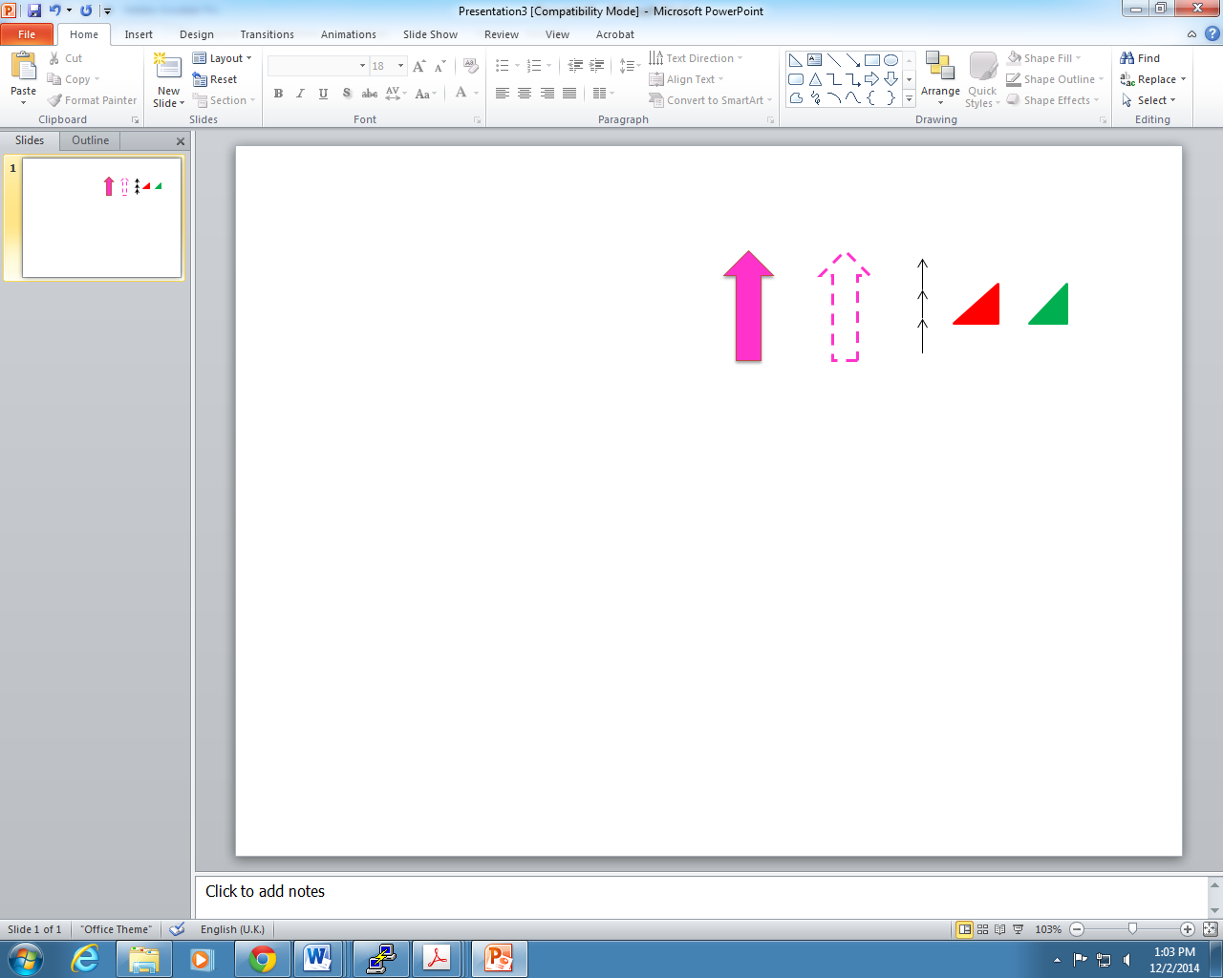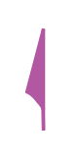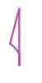
(a) (b) (c) (d) (e) (f) (g)
Figure 9-2 – Existing arrow types and approximate colours approved for use in ECDIS: (a) and (b) for Traffic Separation Schemes; (c) for recommended (one-way) tracks; (d) and (e) for conical buoys; and (f) and (g) for magnetic variation and anomaly

Arrow direction
The direction of the arrow symbol must be the direction (relative to true north) toward which the current is flowing (Figure 9-3). If the map projection is Mercator, angles are preserved, so current direction is identical to direction on the screen. For other map projections, the portrayed direction must be computed.
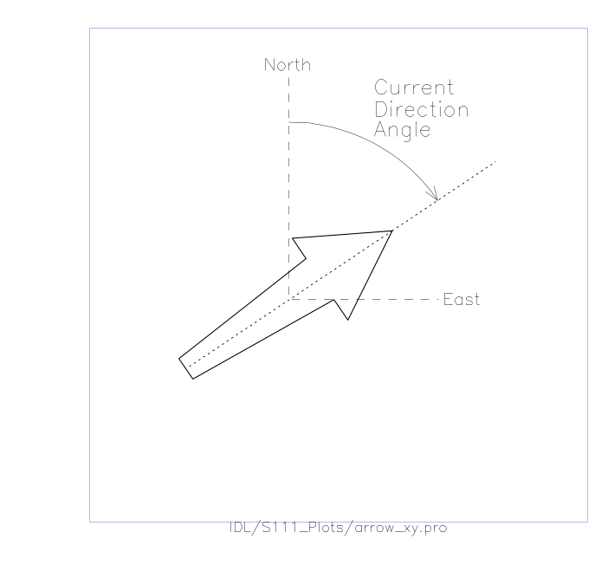
Figure 9-3 – Portrayal of the arrow’s direction, based on the current direction
The dashed line is the arrow’s centerline, and the origin of the East-North axis is at the arrow’s pivot point. True north has a direction of 0 degrees.

Arrow colour and speed bands
The colour of the arrow must be based on the speed value of the data, and must have 9 bands corresponding to the speed ranges (Table 9-1). The range of speeds (Table 9-1) was selected to (a) emphasize differences at low speeds (0.0 to 3 knots); and (b) be capable of displaying large currents (13 knots and above).
NOTE: The largest tidal currents may be those in the strait near Saltstraumen, Norway, which reach 22 knots.
Table 9-1 – Speed ranges (knots) for the 9-band display
Speed Band | Minimum Speed (knots) | Width of Band (knots)
1 | 0.00 | 0.50
2 | 0.50 | 0.50
3 | 1.00 | 1.00
4 | 2.00 | 1.00
5 | 3.00 | 2.00
6 | 5.00 | 2.00
7 | 7.00 | 3.00
8 | 10.00 | 3.00
9 | 13.00 | 86.00

Colours are associated with each speed band, and must be distinguishable in the three viewing environments: day, dusk, and night. Colour values for day conditions are shown in Table 9-2. Colours for dusk and night conditions are given in Annex F (Colour Tables). (The monitor gamma values need to be taken into account – refer to IHO Standards. Also, the portrayal catalogue may adjust colors to enhance the user experience and accommodate interoperability with other products displayed on the ECDIS.)
Table 9-2 – Colour Schema for day conditions (informative)
Speed Band | Colour | Colour Scale Intensity |  |  | Hex RBG | Displayed Colour
Speed Band | Colour | Red | Green | Blue | Hex RBG | Displayed Colour
1 | purple | 118 | 82 | 226 | 7652E2
2 | dark blue | 72 | 152 | 211 | 4898D3
3 | light blue | 97 | 203 | 229 | 61CBE5
4 | dark green | 109 | 188 | 69 | 6DBC45
5 | light green | 180 | 220 | 0 | B4DC00
6 | yellow-green | 205 | 193 | 0 | CDC100
7 | orange | 248 | 167 | 24 | F8A718
8 | pink | 247 | 162 | 157 | F7A29D
9 | red | 255 | 30 | 30 | FF1E1E

Arrow size
The arrow size (height and width) must be a function of the current speed; and for a given speed must be the same regardless of the source of the data. The standard arrow symbol (Figure 9-1) is scaled up or down in size, depending on the speed it is intended to represent.
Let S represent the value of the current speed. An upper limit on the size of the arrow is imposed by requiring the scaling input speed value not to exceed a reference high value, S_{high}. The recommended value for S_{high} is the minimum speed in the highest group in Table 9-1, which is 13.0 knots. The value of S_{high} should be the same for all data sets from multiple sources so that the same speed in different data will be displayed with the same arrow length.
It is desirable to display a small arrow at a location where data is usually available (for example a grid point) but the speed is very low. This can be accomplished by setting a minimum reference speed, S_{low}, so that, as a result, a ‘point’ is displayed. When the speed S falls below S_{low}, then S_{low} is substituted for S.
It is also desirable that the symbol displayed for weak currents should be distinguishable as a current arrow, rather than a generic dark point or short line. Applying the results of experimental investigations and a rule of thumb requiring a minimum dimension of 3.5 mm for viewing at 1 metre distance, the recommended value of S_{low} is set at 2.00 knots.
A third parameter is the reference speed, S_{ref}, at which the arrow symbol has a length equal to the scaling height parameter, H_{ref}. Here S_{ref} is chosen to be 5 knots and H_{ref} is taken to be 10.0 mm. Let S be the current speed to be displayed. If S exceeds S_{high}, then S_{high} is substituted for that speed, since areas of extremely high current speeds are rare and are likely to be avoided by navigators anyway. Therefore, a current with a speed of S will be displayed with a height, H (mm), computed by:
H = H_{ref}∙min{max(S_{low},S),S_{high}}/S_{ref}. [Eqn 9.1]
The arrow width is scaled in a similar fashion. A summary of recommended scaling values is given in Table 9-3. Note that this formula and constants apply only to the size of the symbol, not its colour.
Table 9-3 – Summary of recommended values for arrow display size (see Eqn 9.1). With these values, an arrow representing 5 kt will have a length of 10 mm
Constant | Description | Recommended Value
H_{ref} | Reference height for arrow scaling | 10 mm
S_{ref} | Reference speed for arrow scaling | 5 knots
S_{low} | Minimum speed to be used for arrow length computations | 2.00 knots
S_{high} | Maximum speed to be used for arrow length computations | 13 knots

Numerical values
Current speed and direction, and additional data related to uncertainty and other metadata, should be visible when selected by placing the cursor within the solid area of the arrow shape (Figure 9-4). The data are invisible initially, and when the cursor is placed on the arrow, the data will be shown temporarily. If the arrow is clicked, data will be shown continuously until another point is clicked. The information shown when the arrow is clicked will be displayed in black text inside a box with a white (or other colour for dusk and/or night viewing) background and a black border. The box will normally have zero transparency.
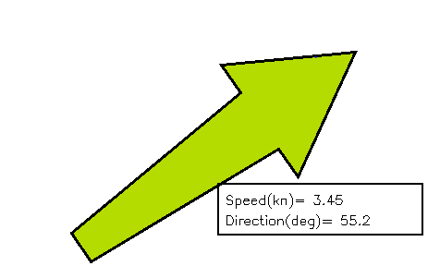
Figure 9-4 – Example of the display of the first level of numerical information available by cursor selection. Note: Arrow length is not to scale
There should be at least three levels of detail of information (Table 9-4). In the first level, speed (knots) and direction (arc-degrees clockwise from true north) shall be displayed. In the second level, there are six additional items, each with appropriate units: data source/station name, latitude, longitude, date, time, and current depth or layer thickness. In the third level, there are at least five additional items: uncertainty in speed; direction; horizontal position; vertical position; and time. A sample image showing a vector with the first level of information is shown in Figure 9-4. The additional levels are accessed by a cursor pick capability (cf. S-101 – IHO Electronic Navigational Chart Product Specification).
Table 9-4 – Sample of numerical information displayed in text at the location of a current vector, organised into levels of priority
Priority Level | Text Information Displayed
1 | Speed, Direction
2 | Data source, Latitude, Longitude, Depth of current, Valid Date, Valid Time
3 | Uncertainty in speed, Uncertainty in direction, Uncertainty in horizontal position, Uncertainty in vertical position, Uncertainty in time

NOTE: The text box in Figure 9-4 requires the use of two additional colours: black for the text and box outline, and white for the interior of the box. Standard ISO colours are to be used. The interior of the box will normally have zero transparency.

Transparency
The symbol transparency must be adjusted according to the background chart/image used (Table 9-5). The value alpha represents the level of opaqueness (relative to the background image) of the arrow and the numerical values displayed. An alpha value of 1 denotes zero transparency and an alpha value of 0 denotes 100% transparency.
Table 9-5 - Alpha (opaqueness) values for arrows with various display backgrounds. Transparency is 1.0 minus the alpha value
Background | Alpha
Satellite image | 1.0
Raster Nautical Chart | 1.0
ENC Day | 1.0
ENC Dusk | 0.4
ENC Night | 0.2

Scalable Vector Graphics
In ECDIS, the arrow symbol (for example Figure 9-5) is drawn using Scalable Vector Graphics (SVG) instructions according to the S-100 SVG profile described in S-100 Part 9 Appendix 9-B. SVG allows a symbol of any given size, orientation, and colour to be displayed by only a few instructions. See Annex G (Scalable Vector Graphics (SVG) Coding) for more details.

Symbol placement
The arrow symbol is placed on the georeferenced background so that the pivot point of the symbol (Figure 9-1) is positioned at the geographic coordinates of the current station or grid point.
NOTE 1: The Producer must ensure that the arrow’s pivot point does not lie on the displayed representation of land; that is, that the current data and the shoreline are consistent.
NOTE 2: The Producer must ensure that the arrow’s pivot point does not lie in a geographic area designated as intertidal when the time-varying water depth has gone to zero.
However, since some stations or grid points are near land, and depending on arrow size, on occasion it is unavoidable that occasionally some part of the arrow symbol will overlie the land or intertidal area.

Application to time series and moving platform data
The portrayal described in this clause applies to all non-gridded coverage types. The following guidelines must be applied for values selection and display:
- Time series at fixed stations (dataCodingFormat 1): Display arrows at the locations of the stations, using the temporal rules described in clause 9.4 and Annex H.
- Moving platform (dataCodingFormat 4): Display arrows at the platform location closest to the selected time as well as preceding and following points within user or system selected spatial and temporal buffers (the same buffers as for route monitoring or planning as appropriate). Arrows may be thinned if necessary using the point-by-point method described at the end of clause 9.3.2, using the distance to preceding displayed location as the cell spacing.
- Stationwise time series (dataCodingFormat 8): Display arrows at station locations for the selected time, using the temporal rules described in clause 9.4 and Annex H.
Cursor pick at a platform or station location should display current information in any format determined by the application developer. An informative format is described in Annex H (H-7 – Pick Report for Time Series Data).

Display of regularly gridded data
The display of gridded data depicts a surface current field of multiple arrows (Figure 9-5), with each individual arrow having the qualities described in clause 9.2. The acceptable arrowhead style for gridded arrows is the style defined in Figure 9-1. As with single-point data, the speed and direction values at individual vectors must be available when the cursor is placed over a vector.
NOTE: Current direction angles cannot be interpolated (in either space or time) directly, but must be derived using the X and Y components of speed. That is, interpolation must be of the east/west and north/south components of speed separately, with the interpolated components then used to calculate speed and direction.

High resolution
A high-resolution display (that is, zooming in) of regularly gridded data display produces a lower density of data (Figure 9-.6). It is not recommended that spatial interpolation be used to estimate current values at locations between grid points or point coverage locations.
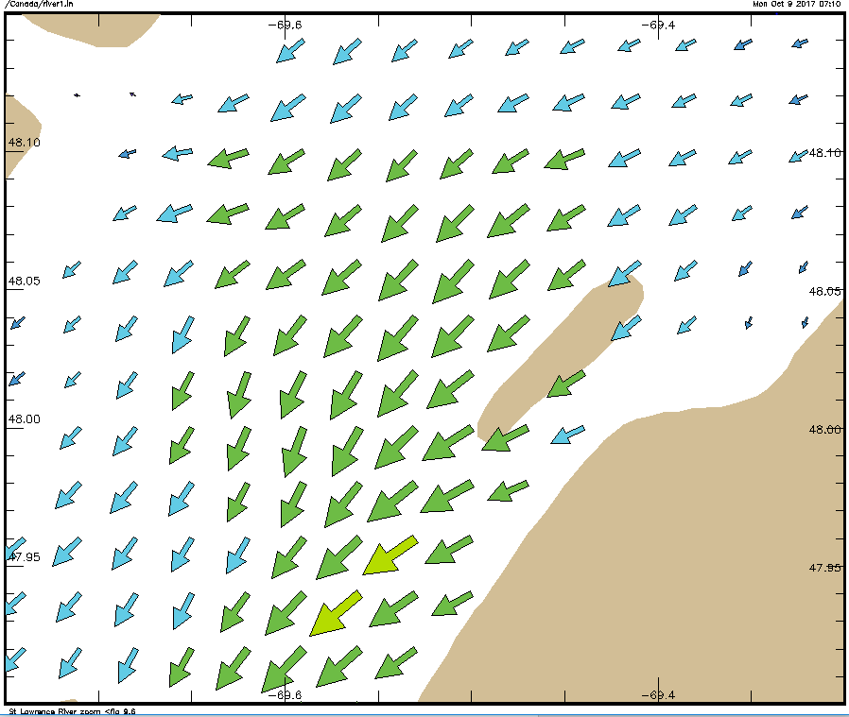
Figure 9-5 – Arrows representing gridded surface current data, with length increasing with speed, and S_{ref} is 5 knots, H_{ref} is 20 mm, and the maximum speed in the data in the image is 3.15 knots. Coastline added for clarity. (Data courtesy of St. Lawrence Global Observatory, Canada)
NOTE: Although some portions of the arrow symbol lie over land, the pivot point does not.
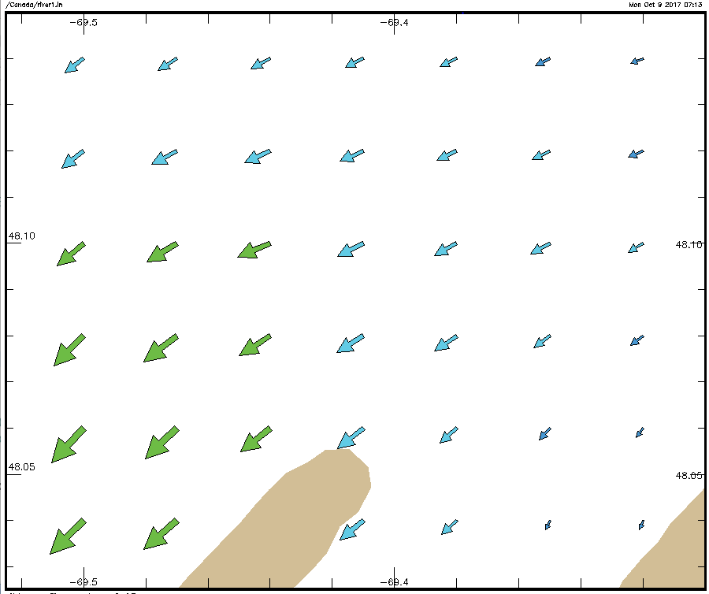
Figure 9-6 – Display of surface current data (see Figure 9-5) but at a higher resolution (data courtesy of St. Lawrence Global Observatory, Canada)

Low resolution
Displaying at a low resolution (that is, zooming out) increases the density of symbols (Figure 9-7a). However, by applying a thinning algorithm, the number of vectors may be reduced (Figure 9-7b). In this case, every fourth vector was plotted.
An example of thinning of regularly gridded data is as follows. Suppose that the grid cell’s diagonal as displayed has a distance of D mm and represents the grid spacing. Note that D is dependent on the specific geographic area and the size of the viewing monitor. If every n^{th} cell is displayed, the displayed spacing is nD. Next, suppose the length of the arrow representing the maximum speed in the displayed field is L_{smax} mm. Then the ratio of the maximum arrow length to the displayed grid spacing is constrained to be less than a prescribed maximum value, R_{max}, here taken to be 0.5. Thus:
R = L_{smax}/(nD) < R_{max} [Eqn 9.2]
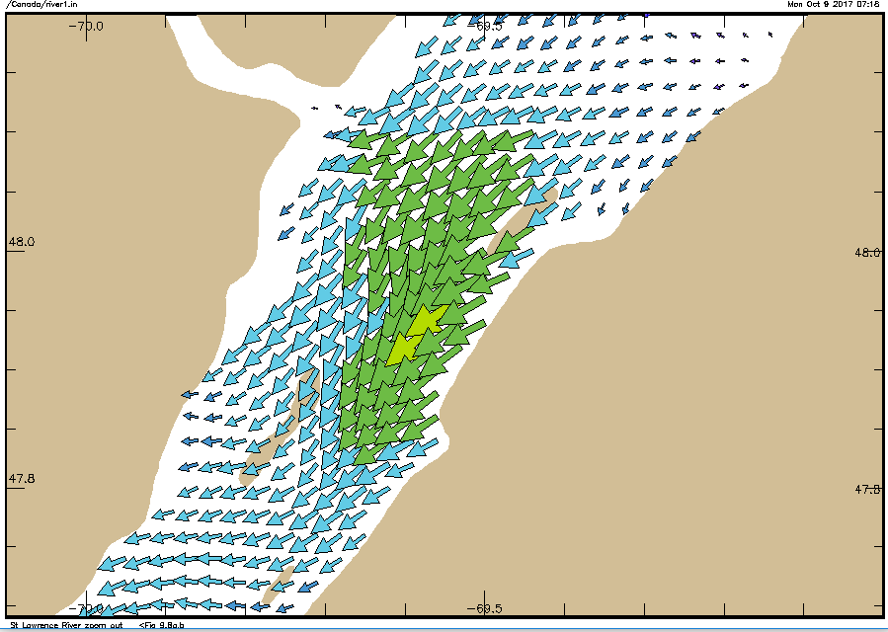
(a)
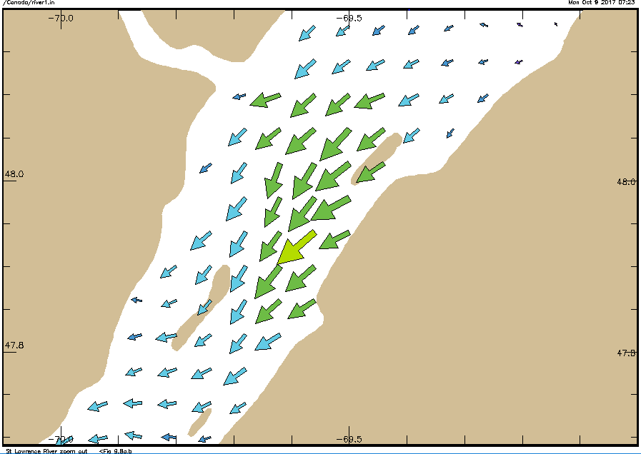
(b)
Figure 9-7 – (a) Surface current vectors (see Figure 9-6) displayed with identical parameters, but at low resolution. (b) Current vectors as in (a), but ‘thinned’ by plotting every fourth point. Note that the coastline data in the Figure may differ from that used to determine model boundaries; in practice, the arrow pivot point must not be placed over land. (Data courtesy of St. Lawrence Global Observatory, Canada)
If the above inequality cannot be met with increment n equal to 1, then a new value for n is computed by the following formula:
n =1 + fix(L_{smax}/(DR_{max})) [Eqn 9.3]
Where fix() is a function that returns the truncated integer value. For plotting, arrows at every n^{th} column and every n^{th} row are drawn, making sure that the row and column with the maximum vector is drawn (Figure 9-7b).
Thinning of irregularly-spaced vectors is more difficult. For each on-screen point the distance to all other on-screen points would have to be calculated, so that the closest point can be determined. The size and direction of the arrow symbols at the point and its nearest point would be compared for overlap. If overlap occurred, one of the symbols would be eliminated. This procedure would be carried out for all on-screen points, keeping track of which points and their symbols had been eliminated. An alternate solution would be to reduce the reference height H_{ref} or increase the reference speed S_{ref} (Table 9-3).

Application to ungeorectified grid data
Portrayal for ungeorectified grids must also display a field of multiple arrows using the same principles as for regular grids, with thinning based either on the point-by-point method described at the end of clause 9.3.2 or the same method as for regular grids but using an average resolution, calculated either over the whole grid or sections of the grid. Application developers may substitute their own thinning heuristics for the methods described in clause 9.3.2.

Temporal rules
The metadata variables related to time are the dateTimeOfFirstRecord, dateTimeOfLastRecord, timeRecordInterval, and numberOfTimes. The time selected for display (that is past, present, or future) of the surface currents by the display system will typically not correspond exactly to the timestamp of the input data. For a correct display, the ECDIS will have to select the correct data.
For data with only a single record (where the timestamp of the earliest value equals that of the latest value) such as real-time data, the surface current values are displayed only if the display time is later than the timestamp and the absolute time difference between the display time and the data timestamp is less than a discrimination interval (for example 5 minutes). For a single record, the variable timeRecordInterval (see clause 12.3) can be used to set the discrimination interval.
For data with multiple times, if the selected display time is later than the first timestamp and earlier than the last timestamp, then the closest but immediately preceding values in the data are displayed. However, if the selected display time is earlier than the first timestamp then the data is not displayed. If the selected time is later than the last timestamp, then surface current values at that time are displayed only if the absolute time difference between the display time and the data timestamp is less than a discrimination interval (for example the value of the variable timeRecordInterval).

ECDIS legend

Contents of legend
The legend should include include the following information when display of the S-111 layer is switched on:
- Data dynamicity (Table 12-3). The entry label (“Name” column in Table 12.10) must be displayed rather than the numeric code.

Placement of legend
The legend, which is to be displayed as an option, must show the relationship between the arrow colours and the speed values. A sample is shown in Figure 9-8. The precise position of the legend if it appears on the monitor will be determined so as to minimize the obscuring of other important navigational information.
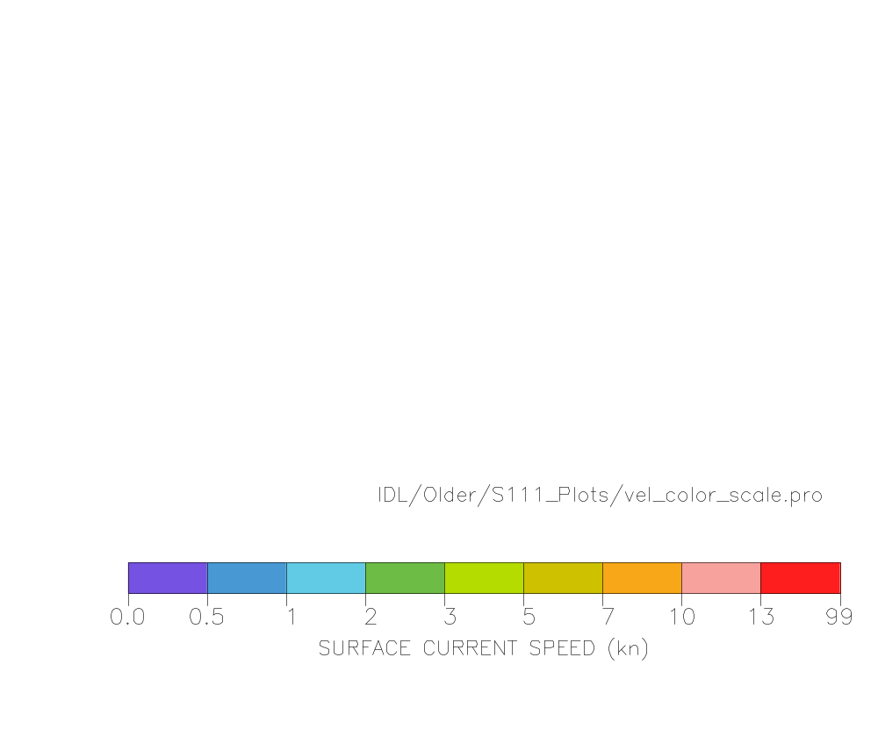
Figure 9-8 – Sample surface current speed scale based on the colours and speed bands in Table 9-2 (informative)

Interoperability
Interoperability principles determine priority in display of elements so that important image elements, such as depth numerals, are not obscured by current vectors. Surface current portrayal must conform to interoperability rules established in S-98.

Symbol priority
Details about symbol priority will be determined in accordance with S-100 standards when they are developed.
One example involves the use of the older charting symbol for currents. When an S-111 dataset is displayed, symbols from the S-101 ECDIS nautical charting suite, in the area where the new data is displayed, must not be displayed. Such symbols include those for tidal stream tables (plus their points and boundary areas); flood and ebb tide stream arrows and their values and boundary areas; and other symbols for rip currents, eddies, breakers, and non-tidal currents.

Colour discrimination
Another criterion is that the arrows colours be distinct when displayed against a background of similar colour. Table 9-6 shows the background colours for various water depth types, and Figure 9-9 shows typical arrows for the nine speed bands. The black arrow border allows the arrow symbol to stand out against the blue and green backgrounds.
Table 9-6 - Chart background colours in two colour scales (courtesy of Korean Hydrographic and Oceanographic Administration)
Name | sRGB |  |  | xyL |  |  | Displayed Colour
Name | Red | Green | Blue | x | y | L | Displayed Colour
Deep Water | 201 | 237 | 255 | 0.28 | 0.31 | 80
Medium Deep Water | 167 | 218 | 252 | 0.26 | 0.29 | 65
Medium Shallow Water | 130 | 202 | 255 | 0.23 | 0.25 | 55
Very Shallow Water | 97 | 184 | 255 | 0.21 | 0.22 | 45
Intertidal | 88 | 175 | 156 | 0.26 | 0.36 | 55
No Values | 147 | 174 | 187 | 0.28 | 0.31 | 40

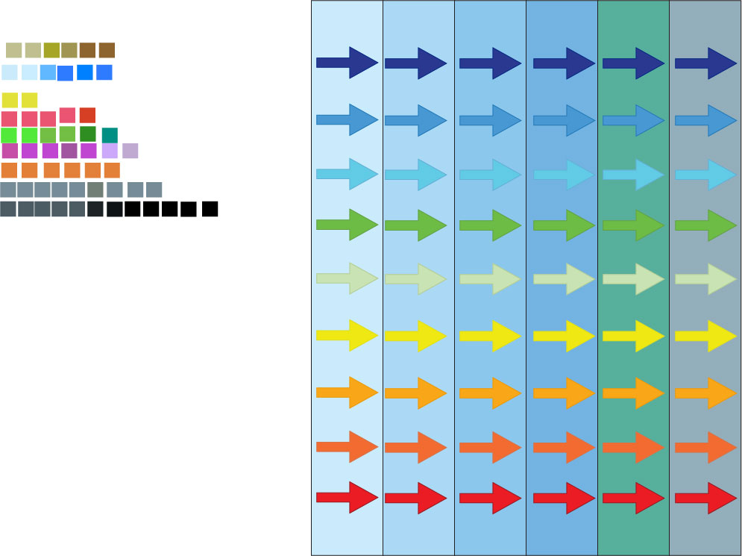
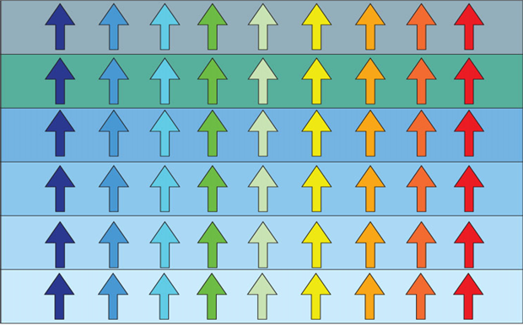
(a)
(b)
Figure 9-9 – Arrows displayed against the (daytime) background colours in Table 9-6. Arrows (a) with borders and (b) without borders. (Figures courtesy of University of New Hampshire)

Sample representation
Surface current vectors comprise a layer to be displayed on demand and, possibly, on top of other data and layers. Consideration must be made so as not to obscure critical navigational data nor create confusion by using symbols or colours similar to those in other layers. Figure 9-10 shows a sample display.
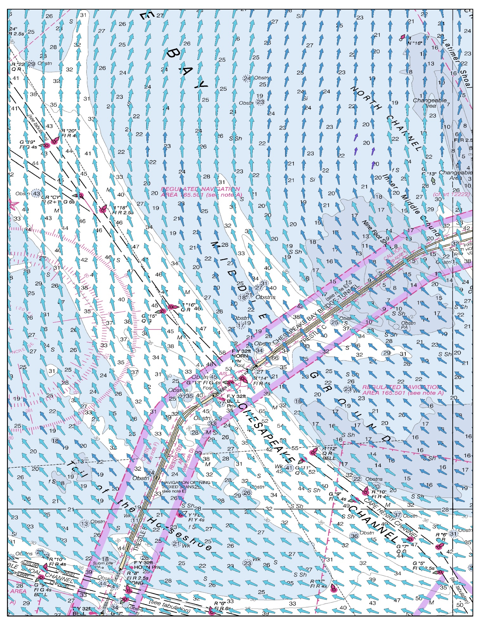
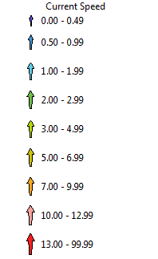

Figure 9-10 – Sample depiction of gridded surface current data in an electronic chart. Note that arrow height in scale may not strictly conform to the portrayal rules. (Image courtesy of the University of New Hampshire, US)

Portrayal rules
A summary of the portrayal rules appears in Annex H – Surface Current Portrayal Rules.

Pick report
Pick reports on S-111 data products should display the following information:
- Feature attributes surfaceCurrentSpeed and surfaceCurrentDirection at the current time and position (current simulated time, if the system is doing a time-varying simulation or animation). If the attribute is populated with a fill value an appropriate substitute (such as the string “unknown” or “--“) must be displayed in place of the fill value, consistent with the implementation’s practices for displaying nilled (GML) or NULL (ISO 8211) mandatory attributes in other data products.
- Speed uncertainty and direction uncertainty derived from the speed and direction uncertainty feature attributes or the uncertainty dataset (Table 10-2). Since there are two possible sources, the following criteria should be used to select the value to be displayed.
  - An uncertainty value is displayed if and only if the corresponding feature attribute is populated with an actual (non-fill) value.
  - An actual (non-fill) value must be displayed in preference to a fill value.
  - The feature attribute is to be preferred to a value from the uncertainty dataset.
  - If an actual (non-fill) value cannot be determined or if the feature attribute is populated with a fill) value, uncertainty may be omitted or displayed as “unknown” (or “--“, etc.) according to application convention.
- For dataCodingFormat 4 or 8, the surfaceCurrentTime attribute, if populated with an actual (non-fill) value.
EXAMPLE:
0.7 ± 0.1 kt
is displayed for surfaceCurrentSpeed = 0.7, speedUncertainty = 0.1 (dataCodingFormat = 2).
If the spatial query returns more than two values records, values must be displayed as a range of lowest and highest values rather than individually listing all values returned.

Construction and packaging of Portrayal Catalogues
The Portrayal Catalogue must be constructed as a main Portrayal Catalogue XML file (see S-100 Part 9, clause 9-13) and other files in subfolders. The structure is described in S-100 clause 9-13.2. The main Portrayal Catalogue XML file and portrayal subfolders described in S-100 must be placed in a single subfolder. When distributed within an Exchange Set, the entire Portrayal Catalogue may be packaged as a zip archive.
Figure 9-11 depicts a hypothetical S-111 Edition 2.0.0 Portrayal Catalogue, with the build date 01 January 2024. The Portrayal Catalogue is located under the folder 111_2_0_0_PC.
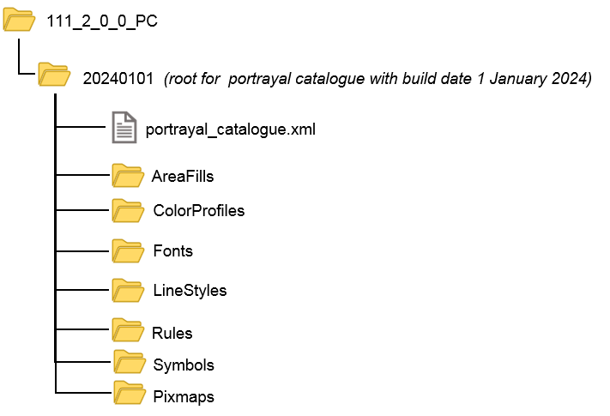
Figure 9-11 - Typical structure for S-111 Portrayal Catalogue
Note that some of the sub-folders will be empty since S-111 defines only coverage features and does not need all the components definable in S-100 Portrayal Catalogues.

Portrayal Catalogue citation information
Citation information for the Portrayal Catalogue is provided in Table 9-10 below.
When selecting a portrayal catalogue to use or distribute, the first two components of the edition number of the portrayal catalogue used must match the edition and revision numbers of this edition of the Product Specification. Build numbers may be provided in otherCitationDetails to distinguish successive releases corresponding to the same edition of the Product Specification. If there are multiple builds for the same edition, the most recent build should be selected in order to use the most recent portrayal catalogue.
EXAMPLE: PC version 2.0.1 may be used with datasets for S-111 Edition 2.0.0.
Table 9-10 – Portrayal Catalogue citation
No. | ISO class or attribute | Type | Value
-- | CI_Citation | Class | --
1 | title | CharacterString | S-111 Portrayal Catalogue
2 | date | CI_Date (class) | --
2.1 | date | DateTime | 2026-06-08T00:00:00 or later
2.2 | dateType | CI_DateTypeCode (ISO codelist) | publication
3 | edition | CharacterString | 2.0.1
4 | editionDate | DateTime | 2026-06-08T00:00:00 or later
5 | citedResponsibleParty | CI_Responsibility (class) | --
5.1 | role | CI_RoleCode (ISO codelist) | publisher
5.2 | party | CI_Organisation (class) | --
5.2.1 | name | CharacterString | International Hydrographic Organization
6 | otherCitationDetails | CharacterString | (reserved, build date as YYYYMMDD)
7 | onlineResource | CI_OnlineResource (class) | --
7.1 | linkage | CharacterString (URL) | https://registry.iho.int/
7.2 | name | CharacterString | S-111 Portrayal Catalogue
7.3 | description | CharacterString | XML Portrayal Catalogue accompanied by related files for symbols, colour profiles, rules, etc

Data Product Format (Encoding)

Introduction
The Surface Current Data Product must be encoded using the Hierarchical Data Format Standard, Version 5 (HDF5).
Format: HDF-5
Character Set: MD_CharacterSetCode (ISO 19115) should be set to utf8
Specification: S-100 profile of HDF-5

HDF5 product structure
The key idea at the core of the S-111 data product structure is this: The organization of the information is substantially the same for each of the four types of surface current data, but the information itself will be interpreted differently.

Data type definition
These data types and their codes are shown in Table 10-1.
Table 10.1 – S-111 data types and values of the variable dataCodingFormat (see S-100 Edition 5.2.2, Table 10c-20)
dataCodingFormat | Type of Data
1 | Time series data at one or more fixed stations (organized by time)
2 | Regularly-gridded data at one or more times
3 | Ungeorectified gridded data or point set data at one or more times
4 | Time series data for one moving platform
8 | Stationwise time series at one or more fixed stations (organised by station) - type (a)

For the use of HDF5, the following key concepts (10c-5.1) are important:
- File - a contiguous string of bytes in a computer store (memory, disk, etc), and the bytes represent zero or more objects of the model;
- Group - a collection of objects (including groups);
- Dataset - a multidimensional array of data elements with attributes and other metadata;
- Dataspace - a description of the dimensions of a multidimensional array;
- Datatype - a description of a specific class of data element including its storage layout as a pattern of bits;
- Attribute - a named data value associated with a group, dataset, or named datatype;
- Property List - a collection of parameters (some permanent and some transient) controlling options in the library;
- Link - the way objects are connected.
In addition, a dataset may have one, two, or more dimensions, and each element in the dataset may be a compound. That is, each element may itself be an array of possibly different datatypes (float, integer, string, etc).

Product structure
The structure of the data product follows the form given in S-100 Part 10c – HDF5 Data Model and File Format. The general structure, which was designed for several S-100 products, not just surface currents, is given in Figure 10-1.
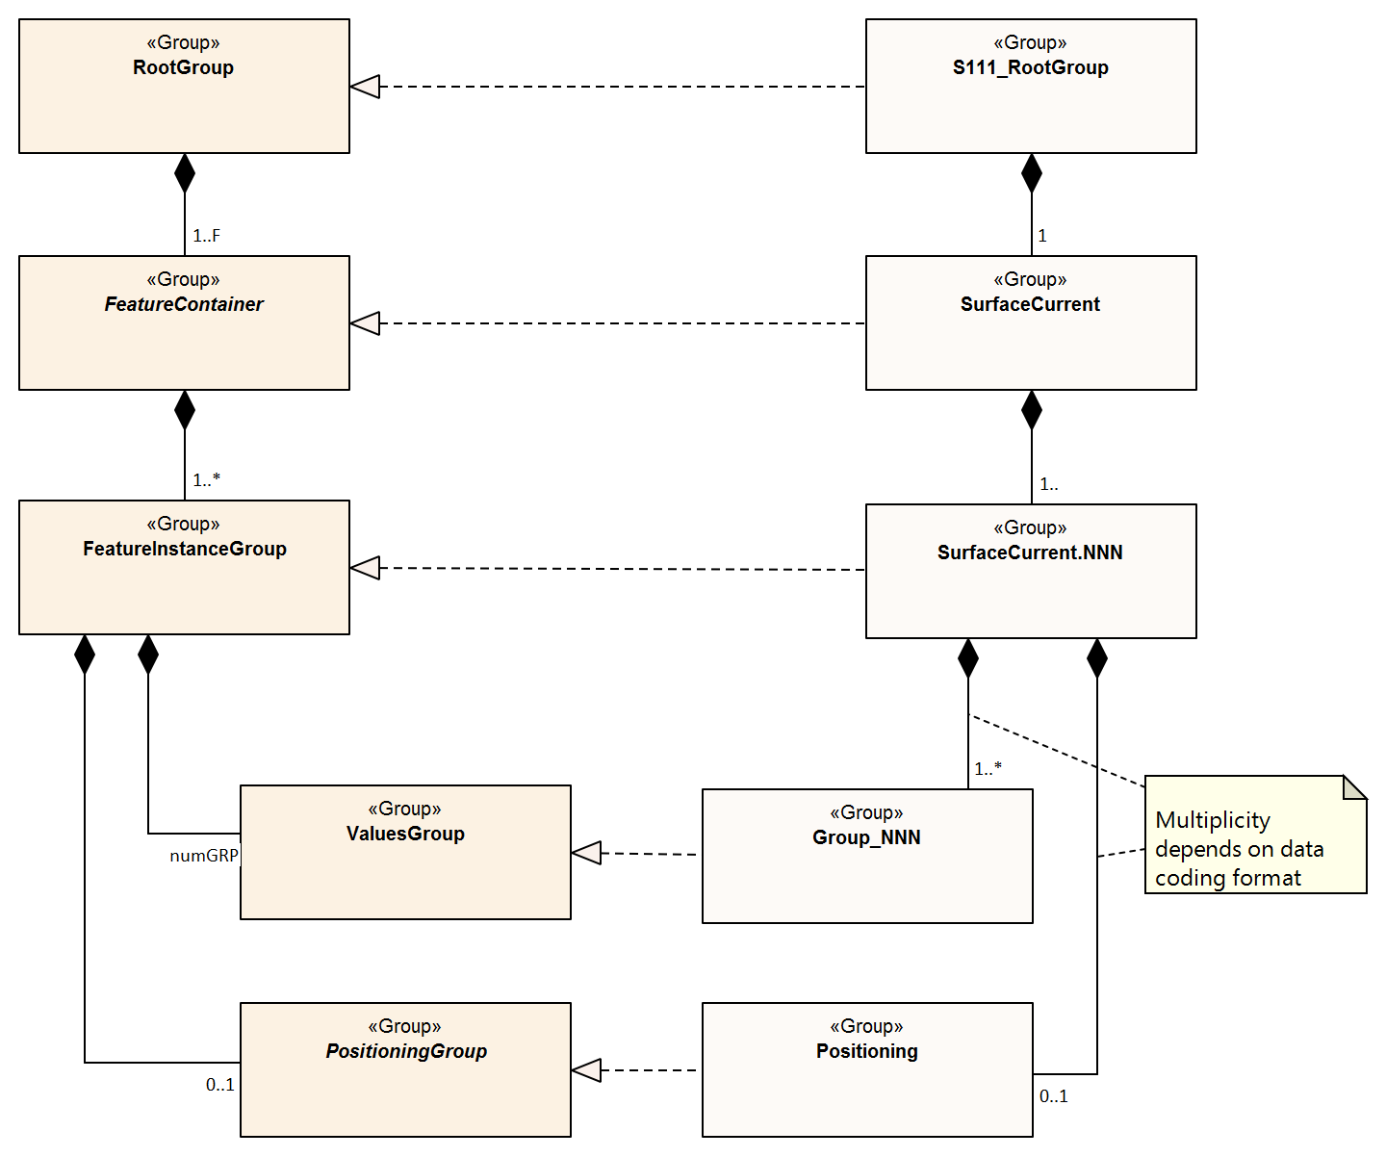
Figure 10-1 – Outline of the data file structure for S-111 data files, showing the realisation of S-111 structure from the generic structure described in S-100 (see Part 10c, Figure 10c-7). Note that there are four levels from top to bottom
In Figure 10-1 there are four levels:
Level 1: At the top level lies the Root Group, and it contains the Root Metadata (Table 12-1) and two subsidiary groups. The Root Metadata applies to all S-100 type products.
Level 2: The next level contains the Feature Information Group and the Feature Container Group. The Feature Information Group contains two datasets: the featureCode, which has the name of the S-100 feature (here SurfaceCurrent), and the feature information dataset (SurfaceCurrent) which contains a compound array with eight parameters for each S-100 feature attribute (speed and direction). The Feature Container Group contains the Feature Metadata (Table 12-2) and one or more Feature Instance Groups. The Feature Metadata is common to all surface current products.
Level 3: This contains one or more Feature Instances. A feature instance is, for example, a time series of gridded data for a single region; or a time series of astronomical predictions for a set of stations.
Feature instances in the same data file must not overlap. This prohibition applies even if the overlapping feature instances contain different types of data (astronomical predictions, forecasts, etc).
Features for different scale ranges must be in separate data files.
Level 4: This contains the actual data for the feature. S-111 uses only the Values Group and, for only some data, the Positioning Group.
The basic structure of the S-111 data product is shown in Table 10-2. Levels refer to HDF5 structuring. (C.f. S-100 Part 10c, Figure 10c-9). Naming in each box below header line is as follows: Generic name; S-100 or S-111 name; and (HDF5 type) group, attribute or attribute list, or dataset.
Table 10.2 – Overview of an S-111 dataset
LEVEL 1 (ROOT) CONTENT | LEVEL 2 CONTENT | LEVEL 3 CONTENT | LEVEL 4 CONTENT
General Metadata
(see Table 12-1)
(h5_attribute)
Feature Codes  Group_F  (h5_group) | Feature Type Name  SurfaceCurrent  (h5_dataset)
Feature Type Codes
featureCode
(h5_dataset)
Feature Type  SurfaceCurrent  (h5_group) | Feature Type Metadata  (see Table 12-2)  (h5_attribute)
Horz. & vert. Axis Names
axisNames
(h5_dataset)
 | First Feature Instance  SurfaceCurrent.01  (h5_group) | Feature Instance Metadata  (see Table 12-.3)  (h5_attribute)
 |  | Location Data  Positioning  (h5_group) | Lon+lat Array  geometryValues  (h5_dataset)
Uncertainty Data
uncertainty
(h5_dataset)
 |  | First data group  Group_001  (h5_group) | Time Attribute  timePoint  (h5_attribute)
Speed+direction Array
values
(h5_dataset)
 |  | Second data group  Group_002  (h5_group) | Time Attribute  timePoint  (h5_attribute)
Speed+direction Array
values
(h5_dataset)
 |  | Third data group  Group_003  (h5_group) | Time Attribute  timePoint  (h5_attribute)
Speed+direction Array
values
(h5_dataset)
 | Second Feature Instance  SurfaceCurrent.02  (h5_group) | Feature Instance Metadata, etc., as for first instance

The following clauses explain entries in Table 10-2 in more detail.

Root group
The Root group contains the Feature Codes group, the Feature Type group, and the simple attributes shown in Table 12-1.

Feature type codes (Group_F)
This group specifies the S-100 feature to which the data applies. The group has no attributes and consists of two components:
featureCode – a dataset with the name(s) of the S-100 feature(s) contained in the data product. For S-111, the dataset has a single element, the string “SurfaceCurrent”.
SurfaceCurrent – this is a dataset with the name contained in the featureCode dataset. The dataset contains a one-dimensional compound array of length two to five (one for each of the two mandatory current attributes: speed and direction, and an additional optional entry for each of the three optional attributes for time and speed/direction uncertainty). Each of the five elements of string values has 8 values, as shown in Table 10-3.
An entry for an optional attribute must be encoded here if the values record for SurfaceCurrent feature instances in this HDF5 file contains that attribute (even if it is populated only with fill values). Conversely, if an attribute is encoded here all SurfaceCurrent instances must include that attribute in their values records, even if it is populated only with fill values. These requirements amount to mandating a 1/1 correspondence between this array and the structure of values record entries in SurfaceCurrent feature instances.
NOTE: Values provided in Table 10-3 are mandatory if the attribute is encoded.

Page intentionally left blank

Table 10.3 – Sample contents of the one-dimensional compound array (length=3, compound elements=8) SurfaceCurrent. All values are strings
N | Name | Explanation | Attribute 1 | Attribute 2 | Attribute 3 (optional) | Attribute 4 (optional) | Attribute 5 (optional)
1 | code | Camel Case Name | surfaceCurrentSpeed | surfaceCurrentDirection | surfaceCurrentTime | speedUncertainty | directionUncertainty
2 | name | Plain text | Surface Current Speed | Surface Current Direction | Surface Current Time | Speed Uncertainty | Direction Uncertainty
3 | uom.name | Units of Measurement | Knot | Degree of Arc | (empty) | Knot | Degree of Arc
4 | fillValue | Denotes missing data | -9999.00 | -9999.0 | 00010101T000000Z | -1.00 | -1.0
5 | datatype | HDF5 datatype | H5T_FLOAT | H5T_FLOAT | H5T_STRING | H5T_FLOAT | H5T_FLOAT
6 | lower | Lower bound on attribute | 0.00 | 0.0 | 19000101T000000Z | 0.00 | 0.0
7 | upper | Upper bound on attribute | 99.00 | 359.9 | 21500101T000000Z | 99.00 | 359.9
8 | closure | Open or Closed data interval. See S100_IntervalType in S-100 Part 1 | geSemiInterval | closedInterval | closedInterval | geSemiInterval | closedInterval

Page intentionally left blank

The values in this array must be consistent with the corresponding entries in the Feature Catalogue, with the exception that Attribute 3 has no uom.name value in the Feature Catalogue.

NOTE: The decimal representation for floating point attributes is only for compatibility with the S-100 Feature Catalogue model.

Type group (SurfaceCurrent)
This group contains a dataset called axisNames and one or more instances of the single feature SurfaceCurrent. A single instance may contain a gridded forecast at multiple hours, a set of time series predictions at several stations, or moving station data for a single station. This group has the simple attributes shown in Table 12-2. For S-111, axisNames consists of two elements, the strings ‘longitude’ and ‘latitude’ or ‘easting’ and ‘northing’ depending on whether the CRS is EPSG 4326 or a UTM/UPS CRS.

Instance group (SurfaceCurrent.nn)
This group contains a single instance of the feature (see clause 10.2.2.3). The groups are numbered from 01 to 99. This group has the simple attributes shown in Table 12-3, as well as the (speed and direction) values groups, the (conditional) positioning group, and a dataset called ‘uncertainty’.
Uncertainty Dataset – The (optional) uncertainty data is contained in a compound HDF5 dataset named ‘uncertainty’. There is a name and an uncertainty value for surface current speed and direction, which are, respectively, surfaceCurrentSpeed and surfaceCurrentDirection. The units of speed uncertainty are knots and the units of direction are arc-degrees. The default, denoting a missing value, is -1.0.
The values in the ‘uncertainty’ dataset are overridden for individual grid points by the respective uncertainty component of the values record when the record is populated by a non-fill value.

Value groups (Group_nnn)
These groups each contain an attribute (the date-time stamp), and the compound data arrays containing surface current speed and direction and optionally surface current time. These groups have the simple attributes shown in Table 12-4. These components are explained below.
Date-Time Stamp - The date-time stamp is an attribute named timePoint with a single (string) value. For gridded (regular and ungeorectified: dataCodingFormat = 2 or 3), the time stamp is the time of validity for all points in the grid. For a time series at moving platforms (dataCodingFormat = 4), the time stamp is the time of the first value.
Value Arrays - The speed and direction values (surfaceCurrentSpeed and surfaceCurrentDirection) are stored in arrays named values, with a prescribed number of rows (numROWS) and, if two-dimensional, columns (numCOLS). If Group_F also describes an optional attribute, the optional attribute must also be present in the values record (populated with fill values if information is not available).
For a time series of fixed or moving stations (dataCodingFormat = 1, 4, and 8), the speed and direction values will be for times in the series as determined by the starting date-time and the data time interval. If the time intervals are non-uniform (only for dataCodingFormat = 4 or 8), then the time for each speed and direction value is given by surfaceCurrentTime.
For a regular grid (dataCodingFormat = 2), the speed and direction values will be for each point in the grid, the data array values is two-dimensional, and for the time for all points in the grid given by the date-time stamp.
For an ungeorectified grid (dataCodingFormat = 3), the speed and direction values will be for each point in the grid, the data array values is one-dimensional, and for the time for all points in the grid given by the date-time stamp.
NOTE: The requirement that the values record include all the attributes described in Group_F means that all feature instances in the dataset must:
- include any optional attribute encoded in Group_F; and
- omit any optional attribute not encoded in Group_F.
A populated (non-fill) value for the speed or direction uncertainty attribute in any value record overrides the corresponding value in the ‘uncertainty’ dataset in the containing SurfaceCurrent.nnn group for that point location.

Conditional geography group (Positioning)
The group named Positioning contains all the locations (longitude and latitude values) that have associated data values. This group has no attributes. In S-111, this group is present in the data product only for dataCodingFormat values of 1, 3, 4, or 8.
The Positioning group is described in S-100 Table 10c-11 and clauses 10c-9.3, 10c-9.10.
The geographic values are stored in the single, one-dimensional compound array named geometryValues, of size numPOS. Each element in the compound array geometryValues contains a pair of float values encoding position coordinates (latitude and longitude for EPSG 4326, easting and northing for UTM/UPS). The value of numPOS and the interpretation of the kinds of locations depends on the dataCodingFormat as well. The values and number of stations/drifters (respectively) for each data type are explained in Table 10-4.
The names of components of the compound type in geometryValues must match in case and spelling the axis names encoded in axisNames, either “latitude” and “longitude” or “easting” and “northing” depending on the type of CRS.
The axis orderings should conform to the order in the horizontal CS encoded in General Metadata (Table 12-1). This order should also be reflected in axisNames.
Since the axis names are used as the names of the elements of the compound type used to encode coordinate values, the dataset is self-describing in this respect and applications should inspect the compound type to determine coordinate order as actually encoded.
Table 10.4 - Values of numPOS for the group Positioning
Data Coding Format | Data Type | Location Data | Array Size: Value of numPOS
1 | Time series at fixed stations | Position of stations | numberOfStations
2 | Regular grid | (Not applicable) | (Not applicable)
3 | Ungeorectified gridded data | Location of the grid nodes | numberOfNodes
4 | Time series at a single moving station | Position of station over time | numberOfTimes
8 | Stationwise time series at fixed stations | Position of stations | numberOfStations

Summary of generalized dimensions
To summarize, there are data groups containing the speed and direction data, which are stored in either one-dimensional arrays of size numROWS or two-dimensional arrays of size numROWS by numCOLS. The total number of data Groups is numGRP.
The four variables that determine the array sizes (numROWS, numCOLS, numPOS, and numGRP) are different, depending upon which coding format is used. Their descriptions are given in Table 10-.5.
Table 10.5 – The array dimensions used in the data product
Data Coding Format | Data Type | Positioning | Data Values
Data Coding Format | Data Type | numPOS | numCOLS | numROWS | numGRP
1 | Fixed Stations | numberOfStations | 1 | numberOfStations | numberOfTimes
2 | Regular Grid | (not used) | numPointsLongitudinal | numPointsLatitudinal | numberOfTimes
3 | Ungeorectified Grid | numberOfNodes | 1 | numberOfNodes | numberOfTimes
4 | Moving Platform | numberOfTimes | 1 | numberOfTimes | 1
8 | Stationwise Fixed Stations | numberOfStations | 1 | numberOfTimes | numberOfStations

Mandatory naming conventions
The following group and dataset names are mandatory in S-100: ‘Group_F’, ‘featureCode’, and (for S-111) ‘SurfaceCurrent’, ‘axisNames’, ‘Positioning’, (for S-111) ‘SurfaceCurrent.nn’, and ‘Group_nnn’ (n is an integer from 0 to 9) Attribute names shown in clause 12.3 are also mandatory.

Summary of product structure
For regularly gridded data, the Surface Current array is two dimensional, with dimensions numPointsLongitudinal and numPointsLatitudinal. These attributes are part of feature instance metadata described in Table 12-3 and S-100 Part 10c, Table 10c-12. By knowing the grid origin and the grid spacings, the position of every point in the grid can be computed by simple formulae.
However, for time series data, moving platforms, and ungeorectified gridded data (that is, when dataCodingFormat is 1, 3, 4, or 8), the location of each point must be specified individually. This is accomplished by the data in Positioning Group, which gives the individual longitude (X) and latitude (Y) for each location. For time series data, the X and Y values are the positions of the stations; the number of stations is numberOfStations. For ungeorectified-gridded data, the X and Y values are the positions of each point in the grid; the number of grid points is numberOfNodes. For moving platforms, the X and Y values are successive positions of the platform, the number of positions is numberOfTimes.
NOTE: If dataCodingFormat is 2, the Positioning group is not present.
The remaining groups each contain a title, a date-time value (attribute timePoint, except for dataCodingFormat = 8), and the current data array. The title can be used to identify each individual station with time-series data. For dataCodingFormat = 2 or 3, the date-time is for the entire grid. The current data array is two dimensional, with a number of columns (numCOLS) and rows (numROWS). For a time series, the current data value record will be for each time in the series. For a grid, the data record will be for each point in the grid.
The format allows features encoding data stationwise (dataCodingFormat=8) or for a moving platform (dataCodingFormat=4) to be encoded with either uniform or non-uniform time intervals.
- For non-uniform time intervals, each record has a date-time encoded in the current data array.
- For uniform time intervals, the time interval is encoded as an attribute of the Values group. In this case, the date-time of individual records is omitted from the current data array.
The groups are numbered 1, 2, etc, up to the maximum number of groups, numGRP. For fixed station stationwise data (dataCodingFormat = 8), the number of groups is the number of stations. For regular and ungeorectified grids and TINs (dataCodingFormat = 2, 3, and 7), and for fixed station timewise data (dataCodingFormat = 1) the number of groups is the number of time records.
The overall structure of the data product is created by assembling the data and metadata. The product structure is compliant with the HDF5 data architecture, which allows multi-dimensional arrays of data to be grouped with metadata. The format of the data product (cf. Figure 10-1) described above is portrayed in Figure 10-2. The Carrier Metadata is discussed in clause 12.3 (Tables 12-1 - 12-4), and the Values group attributes are discussed in clause 12.3 (Table 12-4).
NOTE: The name of each Group is the ‘Group_nnn‘, where nnn is numbered from 1 to numGRP.
HDF5 Dataset
File Metadata (Table 12-1)
Group: SurfaceCurrent
Feature Type Metadata (Table 12-2)
Group: SurfaceCurrent.01
Feature Instance Metadata (Table 12-3)
Group: Positioning (conditional)
X + Y values array (m=0,numPOS-1)
Group: Group_001
Values Group attributes (Table 12-4)
Valid Date-Time₁
Speed + Direction Array (i=0,numCOLS-1, j=0,numROWS-1)
Group: Group_002
Values Group attributes
Valid Date-Time₂
Speed + Direction Array (i=0,numCOLS-1, j=0,numROWS-1)
Group: Group_nnn
Values Group attributes
Valid Date-Time_{numGRP}
Speed + Direction Array (i=0,numCOLS-1, j=0,numROWS-1)
Figure 10-2 – Schematic of the S-111 HDF5 data product structure. The four parameters numPOS, numCOLS, numROWS, and numGRP are explained in Table 10-5.
Group ‘Positioning’ appears only for dataCodingFormat = 1, 3, 4, or 8 (Table 10-5).
Valid Date-Time_{1,2,...numGRP} have different meanings and encodings for dataCodingFormat=1, 2, and 3 compared to dataCodingFormat=8 (see Table 12-4)

Digital Certification Block
Information here is used to certify the validity or integrity of the data.
This Edition does not provide for inclusion of certificates or digital signatures within the HDF5 file. When necessary, certificates and digital signatures must be provided for the HDF5 file as a whole, using the mechanisms described in S-100 Parts 15 and 17.

Feature identifiers
Individual instances of features within a dataset are identified by the name of the instance group, for example, SurfaceCurrent.01, SurfaceCurrent.02, etc. Unique feature identifiers are constructed by combining the file name of the HDF5 dataset with the name of the instance group, separated by a “:” (colon).
EXAMPLE: 111NL00_DENHELDER_TYPE8:SurfaceCurrent.02 identifies the feature instance coded in the SurfaceCurrent.02 instance group in the file named 111NL00_DENHELDER_TYPE8.h5.

Datatypes for coordinates
For coverage types which require grid point coordinates to be explicitly encoded, such as point sets, coordinates must be encoded as 64-bit floating point values of HDF5 datatype H5T_IEEE_F64LE.
Coordinates in embedded metadata must conform to the datatypes specified in clause 12.3.
Coordinates in discovery metadata (the exchange catalogue) must conform to the datatypes specified in clause 12.2 and S-100 Part 17.

Axis names and ordering
Axis names are case-sensitive and must be encoded in lower-case. The permitted combinations are:
- “latitude” and “longitude” for ellipsoidal coordinate systems
- “easting” and “northing” for UTM/UPS
The order of axis names in the axisNames array should be latitude followed by longitude (as in EPSG 6422) or easting followed by northing (as in EPSG 4400).

Data Product Delivery

Introduction
This clause describes how the Surface Current Data Product is to be delivered from the Producer to the end user (that is navigation officer, route planner, etc.).
Method of transfer will be primarily web-based, including ftp, although some products (astronomical predictions) may be delivered via storage media. The data will be supplied either directly from the Producer or through a third party supplier.
Due to the cost of transmitting data via the internet, it is desirable to limit file size and updating frequency whenever possible. In addition, smaller grid sizes are more efficient for loading since applications can automatically load the small cells that are needed quickly, and then load other nearby cells when needed based on ship movement or changes to the view (panning or zooming). Considerations here are the size of each transfer as well as the total volume of data transferred over time (the latter particularly applies to datasets which are issued daily or more frequently, such as forecasts), and application loading efficiency. Maximum size limits for S-111 datasets intended for ECDIS have therefore been empirically established. The size limits are:
- Each S-111 HDF5 data file, as created by the Producer, must be limited to a maximum of 5,000,000 value records.
  - For regular grids (dataCodingFormat=2), this limit is calculated as numPointsLatitudinal X numPointsLongitudinal X numberOfTimes ≤ 5,000,000. Value records partially or fully populated with fill values are included in the count.
  - For other types of coverages (moving platforms, etc.) the limit is calculated by summing the number of value records over all locations and times; the result must not exceed 5,000,000.
EXAMPLE: An S-111 data file containing a regular grid with numPointsLatitudinal=167, numPointsLongitudinal=141, numberOfTimes=180 is counted as containing 167 X 141 X 180 = 4,238,460 value records and satisfies the size limitation.
- The “cell scheming” (geographic extents covered) for datasets, especially datasets which are issued frequently (for example, daily or more frequent forecasts) should be determined so as to reduce the transfer of unnecessary data (information not needed for route planning or monitoring within reasonable time windows). It is recommended that cell scheming and grid density take into account the navigation purposes defined in S100_NavigationPurpose, reproduced below:
  - port - For port and near shore operations
  - transit - For coast and planning purposes
  - overview - For ocean crossing and planning purposes
S-100 Part 15, clause 15-5.2 allows one data compression scheme: Zip (note that this may not provide a significant reduction due to internal compression applied within the HDF file). In addition, the file may be encrypted.
Updating of files typically means issuing a new forecast, or disseminating the latest observed current data for a specific geographic region. This may occur several times per day. Therefore, all files must contain a date-time of issuance of the product. Because of the potentially high frequency (that is, hourly or less) availability of new datasets, the ECDIS system may need to check for new data at a similar frequency. The “resource maintenance” information in external metadata and “delivery interval” in internal metadata should therefore be populated whenever possible.

HDF5 Dataset Packaging
The HDF5-formatted datasets are packaged with metadata and an Exchange Catalogue, and then combined into an Exchange Set. HDF5 files for time series or gridded current data may require internet transmission, since they change several or more times a day.

Exchange Sets
Exchange Sets produced by the Producer consist of files containing an XML Exchange Catalogue, the HDF5 data products, and auxiliary files (Figure 11-1). The auxiliary files include an XML Feature Catalogue, an XML Portrayal Catalogue, SVG files, and additional supporting XML files for alarms and indications, and for interoperability.
The data products include one or more data sets (but of the same S-100 Product Specification types), with each product covering a specific geographic region and specific period of time. The Exchange Catalogue lists the products and contains the discovery metadata.
Exchange Set
Exchange Catalogue
Metadata (includes list of files in Exchange Dataset)
Exchange Catalogue Signature
Signature File
Other Catalogues
Auxiliary files (Feature and Portrayal Catalogue, SVG Files, etc.)
Data Products
Data Product No. 1
Data Product No. 2
Data Product No. 3
Etc
Support Files
Language packs, dictionaries
Figure 11-1 – Schematic diagram of the Exchange Set
The size of datasets (HDF5 data files) can vary widely, depending on the data. Exchange files may be compressed using the DEFLATE compression algorithm commonly used in ZIP archives (cf. S-100 Part 15, clause 15-5.2). Doing so can reduce file size by 80% or more.

Exchange Set structure
The structure of an S-111 Exchange Set must be according to the structure described below, which is based on S-100 Part 17, clause 17-4.2. The S-111 Exchange Set structure is depicted in Figure 11-2.
- All content must be placed inside a top root folder named S100_ROOT. This is the only top level root folder in an Exchange Set containing only S-100 products.
- The S100_ROOT folder must contain a subfolder for S-111 which holds content specific to S-111.
- An S-111 Exchange Set must contain an Exchange Set Catalogue, CATALOG.XML, its digital signature CATALOG.SIGN and may contain any number of S-111 conformant dataset files and Catalogue files.
- The S-111 subfolder must contain subfolders for the component dataset files (DATASET_FILES) and Catalogues (CATALOGUES) as required:
  - The DATASET_FILES subfolder is required if and only if the Exchange Set contains an S-111 HDF5 dataset.
  - The CATALOGUES subfolder is required if and only if the Exchange Set contains a Feature or Portrayal Catalogue. (This Edition of S-111 does not include Interoperability Catalogues, which are described by S-98 and will be part of the exchange set structure described in that specification.)
- The DATASET_FILES folder must contain a subfolder named according to the Producer Code.
- Individual data files must be placed under the Producer subfolder, either directly in the Producer folder, or within a lower-level subfolder hierarchy. Individual data files may be optionally placed in their own subfolders or grouped with other data files.
- An Exchange Set may carry Feature and Portrayal Catalogues in different versions, which should also be grouped together in the CATALOGUES folder.
- If a Portrayal Catalogue is included in the Exchange Set, it should be packaged as either a ZIP archive containing all Portrayal Catalogue files, or a filesystem structure of folders and files. The structure of Portrayal Catalogues is described in S-100 Part 9, clause 9-13.2 and guidance on packaging Portrayal Catalogues is provided in clause 9.9.
- Except for the signature of the Exchange Catalogue file (CATALOG.XML), which is in the CATALOG.SIGN file, all digital signatures are included within their corresponding resource metadata records in CATALOG.XML.
- Dataset and Catalogue file and/or folder names should be such as to avoid inadvertent overwriting of files.
- Digital signatures are required for Exchange Sets and datasets intended for navigation on ECDIS. All resources included within an Exchange Set intended for navigation, including support files and catalogues, must be signed (S-100 Part 17).
- It is not necessary for an Exchange Set to contain more than one build of a Feature or Portrayal Catalogue for the same version of a Product Specification. For example, an Exchange Set will not contain both 111_2_0_0_FC/20210630/ and 111_2_0_0_FC/20220101/ folders for Edition 2.0.0 Feature Catalogues. The presence of both in Figure 11-2 is only for illustrative purposes.
- Inclusion of the dictionary of enumerations in any particular Exchange Set is optional, since it will be the same for all datasets from all producers. For similar reasons, inclusion of the Feature Catalogue and Portrayal Catalogue in any particular Exchange Set is optional. Producers may distribute dummy Exchange Sets containing only the Feature Catalogue, Portrayal Catalogue, and enumerations dictionary, when any of them is updated or when a new version of the Product Specification is released. Validation checks should ensure that these files are present on the system if they are not included in any particular Exchange Set.
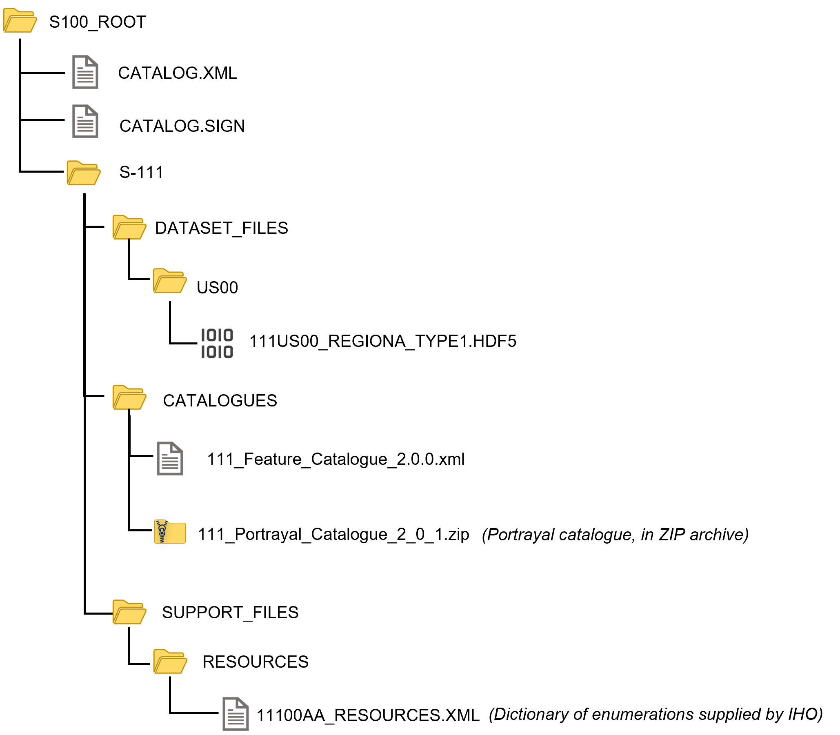
Figure 11-2 – Typical Exchange Set structure
General guidelines for Exchange Set structure are included in S-100 Part 17.
Note that the names and locations of files are coded within the CATALOG.XML or Portrayal Catalogue files, and therefore files and folders should not be renamed or relocated by Producers or end-user systems unless these references can be updated. Portrayal and Feature Catalogues can be relocated to a common system location if their internal structure is maintained.

Exchange Catalogue
The Exchange Catalogue which is in XML format acts as the table of contents for the Exchange Set. The catalogue file of the Exchange Set must be named CATALOG.XML (as specified in S-100 Part 17); no other file in the Exchange Set may have the same name. The contents of the Exchange Catalogue are described in clause 12.
The Exchange Catalogue Schemas for S-111 are the same as for S-100 and may be obtained from the IHO S-100 Schema server: https://schemas.s100dev.net. The S-111 Exchange Catalogue uses an additional product-specific constraints file implementing product-specific restrictions, which is also available from the same site. Use of the additional product-specific constraints file is optional; developers may implement the constraints using any convenient method.

Dataset file naming
The dataset file contains both metadata and one or more sets of speed and direction arrays (see clause 10 – Data Product Format). The dataset name must begin with the three-character Product Specification, followed by the four-character Producer Code (CCCC). Thus surface current datasets begin with the seven-character string ‘111CCCC’.
The characters between this string and the extension are nominally unrestricted in S-100 and S-97 Edition 1.1.0. However, S-111 restricts the “unrestricted” characters as follows:
- Alphabetic characters in the “Latin alphabet”; that is, A-Z and a-z;
- Numeric characters; that is, the characters 0-9;
- The hyphen and underscore characters (“-“ and “_”).
The unrestricted characters may be used to denote geographical region, source of the data, version numbers, and/or any other relevant information. Characters may be lower or upper case. It is not recommended to use unique values such as date/time references as the unrestricted characters need to remain identical between each edition of a dataset.
The filename extension for HDF5 (.h5) must be used to denote the file format.
The total length of the file name shall be no more than 64 characters, including the extension.
EXAMPLE 1: 111US00_CHES_TYPE1.HDF5 for observational data (see clause 12.3.5, Table 12-10) produced by NOAA for Chesapeake Bay (CHES).
EXAMPLE 2: 111US00_ches_dcf8.h5 for a dataset produced by NOAA containing data for NOAA fixed stations in the Chesapeake Bay (ches) organised stationwise (dcf8).
Each producer should adopt a naming scheme that is consistent across its entire S-111 product line. While the examples above are hypothetical, they illustrate how the principles of this clause can be applied by Producers.

Dataset MRN (Informative)
The dataset file name may be mapped to an MRN as follows:
urn:mrn:iho:s111:<ver>:<cccc>:<region>:<type>:<dtg>
where:
- The first part “urn:mrn:iho:s111” is common to all dataset URNs for S-111;
- The product specification version is represented by the “<ver>” part, for example, “2:0:0” for Edition 2.0.0;
- <cccc> represents the 4-character Producer Code;
- <region> represents the geographical region;
- <type> represents the data coding format, for example “type2” for regular grids;
- <dtg> represents the date/time component in the name.
This is an interim rule pending definition of an “S-100-wide” rule for MRNs and will be superseded by the “S-100-wide” rule when it is published.

Support Files
Only the following types of support files are allowed in S-111:
- Optional ‘language packs’ for Feature Catalogues. Each language pack contains a translation of the Feature Catalogue into a specified language.
- Dictionary resource files listing the allowed values and codes of enumerations. There will generally be a single dictionary file for each version of the Product Specification (corrections, if any, will be issued through the usual mechanism for corrections). Inclusion of the dictionary resource file in Exchange Sets is optional, since the Internet location is standardised and manufacturers are permitted to obtain it by other means and install it in an application-specific location.

Support File Naming

General
Support file names are subject to the same naming rules as dataset file names (clause 11.2.3), except that the extension is determined by the support file format.
This clause covers names of language packs and enumeration dictionaries, which are the only support files allowed in this Edition of S-111. Producers who discover a need for other types of support files should conform to the general rule above and consult TWCWG as necessary.

Names of language packs
If a language pack created by a data Producer for the S-111 Feature Catalogue is included, it must have the standard 7-character “111CCCC” prefix and the same base name as the standard IHO-issued Feature Catalogue with the 3-letter ISO 639-2/T language code suffixed. The language codes must be exactly those in the S-100 codelist for languages (S100_MD_LanguageCode, which can be found in the S-100 Schema distribution). The file extension must be “.XML”.
NOTE: A language pack issued by the IHO for the IHO Feature Catalogue will use the IHO Producer Code.

Names of enumeration dictionaries
Enumeration dictionaries are supplied by IHO as part of this Product Specification and should not be renamed.
NOTE (informative): Substitute or extended enumeration dictionaries may be developed if translations are needed. Producers who desire to provide translations of enumeration dictionaries with S-111 Exchange Sets should consult with TWCWG.

Metadata

Introduction
For information exchange, there are several categories of metadata required:
- Metadata about the overall Exchange Dataset and Catalogue;
- Discovery metadata about each of the datasets contained in the Catalogue; and
- Discovery metadata about the support files that make up the package.
The discovery metadata classes have numerous attributes which enable important information about the datasets and accompanying support files to be examined without the need to process the data, for example decrypt, decompress, load etc.
Catalogues (Feature and Portrayal Catalogues) can be included in the Exchange Set in support of the datasets. If included, discovery metadata about the Catalogues must also be provided.
NOTE: S-111 datasets do not reference support files. The only support files allowed in the Exchange Set are “language packs” for Feature Catalogues and enumeration dictionaries, and these are not referenced from within the HDF5 datasets.
Discovery metadata for each HDF5 dataset is given in an XML block within the Exchange Set Catalogue file, and can be accessed without opening the HDF5 file. In addition to discovery metadata, S-111 also provides for carrier metadata that is embedded within the HDF5 file, which provides information needed to process and display the data. Discovery metadata is described in clause 12.2; carrier metadata in clause 12.3.
This clause defines the mandatory and optional metadata needed for S-111. In some cases (if provided by the Producer or Exchange Set packager) the metadata may be repeated in a language other than English. See S-100 Part 17, clauses 17-4.6 – 17-4.8 for guidance on encoding of metadata in languages other than English.

Realisation of Exchange Set components and metadata classes (informative)
The realization of S-111 Exchange Set components and metadata classes from ISO 19115-1 and ISO 19115-3 is the same as in S-100 Part 17, depicted in Figure 12-1. The Figure depicts, from left to right:
- The relevant ISO data exchange structural classes;
- The relevant ISO metadata classes for metadata for exchange;
- S-100 structure classes representing the S-100/S-111 exchange set components;
- The relevant S-100/S-111 Exchange Set metadata classes.
Note that the only support files in S-111 are language packs or enumeration dictionaries, represented by S100_SupportFile. The corresponding metadata blocks are represented by S100_SupportFileDiscoveryMetadata elements.
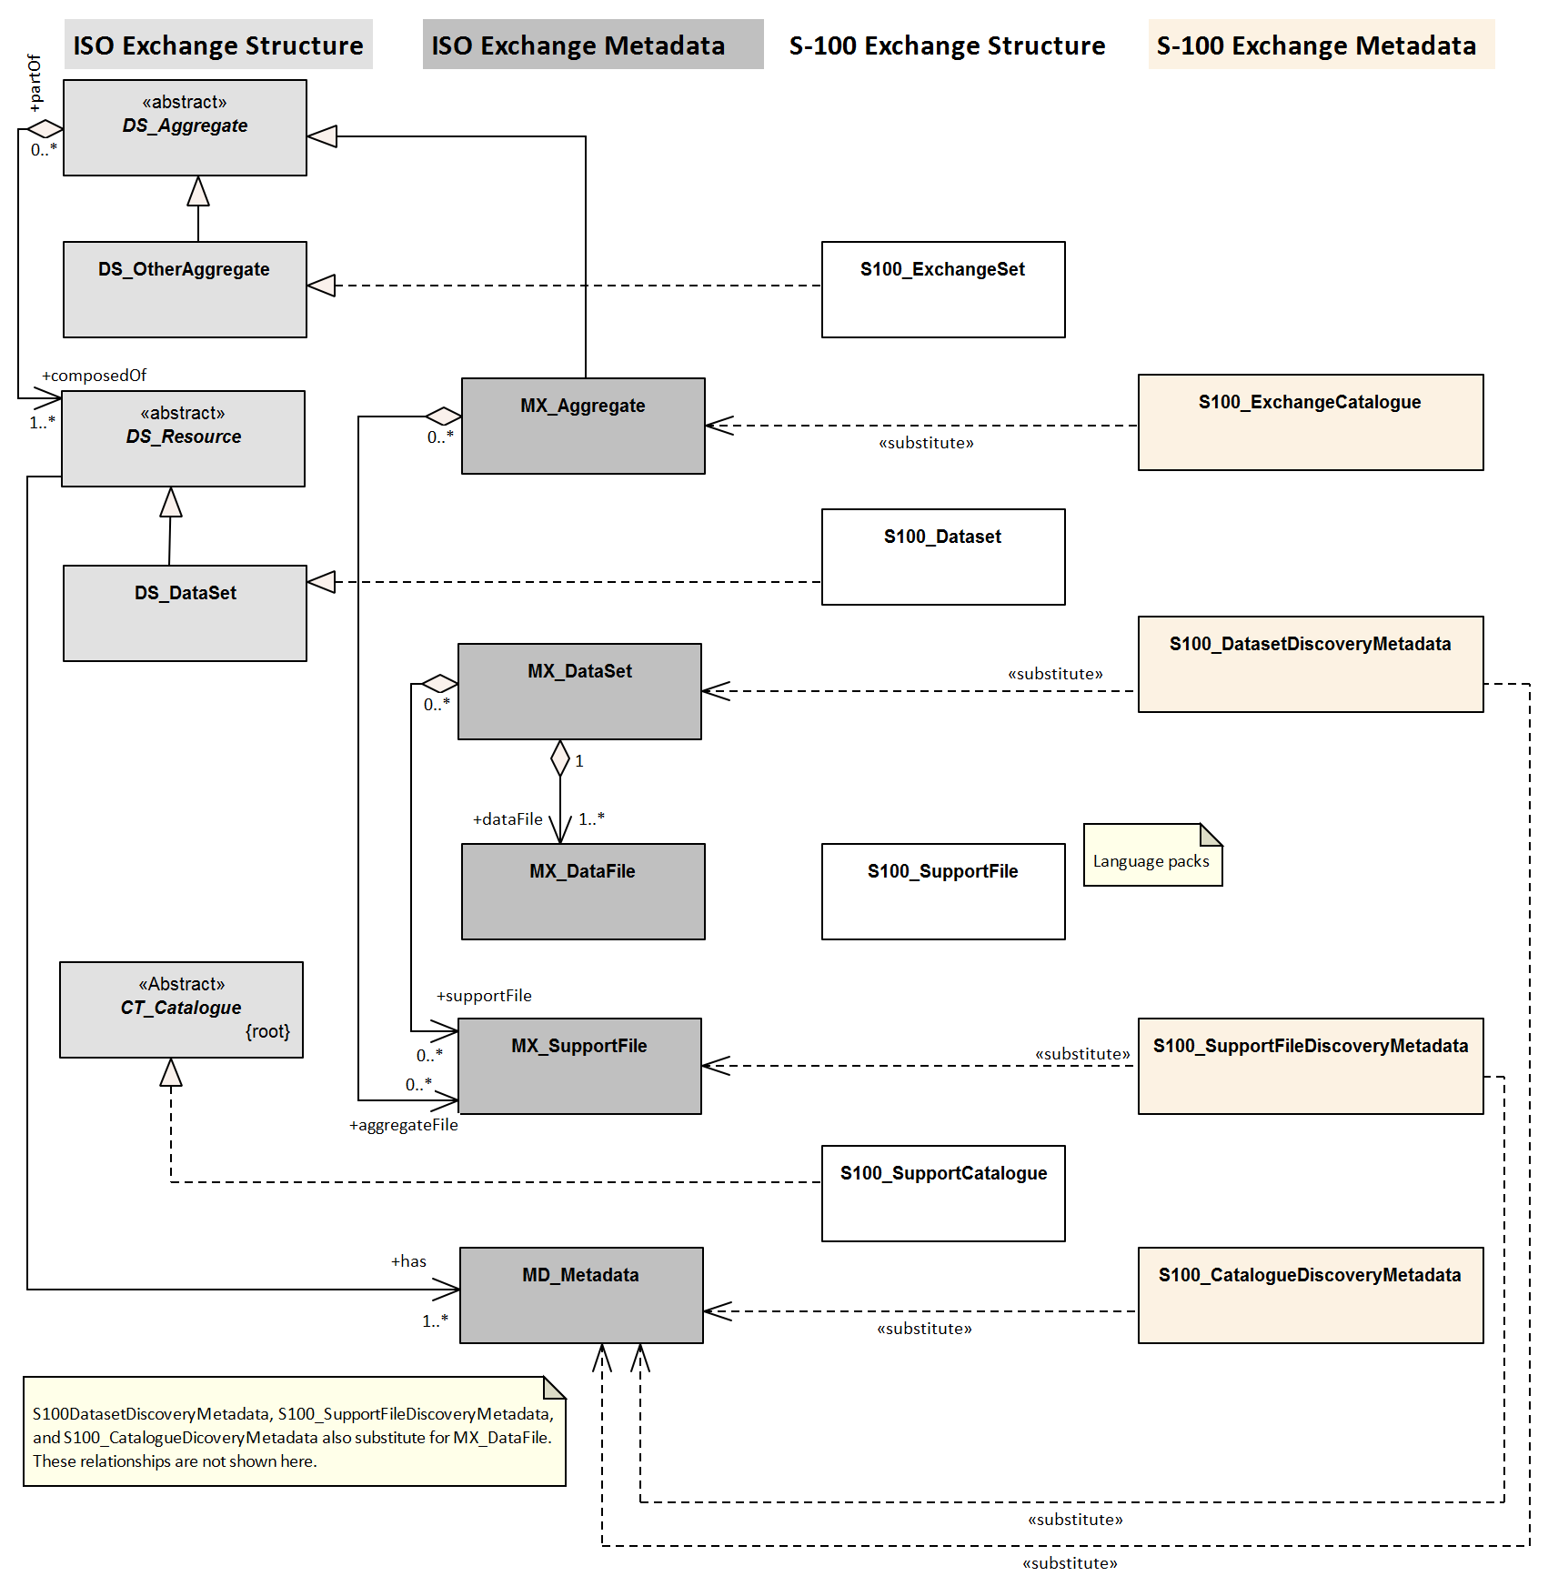
Figure 12-1 – Realisation of the Exchange Set classes (S-100 Part 17, Figure 17-1 with relationships not used in S-111 omitted)

Exchange Set components and related metadata
Figure 12-2 depicts the relationships of Exchange Set “core” elements (datasets and Feature/Portrayal Catalogues) and Exchange Set metadata. This Figure is derived from S-100 Part 17, Figure 17-2. Relationships not applicable to S-111 have been omitted (for example, the link between datasets and support files in S-100 Figure 17-2, because S-111 datasets do not reference support files). Note also that the link between S100_Dataset and S100_CatalogueMetadata is implicit by means of the S-111 version to which the Feature Catalogue, Portrayal Catalogue and dataset conform, which must have the same Edition and revision components.
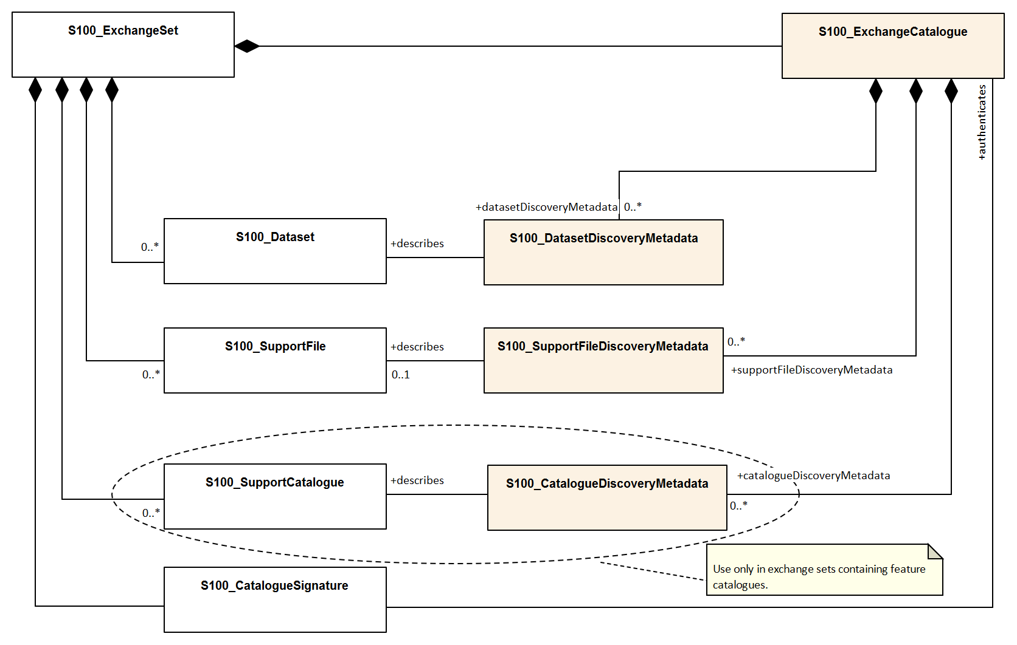
Figure 12-2 – Components and associated metadata for the S-111 Exchange Set (S-100 Part 17, Figure 17-2 with relationships not used by S-111 omitted)
The rules governing the presence and roles of the exchange set components depicted in Figure 12.2 are given below.
- Every exchange set must contain an Exchange Catalogue, represented by S100_ExchangeCatalogue in Figure 12-2.
- Dataset discovery metadata (S100_DatasetDiscoveryMetadata) must be provided in the exchange catalogue for each S-111 dataset in the exchange set.
- Catalogue metadata (S100_CatalogueDiscoveryMetadata) must be provided in the exchange catalogue for any feature and portrayal catalogues included in the exchange set.
- The only support files allowed are language packs and enumeration dictionaries (both represented by S100_SupportFile). Their inclusion in exchange sets is optional.
- Producers must not include ISO metadata files to convey information for ECDIS application processing, since processing these files is not an ECDIS requirement. All information necessary for ECDIS processing must be in CATALOG.XML.
- Language packs are described in S-100 Part 18 and provide translations of feature catalogues.
- If a language pack is included, a support file discovery metadata block (S100_SupportFileDiscoveryMetadata) describing the file must be included in the exchange catalogue.
- A signature file for the Exchange Catalogue must also be included in the Exchange Set (S100_CatalogueSignature).
Since S-111 does not add product-specific metadata attributes, the S-100 metadata classes and Schema are used in S-111 Exchange Sets without extension. The constraints S-111 impose on generic S-100 metadata are described in the documentation tables in clause 12.2.
NOTE: The distribution package implements the additional S-111 constraints on metadata attributes (and many of the S-100 constraints) as Schematron rules in files available from the IHO Schema server. Implementers may substitute any implementation method to apply or check constraints instead of using Schematron-capable processing software.
The tangible representations of the structure classes in Figure 12-2 within actual Exchange Sets are the digital files or folders containing the Exchange Set, dataset(s), Catalogue(s), and support files. The tangible representations of their roles as depicted in Figure 12-2 are the inclusion of the respective components within the Exchange Set. Documentation tables for the structure classes are not provided since the Exchange Set structure is described in clause 11.2.1.
The metadata classes in Figure 12-2 are represented by XML files or XML blocks and are documented in clause 12.2.

Discovery metadata
An outline of the overall concept of an S-111 Exchange Set for the interchange of geospatial data and its relevant metadata is explained in clauses 11.2.1 and 12.1. The place of metadata in the Exchange Set is summarised in clause 12.1.2.
Figure 12-3 depicts the structure of the Exchange Catalogue and its component discovery metadata blocks. The structure is the same as in S-100 Part 17.
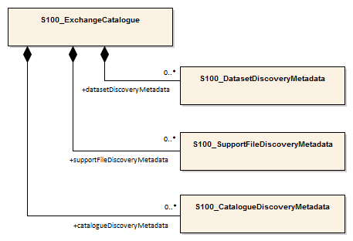
Figure 12-3 – Relationship between Exchange Catalogue, discovery metadata, and dataset (from S-100 Part 17, Figure 17-6)
The detailed structure of the S-111 Exchange Catalogue is depicted in Figure 12-4. This Figure is derived from S-100 Part 17, Figure 17-7, with the following restrictions:
- Elements that are optional in the generic S-100 catalogue model but not used in S-111 are not shown; for example, the updateNumber and updateApplicationDate attributes in the dataset discovery class are not used in S-111.
- Constraints that are specific to S-111 are summarised in a diagram note. Details about constraints are provided in the documentation tables following the diagram.
In S-111 Edition 2.0.0 only Feature and Portrayal Catalogues are allowed.
The language used for the metadata is English.
Time reference for all data will be UTC.
All depth or height values to be given in metres (up to two decimal places for real values).
More detailed information about the various classes and textual descriptions of the constraints are in the Tables in clauses 12.2.1 – 12.2.30 following Figure 12-4. Differences from generic S-100 metadata are emphasized for developer convenience in bold text.

Page intentionally left blank

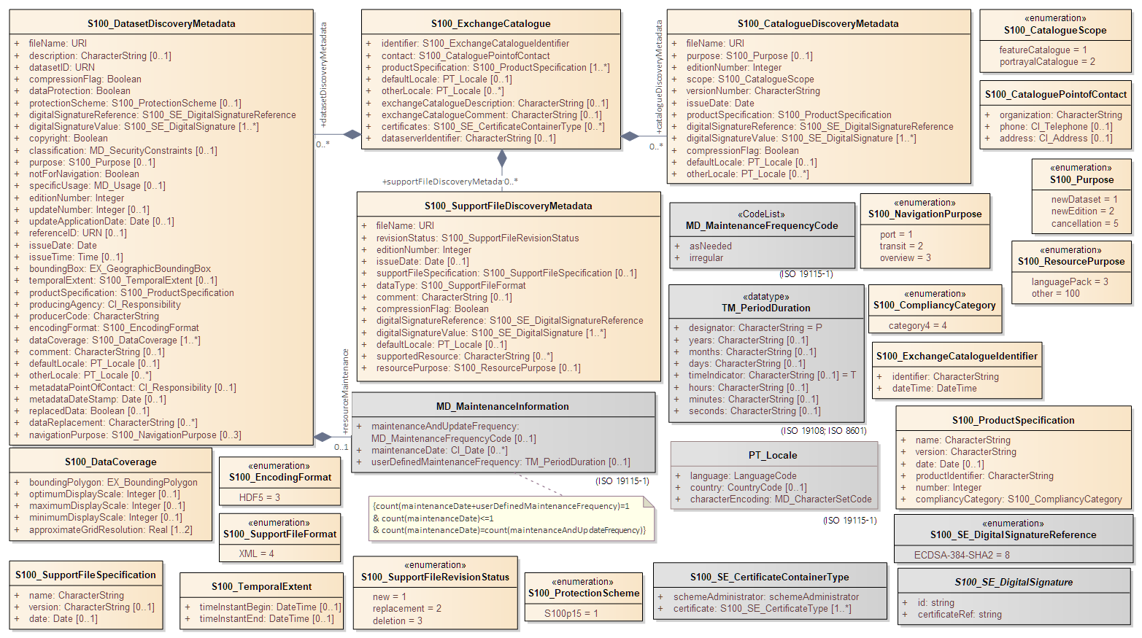
Figure 12-4 - Details of Exchange Set Catalogue classes. Based on S-100 Part 17, Figure 17-7

S100_ExchangeCatalogue
Each Exchange Set has a single S100_ExchangeCatalogue which contains meta information for the data and support files in the Exchange Set. S-111 restricts the S-100 class as described in the Remarks column.
Role Name | Name | Description | Mult | Type | Remarks
Class | S100_ExchangeCatalogue | An exchange catalogue contains the discovery metadata about the exchange datasets and support files | - | - | The optional S-100 attributes identifier, contact, and productSpecification are mandatory in S-111
Attribute | identifier | Uniquely identifies this Exchange Catalogue | 1 | S100_ExchangeCatalogueIdentifier | Mandatory in S-111
Attribute | contact | Details about the issuer of this Exchange Catalogue | 1 | S100_CataloguePointOfContact | Mandatory in S-111
Attribute | productSpecification | Details about the Product Specifications used for the datasets contained in the Exchange Catalogue | 1..* | S100_ProductSpecification | Mandatory in S-111
Attribute | defaultLocale | Default language and character set used for all metadata records in this Exchange Catalogue | 0..1 | PT_Locale | Default is English and UTF-8
Attribute | otherLocale | Other languages and character sets used for the localized metadata records in this Exchange Catalogue | 0..* | PT_Locale | Required if any localized entries are present in the Exchange Catalogue
Attribute | exchangeCatalogueDescription | Description of what the Exchange Catalogue contains | 0..1 | CharacterString
Attribute | exchangeCatalogueComment | Any additional Information | 0..1 | CharacterString
Attribute | certificates | Signed public key certificates referred to by digital signatures in the Exchange Set | 0..* | S100_SE_CertificateContainerType | Content defined in S-100 Part 15. All certificates used, except the SA root certificate (installed separately by the implementing system) shall be included
Attribute | dataServerIdentifier | Identifies the data server for the permit | 0..1 | CharacterString
Role | datasetDiscoveryMetadata | Exchange Catalogues may include or reference discovery metadata for the datasets in the Exchange Set | 0..* | Aggregation S100_DatasetDiscoveryMetadata
Role | catalogueDiscoveryMetadata | Metadata for Catalogue | 0..* | Aggregation S100_CatalogueDiscoveryMetadata | Metadata for the Feature and Portrayal Catalogues, if any
Role | supportFileDiscoveryMetadata | Exchange Catalogues may include or reference discovery metadata for the support files in the Exchange Set | 0..* | Aggregation S100_SupportFileDiscoveryMetadata | The only support files allowed in S-111 are enumeration dictionaries and language packs for Feature Catalogues

S100_ExchangeCatalogueIdentifier
S-111 uses S100_ExchangeCatalogueIdentifier without modification.
Role Name | Name | Description | Mult | Type | Remarks
Class | S100_ExchangeCatalogueIdentifier | An Exchange Catalogue contains the discovery metadata about the exchange datasets and support files | - | - | The concatenation of identifier and dateTime form the unique name
Attribute | identifier | Uniquely identifies this Exchange Catalogue | 1 | CharacterString | See Note 1 for the naming convention
Attribute | dateTime | Creation date and time of the Exchange Catalogue, including time zone | 1 | DateTime | Format: yyyy-mm-ddThh:mm:ssZ

NOTE: Use the file name component of the dataset according to the convention in clause 11.2.3. For example, if the dataset file is named 111ABCDXYZ.HDF5 the metadata identifier should be 111ABCDXYZ. In the event of an Exchange Set containing multiple datasets, use the name of the dataset of largest extent with a “+N” suffix (without quotes), where N is the number of additional datasets in the Exchange Set. If the Exchange Set contains only Feature and/or Portrayal Catalogues, use 111ABCD+N where “ABCD” is the 4-character code of the producer of the Feature or Portrayal Catalogue.

S100_CataloguePointofContact
S-111 uses S100_CataloguePointOfContact without modification.
Role Name | Name | Description | Mult | Type | Remarks
Class | S100_CataloguePointOfContact | Contact details of the issuer of this Exchange Catalogue | - | - | -
Attribute | organization | The organization distributing this Exchange Catalogue | 1 | CharacterString | This could be an individual producer, value added reseller, etc
Attribute | phone | The phone number of the Organization | 0..1 | CI_Telephone
Attribute | address | The address of the Organization | 0..1 | CI_Address

S100_DatasetDiscoveryMetadata
Data in the Discovery Metadata are used to identify the relevance of the dataset to the particular application. S-111 restricts the multiplicity and contents of S100_DatasetDiscoveryMetadata as described in the Remarks column.
Role Name | Name | Description | Mult | Type | Remarks
Class | S100_DatasetDiscoveryMetadata | Metadata about the individual datasets in the Exchange Catalogue | - | - | The optional S-100 attributes updateNumber, updateApplicationDate, otherLocale, and referenceID are not used in S-111  The optional S-100 attributes datasetID dataCoverage, editionNumber, producerCode and boundingBox are mandatory in S-111
Attribute | fileName | Dataset file name | 1 | URI | See S-100 Part 1, clause 1-4.6
Attribute | description | Short description giving the area or location covered by the dataset | 0..1 | CharacterString | For example a harbour or port name, between two named locations etc
Attribute | datasetID | Dataset ID expressed as a Maritime Resource Name | 1 | URN | The URN must be an MRN  Made mandatory in S-111  See clause 11.2.3.1
Attribute | compressionFlag | Indicates if the resource is compressed | 1 | Boolean | true indicates a compressed dataset resource  false indicates an uncompressed dataset resource
Attribute | dataProtection | Indicates if the data is encrypted | 1 | Boolean | true indicates an encrypted dataset resource  false indicates an unencrypted dataset resources
Attribute | protectionScheme | Specification of method used for data protection | 0..1 | S100_ProtectionScheme | In S-100 the only allowed value is “S100p15”
Attribute | digitalSignatureReference | Specifies the algorithm used to compute digitalSignatureValue | 1 | S100_SE_DigitalSignatureReference (see S-100 Part 15)
Attribute | digitalSignatureValue | Value derived from the digital signature | 1..* | S100_SE_DigitalSignature (see S-100 Part 15) | The value resulting from application of digitalSignatureReference  Implemented as the digital signature format specified in Part 15  At least one S100_SE_SignatureOnData is required
Attribute | copyright | Indicates if the dataset is copyrighted | 1 | Boolean | true indicates the resource is copyrighted  false Indicates the resource is not copyrighted
Attribute | classification | Indicates the security classification of the dataset | 0..1 | MD_SecurityConstraints> MD_ClassificationCode (codelist) | 1. unclassified  2. restricted  3. confidential  4. secret  5. top secret  6. sensitive but unclassified  7. for official use only  8. protected  9. limited distribution  Recommended for datasets intended for use on ECDIS (with expected classification as “unclassified”)
Attribute | purpose | The purpose for which the dataset has been issued | 0..1 | S100_Purpose
Attribute | notForNavigation | Indicates the dataset is not intended to be used for navigation | 1 | Boolean | true indicates the dataset is not intended to be used for navigation  false indicates the dataset is intended to be used for navigation
Attribute | specificUsage | The use for which the dataset is intended | 0..1 | MD_USAGE>specificUsage (character string) | Information about specific usage(s) for which the dataset is intended.
Attribute | editionNumber | The Edition number of the dataset | 1 | Integer | Mandatory in S-111  See clause 8.2
Attribute | issueDate | Date on which the data was made available by the data producer | 1 | Date
Attribute | issueTime | Time of day at which the data was made available by the data producer | 0..1 | Time | Mandatory when the interval between datasets is shorter than 1 day, such as 6-hourly forecasts
Attribute | boundingBox | The extent of the dataset limits | 1 | EX_GeographicBoundingBox | Mandatory in S-111
Attribute | temporalExtent | Specification of the temporal extent of the dataset | 0..1 | S100_TemporalExtent | The temporal extent is encoded as the date/time of the earliest and latest data records (in coverage datasets) or date/time ranges (in vector datasets)  If there is more than one feature in a dataset, the earliest and latest time values of records in all features are used, which means the earliest and latest values may be from different features  If date/time information for a feature is not encoded in the dataset, it is treated for the purposes of this attribute as extending indefinitely in the appropriate direction on the time axis, limited by the issue date/time or the cancellation or supersession of the dataset  This attribute is encoded if and only if at least one of the start and end of the temporal extent is known
Attribute | productSpecification | The product specification used to create this dataset | 1 | S100_ProductSpecification
Attribute | producingAgency | Agency responsible for producing the data | 1 | CI_ResponsibleParty>CI_Organisation | See S-100 Table 17-3
Attribute | producerCode | The official IHO Producer Code from S-62 | 1 | CharacterString | Recommended for datasets intended for use on ECDIS. Mandatory in S-111
Attribute | encodingFormat | The encoding format of the dataset | 1 | S100_EncodingFormat | Must be HDF5
Attribute | dataCoverage | Area covered by the dataset | 1..* | S100_DataCoverage | Mandatory in S-111.
Attribute | comment | Any additional information | 0..1 | CharacterString
Attribute | defaultLocale | Default language and character set used in the dataset | 0..1 | PT_Locale
Attribute | metadataPointOfContact | Point of contact for metadata | 0..1 | CI_Responsibility > CI_Individual or CI_Responsibility > CI_Organisation | Only if metadataPointOfContact is  different from producingAgency
Attribute | metadataDateStamp | Date stamp for metadata | 0..1 | Date | May or may not be the issue date
Attribute | replacedData | Indicates if a cancelled dataset is replaced by another data file(s) | 0..1 | Boolean | See Note  Mandatory when purpose = cancellation
Attribute | dataReplacement | Dataset name | 0..* | CharacterString | A dataset may be replaced by 1 or more datasets  See Note  Mandatory when replacedData = true
Attribute | navigationPurpose | Classification of intended navigation purpose (for Catalogue indexing purposes) | 0..3 | S100_NavigationPurpose | Mandatory when notForNavigation = false.
Role | resourceMaintenance | Information about the frequency of resource updates, and the scope of those updates | 0..1 | MD_MaintenanceInformation | S-100 restricts the multiplicity to 0..1 and adds specific restrictions on the ISO 19115 structure and content. See clause MD_MaintenanceInformation in S-100 Part 17  Format: PnYnMnDTnHnMnS (XML built-in type for ISO 8601 duration). See S-100 clause 17-4.9 for encoding guidance  If present, the duration must match the duration encoded in embedded metadata (Table 12-1)

NOTE: replacedData and dataReplacement: The intended use of the attributes replacedData and dataReplacement could be, for example, to provide a mechanism for service providers to build automation when providing replacement data sets to customers within existing subscription periods.

S100_NavigationPurpose
Item | Name | Description | Code | Remarks
Enumeration | S100_NavigationPurpose | The navigational purpose of the dataset | --
Value | port | For port and near shore operations | 1
Value | transit | For coast and planning purposes | 2
Value | overview | For ocean crossing and planning purposes | 3

S100_DataCoverage
Role Name | Name | Description | Mult | Type | Remarks
Class | S100_DataCoverage | A spatial extent where data is provided; and the display scale information for the provided data | - | - | The S-100 attribute temporalExtent is not used
Attribute | boundingPolygon | A polygon which defines the actual data limit | 1 | EX_BoundingPolygon | See the notes below this Table and clause 7.11
Attribute | optimumDisplayScale | The scale with which the data is optimally displayed | 0..1 | Integer | Example: A scale of 1:25000 is encoded as 25000  Guidance for display scales will be provided in a future revision (see note 7 clause 7.10.1)
Attribute | maximumDisplayScale | The maximum scale with which the data is displayed | 0..1 | Integer | Guidance for display scales will be provided in a future revision (see note 7 clause 7.10.1)
Attribute | minimumDisplayScale | The minimum scale with which the data is displayed | 0..1 | Integer | Guidance for display scales will be provided in a future revision (see note 7 clause 7.10.1)
Attribute | approximateGridResolution | The resolution of gridded or georeferenced data (in metres) | 1..2 | Real | A single value may be provided when all axes have a common resolution  For multiple value provision, use axis order as specified in dataset  May be approximate for ungeorectified data  For example, for 5 metre resolution, the value 5 must be encoded  See Note 6. Mandatory in S-111 for grid formats

NOTE 1: If there are multiple grid or TIN features in the dataset, each feature should have a separate dataCoverage attribute in dataset discovery metadata, except that the coverages for intersecting or adjacent features with the same grid resolution may be combined at producer discretion.
NOTE 2: Bounding polygons for grid features should be the same as the spatial extent of the grid, except that large regions uniformly and permanently populated with fill values (such as large land areas) may be excluded. The boundaries are left to the discretion of the data producer, but overly-detailed boundaries and small interior holes are discouraged.
NOTE 2: Bounding polygons for TIN features may either be the union of all triangles defined in the TIN, or the bounding box covering all the vertexes of the TIN.
NOTE 3: Bounding polygons for multipoint features (DCF 1 and 8) may be one or more reasonably minimized polygons or bounding boxes that together cover all data points.
NOTE 5: A boundingPolygon is restricted to a single GML Polygon with one exterior and 0 or more interiors expressed as Linear Rings using SRS EPSG:4326. The exterior and optional interiors shall be composed of a closed sequence of >=4 coordinate positions expressed individually or as a list (posList). The GML polygon shall have a valid GML identifier
NOTE 4: For approximateGridResolution, if the grid cell size varies over the extent of the grid, an approximated value based on model parameters or production metadata should be used.
NOTE 7: More detailed guidance about display scales will be provided in a future edition. In the interim, display scales are left to the discretion of the producer; it is suggested they should be selected so as maintain visually reasonable symbol spacing (avoid overcrowded or overly sparse current arrows) considering navigation purpose (clause 12.2.5) and scale ranges of underlying ENCs.
NOTE 8: More detailed guidance for bounding polygons will be provided in a future edition. In the interim, it is suggested that data producers use polygons for underlying S-102 datasets as a starting point.

S100_Purpose
Role Name | Name | Description | Code | Remarks
Enumeration | S100_Purpose | The purpose of the dataset | - | See clause 8.2. The S-100 values update, reissue and delta are not used.
Value | newDataset | Brand new dataset | 1 | No data has previously been produced for this area
Value | newEdition | New Edition of the dataset or Catalogue | 2 | Includes new information which has not been previously distributed by updates
Value | cancellation | Dataset or Catalogue that has been cancelled | 5 | Indicates the dataset or Catalogue should no longer be used and can be deleted

S100_TemporalExtent
Role Name | Name | Description | Mult | Type | Remarks
Class | S100_TemporalExtent | Temporal extent | -- |  | At least one of the timeInstantBegin and timeInstantEnd attributes must be populated; if both are known, both must be populated. The absence of either begin or end indicates indefinite validity in the corresponding direction, limited by the issue date/time or the cancellation or supersession of the dataset
Attribute | timeInstantBegin | The instant at which the temporal extent begins | 0..1 | DateTime
Attribute | timeInstantEnd | The instant at which the temporal extent ends | 0..1 | DateTime

NOTE 1: In case of overlap in temporal extent between predecessor and successor datasets, the successor dataset prevails. For example, water level or weather forecast datasets may have a temporal extent of N days or hours, but be replaced by new forecast at N – X.
NOTE 2: Precedence and succession can be determined from information in dataset discovery metadata (in particular, issue date, time and temporal extent).

S100_EncodingFormat
Item | Name | Description | Code | Remarks
Enumeration | S100_EncodingFormat | Encoding format | - | Only the HDF5 format is used in S-111
Value | HDF5 | The HDF5 data format as defined in Part 10c | -

S100_ProductSpecification
S-111 uses S100_ProductSpecification without modification.
Role Name | Name | Description | Mult | Type | Remarks
Class | S100_ProductSpecification | The Product Specification contains the information needed to build the specified product | - | - | The optional S-100 attributes name, version and compliancyCategory are mandatory in S-111.
Attribute | name | The name of the Product Specification used to create the datasets | 1 | CharacterString | The name in the Product Specification Register, in the IHO Geospatial Information (GI) Registry. For S-111 Ed. 2.0.0, this is “Surface Currents”  Mandatory in S-111
Attribute | version | The version number of the Product Specification | 1 | CharacterString | For example, 2.0.0 for S-111 Edition 2.0.0  Mandatory in S-111
Attribute | date | The version date of the Product Specification | 0..1 | Date | From the Product Specification Register of the IHO GI Registry. For interim drafts use the version date in Product Specification Metadata
Attribute | productIdentifier | Machine readable unique identifier of a product type | 1 | CharacterString  (Restricted to Product ID values from the IHO Product Specification Register, in the IHO Geospatial Information Registry) | For S-111 this must be the string “S-111” (without quotes)
Attribute | number | The number used to lookup the product in the Product Specification Register of the IHO GI registry | 1 | Integer | From the Product Specification Register in the IHO Geospatial Information Registry  Encode as “0” until this Edition is added to the GI Registry and receives a Registry number. Do not use the number of any other Edition
Attribute | compliancyCategory | The level of compliance of the Product Specification to S-100 | 1 | S100_CompliancyCategory | See S-100 Part 4a, clause 4a-5.5 and clause 7.6 in this Product Specification  Mandatory in S-111

S100_CompliancyCategory
S-111 uses only Category 4 as defined in S-100 Part 4a, clause 4a-5.5.
Role Name | Name | Description | Code | Remarks
Enumeration | S100_CompliancyCategory |  | - | S-111 does not use category1, category2 or category3
Value | category4 | IHO S-100 and IMO harmonized display compliant | 4

S100_ProtectionScheme
S-111 uses S100_ProtectionScheme without modification.
Item | Name | Description | Code | Remarks
Enumeration | S100_ProtectionScheme | Data protection schemes | - | -
Value | S100p15 | IHO S-100 Part 15 | - | See S-100 Part 15

S100_SupportFileDiscoveryMetadata
The only support files in S-111 are enumeration dictionaries and language packs for Feature Catalogues.
Role Name | Name | Description | Mult. | Type | Remarks
Class | S100_SupportFileDiscoveryMetadata | Metadata about the individual support files in the Exchange Catalogue | - | - | S-111 does not use otherDataTypeDescription
Attribute | fileName | Name of the support file | 1 | URI | See S-100 Part 1, clause 1-4.6 and clause 11.2.5 in this Product Specification
Attribute | revisionStatus | The purpose for which the support file has been issued | 1 | S100_SupportFileRevisionStatus | For example new, replacement, etc
Attribute | editionNumber | The Edition number of the support file | 1 | Integer | See clause 8.2.6
Attribute | issueDate | Date on which the data was made available by the Data Producer | 0..1 | Date | Date on which the support file was made available by its producer
Attribute | supportFileSpecification | The Specification used to create this file | 0..1 | S100_SupportFileSpecification
Attribute | dataType | The format of the support file | 1 | S100_SupportFileFormat
Attribute | comment | Optional comment | 0..1 | CharacterString
Attribute | compressionFlag | Indicates if the resource is compressed | 1 | Boolean | true indicates a compressed resource  false indicates an uncompressed resource
Attribute | digitalSignatureReference | Specifies the algorithm used to compute digitalSignatureValue | 1 | S100_SE_DigitalSignatureReference  (see S-100 Part 15)
Attribute | digitalSignatureValue | Value derived from the digital signature | 1..* | S100_SE_DigitalSignature  (see S-100 Part 15) | The value resulting from application of digitalSignatureReference  Implemented as the digital signature format specified in S-100 Part 15
Attribute | defaultLocale | Default language and character set used in the support file | 0..1 | PT_Locale | In absence of defaultLocale the language is English in UTF-8  A support file is expected to use only one as locale. Additional support files can be created for other locales
Attribute | supportedResource | Identifier of the resource supported by this support file | 0..* | CharacterString | Conventions for identifiers are still to be developed in S-100. S-100 allows file URI, digital signature or cryptographic hash checksums to be used.  In the interim, for language packs this attribute will reference the Feature Catalogue file. For enumeration dictionaries, use the Product Specification identifier and version in URI form
Attribute | resourcePurpose | The purpose of the supporting resource | 0..1 | S100_ResourcePurpose | Identifies how the supporting resource is used

S100_SupportFileFormat
Item | Name | Description | Code | Remarks
Enumeration | S100_SupportFileFormat | The format used for the support file | - | S-111 uses only XML; language packs and enumeration dictionaries are XML files
Value | XML | Extensible Markup Language | 4

S100_SupportFileRevisionStatus
S-111 uses S100_SupportFileRevisionStatus without modification.
Item | Name | Description | Code | Remarks
Enumeration | S100_SupportFileRevisionStatus | The reason for inclusion of the support file in this Exchange Set | - | -
Value | new | A file which is new | 1 | Signifies a new file
Value | replacement | A file which replaces an existing file | 2 | Signifies a replacement for a file of the same name
Value | deletion | Deletes an existing file | 3 | Signifies deletion of a file of that name

S100_SupportFileSpecification
Role Name | Name | Description | Mult | Type | Remarks
Class | S100_SupportFileSpecification | The Standard or Specification to which a support file conforms | - | - | -
Attribute | name | The name of the Specification used to create the support file | 1 | CharacterString | S-100 for language packs and enumeration dictionary
Attribute | version | The version number of the Specification | 0..1 | CharacterString | Use the applicable edition of the Standard in the name attribute  For example, “5.0.0” for language packs conforming to S-100 Edition 5.0.0
Attribute | date | The version date of the Specification | 0..1 | Date | Omit or use the publication date in the GI Registry or ISO Catalogue

S100_ResourcePurpose
Item | Name | Description | Code | Remarks
Enumeration | S100_ResourcePurpose | Defines the purpose of the supporting resource | - | S-111 allows only language packs and enumeration dictionaries as support files and the allowed values of the S-100 enumeration are restricted accordingly
Value | languagePack | A Language pack | 3
Value | other | A type of resource not otherwise described | 100 | For an enumeration dictionary, which supports all datasets for a particular version of the Product Specification

S100_CatalogueDiscoveryMetadata
S-111 uses S100_CatalogueDiscoveryMetadata without modification. This class is used to provide metadata about Feature and Portrayal Catalogues.
Role Name | Name | Description | Mult | Type | Remarks
Class | S100_CatalogueDiscoveryMetadata | Class for S-100 Catalogue metadata | - | - | -
Attribute | fileName | The name for the Catalogue | 1 | URI | See S-100 Part1, clause 1-4.6
Attribute | purpose | The purpose for which the Catalogue has been issued | 0..1 | S100_Purpose  (codelist) | The values must be one of the following:  2 new edition  5 cancellation  Default is new edition
Attribute | editionNumber | The Edition number of the Catalogue | 1 | Integer | Initially set to 1 for a given productSpecification.number  Increased by 1 for each subsequent New Edition  Uniquely identifies the version of the Catalogue
Attribute | scope | Subject domain of the Catalogue | 1 | S100_CatalogueScope
Attribute | versionNumber | The version identifier of the Catalogue | 1 | CharacterString | Human readable version identifier
Attribute | issueDate | The issue date of the Catalogue | 1 | Date
Attribute | productSpecification | The Product Specification used to create this file | 1 | S100_ProductSpecification
Attribute | digitalSignatureReference | Specifies the algorithm used to compute digitalSignatureValue | 1 | S100_SE_DigitalSignatureReference  (see S-100 Part 15)
Attribute | digitalSignatureValue | Value derived from the digital signature | 1..* | S100_SE_DigitalSignature  (see S-100 Part 15) | The value resulting from application of digitalSignatureReference  Implemented as the digital signature format specified in S-100 Part 15
Attribute | compressionFlag | Indicates if the resource is compressed | 1 | Boolean | true indicates a compressed resource  false indicates an uncompressed resource
Attribute | defaultLocale | Default language and character set used in the Catalogue | 0..1 | PT_Locale | In absence of defaultLocale the language is English in UTF-8
Attribute | otherLocale | Other languages and character sets used in the Catalogue | 0..* | PT_Locale

S100_CatalogueScope
Item | Name | Description | Code | Remarks
Enumeration | S100_CatalogueScope | The scope of the Catalogue | - | S-111 Exchange Sets do not contain Interoperability Catalogues and the value interoperabilityCatalogue is removed
Value | featureCatalogue | S-100 Feature Catalogue | -
Value | portrayalCatalogue | S-100 Portrayal Catalogue | -

MD_MaintenanceInformation
Role Name | Name | Description | Mult | Type | Remarks
Class | MD_MaintenanceInformation | Information about the scope and frequency of updating | - | - | S-100 restricts the ISO 19115-class to:  - Prohibit maintenanceScope, maintenanceNote, and contact attributes;  - Define restrictions on maintenanceAndUpdate‌Frequency, maintenanceDate, and userDefinedMaintenance‌Frequency attributes
Attribute | maintenanceAndUpdateFrequency | Frequency with which changes and additions are made to the resource after the initial resource is completed | 0..1 | MD_MaintenanceFrequencyCode (codelist) | Must be populated if userDefinedMaintenanceFrequency is not present, otherwise optional. See Table MD_Maintenance‌Frequency‌Code in this clause for values allowed in S-100 metadata
Attribute | maintenanceDate | Date information associated with maintenance of the resource | 0..1 | CI_Date | Exactly one of maintenanceDate and userDefinedMaintenanceFrequency must be populated  Allowed value for dateType: nextUpdate
Attribute | userDefinedMaintenanceFrequency | Maintenance period other than those defined | 0..1 | TM_PeriodDuration | Exactly one of maintenanceDate and userDefinedMaintenanceFrequency must be populated  Only positive durations allowed

MD_MaintenanceFrequencyCode
Item | Name | Description | Code | Remarks
Enumeration | MD_MaintenanceFrequencyCode | Frequency with which modifications and deletions are made to the data after it is first produced | - | S-100 is restricted to only the following values from the ISO 19115-1 codelist. The conditions for the use of a particular value are described in its Remarks
Value | asNeeded | Resource is updated as deemed necessary | 1 | Use only for datasets which normally use a regular interval for update or supersession, but will have the next update issued at an interval different from the usual  Allowed if and only if userDefinedMaintenanceFrequency is not populated
Value | irregular | Resource is updated in intervals that are uneven in duration | 2 | Use only for datasets which do not use a regular schedule for update or supersession  Allowed if and only if userDefinedMaintenanceFrequency is not populated

PT_Locale
Role Name | Name | Description | Mult | Type | Remarks
Class | PT_Locale | Description of a locale | - | - | From ISO 19115-1
Attribute | language | Designation of the locale language | 1 | LanguageCode | ISO 639-2/T 3-letter language codes.
Attribute | country | Designation of the specific country of the locale language | 0..1 | CountryCode | ISO 3166-2 2-letter country codes
Attribute | characterEncoding | Designation of the character set to be used to encode the textual value of the locale | 1 | MD_CharacterSetCode | UTF-8 is used in S-100

LanguageCode, CountryCode and MD_CharacterSetCode are codelists which are defined in resource files within the S-100 XML schemas package and described in the documentation for the S-100 XML Schemas.

S100_SE_CertificateContainer
S-111 uses S100_SE_CertificateContainer without modification.
Role Name | Name | Description | Mult | Type | Remarks
Class | S100_SE_CertificateContainer | A set of signed public key certificates | - | - | Used in S-100 Part 17 Exchange Catalogues
Attribute | schemeAdministrator | The scheme administrator identity | 0..1 | CharacterString | The identity of the Scheme Administrator is contained in the “id” attribute of the schemeAdminstrator element. The Scheme Adminstrator certificate is NOT included in catalogue metadata as it is independently verified by the implementing system
Attribute | certificate | A signed public key certificate | 1..* | Base 64 encoded Character String | Conforms to X.509 encoding. Contains a digitally signed identifier of an entity

S100_SE_DigitalSignatureReference
S-111 uses only the ECDSA-384-SHA2 value of S100_SE_DigitalSignatureReference, in conformity with the restriction in S-100 Part 15, clauses 15-8.7 and 15-8.11.7.
Item | Name | Description | Code | Remarks
Enumeration | S100_SE_DigitalSignatureReference | Algorithm used to compute the digital signature | - | Only ECDSA is currently used in implementations of S-100 for file based transfer of data to ECDIS. Other values are included for interoperability with other implementations by external standards. See S-100 Part 15, clause 15-8.4
Value | ECDSA-384-SHA2 |  | 8 | 384 bits ECDSA: SHA2-384

S100_SE_DigitalSignature
S-111 conforms to S-100 Part 15, clause 15-8-11.4, which states: “The class S100_SE_DigitalSignature is realized as one of either S100_SE_SignatureOnData (a digital signature of a particular identified resource) or an additional digital signature defined using the [same class] which is either a S100_SE_SignatureOnData or S100_SE_SignatureOnSignature element as described in clause 15-8.8. S-100 Part 17 metadata thus allows for multiple digital signatures, a single mandatory S100_SE_SignatureOnData and any number of additional signatures, either of the data or other signatures.” (In S-100, this class is not documented separately.)
S-111 uses the class S100_SE_DigitalSignature without modification; however, in exchange catalogues it is implemented by one of its subclasses S100_SE_SignatureOnData or S100_SE_SignatureOnSignature.
Role Name | Name | Description | Mult | Type | Remarks
Class | S100_SE_DigitalSignature |  | - | Base64 encoded digital signature value | See S-100 Part 15, clause 15-8  Abstract class substituted by one of its subclasses.
Attribute | id | Identifier of the digital signature | 1 | CharacterString | Every signature entry has a unique identifier
Attribute | certificateRef | Signed Public Key | 1 | CharacterString | Identifier of the certificate against which the digital signature validates

S100_SE_SignatureOnData
S-111 uses S100_SE_SignatureOnData without modification.
Role Name | Name | Description | Mult | Type | Remarks
Class | S100_SE_SignatureOnData |  | - | Base64 encoded digital signature value | See S-100 Part 15, clause 15-8  Subclass of S100_SE_DigitalSignature
Attribute | id | Identifier of the digital signature | 1 | CharacterString | Every signature entry has a unique identifier  (Inherited attribute)
Attribute | certificateRef | Signed Public Key | 1 | CharacterString | Identifier of the certificate against which the digital signature validates  (Inherited attribute)
Attribute | dataStatus | The digital signature | 1 | DataStatus

S100_SE_SignatureOnSignature
S-111 uses S100_SE_SignatureOnSignature without modification.
Role Name | Name | Description | Mult | Type | Remarks
Class | S100_SE_SignatureOnSignature |  | - | Base64 encoded digital signature value | See S-100 Part 15, clause 15-8  Subclass of S100_SE_DigitalSignature
Attribute | id | identifier of the digital signature | 1 | CharacterString | Every signature entry has a unique identifier  (Inherited attribute)
Attribute | certificateRef | Signed Public Key | 1 | CharacterString | Identifier of the certificate against which the digital signature validates  (Inherited attribute)
Attribute | signatureref | The digital signature referenced | 1

DataStatus
S-111 uses the S-100 enumeration DataStatus defined in S-100 Part 15 without modification.
Item | Name | Description | Code | Remarks
Enumeration | DataStatus | The state of data when a digital signature is created | -
Value | unencrypted | The data is unencrypted and uncompressed | - | For example, supporting resources
Value | encrypted | The data is compressed and encrypted | - | For example, copy protected datasets
Value | compressed. | The data is compressed only | - | For example, archives of multiple resources

EX_GeographicBoundingBox
From ISO 19115-1.
Role Name | Name | Description | Mult | Type | Remarks
Class | EX_GeographicBoundingBox | Geographic position of the dataset | - | - | Defined in ISO 19115-1: geographic position of the resource
Attribute | westBoundLongitude | Western-most coordinate of the limit of the dataset extent, expressed in longitude in decimal degrees (positive east) | 1 | Real | Arc degrees
Attribute | eastBoundLongitude | Eastern-most coordinate of the limit of the dataset extent, expressed in longitude in decimal degrees (positive east) | 1 | Real | Arc degrees
Attribute | southBoundLatitude | Southern-most coordinate of the limit of the dataset extent, expressed in latitude in decimal degrees (positive north) | 1 | Real | Arc degrees
Attribute | northBoundLatitude | Northern-most, coordinate of the limit of the dataset extent expressed in latitude in decimal degrees (positive north) | 1 | Real | Arc degrees

NOTE (from ISO 19115-1): This is only an approximate reference so specifying the Coordinate Reference System is unnecessary and need only be provided with a precision of up to two decimal places.

EX_BoundingPolygon
From ISO 19115-1.
Role Name | Name | Description | Mult | Type | Remarks
Class | EX_BoundingPolygon | Boundary enclosing the dataset, expressed as the closed set of (x,y) coordinates of the polygon (last point replicates first point) | - | - | Defined in ISO 19115-1: enclosing geometric object which locates the resource, expressed as a set of (x,y) coordinate(s)
Attribute | polygon | Sets of points defining the bounding polygon | 1 | GM_Object | Must be a GML polygon with one exterior and 0 or more interiors expressed as Linear Rings using SRS EPSG:4326  (See S-100 Part 17)

NOTE (from ISO 19115-1): If a polygon is used it should be closed (last point replicates first point).

Page intentionally left blank

Carrier metadata
The metadata for the S-111 product is divided in three sections, corresponding to the General Metadata (Table 12-1), the Feature Type Metadata (Table 12-2), and the Feature Instance Metadata (Table 12-3 and Table 12-4). The Instance Metadata is subdivided into metadata attached to the instance as a whole (Table 12-3) and metadata attached to individual values groups (Table 12-4). Since these values do not reside in the Metadata blocks, but are in the HDF files, they are referred to as Carrier Metadata. The Carrier Metadata consists of the data and parameters needed to read and interpret the information in the Surface Current product even if the other S-111 Metadata files are unavailable.
Note that in Tables 12-1 – 12-4, some of the metadata variables have restrictions on their core values (that is, whether they are optional or mandatory, the specific values allowed, etc) that are not imposed in S-100. These are grouped under the heading ‘Metadata for S-111 with restrictions on core metadata values.’
Mandatory attributes in a section of a Table that is designated for one or more specified dataCodingFormat values are mandatory only for the specified dataCodingFormat value(s).
It is suggested for any enumeration in S-111, to use unsigned integer types (preferably standard integer type H5T_STD_U8LE) for the base type of the numeric code when creating the enumeration.
Figures 12-5 – 12-9 depict the carrier metadata at each level of the structural hierarchy in an HDF5 dataset. The elements (groups and metadata) defined in S-100 are distinguished from those defined in S-111 by prefix and shade. Figure 12-5 is a summary diagram depicting all levels of the structural and their associated metadata components for all the coverage types used in S-111. Figures 12-6 – 12-9 show the details for each structural level and each coverage type.
The same information as in Figures 12-6 – 12-9 is depicted in Annex B (Figures B-6 – B-10) but organised by type of coverage instead of levels in the HDF5 structural hierarchy.
The maximum length of all string HDF5 attributes is 300 characters.
An attribute defined at a lower level supersedes the same attribute defined at a higher level.
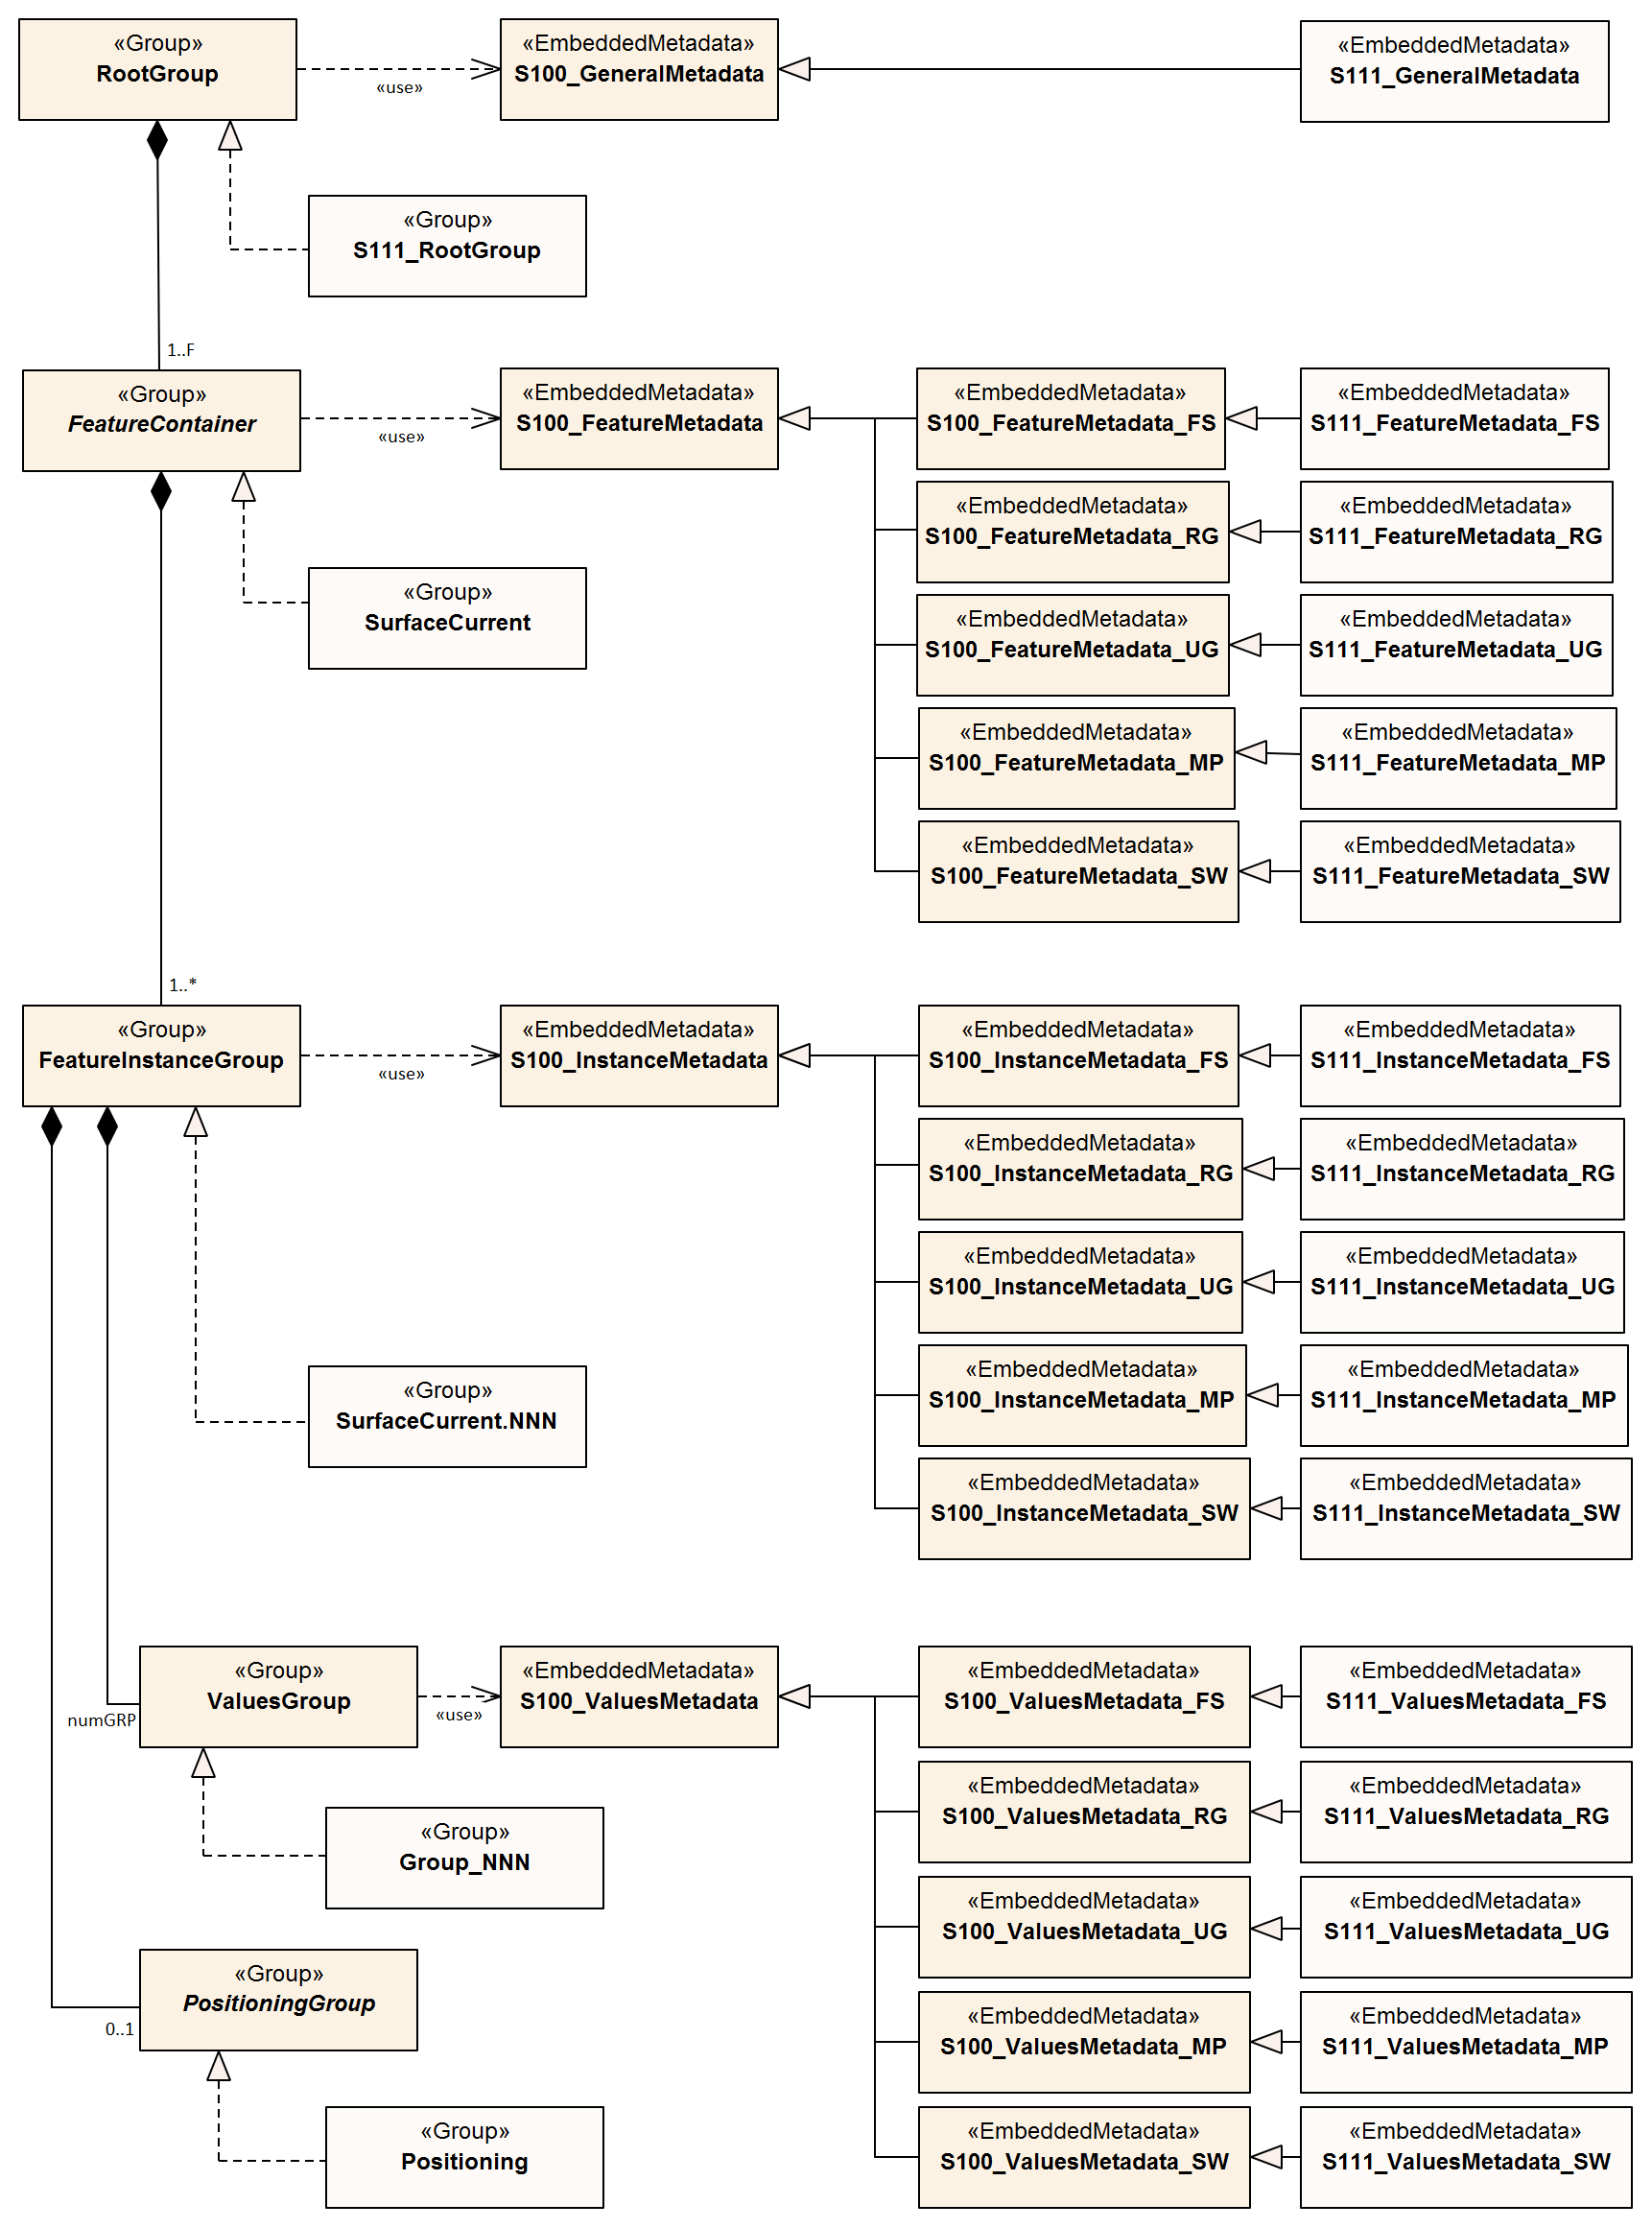
Figure 12-5 – Carrier metadata for the S-111 HDF5 group hierarchy

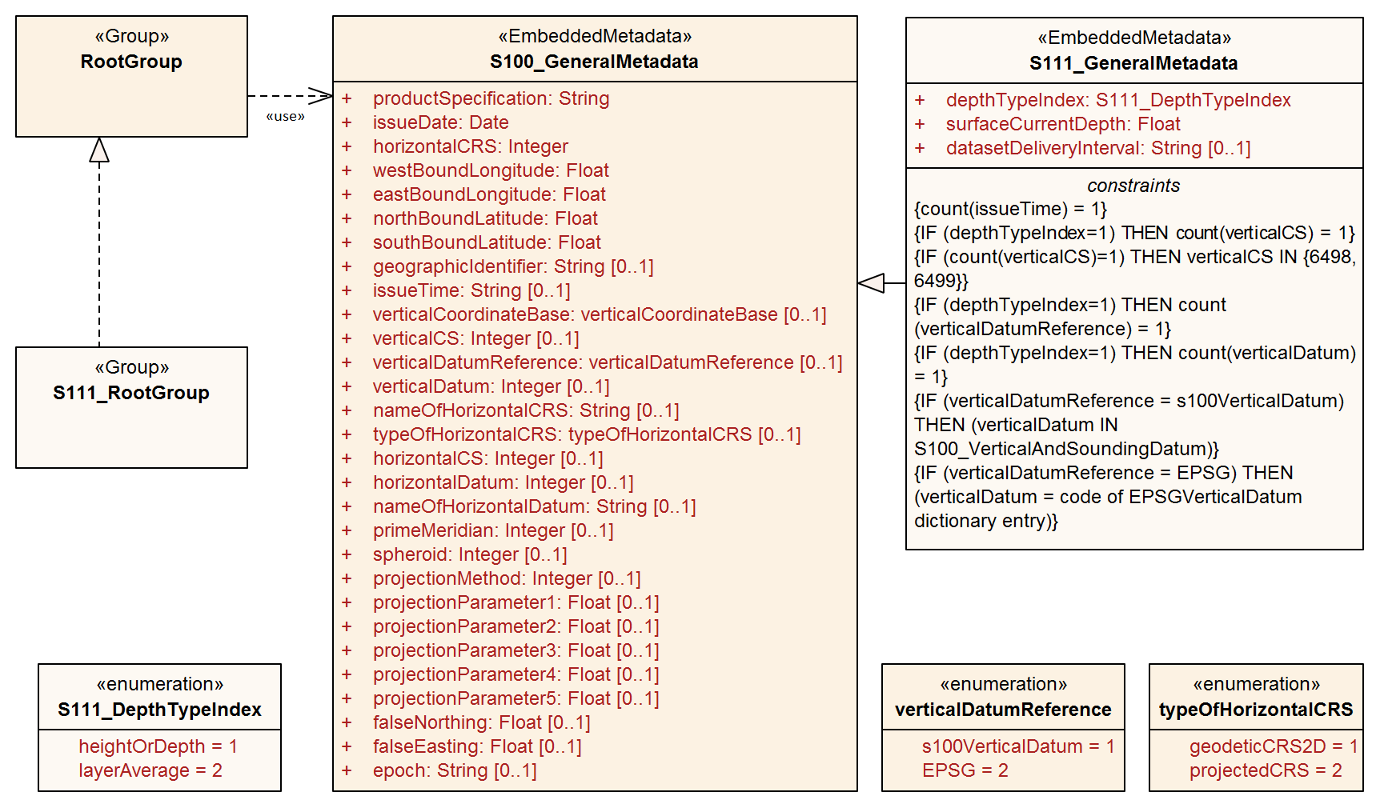
Figure 12-6 – General metadata - Carrier metadata for the root group

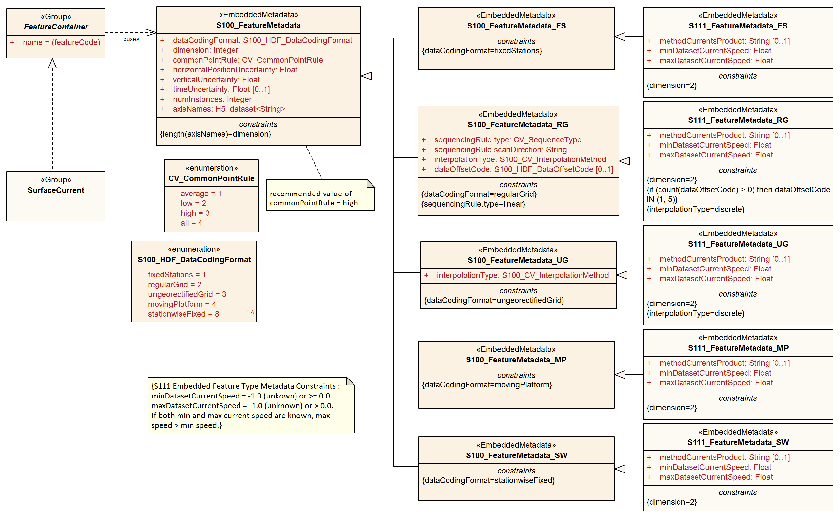
Figure 12-7 – Feature Type metadata - Carrier metadata for the Feature Container group
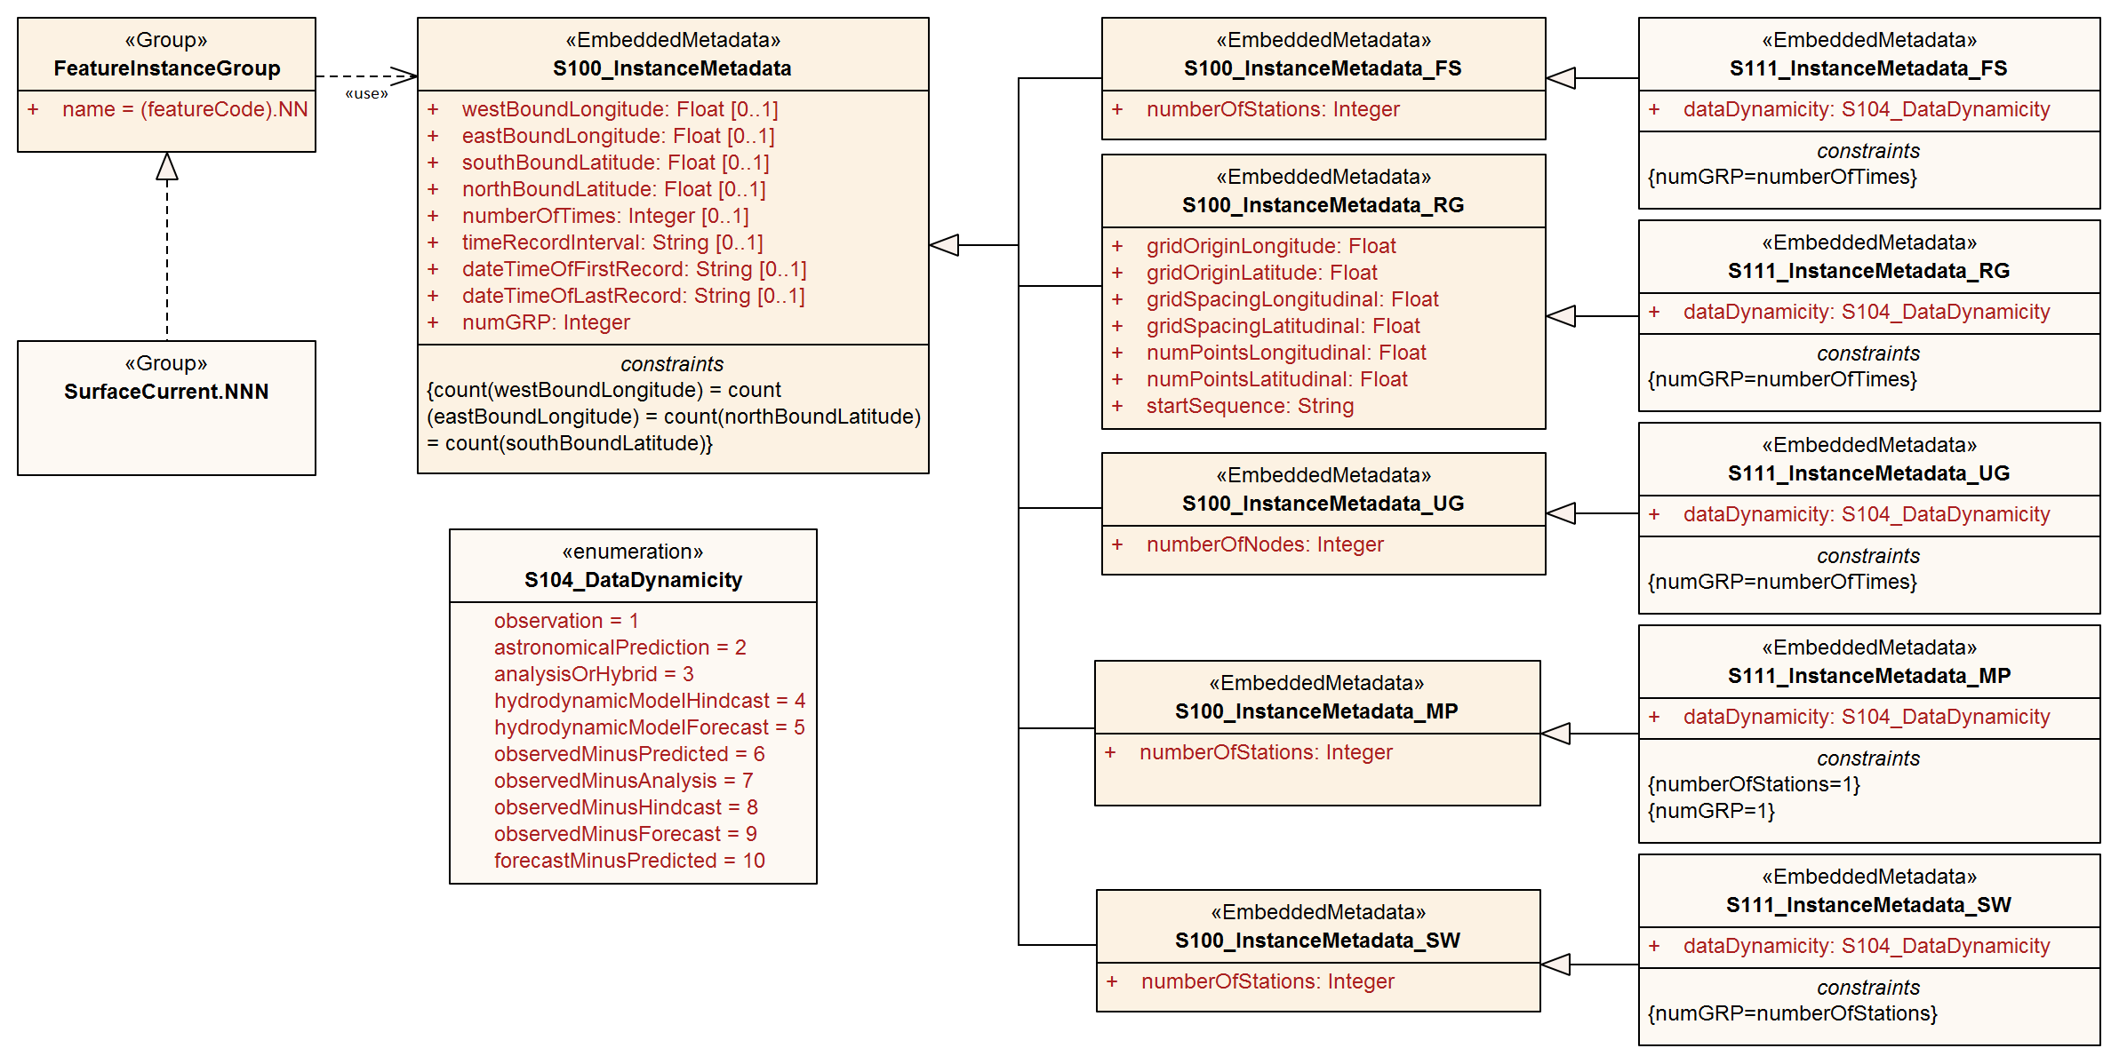
Figure 12-8 – Feature Instance metadata - Carrier metadata for the Feature Instance group
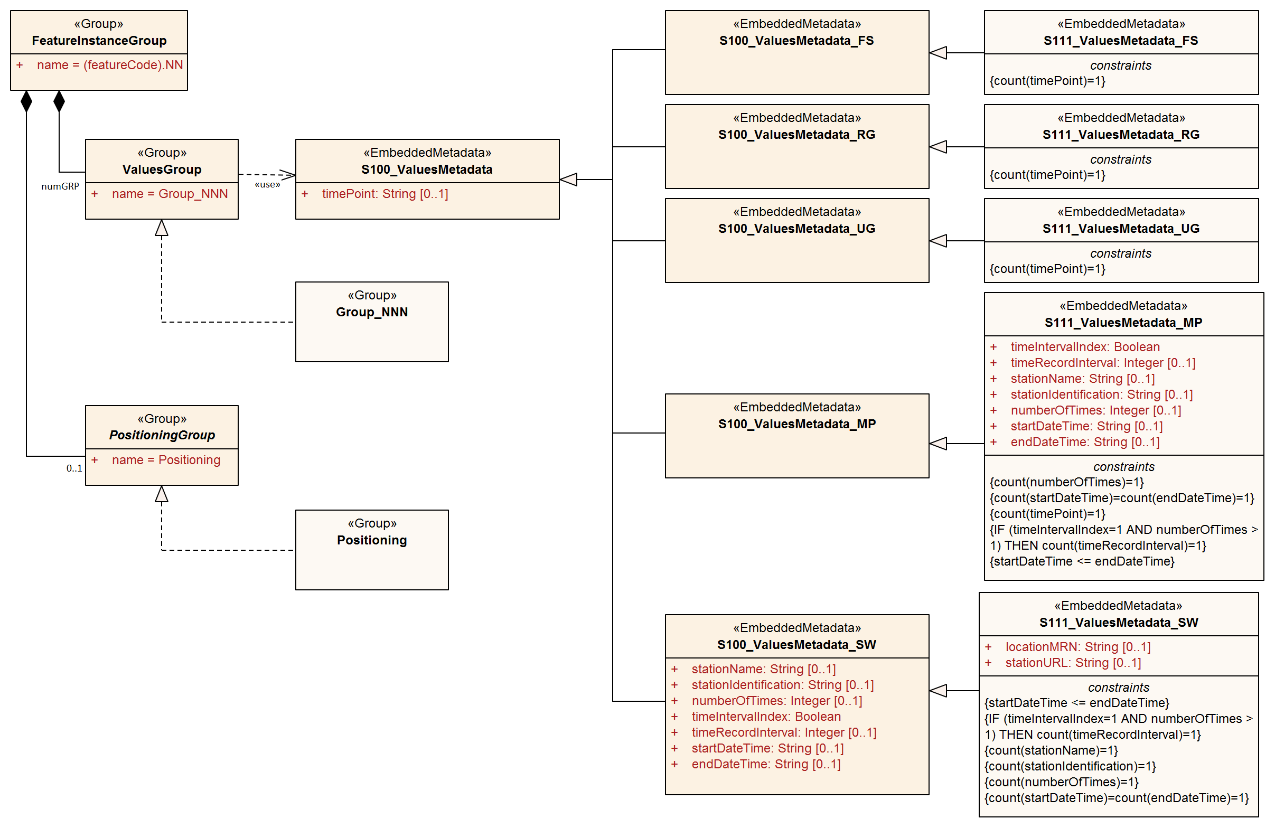
Figure 12-9 – Feature Instance metadata - Carrier metadata for the Values group in each Feature Instance group

For all carrier metadata, latitude and longitude values are precise to 10⁻⁷ degrees except where noted. All times are in UTC format.
All enumeration attributes in carrier metadata must be implemented as HDF5 enumerations. The base type for all enumeration attributes in the following tables must be 8-bit unsigned integer in the HDF5 standard integer type H5T_STD_U8LE.
Integer types are signed integers unless designated as “unsigned”.
Strings must use UTF-8 character encoding. String padding is not specified in this edition of the Product Specification due to the diversity of API framework treatment of padding.

General metadata - details
Table 12.1 - General metadata, related to the entire HDF5 file (see S-100 Part 10c, Table 10c-6). All times are in UTC format
No | Name | Camel Case | Mult | Data Type | Remarks and/or Units
1 | Product Specification number and version | productSpecification | 1 | String | This must be encoded as ‘INT.IHO.S-111.X.Y’, with X representing the Edition number and Y the revision number. See Note 6
2 | Date of data product issue | issueDate | 1 | String | Date must be consistent with issueDate in discovery metadata
3 | Horizontal Coordinate Reference System | horizontalCRS | 1 | Integer 32-bit | EPSG code (clause 5.1) or -1 if user defined  EXAMPLE 1: 4326 (for WGS84) See https://spatialreference.org/ref/epsg/?page=1  EXAMPLE 2: EPSG:9057 is WGS 84 (G1762) realization with valid epoch 2005.0
4 | Bounding box | westBoundLongitude | 1 | Float 64-bit | Area encompassing all feature instances  Units are Decimal Degrees in the EPSG 4326 CS. In accordance with ISO 19115-1 these coordinates need be accurate only to two decimal places
5 | Bounding box | eastBoundLongitude | 1 | Float 64-bit
6 | Bounding box | southBoundLatitude | 1 | Float 64-bit
7 | Bounding box | northBoundLatitude | 1 | Float 64-bit
8 | Geographic location of the resource (by description) | geographicIdentifier | 0..1 | String | Description, or location code from list agreed by data producers  (In S-100: EX_Extent > EX_GeographicDescription.geographicIdentifier > MD_Identifier.code)
9 | Name of the horizontal CRS | nameOfHorizontalCRS | 0..1 | String | Mandatory if horizontalCRS = -1
10 | Type of the horizontal CRS | typeOfHorizontalCRS | 0..1 | Enumeration | Mandatory if horizontalCRS = -1  See Table 12-5
11 | Horizontal coordinate system | horizontalCS | 0..1 | Integer 32-bit | Mandatory if horizontalCRS = -1  Allowed values if typeOfHorizontalCRS = 1 (Geodetic CRS 2D):  - 6422 (Lat, Lon – degree)  Allowed values if typeOfHorizontalCRS = 2 (Projected CRS):  - 4400 (Easting, Northing – metres)  - 4500 (Northing, Easting – metres)
12 | Horizontal datum | horizontalDatum | 0..1 | Integer 32-bit | Mandatory if horizontalCRS = -1  EPSG code or -1 if user defined
13 | Name of horizontal datum | nameOfHorizontalDatum | 0..1 | String | Mandatory if horizontalDatum = -1
14 | Prime meridian | primeMeridian | 0..1 | Integer 32-bit | Mandatory if horizontalDatum = -1; EPSG Code
15 | Spheroid | spheroid | 0..1 | Integer 32-bit | Mandatory if horizontalDatum = -1; EPSG Code
16 | Projection method | projectionMethod | 0..1 | Integer 32-bit | Mandatory if typeOfHorizontalCRS = 2; EPSG Code, see Table 12-7
17 | Projection parameter 1 | projectionParameter1 | 0..1 | Float 64-bit | Only if projectionMethod is used. See Table 12-7
18 | Projection parameter 2 | projectionParameter2 | 0..1 | Float 64-bit | Only if projectionMethod is used. See Table 12-7
19 | Projection parameter 3 | projectionParameter3 | 0..1 | Float 64-bit | Only if projectionMethod is used. See Table 12-7
20 | Projection parameter 4 | projectionParameter4 | 0..1 | Float 64-bit | Only if projectionMethod is used. See Table 12-7
21 | Projection parameter 5 | projectionParameter5 | 0..1 | Float 64-bit | Only if projectionMethod is used. See Table 12-7
22 | False northing | falseNorthing | 0..1 | Float 64-bit | Only if projectionMethod is used. To be applied to the coordinates at axis Northing. [m]
23 | False easting | falseEasting | 0..1 | Float 64-bit | Only if projectionMethod is used. To be applied to the coordinates at axis Easting. [m]
24 | Epoch of realization | epoch | 0..1 | String | Code denoting the epoch of the geodetic datum used by the CRS. For example, 2005.0 for the G1762 realization of the geodetic datum for WGS84. Must match epoch denoted by horizontalCRS.
Additional metadata for S-111
25 | Dataset delivery interval | datasetDeliveryInterval | 0..1 | String | The expected time interval between availability of successive datasets for time-varying data. Must be formatted as PnYnMnDTnHnMnS (ISO 8601 duration). See Note 8
26 | Index for type of depth | depthTypeIndex | 1 | Enumeration | See Table 12-11 – S111_DepthTypeIndex
27 | Depth value | surfaceCurrentDepth | 1 | Float 32-bit | Depth/height value or layer thickness (m)
Additional restrictions on core general metadata for S-111
28 | Time of data product issue | issueTime | 1 | String | Mandatory for S-111. S-100 Time format. All times are in UTC. For example 123000Z
29 | Vertical coordinate system | verticalCS | 1 | Integer 32-bit | Mandatory for S-111 if and only if depthTypeIndex=1.  EPSG Code; Allowed Values  • 6498 (Depth– Metres–Orientation Down)  • 6499 (Height– Metres–Orientation Up)
30 | Vertical coordinate base | verticalCoordinateBase | 1 | Enumeration | Mandatory in S-111  The only allowed value is verticalDatum (see S-100 Table 10c-22)
31 | Vertical datum reference | verticalDatumReference | 1 | Enumeration | Mandatory for S-111 if and only if depthTypeIndex=1.  1: S-100 vertical datum  2: EPSG
32 | Vertical datum | verticalDatum | 1 | Integer 32-bit | Mandatory for S-111 if and only if depthTypeIndex=1.  If verticalDatumReference = 1 this is one of the standard values from S100_VerticalAndSoundingDatum.  If verticalDatumReference = 2 this is an EPSG code for vertical datum

NOTE 1: If the CRS is user defined only the following coordinate systems are supported:
  - Geodetic CS (Latitude, Longitude) – Degrees; and
  - Cartesian CS (Northing, Easting or Easting, Northing) – Metres.
NOTE 2: For the horizontal Datum all EPSG predefined Datums are allowed or any combination of predefined Prime Meridians or predefined Spheroids.
NOTE 3: The projection methods are limited to those given in Table 12-7.
NOTE 4: If the horizontal CRS is defined by the EPSG code, the defined CRS should not use any other elements than the one allowed for user defined CRSs; (for example, no projection method that is not in the Table).
NOTE 5: The bounding box is the data set bounding box; the coverage data feature instances may or may not cover the entire bounding box. If there is only a single coverage feature, its extent may or may not be the same as the data set.
NOTE 6: Beginning S-100 Edition 5.0.0, class S100_ProductSpecification (S-100 Part 17) contains a productIdentifier field whose value must be the Product ID value from the IHO Product Specification Register in the IHO Geospatial Information Registry. Attribute productSpecification in Table 12-1 must use exactly the same value.
NOTE 7: Beginning S-100 Edition 5.0.0, seaSurface and seaFloor have been added to the S100_VerticalAndSoundingDatum enumeration, which makes attribute verticalCoordinateBase redundant. It is included in order to ensure compliance with generic validation checks for attribute verticalDatum.
NOTE 8: Dataset delivery interval is encoded only if the dataset is part of a sequence delivered at known intervals (for example, daily, weekly, or 6-hourly forecasts). S-100 Part 17, clause 17-4.9 contains detailed guidance for encoding the discovery metadata equivalent of this attribute (userDefinedMaintenanceFrequency) and the same guidelines apply to encoding this attribute. If this attribute and its discovery metadata equivalent are both encoded (in the HDF5 dataset and discovery metadata block respectively), the durations encoded by them must be the same. Intervals greater than monthly may be encoded at Producer discretion.

Feature Type metadata - details
Table 12.2 – Feature Type metadata, pertaining to the SurfaceCurrent feature type (See S-100 Part 10c, Table 10c-10)
No | Name | Camel Case | Mult | Data Type | Remarks and/or Units
1 | Data organization index  (Used to read the data.  See Table 10-1) | dataCodingFormat | 1 | Enumeration | See Table 12-9. The allowed values are:  1: Time series at fixed stations  2: Regularly-gridded arrays  3: Ungeorectified gridded arrays  4: Moving platform  8: Stationwise time series  (This Product Specification allows the use of only 1-4 and 8 from S-100)
2 | Dimension | dimension | 1 | Integer 8-bit unsigned | The (spatial) dimension of the feature instances. For currents, use 2  This is the number of coordinate axes, not the rank of the HDF5 arrays storing coordinates or values
3 | Common Point Rule | commonPointRule | 1 | Enumeration | The procedure used for evaluating the coverage at a position that falls on the boundary or in an area of overlap between geometric objects. Recommend using 3 (‘high’)  1: average  2: low  3: high  4: all
4 | Horizontal position uncertainty | horizontalPositionUncertainty | 1 | Float 64-bit | -1.0 (unknown) or positive value (m)
5 | Vertical position uncertainty | verticalUncertainty | 1 | Float 32-bit | -1.0 (unknown) or positive value (m)
6 | Time uncertainty | timeUncertainty | 0..1 | Float 32-bit | -1.0 (unknown) or positive value (s)
7 | Number of feature instances | numInstances | 1 | Integer 32-bit unsigned | Num. of stations, gridded forecasts, etc
Additional metadata for S-111
8 | Methodology | methodCurrentsProduct | 0..1 | String | Brief description of current meter type, forecast method or model, etc
9 | Min. current speed in dataset | minDatasetCurrentSpeed | 1 | Float 64-bit | -1.0 (unknown) or non-negative value (kt). Use the same precision as the corresponding attribute in the values record
10 | Max. current speed in dataset | maxDatasetCurrentSpeed | 1 | Float 64-bit | -1.0 (unknown) or positive value (kt). If both are known, max. speed must be > min. speed. Use the same precision as the corresponding attribute in the values record
dataCodingFormat = 1 (fixed stations)
-- | (none)
dataCodingFormat = 2 (regular grid)
11 | Sequencing Rule | sequencingRule.type | 1 | Enumeration | Method to be used to assign values from the sequence of values to the grid coordinates. Components:  type: Enumeration CV_SequenceType  For example 1 (for ‘linear’)
12 | Sequencing Rule | sequencingRule.scanDirection | 1 | String | scanDirection: String <axisNames entry> (comma-separated)  For example “latitude,longitude” implies column-major storage. See S-100 Figure 8-6. For regular grids, “longitude,latitude” or “easting,northing” are suggested as corresponding to intuitive grid point order (+ve eastward/northward).  The order in axisNames and the order in sequencingRule.scanDirection are independent; scanDirection describes the storage order of the values array.
Metadata with restrictions on core metadata values
13 | Interpolation Type | interpolationType | 1 | Enumeration | Interpolation method recommended for evaluation of the S100_GridCoverage  Values: CV_InterpolationMethod (ISO 19123). For S-111, must use 10 (for ‘discrete’)
14 | Offset of data point in cell | dataOffsetCode | 0..1 | Enumeration | Mandatory if data points are at grid cell centres. See S-100 clauses 10c-9.6 and 8-5.2.8.  The allowed values in S-111 are:  1: XMin, YMin (“Lower left”)  5: Barycenter (centroid) of cell  The default is “Lower left” and this attribute may be omitted if data points are at cell lower-left corners. Other cell corners are not allowed.
dataCodingFormat = 3 (ungeorectified grid)
Metadata with restrictions on core metadata values
11 | Interpolation Type | interpolationType | 1 | Enumeration | Must use 10 (for ‘discrete’)
dataCodingFormat = 4 (moving platform)
-- | (none)
dataCodingFormat = 8 (fixed stations, stationwise)
-- | (none)

Feature Instance metadata - details
Table 12.3 – Feature Instance metadata, pertaining to the feature instance (see S-100 Part 10c, Table 10c-12). All times are in UTC format
No | Name | Camel Case | Mult | Data Type | Remarks and/or Units
1 | Bounding box | westBoundLongitude | 0..1 | Float 64-bit | Area of specific grid, set of stations, etc. S-100 Edition requires either this or the domainExtent dataset to be populated. Since S-111 does not use domain extent polygons the bounding box must be populated.  The unit must conform to the CRS used for the dataset (for example, degrees for the geographic 2D CRS EPSG 4326; and metres for the UTM zone projected CRS EPSG 32710)
2 | Bounding box | eastBoundLongitude | 0..1 | Float 64-bit
3 | Bounding box | southBoundLatitude | 0..1 | Float 64-bit
4 | Bounding box | northBoundLatitude | 0..1 | Float 64-bit
5 | Number of time records | numberOfTimes | 0..1 | Integer 32-bit unsigned | The total number of time records. For dataCodingFormat = 8, this variable may be overridden by the corresponding one in the values group attributes (Table 12-4)
6 | Time interval | timeRecordInterval | 0..1 | Integer 16-bit unsigned | The interval between time records. Units: Seconds. For dataCodingFormat = 8, this variable may be overridden by the corresponding one in the values group attributes (Table 12-4)
7 | Valid time of earliest value | dateTimeOfFirstRecord | 0..1 | String | DateTime, UTC format. First record in the Instance
8 | Valid time of latest value | dateTimeOfLastRecord | 0..1 | String | DateTime, UTC format
9 | Number of value groups | numGRP | 1 | Integer 32-bit unsigned | Number of Group_nnn  dataCodingFormat = 1, 2, and 3, equals the number of time points. For dataCodingFormat = 4, fixed at 1. For dataCodingFormat = 8, equals the number of stations
Additional metadata for S-111
10 | Data dynamicity | dataDynamicity | 1 | Enumeration | See Table 12-10. The allowed values are:  1: Observation  2: Astronomical prediction  3: Analysis or hybrid method  4: Hydrodynamic model hindcast  5: Hydrodynamic model forecast  6: Observed minus predicted  7: Observed minus analysis  8: Observed minus hindcast  9: Observed minus forecast  10: Forecast minus predicted  Note: if a difference is provided (6-10), suggested to also provide the other two series.
dataCodingFormat = 1 (fixed stations)
11 | Number of fixed stations | numberOfStations | 1 | Integer 32-bit unsigned | Number of individual fixed stations in this instance
dataCodingFormat = 2 (regular grid)
11 | Longitude of grid origin | gridOriginLongitude | 1 | Float-Double (64-bit) | Units must be consistent with the horizontal CRS. For example, degrees for EPSG 4326, metres for UTM zones
12 | Latitude of grid origin | gridOriginLatitude | 1 | Float-Double (64-bit) | Units must be consistent with the horizontal CRS
13 | Grid spacing, long. | gridSpacingLongitudinal | 1 | Float-Double (64-bit) | Units must be consistent with the horizontal CRS
14 | Grid spacing, lat. | gridSpacingLatitudinal | 1 | Float-Double (64-bit) | Units must be consistent with the horizontal CRS
15 | Number of points, long. | numPointsLongitudinal | 1 | Integer 32-bit unsigned | numCOLS
16 | Number of points, lat. | numPointsLatitudinal | 1 | Integer 32-bit unsigned | numROWS
17 | Start sequence | startSequence | 1 | String | For example, “0,0” (without quotes) for lower left. For upper left, “0,n”, where n is the value of numROWS-1. First value represents first axis in sequencingRule.scanDirection (Table 12-2), second value represents second axis
dataCodingFormat = 3 (ungeorectified grid)
11 | Number of nodes | numberOfNodes | 1 | Integer 32-bit unsigned | The total number of grid points
dataCodingFormat = 4 (moving platforms)
11 | Number of stations | numberOfStations | 1 | Integer 32-bit unsigned | Value is always 1
dataCodingFormat = 8 (fixed stations, stationwise)
11 | Number of fixed stations | numberOfStations | 1 | Integer 32-bit unsigned | Number of individual fixed stations in this instance

Values Group attributes - details
An expanded new metadata block is required for the Values Groups (Table 12-4). The variables stationName and stationIdentification have been added for both identification and possibly for inclusion in the text of the graph. The series start and end times, number of records, and time interval index are included since they may differ for each series.
Table 12.4 – Values Group attributes (see S-100 Part 10c, Table 10c-19). This table also shows text and an entry of non-uniform time intervals are allowed
No | Name | Camel Case | Mult | Data Type | Remarks and/or Units
dataCodingFormat = 1 (fixed stations), 2 (regular grid), 3 (ungeorectified grid), 4 (moving platform)
1 | Time stamp | timePoint | 1 | String | DateTime. All times are in UTC. See clause 10.2.2.5
dataCodingFormat = 8 (fixed stations, stationwise) and 4 (moving platform)
2 | Index for time interval | timeIntervalIndex | 1 | (Integer) 8-bit unsigned | 1 (TRUE) denotes uniform time interval; interval provided by timeRecordInterval.  0 (FALSE) denotes non-uniform time interval  This is a boolean implemented as described in S-100 Part 10c, Table 10c-1
3 | Time interval | timeRecordInterval | 0..1 | Integer 16-bit unsigned | Only if timeIntervalIndex = 1 and numberOfTimes > 1  The uniform interval between time records. Units: Seconds. Value here overrides corresponding value at Instance level
4 | Name of the station | stationName | 0..1 | String | Descriptive text, or ‘Not Available’
5 | Station identification number | stationIdentification | 0..1 | String | Letter-number combination, or ‘Not Available’
6 | Number of time records | numberOfTimes | 1 | Integer 32-bit unsigned | Use at Values Group level only for dataCodingFormat = 8  (Only mandatory if timeIntervalIndex=1.) Value here overrides corresponding value at Instance level
7 | Valid time of earliest value | startDateTime | 1 | String | Mandatory for S-111. DateTime format
8 | Valid time of latest value | endDateTime | 1 | String | Mandatory for S-111. DateTime format
dataCodingFormat = 8 (fixed stations, stationwise)
9 | Location Maritime Resource Name | locationMRN | 0..1 | String | The Maritime Resource Name assigned to the station, if any  Must be formatted as an MRN (cf. IALA G1143)
10 | URL to station or data portal. | stationURL | 0..1 | String | URL to station or data portal  Must be an http or https URL (S-100 Part 1, clause 1-4.6; RFC 3986)

Additional enumerations used in carrier metadata
Table 12.5 – Type of the horizontal CRS
Item | Name | Description | Code | Remarks
Enumeration | typeOfHorizontalCRS | Codes for describing the type of the two-dimensional horizontal CRS | -
Literal | geodeticCRS2D | Two-dimensional geodetic CRS | 1
Literal | projectedCRS | Projected CRS | 2

Table 12.6 – Vertical datum reference
Item | Name | Description | Code | Remarks
Enumeration | verticalDatumReference |  | -
Literal | s100VerticalDatum | The vertical datum is one of those listed in S100_VerticalAndSoundingDatum | 1
Literal | EPSG | The vertical datum is one of those listed in the EPSG Registry | 2

Table 12.7 – Projection methods and their parameters
Name | EPSG Code | Parameter 1 | Parameter 2 | Parameter 3 | Parameter 4 | Parameter 5
Mercator | 9805 | Latitude of 1st standard parallel | Longitude of natural origin | - | - | -
Transverse Mercator | 9807 | Latitude of natural origin | Longitude of natural origin | Scale factor at natural origin | - | -
Oblique Mercator | 9815 | Latitude of projection centre | Longitude of projection centre | Azimuth of initial line | Angle from Rectified to Skew Grid | Scale factor on initial line
Hotline Oblique Mercator | 9812 | Latitude of projection centre | Longitude of projection centre | Azimuth of initial line | Angle from Rectified to Skew Grid | Scale factor on initial line
Lambert Conic Conformal (1SP) | 9801 | Latitude of natural origin | Longitude of natural origin | Scale factor at natural origin | - | -
Lambert Conic Conformal (2SP) | 9802 | Latitude of false origin | Longitude of false origin | Latitude of 1st standard parallel | Latitude of 2nd standard parallel | -
Oblique Stereographic | 9809 | Latitude of natural origin | Longitude of natural origin | Scale factor at natural origin | - | -
Polar Stereographic | 9810 | Latitude of natural origin | Longitude of natural origin | Scale factor at natural origin | - | -
Krovak Oblique Conic Conformal | 9819 | Latitude of projection centre | Longitude of projection centre | Azimuth of initial line | Latitude of pseudo standard parallel | Scale factor on pseudo standard parallel
American Polyconic | 9818 | Latitude of natural origin | Longitude of natural origin | - | - | -
Albers Equal Area | 9822 | Latitude of false origin | Longitude of false origin | Latitude of 1st standard parallel5 | Latitude of 2nd standard parallel6 | -
Lambert Azimuthal Equal Area | 9820 | Latitude of natural origin | Longitude of natural origin | - | - | -

Table 12.8 – S100_VerticalAndSoundingDatum
Item | Name | Description | Code | Remarks
S100_Codelist | S100_VerticalAndSoundingDatum | Allowable vertical and sounding datums | - | S-111 allows only the standard values of this codelist, which makes it effectively an enumeration for S-111 purposes
Value | meanLowWaterSprings | The average height of the low waters of spring tides. This level is used as a tidal datum in some areas. | 1 | (MLWS)
Value | meanLowerLowWaterSprings | The average height of lower low water springs at a place. | 2 | -
Value | meanSeaLevel | The average height of the surface of the sea at a tide station for all stages of the tide over a 19-year period, usually determined from hourly height readings measured from a fixed predetermined reference level. | 3 | (MSL)
Value | lowestLowWater | An arbitrary level conforming to the lowest tide observed at a place, or somewhat lower. | 4 | -
Value | meanLowWater | The average height of all low waters at a place over a 19-year period. | 5 | (MLW)
Value | lowestLowWaterSprings | An arbitrary level conforming to the lowest water level observed at a place at spring tides during a period of time shorter than 19 years. | 6 | -
Value | approximateMeanLowWaterSprings | An arbitrary level, usually within 0.3m from that of Mean Low Water Springs (MLWS). | 7 | -
Value | indianSpringLowWater | An arbitrary tidal datum approximating the level of the mean of the lower low water at spring tides. It was first used in waters surrounding India. | 8 | -
Value | lowWaterSprings | An arbitrary level, approximating that of mean low water springs (MLWS). | 9 | -
Value | approximateLowestAstronomicalTide | An arbitrary level, usually within 0.3m from that of Lowest Astronomical Tide (LAT). | 10 | -
Value | nearlyLowestLowWater | An arbitrary level approximating the lowest water level observed at a place, usually equivalent to the Indian Spring Low Water (ISLW). | 11 | -
Value | meanLowerLowWater | The average height of the lower low waters at a place over a 19-year period. | 12 | (MLLW)
Value | lowWater | The lowest level reached at a place by the water surface in one oscillation. | 13 | (LW)
Value | approximateMeanLowWater | An arbitrary level, usually within 0.3m from that of Mean Low Water (MLW). | 14 | -
Value | approximateMeanLowerLowWater | An arbitrary level, usually within 0.3m from that of Mean Lower Low Water (MLLW). | 15 | -
Value | meanHighWater | The average height of all high waters at a place over a 19-year period. | 16 | (MHW)
Value | meanHighWaterSprings | The average height of the high waters of spring tides. | 17 | (MHWS)
Value | highWater | The highest level reached at a place by the water surface in one oscillation. | 18 | (HW)
Value | approximateMeanSeaLevel | An arbitrary level, usually within 0.3m from that of Mean Sea Level (MSL). | 19 | -
Value | highWaterSprings | An arbitrary level, approximating that of mean high water springs (MHWS). | 20 | -
Value | meanHigherHighWater | The average height of higher high waters at a place over a 19-year period. | 21 | (MHHW)
Value | equinoctialSpringLowWater | The level of low water springs near the time of an equinox. | 22 | -
Value | lowestAstronomicalTide | The lowest tide level which can be predicted to occur under average meteorological conditions and under any combination of astronomical conditions. | 23 | (LAT)
Value | localDatum | An arbitrary datum defined by a local harbour authority, from which levels and tidal heights are measured by this authority. | 24 | -
Value | internationalGreatLakesDatum1985 | A vertical reference system with its zero based on the mean water level at Rimouski/Pointe-au-Père, Quebec, over the period 1970 to 1988. | 25 | -
Value | meanWaterLevel | The average of all hourly water levels over the available period of record. | 26 | -
Value | lowerLowWaterLargeTide | The average of the lowest low waters, one from each of 19 years of observations. | 27 | -
Value | higherHighWaterLargeTide | The average of the highest high waters, one from each of 19 years of observations. | 28 | -
Value | nearlyHighestHighWater | An arbitrary level approximating the highest water level observed at a place, usually equivalent to the high water springs. | 29 | -
Value | highestAstronomicalTide | The highest tidal level which can be predicted to occur under average meteorological conditions and under any combination of astronomical conditions. | 30 | (HAT)
Value | balticSeaChartDatum2000 | Baltic Sea Chart Datum 2000 | 44 | -
Value | internationalGreatLakesDatum2020 | The 2020 update to the International Great Lakes Datum, the official reference system used to measure water level heights in the Great Lakes, connecting channels, and the St Lawrence River system | 46 | Unlike the previous two IGLDs, this datum update will use a geoid-based vertical datum that will be accessible using global navigation satellite systems (GNSS) such as the Global Positioning System (GPS)
Value | seaFloor | The bottom of the ocean and seas where there is a generally smooth gentle gradient. Also referred to as sea bed (sometimes seabed or seabed), and sea bottom | 47 | -
Value | seaSurface | A two-dimensional (in the horizontal plane) field representing the air-sea interface, with high-frequency fluctuations such as wind waves and swell, but not astronomical tides, filtered out | 48 | -
Value | nationalLowWaterDatum | A low water datum defined by a National authority, from which levels, clearances and tidal heights are measured by this authority. | 50 | -

The descriptions are reproduced verbatim from the IHO GI Registry as of August 2026.
Table 12.9 – S100_HDF_DataCodingFormat
Item | Name | Description | Code | Remarks
Enumeration | S100_HDF_‌DataCodingFormat | Data coding formats for S-100 HDF5 data | - | S-111 does not use TIN, irregularGrid, or variableCellSize data coding formats
Value | fixedStations | Data at multiple discrete fixed point locations | 1
Value | regularGrid | Data at grid points forming a regular grid with constant cell spacing | 2 | Regular grids are commonly composed of perpendicularly crossing lines of equal spacing on each dimension, creating square or rectangular cells
Value | ungeorectifiedGrid | Data that does not include any information that can be used to determine a cell’s geographic coordinate values, or in which cell spacing is variable, and there is no predefined association between one cell’s location and that of another | 3 | For example, a digital perspective aerial photograph without georectification information included
Value | movingPlatform | Data at sequential discrete point  locations of a moving sensor  platform | 4
Value | stationwiseFixed | Time series at fixed stations (stationwise) | 8 | Data at multiple discrete fixed point locations organized by station

Table 12.10 – S104_DataDynamicity
Item | Name | Description | Code | Remarks
Enumeration | S104_DataDynamicity | Classification of data according to the relationship between the time of its collection, generation, or calculation of generation parameters, in relation to the time of publication of the dataset | - | See Note 3 below
Value | observation | Values from in-situ sensor(s); may be quality controlled and stored after collection | 1 | Includes both historical and real-time observations.  See also Notes 1 and 2 below
Value | astronomicalPrediction | Values computed using harmonic analysis or other proven method of tidal analysis | 2 | IHO Res. 3/1919, as amended
Value | analysisOrHybrid | Values calculated by statistical or other indirect methods, or a combination of methods | 3 | A hybrid method combines two or more approaches
Value | hydrodynamicHindcast | Values calculated from a two- or three-dimensional dynamic simulation of past conditions using only observed data for boundary forcing, via statistical method or combination | 4 | A hindcast is a model simulation that attempts to recreate present conditions by using the most recent observational data
Value | hydrodynamicForecast | Values calculated from a two- or three-dimensional dynamic simulation of future conditions using predicted data for boundary forcing, via statistical method or combination | 5 | A forecast is a simulation made for many hours into the future using predicted winds, water levels, etc
Value | observedMinusPredicted | Values computed as observed minus predicted values | 6 | Observation minus astronomical prediction
Value | observedMinusAnalysis | Values computed as observed minus analysis values | 7 | Observation minus analysis or hybrid
Value | observedMinusHindcast | Values computed as observed minus hindcast values | 8 | Observation minus hydrodynamic hindcast
Value | observedMinusForecast | Values computed as observed minus forecast values | 9 | Observation minus hydrodynamic forecast
Value | forecastMinusPredicted | Values computed as forecast minus predicted values | 10 | Hydrodynamic forecast minus astronomical prediction

NOTE 1: The time period covered by the observations should be encoded in the metadata attribute temporalExtent.
NOTE 2: Sensors (for example tide gauges deployed along a channel) are monitored by the data collecting Authority. After data acquisition, the data are quality controlled and stored by the Producing Authority.
NOTE 3: Data dynamicity being the same in S-104 and S-111, the original “S104” prefix is retained. The relevant values are defined so as to be applicable to both products.
See clause 7.1 for detailed descriptions of the types of data based on the time-dependence of the source.
Table 12.11 – S111_DepthTypeIndex
Item | Name | Description | Code | Remarks
Enumeration | S111_DepthTypeIndex | Index for type of depth | - | See Annex E, clause E-6.1
Value | heightOrDepth | Height or depth | 1 | The level of the current is referenced to a datum, which can be the sea surface, the sea bottom, or a standard tidal datum. If the coordinate system axis is directed upward and the level of the current is below the datum, the depth will have a negative value
Value | layerAverage | Layer average | 2 | The thickness of the layer is specified as a positive value

Table 12-12 - Data offset code
Item | Name | Description | Code | Remarks
Enumeration | S100_HDF_DataOffsetCode | Enumeration for describing the location of the data point | -
Value | LowerLeft | Grid coordinates XMin, YMin (“Lower left”) corner of cell | 1
Value | - UpperRight | Grid coordinates XMax, YMax (“Upper right”) corner of cell | 2 | Not permitted in S-111 datasets
Value | - LowerRight | Grid coordinates XMax, YMin (“Lower right”) corner of cell | 3 | Not permitted in S-111 datasets
Value | - UpperLeft | Grid coordinates XMin, YMax (“Upper left”) corner of cell | 4 | Not permitted in S-111 datasets
Value | Barycenter | Centroid of cell | 5

NOTE: “Min” and “Max” are relative to the grid origin, conventionally the southwest corner of the grid, and the conventional axis orientations (northward-positive and eastward-positive). With these conventions the “lower left” corner of a grid cell is the southwest corner of the cell.

Language
The language used for the Discovery Metadata and the Carrier Metadata is English.

Page intentionally left blank

- – Data Classification and Encoding Guide

A-1 Features
Surface Current (SurfaceCurrent)
IHO Definition: FEATURE: SURFACE CURRENT: A current that does not extend more than a few (2-3) metres below the surface.
S-111 Geo Feature: Surface Current
Primitives: pointSet, coverage
S-111 Attribute | Allowable Encoding Values | Type | HDF5 File Type | Multiplicity
Surface Current Speed | Must be in decimal knots, maximum resolution 0.01 knot | RE | H5T_IEEE_F64LE | 1
Surface Current Direction | Must be in decimal arc-degrees, maximum resolution 0.1 arc-degree | RE | H5T_IEEE_F32LE | 1
Surface Current Time | YYYYMMDDTHHMMSSZ | DT | 16-character fixed-length UTF-8 string | 0..1
Speed Uncertainty | Must be in decimal knots, maximum resolution of 0.01 knot | RE | H5T_IEEE_F64LE | 0..1
Direction Uncertainty | Must be in decimal arc-degrees, maximum resolution 0.1 arc-degree | RE | H5T_IEEE_F32LE | 0..1

A-2 Feature Attributes
1. Surface Current Speed (surfaceCurrentSpeed)
Surface Current Speed: Magnitude of current velocity at the water surface, measured or calculated at a depth (or range of depths) consistent with the data product..
Unit: Knot (kt)
Maximum Resolution: 0.01 kt
Format: xxx.xx
Example: 2.54
Remarks:
- Valid speed always non-negative.
- Negative number denotes land mask or missing value.
- 0.01 kt equals 0.5144 cm/s.
- Must be populated with a non-fill value if surfaceCurrentDirection is populated with a non-fill value at the same point.

2. Surface Current Direction (surfaceCurrentDirection)
Surface Current Direction: The direction toward which a surface current is flowing, called the set of the surface current.
Unit: Degree of Arc (˚)
Maximum Resolution: 0.1 ˚
Format: xxx.x
Example: 298.3
Remarks:
- Direction clockwise from true north.
- Valid direction always non-negative.
- Negative number denotes land mask or missing value.
- Must be populated with a non-fill value if surfaceCurrentSpeed is populated with a non-fill value at the same point

3. Surface Current Time (surfaceCurrentTime)
Surface Current Time: The time of the surface current data, expressed in ISO 8601 Date-time format.
Unit: Years, months, days, hours, minutes, seconds
Resolution: 1 second
Format: YYYYMMDDTHHMMSSZ, where Y is year, M is month, D is day, H is hour, M is minute, and S is second
Example: 19850412T101530Z denotes 10 hours, 15 minutes, and 30 seconds, Universal Time on 12 April 1985.
Remarks:
- Required only for fixed station (stationwise) time series data (dataCodingFormat = 8) with non-uniform time intervals and moving platform time series (dataCodingFormat = 4) with non-uniform time intervals.
- All times are in UTC (Universal Time Coordinated).

4. Direction Uncertainty (directionUncertainty)
Direction Uncertainty: The best estimate of the accuracy of a bearing.
Unit: Degree of Arc (˚)
Maximum Resolution: 0.1 ˚
Format: xx.x
Example: 10.0 for an uncertainty of 10 degrees.
Remarks: No remarks

5. Speed Uncertainty (speedUncertainty)
Speed Uncertainty: Estimate characterising the accuracy of a speed value, or of the magnitude component of a velocity.
Unit: Knot (kt)
Maximum Resolution: 0.01 knots
Format: xx.xx
Example: 0.3 for an uncertainty of ± 0.3 knots.
Remarks:
- The estimate is as defined within a particular confidence level and expressed as a positive value.

- – Comprehensive Model Including Application Schema and Carrier Metadata (UML Diagrams)
Figure B-1 depicts the various components of the S-111 model. The Meta-features and Exchange Set Metadata components are empty because S-111 does not define any meta-features or extend S-100 Exchange Catalogue classes. Figure B-2 depicts the derivation of the S-111 packages from various S-100 components.
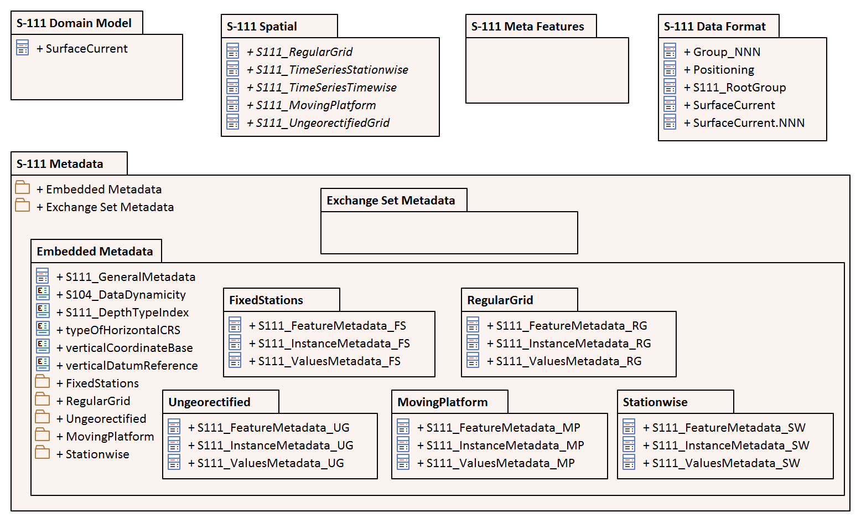
Figure B-1 – S-111 Model components

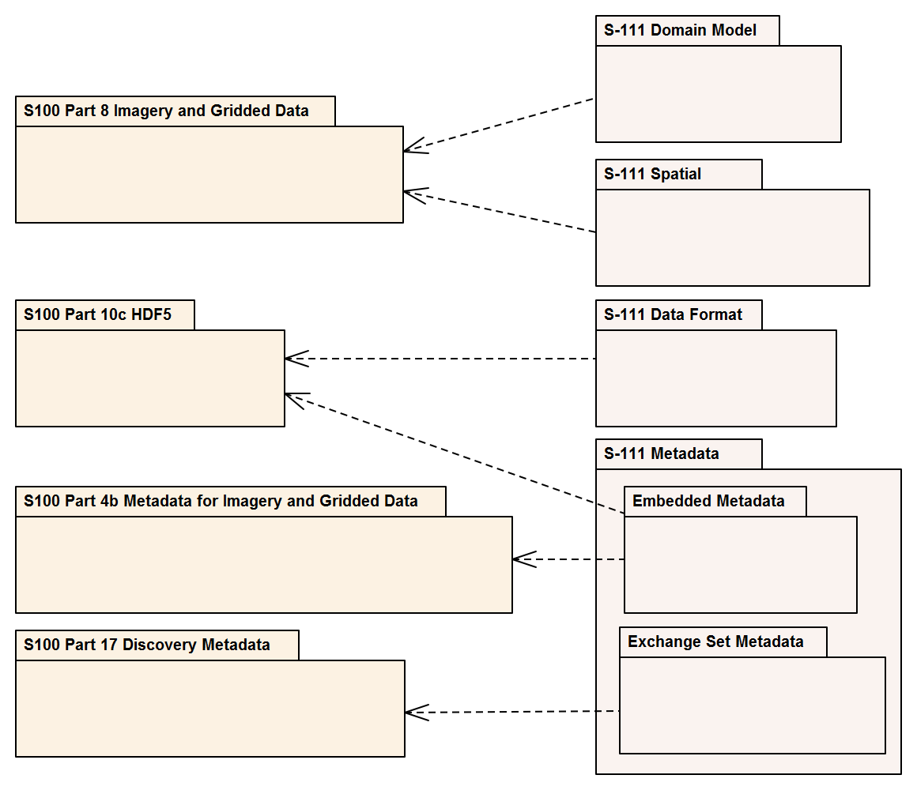
Figure B-2 – Derivations from S-100
Figure B-3 depicts the coverage types used in S-111 and their realizations from the conceptual coverages in S-100 Part 8 and ISO 19123. This is a more detailed version of Figure 4-2. Note that the realizations are not directly from the Part 8 and ISO 19123 classes, but via corresponding notional classes for the HDF5 implementations of the various data coding formats (not included in this diagram). For example, S111_RegularGrid is a notional extension of a notional S-100 class Part10c::S100_HDF_RegularGrid which encapsulates the encoding of dataCodingFormat 2 in HDF5. The notional classes are omitted to reduce diagram clutter.
The implementation of most attributes in the S-100 Part 8 model by S-100 Part 10c closely follows the names and types of the attributes. Certain attributes in the S-100 Part 8 and ISO 19123 models are simplified in S-100 Part 10c HDF5 implementation, as follows:
- HDF5 Regular Grid and Ungeorectified Grid (data coding formats 2 and 3) implement S100_Grid and CV_ReferenceableGrid respectively:
  - The attribute origin is implemented in the form of two HDF5 attributes, gridOriginLatitude and gridOriginLongitude.
  - The attribute offsetVectors is implemented in the form of two HDF5 attributes, gridSpacingLongitudinal and gridSpacingLatitudinal.
- The rangeType attribute common to all coverage types is implemented implicitly in the S-100 Feature Catalogue’s binding of attributes to a feature and in the name/datatype information in feature information datasets in the Feature Information group (S-100 Part 10c, Table 10c-8).

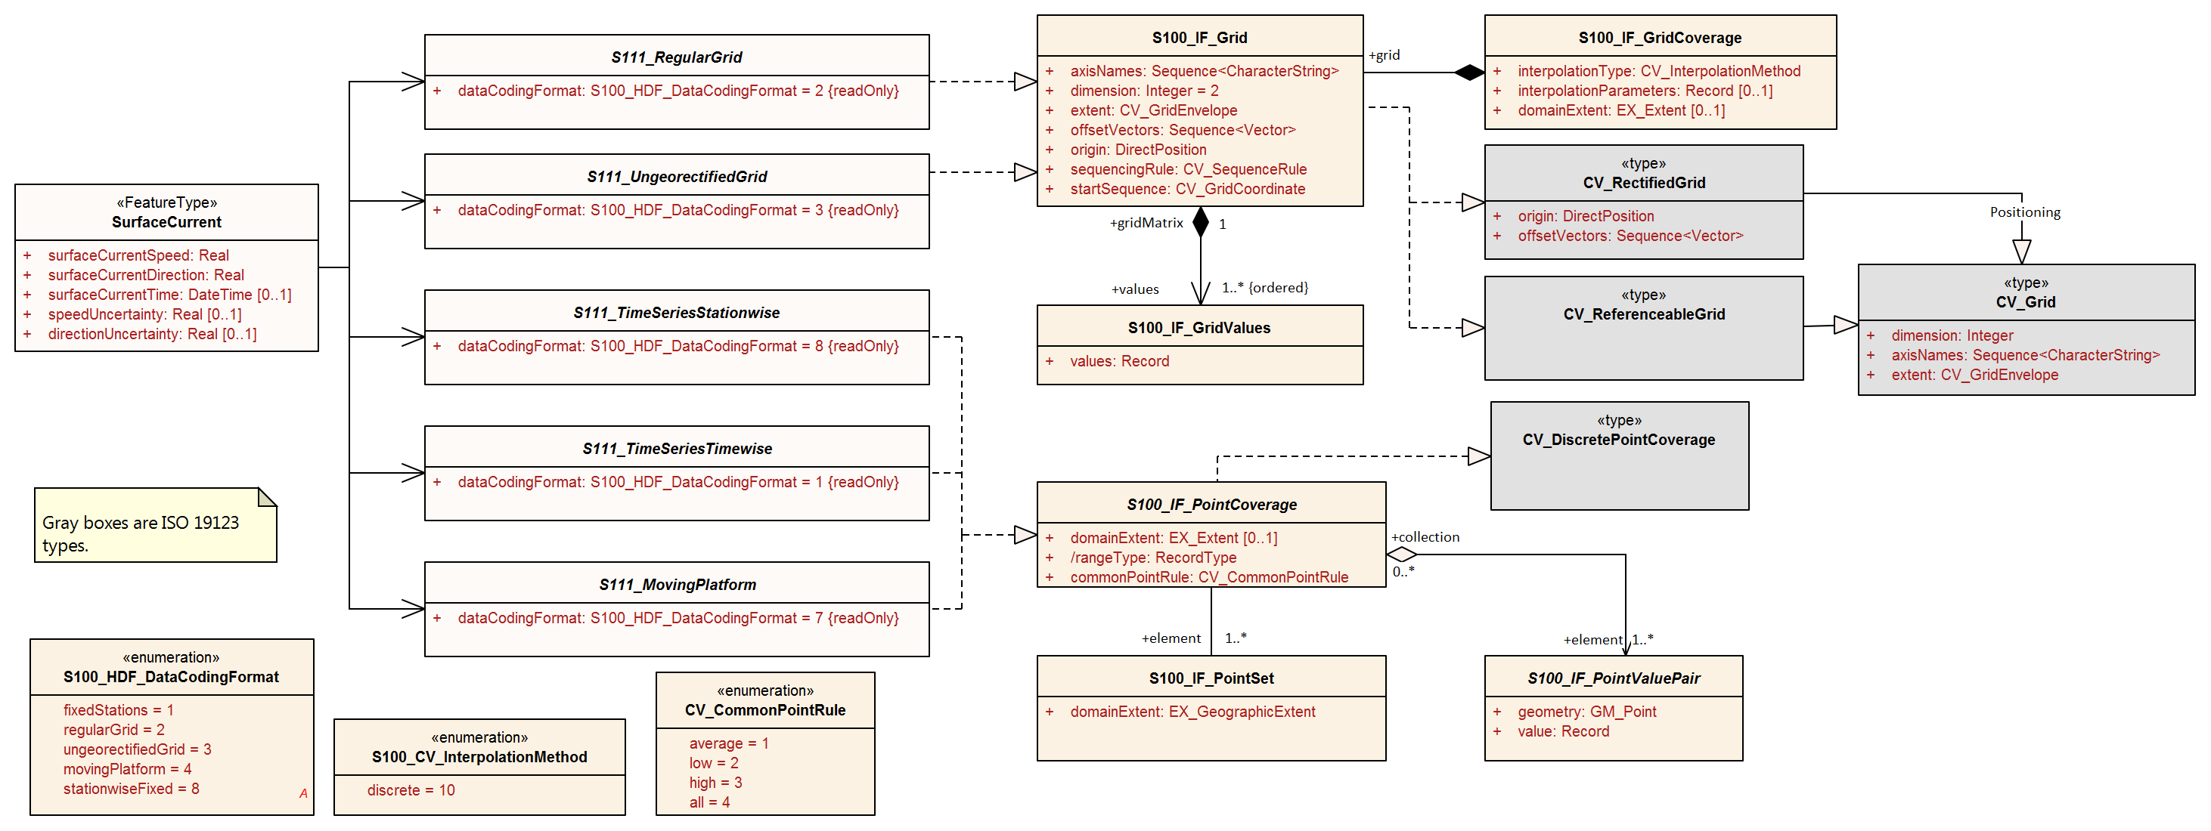
Figure B-3 Spatial Types – Coverages with Realizations from S-100 Part 8 and ISO 19123

Page intentionally left blank

Figure B-4 depicts the single domain feature type. The SurfaceCurrent feature class (Figure B-4) has two mandatory attributes: surfaceCurrentSpeed and surfaceCurrentDirection. These variables capture the speed of current over ground and the general direction of the current at the location of the data. It also has three optional attributes: surfaceCurrentTime, speedUncertainty, and directionUncertainty. An instance of SurfaceCurrent may be part of a time series, as described in the metadata.
Figure B-4 – Surface Current feature class
Figure B-5 depicts the external Catalogue metadata classes (the same information as Figure 12-4).
Figures B-6 through B-10 depict the same information as Figures 12-6 through 12-9, organised by coverage type instead of structural level. Different levels in the HDF5 structure (root, feature type, feature instance, and value) are indicated by backgrounds of different colours.

Page intentionally left blank

Figure B-5 – Exchange Set class details
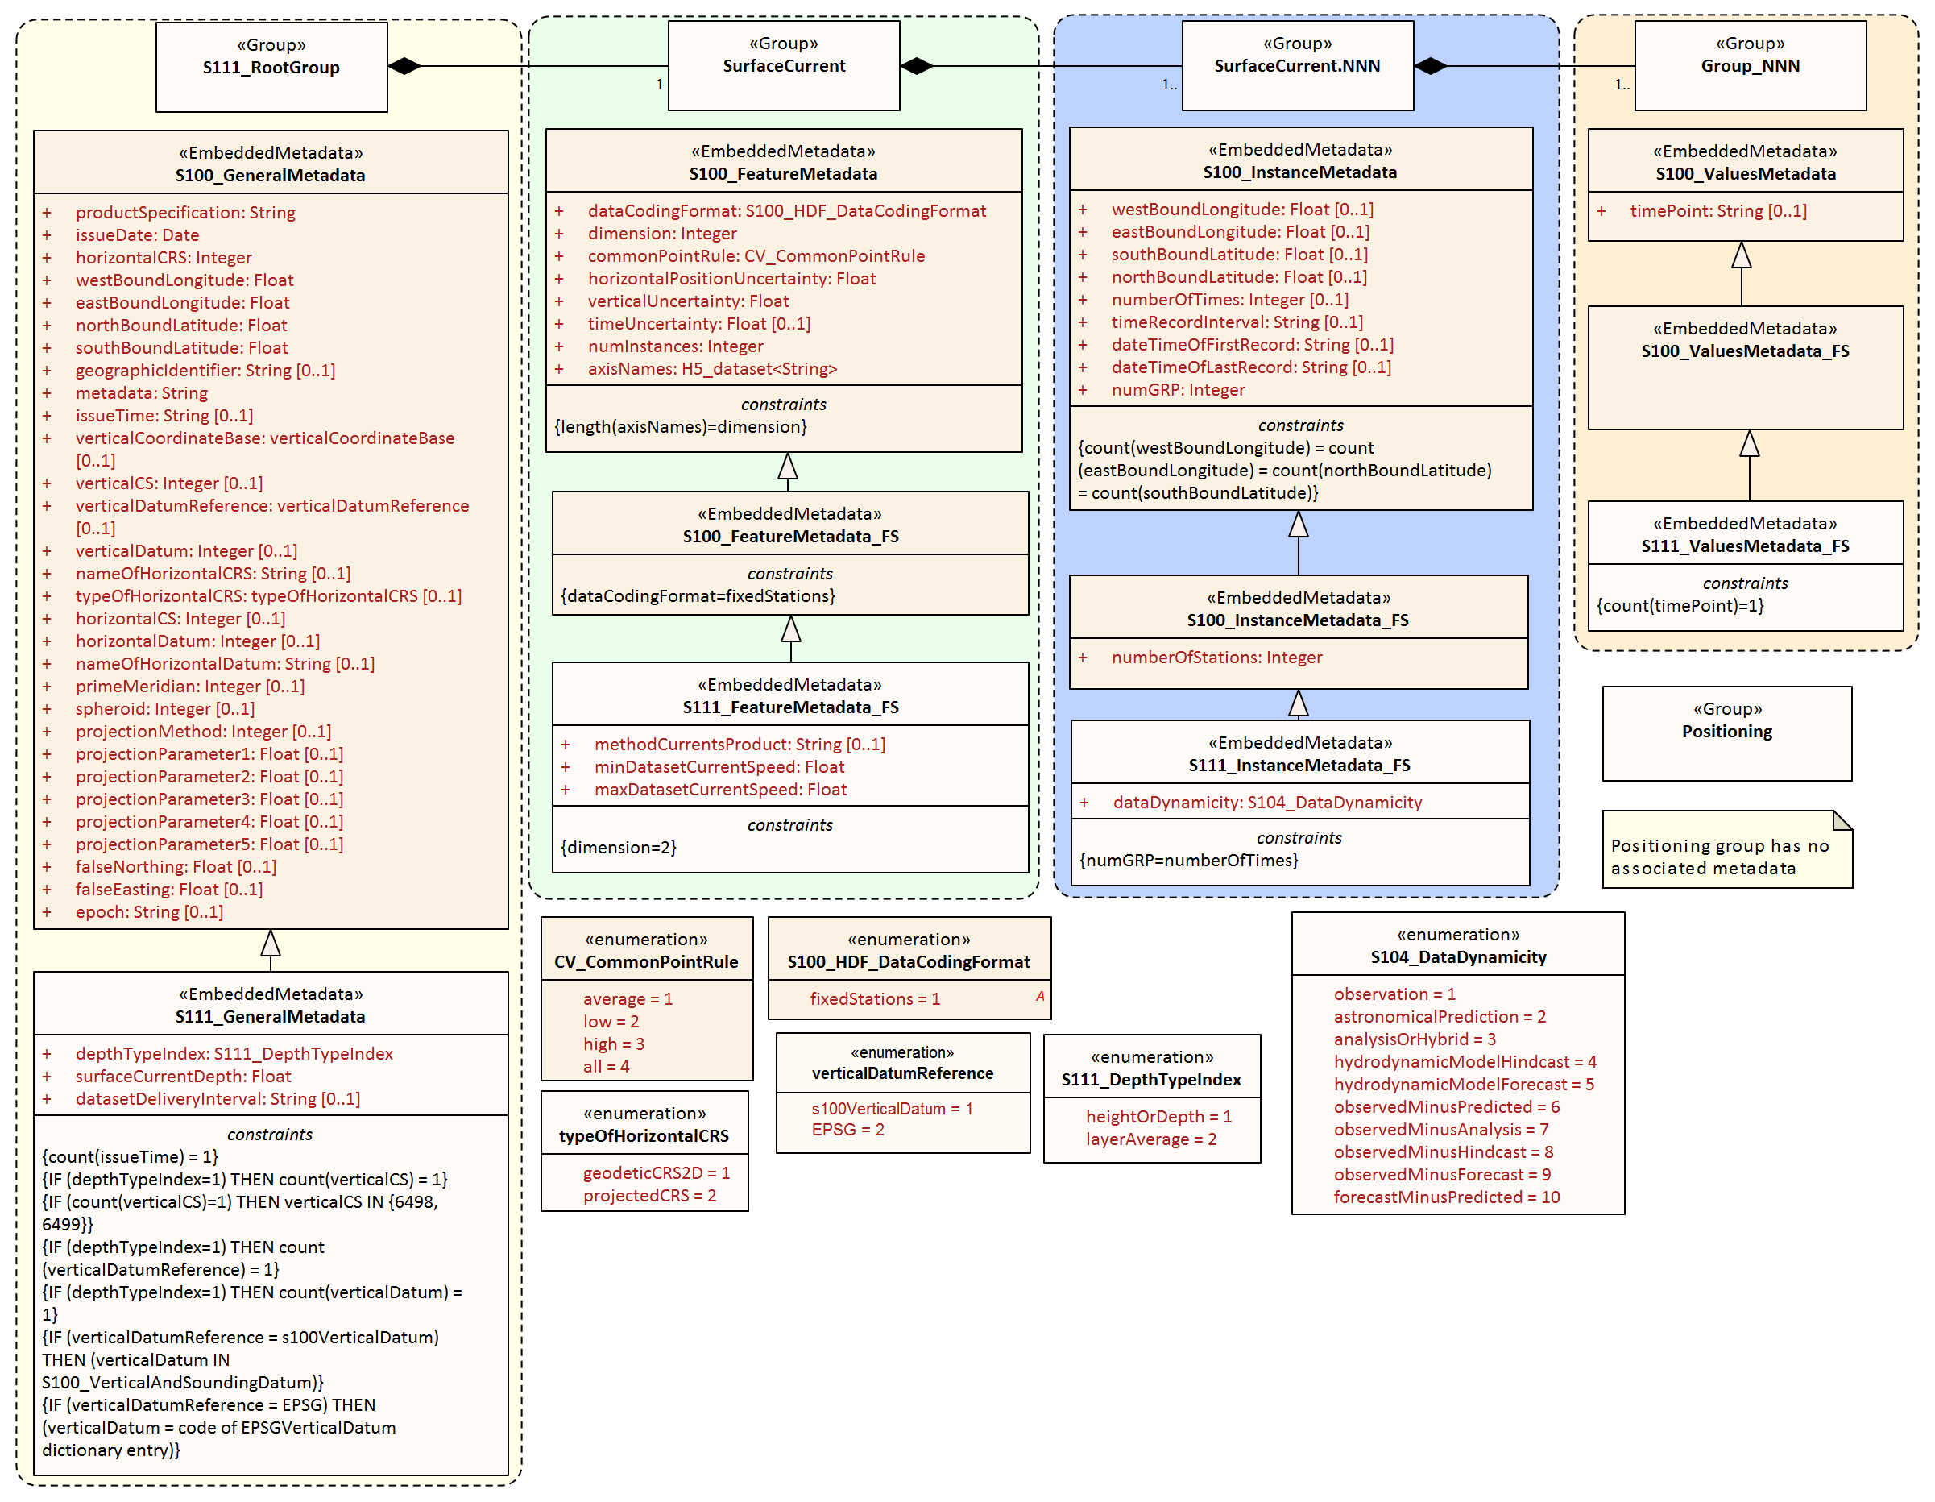
Figure B-6 – All carrier metadata for coverage type Fixed Stations (data coding format 1)
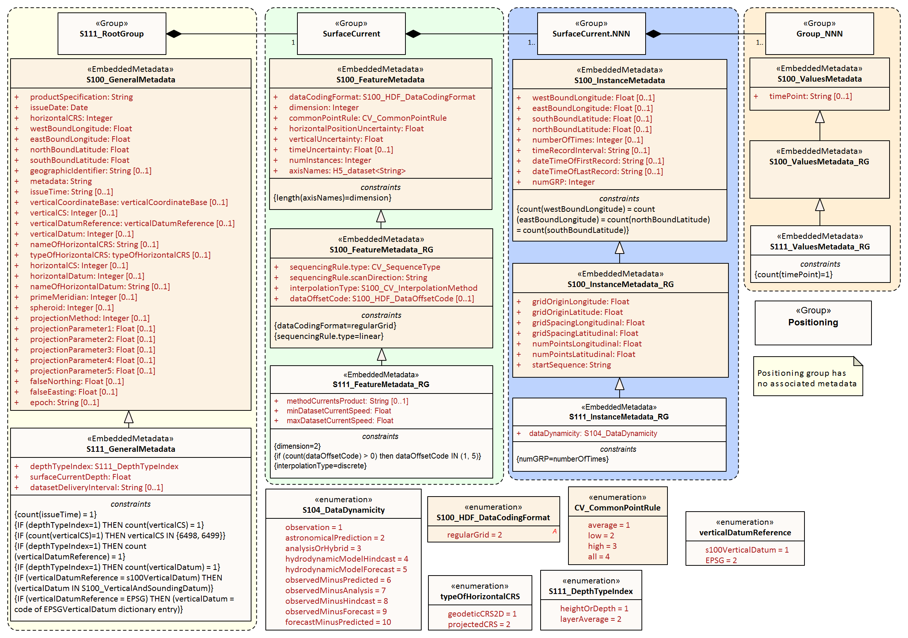
Figure B-7 – All carrier metadata for coverage type Regular Grid (data coding format 2)
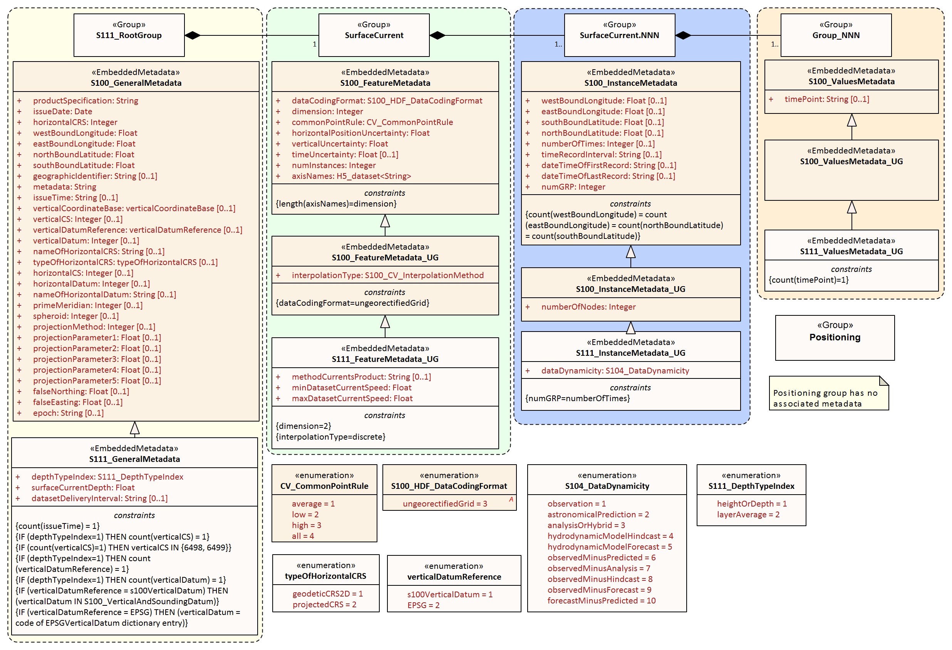
Figure B-8 – All carrier metadata for coverage type Ungeorectified Grid (data coding format 3)
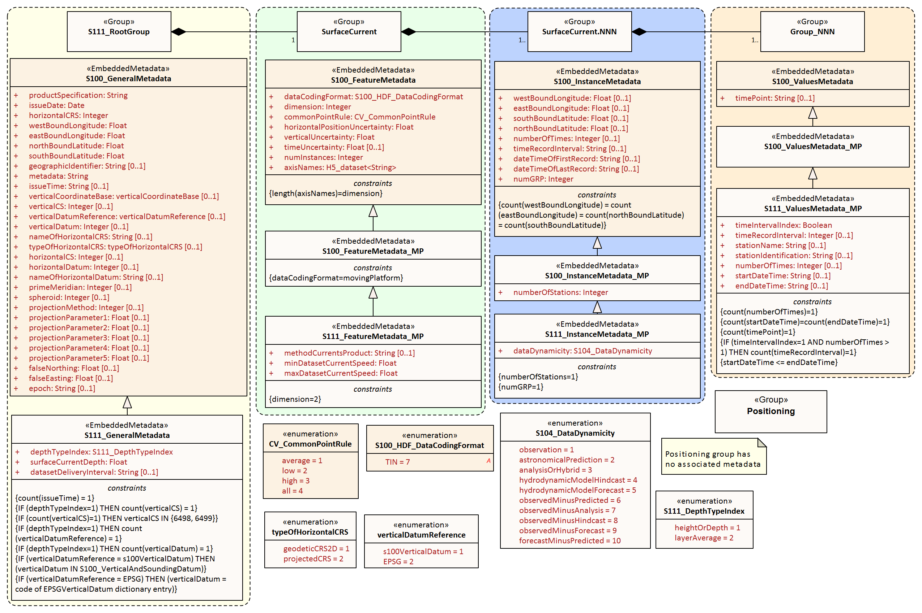
Figure B-9 – All carrier metadata for coverage type Moving Platform (data coding format 4)

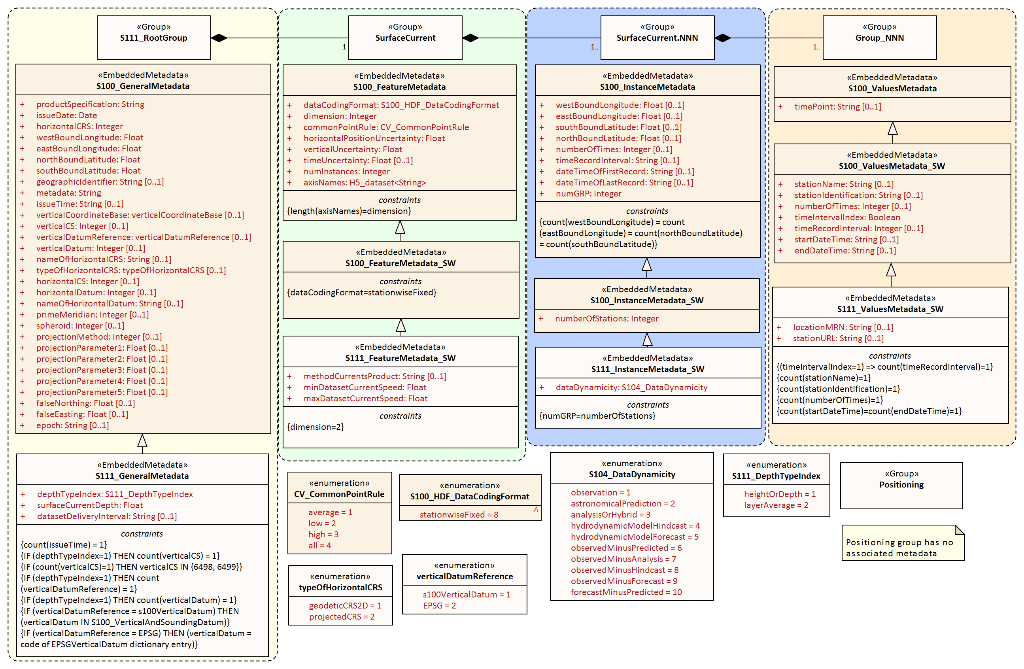
Figure B-10 – All carrier metadata for coverage type Fixed stations (Stationwise) (data coding format 8)

- – Feature Catalogue
C-1 Meta Feature Types
[None]

C-2 Geo Feature Types
C-2.1 Surface Current
Definition: A current that does not extend more than a few (2-3) metres below the surface.
CamelCase: SurfaceCurrent
Alias:
Super type:
Feature use type: geographic
Primitive: coverage pointSet
Remarks: No remarks.
Attribute Bindings:
S-111 Attribute | Allowable Encoding Value | Type | Multiplicity
Surface Current Speed |  | RE | 1, 1
Surface Current Direction |  | RE | 1, 1
Surface Current Time |  | DT | 0, 1
Speed Uncertainty |  | RE | 0, 1
Direction Uncertainty |  | RE | 0, 1

C-3 Carto Feature Types
[None]

C-4 Information Types
[None]

C-5 Simple Attributes
C-5.1. Direction Uncertainty
Definition: The best estimate of the accuracy of a bearing.
CamelCase: directionUncertainty
Alias:
Value type: real
Remarks: No remarks.
Unit of measure name: Degree of Arc definition: 1° = (π/180) rad symbol: °
Quantity specification: planeAngle
Constraints:
String Length | Text Pattern | Range |  | Precision
(not specified) | (none) | lowerBound | 0.0 | 1
(not specified) | (none) | upperBound | 359.9 | 1
(not specified) | (none) | closure | closedInterval | 1

C-5.2. Speed Uncertainty
Definition: Estimate characterising the accuracy of a speed value, or of the magnitude component of a velocity.
CamelCase: speedUncertainty
Alias:
Value type: real
Remarks: The estimate is as defined within a particular confidence level and expressed as a positive value.
Unit of measure name: Knot definition: A nautical unit of speed. One knot is one nautical mile per hour. symbol: kt
Quantity specification: speed
Constraints:
String Length | Text Pattern | Range |  | Precision
(not specified) | (none) | lowerBound | 0.00 | 2
(not specified) | (none) | upperBound | (not specified) | 2
(not specified) | (none) | closure | geSemiInterval | 2

C-5.3 Surface Current Direction
Definition: The direction toward which a surface current is flowing, called the set of the surface current.
CamelCase: surfaceCurrentDirection
Alias:
Value type: real
Remarks: No remarks.
Unit of measure name: Degree of Arc definition: 1° = (π/180) rad symbol: °
Quantity specification: planeAngle
Constraints:
String Length | Text Pattern | Range |  | Precision
(not specified) | (none) | lowerBound | 0.0 | 1
(not specified) | (none) | upperBound | 359.9 | 1
(not specified) | (none) | closure | closedInterval | 1

C-5.4 Surface Current Speed
Definition: Magnitude of current velocity at the water surface, measured or calculated at a depth (or range of depths) consistent with the data product.
CamelCase: surfaceCurrentSpeed
Alias:
Value type: real
Remarks: Its units are the units of speed, for example knots.
Unit of measure name: Knot definition: A nautical unit of speed. One knot is one nautical mile per hour. symbol: kt
Quantity specification: speed
Constraints:
String Length | Text Pattern | Range |  | Precision
(not specified) | (none) | lowerBound | 0.00 | 2
(not specified) | (none) | upperBound | (not specified) | 2
(not specified) | (none) | closure | geSemiInterval | 2

C-5.5 Surface Current Time
Definition: The time of the surface current data, expressed in ISO 8601 Date-time format.
CamelCase: surfaceCurrentTime
Alias:
Value type: dateTime
Remarks: Unit: Years, months, days, hours, minutes, seconds; Resolution: 1 second. Example: 19850412T101530Z denotes 10 hours, 15 minutes, and 30 seconds, Universal Time on 12 April 1985.
Constraints
String Length | Text Pattern | Range | Precision
(not specified) | (((((19)|(20))\d{2})|(21([0-4]\d)))(1[0-2]|0[1-9])(3[01]|0[1-9]|[12][0-9])T(2[0-3]|[01][0-9]):?([0-5][0-9]):?([0-5][0-9])Z)|(21500101T000000Z) | (not specified) | (not specified)

C-6 Complex Attributes
[None]

C-7 Roles
[None]

C-8 Information Associations
[None]

C-9 Feature Associations
[None]

C-10 Feature Catalogue XML
The feature catalogue is provided as a separate XML file and can be downloaded from the IHO Geospatial Information Registry.
- – Use Cases

D-1 Ferry Sailing Plan Optimization

D-1.1 Summary
Name: | Ecological Benefit of Route Planning with Surface Current Information  (Courtesy HyunSoo Choi – KRISO; KHOA)
Description: | A ferry operator plies between locations subject to constraints on departure and arrival times, route, and speed restrictions. There is some flexibility as to the exact route travelled. S-111 Surface Current time series information covering the time of the planned transit is available to the operator. The ferry operator uses information about surface currents to establish a sailing plan based on dynamic waterway information, including determining a target speed for each section of a planned route so as to optimise fuel consumption. Engine speeds at different sections of the route are planned to take advantage of current flow.  The optimal sailing plan allows the ferry to complete the transit within acceptable parameters for time, speed restrictions, and routing, while reducing fuel consumption and pollutant emissions.  Current predictions may also be utilized to prepare sailing plans that minimize vessel exposure to conditions which pose more demands on equipment and more risk to vessel safety.  The main users are ferry operators, navigation officers, and pilots.
Potential Actors: | Marine Pilots, Navigation Officers, Shipping Companies, Ferry Operators.
Potential Applications: | - Route monitoring.  - Route planning.  - Reduction of fuel consumption.  - Reduction of pollutant emissions.  - Increased vessel safety.
Data Requirements: | - High quality current forecast with adequate spatial and temporal resolution.
Technical Aspects and Post- Processing: | --

D-1.2 Additional details
Long-distance ferry routes between Mokpo and Jeju were selected to evaluate the impact of tidal currents on ship operations. The route is about 92 miles, which takes 4 hours and 30 minutes in general conditions. The ferry is a 9,832-ton ship with 900 people on board.
A simulation explored two scenarios:
- Scenario 1 considers general operating patterns for legal routes that actually operate.
- Scenario 2 optimizes RPM usage by section by taking into consideration S-111 seawater flow.
Fuel consumption during different sections of the routes for the two scenarios is compared in Figure D-1 below.
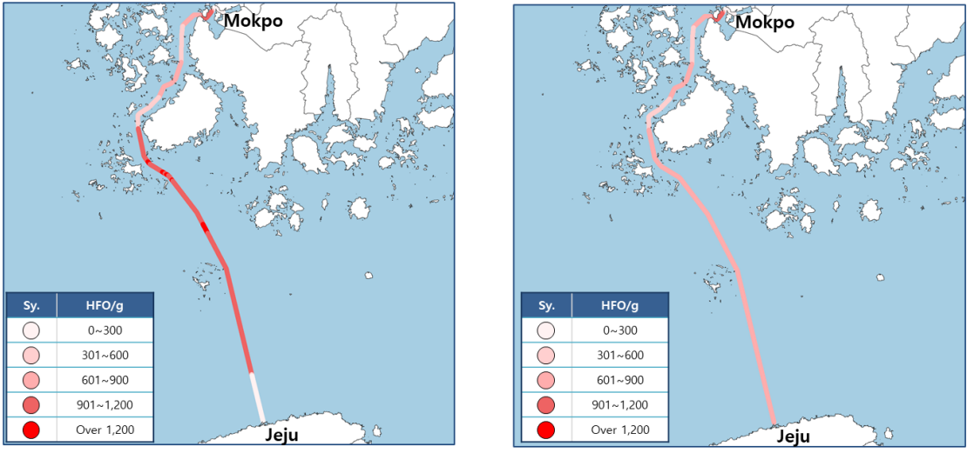
Figure D-1 Fuel consumption for route plan scenarios. Left: Scenario 1 (typical transit); Right: Scenario 2 (with RPM optimization)
Scenario 1 shows that fuel consumption is somewhat high because it operates at a high speed of 23-24 knots after leaving the speed limit area near Mokpo, and then approaches in time for entry by lowering RPM consumption from near Jeju Port. Scenario 2 optimized the RPM use plan by considering the flow of seawater in advance for each point where the ship moves. In addition, ships were allowed to use seawater flow near Jindo Island, where the maximum flow rate occurs.
- Normal Route Planning
  - Uses only the changing time of falling and rising currents
  - After departing from Mokpo, proceed at full speed and adjust speed near Jeju
- Optimal Route Planning
  - When establishing a sailing plan, the operator can check the predicted currents (direction, current speed) on an hourly basis.
  - After checking the dynamic waterway information for each time segment provided by S-100 data products, set the target speed for each section and arrive at Jeju.
- S-111 Surface Currents with 1hr interval
  - During sailing, there will be RPM differences under the influence of the flow.

D-1.3 Simulation Results
The amount of fuel consumed for 4 hours and 30 minutes was analysed using the engine RPM log and fuel consumption rate used in the simulation. The fuel required 13.02 tons and 11.12 tons, respectively, which reduced fuel consumption by 14.6% when the ship was operated after establishing an optimized routing plan in consideration of S-111 seawater flow. Although the arrival time and average speed were almost the same, it can be seen that the route plan reflecting S-111 surface currents and considering Just-in-time is much more economical.
As fuel consumption was reduced by about 14.6%, the emission of pollutants such as carbon and nitrogen oxides was also reduced to a similar percentage.

D-1.4 Data
The range of S-111 data generated by KHOA's physical prediction model is 72 hours. Surface currents grids are 300m 2km and 3km, and 2km grids were used in this test.

Acknowledgements
All images and data in this use case are courtesy HyunSoo Choi (Korea Research Institute of Ships and Ocean Engineering) and KHOA (Korea Hydrographic and Oceanographic Agency). Further information is available in the following paper:
Ecological Benefit and Navigational Safety Study based on S-10X Data. Paper at S-100 WG8 (November 2023), submitted by: Republic of Korea (KHOA, KRISO) (S100WG8-32, https://iho.int/en/s-100wg8-2023. Downloaded 15 February 2024).

Page intentionally left blank

- – Surface Current Data
This Annex describes the sources of data, methods of organizing surface current data (the time series and the grid), how the data product format is derived. In the last part of this Annex we discuss additional features of current data.

E-1 Data Sources
For the purposes of this Product Specification, surface current data is categorized as one of three types, depending on the source of production. These are:
- Historical and real-time observation;
- Astronomical prediction; and
- Model-based forecast or prediction.
An historical observation consists of a time series of values at a specific location or area, often at a specific elevation above the bottom or below the surface. Observations can be for a fixed point (current meter), a moving point (for example, a Lagrangian drifter), along a vertical or horizontal line (Doppler profiler), or an area (coastal radar). A real-time (or near-real-time) observation is actually a historical observation but for the very recent past. The astronomical tidal current prediction is often a time series computed by a mathematical formula using harmonic constants. This prediction applies to a specific location and depth, and is often produced many months ahead of time.
The astronomical predictions for multiple stations are often combined into a digital tidal atlas, and the individual predicted currents are usually keyed to the time and amplitude of tidal water levels at a nearby station.
Finally, model-based forecasts or predictions are usually produced by a two- or three-dimensional numerical hydrodynamic model, and include astronomical tide, meteorological forcing, river inflow, spatially varying water density, and open ocean boundary inputs. A model-based hindcast, including an analysis, is based on historically-observed conditions. A forecast is usually produced to predict conditions a few hours or days ahead into the future.

E-2 Data Organization
Data are usually organized by the Data Producer into either (a) a time series of values, such as for historical and real-time observations at a single point; or (b) a gridded set of values, such as from a model-based forecast or sea-surface analysis.

E-2.1 Time series data
An historical observation consists of a time series of values at a specific location or area, often at a specific elevation above the bottom or below the surface. Observations can be for a single point (current meter), along a line (Doppler profiler), or an area (coastal radar).
The data for individual current meter stations are most conveniently organized in a time series.
For example, for historical observations and astronomical predictions, each record in the series consists of a time for which the data are valid and the water current data itself: speed and direction. Descriptive data may be contained in a metadata block at the beginning of the file.
Real-time data is similar to historical data in that, in addition to dataset metadata, they include either a single near-real-time value or a time series of values for speed and direction, with the most recent being the near-real-time value. A sample file containing observations is shown in Figure E-1.
# Station ID: cb1101
# # Orientation: Down (Buoy-Mounted)
# # Time Zone: UTC
# # Approx. Depth: Near Surface
# # Blank rows indicate missing data. See our data
# # disclaimer online.
# #
# # Date Time Speed (knots) Dir (true)
# 2014-12-01 00:00:00 1.08 215
# 2014-12-01 00:06:00 1.00 225
# 2014-12-01 00:12:00 0.83 226
# 2014-12-01 00:18:00 0.73 230
# 2014-12-01 00:24:00 0.80 223
# 2014-12-01 00:30:00 0.77 236
# 2014-12-01 00:36:00 0.73 229
# 2014-12-01 00:42:00 0.61 224
# 2014-12-01 00:48:00 0.71 224
# 2014-12-01 00:54:00 0.71 220
# 2014-12-01 01:00:00 0.67 230
Figure E-1 – Portion of an actual text file containing surface current observations at 6-minute intervals. The native format is ASCII text (other options were available). Data courtesy of the Centre for Operational Oceanographic Products and Services, US
The sample file contains (a) a metadata block, with information on the station, location, instrument type, and depth, and (b) a header line followed by multiple lines of values which include the date and time, the current speed, and the current direction.
The file shown in Figure E-1 can be reformatted so that the metadata appears at the beginning of the file, and the speed at direction data is group for each time (Figure E-2a).
[Metadata block for station # 1]
Value of Time 1: 2014-12-01 00:00:00
Speed at Time 1 = 1.08
Direction at Time 1 = 215
Value of Time 2: 2014-12-01 00:06:00
Speed at Time 2 = 1.00
Direction at Time 2 = 225
Value of Time 3: 2014-12-01 00:12:00
Speed at Time 3 = 0.83
Direction at Time 3 = 226
Figure E-2a – Reformatted time series or real-time data
The data in Figure E-2a can be rearranged so that all the speeds and all the directions appear in a sequence, as in Figure E-2b.
[Metadata block for station # 1]
Value of Time 1: 2014-12-01 00:00:00
Speed = 1.08, 1.00, 0.83
Direction = 215, 225, 226

Figure E-2b – Reformatted time series data

E-2.2 Gridded data
For certain data products that cover a specific geographic area, the data are most likely to be gridded. Examples are hindcasts and forecasts produced by a hydrodynamic model; currents derived from the analysis of sea-surface topography; and currents derived from high-frequency coastal radar observations.
Many spatial grids are regular (that is, having uniform spacing in each direction) and geodetic (with the X axis directed toward the east and Y axis directed toward the north). Such grids are defined by several parameters: the origin (longitude and latitude of a geographic point); the grid spacing along each axis (degrees); and the number of points along each axis. Given an uncertainty in the location of the origin and in the spacing, there will be an uncertainty on the precise position of the grid points. A portion of the metadata and the current speed data from a forecast model is shown in Figure E-3. There are similar data for the current direction grid.
NOTE: some datasets contain a land mask array, for the purpose of determining whether a grid point represents land or water. Herein the Product Specification uses a land mask value (for example -99.999), which is substituted for a gridded value which is on land, to represent land, thus reducing the number of arrays required.
Dataset 'speed(knots)'
Size: 500x325
MaxSize: 500x325
Datatype: H5T_IEEE_F32LE (single)
ChunkSize: 1x325
Filters: deflate(9)
FillValue: 0.000000
Attributes:
'organization': 'Center Canadian Meteorological Service - Montreal (RSMC) (54) '
'Delta_Longitude': '0.02993999933078885 '
'Delta_Latitude': '0.019938461092802194 '
'forecastDateTime': '20140611_180000 '
'Product': 'Type: Forecast products Status: Operational products '
'Minimum_Latitude': '45.5 '
'Maximum_Latitude': '51.97999985516071 '
'Maximum_Longitude': '-56.030000334605575 '
'Number_Of_Cells_South_North': '325 '
'Minimum_Longitude': '-71.0 '
'Number_Of_Cells_West_East': '500 '
'generatedDateTime': '20140611_000000 '
'units': 'mm/s '
speed(knots) =
0, 0, 0, 0.5191959, 0.5159838, 0.5159435, 0.5186388,
0.5209069, 0.5167338, 0.5114825, 0.4738558, 0.378551, 0.2911682,
0.204335, 0.1294665, …

Figure E-3 – A portion of the actual metadata and the gridded current speed data produced by the Canadian Meteorological Service from a model-based forecast. The native format is HDF5
Note that the data for current speed in Figure E-3 is organized similarly to that for time series: (a) metadata followed by (b) a header record and then the data. However, unlike the time series, the data are valid for a single time (the value of which appears elsewhere in the metadata).
Current data produced on ungeorectified grids or on unstructured grids, or for surface drifters, may be incorporated by spatially referencing each individual velocity location by explicitly giving its latitude and longitude in the metadata.
For gridded data in general, the metadata for both speed and direction will be the same, so only one metadata block is required to describe both the speed and direction data (Figure E-4). The data for speed in Figure E-3 is a series of values at grid points, starting from the lower left corner of the grid and proceeding along the first row until the end, then starting with the first point in the second row, and so on. Note that for the two fields (speed and direction) in this example, the memory required is 0.325 mb.
[Metadata block for gridded fields]
Value of Time 1
Speed at T1 = 0, 0, 0, 0.5191959, 0.5159838, 0.5159435, 0.5186388, 0.5209069, 0.5167338, 0.5114825, 0.4738558, 0.378551, 0.2911682, 0.204335, 0.1294665, …
Direction at T1 = 0, 0, 0, 32.7725, 30.33029, 27.84417, 26.28601, 26.46908, 26.46744, 26.56505, 25.9423, 24.28312, 23.54004, 24.69553, 28.52312, …
Figure E-4 – A portion of a generalized file with the metadata and the gridded current speed and direction data at one specific time from a model-based forecast shown in Figure E-3

E-3 Digital Tidal Atlas Data
A digital tidal atlas typically contains speed and direction information for a number of locations, the valid time of which is expressed as a whole number of hours before and/or after either time of high water at a reference tidal water level station or time of maximum flood current at a reference station. Often the speed and direction are given for both neap and spring tide conditions (Table E-1).
Data in the atlas format, when used with daily predictions of tidal water levels or currents at a reference station, can be converted into time series data (see Figure E-2b), and thus into the S-111 format. This conversion is to the responsibility of the Data Producer.
Table E-1 – Example of digital tidal data for a station off the French coast. Speed and direction vary by hour relative to high water at a reference station, and by tide range. Data courtesy of Service Hydrographique et Océanographique de la Marine, France.
Hour | Speed (ms⁻¹) |  | Direction (deg)
Hour | Neap | Spring | Neap | Spring
-6 | 0.924 | 0.991 | 234.0 | 232.8
-5 | 0.991 | 1.047 | 235.4 | 233.5
-4 | 1.015 | 1.104 | 233.1 | 234.8
-3 | 0.939 | 1.132 | 233.4 | 233.0
-2 | 0.447 | 0.947 | 233.7 | 233.3
-1 | 0.302 | 0.061 | 232.8 | 200.1
0 | 0.444 | 0.292 | 232.5 | 56.0
1 | 0.562 | 0.044 | 232.5 | 68.2
2 | 0.596 | 0.469 | 232.4 | 231.2
3 | 0.620 | 0.662 | 232.5 | 231.3
4 | 0.705 | 0.779 | 232.7 | 231.6
5 | 0.797 | 0.886 | 233.0 | 232.1
6 | 0.876 | 0.967 | 233.5 | 232.6

E-4 Moving Platform Data

E-4.1 Drifting platforms
Moving platforms (for example, surface Lagrangian drifters) float along with the currents and represent the motion at some depth depending on the specific design. The data are often available, in the raw form, as a list with locations and (usually non-equally-spaced) times (Figure E-5). The data are often telemetered from the drifter to a collection station.
OBJECTID,ARID,YR,MON,DD,HH,MM,SS,LAT,LON,ACC
127134,52299,2005,9,25,7,18,16,15.57400000000,142.82200000000,2
127135,52299,2005,9,25,8,58,0,15.57400000000,142.80000000000,2
127136,52299,2005,9,25,18,47,37,15.54300000000,142.72100000000,2
127137,52299,2005,9,25,19,47,45,15.54100000000,142.71100000000,2
127138,52299,2005,9,25,21,27,29,15.53300000000,142.69200000000,2
127139,52299,2005,9,26,6,55,6,15.49900000000,142.65500000000,1
127140,52299,2005,9,26,8,34,6,15.48600000000,142.64400000000,2
127141,52299,2005,9,26,18,35,27,15.43800000000,142.59300000000,1
127142,52299,2005,9,26,19,23,51,15.43300000000,142.59000000000,2

Figure E-5 – Portion of an Argos System CLS file describing the positions and times of a specific Lagrangian drifter
In the raw form, the data must be converted into speed and directions. This can be accomplished by cubic spline interpolation of the longitudes and latitudes separately, then dividing the difference in position by the differences in time. The data can be converted into time series data (see Figure E-2b), and thus into the S-111 format.

E-4.2 Propelled platforms
Other moving platforms such as ships or wave riders may be self-propelled to some degree or use a means of propulsion independent of drift, in which case instantaneous positions cannot be used to determine current speed and direction. Such platforms may carry hydroacoustic current meters which can be used to determine current speed and direction, such as acoustic Doppler current profilers. Data from such platforms includes locations associated with time stamped current speed and direction values, obtained after cleaning and processing of the raw sensor data. Time stamps may be at non-uniform intervals for various reasons. Such data can be carried in S-111 datasets as non-uniform moving platform data, with time stamps associated to each observation instead of a uniform time interval for the whole series.

E-5 Preliminary Data Product Format
Two forms of data (Figure E-2b and E-4) are similar, the main difference being that the multiple values for each variable in Figure E-4 correspond to multiple grid points, rather than the multiple times in Figure E-2b (at a single station). Thus the two forms can be combined into a single form (Figure E-6, although the data are interpreted differently. Other forms of data (Figures E-4 and E-5) must be processed to fit the format.
Metadata Block
Location Data
Time and Location 1
Surface current speed(s)
Surface current direction(s)
Time and Location 2
Surface current speed(s)
Surface current direction(s)
Figure E-6 – Schematic of the preliminary product data set. The product can represent either a time series at a number of stations or gridded data

E-6 Additional Features of the Data
The following clauses described additional features of current data and types.

E-6.1 Vertical Reference Datums
The vertical location of the current in the water column is normally referenced to some vertical datum. In this Product Specification, the datum is selectable: it can be the sea surface, the sea bottom, or any of the standard tidal datums.
In principle, it is possible to transform elevations between the different datums. The separation between a standard tidal datum and the sea surface varies with time, and can be obtained by a prediction of the water level at the location of the current. In the case of a hydrodynamic model for currents, the model itself usually includes a water level prediction. The separation between the sea bottom and the standard tidal datum is often contained automatically in bathymetric data that is referenced to a chart datum. If chart datum and the selected currents datum are different, an estimation of the difference in elevation is required.

E-6.2 Uncertainty
Uncertainty is the estimate of the error in any measurement or value; since the error (difference between true and observed value) depends on true value, which can never be measured. For practical purposes, the confidence level is 95% and the uncertainty is defined herein as 1.96 times the standard deviation of the differences between observed and predicted values (cf. S-44. IHO Standards for Hydrographic Surveys, 5th Edition February 2008). For multiple sources of uncertainty, the total propagated uncertainty is the relevant value.
For example, the comparison between a predicted speed and the observed speed is normally based on an analysis using the time series for each. The standard deviation of the speed differences at each point in the series can be computed by the common formula. The calculation is similar for direction. It should be noted that for model-based predictions, uncertainty usually increases with the projection into the future.
Uncertainty for location is somewhat different. Horizontal locations of fixed or drifting observing stations are determined by surveying or GPS. The inherent uncertainties in these types of measurements are normally documented. For gridded hydrodynamic model data, uncertainties are based on the precision of the grid parameters (origin and spacing) and, if used, on any transformation from Cartesian (flat plane) position to geographic location. For coastal radar, uncertainty in position may be estimated by the local geometry and radar’s accuracy in computing distances and angles.
Vertical locations of fixed or drifting observing stations are determined by surveying or GPS, and by configuration geometry. For gridded hydrodynamic model data, uncertainties are determined in a manner similar to the horizontal positions, but with consideration for uncertainties in instantaneous sea surface height, actual water depth, and vertical (if used).
Uncertainties in time are based on instrumentation and GPS parameters, record keeping, and computer/processing accuracy.
- – Colour Tables (Informative)
Below are typical colour tables for the day, dusk, and night conditions (Tables F-1, F-2, and F-3). The estimates for dusk and night were obtained by first converting the values for RGB colours for day conditions (see clause 9.2.3) to xyL values, where L is luminance. The conversion assumes the colours are the standard RGB (sRGB) and the calculations follow the explanation in IEC 61966 (IEC 61966-2-1:1999 – Multimedia systems and equipment - Colour measurement and management - Part 2-1: Colour management - Default RGB colour space - sRGB. Note that in S-52 colours, the conversion from xyY to xyL requires that L=100Y.
Existing xyL data for dusk and night conditions for approximately 50 S-52 colours (S-52 Presentation Library Edition 4.0.0, Part 1, Appx. A) demonstrate that for the lower light conditions luminance is reduced while the x and y values remain approximately constant. Here, for each S-111 colour, the closest (that is, smallest root mean square of the sum of the squares of the difference in x values and y values) S-52 colour for day conditions was identified, and that colour’s luminance reduction factors for the other light conditions were used to calculate the new S-111 xyL values. Finally, the new xyL values were converted to RGB values and their hexadecimal equivalents.
NOTE: The contents of this Annex are “as of publication” and may be revised for usability and interoperability based on user testing and ECDIS requirements in S-98 and applicable IMO/IEC standards. The content of the S-111 Portrayal Catalogue should prevail in case of conflict between the latest formal release of the Portrayal Catalogue and the contents of this Annex.
Table F-1 – Colour parameters for DAY conditions for each speed band. The last row (Band ‘All’) shows the colour for the arrow border
Band | Token | Colour | x | y | L | R | G | B | RGB Hex
1 | SCBN1 | purple | 0.21 | 0.14 | 15 | 118 | 82 | 226 | 7652E2
2 | SCBN2 | dark blue | 0.21 | 0.24 | 29 | 72 | 152 | 211 | 4898D3
3 | SCBN3 | light blue | 0.23 | 0.29 | 51 | 97 | 203 | 229 | 61CBE5
4 | SCBN4 | dark green | 0.33 | 0.52 | 40 | 109 | 188 | 69 | 6DBC45
5 | SCBN5 | light green | 0.39 | 0.53 | 61 | 180 | 220 | 0 | B4DC00
6 | SCBN6 | yellow-green | 0.43 | 0.50 | 51 | 205 | 193 | 0 | CDC100
7 | SCBN7 | orange | 0.49 | 0.45 | 48 | 248 | 167 | 24 | F8A718
8 | SCBN8 | pink | 0.40 | 0.33 | 48 | 247 | 162 | 157 | F7A29D
9 | SCBN9 | red | 0.64 | 0.33 | 21 | 255 | 30 | 30 | FF1E1E
All | CHBLK | black | 0.28 | 0.31 | 0 | 0 | 0 | 0 | 000000

Table F-2 – Colour parameters for DUSK conditions for each speed band. The last row (Band ‘All’) shows the colour for the arrow border
Band | Token | Colour | x | y | L | R | G | B | RGB Hex
1 | SCBN1 | purple | 0.21 | 0.14 | 7 | 81 | 55 | 159 | 51379F
2 | SCBN2 | dark blue | 0.21 | 0.24 | 3 | 20 | 52 | 76 | 14344C
3 | SCBN3 | light blue | 0.23 | 0.29 | 3 | 19 | 51 | 58 | 13333A
4 | SCBN4 | dark green | 0.33 | 0.52 | 13 | 64 | 114 | 39 | 407227
5 | SCBN5 | light green | 0.39 | 0.53 | 21 | 110 | 136 | 0 | 6E8800
6 | SCBN6 | yellow-green | 0.43 | 0.50 | 18 | 126 | 119 | 0 | 7E7700
7 | SCBN7 | orange | 0.49 | 0.45 | 15 | 147 | 97 | 1 | 936101
8 | SCBN8 | pink | 0.40 | 0.33 | 5 | 86 | 53 | 51 | 563533
9 | SCBN9 | red | 0.64 | 0.33 | 9 | 178 | 1 | 1 | B20101
All | CHBLK | black | 0.28 | 0.31 | 20 | 107 | 127 | 137 | 6B7F89

Table F-3 – Colour parameters for NIGHT conditions for each speed band. The last row (Band ‘All’) shows the colour for the arrow border
Band | Token | Colour | x | y | L | R | G | B | RGB Hex
1 | SCBN1 | purple | 0.21 | 0.14 | 1 | 26 | 15 | 59 | 1A0F3B
2 | SCBN2 | dark blue | 0.21 | 0.24 | 1 | 4 | 17 | 28 | 04111C
3 | SCBN3 | light blue | 0.23 | 0.29 | 0 | 3 | 14 | 17 | 030E11
4 | SCBN4 | dark green | 0.33 | 0.52 | 2 | 19 | 40 | 8 | 132808
5 | SCBN5 | light green | 0.39 | 0.53 | 3 | 38 | 49 | 0 | 263100
6 | SCBN6 | yellow-green | 0.43 | 0.50 | 2 | 45 | 42 | 0 | 2D2A00
7 | SCBN7 | orange | 0.49 | 0.45 | 2 | 54 | 33 | 0 | 362100
8 | SCBN8 | pink | 0.40 | 0.33 | 1 | 33 | 17 | 17 | 211111
9 | SCBN9 | red | 0.64 | 0.33 | 1 | 63 | 0 | 0 | 3F0000
All | CHBLK | black | 0.28 | 0.31 | 2.5 | 37 | 45 | 49 | 252D31

- – Scalable Vector Graphics (SVG) Coding (Informative)
The Surface Current arrow symbols are defined in the IHO GI Registry and included in the Portrayal Catalogue. The following is a sample of typical symbol files and a few images created from the files.
NOTE: The contents of this Annex are “as of publication” and may be revised for usability and interoperability based on user testing and ECDIS requirements in S-98 and applicable IMO/IEC standards. The content of the S-111 Portrayal Catalogue should prevail in case of conflict between the latest formal release of the Portrayal Catalogue and the contents of this Annex.

G-1 Sample SVG Images
Sample images showing the vector arrows generated by the SVG and CSS codes appear in Figure G-1. The image was created by opening the file in Microsoft Internet Explorer©.
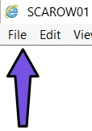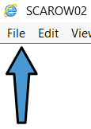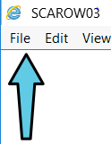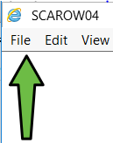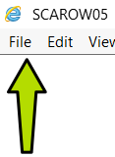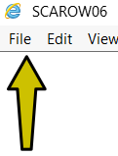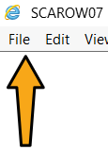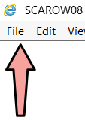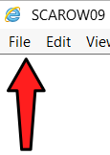
Figure G-1 – Web browser images of the arrows for speed bands 1 through 9 (day conditions), as generated by the .svg and .css codes in this Annex. Shown larger than actual size

G-2 Sample SVG File to Display Arrows
SVG symbols for arrows conform to the SVG profile described in S-100 Part 9 Appendix 9-B. The sample .svg file shown (Figure G-2) describes a typical SVG file for symbol SCAROW01, the arrow for speed band 1, day light conditions. The fill and border colours of the arrow symbols are designated by the “class” attributes on the “path” elements, and the actual colours corresponding to each class are defined in the CSS style files for day/night/dusk palettes. Symbols for other bands are similar but designate different fill colours.
The coordinate system for the symbol is defined as follows:
- The overall width and height of the symbol are defined in mm.
- The viewbox covers the range of coordinates used for the symbol.
- The pivot point of the symbol is designed to be at the 0.0, 0.0 position.
- The default coordinate system used for S-100 SVG has the origin in the upper left corner with the x axis pointing to the right and the y-axis pointing down.
For example, using the image coordinates shown in Figure 9-1, the SVG coordinate system, and Lref of 10 mm, a ‘path’ command would contain
M -0.5, 5. L -0.5, 5.0 -1.0,-1.5 -2.,-1.5 0.,-5.0 2.0,-1.5 1.0,-1.5 0.5,5.0 -0.5, 5.0 Z
where M is the moveto instruction, L is the lineto instruction, and Z denotes the end of the drawing. The coordinates are given in mm.
<?xml version="1.0" encoding="UTF-8" standalone="no"?>
<?xml-stylesheet href="SVGStyle_S111day.css" type="text/css"?>
<svg xmlns="http://www.w3.org/2000/svg"
xmlns:iho="http://www.iho.int/SVGMetadata/5.2"
version="1.2" baseProfile="tiny" xml:space="preserve" shape-rendering="geometricPrecision" fill-rule="evenodd"
width="6mm" height="11mm" viewBox="-3 -5.5 6 11">
<title>SCAROW01</title>
<desc>Surface Current Vector Band 1</desc>
<metadata>
<iho:S100SVG xmlns:iho="http://www.iho.int/SVGMetadata/5.2">
<iho:Description iho:publisher="IHO" iho:creationDate="2026-06-19" iho:source="TWCWG" iho:format="S100SVG" iho:version="2.0" />
</iho:S100SVG>
</metadata>
<path d="M 0,5 L -0.5,5 L -1.0,-1.5 L -2.0,-1.5 L 0,-5 L 2.0,-1.5 L 1.0,-1.5 L 0.5,5 L 0,5 Z" fill="#7652E2" stroke="#000000" class="fSCBN1 sCHBLK" stroke-linecap="round" stroke-linejoin="round" stroke-opacity="1" stroke-width="0.32" />
<g display="none" stroke-width="0.16" fill="none" class="layout">
<rect x="-3" y="-5.5" height="11" width="6" fill="none" class="svgBox" />
<rect x="-3" y="-5.5" height="11" width="6" fill="none" class="symbolBox" />
<g stroke="red" class="pivotPoint">
<circle cx="0" cy="0" r="0.5" />
<line x1="0" y1="-0.5" x2="0" y2="0.5" />
<line x1="-0.5" y1="0" x2="0.5" y2="0" />
</g>
</g>
</svg>
Figure G-2 – SVG code for the arrow symbol for speed band 1 (SCAROW01).

G-3 Sample CSS File
Below (Figure G-3) is the Cascading Style Sheet (css) file used in Figure G-1. This file defines colours for the “day” palette. Similar files are provided for “dusk” and “night” palettes. Switching between palettes is managed by the application software and rendering system.

/*
* CSS styles for S-111 Day color table
* Source: S-111 V. 2.0.1-20260619
* stroke style for symbolBox, svgBox, pivotPoint as in S-101 SVGStyle CSS
*/
.layout {display:none} /* used to control visibility of symbolBox, svgBox, pivotPoint (none or inline) */
.symbolBox {stroke:black;stroke-width:0.16;} /* show the cover of the symbol graphics */
.svgBox {stroke:blue;stroke-width:0.16;} /* show the entire SVG cover */
.pivotPoint {stroke:blue;stroke-width:0.16;} /* show the pivot/anchor point, 0,0 */
.sl {stroke-linecap:round;stroke-linejoin:round} /* default line style elements */
.f0 {fill:none} /* no fill */
.sCHBLK {stroke:#000000} /* sRGB line colour for all surface current arrow tokens */
.fSCBN1 {fill:#7652E2} /* sRGB line colour for colour token STEP1: S111 Step 1 color */
.fSCBN2 {fill:#4898D3} /* sRGB line colour for colour token STEP2: S111 Step 2 color */
.fSCBN3 {fill:#61CBE5} /* sRGB line colour for colour token STEP3: S111 Step 3 color */
.fSCBN4 {fill:#6DBC45} /* sRGB line colour for colour token STEP4: S111 Step 4 color */
.fSCBN5 {fill:#B4DC00} /* sRGB line colour for colour token STEP5: S111 Step 5 color */
.fSCBN6 {fill:#CDC100} /* sRGB line colour for colour token STEP6: S111 Step 6 color */
.fSCBN7 {fill:#F8A718} /* sRGB line colour for colour token STEP7: S111 Step 7 color */
.fSCBN8 {fill:#F7A29D} /* sRGB line colour for colour token STEP8: S111 Step 8 color */
.fSCBN9 {fill:#FF1E1E} /* sRGB line colour for colour token STEP9: S111 Step 9 color */
Figure G-3 – CSS file for surface current arrow symbols, Day condition.

Page intentionally left blank

- – Surface Current Portrayal Rules

H-1 Introduction
This Annex summarizes the rules and formulae discussed in Clause 9 (Portrayal) for display of the surface current arrow symbol. The placement of the colour scale and the pick report boxes are not discussed.
The surface current feature is characterized by (1) a speed (knots) and (2) a direction (arc-degrees clockwise from north). Speed values are given to the nearest 0.01 knot, and direction values to the nearest 0.1 arc-degree. The speed and direction values are stored in the HDF file as a dataset (DS). The current speed and direction values are applicable to a specific geographic location, denoted by (1) a longitude (arc-degrees) and (2) a latitude (arc-degrees). The current is valid for a specific depth, or as a vertical average over a depth. The depth and datum, or the averaging depth, are given in the Carrier Metadata (clause 12.3). The current is also valid for a specific date and time, the values of which are given either as an attribute of the DS (a time stamp) or must be calculated using the time of the first value, the length of time interval, and the number in the series.

H-2 The Surface Current Symbol
Rule 1: The basic symbol for SVG is as shown in Figure H-1. The nominal height of the symbol is 10.0 mm.
Figure H-1 - Surface current arrow symbol, showing x- and y-coordinates of the vertices (mm) and the pivot point (+)
(0.0, -5.0)
(2.0, -1.5)
(-2.0, -1.5)
(1.0, -1.5)
(-1.0, -1.5)
(0.5, 5.0)
(-0.5, 5.0)
+
X direction
Y direction
Rule 2: A null value for speed and direction (see Table 10-3) means that the point represents land, or the value is missing. In either case, no arrow symbol is displayed.
Rule 3: The colour of the arrow is set by the band within which the speed falls. The colours for nine speed bands are shown in Table H-1.
NOTE 1: Within any speed band, the lower speed is given as the Minimum Speed in Table H-1, and the upper speed is just less than the Minimum Speed in the next higher band. Therefore in Band 2,
0.5 < speed in Band 2 < 1.0 [Eqn H.1]
NOTE 2: As an option, the speed bands may be adjusted to provide more colour contrast. For example, to emphasize lower speeds, the bands 3 and 4 could be 1.00 to 01.50 and 1.50 to 2.00. Of course, in this example, the minimum speed for band 5 would have to be reduced to 2.00 to maintain coverage for all speeds. (Such adjustments to speed bands should only be in portrayal catalogues, differentiated by edition or version numbering of portrayal catalogues, and reflected in the relevant legends.)
Table H-1 – Speed bands, colour names, RGB colour values, and resulting day colours for current speeds (informative)
Speed Band | Min  Speed (knots) | Speed Band  Width (knots) | Colour | RGB Colour Scale Intensity |  |  | Displayed Colour
 |  |  |  | Red | Green | Blue | Displayed Colour
1 | 0.0 | 0.5 | purple | 118 | 82 | 226
2 | 0.5 | 0.5 | dark blue | 72 | 152 | 211
3 | 1.0 | 1.0 | light blue | 97 | 203 | 229
4 | 2.0 | 1.0 | dark green | 109 | 188 | 69
5 | 3.0 | 2.0 | light green | 180 | 220 | 0
6 | 5.0 | 2.0 | yellow-green | 205 | 193 | 0
7 | 7.0 | 3.0 | orange | 248 | 167 | 24
8 | 10.0 | 3.0 | pink | 247 | 162 | 157
9 | 13.0 | 86.0 | red | 255 | 30 | 30

Rule 4: Colours for dusk and night are given in Annex F (Colour Tables). Note that adjustments to the values in Annex F may be made in the IHO portrayal catalogue to improve the visual experience on ECDIS and accommodate interoperability. Applications should use the colors in the published portrayal catalogue.
Rule 5: There is a separate symbol for each speed band. Each symbol has a unique colour.

H-3 Symbol Size and Orientation
Rule 6: The size of the arrow symbol is scaled in proportion to the current speed. The height of the arrow, H (mm), is a function of the speed of the current, S (knots). Allowances are made to (a) display a small symbol even if the speed to near zero and (b) enforce a maximum arrow size. The scaling relationship is:
H = H_{ref}∙min{max(S_{low},S),S_{high}}/S_{ref}. [Eqn H.2]
The following table gives the nominal values for the four constants.
Table H-2 – Summary of recommended values for arrow display size. With these values, an arrow representing 5 knots will have a length of 10 mm
Constant | Description | Recommended Value
H_{ref} | Reference height for arrow scaling | 10 mm
S_{ref} | Reference speed for arrow scaling | 5 knots
S_{low} | Minimum speed to be used for arrow length computations | 2.00 knots
S_{high} | Maximum speed to be used for arrow length computations | 13 knots

Rule 7: The arrow is rotated to show the direction of current using the value for direction (Figure H-2).
Figure H-2. Portrayal of the arrow’s direction, based on the current direction. The dashed line is the arrow’s centerline, and the origin of the East-North axis is at the arrow’s pivot point. True north has a direction of 0 degrees

H-4 Placement of the Symbol
Rule 8: The surface current arrow is placed in the display so that the pivot point corresponds to the given values of longitude and latitude.
Rule 9: The Data Producer must ensure that the pivot point shall not be located over land. That a portion of the arrow symbol lies over land is acceptable.
Rule 10: The Data Producer must ensure that if the arrow’s pivot point lies in a geographic area designated as intertidal, then when the time-varying water depth has gone to zero the symbol is not displayed.

H-5 Thinning of a Field of Arrows
Displaying at a low resolution (that is, zooming out) increases the density of symbols. However, by applying a thinning algorithm, vector symbol overlap can be reduced. The algorithm discussed below works for regularly gridded data only.
Suppose that the grid cell has a width of gridSpacingLongitudinal and height of gridSpacingLatitudinal (see Table 12-3), and has a diagonal distance of D mm. Note that D is dependent on the map scale of the display. Also suppose that the height of the arrow symbol for the maximum speed in the display area is H_{max}.
Suggested Rule 11: For thinning regularly gridded data, arrows at every n^{th} column and every n^{th} row are drawn, but making sure that the row and column with the maximum vector is drawn. With a R_{max} value of 0.5,
n =1 + fix{H_{max}/(0.5D)} [Eqn H.3]
The value of n must be calculated by the ECDIS.
S-98 contains a detailed description of a suggested algorithm for implementing thinning by drawing symbols at only n X n grid points.
Suggested Rule 12: For thinning non-regularly spaced data, one potential solution would be to either reduce the reference height H_{ref} or increase the reference speed S_{ref} (Table J-2), so as to make each symbol smaller. Thus either S_{ref} of H_{ref}, or both, must be user-selectable.
Another method, based on the fact that non-regularly spaced data values are ordered in a nearly random manner, would be to reduce the number of symbols by plotting only every n^{th} vector. This method would require that the value of n be entered by the user.

H-6 Temporal Rules
Let T_{s} be the time selected by the user or the ENC for display of data, and let T_{E} be equal to dateTimeOfLastRecord + timeRecordInterval.
Rule 13a: If T_{s} is earlier than the timestamp of the first data in the series, dateTimeOfFirstRecord, no arrows are displayed.
Rule 13b: If T_{s} is later than T_{E}, no arrows are displayed.
Rule 13c: If T_{s} is later than the first timestamp and earlier than T_{E}, then the arrows for the data are plotted if the timestamp is (a) later than Ts, but (b) less than T_{s} + timeRecordInterval.

H-7 Pick Report for Time Series Data (informative)
In the absence of specific guidance in S-98 Annex C, the tidal stream panel display described in S-98 Annex C (for example, clause 15 4 in S-98 Edition 1.0.0) may be adapted for the purpose of displaying time series current information in response to a cursor pick by the user. A simple adaptation might consist of using the tabular format described in S-98 Annex C but replacing the “reference tide” attribute by the timestamp selected in the previous paragraph and omitting the “reference tide type” attribute. Figure H-3 depicts the concept. The table in Figure H-3 is an adaptation of the depiction of tidal stream tables for paper charts described in S-4 (B-407.3).
Tidal Station: (station name)
Tidal Station Identifier: (station identifier) |  | Data From: SURF CUR (S-111)
 | Hours | Direction of stream (degrees) | Rates (knots)
Before | -6
Before | -5
Before | -4
Before | -3
Before | -2
Before | -1
YYYY-MM-DD HH:MM:SS Z | 0
After | +1
After | +2
After | +3
After | +4
After | +5
After | +6
Figure H-3 – Notional pick report structure for data at multiple times
The time display (“Hours” column), the selection of time-value combinations to display, and the number of rows should be adapted to the time interval and number of records in the time series, so as to cover suitable periods before and after the selected display time.
NOTE: S-111 does not mandate a tabular display of data for any of its time series types. The tabular display described in this clause is intended only as a guideline for ECDIS developers desiring to implement a tabular format.

The exception is Usability, measures for which are necessarily defined in terms of requirements specific to the data product.
Names of measures other than attributeValueUncertaintyMean are planned corrections by the DQWG to the names listed in S-100 Edition 5.2.0 Part 4c.
Since cancellations cannot always be predicted, this requirement obviously cannot be put into effect until the cancellation arrives on the system.
This Product Specification does not mandate maintenance of temporal continuity between cancelled and replacement datasets. External factors such as production constraints, producers’ own data standards or ECDIS performance standards may be determinative and must be taken into account.
Courtesy NAUDEQ.
IEC 60945 as cited in S-52 specifies that character size in mm be not less than 3.5 x the viewing distance in metres. According to this criterion "readable from 1 metre” requires that characters be not less than 3.5 mm in size. A 3.5mm symbol or character subtends an angle of approximately 12 arc minutes at a distance of 1 metre.
Note that this is a recommended value; manufacturers may adjust it as necessary in particular circumstances, such as a lower or higher normal viewing distance. The basic requirement is that the symbol should be distinguishable as an arrow.
Calculated using Eqn. 9.1 and an allowance for the border extending outside the filled area of the arrow symbol.
Folder names in the official distribution of the Portrayal Catalogue prepared by the IHO Secretariat may vary.
Producer Codes may be obtained from the IHO Producer Code Register in the IHO GI Registry. The four-character S-100 “Alpha” codes must be used.
Exceptions: (1) Producer Codes must use the same case as the IHO Producer Code Register. (2) A name component taken from an external Specification, must follow the rules in that Specification (for example, “20190703T00Z” for a time component in ISO 8601 basic format, not “20190703t00z”).
Temporarily suspended; S-97 1.1.0 states digital signatures are essential only for technical readiness level 3.
See the guidance on HDF5 datatypes (https://support.hdfgroup.org/HDF5/Tutor/datatypes.html, retrieved 20 August 2021) for more information on the use of standard vs native types when creating a dataset and for memory operations (read/write).
S-100 lists permitted numeric codes and descriptions in Part 10c (Table 10c-10) but does not define labels. Pending definition of an enumeration in S-100, the encoding should use the labels “LowerLeft” and “Barycenter” for codes 1 and 5 respectively. The labels “UpperRight”, “LowerRight”, “UpperLeft” may be used with codes 2, 3, and 4 to define the HDF5 enumeration data type but must not be encoded as values of the dataOffsetCode attribute. A validation check in S-158:111 will enforce this constraint.
For moving platforms, these are technically additional attributes defined by S-111.

