Data packet protocol

Data packet consists of two parts: header and data.
Header:
Byte position | Description
packet[0] | Message type. Can be one of WIFI_CONFIG or MQTT_CONFIG.
packet[1] | Data length MSB byte
packet[2] | Data length LSB byte
Table 1. Structure of header.

Bytes from packet[3] are data that represents configs. To get data size you need to calculate it: size = packet[1] << 8 | packet[2].
Bytes starting from packet[3] to packet[size-1] are payload. Wifi configuration consists of two data fields: wifi ssid and wifi password. To distinguish between ssid and password we use symbol ‘\n’ as separator. So, if you want to parse packet – skip first 3 bytes and split packet by separator.

General structure of wifi config packet:
WIFI_CONFIG | Size MSB | Size LSB | SSID | SEPARATOR | PASSWORD

General structure of mqtt config packet:
MQTT_CONFIG | Size MSB | Size LSB | Server name | SEPARATOR | Port | SEPARATOR | User | SEPARATOR | Password

Table 2: Constants and description
Constant | Value | Description
WIFI_CONFIG | 3 | Indicates that current packet is for wifi configuration.
MQTT_CONFIG | 4 | Indicates that current packet is for mqtt configuration.
SEPARATOR | ‘\n’ | Byte used for splitting payload.
HEADER_SIZE | 3 | Size of header.
HEADER_TYPE_INDEX | 0 | Index of byte that represents payload type(WIFI_CONFIG or MQTT_CONFIG).
HEADER_LEN_MSB_INDEX | 1 | MSB byte of payload size
HEADER_LEN_LSB_INDEX | 2 | LSB byte of payload size.
WIFI_ERROR | 10 | Error code. ESP32 module sends this value if connection to WiFi failed.

State identification

One RGB LED is used for state identification. Table below lists all possible states and appropriate description.

Color | Description
Red | Not connected to WiFi.
Green | Connected to WiFi.
Blue | Resetting all configs.
Table 3. Description of RGB identifier.
When you press reset button – blue led turns on. When reset is finished – this led turns off and ESP32 module automatically restarts.

Button connection schematic
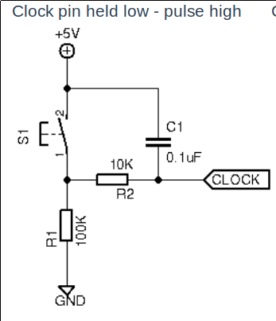

pic. 1 Button debouncing schematic.

