ESP8266 login procedure example

Step 1. Install this libraries: WifiManager and ArduinoJson. Click – Sketch→Include library→Manage libraries and type name of the library. In this project we use WifiManager library → WhareHauoraWifiManager and standard ArduinoJson library.
Step 2. Clone github repo from this link: https://github.com/ihor96berizka/Smart_house_ESP8266_NodeMCU. Go to the AutoConnectWithFSParameters folder. Here you will find Arduino project which performs login procedure.
Step 3. Connect your ESP8266 NodeMCU module to PC. Open this project in Arduino IDE and program MCU.
Step 4. Open Serial Monitor, set baudrate = 115200. If everything is correct – you`ll see output like on figure 1.

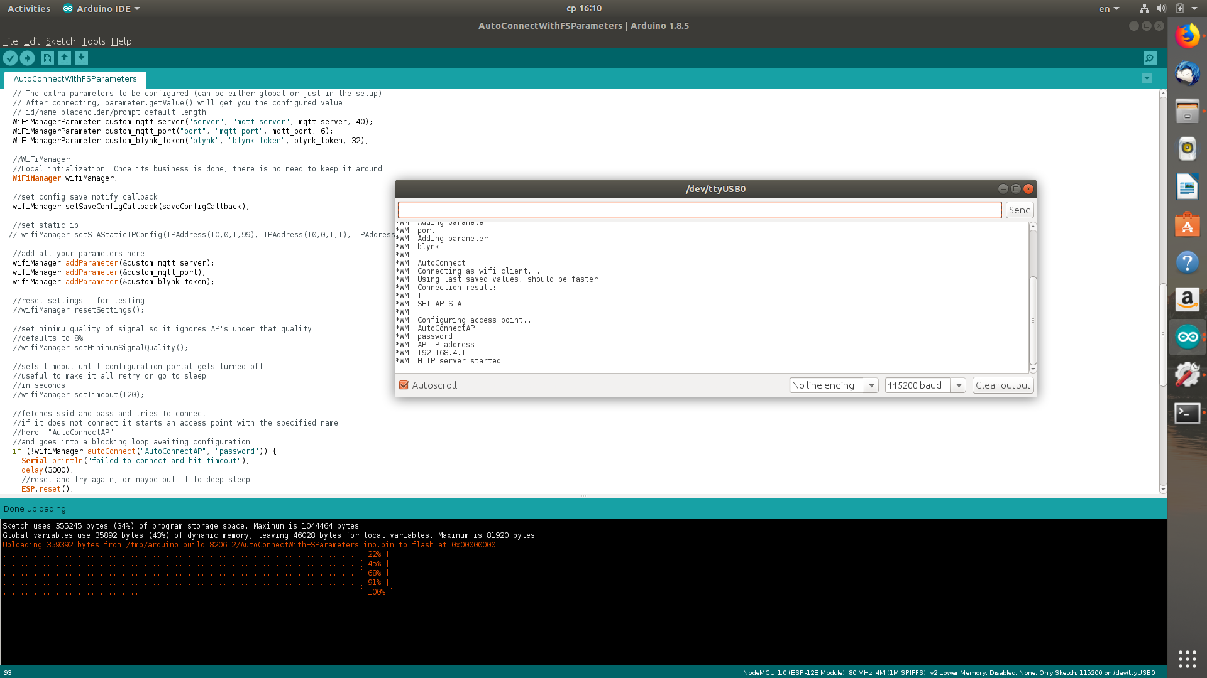
Figure 1. Output in Serial Monitor after ESP8266 module restart.

As you can see from output: ESP8266 now working in access point mode and hosts server with default address: 192.168.4.1 so you can turn on any device with wi-fi and connect to ESP8266. SSID = ESP_AP, password = password.
Step 5. Connect to this access point using smartphone\PC\laptop. I have used RPi3 for this example. Open your browser and in address textbox write address of ESP8266 server: 192.168.4.1. Then you will see window like on figure 2.

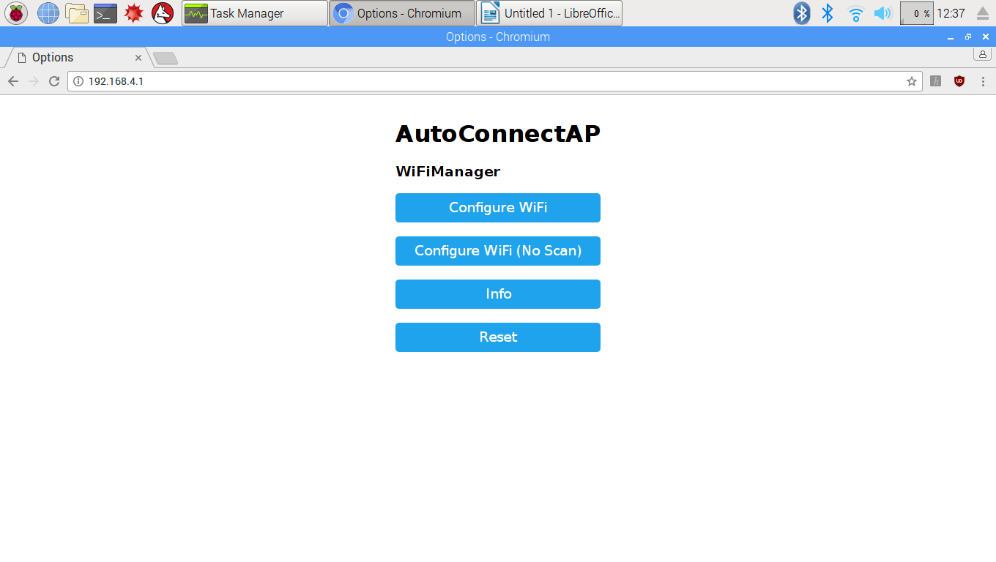
Figure 2. Login menu

Step 6. Click on Configure WiFi button. You will see window like on figure 3.

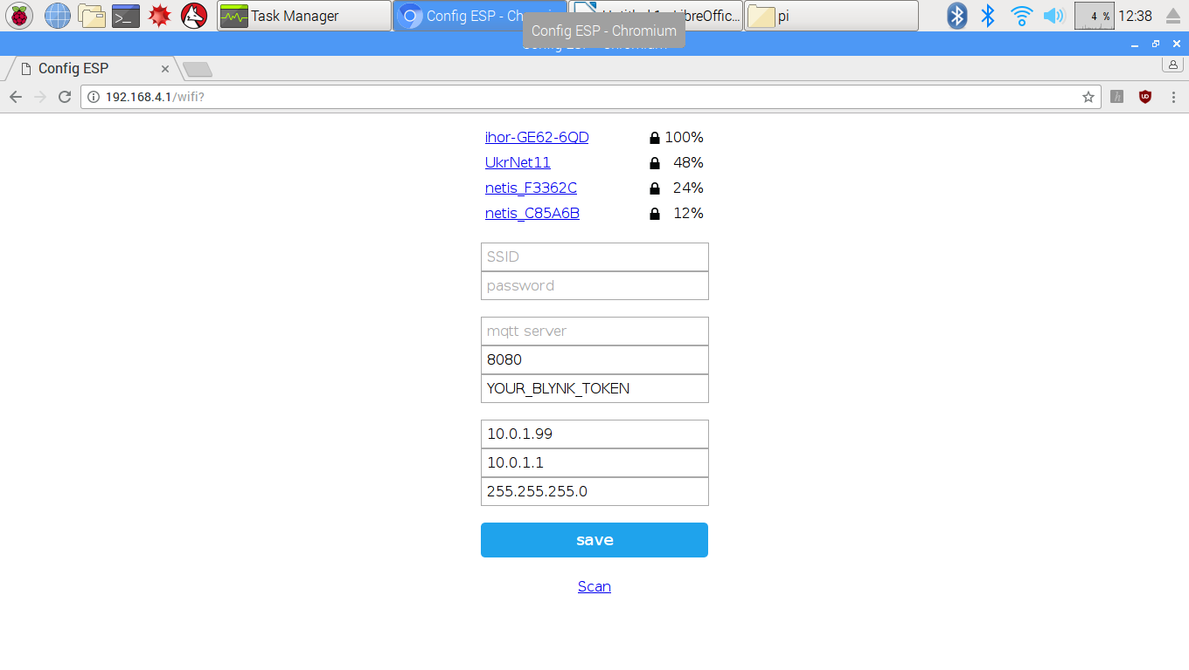
Figure 3. Configure WiFi window.

Here you can see all avaiable WiFi access points. Choose one of them (for example first one) and enter password.

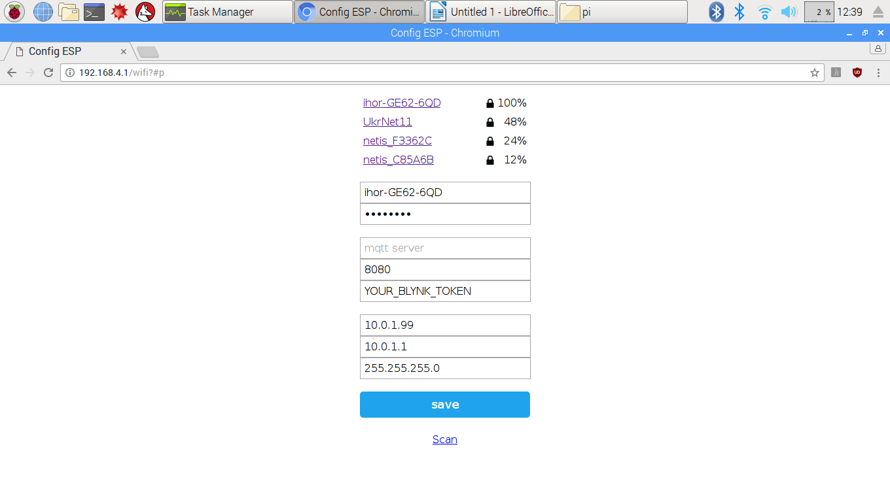
Figure 4. Configuring WiFi connection.

Next press save button. You will see window like on figure 5.

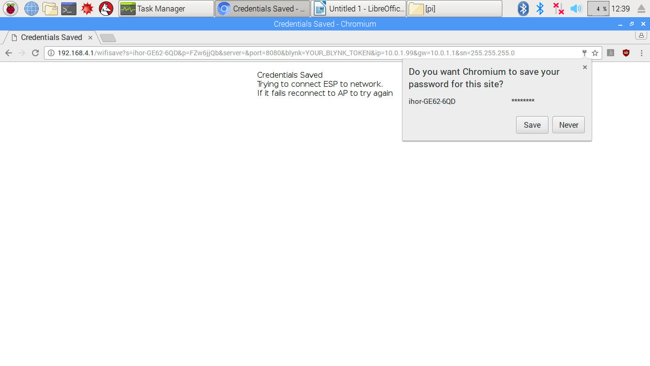
Figure 5. Finishing configuring WiFi connection.

Step. 7. To verify if ESP8266 module is connected to selected WiFi access point – open Serial Monitor. If everything went right – you will see output like on figure below.

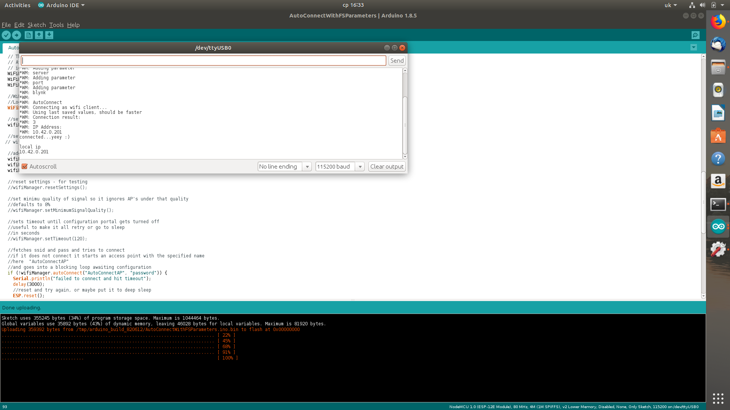
Figure 6. Serial Monitor output after connecting to selected WiFi access point.

On figure 6 you can see message that module is connected to network and its local IP address.

Step 8. Now its time to verify that module is really connected to specified WiFi access point.
If your access point is router – open router menu and check if this IP address is in list of connected devices.
In this example I have used my laptop as WiFi hotspot. So, open terminal on your laptop and enter command: arp -e. This command will list all connected devices to this access point and their IP addresses. Output is shown on figure below. As you can see – there is one device connected to this WiFi access point (wlp2s0 interface) and it has IP addresses similar to our ESP8266 module. So, we can assume that this is our ESP8266 module.

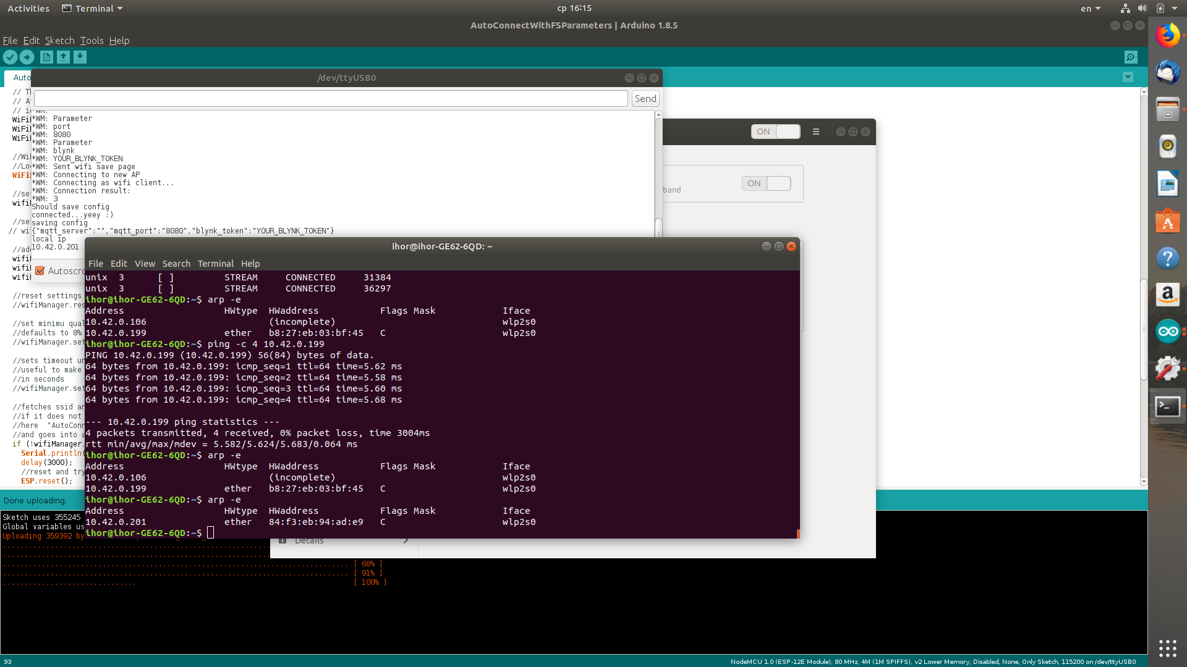
Figure 7. Output of arp -e command.

