Таб.1
 | Выдано программой | Принято FDC
1 | sending(29) $EPVHW,,,,,14.0,N,,,A*64  sending(30) $EPVHW,,,,,14.1,N,,,A*65  sending(31) $EPVHW,,,,,14.0,N,,,A*64  sending(32) $EPVHW,,,,,14.1,N,,,A*65  sending(33) $EPVHW,,,,,14.0,N,,,A*64  sending(34) $EPVHW,,,,,14.1,N,,,A*65  sending(35) $EPVHW,,,,,14.0,N,,,A*64  sending(36) $EPVHW,,,,,14.1,N,,,A*65  sending(37) $EPVHW,,,,,14.0,N,,,A*64  sending(38) $EPVHW,,,,,14.1,N,,,A*65  sending(39) $EPVHW,,,,,14.0,N,,,A*64  sending(40) $EPVHW,,,,,14.1,N,,,A*65 | $EPVHW,,,,,14.0,N,,,A*64  $EPVHW,,,,,14.1,N,,,A*65  $EPVHW,,,,,14.0,N,,,A*64  $EPVHW,,,,,14.1,N,,,A*65  $EPVHW,,,,,14.0,N,,,A*64  $EPVHW,,,,,14.1,N,,,A*65  $EPVHW,,,,,14.0,N,,,A*64  $EPVHW,,,,,14.1,N,,,A*65  $EPVHW,,,,,14.0,N,,,A*64  $EPVHW,,,,,14.1,N,,,A*65  $EPVHW,,,,,14.0,N,,,A*64  $EPVHW,,,,,14.1,N,,,A*65
2 | sending(20) $EPVTG,,,,,14.0,N,,,A*68  sending(21) $EPVTG,,,,,14.1,N,,,A*69  sending(22) $EPVTG,,,,,14.0,N,,,A*68  sending(23) $EPVTG,,,,,14.1,N,,,A*69  sending(24) $EPVTG,,,,,14.0,N,,,A*68  sending(25) $EPVTG,,,,,14.1,N,,,A*69  sending(26) $EPVTG,,,,,14.0,N,,,A*68  sending(27) $EPVTG,,,,,14.1,N,,,A*69  sending(28) $EPVTG,,,,,14.0,N,,,A*68  sending(29) $EPVTG,,,,,14.1,N,,,A*69  sending(30) $EPVTG,,,,,14.0,N,,,A*68  sending(31) $EPVTG,,,,,14.1,N,,,A*69  sending(30) $EPVTG,,,,,14.0,N,,,A*68  sending(31) $EPVTG,,,,,14.1,N,,,A*69  sending(32) $EPVTG,,,,,14.0,N,,,A*68  sending(33) $EPVTG,,,,,14.1,N,,,A*69 | $EPVTG,,,,,14.0,N,,,A*68  $EPVTG,,,,,14.1,N,,,A*69  $EPVTG,,,,,14.0,N,,,A*68  $EPVTG,,,,,14.1,N,,,A*69  $EPVTG,,,,,14.0,N,,,A*68  $EPVTG,,,,,14.1,N,,,A*69  $EPVTG,,,,,14.0,N,,,A*68  $EPVTG,,,,,14.1,N,,,A*69  $EPVTG,,,,,14.0,N,,,A*68  $EPVTG,,,,,14.1,N,,,A*69  $EPVTG,,,,,14.0,N,,,A*68  $EPVTG,,,,,14.1,N,,,A*69  $EPVTG,,,,,14.0,N,,,A*68  $EPVTG,,,,,14.1,N,,,A*69  $EPVTG,,,,,14.0,N,,,A*68  $EPVTG,,,,,14.1,N,,,A*69
3 | sending(1) $EPHDT,32.1,T*07  sending(5) $EPHDT,3.0,T*34  sending(9) $EPHDT,3.1,T*35  sending(13) $EPHDT,3.2,T*36  sending(17) $EPHDT,3.3,T*37  sending(21) $EPHDT,3.4,T*30  sending(25) $EPHDT,3.5,T*31  sending(29) $EPHDT,3.6,T*32  sending(33) $EPHDT,3.7,T*33  sending(37) $EPHDT,3.8,T*3C  sending(41) $EPHDT,3.9,T*3D  sending(45) $EPHDT,4.0,T*33  sending(49) $EPHDT,4.1,T*32  sending(53) $EPHDT,4.2,T*31 | $EPHDT,32.1,T*07  $EPHDT,3.0,T*34  $EPHDT,3.1,T*35  $EPHDT,3.2,T*36  $EPHDT,3.3,T*37  $EPHDT,3.4,T*30  $EPHDT,3.5,T*31  $EPHDT,3.6,T*32  $EPHDT,3.7,T*33  $EPHDT,3.8,T*3C  $EPHDT,3.9,T*3D  $EPHDT,4.0,T*33  $EPHDT,4.1,T*32  $EPHDT,4.2,T*31
4 | sending(30) $EPDBT,11.8,f,3.6,M,6.6,F*39  sending(31) $EPDBT,12.8,f,3.9,M,7.1,F*33  sending(32) $EPDBT,13.8,f,4.2,M,7.7,F*38  sending(33) $EPDBT,14.8,f,4.5,M,8.2,F*32  sending(34) $EPDBT,15.7,f,4.8,M,8.8,F*3B  sending(35) $EPDBT,16.7,f,5.1,M,9.3,F*3A  sending(36) $EPDBT,17.7,f,5.4,M,9.9,F*34  sending(37) $EPDBT,18.7,f,5.7,M,10.4,F*0D  sending(38) $EPDBT,19.7,f,6.0,M,11.0,F*0D  sending(39) $EPDBT,20.7,f,6.3,M,11.5,F*01  sending(40) $EPDBT,21.7,f,6.6,M,12.1,F*02  sending(41) $EPDBT,22.6,f,6.9,M,12.6,F*08  sending(42) $EPDBT,23.6,f,7.2,M,13.2,F*06  sending(43) $EPDBT,24.6,f,7.5,M,13.7,F*03  sending(44) $EPDBT,25.6,f,7.8,M,14.3,F*0C  sending(45) $EPDBT,26.6,f,8.1,M,14.8,F*02 | $EPDBT,11.8,f,3.6,M,6.6,F*39  $EPDBT,12.8,f,3.9,M,7.1,F*33  $EPDBT,13.8,f,4.2,M,7.7,F*38  $EPDBT,14.8,f,4.5,M,8.2,F*32  $EPDBT,15.7,f,4.8,M,8.8,F*3B  $EPDBT,16.7,f,5.1,M,9.3,F*3A  $EPDBT,17.7,f,5.4,M,9.9,F*34  $EPDBT,18.7,f,5.7,M,10.4,F*0D  $EPDBT,19.7,f,6.0,M,11.0,F*0D  $EPDBT,20.7,f,6.3,M,11.5,F*01  $EPDBT,21.7,f,6.6,M,12.1,F*02  $EPDBT,22.6,f,6.9,M,12.6,F*08  $EPDBT,23.6,f,7.2,M,13.2,F*06  $EPDBT,24.6,f,7.5,M,13.7,F*03  $EPDBT,25.6,f,7.8,M,14.3,F*0C  $EPDBT,26.6,f,8.1,M,14.8,F*02

VTG - Course Over Ground and Ground Speed
Путевой угол и скорость относительно груна
The actual course and speed relative to the ground.
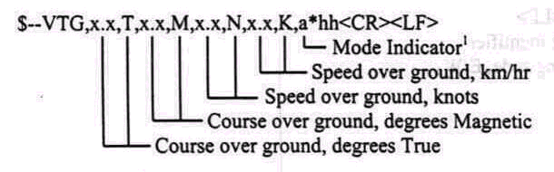
Notes:
1) Positioning system Mode Indicator: A = Autonomous mode
D = Differential mode
E = Estimated (dead reckoning) mode
M = Manual input mode
S = Simulator mode
N = Data not valid

The positioning system Mode Indicator shall not be a null field
$EPVTG,,,,,14.0,N,,,A*68 | выделенное значение (скорость в узлах относительно грунта) должно изменятся  от 14,0 до 14,1

VHW - Water Speed and Heading
Курс и скорость относительно грунта
The compass heading to which the vessel points and the speed of the vessel relative to the water.
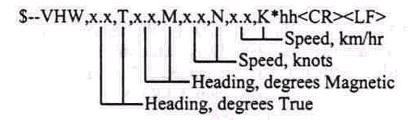
$EPVHW,,,,,14.0,N,,,A*64 | выделенное значение (скорость в узлах) должно изменятся от 14,0 до 14,1

HDT-Heading. True
Курс истинный
Actual vessel heading in degrees True produced by any device or system producing true heading.
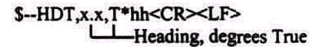
$EPHDT,32.1,T*07 | выделенное значение (курс в градусах) должен изменятся от 0,0 до 359,9 шаг – 0,1

DBT - Depth Below Transducer
Глубина под гидроакустическим преобразователем
Water death referenced to the transducer.
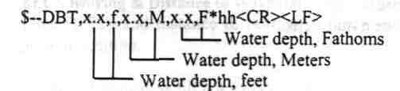
Water depth, fathoms – глубина - морская сажень – 1 морская сажень = 1,83 метра
Water depth, meters – глубина - метры
Water depth, feet – глубина - футы – 1 фут = 0,305 метра
$EPDBT,11.8,f,3.6,M,6.6,F*39 | выделенное значение (глубина в метрах) должно изменяться от 50 до 10  шаг – 1.0

Период передачи предложений 1 секунда.

В таб.1 приведены примеры выдачи и приема предложений.

