**Traffic Sign Recognition & Realtime Detection**

**Traffic Sign Image Classification:**

**Dataset used for Traffic Sign Recognition:**

* <https://benchmark.ini.rub.de/gtsrb_news.html>

**Summary of the dataset:**

* More than 40 classes in the dataset
  + Speed limit (20km/h)
  + Speed limit (30km/h)
  + Speed limit (50km/h)
  + Speed limit (60km/h)
  + Speed limit (70km/h)
  + Speed limit (80km/h)
  + End of speed limit (80km/h)
  + Speed limit (100km/h)
  + Speed limit (120km/h)
  + No passing
  + No passing veh over 3.5 tons
  + Right-of-way at intersection
  + Priority road
  + Yield
  + Stop
  + No vehicles
  + Veh > 3.5 tons prohibited
  + No entry
  + General caution
  + Dangerous curve left
  + Dangerous curve right
  + Double curve
  + Bumpy road
  + Slippery road
  + Road narrows on the right
  + Road work
  + Traffic signals
  + Pedestrians
  + Children crossing
  + Bicycles crossing
  + Beware of ice/snow
  + Wild animals crossing
  + End speed + passing limits
  + Turn right ahead
  + Turn left ahead
  + Ahead only
  + Go straight or right
  + Go straight or left
  + Keep right
  + Keep left
  + Roundabout mandatory
  + End of no passing
  + End no passing veh > 3.5 tons

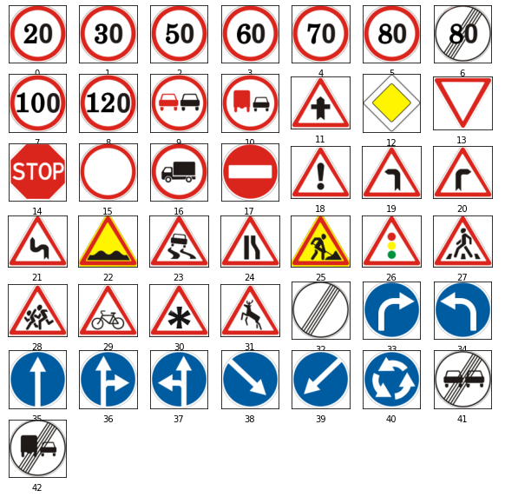

* More than 50,000 images in total

**Training Steps:**

* Split dataset into train & test set where 70% for training and 30% for testing
* Build an image classification model from scratch using TensorFlow Keras.
* Trainable params: 2,796,555

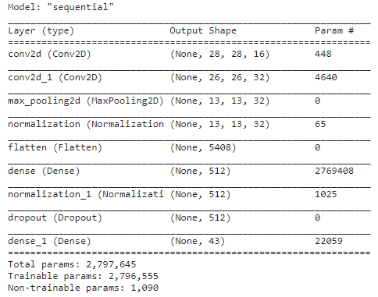

* “categorical_crossentropy” loss & “Adam” optimizer used for training
* No of Epoch used: 20 & Batch Size 32
* Training Time (2min 10sec)
* Proportion of correct classification Graph

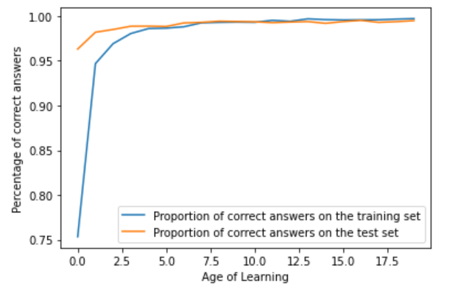

* Error on Training & Testing Graph

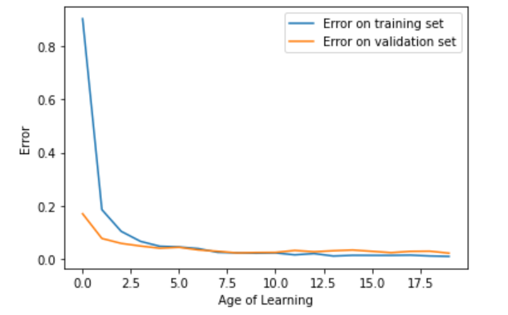

* Test accuracy: 97.015%

**Traffic Sign Realtime Detection:**

**Dataset used for sign detection:**

* <https://benchmark.ini.rub.de/gtsdb_dataset.html>

**Summary of the dataset:**

* 900 images (divided in 600 training images and 300 evaluation images)
* 4 Primary Categories:
  + **Prohibitory:** Prohibitory category consists of following Traffic Signs: speed limit, no overtaking, no traffic both ways, no trucks.
  + **Danger:** Danger category consists of following Traffic Sings: priority at next intersection, danger, bend left, bend right, bend, uneven road, slippery road, road narrows, construction, traffic signal, pedestrian crossing, school crossing, cycles crossing, snow, animals.
  + **Mandatory:** Mandatory category consists of following Traffic Sings: go right, go left, go straight, go right or straight, go left or straight, keep right, keep left, roundabout.
  + **Other:** Other category consists of following Traffic Sings: restriction ends, priority road, give way, stop, no entry.

**Training Steps:**

* YOLO (You Only Look Once) Detection Framework is used for the detection
* Converted the dataset into YOLO format
* YOLOv5s6 Model Architecture:

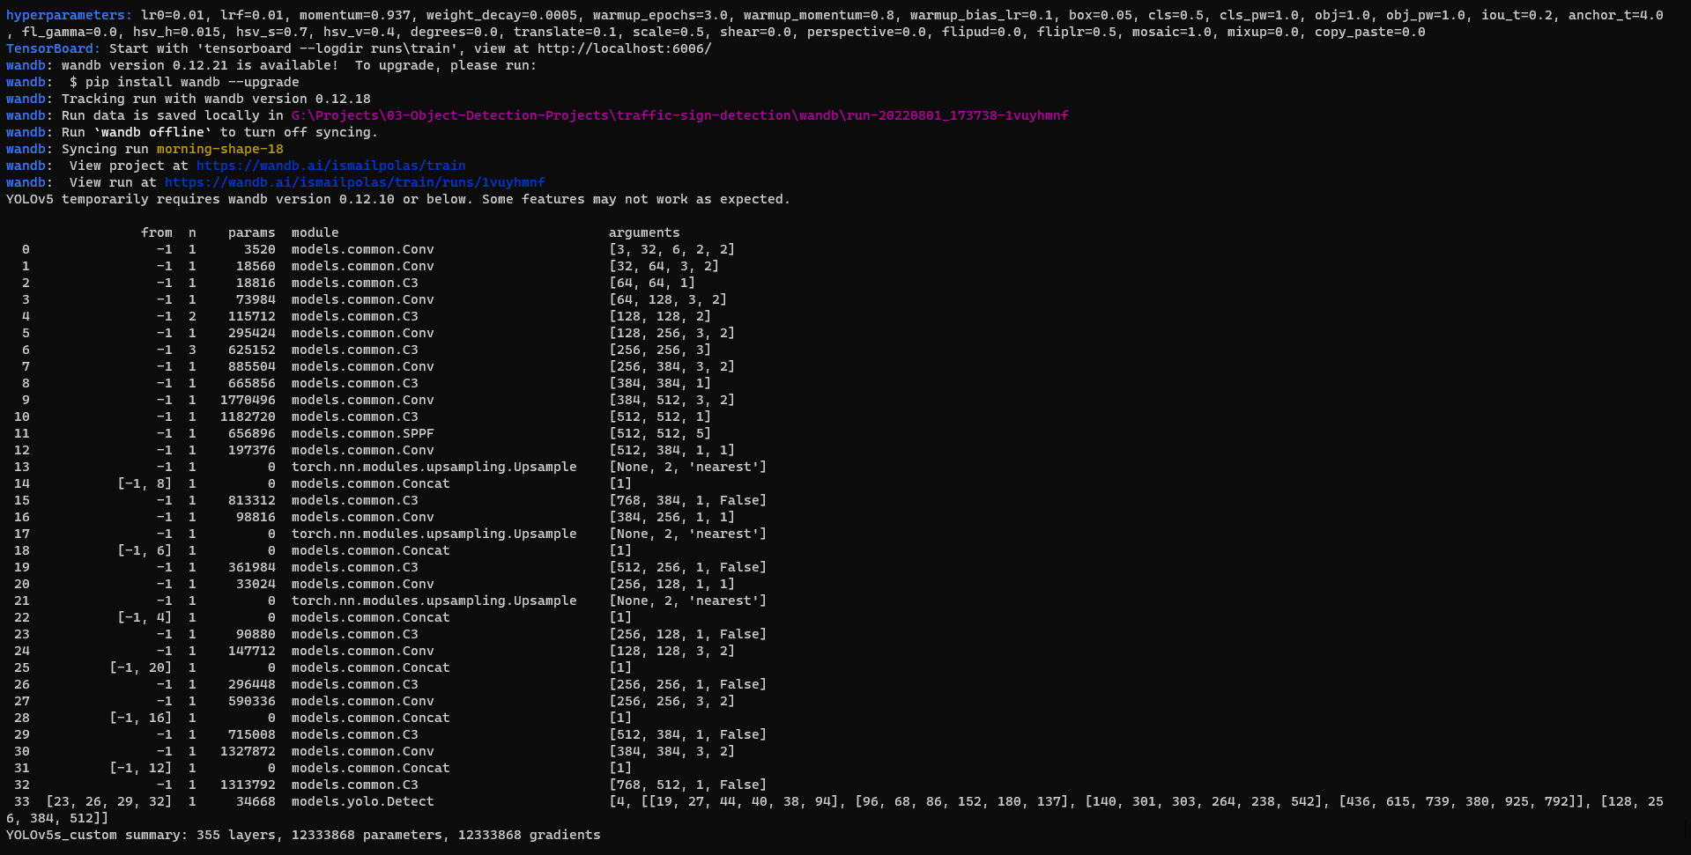

* Image size: 1280x1280
* Batch Size: 16
* Labels Summary:

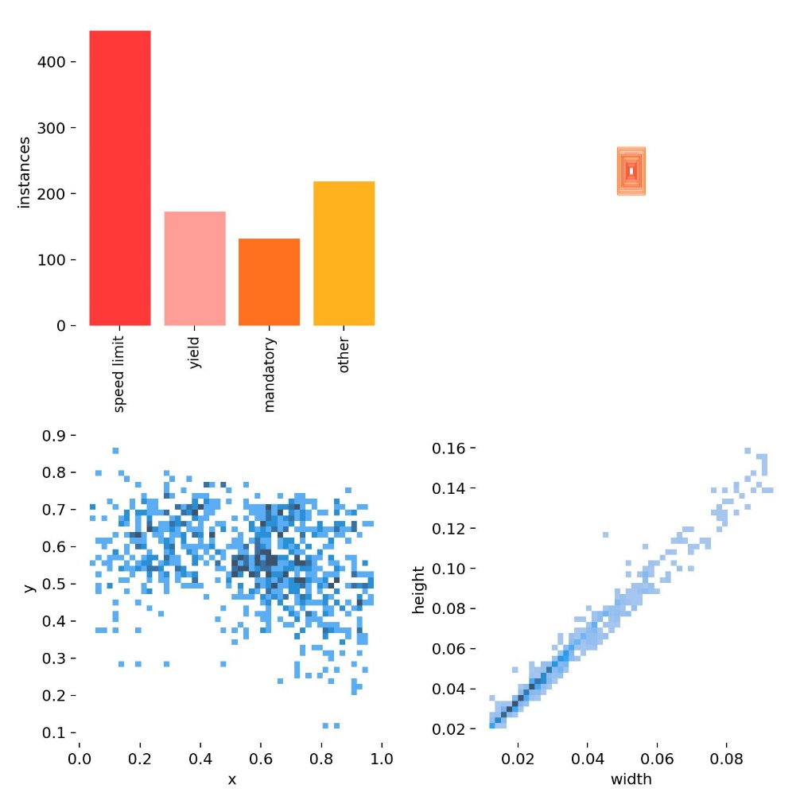

* GROUND TRUTH AUGMENTED TRAINING DATA:

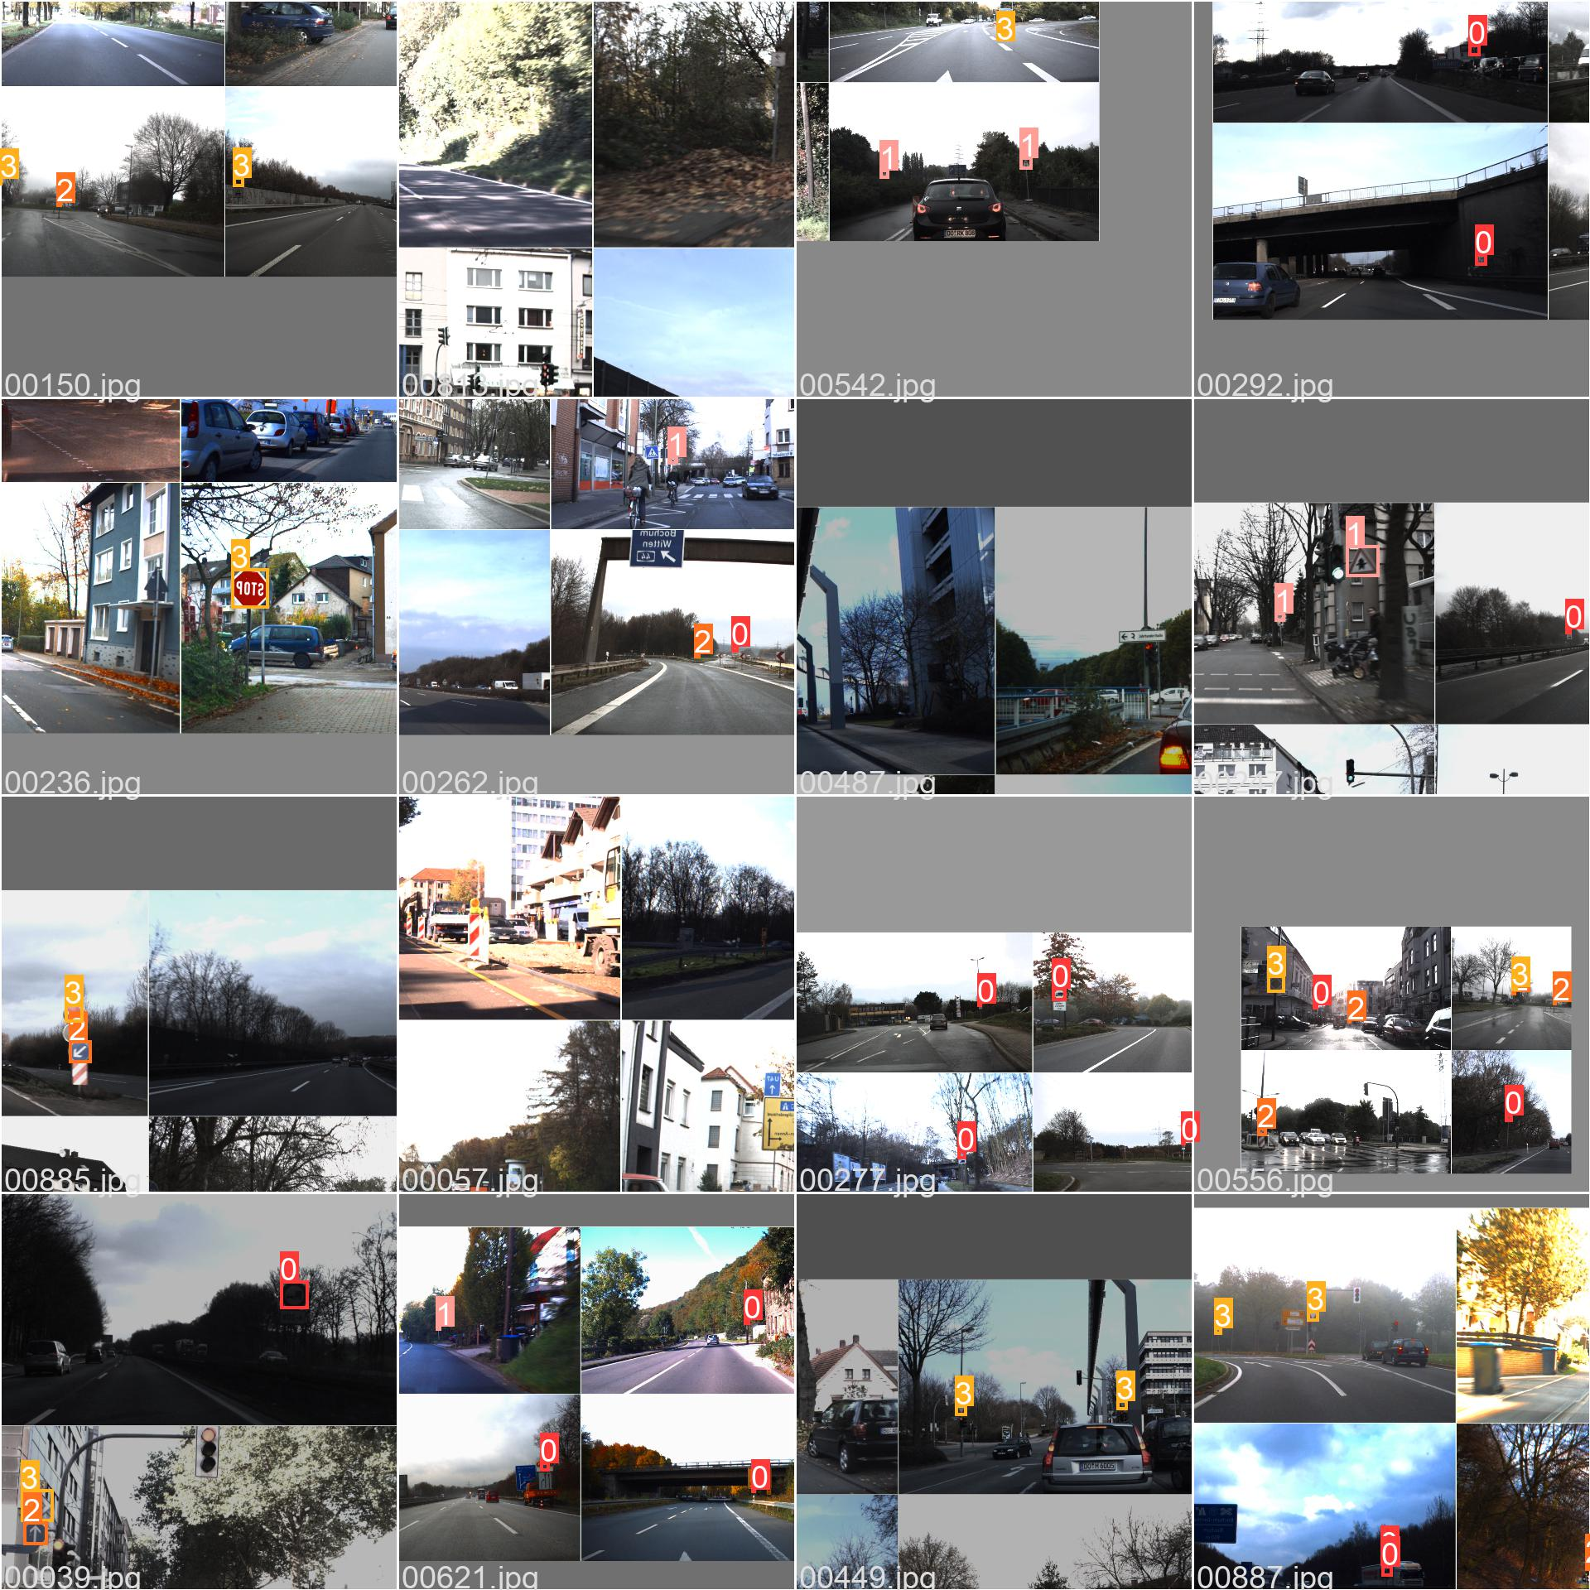

* **Total No of Epochs**: 200
* **Hyperparameters:** lr0=0.01, lrf=0.01, momentum=0.937, weight_decay=0.0005, warmup_epochs=3.0, warmup_momentum=0.8, warmup_bias_lr=0.1, box=0.05, cls=0.5, cls_pw=1.0, obj=1.0, obj_pw=1.0, iou_t=0.2, anchor_t=4.0, fl_gamma=0.0, hsv_h=0.015, hsv_s=0.7, hsv_v=0.4, degrees=0.0, translate=0.1, scale=0.5, shear=0.0, perspective=0.0, flipud=0.0, fliplr=0.5, mosaic=1.0, mixup=0.0, copy_paste=0.0
* **Average time for per epoch training:** 23 sec
* **Total time of Training: 2.179 hrs.**

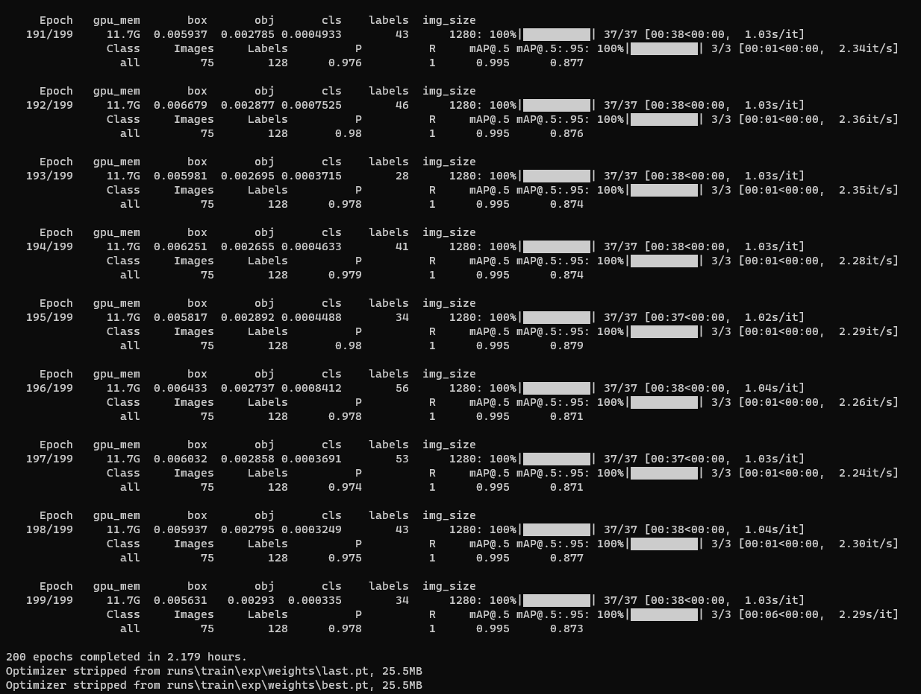

* **Training Summary:**

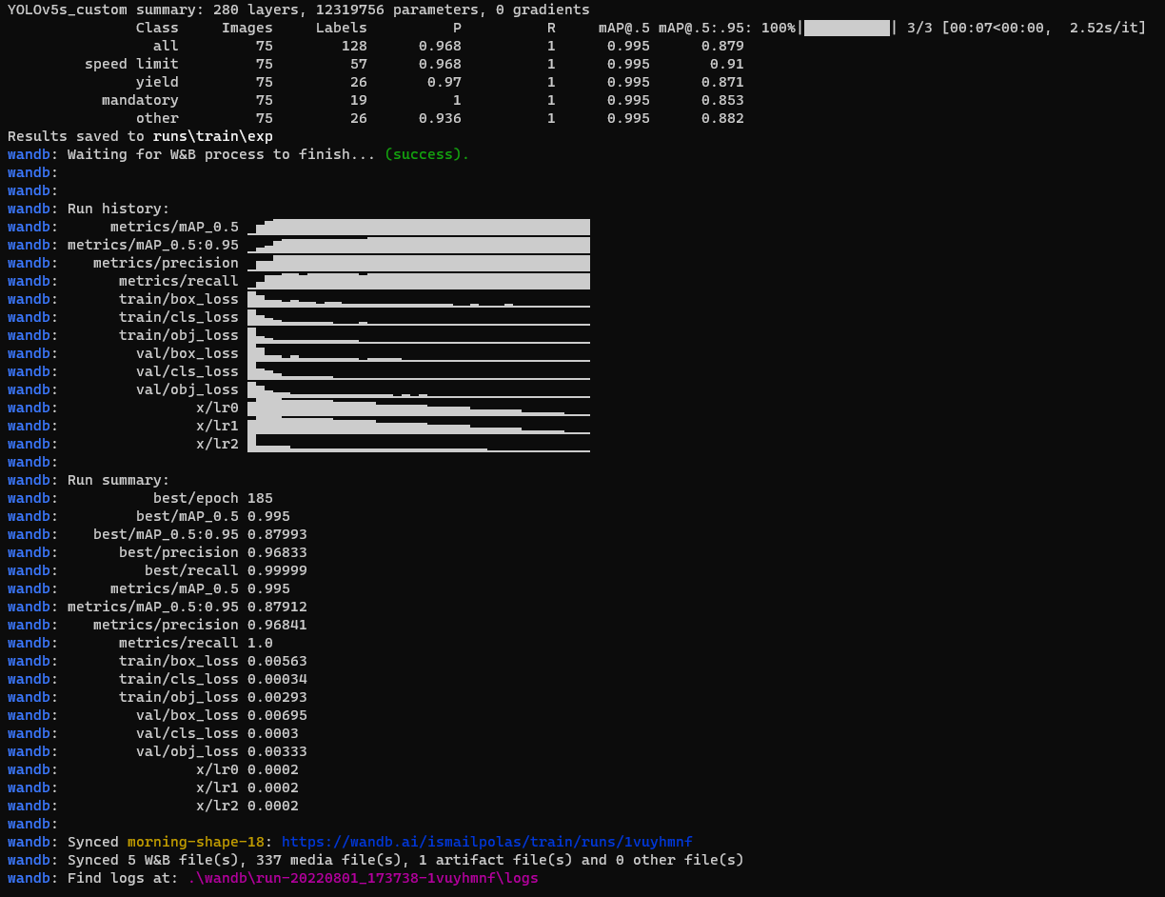

* **Confusion Matrix:**

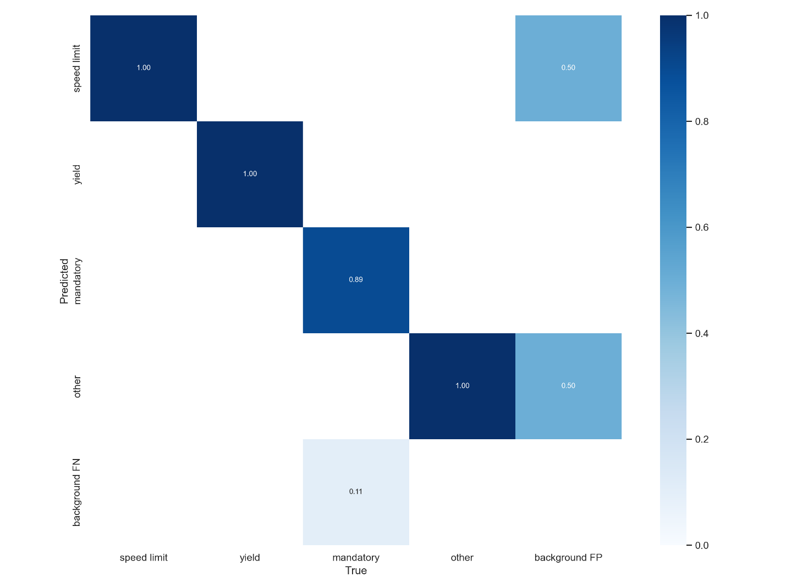

* **F1-Curve:**

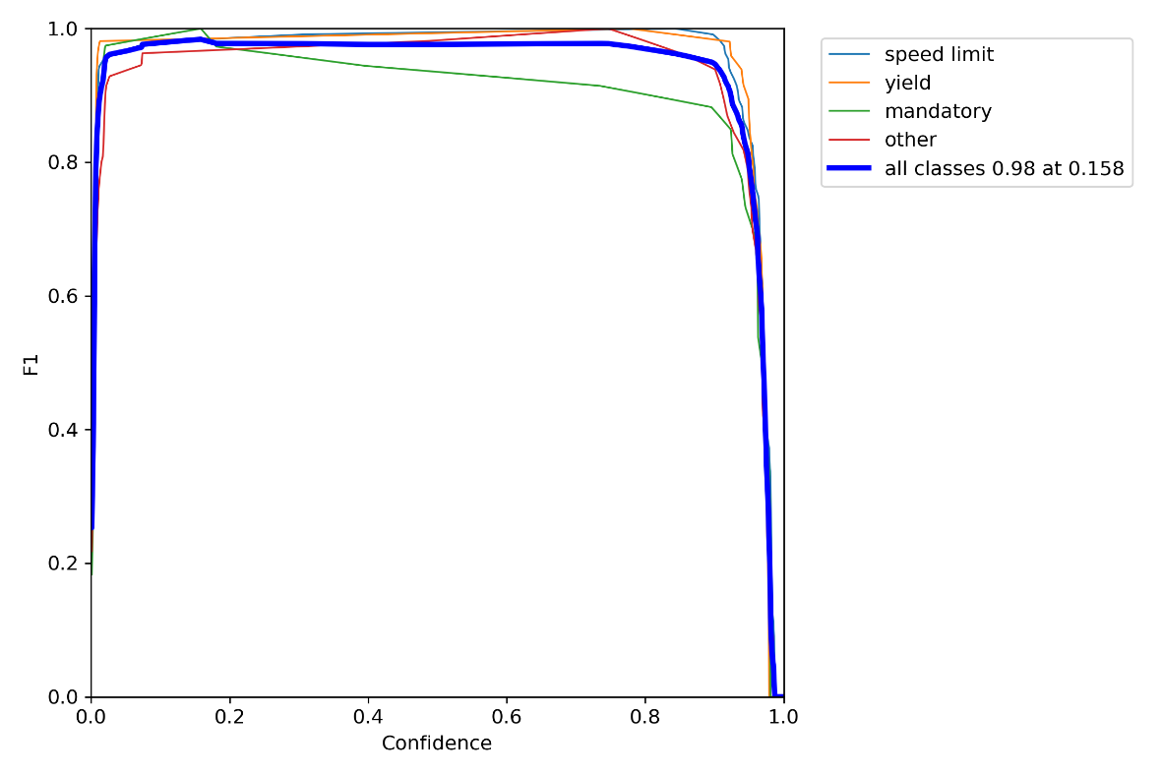

* Training Result:

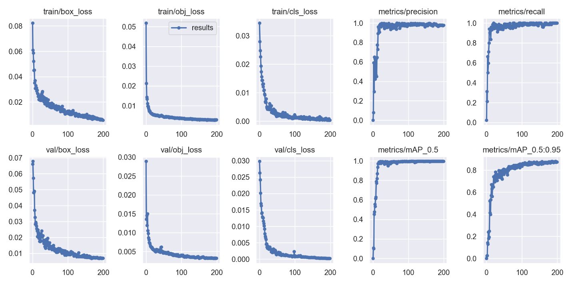

* Testing Result:

