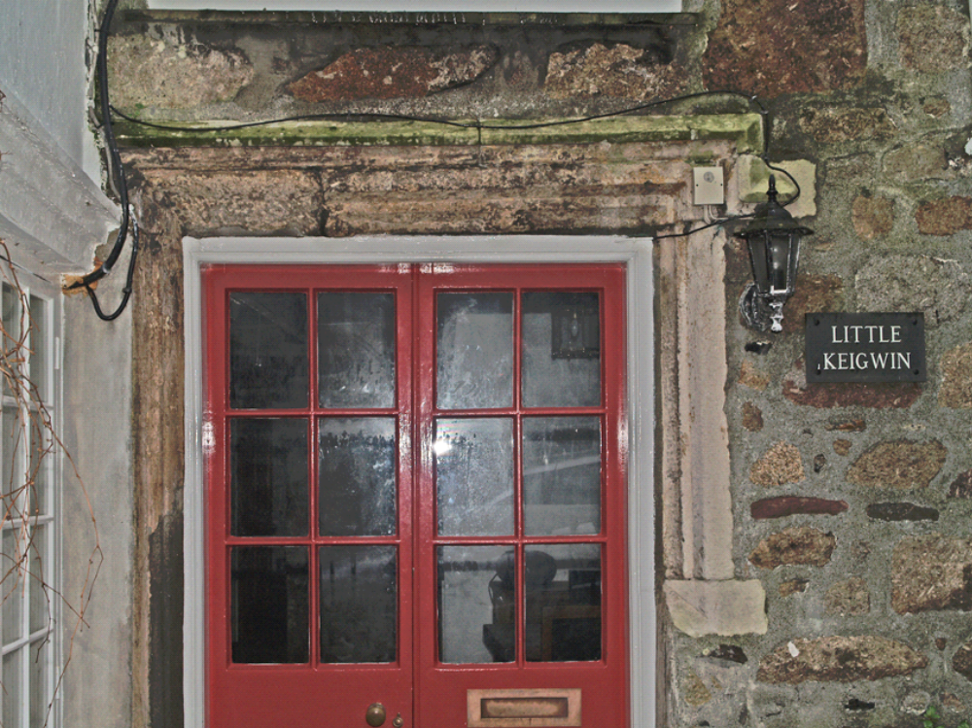

5. Little Keigwin: lintel and jamb remains of freestone 3-light mullioned window

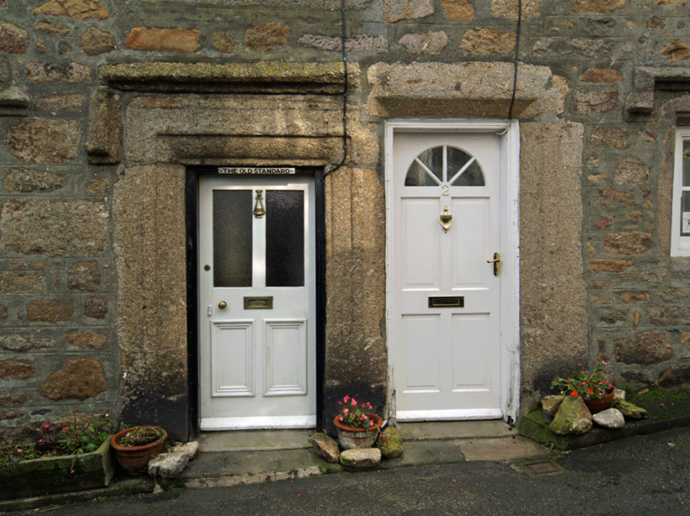
6. The Old Standard: original doorway (left) and later doorway of reused material

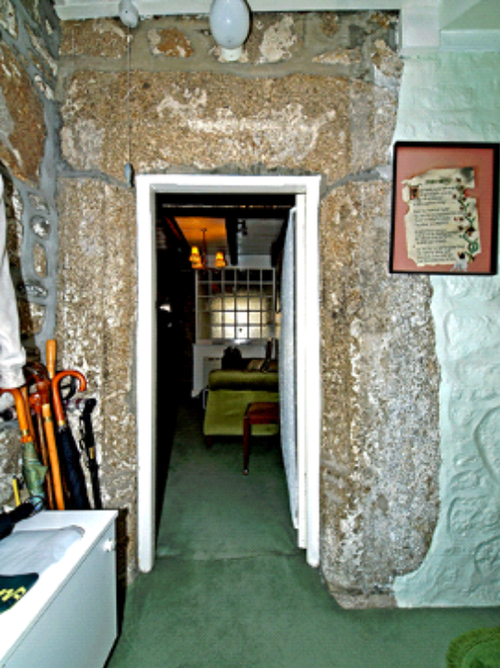  7.Keigwin: doorway rear of through-passage | 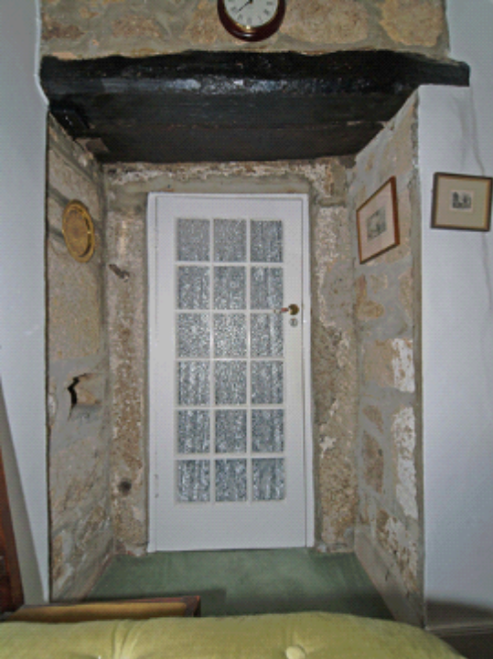  8. Keigwin: interior of rear doorway
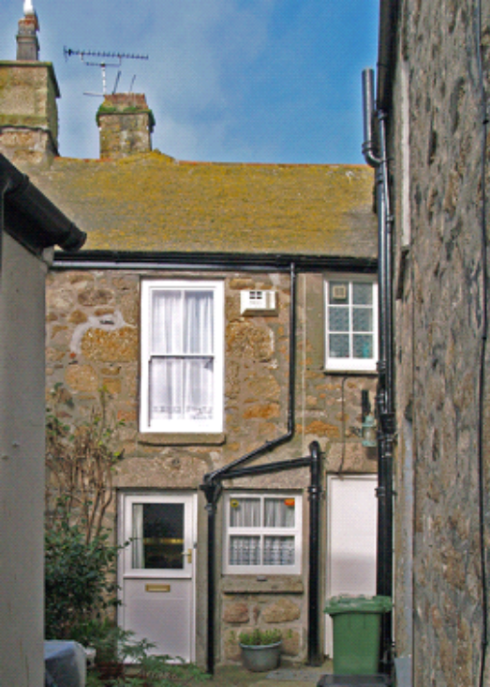  9. Keigwin: rear wing | 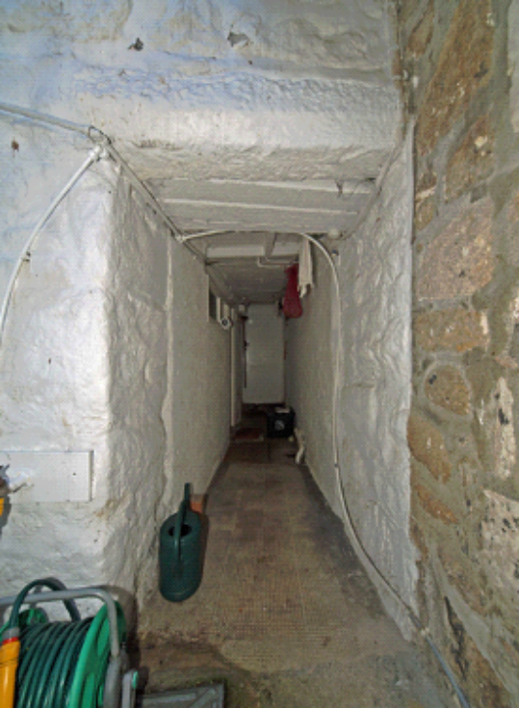  10. Keigwin: doorway from rear court to rear

11. Keigwin: chamfered jamb of hall fireplace

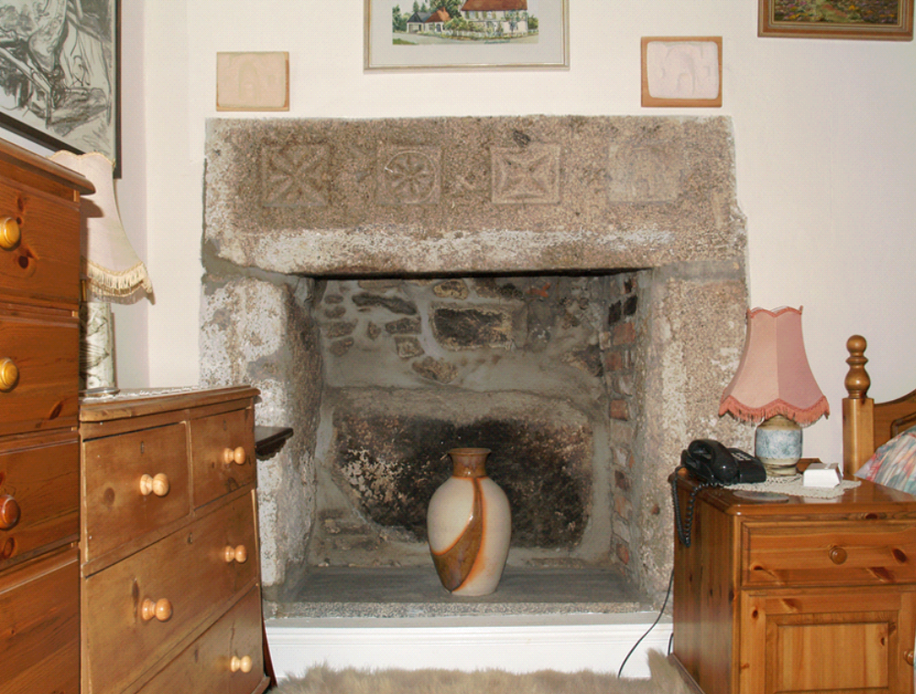

12. Keigwin: fireplace with carved motifs, in chamber above hall: the Keigwin rebus is shown in a plaster cast

