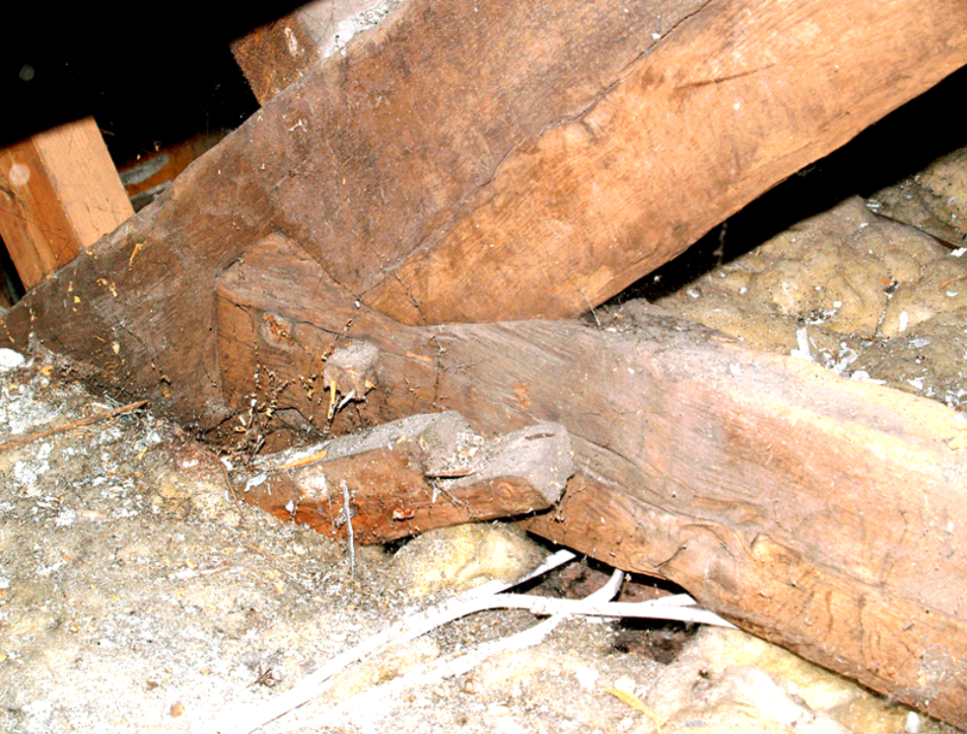

17. Keigwin: front roof structure with detail of collar joint and evidence for former barrel ceiling

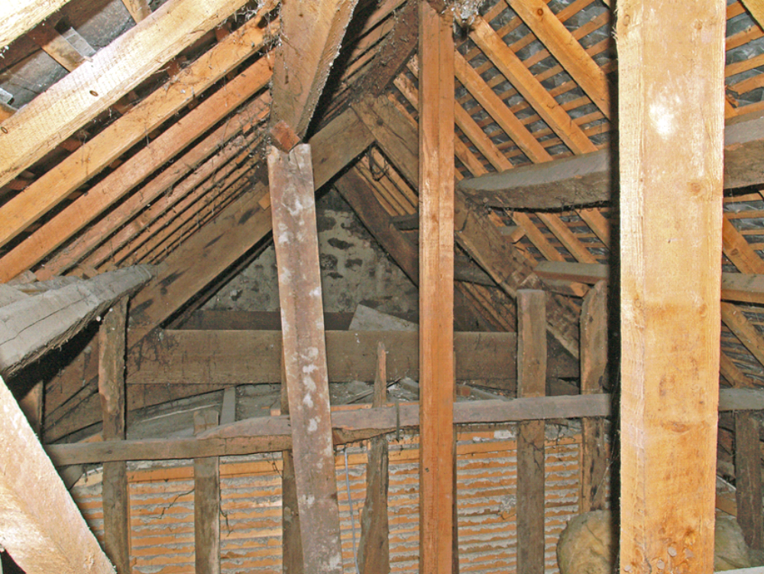

18. Keigwin: roof over parlour wing and barrel ceiling structure
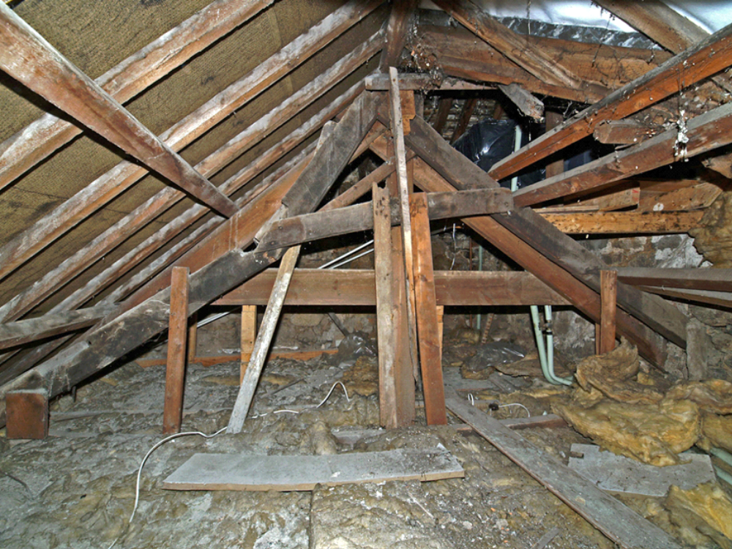

19. Keigwin: roof over rear range; original smoke-blackened truss at west end

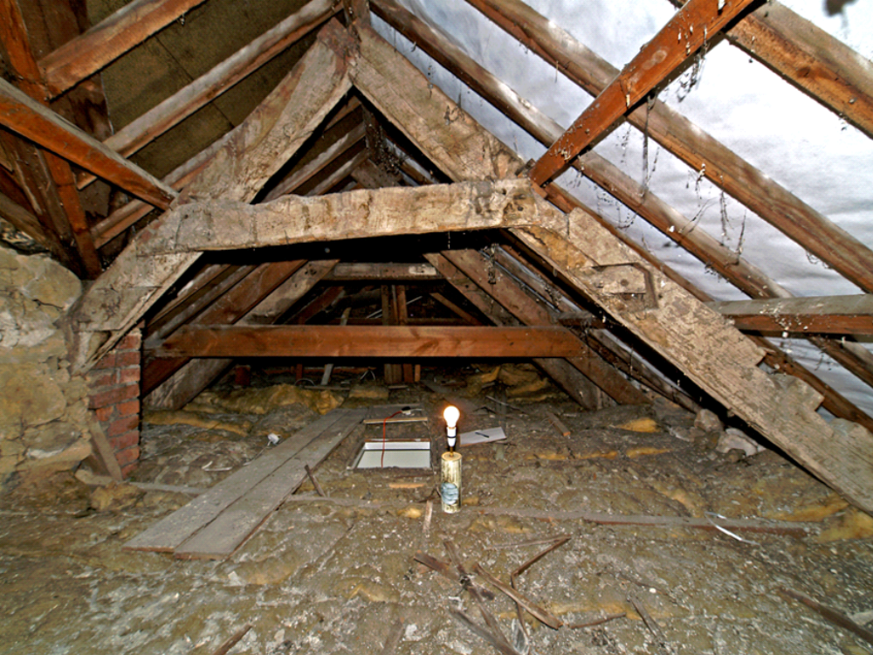

20. Keigwin: roof over east extension to rear range originally with for 2 tiers of collars
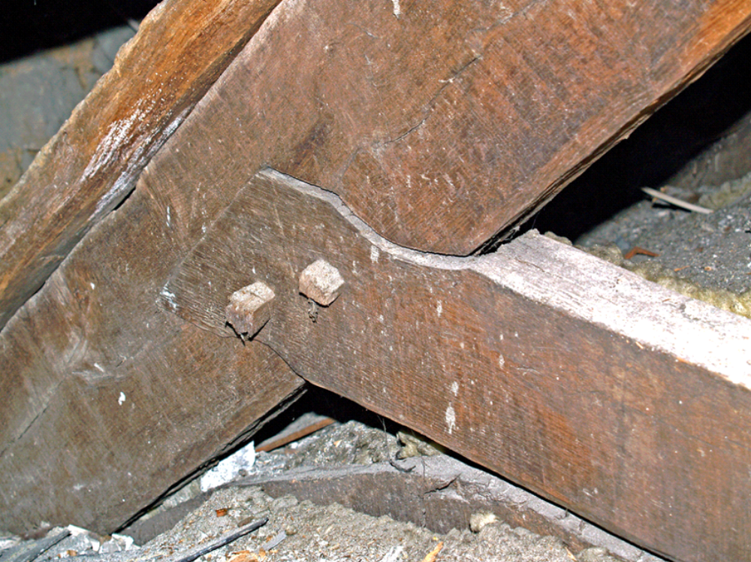

21. Little Keigwin: front roof structure detail of collar joint and brace supporting barrel ceiling

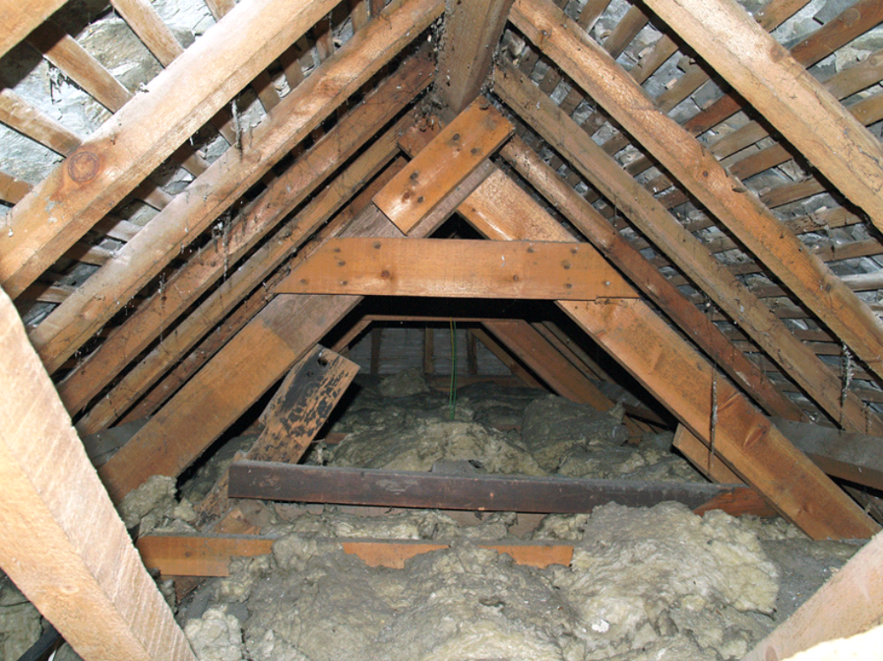

22. Little Keigwin: steep-pitched original truss over front wing under later roof structure

