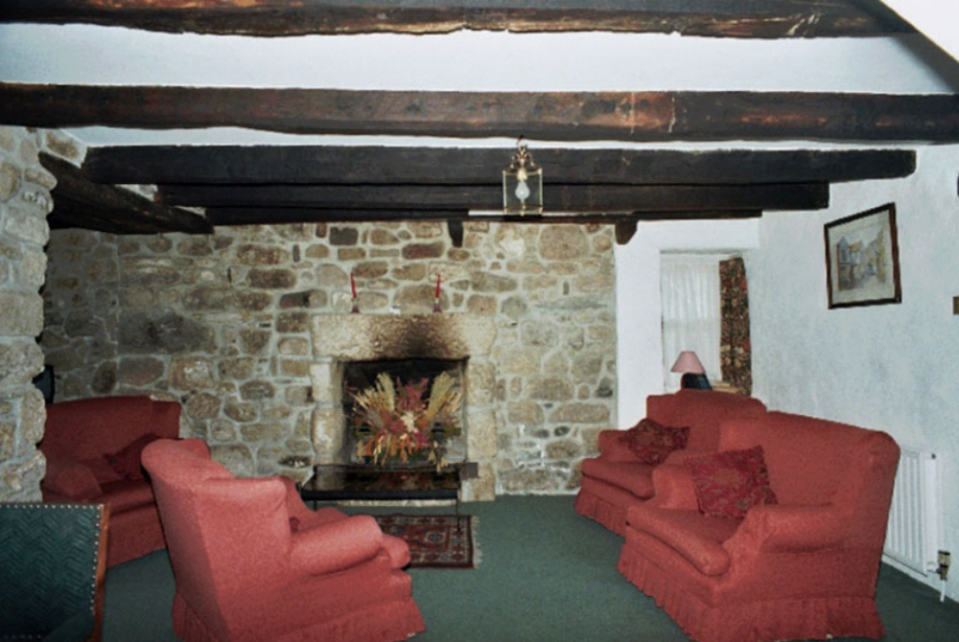

23. Little Keigwin: main front room with later inserted fireplace (note chamfered joists)

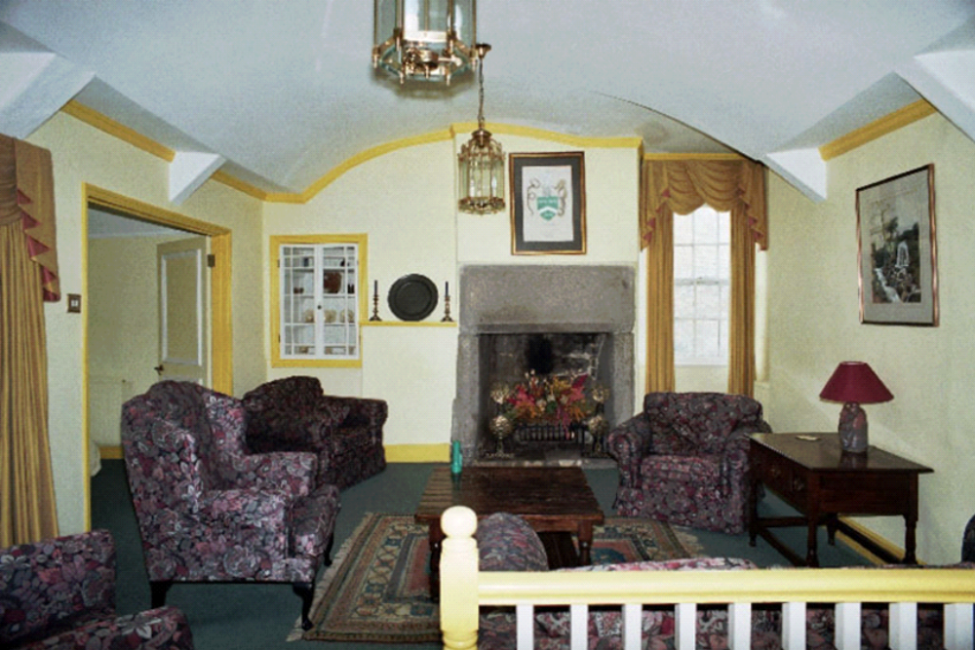

24. Little Keigwin: principal chamber with chamfered fireplace and plaster barrel ceiling
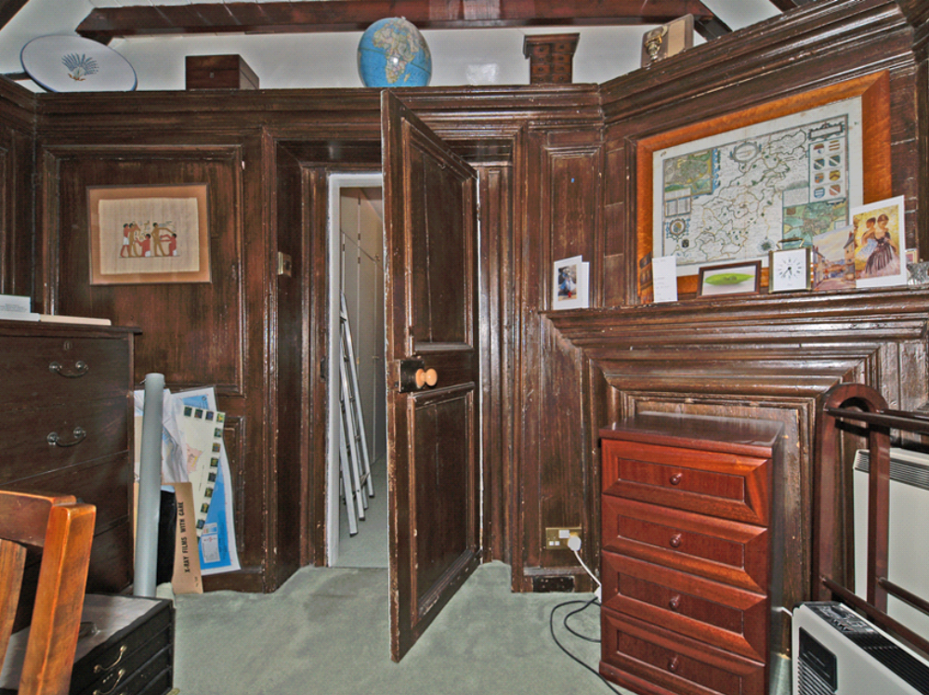

25. Keigwin: bolection-moulded panelled room over porch

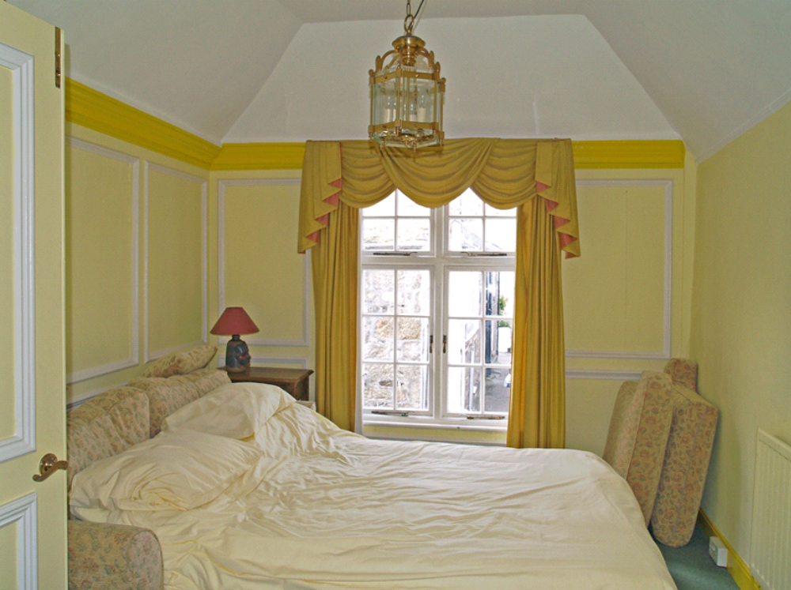

26. Little Keigwin: Bolection-moulded panelled room over front wing

