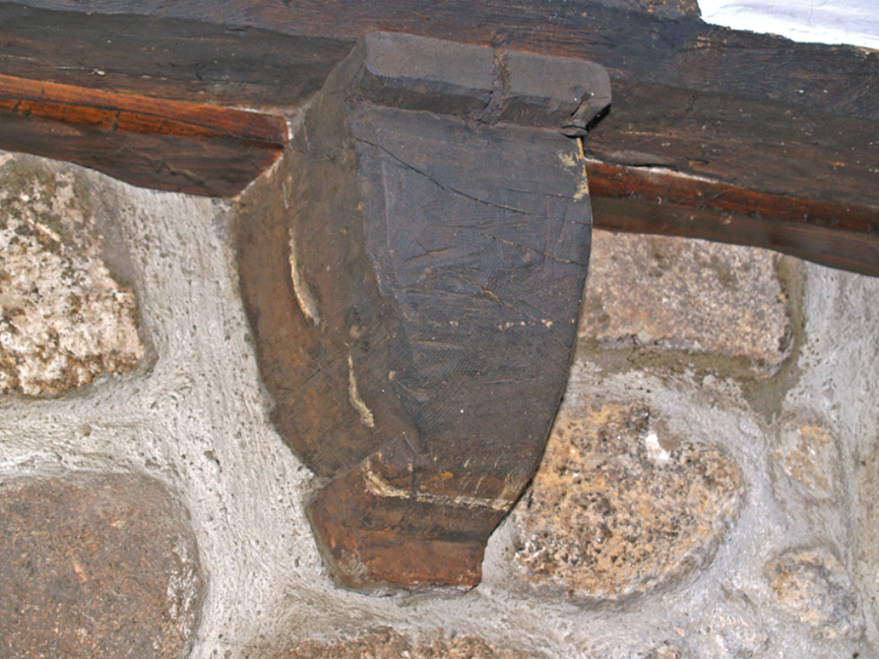

27. Little Keigwin: principal ground-floor room, moulded corbel under 1st-floor fireplace

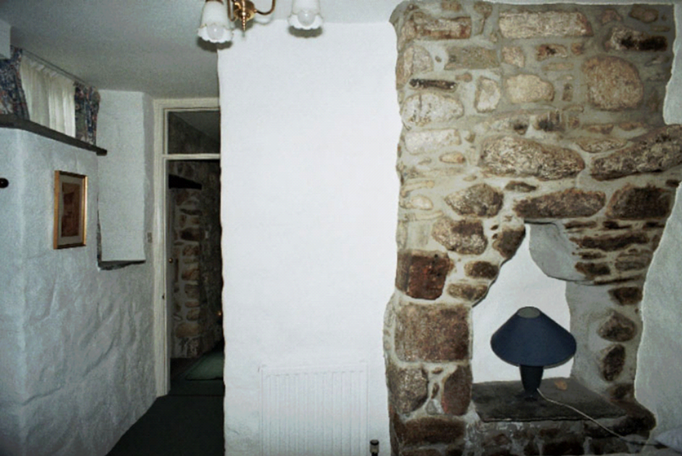

28. Little Keigwin: 18th century oven inserted to 17th century fireplace since mostly removed
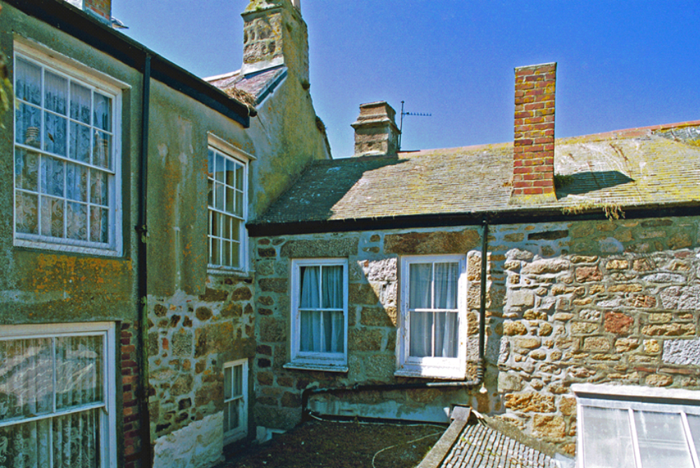

29. Little Keigwin rear wing and 19th century rear range of the Old Standard

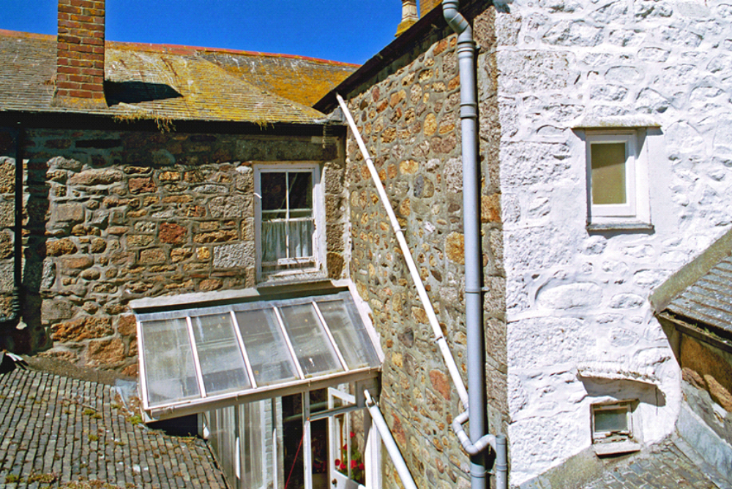

30. Old Standard: rear range and rear wing rebuilt c1900 on site of former medieval house

