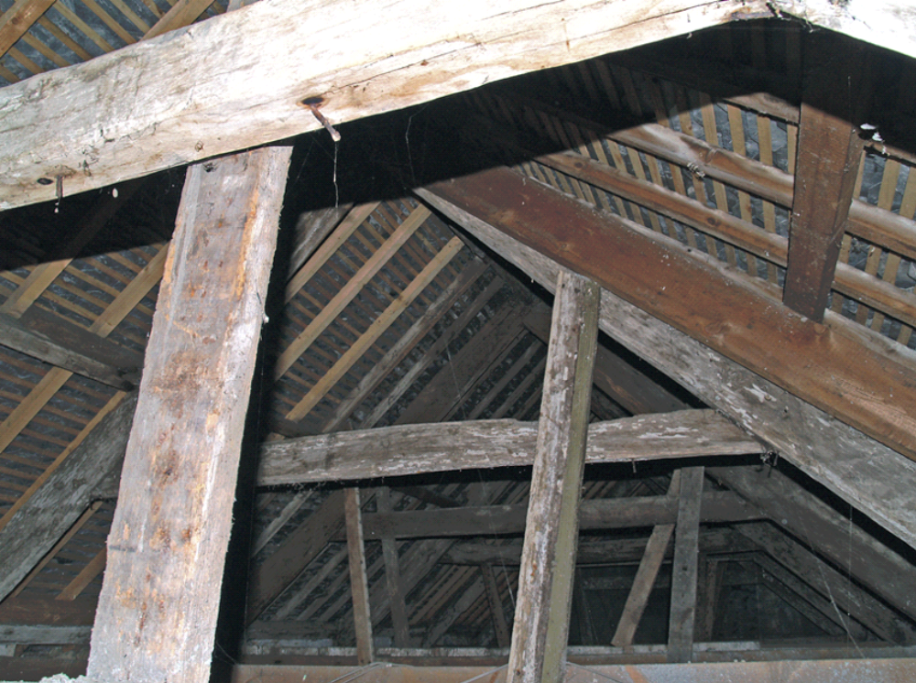

31. Old Standard: original 7-bay roof structure over front range (note lime-wash)

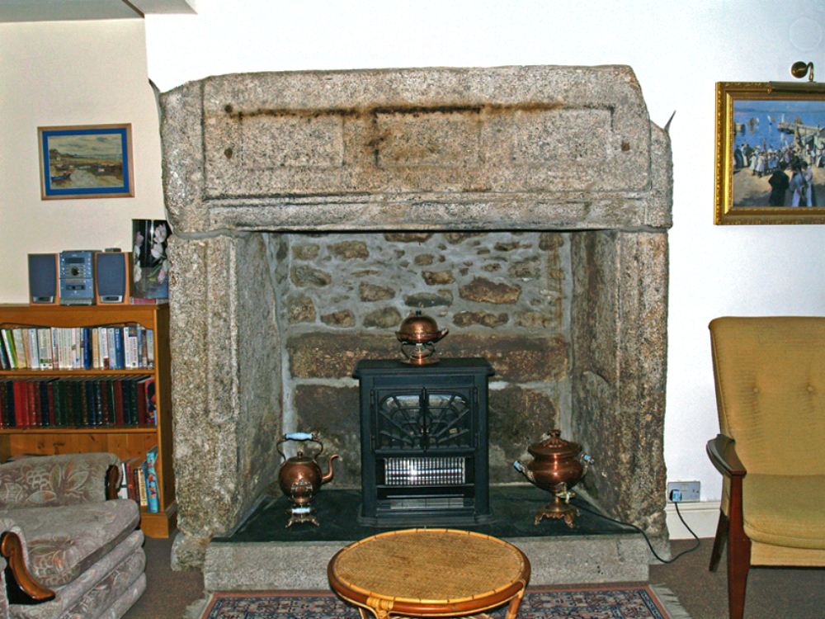

32. Old Standard: moulded granite hall fireplace with panelled lintel, at west gable end
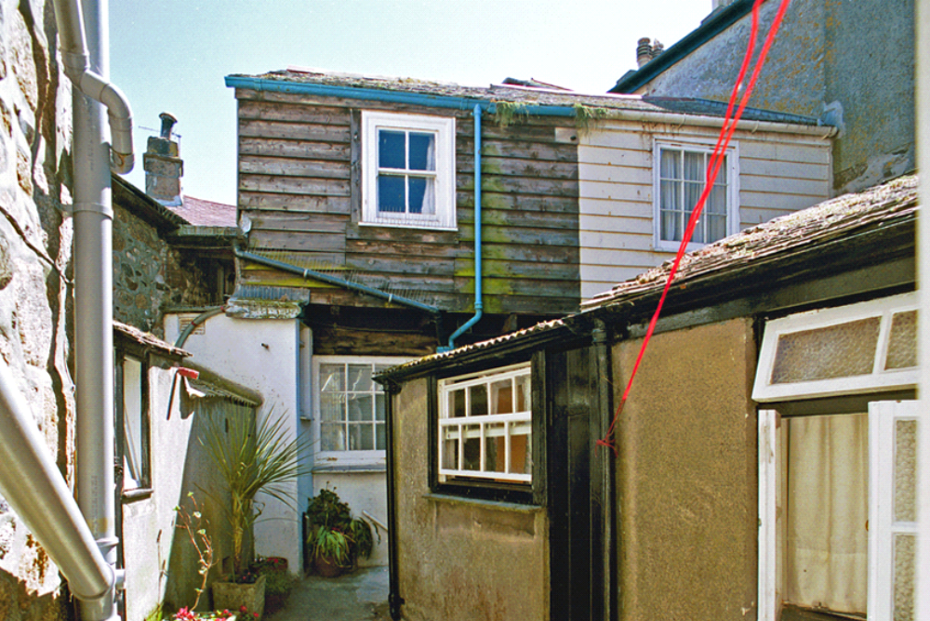

33. Old Standard: 19th century fish cellar range at rear

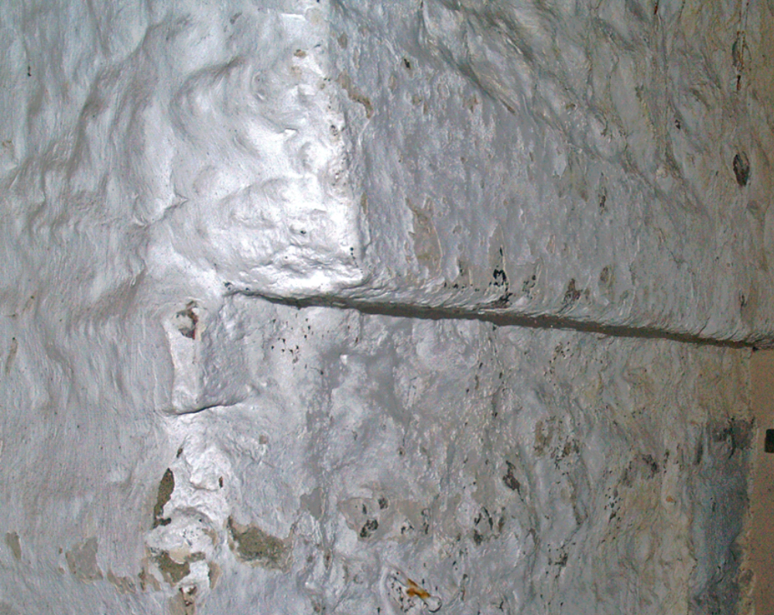

34. Old Standard: corbelled beam shelf for pilchard-pressing floor

