LEDBURY PEOPLE OF NOTE

Stephen Ballard, civil engineer, 1804 - 1890
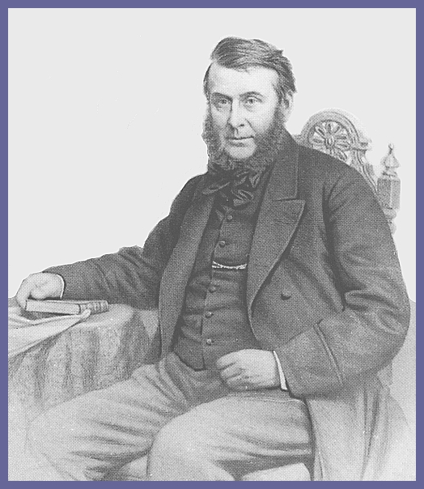
Stephen Ballard was born on 5th April 1804 at Ivy House in
Malvern Link. His father Philip was a Herefordshire man who
married Charlotte Baylis, who came from a well-known Ledbury
family, on 27 January 1795 in Ledbury. He had an elder brother,
Thomas who was an artist and painted the Last Supper for the
Ledbury Parish Church altar. There were also three other
brothers and three sisters.¹ He was educated at Worcester
Grammar School and started work in horticulture at the age of 18
but decided to become apprentice to a Cheltenham builder,
Henry Lucy, and began work there in May 1825. In August 1827 he applied for and was appointed Clerk to the Herefordshire and Gloucestershire Canal Navigation Company. They allowed him to gain experience by accepting extra duties and for a year he worked for the engineer, Thomas Rhodes, recording river flows and surveying for the Severn Navigation Company. With this experience, he became an associate of the Institution of Civil Engineers in 1836 at the age of 32. He received the Telford Medal from the Institution for his invention of an ice-breaker which was first launched from Ledbury Wharf on 20th December 1837.

Stephen Ballard lived with another brother, Robert, who had a brickworks in Ledbury on the site of the present Ledbury Preserves factory, in a house in Bye Street from the time when he was appointed to the canal company but, when his brother married in February 1839, Stephen moved to a house in South Parade, Ledbury. Soon after joining the canal company, he put forward plans to make a start on the Ledbury to Hereford section. The management of the company - which included Earl Somers of Eastnor, Major-General Sir James Kyrle Money, John and Robert Biddulph of Ledbury Park, Thomas Ballard, Hubert Edy and Thomas Baylis,- were by this stage looking for a route that would be capable of conversion to a railway! Excavation began in November 1839 and the water-filled canal reached Hereford in May 1845 to almost complete lack of interest from Herefordians. That same day, 22nd May, Stephen Ballard left to take up a two-year post as Resident Engineer on a drainage scheme in the Fens.

He had an offer of supervision of railway construction work in Canada in 1852 but, when the work in the Fens was completed, he moved back to Colwall, near Ledbury and was planning to marry. In June 1854 he married Maria Bird who came from Yaxley near Peterborough and in 1858 they made their home in Colwall at ‘The Winnings’ farm. (His elder brother, Thomas, had a daughter Charlotte and, about 13 years later, she married a George Bird). Stephen and Maria had nine children the last, Ernest, being born in 1870.¹
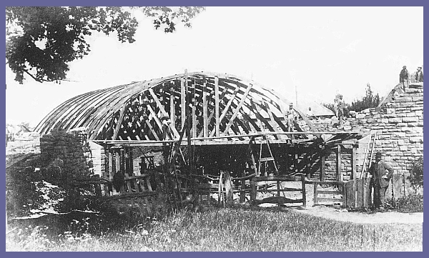

When the Hereford to Worcester railway line was being planned, Stephen Ballard was appointed engineer for the line. The Hereford to Worcester railway line Act was passed in 1853 and work started in 1854. Three stations were built between Hereford and Ledbury and the Ledbury to Colwall section was completed in April 1861 with the tunnel through to Malvern the following year. The line was operated by the West Midland Railway.

One of his last works was to construct, in 1884, a carriage drive along the west side of the Malvern Hills. It was completed in October 1887 in Queen Victoria's Golden Jubilee year. Named ‘Jubilee Drive’ it was built on The Winnings Estate land by his own employees using pick and shovel! ³

Stephen Ballard died in December 1890 aged 86 and, according to his late grandson, who was also called Stephen, he and his wife and some of his family are buried in a private burial ground over the railway tunnel on land formerly part of ‘The Winnings’ farm. The farm buildings have now gone and the land sold for housing development.²

Sources:
1 Paul Ballard, Ballard Genealogy & Heraldry
at http://www.paul-ballard.com/pedigrees/p36.htm#i7841 Accessed 31 May 2007
2 Stephen Ballard, Ballards of Herefordshire see also http://www.ballardgen.com/stephen_ballard_book/stephen_ballard_book.htm Accessed 31 May 2007
3 Stephen Ballard (III) Colwall Collection (1999) ISBN 1 673809 37 9
David E. Bick, The Hereford & Gloucester Canal (2003) ISBN 0 85361 599 3
Herefordshire Record Office, Harold Street, Hereford at
http://www.herefordshire.gov.uk/leisure/libraries/3584.asp Accessed 31 May 2007

Postscript: Robert Ballard, Stephen’s brother, married Catherine Maria Pedlingham and they had a son Robert born on 28 March 1839 in Ledbury who also became a railway engineer. He first attended King Edward Grammar School, Ledbury and later trained as a civil engineer under his uncle, Stephen Ballard. Working for Peto, Brassey & Betts, railways contractors, he was sent to New South Wales in 1859 and over the years constructed a number of railways working for Government departments and private contractors. His reputation was as a bold innovator patenting a number of his own inventions as his uncle had done before him. He married Tamar Brown, in New South Wales, on 22 December 1862 and they had seven children. He died in London on 22 November 1912.

Australian Dictionary of Biography http://www.adb.online.anu.edu.au/biogs/A030082b.htm Accessed 31 May 2007

Document prepared by: Barry Sharples of Bosbury, Ledbury, Herefordshire (2007)

