8 High Street, ledbury
Duncan James, ‘An analysis of the historic fabric of late 16th and early 17th century buildings in Ledbury, Herefordshire’, unpub. report for EPE, 2007

5.07 8 High Street RCHM 13 NGR SO 7112 3767
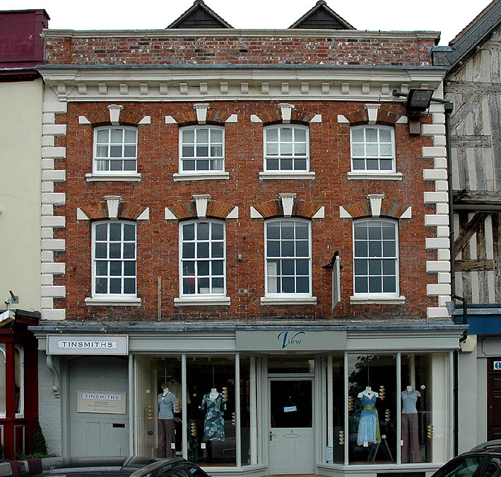
8 High Street. West elevation.
The brick front of this building with its stone quoins and deep moulded cornice belongs to the first half of the 18th century but it is a re-facing of what is probably an early 17th century timber-framed structure. [RCHM notes 1930].
This refacing, in effect underbuilds both first and second floor jetties, increasing the available floor space, especially at street level. The earlier building is indicated by the two gables visible above the parapet. Also, as Hillaby noted, it is possible to see, intruding into the upper part of the first floor windows, the unaltered floor level of the earlier house. [Hillaby Ledbury, A Medieval Borough (1997), p.94].
The RCHM noted two smaller timber-framed buildings, both “probably of early 17th century date”. [RCHM notes 1930].

