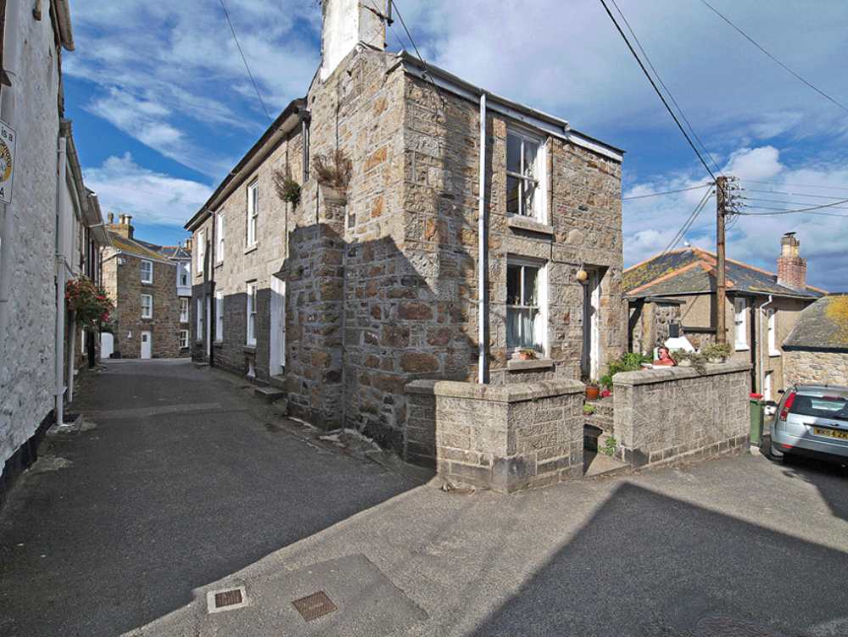

35. Context: Keigwin Place and remains of Dolly Pentreath’s house (rear of telegraph pole)

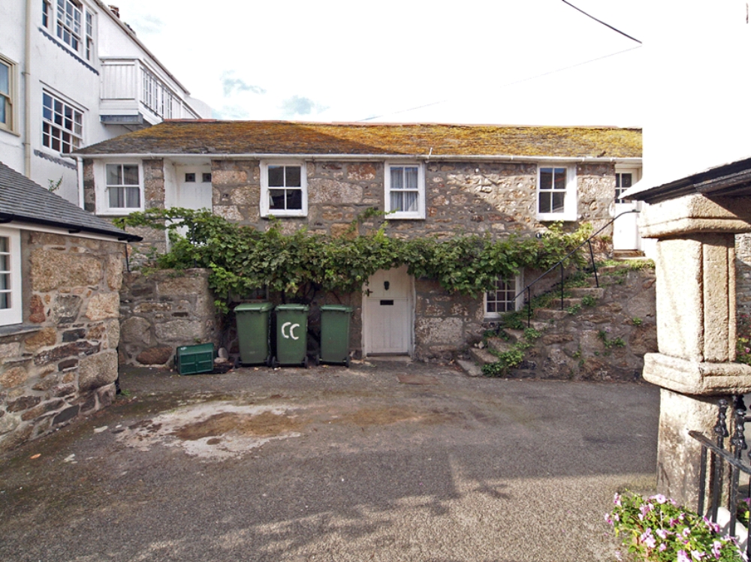

36. Context: Keigwin Place: late 18th century former fish-cellar building north of the Keigwin

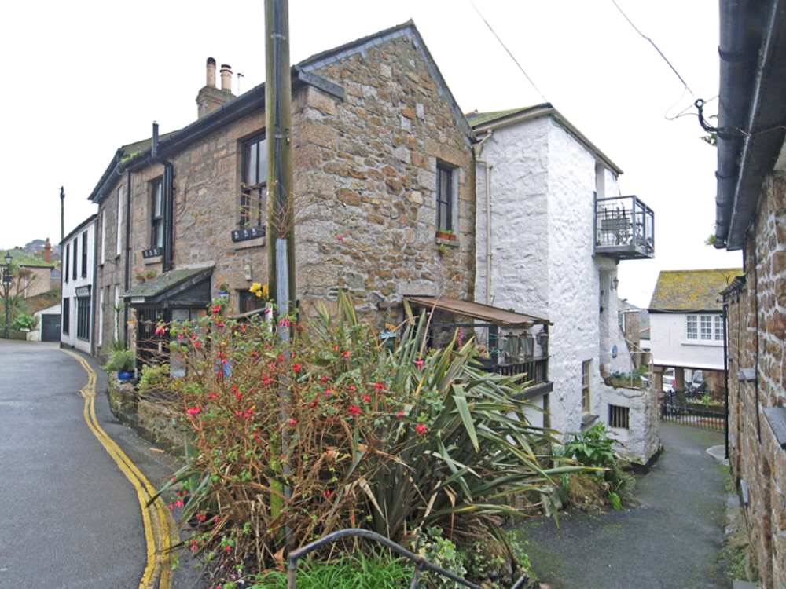

37. Context: Chapel Street and Keigwin Place: buildings north-east of Keigwins

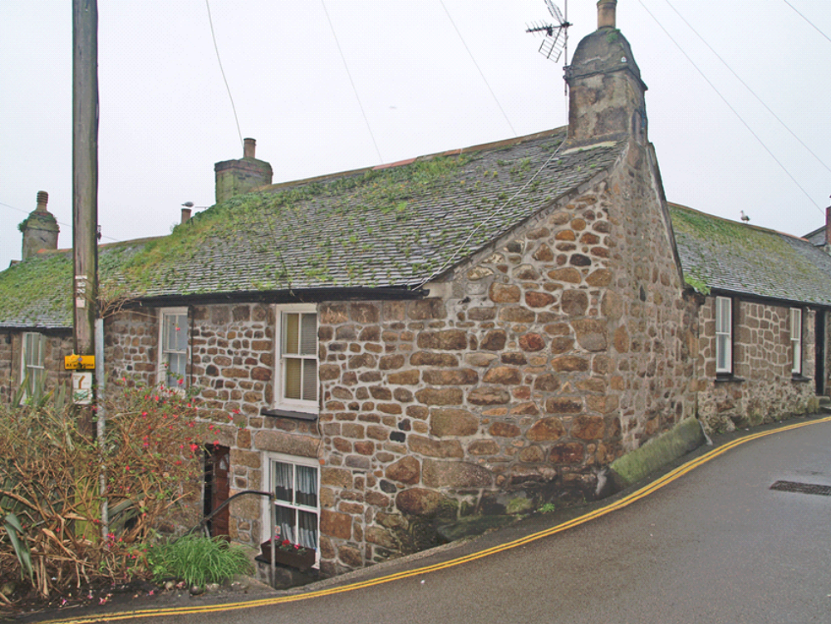

38. Context: houses west of Keigwins (17th century dressed granite stack but rebuilt front wall)

