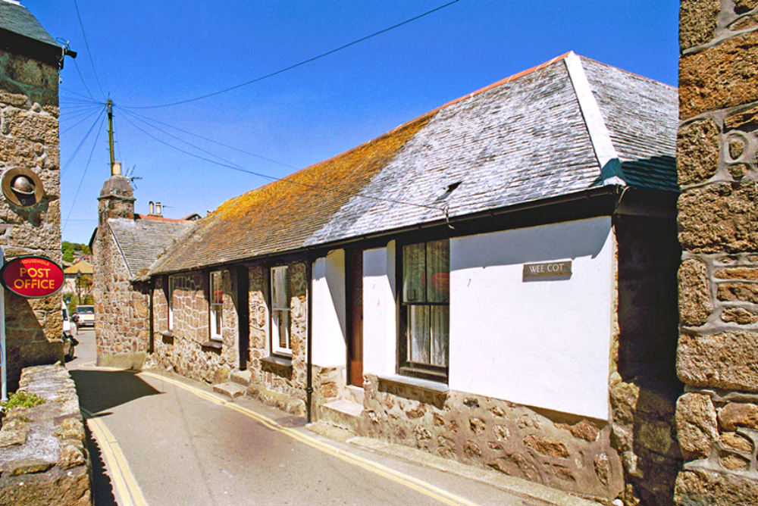

39. Context: Chapel Street: probable net lofts over fish-cellars adjoining 17th century house

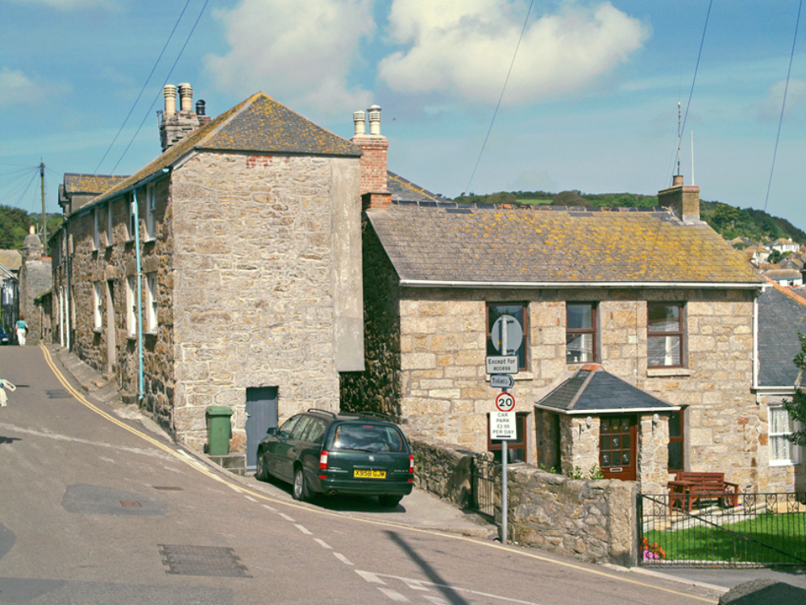
40. Context: Chapel Street: houses with jettied upper floors to rear
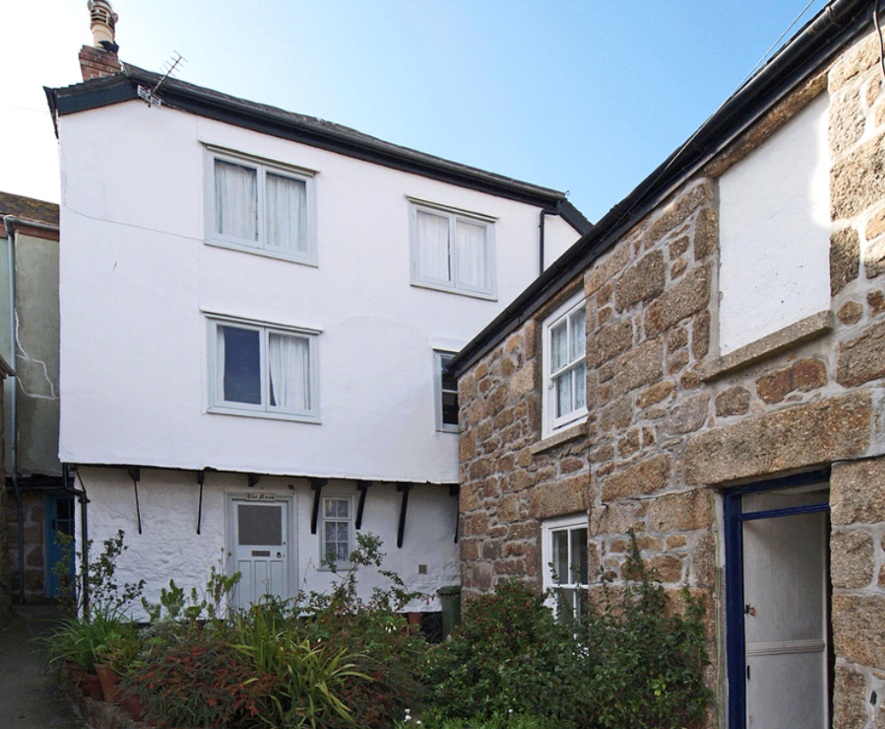

41. Context: jettied rear at south end of Chapel Street and Wesley House

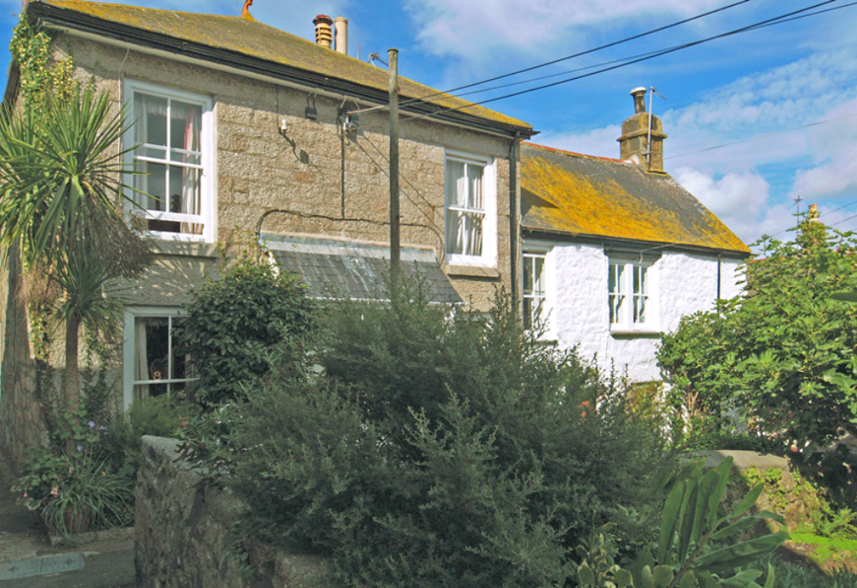

42. Context: houses south of Keigwins and Old Standard (note dressed granite stack)

