completed parish survey questionnaire for launcells

Date of Completion
16th October 2006

Name of Volunteer
L Richardson – U3A Launceston Group

Grid Reference
1902440056

Status (In use/redundant – open/closed)
Church of England – in use

Guide Book/sheet/tablet?
St Swithens –A Short History of Launcells Church 5op. Francis Shearme 1969 (Revised 1990, 200, 2003) 8 pages. Present edition June 2003. Free laminated sheets giving brief details of main points of interest.

In addition:
Some of the memorials and monuments at the Parish Church of St Swithin, Launcells. 50p. 10 pages.
Both published by the Parish Church Council of St. Swithin, Launcells, The Vicarage, Diddies Road, Stratton, Bude, Cornwall. EX23 9DW. Both sizes 6” x 8” stapled.

Stained Glass Windows
There is no stained glass – the church is extremely light.

Bench Ends
The carved pew ends are said to date from the fifteenth century and are very fine. Each one is divided vertically into two with different carvings in each side. Possibly from the same workshop as Kilkhampton and Poughill. (See Photographs numbered as follows):
1. Cross and crown of thorns ?Hera!dic crest
2 Sword [Scimitar] of Peter cutting the ear of the servant
3 St Andrews cross
4 Spice box and nails Harrowing of Hell
5 ? Easter Day-Christ the gardener {a spade} Supper at Emmaeus
6 Doubting Thomas Ascension-Footprints and cloud
7 Empty tomb and shroud Three boxes ?three Marys
8 Pomegranite
9 Pentecost Descent of the Holy Spirit, Marys heart pierced.
10 Spear, sponge,hyssop, nails
11 Descent from the Cross Pincers, ladder, nails
12 Mary Queen of Heaven [Initial]
13 Initials
14 St Andrews Cross
15 As 8
16 ?Thirty pieces of silver
17 Pillar, Scourges
18 St Andrews Cross
Description:
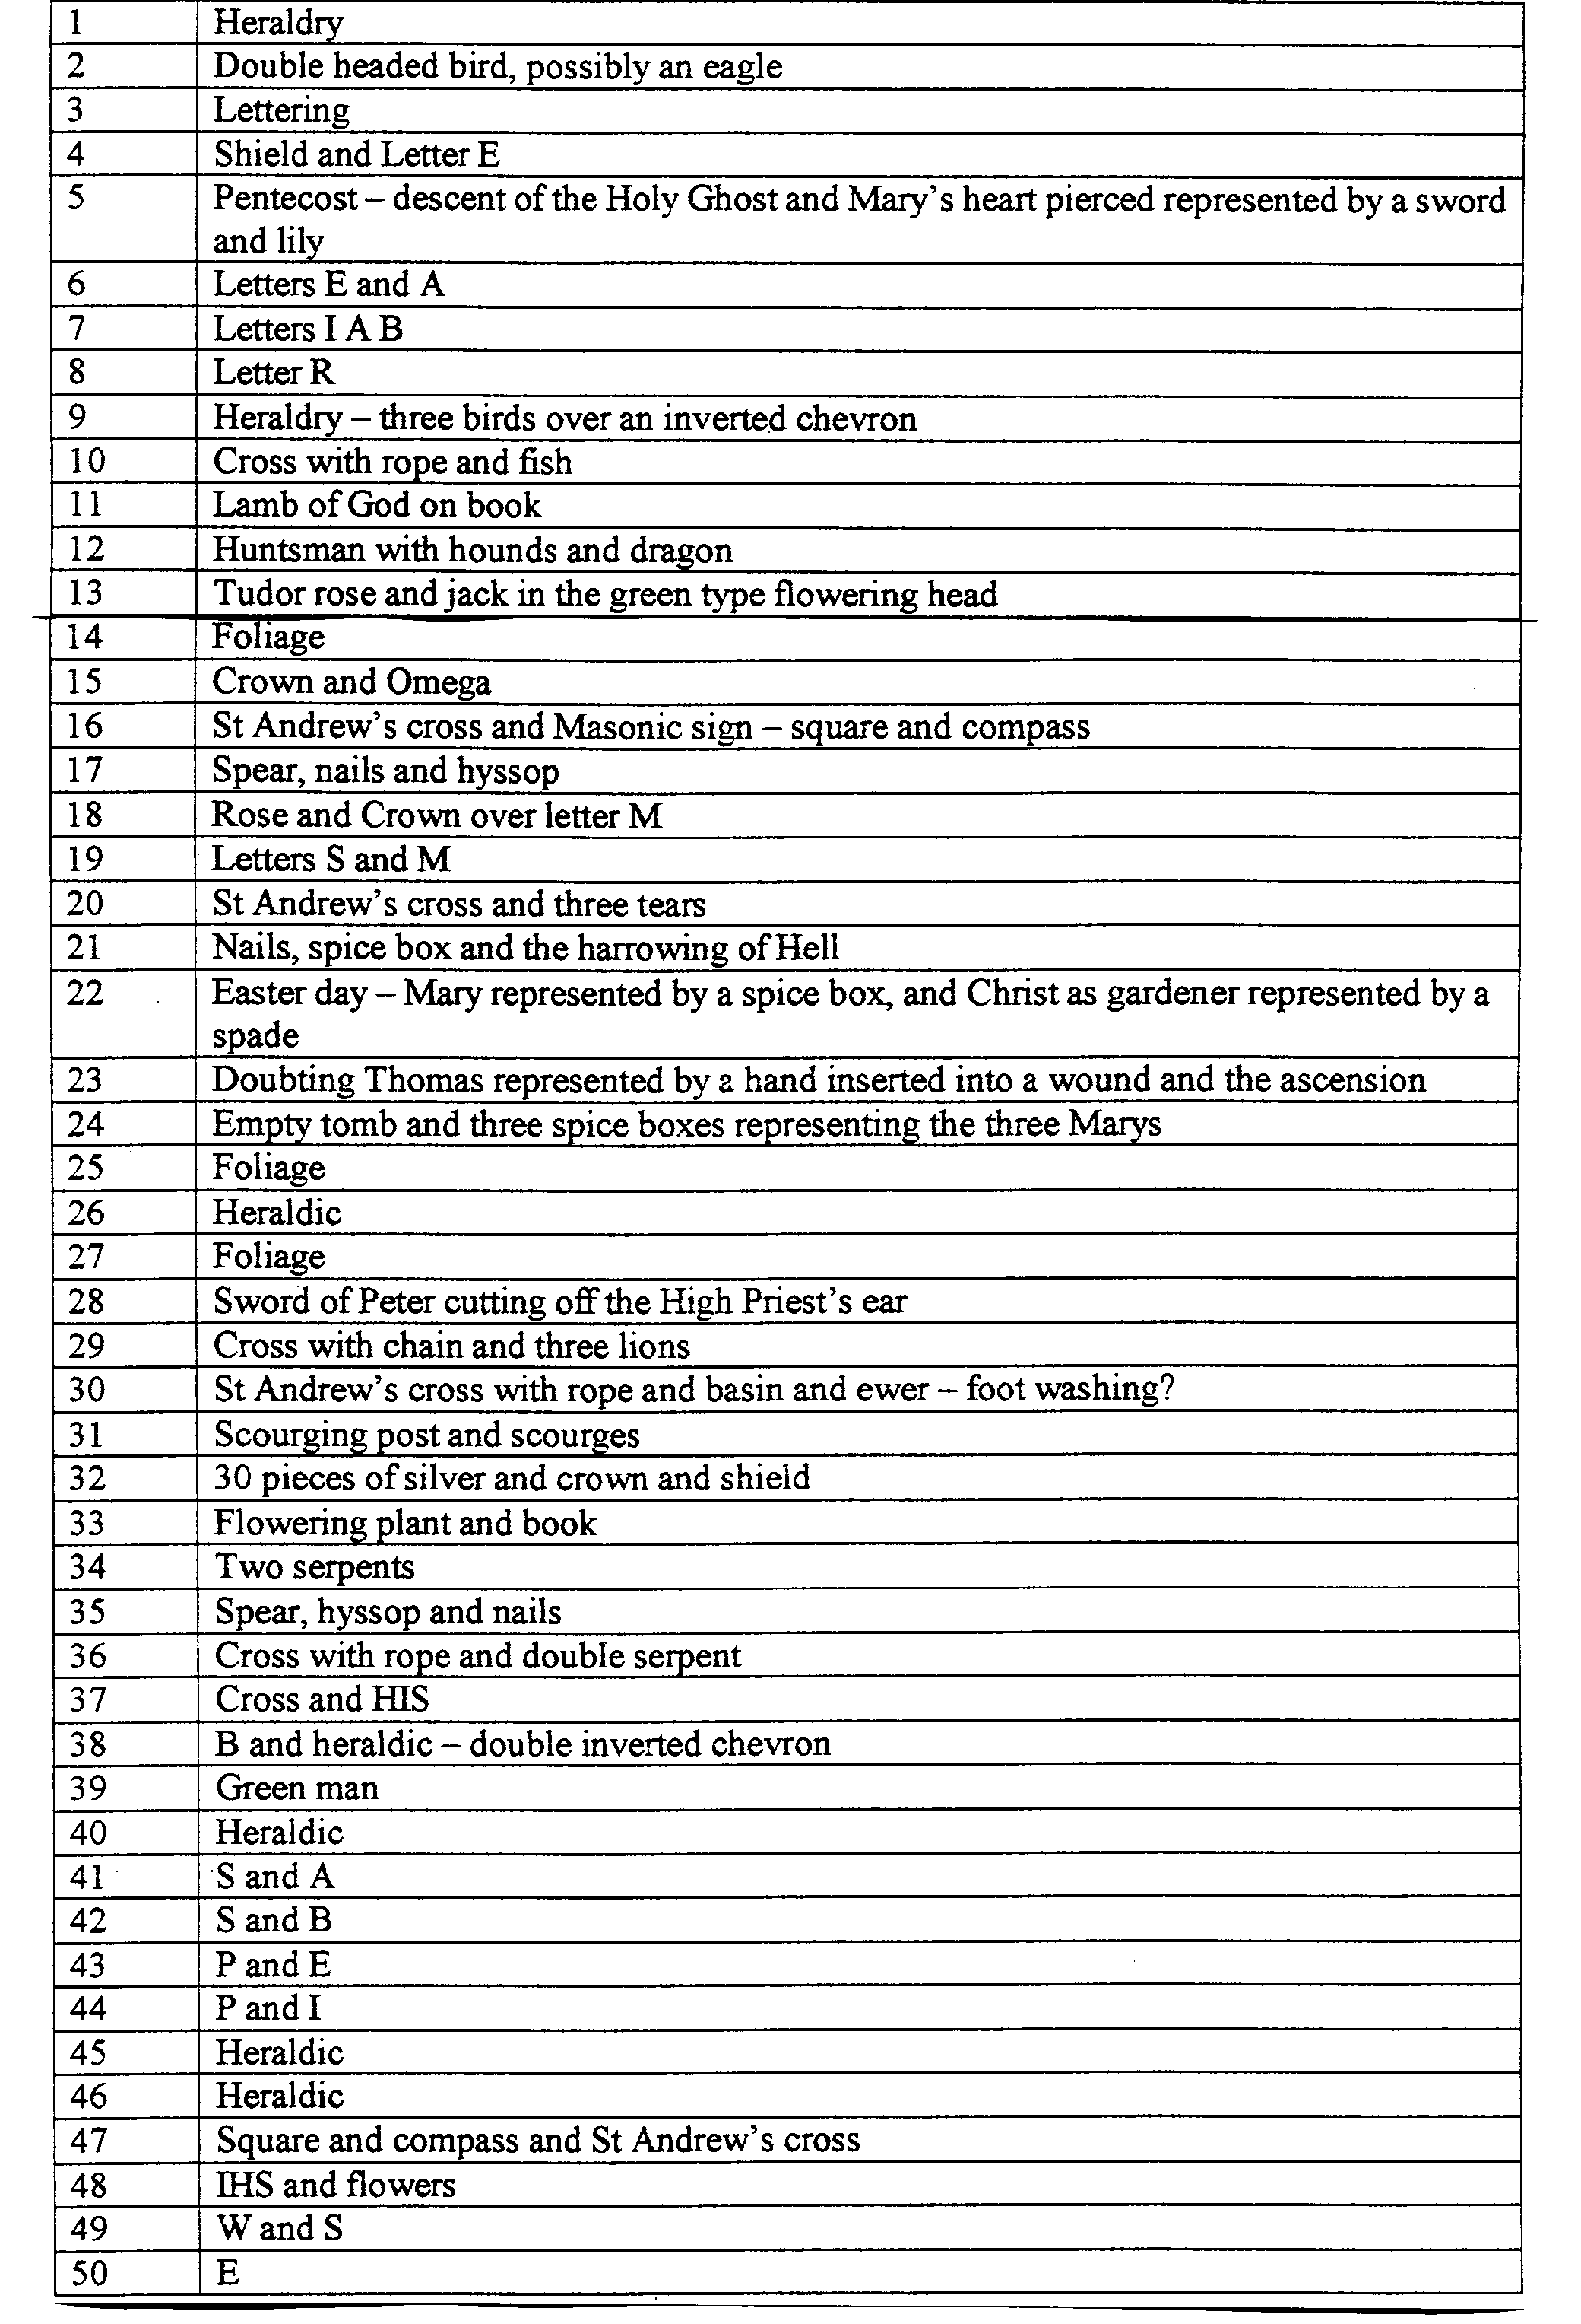

Chapels
None.

Holy Wells
St. Swithins Holy Well.
Location: 100 yards south east of the church adjacent to the lane entrance.
Nature of Location: In a hollow beside the road leading to the church (by the roadside stream).
Surviving Remains: Stonework with painted notice. The well is still in operation and is reputed never to have run dry.

Crosses
None

Wall paintings
None

Other Religious Sites
Possibly the association of the church with Augustinian Canons at Hartland reflected in ‘Fish Ponds’ to the south west (100 yaards) of the building.

To the east of the church is a house called Launcells Barton, a Georgian house built on the site of the original Launcells House, the country seat of the Abbot of Hartland. Evidence of three fish ponds remain.

Books of Reference, Articles or others sources referred to
N Pevsner – Buildings of England (1970)
C.G. Henderson. The Cornish Church Guide (1925)
S. Jenkins. England’s Thousand Best Churches 1999 Allen Lane.
A. Clifton-Taylor English Parish Churches (as works of art) 1974 O.U.P.
Collins Guide to English Parish Churches (Ed. J. Betjeman) 1958 Collins.
There is a little information about the church on the website www.achurchnearyou.com

Personal comment
This church was visited by two volunteers, Andrea Surgeoner and L Richardson, each unknown to the other, and this report is a combination of their findings.

