completed parish survey questionnaire for
st breward

Date of Completion
17th March 2006

Name of Volunteer
Mrs Pamela J Bousfield

Grid Reference
SX 097773

Status (In use/redundant – open/closed)
In use weekly. Open daily Easter to September in daylight hours. Information at church re access to key

Guide Book/sheet/tablet?
Good guide booklet £1; Postcards of the church and village for sale. Plasticised guide sheet and hard-back A History of St Breward not to be taken away, but the history is on sale at the Post Office and Store.

Stained Glass Windows
None thought to be older than 1559.

Bench Ends
Please see next page for more hand drawn examples
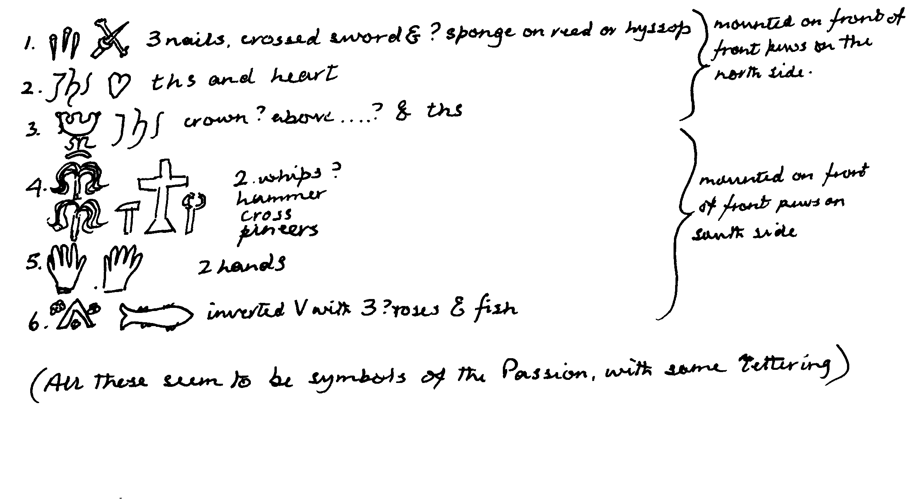
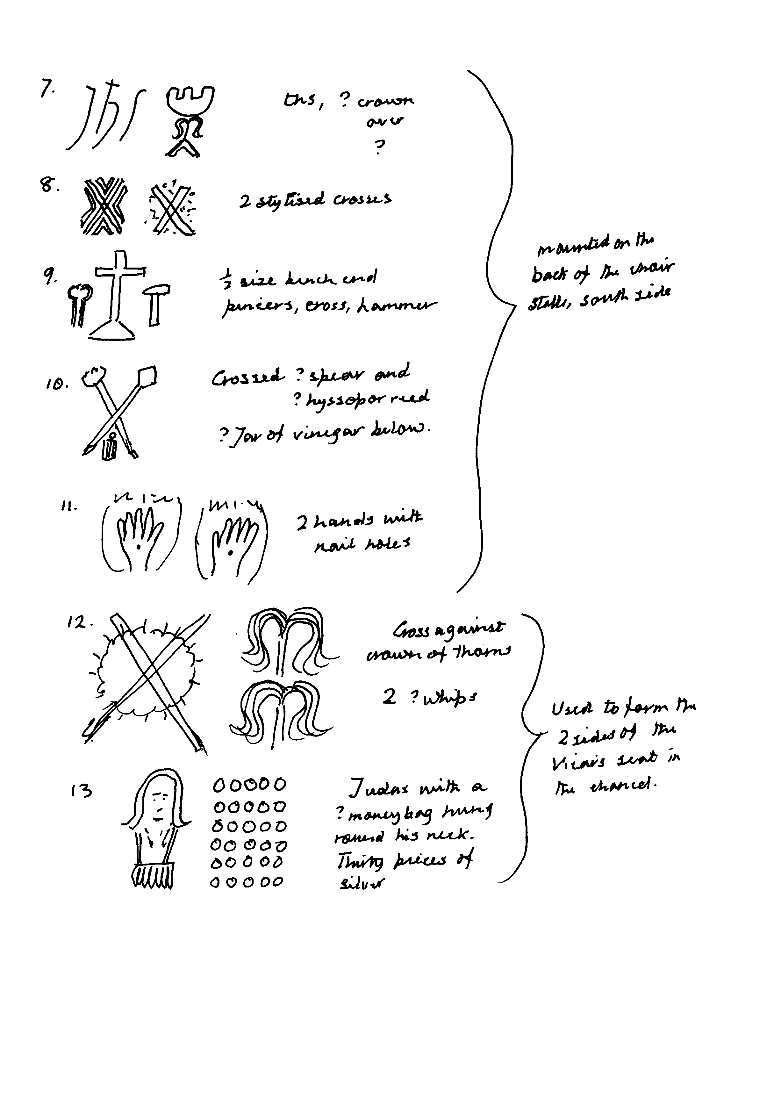

Chapels
Chapel 1.
Location: (SX 097773) On the site of the present Parish Church there may have been a Saxon church or chapel which in turn was built on the site of a Celtic oratory where St Branwalader would have had a habitation, (possibly a cell) in the 6th century. No known surviving remains.
Chapel 2. Chapel of St James, licensed in 1419.
Location: (SX 089769) Probably at what is now Chapel Farm near the Holy Well.
Nature of Location: Woodland near the east bank of the River Camel.
Surviving Remains: Some carved stones said to have been used in the building of Chapel Farm, but non has been identified in the 21st century.

Chapel 3. Chapel of St Michael at Rough Tor, licensed in 1371, 1419, 1435 and 1535
Location: (SX 145802). Close to the summit of Rough Tor.
Nature of Location: Rocky open moorland.
Surviving Remains: Flat slabs of rock surrounded by very low remains of walls. (A plaque commemorates the 43rd Wessex Division and the N.W. European campaign of 1944).

Holy Wells
Holy Well 1. Holy Well of St James.
Location: (SX 091769) Near Chapel Farm, east of the road from Limb Head to Chapel, beside the footpath from hill to chapel.
Nature of Location: In woodland.
Surviving Remains: Construction in good condition since the stonework was repaired and the site cleared of fallen trees in 1995. No water in it since the source was diverted probably as the result of mining operations in the vicinity in the 19th century.

Crosses
Cross 1. Churchyard Cross.
Location: (SX 0973 7729) In St Breward churchyard, across the lane from the church and over towards the east.
Nature of Location: The greater part of what must have been a very fine four hole cross-head was then given a massive granite shaft and set up in its present position in the 20th century.
Cross 2. Middlemoor Cross.
Location: (SX 1250 7930) on an ancient track from Fernacre to the church, via Swallock.
Nature of Location: Open moorland.
Surviving Remains: In good condition despite having fallen and been re-erected in 1873 and again in 1938. It is over 5ft. tall, is roughly hewn and has a simple cross incised on both sides of the head.
Cross 3. Name unknown.
Location: (SX 0892 7561). On a rockery in front of Higher Lank farmhouse.
Nature of Location: Private garden, visible from The Lane.
Surviving Remains: Cross head only, placed there by Mr William Collins, who acquired the farm in 1813. He was a collector and preserver of antiquities but left no record of where they had been found.

Other Religious Sites
None known

Books of Reference, Articles or others sources referred to
Mary Henderson, A Survey of Ancient Crosses of Cornwall 1952-1983
Charles Henderson MSS for a Parochial History of East Cornwall (RIC 1924)
St Breward History Group A History of St Breward Edited and published by Pamela Bausfield 1988, re-printed 1988 and 1999. Particularly chapters 1,3 and 7.
Sir John Maclean Parochial and Family History of the Deanery of Trigg Minor Chapter on St Breward, pages 353-354 (1871)
Andrew Langdon Stone Crosses in North Cornwall 1992 (Pages 20-23) pub. Federation of Old Cornwall Societies.

Miscellaneous
St Breward is a corruption of the name of our 6th century Cornish Patron, Saint Branwalader. Other spellings of St Breward include:
Sancti Branwalarethi (early 12th century)
Sancti Brewueredi (c.1190)
Sancto Bruereto (1272)
Sancti Brueredi (1276)
St Bruard (1733)
St Bruerdus (1846)

