the sunderland coal trade
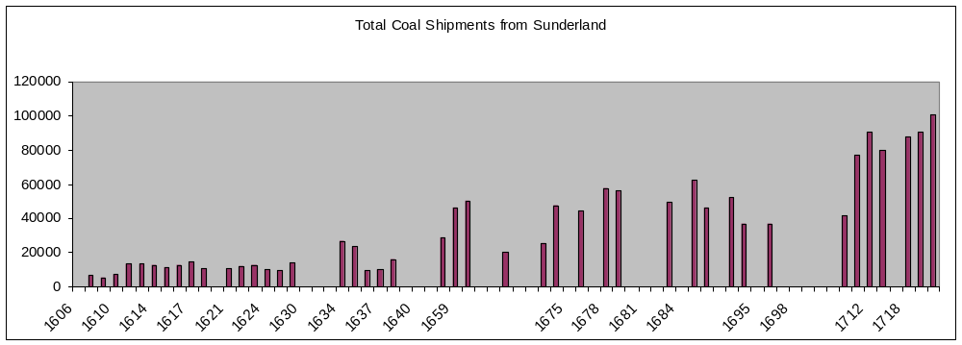
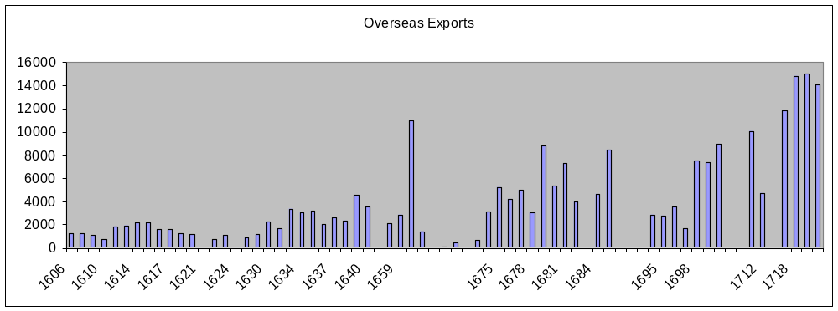

Sources for graphs:
Hatcher, British Coal Industry, 493-5, is preferred to Dietz, ‘The North-East Coal trade’, 291, for 1606-1700; supplemented by Dietz; supplemented for 1608, 1610, 1623 and 1630-1 by E Sussex RO, GLY/ 387, /447-58, /478-96, and for 1635-8 by W Yorks RO, Leeds, 100/PO/6/VI/4; Dietz, North-East Coal trade’, 291, for 1703-20.

The coal trade peaked in summer, a mark of how dangerous it was during the rest of the year to navigate the east coast and the mouth of the Wear, ‘narrow and shallow, called a dry harbour as at low tide craft lie on the ground’. When conditions allowed, extraordinary effort was made to load and despatch ships, day or night, inside the port or out at sea. During the 17th century, before there were concerted moves to improve the river, when the tide was out ‘keelmen [were] often forced to haul their keels by a line… and so to draw and tug them by mere strength, up and down the … river’ and manually beach the vessels on the shore. When ships had been delayed ‘through adverse winds and other causes’, the Sunderland trade did not stop. Coal fitters despatched keels upriver for more loads, hoping that ships might be in port when the keels returned, so that the coal could be sent out without delay.

The 17th-century fitter was a gentleman agent who bought coal and transported it by keel from the staithes on the coalfield near Lambton and Lumley, then negotiated its sale to ships’ masters who carried it to market elsewhere in England and overseas. Ralph Clarke, a prominent figure in Sunderland in the 1670s, was a typical fitter with a range of commercial interests. He owned a malt mill and brewery adjoining his house between High Street and the river, as well as large numbers of keels and shares in ocean-going vessels. By 1679 his fleet included 10 seven-chaldron coal keels, one four-chaldron coal boat, and a three-chaldron coal boat, to a total value of £200, each with a named skipper. Two of these keels he had acquired for £44 from another fitter, Samuel Yallowley, in 1674. From the summer of 1680 a batch of records has survived of Clarke’s purchases and sales of coal, 292 transactions in all. He dealt mainly in seven-chaldron (18.55 tons) lots from keel skippers and others. At that time Clarke owned several other properties ‘upon the quay and elsewhere in Sunderland’ along with 14 keels or barges and part interests in 32 sea-going vessels.

Customs duties were collected on all coal shipped out of Sunderland, so quantities were recorded. Some of the lists survive, from which these graphs have been drawn. It is not usually certain, however, whether the measures are Newcastle (53 hundredweight or 2.65 tons) or London (28 hundredweight, 1.4 tons) chaldrons. Even though incomplete and sometimes unclear, the graphs show a dramatic rise in total coal sales over the century, and a matching increase in overseas exports. Certainly by 1700 Sunderland was ‘noted for its sea coal trade’, supplying a ‘great quantity of coals’ and employing ‘great numbers of ships yearly in carrying coals…’ Most was transported along the east and south coasts of England and some to Scotland. Only a relatively small proportion – in 1710, 28 per cent – of Wear coal was sold in London.

Sources:
B. Dietz, ‘The North-East Coal trade, 1550-1750: Measures, Markets and the Metropolis’, Northern History, 22 (1986), 282-5; G. Miège, A New State of England, under our Present Sovereign Queen Anne (1702), 41; HL, LP/189/5; East Sussex RO, GLY/387, /447-58, /478-96; TWAS, 202/1111; Potts, Sunderland, 129-31; DRO, D/Lo/D 323, 328, 360, 390/6; /24; D/Lo/F 392.

Gill Cookson

copyright
All rights, including copyright ©, of the content of this document are owned or controlled by the University of London. For further information refer to http://www.englandspastforeveryone.org.uk/Info/Disclaimer

